saqarTvelos ganaTlebis da mecnierebis saministro

saqarTvelos teqnikuri universiteti
s

marina tefnaZe _ asoc. profesori

m e r q a n m c o d n e o b a
satyeo saqonelmcodneobis safuZvlebiT

Tbilisi 2007
Sesavali

Cveni planetis udidesi nawili dafarulia tyeebiT. maT uWiravT xmeleTis erTi mesamedi. tyis ekologiuri mniSvnelobis Sefaseba Znelia. sakmarisia aRiniSnos, rom dRe-RameSi sul cota 10 saaTi adamiani sunTqavs tyeebis mier aRdgenili JangbadiT. tye aRadgens samrewvelo sawarmoebisa da satransporto saSualebebis mier milionobiT tona sxvadasxva sawvavis wvis Sedegad ganadgurebul Jangbads. mcenareebi gamoimuSaveben organul masas (fitomasas), romelic aucilebelia dedamiwaze sicocxlis arsebobisaTvis. tye, rogorc biosferos aucilebeli nawili, akumulirebs mzis energias, gavlenas axdens klimatze, wylisa da gazis mimoqcevaze bunebaSi. naxSirmJava gazi da sxva mavne samrewvelo gamonabolqvebi STainTqmeba tyis mcenareebis mier. tye aregulirebs niadagSi wylis marags, icavs mas eroziisagan, mtvriani qariSxlisagan. igi asrulebs gamajansaRebel da sanitarul _ higienur funqciebs. msoflio nedleulis warmomadgenelTa Soris merqans badali ar gaaCnia. Znelia davasaxeloT saxalxo meurneobis dargi, sadac merqani ar gamoiyenebodes. merqnis am upiratesobas sxva masalebTan SedarebiT ganapirobebs misi sami damaxasiaTebeli niSani: 1. igi universaluria; 2. moipoveba uxvad da 3. praqtikulad amouwuravia.
merqnis msoflio maragi Seadgens 360 mlr. m³ aqedan 125 mlr. m³ uWiravs wiwvovan jiSebs. merqanze moTxovnileba msoflioSi ganu-wyvetliv izrdeba. igi amJamad 2,5 mlr. m³-s aRwevs weliwadSi da mosalodneli prognozebiT 2010 wlamde gaormagdeba.
merqnis mravalmxrivi gamoyeneba aixsneba am produqtSi mravali Zvirfasi Tvisebis iSviaTi SerwymiT. Mmerqani warmoadgens mtkice da amave dros msubuq masalas, romelsac gaaCnia kargi Tbosaizolacio Tvisebebi, unari aqvs aitanos dartymiTi datvirTvebi, CaaxSos vibracia. igi advilad muSavdeba mWreli iaraRebiT, advilad webdeba da mopirkeTdeba, iWers liTonis samagrebs, gaaCnia SesaniSnavi dekoraciuli Tvisebebi, axasiaTebs unikaluri rezonansuli unari. yovelive es saSualebas iZleva merqani gamoyenebuli iqnes samSeneblo detalebisa da konstruqciebis, aseve avejisa da musikaluri instrumentebis, tarisa da sportuli inventaris warmoebaSi. mas iyeneben aseve Spalebis saxiT, samTomadno mrewvelobaSi, saTbobad da kidev bevri sxva daniSnulebiT.
magram, mTel rig dadebiT TvisebebTan erTad ar SeiZleba ar aRiniSnos misi uaryofiTi Tvisebebic. esenia: araerTgvarovani aRnagoba, anizotropia anu Tvisebebis cvalebadoba, mankebis arseboba, SeSrobisa da gajirjvebis unari, dabrecva da daskdoma, lpoba da advilad aaleba. CamoTvlili naklovanebebis aRmofxvra SeiZleba merqnis qimiuri da qimiur-meqanikuri gadamuSavebiT furclovan da filovan masalad, qaRaldad, muyaod, fanerad da a.S. es masalebi bunebriv merqanTan erTad gamoiyenebian mSeneblobaSi, saavejo, saaviacio, eleqtroteqnikur da saxalxo meurneobis sxva dargebSi.
merqanSi antiseptikebis, antipirenebis, fisebis Seyvana, agreTve misi plastificireba da dawnexva saSualebas gvaZlevs gavaumjobesoT naturaluri merqnis Tvisebebi da miviRoT bio - da cecxlgamZle masalebi, romelTac gaaCniaT maRali simtkice, cveTamedegoba da formamedegoba, aseve sxva saWiro teqnologiuri da saeqsploatacio Tvisebebi.
merqani gamoiyeneba rogorc nedleuli mravali Zvirfasi produqtis dasamzadeblad. Mmag.: soflis meurneobaSi cxovelebis sakvebad, safeiqro warmoebaSi xelovnuri boWkos misaRebad, merqnis naxSiris misaRebad naxevargamtarebis damzadebisaTvis, samkurnalo preparatebis dasamzadeblad da sxva.
sawvavis maragis SezRudvis pirobebSi merqani perspeqtivaSi aRmoCndeba ZiriTadi nedleuli Txevadi da gazisebri sawvavis warmoebisaTvis. amJamad merqanze arsebuli didi moTxovnileba da misi farTo gamoyenebis perspeqtiva momavalSi mwvaved svams sakiTxs tyis simdidris racionalurad gamoyenebis Sesaxeb.
merqnisgan miRebuli produqtebis CamoTvla (rac TiTqmis 20 000-mdea) Sors wagviyvans, sakmarisia avRniSnoT, rom navTis, naxSiris da gazisagan gansxvavebiT igi miekuTvneba ganaxlebad bunebriv resurs. es udavo upiratesoba merqnis nedleulisa wiaRiseuli resursebis mimarT gansazRvravs mis farTo gamoyenebas momavalSi.
merqnis, rogorc momavlis masalis SefasebaSi did rols TamaSobs misi ganumeorebeli esTetikuri Tvisebebi. Zalian Zlieria adamianis miswrafeba am keTilSobil bunebriv masalasTan urTier-Tobisken.
merqanmcodneoba, rogorc mudmivad ganviTarebadi mecniereba, moicavs biologiuri, qimiuri, fizikuri da meqanikuri kvlevebis Sedegad merqnis aRnagobaze da Tvisebebze miRebuli monacemebis kompleqss. igi warmoadgens bazas, romelsac eyrdnoba danarCeni satyeo-teqnikuri disciplinebi.

Tavi I. merqnis aRnagoba.
1.1. mozardi xis nawilebi.

mcenareebi iyofa or klasad: dabali da maRali klasis mcenareebi. dabali klasis mcenareebs Rero ar gaaCniaT. maT miekuTvneba baqteriebi, wyalmcenareebi, sokoebi. maRali klasis mcenareebs ki _ xavsebi, gvimrebi, SiSvelTesliani da farulTesliani mcenareebi. merqani miekuTvneba swored bolo or jgufs. wiwvovani jiSebi SiSvelTeslianebia. isini farulTes-lianebisgan gansxvavdebian yvavilisa da foTlis formiT. SiSvelTeslianebs gaaCniaT nemsisebri foToli, romelsac wiwvs eZaxian. aqedan warmodgeba maTi dasaxeleba _ wiwvovani jiSebi. farulTeslianebs gaaCniaT sxvadasxva garSemowerilobis firfitis formis foTlebi, romlebzedac SeimCneva gantotvili daZarRvu-lobani. aqedan warmodgeba maTi dasaxeleba _ foTlovani jiSebi. ZiriTadi sawarmoo daniSnulebis wiwvovani jiSebia: fiWvi, naZvi, soWi, kedari, lariqsi, Rvia da urTxeli. danarCeni sawarmoo jiSebi miekuTvnebian foTlovanebs: muxa, wifeli, cacxvi, wabli, alva, ifani, aryi da sxva.
mozardi xe Sedgeba sami nawilisagan: fesvebi, Rero anu tani da varji anu krona. Ees ukanaskneli warmoadgens foTlebisa da totebis erTobliobas (nax.1). ganvixiloT TiToeuli maTganis funqciebi:
kronis foTlebSi xis sicocxleSi haeridan STanTqmuli naxSirmJava gazisa da niadagidan Sewovili da tanis saSualebiT miwodebuli wylis saSualebiT, mzis energiis moqmedebiT mimdinareobs fotosinTezi _ mcenaris sicocxlisaTvis aucilebeli rTuli organuli nivTierebebis warmoqmnis procesi. cocxal mozard organizmSi, garda fotosinTezisa, mimdinareobs sxva fiziologiuri procesebic: sunTqva, kveba, sakvebi nivTierebebis gardaqmna da gadaadgileba, wylis aorTqleba da sxva. am procesebis urTierTmoqmedebis Sedegad mcenareebi izrdebian da viTardebian.
fesvebi warmodgenilia mTeli sistemiT. igi moicavs wvril da msxvil fesvebs. wvrili fesvebi iwoven niadagidan wyals da masSi gaxsnil mineralur nivTierebebs, xolo msxvili fesvebi ikaveben xes vertikalur mdgomareobaSi, atareben wyals da inaxaven sakvebi nivTierebebis marags.
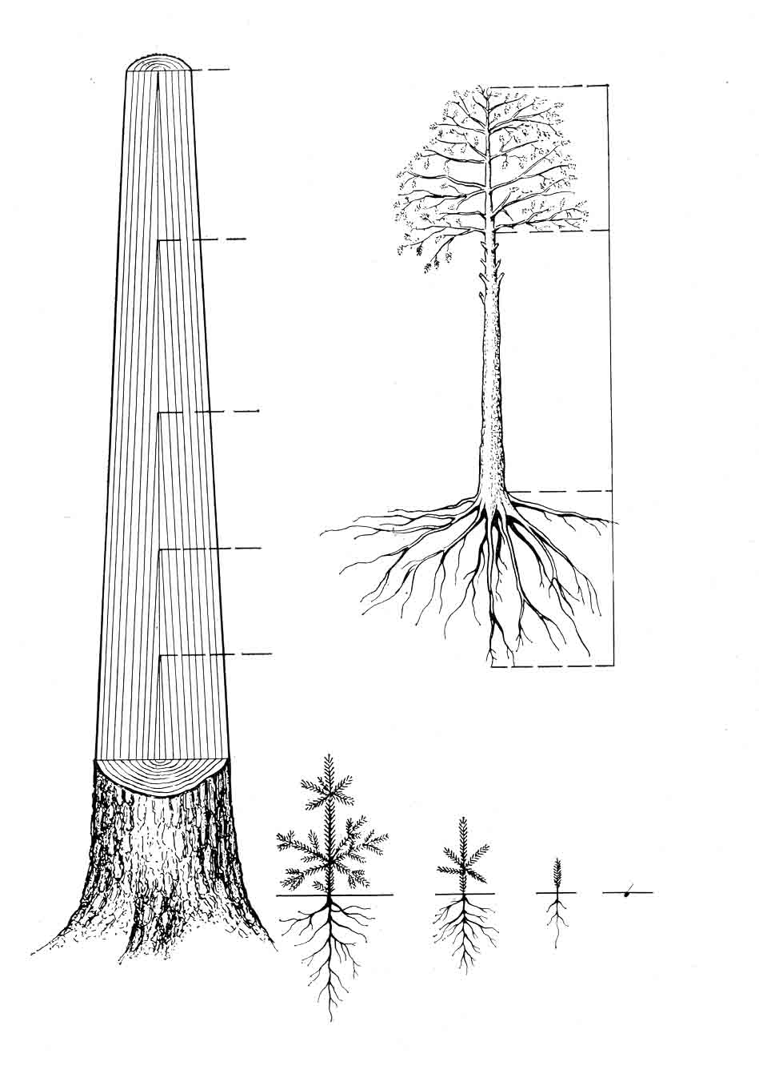
8 weli
7 weli
6 weli
5 weli
4 weli
varji
Rero
fesvebi
3 weli
2 weli
1 weli
Tesli
nax.1. mozardi xis nawilebi da Reros Camoyalibebis sqema.
a) mozardi xe; b) Reros formirebis sqema 13 wlian wiwvovan xeze.

Rero akavSirebs fesvTa sistemas varjTan. Mmis funqcias Seadgens gaataros wyali da masSi gaxsnili mineraluri nivTierebebi fesvebidan varjisaken _ aRmavali deni, amave dros igi atarebs kronaSi gamomuSavebul wyalSi gaxsnil organul plastikur nivTierebebs kronidan fesvebisaken _ daRmavali deni. tanis funqcias Seadgens aseve Seinaxos samarago sakvebi nivTierebebi da ganalagos masze krona, varji. xis tans mTavari samrewvelo mniSvneloba gaaCnia.

1.2. xis tanis mTavari Wrilebi da nawilebi.

xis tanis Seswavlas vaxdenT sami mimarTulebiT: torsuli (ganivi), radialuri da tangentaluri.
torsuli Wrili ewodeba sibrtyes, romelic gatarebulia xis tanis RerZis marTobulad. radialuri Wrili miiReba xis tanis radiusze Wris gatarebis Sedegad. tangentaluria Wrili, romelic gadis xis tanis paralelurad torsis centridan garkveuli manZilis daSorebiT (nax. 2).
qerqi
guli
gulguli
cila
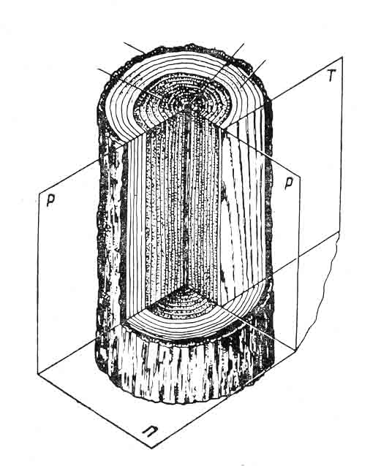
nax. 2. xis tanis ZiriTadi nawilebi da mTavari Wrilebi.
П _ ganivi (torsuli); Р _ radialuri; Т _ tangentaluri

Reros ZiriTadi anatomiuri elementebi advili SesamCnevia xis torsul Wrilze. SevamCnevT, rom mis centrSi mdebareobs muqi feris laqa, romelsac gulguli ewodeba. Sua nawili torsuli Wrilisa, romelsac yvelaze didi moculoba uWiravs, warmoadgens sakuTriv merqans. Ees ukanaskneli garSemoxveulia qerqiT. Mmerqansa da qerqs Soris moTavsebulia SeuiaraRebeli TvaliT SeumCneveli fena, romelsac kambiumi ewodeba. igi ganapirobebs merqnisa da qerqis zrdas siganeSi.
gulguli iSviaTad mdebareobs torsis geometriul centrSi. mas, Cveulebriv, eqscentruli mdebareoba uWiravs. jiSebis umete-sobaSi gulguli mrgvali an ovaluri formisaa. Mmisi diametri ar aRemateba 2-dan 5 milimetrs. zogierT jiSebSi gulguli samkuTxaa (muryani) an oTxkuTxa (ifani). Wadars gaaCnia xuTkuTxa gulguli, xolo muxas – varskvlaviseburi.
grZiv WrilSi gulguli warmoadgens mils, romelsac wiwvovan jiSebSi SedarebiT swori forma aqvs, xolo foTlovanebSi – klaknili.
Gganiv Wrilze qerqs gaaCnia rgolis forma. Mmisi Siga nawili, romelic gulgulisken aris mimarTuli, Cveulebriv ufro Ria ferisaa da uSualod esazRvreba kambiums. Aam Sres lafani ewodeba. Mmisi daniSnulebaa gaataros foTlebSi warmoqmnili organuli sakvebi nivTierebebi xis tanSi dabla. gareTa nawili warmoadgens sakuTriv qerqs. Mmisi daniSnulebaa daicvas xis tanis cocxali qsovilebi temperaturis mkveTri cvalebadobisagan, wylis aorTqlebisagan, merqanSi sokoebisa da baqteriebis SeRwevisa da meqanikuri dazianebisagan.
zedapiris xasiaTis mixedviT qerqi SeiZleba iyos gluvi, Rariani, qacviani, boWkovani da xaliani. Rariani qerqi aqvs muxas, qacviani _ fiWvs, boWkovani _ Rvias, xaliani ki WonWyatas. qerqis moculoba xis tanis moculobasTan did farglebSi meryeobs da Seadgens 6–25%. ukanasknel xans daisaxa qerqis efeqturi gamoye-nebis gzebi. Qqerqisagan SeiZleba miRebuli iqnes Zvirfasi qimiuri produqtebi, romelic gamoiyeneba tyavis warmoebaSi, medicinaSi, metalurgiaSi, mSeneblobaSi. sawvavad qerqi didi xania gamoiyeneba.

Tavi II. xis tanis makroskopuli aRnagoba.
2.1. guli, cila, mwife merqani.

xis tanis ganiv Wrilze merqnis bevr jiSebSi gamoirCeva muqad Seferili centralurizona _ guli da Ria feris periferiuli zona _ cila (nax. 2).
Mmozard xeSi cila cocxali nawilia, xolo guli _ mkvdari, romelic ar monawileobs fiziologiur procesebSi. Aadreul asakSi yvela jiSis merqani Sedgeba mxolod cilisagan. Ddrois gasvlis Semdeg centralur zonaSi xdeba cocxali elementebis kvdoma, wyalgamtari gzebis daxSoba da eqstraqtuli nivTierebebis dagroveba. amasTan zogierT jiSebSi intensiuraT mimdinareobs feris Secvla aRniSnul zonaSi _ is muqdeba, e.i. warmoiqmneba guli. aseT jiSebs gulians uwodeben.
zogierT jiSebSi merqnis centraluri nawilis kvdomas Tan ar axlavs gamuqeba. erTgvarovani feris mqone jiSebs cilovans uwodeben. maTSi tenis Semceloba centralur da periferiul nawils Soris ar gansxvavdeba. Tu merqnis centralur zonaSi aris naklebi raodenobis teni, vidre periferiulSi, maSin aseT jiSebs mwife merqnians uwodeben.
wiwvovani jiSebidan gulians miekuTvneba: fiWvi, kedari, Rvia da urTxeli. Mmwife merqnians _ naZvi da soWi. foTlovani jiSebidan guliania muxa, ifani, kakali, tirifi, alva da sxva. ciliani _ aryi, Txmela, wifeli, rcxila, nekerCxali da sxva.
cilis daniSnulebaa gaataros wyali da masSi gaxsnili mineraluri an organuli nivTierebebi, xolo guli asrulebs meqanikur funqcias. is ZiriTadad gamoiyeneba Txevadi nivTierebis taris dasamzadeblad.

2.2. wliuri Sreebi, adreula da gviana merqani

zomier klimatur pirobebSi gazrdili xis torsul Wrilze SegviZlia SevamCnioT gulgulis garSemo dalagebuli koncentruli wrexazebi, romlebic warmoadgenen xis tanis wliur namets. amis gamo mas wliur Sres uwodeben. wliuri Sreebi gansakuTrebiT kargad Cans wiwvovan jiSebSi.
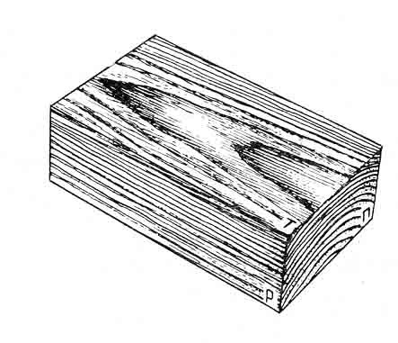
radialur Wrilze wliuri Sreebi urTierT paraleluri swori xazebis saxiT Cans, xolo tangentalurze klaknili xazebis saxe aqvT (nax. 3). wliuri Sreebis ricxvi kintidan wverosaken mcirdeba, rac imiT aixsneba, rom xe izrdeba ara marto siganeSi, aramed simaRleSic. Aamgvarad, wliuri Sreebis raodenobis mixedviT SegviZlia gavigoT xis tanis im nawilis asaki, sadac gatarebulia Wra.
nax. 3. wliuri rgolebi mTavar Wrilebze:
adreuli (Ria feris) da gviani (muqi feris) merqani ganiv - П, radialur - Р da tangentalur - Т Wrilebze.

wliuri Sre Sedgeba ori nawilisagan: Ria feris Siga nawili, romelic gulgulisken aris miqceuli, warmoadgens adreul merqans. igi warmoqmnilia gazafxulze, vegetaciis pirvel periodSi, gare, muqad Seferili nawili warmoadgens gviana merqans. Ggansxvaveba adreula da gviana merqans Soris mkveTrad SeimCneva wiwvovan jiSebSi. Aadreula merqnis funqciaa gaataros wyali da masSi gaxsnili mineraluri nivTierebebi fesvebidan varjisaken. xolo gviana merqani ufro meqanikuri funqciis matarebelia.NTanafardoba adreula da gviana merqans Soris Zalian did sazRvrebSi icvleba da damokidebulia jiSze, xis zrdis pirobebze da xis tan-SiNadgilmdebareobaze.Nimis gamo, rom gviana merqani ufro mkvrivia, ufro magaria da ufro mZimea, vidre adreula merqani, masze didadaa damokidebuli merqnis meqanikuri maxasiaTeblebi, rogoricaaNmoculobiTi wona, simkvrive da simtkice.
wliuri Sreeebis sigane did sazRvrebSiNicvleba. Yyvelaze viwro wliuri Sreebi axasiaTebs nelad mzard jiSebs _ 1-mm-mde (bza). xolo swrafad mzardi jiSebisaTvis damaxasiaTebeliaNganieri wliuri SreE10 mm-mde (cacxvi, tirifi).
radiusis mimarTulebiT wliuri Sreebis sigane Semdegnairad icleba: gulgulTan ganlagebulia SedarebiT viwro wliuri Sreebi, Semdeg maTi sigane matulobs, xolo garkveuli momentidan iwyebs klebas qerqisaken. wliuri SreebisAintensivoba damoki-debulia agreTve meteorologiur pirobebze. maTi siganis mixedviT msjeloben im meteorologiur pirobebze, romelSic warmoiSva mocemuli wliuri Sre. Aamas swavlobs mecniereba, romelsac dend-roklimatologia awodeba.
xis tanis simaRlis mixedviT wliuri Sreebis sigane normalurad matulobs, ris gamoc xis tani srulmerqniania anu xes gaaCnia cilindris forma. Uumetes xeebSi SeimCneva diametris kleba kintidan wverosaken. Aam SemTxvevaSi xis tani wowebiania, radgan diametris klebas kintidan wverosaken woweba ewodeba.
xandaxan wliuri Sreebi gulgulis urTierT sawinaaRmdego mxareze uTanabrod viTardeba. am SemTxvevaSi xis tani iZens eqscentrul aRnagobas (nax. 4).

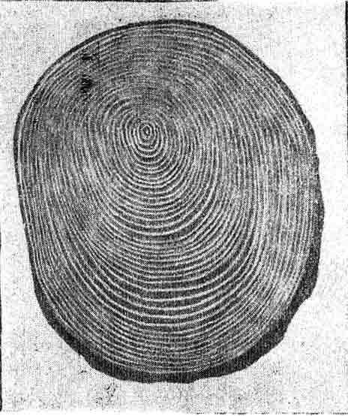

nax. 4. fiWvis tanis ganivi Wrilis gulguli sagrZnoblad gadanacvlebulia

2.3. gulgulis sxivebi

zogierTi jiSis merqnis torsul Wrilze kargad SeimCneva brwyinvale xazebi, romelTac radialuri mimarTuleba gaaCniaT. maT gulgulis sxivebi ewodebaT. zogierTi sxivi iwyeba gulgulidan da gadis qerqamde, grZeldeba ra masSic. aseT sxivebs pirveladi gulgulis sxivebi ewodebaT. zogierTi ki aRiZvreba gulgulidan garkveul manZilze da grZeldeba masSic. aseT sxivebs meoradi sxivebi ewodebaT. Mdamoukideblad imisa, sxivi pirveladia Tu meoradi, aRZruli sxivi bolomde kveTs xis tans.
siganis mixedviT ganasxvaveben Semdegi saxis gulgulis sxivebs: Zalze viwro, romelTa danaxva SeuiaraRebeli TvaliT SeuZ-lebelia, viwro, romelTa garCeva SeuiaraRebeli TvaliT Znelia da ganieri, romelTa danaxvac Tavisuflad SeiZleba. Gganieri sxivebi gaaCniaT muxas, wifels, Wadars. viwro, magram TvaliT SesamCnevi sxivebi gaaCniaT nekerCxals, Telas, cacxvs. Zalian viwro _ wiwvovan jiSebs, xolo foTlovanebidan _ ifans, arys, verxvs, tirifs, da sxvas.
radialur Wrilze gulgulis sxivebi Cans rogorc mokle an grZeli brwyinavi xazebi an laqebi, romlebic merqanTan SedarebiT ufro Riad an muqad aris Seferili. tangentalur Wrilze gulgulis sxivebs gaaCniaT TiRistaris magvari forma (nax. 5).
M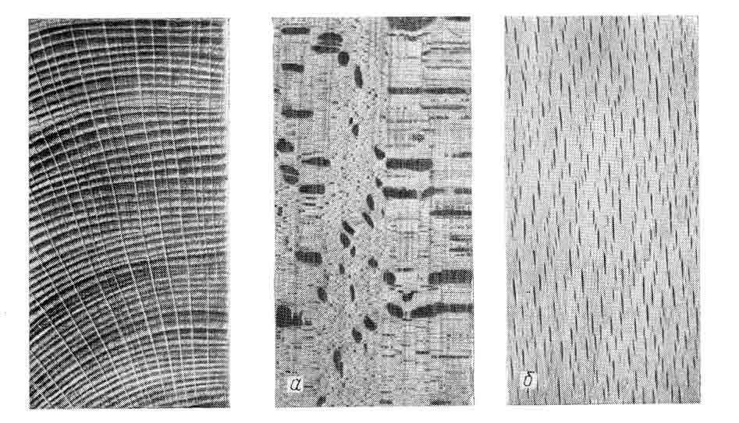
nax. 5. gulgulis sxivebi wiflis merqnis ganiv Wrilebze.

mozard xeSi gulgulis sxivebi atareben wyals da masSi gaxsnil organul nivTierebebs horizontaluri mimarTulebiT, agreTve inaxaven samarago sakveb nivTierebebs.

2.4. WurWlebi

aqamde ganxiluli elementebi damaxasiaTebeli iyo orive jiSis merqnisaTvis. WurWlebi damaxasiaTebelia mxolod da mxolod foTlovani jiSis merqnisaTvis. maT torsul Wrilze SeimCneva mcire zomis naxvretebi, romlebic warmoadgenen WurWlebis ganiv Wrilebs. WurWlebs gaaCniaT sxvadasxva zomis milebis forma. Gganasxvaveben wvril da msxvil WurWlebs. imis mixedviT, Tu rogor arian ganlagebuli msxvili da wvrili WurWlebi, ganasxvaveben rkalWurWlovan da gafantulWurWlovan jiSebs. rkalWurWlovan jiSebSi msxvili WurWlebi ganlagebulia Tanabrad wliuri Sris orive zonaSi. gafantulWurWlovanSi ki WurWlebi gafantulad arian warmodgenili.
rkalWurWlovan jiSebs miekuTvnebian: muxa, ifani, wabli, Tela, TelamuSa da sxva. rac Seexeba gafantulWurWlian jiSebs, foT-lovani jiSebis umetesoba aseT jiSebs warmoadgens. Eesenia: aryi, verxvi, wifeli, Wadari da sxva.
WurWlis simaRle 10 sm-s ar aRemateba, Tumca muxis merqanSi misi simaRle 3,6 m-mdea. maTi diametri meryeobs 0,1 mm-dan 0,4 mm-mde.
mozard xeSi WurWlebi atareben wyals da masSi gaxsnil mineralur nivTierebebs fesvvebidan kronisaken, xolo moWril xeSi, warmoadgenen ra sust elementebs, amcireben merqnis simtkices.

2.5. fisis savali milebi.

Ffisis savali milebi damaxasiaTebelia mxolod da mxolod wiwvovani jiSis merqnisaTvis, isic ara yvelasaTvis. Ffisi moipoveba fiWvis, naZvis, kedaris da lariqsis merqanSi. xolo soWs, Rvias da urTxels fisis savali milebi ar gaaCniaT.
Yyvelaze didi raodenobiT fisis savali milebi gaaCnia fiWvs. Gganasxvaveben ori saxis fisis saval mils: vertikalursa da horizontalurs. Hhorizontaluri fisis savali milebi miyvebian gulgula sxivebs da gaerTianebuli arian vertikalur fisis saval milebTan erTian sistemad. Yyvelaze didi zomis fisis savali milebi gaaCnia kedars. MmaTi diametria 0,14 mm, fiWvisa _ 0,1 mm, naZvisa _ 0,09 mm, lariqsisa _ 0,08 mm. milebis sigrZe meryeobs 10 – 80 sm-is farglebSi. maTi moculoba Seadgens merqnis moculobis Zalian mcire procents. fiWvisaTvis – 0, 7%, lariqsisaTvis – 0,2%. isini nakleb gavlenas axdenen merqnis meqanikur maCveneblebze, Tumca amcireben merqnis wyalSeRwevadobas, amaRleben merqnis medegobas lpobisadmi da mis Tbounarianobas.

Tavi III. merqnis qimiuri Semadgenloba.
G
gamokvlevebma gviCvena, rom elementaruli Semadgenloba merqnisa praqtikulad jiSze ar aris damokidebuli. mSrali merqani Seicivs 49,5% naxSirbads, 44,2% Jangbads azotTan erTad da 6,3% wyalbads. Ggarda organuli nivTierebisa merqanSi gvaqvs agreTve mineraluri naerTebi, romlebic wvis Sedegad gvaZleven nacars 0,2 –dan 1,7% -mde.
merqanSi Semavali ZiriTadi qimiuri elementebi qmnian rTul organul nivTierebebs. Eesenia: celuloza, hemiceluloza da lignini.
celuloza Zalian mdgradi qimiuri naerTia. igi ar ixsneba Cveulebriv gamxsnelebSi, wyalSi, spirtSi, eTerSi, acetonSi da sxva. hemiceluloza da lignini advilad ixsneba organul gamxsnelebSi.
Ddidi gamoyeneba hpoves fisebma da mTrimlavma nivTierebebma. Ffisebi gamoiyeneba optikaSi, mikroskopebis teqnikaSi, rogorc sawmendi da sxva. lariqsis fisi gamoiyeneba laq-saRebavebis warmoebaSi. fiWvis fisisagan Rebuloben skipidarsa da kanifols, romlebic Semdeg gamoiyenebian qaRaldisa da sapnis warmoebaSi
foTlovani jiSis merqanSi moipoveba nivTierebaTa jgufi, romelTac tanidebs anu mTrimlav nivTierebebs uwodeben. isini gamoiyenebian tyavis warmoebaSi. tyavis Trimvla tyavs aniWebs elastiurobas, wyalmedegobas da xangamZleobas. Yyvelaze didi raodenobiT tanidebs Seicaven wabli, muxa da wifeli.

Tavi IV. merqnis fizikuri Tvisebebi.
4.1. merqnis garegani saxe.

merqnis feri. Uukanasknel periodamde merqnis feris daxa sia- TebisaTvis iyenebdnen sityvier aRwerilobas, rac umetes SemTxvevaSi WeSmaritebasTan axlos ar iyo. saqme imaSia, rom TiToeul adamians sruliad gansxvebuli unari aqvs aRiqvas esa Tu is feri. Bbolo wlebSi Camoyalibda specialuri mecniereba, romelic Seiswavlis masalaTa da saganTa ferebs. Aam mecnierebas kolorimetria ewodeba.
Mmerqnis feri Zalian did diapazonSi icvleba da SeiZleba iTqvas, rom speqtris yvela ferebs moicavs. Mmerqnis feris maxasiaTeblebi SeiZleba davadginoT fotoeleqtruli xelsawyo kolorimetriT an ferTa atlasiT, romelSic mocemulia ferTa didi raodenoba. atlasis TiToeul gverdze mocemulia gansxvavebuli sixSirisa da simuqis mqone erTi da igive feris nimuSebi. gamosakvlev zedapirs SeurCeven mis ferTan miaxloebul fers da atlasze TandarTuli cxrilebidan ipovian feris nomers da sxva maxasiaTeblebs.
ZiriTadi nivTiereba, romlisganac Sedgeba merqani _ celuloza ufero da usunoa. Mmerqans Seferilobas aZlevs ujredis RruSi da mis garsSi (kedlebSi) moTavsebuli mRebavi da mTrimlavi nivTierebebi, fisebi da maTi daJangvis produqtebi.
msoflioSi arsebuli merqnis jiSebis feri sxvadasxvagvaria. is meryeobs TeTri feridan (verxvi, soWi) Sav feramde (polisandri).
feri damokidebulia, upirveles yovlisa, klimatur pirobebze. Klimaturi sartylis pirobebSi ki _ jiSze, xolo jiSebs Soris _ xnovanebaze da zrdis pirobebze.
unda aRiniSnos, rom mravali jiSis merqani moWris Semdeg haerisa da sinaTlis zemoqmedebis Sedegad muqdeba. magaliTad, axalmoWrili Txmelis vardisferi merqani swrafad icvlis fers da Rebulobs moyviTalo-mowiTalo Seferilobas, masSi arsebul mTrimlav nivTi-erebaTa daJangvis gamo. Grkinis marilebis moqmedebiT xogierTi jiSis merqani Savdeba masSi arsebuli mTrimlavi nivTierebebis rkinis marilebTan SeerTebis gamo (muxa,wabli). amave mizeziT warmoiSveba nedli muxis daxerxvis Semdeg mis zedapirze Savi zolebi da laqebi. fiWvis cila dacurebis Sedegad zogjer yviTel fers Rebulobs, xolo aryis merqani _ narinjisfers. feris Secvlas iwvevs agreTve sokovani daavadebebi.
merqnis fers praqtikuli mniSvneloba aqvs avejisa da musikaluri instrumentebis warmoebaSi, mxatvrul nakeTobebSi da sxva.
bzinva. Bbzinva warmoadgens merqnis unars orientirebulad aireklos masze dacemuli sinaTlis nakadi. cnobilia, rom mkacrad orienti-rebulad sinaTlis nakads aireklaven sarkiseburi zedapirebi, xolo mqrqali zedapirebi sinaTlis nakads gabneulad anu difuzurad aireklaven. rac ar unda kargad iyos damuSavebuli merqnis zedapiri, igi mainc Sors aris sarkiseburi zedapirisagan. Mmetnaklebad sinaTlis nakads mkacrad orientirebulad aireklaven gulgulis sxivebi.
bzinva raodenobrivad SegviZlia davaxasiaTod areklili sxivebis nakadis SefardebiT dacemuli sxivebis nakadTan gamosaxuli procentebSi. Bbzinvas gansazRvraven specialuri xelsawyoebiT _ bzinvamzomebiT. maTi muSaobis principi Semdegia: gamnaTeblis Tavakidan gamosakvlev zedapirze mimarTaven paraleluri sxivebis konas, romelic zedapirisadmi mimarTulia 45º_iT. areklili sxivebi linzebis sisteme-bisa da diafragmis gavliT moxvdeba TugusSi moTavsebul fotoele-mentze. Tugusi aseve 45º-iT aris daxrili zedapirisadmi. Aareklili sxivebis moqmedebiT fotoelementis wredSi aRiZvreba deni, romelic miT ufro metia, rac metia merqnis bzinva. sxvadasxva jiSis Sedarebisas aRmoCnda, rom yvelaze meti bzinva aqvs verxvis merqans.
merqnis teqstura. es aris naxati, romelic miiReba merqnis anato-miuri elementebis gadaWriT. Rac ufro rTulia merqnis Sedgeniloba da mravalferovania misi calkeuli elementebis Serwyma, miT ufro mdidaria teqstura. cxadia, rom wiwvovani jiSebis teqstura, maTi anatomiuri simartivis gamo, ufro Raribia foTlovani jiSebis teqstu-rasTan SedarebiT, vinaidan isini gamoirCevian anatomiuri elementebis simravliT. e. i. teqstura damokidebulia jiSze. erTi jiSis farglebSi _ masze gatarebul Wrilze. zogierTi jiSi lamazi teqsturiT xasiaT-deba radialur Wrilze, zogierTic _ tangentalurze. BboWkoebis aburdulobiT (javarianobiT) da Sesabamisad lamazi teqsturiT xasiaT-deba gamonazardebis merqani. igi xSirad gamoiyeneba dekoratiuli miz-nebisaTvis. gansakuTrebiT lamazia kareliis aryisa da nekerCxlis merqa-ni. am ukanasknelisTvis damaxasiaTebelia e.w. ”Citis Tvali” (nax.@6), romelsac warmoqmnis ylortebad Camouyalibebeli mZinare kvirtebi. aseTi merqani Zalian Zvirad fasobs.
merqnis suni. suns merqanSi ZiriTadad ganapirobebs masSi arsebuli mTrimlavi nivTierebebi, eTerzeTebi da fisebi. axladmoWril merqanSi suni ase Tu ise igrZnoba, magram dayovnebis Semdeg igi TandaTan kargavs mas. gansakuTrebiT mkveTri suniT xasiaTdeba wiwvovani jiSis merqani, xolo foTlovanebidan iseTebi, romlebic didi raodenobiT tanidebs Seicaven.

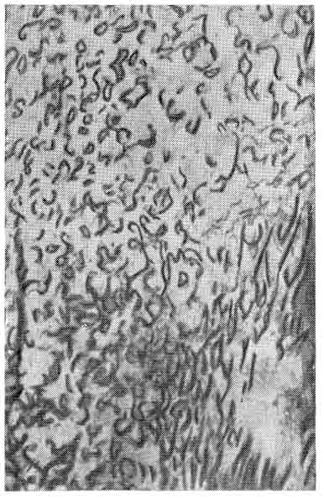
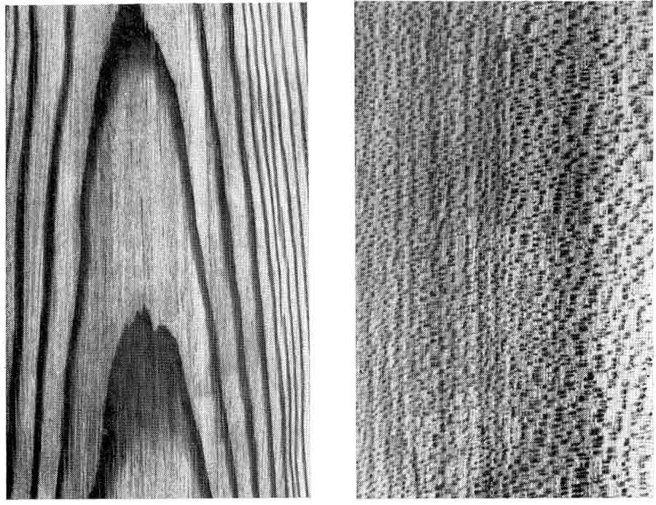
a) b) g)
nax. 6. merqnis teqstura: a) lariqsi (tangentaluri Wrili);
b) Tela (radialuri Wrili);
g) kareliis aryi.

4.2. merqnis tenianoba da misi gazomvis meTodebi.

mozardi xis normaluri sicocxlis unarianoba ganapirobebs merqanSi tenis arsebobas. moWril xeSi ki tenis raodenoba damokidebulia misi Senaxvisa da transportirebis pirobebze _ SeiZleba iklebdes an imatebdes.
merqanSi tenis raodenobis dasaxasiaTeblad SemoRebulia sidide, romelsac tenianobas uwodeben. merqnis tenianoba aris merqanSi arsebuli tenis masa Sefardebuli mSrali merqnis masasTan gamosaxuli procentebSi. Aam tenianobas absolutur tenianobas uwodeben:
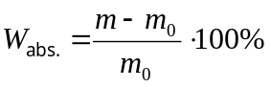
sadac _ sveli merqnis masa, g; 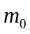 _ absoluturad mSrali merqnis masa, g; 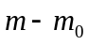 _ merqanSi arsebuli tenis masa, g.
arsebobs tenianobis gansazRvris ori meTodi: pirdapiri da iribi. Oorive meTodi standartizebulia.
pirdapiri meTodiT tenianobis gazomvisas xiwvebisagan ganTavisuf-lebul merqnis nimuSs awonian sasworze 0,001 g sizustiT, moaTavseben winaswar imave sasworze awonil SuSis biuqsSi da Tavdauxuravad Seitanen eleqtro karadaSi, romelic aRWurvilia TermometriTa da temperaturis maregulirebeliT. Srobas awarmoeben 1032º temperaturaze. nimuSis pirvel awonvas awarmoeben karadaSi Setanidan 8-10 sT-is Semdeg. amisaTvis karadidan gamoitanen nimuSian biuqss, swrafad daaxuraven Tavsaxurs da gasaciveblad moaTavseben specialur WurWelSi – eqsikatorSi (nax. 7). Eeqsikatoris Zirze dayrilia higroskopuli marili, ris gamoc eqsikatorSi mudmivad mSrali haeria. eqsikatorSi dayovnebis Semdeg nimuSian biuqss amoiReben da awonian. Semdeg awonvebs awarmoeben 2-3 sT-is intervaliT. rodesac bolo ori awonvis Sedegi erTmaneTs daemTxveva an maT Soris gansxvaveba iqneba 0,002 g, es imas niSnavs, rom nimuSi absoluturad mSralia. tenianobas angariSoben formuliT:
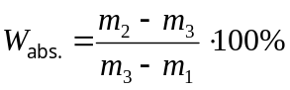
sadac, 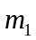_ biuqsis masaa g; 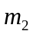 _ merqnis masa biuqsTan erTad gamoSrobamde g; 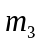 _ merqnis masa biuqsTan erTad gamoSrobis Semdeg;
merqnis tenianobis gansazRvris pirdapiri meTodi zustia, magram xangrZlivia, did dros moiTxovs. Ees nakli ar axasiaTebT irib meTo-debs. tenianobis gazomvis es meTodebi damyarebulia merqnis iseTi fizikuri Tvisebebis maCveneblebis gazomvaze, romlebic damokidebulia merqanSi arsebuli tenis raodenobaze.
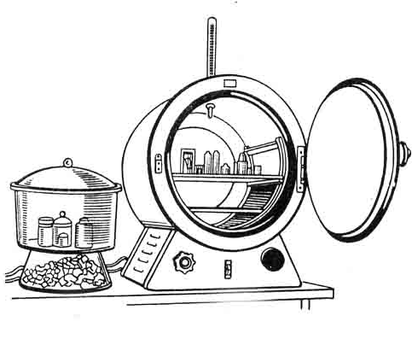
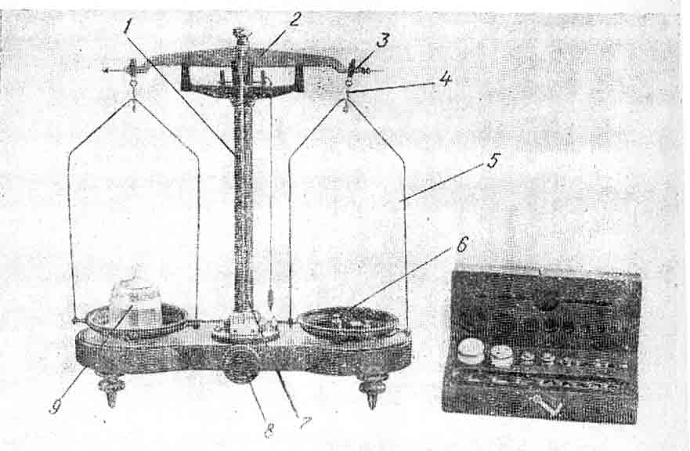
Y
a
b
nax. 7. a. laboratoriuli saSrobi karada. b. teqnikuri saswori.

yvelaze metad gavrcelebulia eleqtruli tenmzomebi, romelTa muSaobis principi damyarebulia merqnis eleqtrogamtarobis gazomvaze. (nax. 8). Eeleqtrotenmzoms gazomvis ori diapazoni aqvs: 7_22% da 22_60%. merqanTan kontaqti xorcieldeba gadamwodze arsebuli sami nemsisebri eleqtrodis saSualebiT. Ggadamwodis nemsebi Sedian merqanSi gverdiTi zedapiridanU(da ara torsuli). tenianoba izomeba 10 mm siRrmeze. amasTan, nemsebis SemaerTebeli xaziU ganlagebuli unda iyos boWkoebis gaswvriv. Ggazomva tardeba merqnis im adgilze, romelsac ara aqvs mankebi. xelsawyos skala Udagraduirebulia fiWvis merqnis tenis procentSi. sxva jiSis merqnis tenianobis gansazRvrisaTvis gamoiyeneba xelsawyoze TandarTuli gadasaangariSebeli cxrili.Uam xelsawyoTi tenianobis gansazRvrisaTvis saWir0a sul 10 wm (nemsebis merqanSi Seyvanis momentidan). Ggazomvis absoluturi cdomileba 7_30 %-ian diapa-zonSiUUSeadgens 2-3 %-s,Axolo 30 %-is zeviT _ mniSvnelovnad mets.
Aam xelsawyoebis nakli, garda sizustis cdomilebisa, aris kidev is, rom isini gviCveneben mxolod im adgilis tenianobas, sadac Seyvanilia nemsisebri kontaqtebi, ris gamoc, nimuSis tenianobis gansazRvrisaTvis saWiro xdeba masSi ramodenime adgilze nemsebis Seyvana da Semdeg saSualo ariTmetikulis gamoangariSeba.
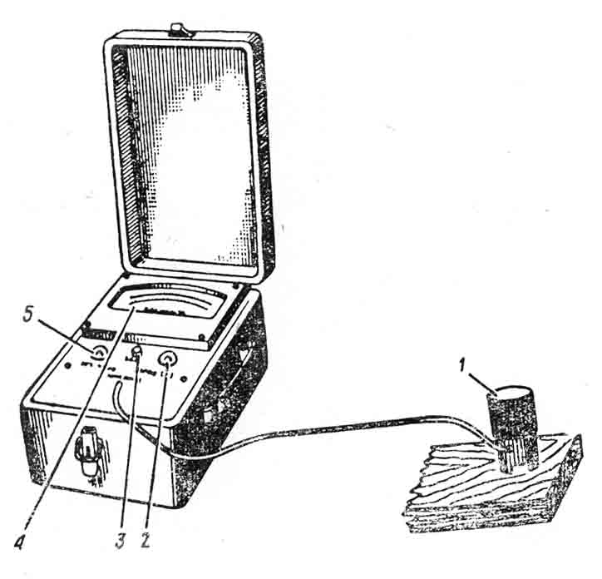

nax. 8. eleqtrotenmzomi

Gganasxvaveben merqanSi arsebuli tenis or formas: bmuls anu higroskopuls da Tavisufals. Bbmuli teni moTavsebulia ujredis garsis kedlebSi, xolo Tavisufali _ ujredis RruSi da ujredSoris sivrceSi. Mmerqnis im mdgomareobas, rodesac gvaqvs bmuli tenis maqsimaluri raodenobaLda ar gvaqvs Tavisufali teni, ewodeba merqnis higroskopulobis zRvari anu ujredis garsis gajerebis wertili.E
dadgenilia, rom bmuli tenis maqsimaluri raodenoba praqtikulad ar aris damokidebuli jiSze. igi icvleba 28,4-dan 31,4 %-mde da saSualod yvela jiSisaTvis Seadgens 30 %-s.
merqanSi arsebuli tenis raodenobis mixedviT ganasxvaveben merqnis Semdeg mdgomareobebs:
- sveli mdgomareoba, rodesac merqnis tenianoba 100 %-ze metia.
- axladmoWrili merqani, rodesac tenianoba 50_100 %-ia.
- haerul-mSrali mdgomareoba, rodesac tenianoba 5_20 %-ia.
- oTaxis mSrali mdgomareoba, rodesac tenianoba 8_12 %-ia.
- absoluturad mSrali mdgomareoba, rodesac tenianoba 0 %-ia.
(1) mdgomareobiT xasiaTdebian sortimentebi, romlebic xangrZlivad iyvnen Senaxuli wyalSi. (2)-s TviTon dasaxeleba gviCvenebs. (3) mdgomare-obiT xasiaTdeba Ria haerze didxans dayovnebuli merqani. (4) mdgomare-obiT _ oTaxSi didxans dayovnebuli merqani. (5) mdgomareobas SeiZleba mivaRwioT merqnis absoluturi gamoSrobiT.

4.3. sorbcia da desorbcia.

Mmerqani higroskopuli masalaa, romelic garemosTan kontaqtisas gascems an STanTqavs tens. saerTod garemos mdgomareoba xasiaTdeba temperaturiTa da fardobiTi tenianobiT (teniT gajerebis xarisxiT), romelic icvleba 0-dan 100 %-mde.
Mmerqnis tenian haerSi moTavsebisas SeiZleba adgili hqondes sam movlenas:
1. rodesac mudmivi parametrebis mqone haerSi moTavsebisas merqa- ni STanTqavs tens, am movlenas sorbcia ewodeba.
2. rodesac mudmivi parametrebis mqone haerSi moTavsebisas merqani gascems tens desorbcia ewodeba.
3. rodesac merqani arc gascems da arc STanTqavs tens am movlenas wonasworuli mdgomareoba ewodeba.
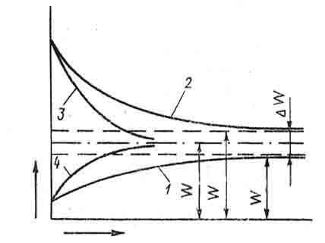
nax. 9-ze mocemuli sorbciis (1), desorbciis (2) da wonasworuli mdgomareobis (3) mrudebi maTi cvlilebis kanonzomierebas. abscisTa RerZze gadazomilia dro, ordinataze _ tenianoba.Lrogorc grafi-kidan Cans, sorbciisa da desorbciisas merqani miiswrafisLgarkveuli zRvruli tenianobisaken, romelsac mdgradi tenianoba ewodeba.

dro
tenianoba

nax. 9. sorbciisa da desorbciis mrudebi.
won.
md.d.
md.s.

sorbcia da desorbcia absoluturad Seqcevadi procesebi ar arian. maT mdgrad mdgomareobebs Soris sxvaobas tenianobis histereziss uwodeben. igi Seadgens daaxloebiT 2,5 %-s.
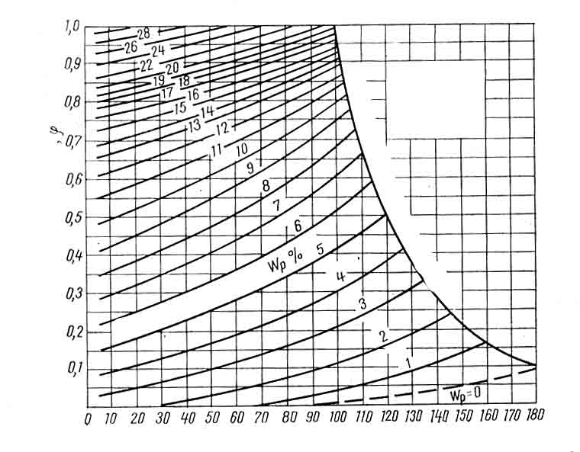
maRali
wnevis
garemo
temperatura t⁰ C
fardobiTi tenianoba
wonasworuli tenianoba
nax. 10. merqnis wonasworuli tenianobis diagrama

wonasworuli tenianobis gansazRvrisaTvis arsebovs specialuri diagrama, romelic Sedgenilia koordinatebSi haeris temperatura-haeris tenianoba (nax. 10).
wonasworuli tenianoba damokidebuli ar aris merqnis jiSze, igi damokidebulia mxolod haeris parametrebze.

4.4. SeSroba da gajirjveba

merqnis xazovani zomebis da moculobis Semcirebas, gamowveuls bmuli tenis aorTqlebiT, SeSroba ewodeba. Mmerqnis ujredebis siRrueSi da ujredSoris sivrceSi moTavsebuli Tavisufali tenis aorTqleba ar iwvevs SeSrobas. zog SemTxvevaSi SeSrobiT gamowveuli forma-zomis cvalebadoba imdenad didia, rom man SeiZleba gamoiwvios konstruqciis simtkicis Semcireba, rRvevac ki. Aam movlenis sapirispiro movlenas warmoadgens gajirjveba _ merqnis xazovani an moculobiTi zomebis mateba, gamowveuli tenianobis matebiT higroskopulobis zRvramde. Tu SeSroba yovelTvis uaryofiTi Tvisebaa, gajirjvebis unari zogierT SemTxvevaSi dadebiTad aris gamoyenebuli (xis kasrebis damzadebisas, xis gemTmSeneblobaSi da sxva.).
merqnis SeSroba damokidebulia jiSze, zrdis pirobebze da nimuSis mdebareobaze xis tanSi. erTi da igive jiSSi sruli xazovani SeSroba boWkoebis gaswvriv Seadgens 0,01_0,3 %-s. boWkoebis ganivad radialuri SeSroba udris 3_5%-s, tangentaluri _ 6_10%-s. moculobiTi SeSroba saSualod udris 12%-s.
boWkoebis ganivi mimarTulebiT SeSrobas didi praqtikuli mniSv-neloba aqvs. morebis ficrebad da Zelakebad daxerxvis dros, aucilebelia saTanado nametis micema SeSrobiT gamowveuli danaklisis dasafaravad. tangentaluri mimarTulebiT SeSrobis koeficienti 1,2_2-jer metia radialur mimarTulebasTan SedarebiT. rac ufro metia es sxvaoba, miT metia merqnis midrekileba daskdomisa da dabrecvisadmi (nax. 11 da 12).

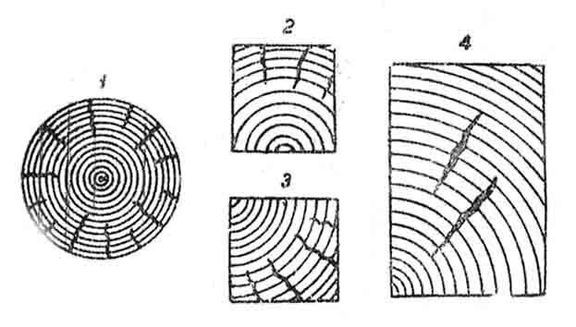
nax.11. SeSrobis bzarebi: 1 - mrgval sortimentSi; 2-3 _ ZelakebSi;
4 _ Sinagani bzarebi.

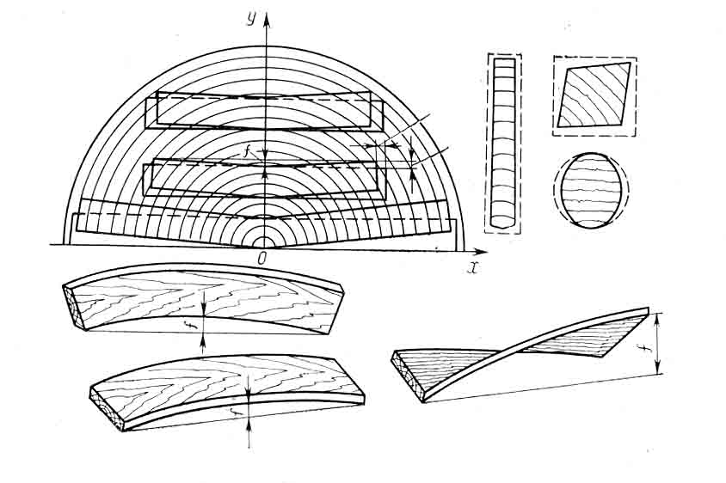
a)
b)
g)
d)
e)
z)
v)
M
nax. 12. dabrecvis saxeebi:
ganivi _ a) Rariseburi; b) trapeciuli; g) rombiseburi; d) ovaluri.
grZivi _ e) wiboze; v) fenobze; z) xraxnuli dabrecva.

merqnis radialuri da tangentaluri SeSrobis sxvaoba, araTanabari SeSroba, gamowveuli masSi tenis neli tempiT gadaadgilebis gamo, iwvevs merqnis Sinagan daZabulobas. SeSrobis dros zedapiruli fenebi mcirdebian zomebSi, xolo Sida fenebSi, Semonaxuli tenis gamo, jer kidev ar mimdinareobs SeSroba. Aamis gamo, zedapiruli fenebi imyofebian gamWimavi Zabvebis, xolo Siga fenebi _ kumSvis Zabvebis gavlenis qveS. Tu gaWimvis Zabvebis sidide gadaaWarbebs merqnis simtkicis zRvars boWkoebis ganivad gaWimvis dros, zedapirul fenebSi moxdeba merqnis mTlianobis darRveva da warmoiSveba napralebi. Sinagani napralebi Cndeba Siga fenebSic, Siga fenebSi daWimulobis sagrZnobi zrdis gamo.
merqnis sxvadasxva mimarTulebiT araTanabari SeSrobis gamo xdeba merqnis grZivi da ganivi dabrecva, rac gamoixateba sortimentis kveTis formis SecvlaSi.

4.5. merqnis simkvrive

meqrnis simkvrive aris moculobiTi masa anu erTeuli moculobis masa ganzomilebiT kg/m an g/sm. Mmerqnis am Tvisebis dasaxasiaTeblad arsebobs ramodenime maxasiaTebeli:
1. merqnuli nivTierebis simkvrive warmoadgens ujredis garsis Semadgenili nivTierebis erTeuli moculobis masas. vinaidan, merqnis elementaruli qimiuri Semadgenloba praqtikulad ar aris damokidebuli jiSze da saSualod yvela jiSisaTvis Seadgens 1,53 g/sm.
2. absoluturad mSrali merqnis simkvrive gamoiTvleba formuliT:
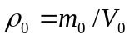
sadac - merqnis nimuSis masaa, rodesac W=0, g, kg; V₀ _ merqnis nimuSis moculoba, rodesac W=0, sm³, m³;
3. sveli merqnis simkvrive gamoixateba sveli merqnis nimuSis masis SefardebiT mis moculobasTan imave tenianobaze.
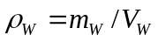
sadac 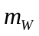 - merqnis masaa W tenianobaze g, kg; V_{W} - merqnis nimuSis moculobaa W tenianobaze sm, m.
4. merqnis simkvrive normalizebuli tenianobisas gamoixateba 12 %-iani tenianobis mqone merqnis nimuSis masis SefardebiT mis moculobasTan imave tenianobaze da aRiniSneba.
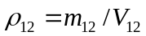
merqnis simkvrive mniSvnelovnadaa damokidebuli mis tenianobaze. cnobarebSi merqnis fiziko-meqanikuri maCveneblebis monacemebi gansazRvrulia 12 %-ian tenianobaze.
merqnis jiSebis simkvrive farTo diapazonSi icvleba. Yyvelase dabali simkvrivis merqani aqvs soWs (345), tirifs (415), da sxva. yvelase maRali ki _ samSits (960), rkinisebr arys (970), saqsauls (1040).
simkvrivis mixedviT 12 %-ian tenianobaze yvela jiSi SeiZleba davyoT sam jgufad: a) dabali simkvrivis jiSebi (simkvrive 540 da naklebi), wiwvovanidan fiWvi, naZvi, soWi, kedari; foTlovanebidan _ alva, cacxvi, tirifi, verxvi, Txmela wabli, Bb) saSualo simkvrivis jiSebi (simkvrive 550 _ 740), wiwvovanebidan _ lariqsi, urTxeli; foTlovanebidan _ aryi, wifeli, Tela, msxali. muxa, kakali, xurma, vaSli, ifani. Gg) maRali simkvrivis jiSebi (simkvrive 750 da meti) _ akacia, rkinisebri aryi, rcxila, Zelqva, saqsauli, samSiti da sxva.
ucxour jiSebSi aris rogorc Zalian mcire simkvrivis (balza_120), aseve Zalian maRali simkvrivis (bakauti_ 1300) jiSebi.
Mnormalizeburi tenianobisas merqnis saSualo simkvrivis, abso- luturad mSrali merqnis simkvrivis da sabaziso simkvrivis mniSvneloba yvelaze gavrceleburi jiSebisaTvis mocemulia cxrilSi.

merqnis simkvrivis sasualo mniSvneloba
jiSi | simkvrive, kg/m³ |  | sabaziso simkvrive, kg/m³ | jiSi | simkvrive, kg/m³ |  | sabaziso simkvrive, kg/m³
jiSi | 12 | 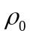 | sabaziso simkvrive, kg/m³ | jiSi | 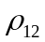 |  | sabaziso simkvrive, kg/m³
lariqsi  fiWvi  naZvi  kedari  soWi  rcxila  akacia  msxali  muxa  nekerCxali | 660  500  445  435  375  800  800  710  690  690 | 630  470  420  410  350  760  760  670  650  650 | 520  400  360  350  300  630  630  570  550  550 | ifani  wifeli  Tela  aryi  kakali  Txmela  verxvi  cacxvi  alva  tirifi | 680  670  650  630  590  520  495  495  455  455 | 645  640  615  600  560  490  470  470  430  430 | 550  530  520  500  470  420  400  400  360  360

A
ALE
Tavi V. merqnis meqanikuri Tvisebebi
5.1. zogadi cnebebi

konstruqciul da mosapirkeTebel masalad merqnis gamoyenebisas, aseve misi gadamuSavebis bevri teqnologiuri procesisaTvis reJimebis Sedgenisa da kompoziciuri masalebis SeqmnisaTvis mJRavndeba misi meqanikuri Tvisebebi, romelTac miekuTvneba simtkice da deformaciis unari, aseve meqanikur zemoqmedebasTan dakavSirebuli zogierTi saeq- spluatacio da teqnologiuri Tviseba.
simtkice axasiaTebs merqnis unars winaaRmdegoba gauwios meqanikuri datvirTvebiT gamowveul rRvevas. Aam meqanikuri Tvisebis maCvenebelia simtkicis zRvari _ Zabvis maqsimaluri sidide, romelsac uZlebs masala rRvevis gareSe. simtkicis zRvris maCvenebels gansazRvraven gaWimvaze, kumSvaze, statikur Runvaze, Zvraze da iSviaTad grexaze. Mmerqani miekuTvneba anizotropul masalas, amitom simtkicis maCveneblis gansazRvras axdenen sxvadasxva struqturuli mimarTulebiT _ boWkoebis grZivi da ganivi (radialuri da tangentaluri) mimarTulebiT.
Mmerqnis deformacia aris misi unari Seicvalos forma da zoma gare Zalebis moqmedebiT. Mmerqnis unars winaaRmdegoba gauwios deformacias sixiste ewodeba.
simagre-sisale aris unari, winaaRmdegoba gauwios sxeulma masSi sxva myari sxeulis SeWras. Ddrekadoba ki aris unari aRidginos pirvandeli forma da zoma masze moqmedi Zalebis moxsnis Semdeg.
Mmerqanze momqmedi gare Zalebi maTi xasiaTis mixedviT masSi sxvadasxva deformaciebs warmoSoben. arCeven gare Zalebis moqmedebis Semdeg saxeebs:
1. gaWimva an kumSva, rasac adgili aqvs dgarebis, svetebis, bagirebis muSaobis dros;
2. Runva _ adgili aqvs koWebis, RerZebis, sazidrebisa da sxvaTa muSaobis dros;
3. grexa _ adgili aqvs lilvebis muSaobisas;
4. Wra _ adgili aqvs moqlonebisa da WanWikebis muSaobisas;
5. axleCa _ adgili aqvs Wdobis dros, kerZod, xis formebis sayrden kvanZebSi.
saerTod cnobilia, rom merqani warmoadgens yvelaze ufro gavrcelebul samSeneblo masalas. gavixsenoT sagzao mSeneblobaSi xidebi, jebirebi, eleqtro, satelefono da satelegrafo boZebi da maTi sabjenebi; samoqalaqo da samrewvelo mSeneblobaSi: sarTulsSua gadaxurvebi, xaraCoebi; hidroteqnikur nagebobebSi: ximinjebi, zRudarebi, kaSxalebi, saojaxo nivTebi, aveji da sxva. advilad davrwmundebiT, rom merqani, rogorc samSeneblo masala yovlismomcvelia.

5.2. merqnis meqanikuri gamocdebis Taviseburebebi.

merqnis meqanikur gamocdebs awarmoeben sufTa anu mankebisagan ganTavisuflebul merqnis nimuSebze. nimuSebi unda iyos sakmarisad mcire ganiv kveTSi, Tumca unda Seicavdes wliuri Sreebis garkveul raodenobas. sufTa nimuSebis gamocda saSualebas iZleva Sedarebuli iqnes sxvadasxva jiSis merqnis meqanikuri Tvisebebi ise, rom ar gavarTulod mankebiT gamowveuli ama Tu im meqanikuri maCveneblis dadgena. Mmcire zomis nimuSebis gamocda xdeba mcire simZlavris manqanebze.
Mmeqanikuri gamocdebisas miRebuli maCveneblebi gamoiyeneba rogorc amosavali monacemebi naturaluri zomis elementebis gaangariSebisas. Ggamocdebis Catarebisas didi mniSvneloba aqvs garemo aris parametrebs. miRebulia, rom merqnis meqanikuri gamocdisas haeris temperatura unda Seadgendes 20±5°C da haeris fardobiTi tenianoba = 65 ±15%-s. merqnis simtkicis maCveneblebis SedarebisaTvis aucilebelia maTi erT garkveul tenianobaze dayvana. standartiT rekomendebulia simtkicis maCveneblebis dadgena 12 %-ian tenianobaze.
cxadia, rom meqanikuri maCveneblis dadgena ver moxerxdeba erTi an ori nimuSis gamocdiT, aucilebelia aTeulobiT nimuSis gamocda da miRebuli Sedegis ganzogadoeba.

5.3. gamocdis procedura da gamosacdeli danadgari

merqnis meqanikuri Tvisebebis gansazRvras axdenen universaluri gamosacdeli manqaniT, romelic saSualebas iZleva iZulebiT daarRvios nimuSi da warmoqmnili Zala gazomili iqnes datvirTvis sididis ara umetes 1 % cdomilebiT. monacemebi manqanis Zalsazomze aiTvleba skalis danayofis fasamde. gamocdis dros saWiroebis mixedviT aseve iyeneben mikrometrebs, indikatorebs, tenzometrebs da sxva. zogierTi saxis gamocdisTvis saWiroa specialuri gamosacdeli manqanebis gamoyenebac (mag. Qqanqara urnalis). Mmasalebis statikuri gamocdisaTvis 50 000 niutoni maqsimaluri datvirTvis mqone universaluri gamosacdeli manqanis P _ 5 sqema naCvenebia nax. 13-ze. Mmanqanas aqvs datvirTvis sami diapazoni: 2000_10 000; 5000_25 000; 10 000_50 000 n. iseTi gamocdebisaTvis, romlebic moiTxoven SedarebiT mcire rRvevad datvirTvebs (kumSvisas, gaWimvisas, boWkoebis ganivi mimarTulebiT xeTqvisas da sxva), gamoyenebuli unda iyos mcire simZlavris 1 000_2 000 n gamosacdeli manqana. Mmanqanebi aRWurvilia diagramuli aparatiT “ datvirTva _ deformacia” or masStabSi, Tumca meti sizustisaTvis gamosacdel merqanze deformaciis gasazomad mimagrebulia xelsawyo – tenzometri.
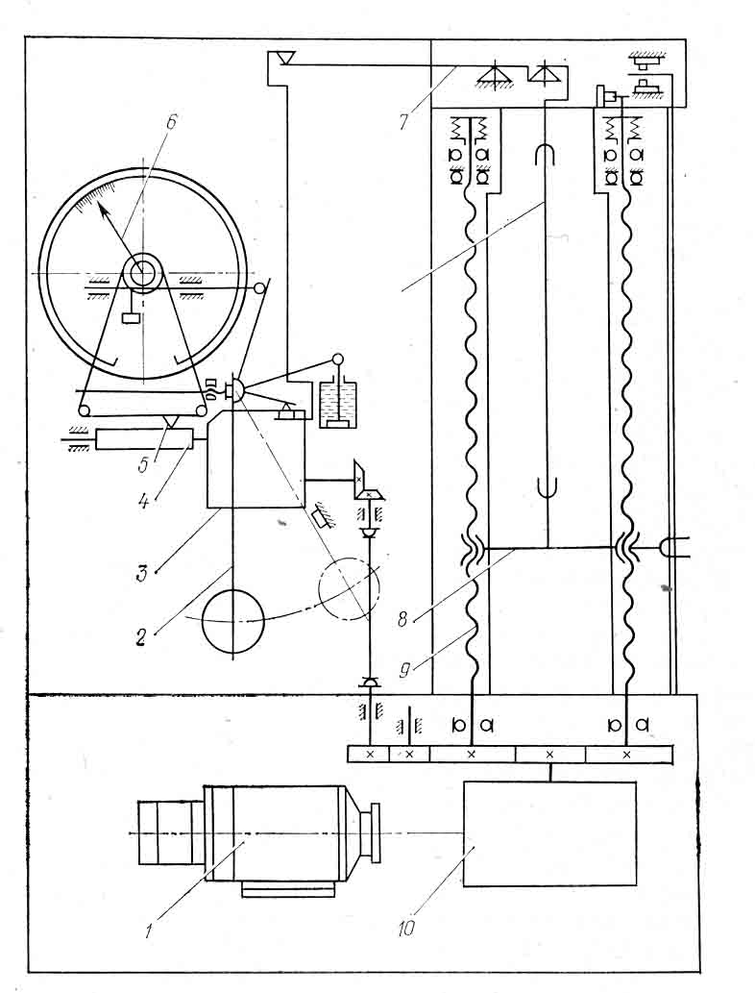
nimuSi
nax. 13. gamosacdeli manqana P-5-is sqema

1. eleqtroZravi; 2. qanqara; 3. masStabis reduqtori; 4. doli. 5. kalami; 6. isari; 7. saxeluri; 8. moZravi traversa; 9. moZravi xraxni;
10. Wia reduqtori.
Mmeqanikuri Tvisebebis maCveneblis sidide damokidebulia datvir-, Tvebis xangrZlivobaze, amitom standartebSi reglamentirebulia datvir-Tvebis xangrZlivoba gamocdis saxeobisa da dasaSvebi gadaxrebis mixedviT.
Ggamocda unda Catardes laboratoriaSi, sadac kondicioneris saSualebiT SenarCunebulia haeris temperature 202⁰C da fardobiTi tenianoba 605%, rac uzrunvelyofs gamocdamde da gamocdis procesSi nimuSebis tenianobis SenarCunebas.

5.4. merqnis simtkice gaWimvaze.

gaWimva boWkoebis grZivi mimarTulebiT. datvirTvis aseTi zemoqmedebisas merqnis simtkicis gansazRvrisaTvis gamoiyeneba rTuli formis masiurTaviani nimuSebi. nimuSis forma, zomebi da Camagrebis sqema naCvenebia nax.14-ze. aseTi formis nimuSis gamoyenebisas ar xdeba Camagrebis adgilebSi misi rRveva. Camagrebis nawilidan muSa nawilze gadasvla mdovred unda ganxorcieldes, raTa ar moxdes Zabvebis koncentracia gadasvlis adgilebSi.
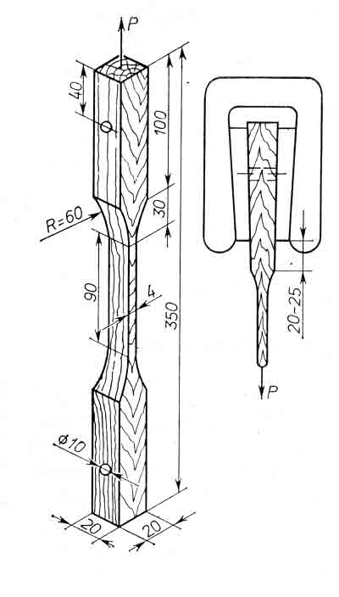
a
b
nax. 14. merqnis gamocda boWkoebis grZivi mimarTilebiT gaWimvaze
a. nimuSo; b. gamosacdel manqanaSi nimuSis Camagrebis sqema
Ggamocdis win zomaven nimuSis muSa nawilis sisqesa da siganes cdomilebiT 0,1 mm da Camagrebis nawilis naxvretSi deben liTonis milisas da orive mxridan aTavseben gamosacdeli manqanis satacSi. nimuSs datvirTaven Tanabrad 1500 kg/ ZaliT iseTi siCqariT, rom misi rREveva ganxorcieldes 1,5_2 wuTSi. rRvevis momentSi aiTvlian mrRvev Zalas sizustiT 1 kg-mde. simtkicis zRvars angariSoben formuliT:
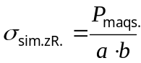 kg/sm²
Uunda aRiniSnos, rom merqnis simtkicis zRvari boWkoebis grZivi mimarTulebiT gaWimvisas Zalian maRalia, saSualod Seadgens 1300 kg/sm. Mmiuxedavad amisa, merqani Zalian iSviaTad muSaobs konstruqciebSi da nakeTobebSi boWkoebis grZivi mimarTulebiT gaWimvaze, radgan Tavidan ver avicilebT detalebis rRvevas Camagrebis adgilebSi.
gaWimva boWkoebis ganivi mimarTulebiT. amJamad arsebuli standartis mixedviT gamocdisaTvis rekomendebulia nax. 15-ze mocemuli nimuSis forma dazoma. Ees nimuSi moklea da amave dros muSa nawilis sisqe ornaxevarjer sqelia, aseve sqelia Camagrebis nawilic. Aam SemTxvevaSi nimuSi magrdeba gamosacdel manqanaSi samagri nawilis sibrtyeebiT. datvirTvas ganaxorcieleben 25050 kg/wT siCqariT. miaRweven ra nimuSis rRvevas, aiTvlian Zalas 5 kg sizustiT. simtkicis zRvars gamoiTvlian rogorc wina SemTxvevaSi kg/sm². Cveulebrivad, radialuri mimarTulebiT gaWimvisas simtkicis zRvari ufro maRalia, vidre tangentaluri mimarTulebiT da saSualod Seadgens 50 kg/sm. rogorc vxedavT, boWkoebis ganivi mimarTulebiT gaWimvisas merqnis simtkicis zRvari Seadgens 1/20-s boWkoebis grZivi mimarTulebiT gaWimvis simtkicis zRvrisa. Aamis gamo merqani ar gamoiyeneba iseT konstruqciebSi, sadac mas mouxdeboda boWkoebis ganivi mimarTulebiT deformaciaze muSaoba, Tumca am maCveneblis codna aucilebelia, rodesac vswavlobT Srobis procesSi warmoSobil Siga Zabvebs da maTi ganviTarebis Taviseburebebs.

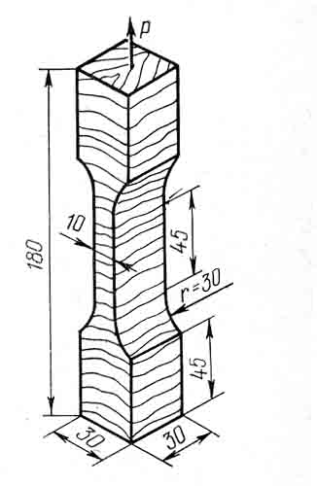

nax. 15. boWkoebis ganivi mimarTulebiT gaWimvaze
gamosacdeli merqnis nimuSi

5.5 merqnis simtkice kumSvisas.

kumSva boWkoebis grZivi mimarTulebiT. gamocdisaTvis iyeneben oTxwaxnaga marTkuTxa prizmis formis nimuSs. Pprizmis fuZe Seesabameba bazisur kveTs (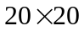), xolo simaRle 30 mm. faqtiuri praqtikuli zomebi da gaizomeba 0,1 mm sizustiT nimuSis simaRlis naxevarze (nax. 16).
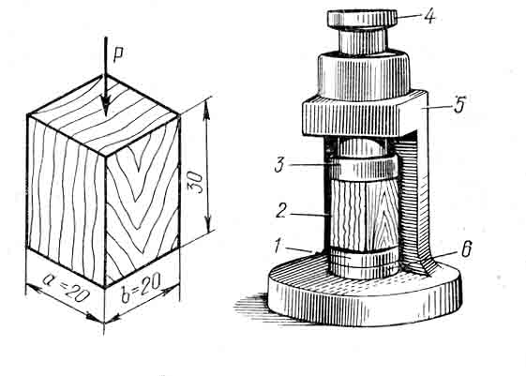
a b

nax. 16. merqnis gamocda boWkoebis grZivi mimarTulebiT kumSvaze.
a - nimuSi; b - xelsawyo

nimuSs moaTavseben gamosacdel manqanaSi da ganaxorcieleben davirTvas 40001000 kg/wT siCqariT. nimuSs miiyvanen darRvevamde da manqanis skalaze aiTvlian mrRvev Zalas da gamoiTvlian simtkicis zRvars:

boWkoebis grZivi mimarTulebiT kumSvisas SeiZleba gamovyoT rRvevis yvelaze gavrcelebili saxeebi (nax. 17): rbil da tenian merqanSi SeimCneva zeda da qveda nawilebSi boWkoebis Telva, xolo rodesac mimdinareobs magari jiSis merqnis gamocda, am SemTxvevaSi SeimCneva boWkoebis urTierTZvra. Zvra xorcieldeba xazze, romelic nimuSis grZivi RerZis mimarT adgens 60-70_ian kuTxes nimuSis tangentalur zedapirze. Zalian xSirad darRveul nimuSze SeiZleba aRmoCndes ori Semxvedri iribi xazi, romlebic warmoqmnian solisebur ubans, romlis qveSac Cans grZivi gaxeTqvis bzari. xandaxan SeimCneva nimuSis ganfena da rRvevis sxva saxeebi. Yvelaferi es adasturebs merqnis simtkicis maCveneblebze aRnagobisa da meqanikuri Tvisebebis anizotropias.
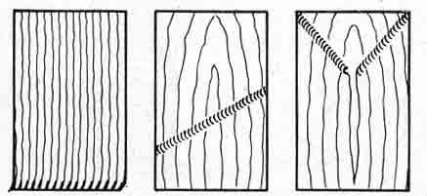
a b g
nax. 17. boWkoebis grZivi mimarTulebiT kumSvaze merqnis nimuSis darRvevis tipiuri saxeebi.

a - torsebis moTelva; b - iribi naoWi; g - Semxvedri iribi naoWebi.

Cveulebriv, merqani did winaaRmdegobas uwevs boWkoebis grZivi mimarTulebiT deformacias, ris gamoc igi xSirad gamoiyeneba ximinjebad, sadgarebad da sxva.
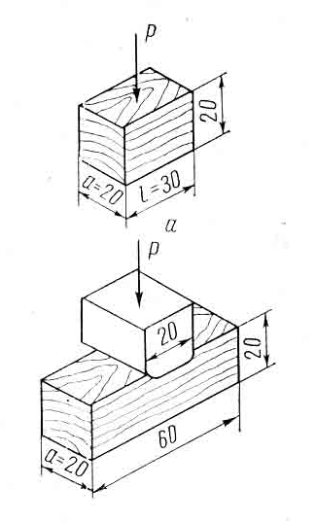
kumSva boWkoebis ganivi mimarTulebiT. Aam SemTxvevaSi ganasxvaveben gamocdis sam saxes: mTliani zedapiris kumSvas, adgilobriv Telvas da nawilobriv Telvas (nax.18). pirvel SemTxvevaSi datvirTva xorcieldeba nimuSis mTel sigrZesa da siganeze, meore SemTxvevaSi _ mTel siganesa da sigrZis nawilze, xolo mesame SemTxvevaSi _ siganisa da sigrZis nawilze. Gamosacdeli nimuSis zomebia 202030. mas aTavseben gamosacdeli mamqanis sadgarze da datvirTaven 10020 kg/sm² ZaliT. aseT deformacias Telvis deformacia ewodeba. nimuSis deformacias zomaven indikatoriT rbili jiSisaTvis yoveli 20 kg Zalis ganxorcielebis Semdeg, xolo magari jiSisaTvis yoveli 40 kg ZaliT datvirTvis Semdeg. Ggamocdas agrZeleben proporciulobis zRvris TvalnaTliv gadalaxvamde. Cdebis Sedegad dadgenilia, rom simtkicis zRvari boWkoebis ganivi mimarTulebiT kumSvisas 10-jer naklebia, vidre misi simtkicis zRvari boWkoebis grZivi mimarTulebiT kumSvisas.

nax. 18. merqnis nimuSis gamocda boWkoebis ganivi mimarTulebiT kumSvaze.
a - kumSvaze gamosacdeli nimuSi;
b - Telvaze gamosacdeli nimuSi.

5.6. merqnis simtkice statikuri Runvisas.

Mmerqnis simkvrive statikuri Runvisas _ merqnis erT-erTi mniSvne-lovani maxasiaTebelia. gamocdisaTvis gamoiyeneba Zelakis formis nimuSi zomiT 202020. nimuSis sigrZis SuaSi misi siganis _ radialuri da simaRlis _ tangentaluri mimarTulebiT 0,1 mm cdomilebiT gazomvis Semdeg mas aTavseben or sayrdenze (nax. 19).
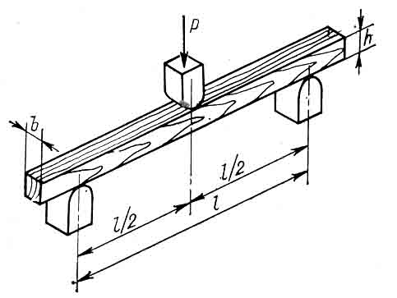
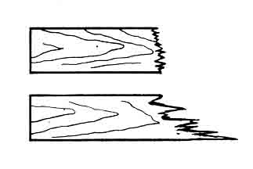

b

a
g

nax. 19. a - statikur Runvaze merqnis gamocdis sqema.
nimuSis darRvevis saxeebi: b - gluvi; g - boWkovani.
manZili sayrdenis centrebs Soris tolia 240 mm. datvirTva xdeba nimuSis SuaSi erT wertilSi. sayrdenebs da damtvirTav danas aqvs 30 mm-iani radiusiT momrgvalebuli forma. uwyveti datvirTvis siCqare iseTia, rom nimuSi unda dairRves 1_2 wuTis Semdeg. gansazRvraven ra maqsimalur datvirTvas, simtkicis zRvars gamoiTvlian formuliT:
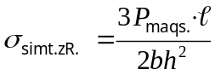 kg/sm²
datvirTvis dros nimuSSi aRiZvreba mkumSavi Zabvebi zeda nawilSi da gamWimavi _ qveda nawilSi. radgan merqnis simtkicis zRvari boWkoebis gaswvriv kumSvaze mniSvnelovnad mcirea gaWimvis simtkicesTan SedarebiT, rRveva iwyeba kumSvis zonaSi TvaliT uxilavi nakecebis saxiT. saboloo rRveva ki xdeba gaWimvis zonaSi.
imis gamo, rom simtkice Runvisas didia da aseve advilia am deformaciaze datvirTvis modeba, merqani farTod gamoiyeneba am saxis deformaciaze momuSave detalebad. radialuri da tangentaluri mimarTulebiT Runvisas gansxvavebas mxolod wiwvovani jiSebi amJRavneben. tangentaluri mimarTulebiT simtkicis zRvari aq 10-12%-iT metia, vidre radialuri. foTlovanebSi ki praqtikulad erTnairia.

5.7. merqnis sisale

merqnis sisales mniSvneloba aqvs misi mWreli iaraRebiT damuSavebisas, xerxvisas, randvisas, Sponis axdisas, iatakebSi da xis fenilebSi cveTisas. Gganasxvaveben sami saxis sisales: torsuls, radialursa da tangentalurs. gamocdisaTvis iReben nimuSs zomiT 505050. gamocdas awarmoeben merqanSi naxevradsferul Taviani puansonis CanergviT. Mmerqnis jiSebi sisalis mixedviT iyofa sam jgufad: rbili (sisale 400 kgZ/sm² dabla), magari (sisale 400_800 kgZ/sm²) da Zalian magari (800 kgZ/sm²). am ukanasknels miekuTvneba akacia, rcxila, samSiti, rkinis aryi, urTxeli.
statikuri sisalis garda arsebobs aseve dinamikuri anu dartymiTi sisale. Mmas Semdegnairad gansazRvraven: aiReben merqnis nimuSs da mis radialur zedapirze naxevari metris simaRlidan daagdeben 25 mm diametris foladis burTulas. gaiangariSeben daxarjul muSaobas burTulis wonisa da manZilis erTmaneTze gamravlebiT, miRebul Sedegs gayofen anabeWdis farTze da miiReben ,merqnis sisalis maCvenebels.

5.8. dartymiTi siblante.

Mmerqnis unari, winaaRmdegoba gauwios dartymiT deformacias, xasiaTdeba im maqsimaluri muSaobiT, romelic SeuZlia STanTqos merqanma rRvevis gareSe. rac ufro naklebia am dros merqnis dasarRvevad saWiro muSaoba, miT metia merqnis simyife. Ggamocdis principuli sqema aseTia (nax. 20): aiReben merqnis iseTive nimuSs, rogorc statikur Runvaze gamocdisas. Ggamocdas awarmoeben specialur manqanaze, romelsac qanqara urnals uwodeben. sawyis pirvandel mdgomareobaSi qanqaras gaaCnia garkveuli energiis maragi, romelic SeiZleba ganvsazRvroT misi awevis H₁ simaRliT. nimuSi isea moTavsebuli, rom qanqaris dartyma moxdes misi sigrZis SuaSi. Qqanqara, daamtvrevs ra nimuSs, aiwevs H₂ simaRleze. muSaoba, romelic am dros STanTqa nimuSma ganisazRvreba.
sxvaobis mixedviT. dartymiTi siblante iangariSeba formuliT:
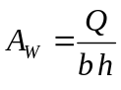
sadac  aris SqanTqmuli muSaoba j-Si, xolo b da h nimuSis sigane da simaRlea sm-Si. foTlovani jiSebis dartymiTi siblante orjer metia, vidre wiwvovanebisa.
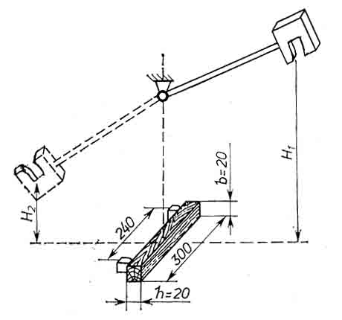

nax. 20. merqnis dartymiT siblanteze gamocdis sqema.

5.9. merqnis winaRoba cveTisadmi.

cveTamedegoba axasiaTebs merqnis unars, winaaRmdegoba gauwios misi zedapiris TandaTanobiT rRvevas masze myari sxeulis, abraziuli elementebis an mikrousworobebis xaxunisas.
Gganasxvaveben ori saxis cveTas: cveTis pirvel saxes adgili aqvs silis da sxva abraziuli nivTierebebis moqmedebis Sedegad iatakebze, gemis gembanebze da sxva. meores ki _ manqanaTa moxaxune zedapirebSi.
Ppirveli saxis cveTis gamocdisas aiReben nimuSs zomiT 505050 da aTavseben specialur manqanaze, romelic uzrunvelyofs merqnis cveTas erTroulad moZravi da mbrunavi Tavis saSualebiT (nax.21). aseTi gamocdebis mizania _ Seiqmnas xis iatakebis, safexurebisa da fenilebis cveTis realurTan miaxloebuli procesis imitireba. Mmanqanis Tavze damagrebulia korundis zumfara. 400 ormagi svlis Semdeg nimuSs aiReben manqanidan da gazomaven. cveTis maCvenebels gamoiTvlian formuliT:
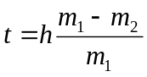 mm.
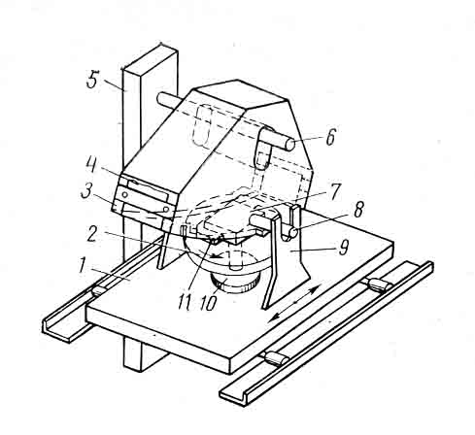
sadac h-aris nimuSis simaRle gamocdamde mm; m₁-nimuSis masa gamocdamde, g; xolo m₂-nimuSis masa gamocdis Semdeg, g. Ggamocdas awarmoeben rogorc torsul, aseve radialur da tangentalur zedapirebze.

nax. 21. cveTaze meqrnis gamosacdeli manqana. 1-magida; 2-diski; 3-tvirTi; 4-abraziuli zumfara; 5-dgari; 6-RerZi; 7-nimuSi; 8-sarWi; 9-dgari; 10-meqanizmi; 11-nimuSis dasamagrebeli xelsawyo.

Mmeore saxis gamocdis dros merqnis gamoscdel nimuSs uZravad daamagreben. manqanis TavSi Caamagreben nawrTobi saiaraRo foladisagan damzadebul mbrunav milisas, romelic garkveuli ZaliT awveba nimuSs. cveTas axasiaTeben im Rrmulis moculobiT, romelic milisas garkveuli brunTa ricxvis Semdeg darCeba nimuSze.
5.10. merqnis unari daimagros liTonis samagrebi.

Mmerqnis unikalur Tvisebas, daimagros lursmnebi, sWvalebi, kavebi da liTonis sxva samagrebi, didi mniSvneloba aqvs praqtikaSi.
merqanSi liTonis samagrebis CarWobisas boWkoebi nawilobriv iWreba, xolo nawilobriv iRuneba. Msamagris gverdebze defor-mirebuli merqnis mxridan xdeba dawola, ris Sedegadac gamowveuli xaxuni iWers samagrs. MwinaaRmdegoba, romelsac merqani uwevs samagris amoZrobas, ganisazRvreba Semdegnairad: Zelakis formis merqnis nimuSSi, zomebiT 5050 mm da sigrZiT 150 mm arWoben lursmans an Caxraxnian sWvals nax. 22-ze mocemuli sqemiT. gamocdisaTvis iyeneben 2 mm diametris lursmans da 4 mm diametris sWvals. Mlursmnis CaWedebis siRrme 301 mm, sWvalis Caxraxnis _ 201 mm.
sWvalebs Caxraxnian winaswar gaburRul naxvretebSi. lursmnebian (sWvalebian) nimuSs moaTavseben mowyobilobaSi. Llursmnebis (sWvalebis) amoZrobas awarmoeben 1_3 wT-is ganmavlobaSi manqanis caluRis Tanabari siCqariT gadaadgilebisas. samagris amoZrobis momentSi aiTvlian maqsimalur Zalas 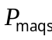 da gamoiTvlian amoZrobis xvedriT winaaRmdegobas formuliT: 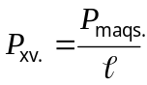 sadac _ aris lursmnis (sWvalis) CarWobis (Caxraxnis) siRrme (nax. 22).
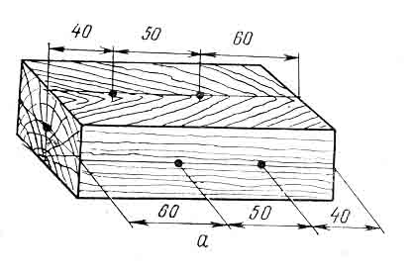

nax. 22. merqnis gamocda lursmnebisa da Wvalebis damagrebis unarze.

samagrebis amoZrobis winaaRmdegoba damokidebulia mimarTulebaze. Zala, romelic saWiroa samagris amosaZrobad merqnis nimuSis torsuli zedapiridan 10_50%-iT naklebia, vidre ganivi zedapiridan samagris amoZrobis Zala. radialuri da tangentaluri mimarTulebiT amoZrobis winaRoba praqtikulad erTnairia.
liTonis samagrebis daWeris unari damokidebulia aseve merqnis jiSze, simkvriveze da tenianobaze. simkvrivis zrda iwvevs amoZrobis winaaRmdegobis zrdas. mag.: samagris CarWoba da amoZroba rcxilis merqanSi (simkvrive 730kg/m³)TiTqmis 4-jer metia, vidre igive fiWvis merqnidan (simkvrive 440 kg/m³). rac ufro metia merqnis tenianoba, miT ufro advilia samagris CarWoba. gaSrobisas merqnis unari daimagros liTonis samagrebi mcirdeba, radgan mcirdeba xaxuni merqansa da samagrs Soris. svel merqanSi liTonis samagrebi Jangdeba da maTi damWeri Zalac sustdeba.

Tavi 6. merqnis mankebi.
zogadi cnebebi.

Mmerqnis garegani saxis Secvlas, misi aRnagobis mTlianobis darRvevas an sxva raime naklovanebebs mankebs uwodeben. merqnis mankebi standartizebulia. Ees aris mniSvnelovani dokumenti, romlis safuZvelze yalibdeba moTxovnebi merqnis nedleulisa da nakeTobis mimarT da romelSic gaTvaliswinebulia yvela saerTa-Soriso moTxovna merqnis produqciis xarisxze. standarti moicavs merqnis mankebis farTo nomenklaturas da dayofilia 9 jgufad: 1. rokebi, 2. bzarebi, 3. xis tanis formis mankebi, 4. merqnis aRnagobis mankebi, 5. qimiuri Seferilobani, 6. sokovani dazianebebi, 7. biologiuri dazianebebi, 8. aranormaluri dagrovebebi merqanSi, meqanikuri dazianebebi da damuSavebis mankebi. 9. deformaciebi. TiToeul dasaxelebul jgufSi Sedis mankebis ramodenime saxeoba.

6.1. rokebi

yvelaze gavrcelebuli mankia. isini warmoadgenen xis tanSi totis Canasaxs an TviT tots. maT sakuTari wliuri Sreebi da sakuTari gulguli axasiaTebT. rokebi formis mixedviT iyofian mrgval, ovalur da wagrZelebul rokebad. Mmrgvali roki miiReba maSin, rodesac rokis tani isea gadaWrili, rom didi diametris Sefardeba patara diametrTan ors ar aRemateba. Oovaluria roki, rodesac didi diametris Sefardeba patarasTan orsa da oTxs Soris aris, wagrZelebulia roki, rodesac diametrebis Sefardeba oTxze metia (nax. 23).
D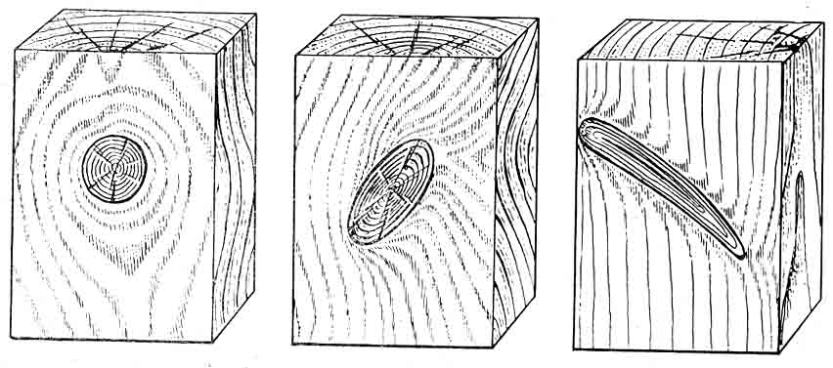
a b g
nax.23. rokebi: a - mrgvali; b - ovaluri; g - wagrZelebuli

daxerxil sortimentebSi ganlagebis mixedviT ganarCeven fenobis roks _ gamosuls sortimentis farTo nawilze, wibos roks _ gamosuls mis viwro nawilze, waxnagis _ erTdroulad gamosuls rogorc fenobze, aseve wiboze, torsuls _ sortimentis mokle mxares (torsze).
Tu roki gadis erTi wibodan meoremde mTeli fenobis gavliT uwodeben Cakeril roks. Ggarda amisa sortimentSi gamoyofen erTmxriv rokebs, romlebic gamodian sortimentis mxolod erT mxares, an gamWols _ gamomavals mis or mopirdapire mxares. fiWvisa da lariqsis merqnisaTvis damaxasiaTebelia gantotvili rokebi _ gamosuli erTi wertilidan da mimarTuli sxvadasxva mxares (nax. 24).
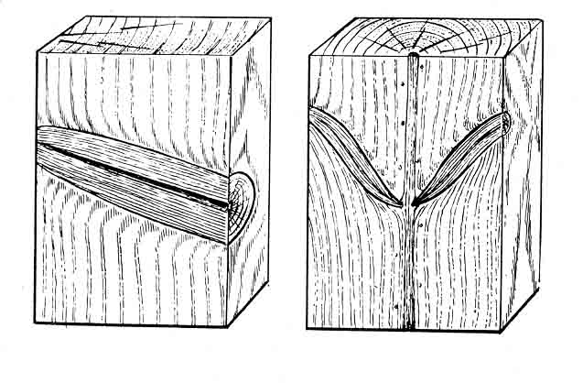

nax. 24. rokebi: a - Cakerili;
b - gantotvili

a b
merqanTan Sezrdis mixedviT ganasxvaveben rokebs: Sezrdils, romlis mTeli perimetri an misi ¾3/4 Sezrdilia mis garemomcvel merqanTan. naxevradSezrdilia roki, romlis perimetri 1/3-dan 3/4¾-¾mde Sezrdilia mis garemomcvel merqanTan. Seuzrdeli anu amo-vardnebadia roki, romlis perimetri an saerTod ar aris dakavSirebuli garemomcvel merqanTan an dakavSirebulia mxolod mis 1/3-ze (nax. 25).

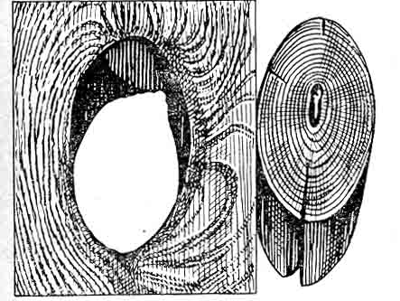

nax. 25. amovardnebadi roki.

merqnis mdgomareobis mixedviT ganarCeven janmrTel, lpobadawyebul, dampal da Tambaqosmagvar rokebs. janmrTelia roki, romlis merqansac ar etyoba sidamplis niSnebi. Llpoba-dawyebulia roki, Tu misi perimetris 1/3 dampalia, xolo dampali ewodeba roks, romlis perimetris ¾3/4 dampalia. Tambaqosmagvari rokebi imyofebian lpobis ukanasknel stadiaSi, rodesac is xelis SexebiT burnuTiviT iSleba.
rokebis raodenobas didi mniSvneloba aqvs sortimentis xarisxis dasadgenad. Aam dros aRniSnuli unda iqnes erT grZiv metrze rokebis raodenoba, maTi merqnis mdgomareoba da Sezrdis xarisxi.
marTalia, roki merqnis aucilebeli atributia, magram igi umetes SemTxvevaSi uaryofiT gavlenas axdens merqanze. isini auareseben merqnis garegan saxes, arRveven mis erTgvarovnebas da iwveven boWkoebisa da wliuri rgolebis gamrudebas, rac iwvevs merqnis bevri meqanikuri maCveneblis Semcirebas. maRali simagris gamo, janmrTeli rokebis mWreli iaraRebiT damuSaveba rTulia. Ggamonaklisi SemTxvevaa merqnis simtkicis zRvris zrda kumSvaze, Tu datvirTva rokze modis. Tumca bevr uaryofiT TvisebasTan SedarebiT, misi es dadebiTi Tviseba imdenad umnuSvneloa, rom mxedvelobaSi ar miiReba.

6.2. bzarebi

es manki warmoadgens merqnis metad Tu naklebad wagrZelebul nabzars, romelic warmoiqmneba merqanSi Siga daZabulobebis Sedegad, Tu daZabulobis sidide gadaaWarbebs merqnis simtkicis zRvars boWkoebis ganivi mimarTulebiT gaWimvaze. Gganasxvaveben bzarebs, warmoSobils mozard xeSi da bzarebs, warmoSobils moWril xeSi. Ppirvels miekuTvnebian metikuri bzarebi, anatkeCi da yinvanabzari, meores ki _ SeSrobis bzarebi.
metikuri bzarebi warmoadgenen mozardi xis Sinagan radialur bzars, romelic yvela jiSis xeSi gvxvdeba, gansakuTrebiT ki gadaberebul xeebSi. Mmetikuri bzarebi gareT ar gamodian, isini iwyebian kintidan da miemarTebian varjisaken. xSirad aseTi bzaris sigrZe 10-m-sac aRwevs. Mmrgval sortimentebSi metikuri bzarebi SeimCneva torsebze. Ddaxerxil xe-tyeSi ki SeiZleba Segvxvdes torszec, fenobzec da wibozec (nax. 26). Mmrgval sortimentebSi ganlagebis mixedviT ganarCeven martiv da rTul metikur bzars. Mmartivia bzari, romelic ganlagebulia erT sibrtyeSi sortimentis mTel sigrZeze. rTuli ewodeba or an ramodenime bzars ganlagebuls erTmaneTis mimarT garkveuli kuTxiT, aseve erT an or bzars, romlebic erT sibrtyeSi ar arian ganlagebuli. Ees ukanaskneli saxeoba metikuri bzarisa SeimCneva merqanSi boWkoebis spiraluri ganlagebisas. aseTi bzarebi Cndeba xeSi rogorc zrdis dros, aseve xis moWrisas misi miwaze davardnis Sedegad.

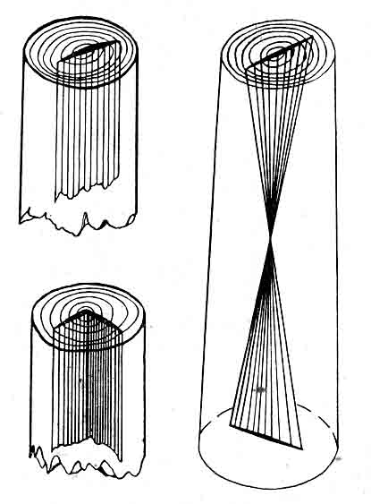

nax. 26. mrgval satyeo masalebSi metikuri bzarebis ganlagebis sqema: a - martivi metikuri bzari; b, g - rTuli metikuri bzarebi
a
b
g

anatkeCi warmoadgens wliuri Sreebis aSrevebas (ganfenas) mozard xeSi. xis tanis gareTa zedapirze igi ar Cans, mrgvali sortimentebis torsze ki SesamCnevia rkalis magvari Rrmulis saxiT, xolo daxerxil masalebSi _ CaRrmavebuli Raris saxiT (nax. 27).

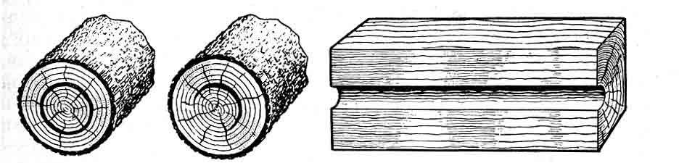
a b g

nax. 27. anatkeCis ganlagebis sqema: a, b _ mrgval sortimentebSi;
g - daxerxil masalebSi

Yyinvanabzari warmoadgens garegan mkvriv nabzars merqnisas, romelic siRrmeze radialuri mimarTulebiT vrceldeba (nax. 28). Yyinvanabzari warmoiSveba zamTarSi temperaturis mkveTri dace-misas. igi SeiZleba iyos aseve mexis dacemis Sedegic. Ggaredan bzaris sigane metia da TandaTanobiT mcirdeba, SevdivarT ra siRrmeSi. xandaxan yinvanabzari gulgulamdec aRwevs.
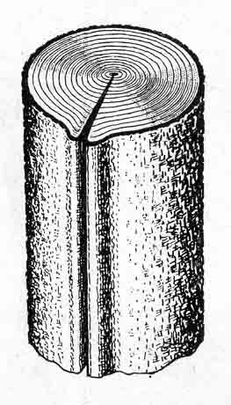

nax. 28. yinvanabzari

SeSrobis bzarebi warmoadgenen Srobis dros warmoSobil Siga daZabulobebis Sedegs. isini vrceldebian sortimentis gverdiTi zedapiridan siRrmeSi radialuri mimarTulebiT (nax. 29). Aam bzarebs naklebi sigrZe aqvT sortimentSi, maTi sigrZe ar aRemateba 1 m-s da naklebi siRrmiT xasiaTdebian. bzarebi SeiZleba warmoiSvas didi ganikveTis mqone daxerxili xe-tyis Srobis bolo stadiaSi. aseTi bzarebi sortimentis gare zedapirze ar Cans, amitom maT Sinagan bzarebsLuwodeben. sortimentSi ganlagebis mixedviT ganasxvaveben torsul, fenobisa da wibos bzarebs. tor-uli bzarebi sortimentis gverdiT zedapirebze ar gamodian. Ffenobis bzarebi SeimCneva fenobze da xandaxan torszec. wibos bzarebi ganlagebulia wiboebze da SeiZleba torszec. garda amisa, daxerxil xe-tyeSi ganasxvaveben calmxriv da gamWol bzarebs. calmxrivi ewodeba bzars, romelic gamodis sortimentis erT romelime zedapirze, xolo gamWoli _ romelic gamodis sortimentis or gverdiT zedapirze an orive torsze. Bbzarebi amcireben merqnis fiziko-meqanikur maCveneblebs, radgan arRveven merqnis mTlianobas.
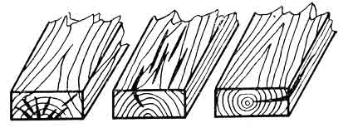

nax. 29. SeSrobis bzarebi:
a - torsuli; b - fenobis; g - waxnagis.

a b g

6.3. xis tanis formis mankebi.

mankebis am jgufs miekuTvneba zedmeti woweba, kintianoba, ovaluroba, nuJrebi da simrude.
zedmeti woweba. nebismieri jiSis xis tanisaTvis damaxasiaTebelia diametri Semcireba kintidan wverosaken. sigrZis erTeulze mosul diametris Semcirebis sidides wowebas uwodeben. wowebis dasadgenad zomaven xis tanis kintis diametrs kintidan 1 m-is daSorebiT sm-Si, gamoakleben mas sortimentis wveros diametrs, gazomils sm-Si, da Seafardeben sortimentis sigrZesTan, gazomils m-Si:
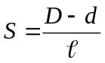 sm/m
Tu wowebis sidide metia 1 sm/m-ze, maSin igi mankad CaiTvleba da mas zedmet wowebas uwodeben. igi damokidebulia bevr faqtorze: xis jiSze, zrdis pirobebze, xis tanis im nawilze, saidanac sortimentia gamoxerxili. foTlovani jiSis xis tani xasiaTdeba ufro meti wowebiT, vidre wiwvovani. gansakuTrebiT didia iseTi xis tanis woweba, romelic gazrdilia meCxer koromSi an Tavisufal adgilze. Yyvelaze naklebi woweba axasiaTebT xis tanis Sua nawilidan gamoxerxil sortimentebs. Yyvelaze metiT _ wveros nawilidan, xolo kintis nawilidan miRebuli sortimentebi saSualo wowebiT xasiaTdebian.
kintianoba warmoadgens xis tanis Ziris nawilSi diametris mkveTr gadidebas (nax. 30). Kkintianoba yvela jiSis xis tanSi gvxvdeba. igi zedmeti wowebis kerZo SemTxvevadac SeiZleba CaiTvlos. Fformis mixedviT ganasxvaveben mrgval da Rarovan kintianobas. Aam ukanasknels zogjer Rarovnebasac uwodeben. mrgvali kintianobisas kintis nawilis ganikveTi uaxlovdeba wres, xolo Rarovani kintianibisas _ varskvlavis formas. Kkintianoba arTulebs mrgvali sortimentis gamoyenebas daniSnulebis mixedviT. Aamave dros zrdis narCenebis raodenobas daxerxvisas da Sponis axdisas.
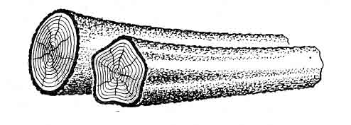
nax. 30. kintianoba: a - mrgvali; b - Rarovani.
a
b

ovalurobas adgili aqvs im SemTxvevaSi, rodesac xis tanis nebismieri adgilis didi diametri 1,5-jer aRemateba mcire diametrs. Ees mankic arTulebs sortimentis gamoyenebas da zrdis narCenebis raodenobas misi damuSavebis dros.
nuJrebi warmoadgens xis tanis adgilobriv gasqelebas (nax. 31). nuJris forma umetesad momrgvalebulia. Ggaregani saxis an merqnis aRnagobis mixedviT nuJrebi iyofian or jgufad: nuJrebi, romleb-sac gaaCniaT gluvi zedapirebi da xasiaTdebian merqnis met-nak-lebad swori aRnagobiT da nuJrebi, romelTac gaaCniaT araswori zedapiri da xasiaTdebian merqnis javarianobiT an boWkoebis abur-duli ganlagebiT. Mmeore saxis nuJrebs xSirad Tiebsac uwodeben. igi ZiriTadad damaxasiaTebelia foTlovani jiSis merqnisaTvis, xolo pirveli saxis nuJrebi gvxvdeba orive jiSis merqanSi. Yyvelaze ufro xSirad Tiebi gvxvdeba aryis da kaklis merqanSi. Kkareliis aryis Tiebiani merqnis Wrili gamoirCeva lamazi teqsturiT, rac didad fasobs saavejo warmoebaSi. wiwvovani jiSis gluvi nuJrebi xasiaTdebian fisis maRali SemcvelobiT da warmoadgenen karg nedleuls merqnis mSrali gamoxdisaTvis.
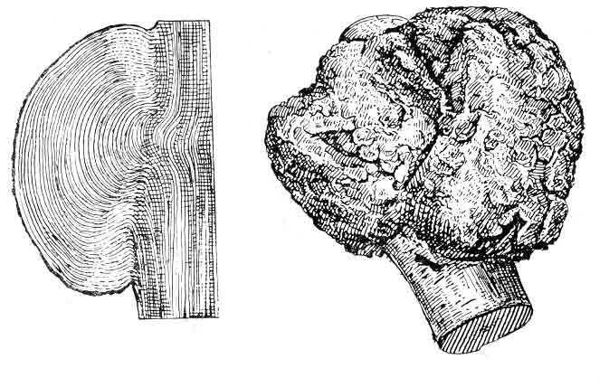

nax. 31. nuJrebi: a - gluvi _ fiWvze;
b - Rarovani _ kareliis aryze.

a
b

simrude gvxvdeba yvela jiSis merqanSi. Gganasxvaveben cal-mxriv da mravalmxriv simrudes. simrude calmxrivia, Tu sorti-menti gamrudebulia erT sibrtyeSi, xolo mravalmxrivia simrude, Tu sortimenti gamrudebulia sxvadasxva sibrtyeSi an erT sibr-tyeSi, magram sxvadasxva adgilas. simrude arTulebs merqnis gamoyenebas damiSnulebis mixedviT, amcirebs daxerxili xe-tyis da Sponis gamosavals. simrudis gavlenis Sesamcireblad grZel sortimentebs anawevreben xolme sigrZeze.

6.4. merqnis aRnagobis mankebi.

am jgufSi Sedis mankebis didi raodenoba: boWkoebis daxra, javarianoba da xveula. Ees mankebi gamowveulia boWkoebis araswori ganlagebiT. Aamave jgufSi Sedis gverdela da gaWimuli merqani, romlebic warmoadgenen wliuri Sreebis uTanabro ganviTarebis Sedegs. aseve ormagi gulguli, Sinagani cila, cru guli, laqianoba, gverdxmeloba, amonazardi, kibo, Canafisi, fisis jibe-ebi, wyalSre.
boWkoebis daxra warmoadgens sortimentis grZivi RerZidan boWkoebis gadaxras. Pperiferiul zonebSi misi sidide ufro didia, vidre Sinagan zonebSi. boWkoebis daxra arTulebs merqnis meqa-nikur damuSavebas da amcirebs misi moRunvis unars, iwvevs SeSro-bis sididis zrdas da gamomwvevia xraxnuli dabrecilobisa (nax. 32).
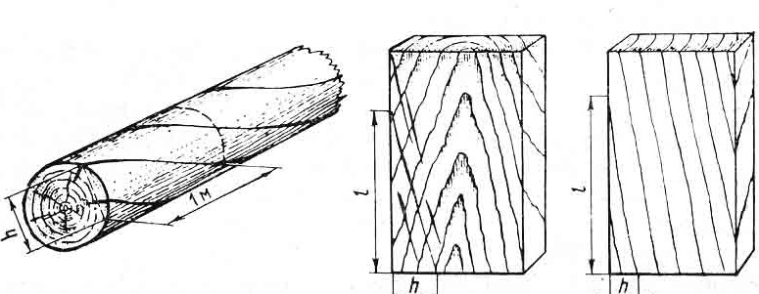
a b g
nax. 32. boWkoebis daxra: a - tangentaluri daxra mrgval satyeo masalebSi; b, v _ tangentaluri da radialuri daxra daxerxil produqciaSi

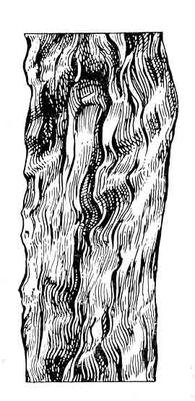
javarianoba warmoadgens boWkoebis klaknil an aburdul ganlagebas, romelic yvelaze metad gvxvdeba foTlovani jiSis merqanSi. Gganasxvaveben talRovan da aburdul javarianobas. Mmiuxe-davad imisa, rom javarianoba mankia aseTi saxis merqani Tavisi lamazi teqsturis gamo gamoiyeneba mopirkeTebisaTvis (nax. 33).

nax. 33. javarianoba aryis xeSi.

xveula ewodeba rokebTan da CanazardebTan wliuri Sreebis adgilobriv gamrudebas. xveula ori saxisaa: calmxrivi da gamWoli (nax. 34). calmxrivi ewodeba xveulas, romelic gamodis sortimentis erT an Oor momijnave zedapirze. gamWoli ewodeba xve-ulas, romelic gamodis sortimentis or urTierTsapirispiro zedapirze.
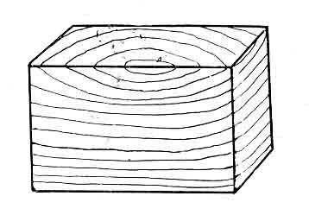
Ggverdela merqnis normaluri aRnagobis cvlilebaa, romelic gamoixateba gviana merqnis siganis mkveTrad gadidebaSi (nax. 34). Gganasxvaveben adgilobriv da mTlian gverdelas.

nax. 34. calmxrivi xveula

gaWimuli merqani foTlovani jiSis merqnisTvisaa damaxasiaTebeli. Ees aris wliuri Sreebis siganis zrda ara SekumSul, aramed gaWimul zonaSi. gaWimuli merqani mkveTrad gansxvavdeba normalurisagan rogorc aRnagobiT, aseve Tvisebebi.
gulguli warmoadgens xis tanis normalur warmonaqms. Ppirvelad merqanTan erTad igi qmnis gulgulis milaks. Ggulgu-li warmoadgens 2_5 mm diametric mura feris mrgval an varskvlavis formis mqone laqas, romelic faSari qsovilebisagan Sedgeba. Mmrgval sortimentebSi gulguls Tavidan ver avicilebT, amitom igi aq mankad ar iTvleba, xolo namzadi, romelic gulgulis mils Seicavs, dabali simtkiciT xasiaTdeba. Ggarda amisa, gulguliani daxerxili xe-tyis Srobisas dabzarva ufro metadaa mosalodneli, ris gamoc mcirdeba merqnis xarisxi. zogierTi specialuri daniSnulebis sortimentSi ki gulguli saerTod dauSvebelia.
ormagi gulguli SeimCneva iseT sortimentSi, romelic gamoxerxilia xis tanis im nawilidan, sadac igi iyofa or damou-kidebel varjad. Oorive gulguls Tavisi damoukidebel wliur SreTa sistema gaaCnia. Oormag gulguliani merqani ufro metad ibriceba da ibzareba. Mmisi daxerxva da misgan Sponis axda gaZn-lebulia da meqanikur damuSavebas Tan axlavs narCenebis didi raodenoba (nax. 35).
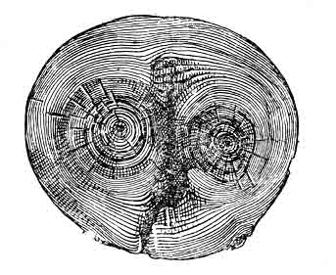

nax. 35. fiWvis tanis ormagi gulguli

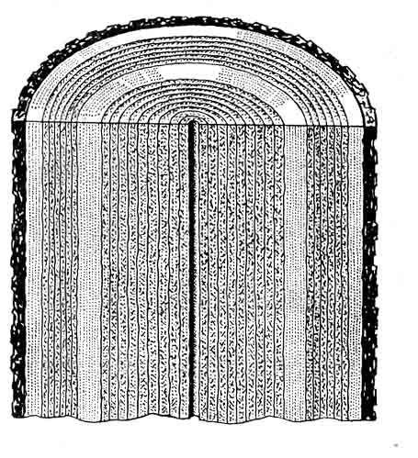
Sinagani cila xSirad SeimCneva muxisa da ifnis merqanSi, rodesac gulis zonaSi warmoiSveba ramodenime erTmaneTis momijnave wliuri Sre, romlebic Zalian gvanan cilas rogorc feriT, aseve sxva TvisebebiTac. tangentalur zedapirebze Sinagani cila SeimCneva met-naklebad farTo zolebis saxiT. Ees manki warmoiSveba kambiumis normaluri moqmedebis darRvevis Sedegad. Sinagan ciliani merqani ar gamoiyeneba Txevadi nivTierebebis taris dasamzadeblad misi maRali wyalSeRwevadobis gamo. aseT mankiani merqani naklebad mdgradia lpobisadmi (nax. 36).

nax. 36. Sinagani cila

cru guli ewodeba foTlovani jiSis ugulo merqnis muqad Seferil zonas. Nnamdvili gulisagan igi gansxvavdeba araerTgvarovani aRnagobiT da naklebad swori formiT. cru guli gansakuTrebiT damaxasiaTebelia wiflis, aryis, rcxilis da nekerCxlis merqnisaTvis. Fformis mixedviT gvxvdeba mrgvali, varskvlaviseburi da frTovanas formis cru guli (nax. 37). cru gulis merqani SeRebilia muq rux an mowiTalo rux ferad, xandaxan iisferi an muqi mwvane elferiT. sortimentis grZiv Wrilebze SesamCnevia erTi an ramodenime aRniSnuli feris farTo zolebi. maT warmomqmnel mizezebad saxeldeba qsovilebis asakobrivi diferencireba, sokoebis zemoqmedeba da Zlieri yin-vebis gavlena.

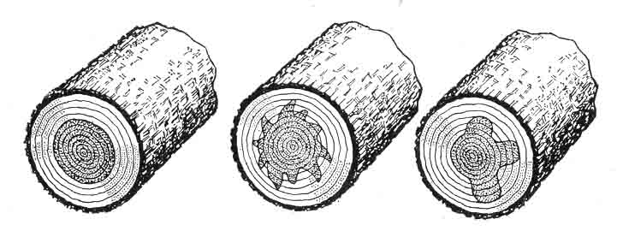
nax. 37. cru guli: a - mrgvali;
b - varskvlaviseburi;
g - frTovanas formis.

a b g

cru guli amaxinjebs merqnis garegan saxes. Mmas naklebi wyalSTanTqma da dabali simtkice axasiaTebs. Mmisi moRunvis da-bali unari iwvevs didi raodenobis wuns grexili avejis warmoe-baSi.
laqianoba warmoiSveba foTlovani jiSis merqanSi sxvada-sxva fiziko-meqanikuri faqtorebis, sokoebisa da mwerebis zegav-leniT. Ees aris mcire zomis muqad Seferili ubnebi, romlebic ganlagebis mixedviT radialur da tangentalur laqianobad iyofa. Mmrgval sortimentebSi laqianoba mxedvelobaSi ar miiReba. igi gavlenas ar axdens merqnis fiziko-meqanikur Tvisebebze, magram radialuri laqianobis mqone masalam aucileblad unda gaiaros kameruli Sroba.
Ggverdxmeloba warmoadgens xis tanis garegan calmxriv sikvdils. mkvdari uqerqo nawili, Cveulebriv, wagrZelebulia xis tanis sigrZeze da amave dros CaRrmavebulia danarCen zedapirTan SedarebiT. es manki gvxvdeba yvela jiSis merqanSi (nax. 38). Mmisi warmoSobis mizezia mozard xeze qerqis moSoreba an xanZari.
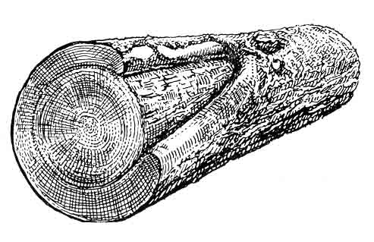

nax. 38. gverdxmeloba.

amonazardi ewodeba xis tanSi nawilobriv an mTlianad Cazrdil qerqs da mkvdar merqans. Mmerqnis axali fenebi, romle-bic izrdebian dazianebis Semdeg, ar Seezrdebian maT qveS mdebare Zvel fenebs, ris gamoc axalsa da Zvel fenebs Soris xSirad rCeba garkveuli are, romelic Sevsebulia qerqis narCenebiT. Ggamyarebuli fisiT da a.S.
Gganasxvaveben Ria da daxurul amonazards (nax. 39). Riaa amonazardi, rodesac dazianebis kideebi erTmaneTs exeba, magram zevidan merqnis axali fenebi ar warmoiSveba. Ria amonazardi mrgvali sortimentebis gverdiT zedapirebze CaRrmavebuli for-misaa. Ddaxuruli amonazardi warmoiSveba, rodesac dazianebuli xis tani amoivseba merqnis axali fenebiT. Mmisi aRmoCena SeiZleba mxolod xis tanis torsul Wrilze.
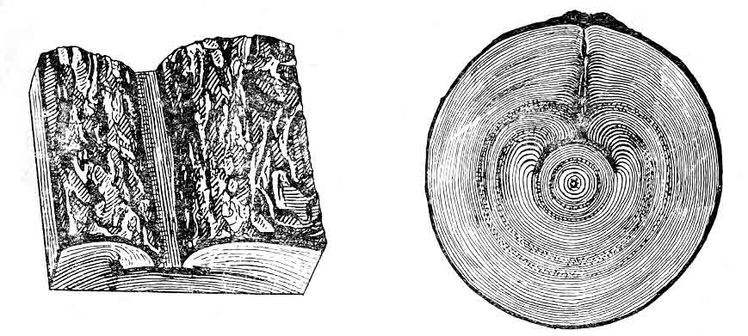
a b

nax. 39. amonazardi: a - Ria; b - daxuruli
A
amonazardi arRvevs merqnis mTlianobas. Mmerqnis xarisxze misi gavlena damokidebulia mis saxeobaze, zomebze, adgilmde-bareobaze, raodenobaze da aseve sortimentis maxasiaTeblebze.
Kkibo warmoadgens Wrilobas, romelic warmoiSveba xis tanis zedapirze sokoebisa da baqteriebis zemoqmedebis Sedegad. kibo SeiZleba iyos Ria da daxuruli, anu rodesac qerqis qsovilebi dazianebuli adgilebis garSemo aranormalurad aris gasqelebuli (nax. 40). aRniSnuli manki gvxvdeba orive jiSis merqanSi. wiwvovanebSi kibos Tan sdevs fisis intensiuri gamoyofa.
Ffisis jibeebi ewodeba wliur Sreebs Soris arsebul fisiT savse zolebs. aseTi jibeebi gvxvdeba fisis savali milebis mqone wiwvovani jiSis merqanSi. torsul Wrilze moCans rkalis magvari fisiT Sevsebuli jibeebi bzarebis saxiT. tangentalur zedapirze fisis jibeebi warmoadgenen ovaluri formis CaRrmavebebs, radialurze ki _ mokle naxvretebis saxiT. gansakuTrebiT xSirad gvxvdeba naZvis merqanSi (nax. 41). maTi zomebi meryeobs ramodenime mm-dan 10-15 sm-mde. daxerxil sortimentebSi fisis jibeebi amcireben merqnis simtkices, arTuleben zedapirebis mopirkeTebas da Sewebebas, radgan fisis jibeebidan gamosuli fisi afuWebs nakeTobis zedapirs.
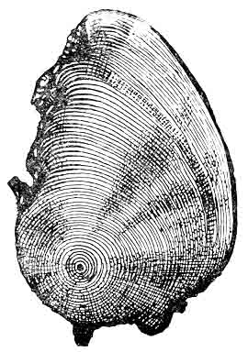
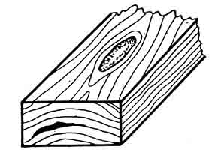

nax. 40. fiWvis kibo nax. 41. fisis jibe

wyalSre ewodeba gulis an mwife merqnis maRaltenian ubnebs axladmoWril mdgomareobaSi. igi gvxvdeba yvela jiSis merqnis kintis nawilSi, magram yvelaze xSirad fiWvisa da naZvis merqanSi, iSviaTad _ aryisa da verxvis merqanSi. satyeo masalis torsze Cans sxvadasxva formis muqi laqebis, xolo grZiv Wrilerze _ zolebis saxiT. zamTarSi SeimCneva Cayinuli SuSis magvari zolebis saxiT. wyalSriani merqnis fiziko-meqanikuri Tvisebebi 10 _ 20%-iT dabalia, vidre janmrTeli merqnisa. SeSrobisa da gajirjvebis unari ki maRalia. wyalSriani merqani rTulad eqvemdebareba antiseptikebiT gaJRenTvas.

6.5. qimiuri Seferilobebi.

Qqimiuri Seferilobebi, warmoSobili axlad moWril an dacurebul merqanSi, warmoadgens qimiuri da bioqimiuri proce-sebis Sedegs. isini ar vrceldebian 5 mm_ze met siRrmeze. Mmerqnis gamoSrobis Semdeg qimiuri Seferiloba gauferuldeba xolme.
Aarsebobs qimiuri Seferilobebis ori jgufi: mTrimleloba da siyviTle. mTrimleloba warmoadgens qerqisqveSa fenebis 3_5 mm-is siRrmis mowiTalo_moyavisfro an mura feris Seferilobas. igi damaxasiaTebelia mTrimlavi nivTierebebiT mdidari jiSebisaTvis. siyviTle ki SeimCneva dacurebiT miRebuli wiwvovani jiSis merqanSi. igi warmoadgens mTlian zedapirul moyviTalo limonisfer Seferilobas, romelic aRiZvreba Jangbadis ukmariso-biT cilis cocxali ujredebis Semadgenel elementebSi qimiuri cvlilebebis Sedegad. am dros warmoSobili yviTeli feris nivTierebebi merqnis Srobis procesSi gamodian sedapirze.
Qqimiuri Seferilobebi gavlenas ar axdenen merqnis fiziko-meqanikur Tvisebebze, magram arsebiTad afuWeben mosapirkeTebeli masalis garegan mxares.

6.6. sokovani daavadebebi.

sokoebi miekuTvnebian umartives sporovan cocxal organi-zmebs, e.i. isini mravldebian sporebis saSualebiT. sokoebi iyofian parazitebad da saprofitebad. Pparazitebi iseTi sokoebia, romlebic ikvebebian mxolod cocxali organizmebiT, xolo saprofitebi ikvebebian mkvdari merqnis organizmebiT. xis dazianeba sokovani daavadebiT xdeba sporebis saSualebiT. maT Zalian mcire wona, martivi ujredi da sqeli garsi aqvT. maTi gadatana xdeba qaris, wylis, cxovelebisa da frinvelebis saSua- lebiT. xelovnuri an bunebrivi nabzarebidan moxvdebian ra xis organizmSi, sporebi iwyeben gavrcelebas. sokovani daavadebis ganviTarebisaTvis xelsayreli pirobebia saWiro. Tu merqnis tenia-noba 20%-ze naklebia, sokovani daavadeba ver ganviTardeba. Aaseve SeuZlebelia maTi ganviTareba 45⁰ –ze meti temperaturisas. wyliT gajerebul merqanSi, uJangbadobis gamo, sokoebi ver viTardeba. swored amiT aixsneba xis damamuSavebel sawarmoebSi merqnis svel mdgomareobaSi Senaxva.
spori, moxvdeba ra gavrcelebisaTvis saWiro pirobebSi, iw-yebs ganviTarebas. sokoebi pouloben merqanSi ori saxis sakveb nivTierebas: ujredSiga nivTierebebs da ujredis garss. sakvebis kargad aTvisebisaTvis, sokoebi gamoyofen specialur nivTierebebs _ fermentebs. isini iwveven merqnis rRvevas da maT merqanmrRvev sokoebs uwodeben, gansxvavebiT merqanmRebavi sokoebisagan, romle-bic mxolod merqnis feris Secvlas iwveven da ar amcireben merq-nis fiziko-meqanikur Tvisebebs.
Gganasxvaveben ori saxis lpobas: koroziuls da destruq-ciuls. Kkoroziuli lpobisas sokovani daavadebis hifebi akeTeben wvril xvrelebs merqnis ujredebSi, xolo Semdeg mas afarToeben. Uujredis garsi TandaTanobiT lRveba da maTgan mxolod nafleTebi rCeba. Ldestruqciuli lpobisas ki mimdinareobs merqnis TandaTanobiTi daSla xvrelebis warmoqmnis gareSe. aseTi saxis dampali merqani napralebiania.
Siga gamuqeba warmoadgens lpobis sawyis stadias, romelic mJRavndeba xis tanis centraluri nawilis feris cvlilebaSi da romelsac Tan sdevs merqnis simtkicis Semcireba. moWril merqanSi am mankis ganviTareba wydeba. Ggulis an mwife merqnis zonaSi torsze gvxvdeba msxvili zomis sxvadasxva formis laqebi. grZiv Wrilebze SeimCneva zoliseburi laqebi, romlebic SeiZleba iyos mura, mowiTalo, moyavisfro, iSviaTad Savi da iisferi. Siga gamu-rafreba iwvevs merqnis zogierTi meqanikuri maCveneblis Semci-rebas.
Sinagani sidample warmoadgens mozardi xis merqnis mrRvevi sokoebiT dazianebis saboloo stadias. Aam manks Tan axlavs merq-nis sisalisa da simtkicis Semcireba, normaluri struqturisa da feris cvlileba. Mmrgval sortimentebSi sidample SeimCneva rogorc sxvadasxva moxazulobis msxvili zomis laqebi an ro-gorc xis tanis centralur nawilSi gamavali mTliani zona.
xis tanSi ganlagebis mixedviT ganasxvaveben kunZisa da tanis sidamples. kunZis sidample iwyeba ra fesvebidan an Wrilo-bebiT dazianebuli kunZis nawilidan, wverosaken TandaTan viw-rovdeba. tanis sidample ki viTardeba motexili totebidan an tanze arsebuli Wrilobebidan. igi vrceldeba warmoSobis adgili-dan rogorc zeviT, aseve qveviT da aqvs sigaris forma (nax. 42).
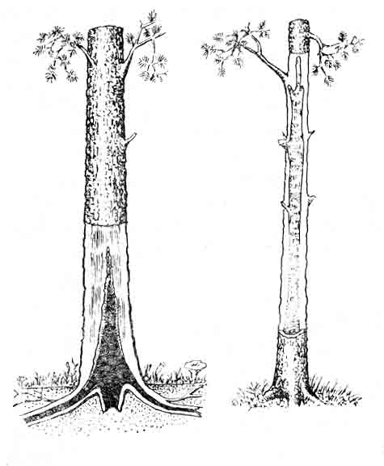

nax. 42. gulis sidample mozard xeSi.
a - kunZis sidample;
b - tanis sidample.

merqnis dazianebis xarisxis mixedviT Sinagan sidamples yofen Semdeg saxeebad: Wreli sacrisebri, mura bzarebiani da TeTri marmarilosebri.
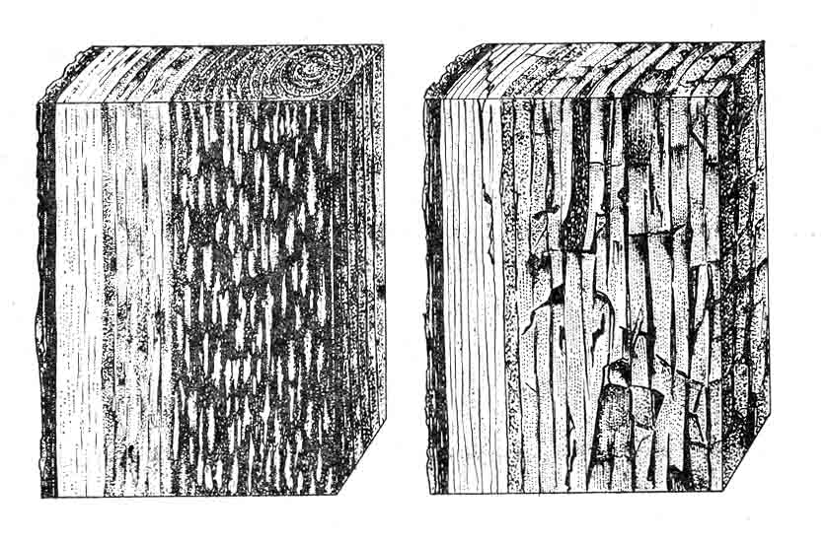
Wreli sacrisebri sidample dazianebuli merqnis mowiTalo an mura fonze SeimCneva mravalricxovani wvrilTeTri an moyviTa-lo laqebis saxiT. Tu dazianeba Rrmaa _ merqani Zalian rbildeba da advilad deformirdeba xeliT dawoliT. sidamplis es saxeoba gvxvdeba orive jiSis merqanSi (nax. 43, a).

nax. 43. gulis sidample:
a - Wreli sacrisebri sidample;
b - mura bzarebiani sidample.

a b

murabzarebiani sidample xasiaTdeba dazianebuli merqnis bzarebiani struqturiT. Bbzarebi mimarTulia rogorc boWkoebis grZivi, aseve ganivi mimarTulebiT. aseTi mankiT dazianebuli mer-qani iSleba prizmis formis patara nawilebad, advilad deformirdeba da ifSvneba xelSi (nax. 43, b).
TeTr marmarilosebr sidamples gaaCnia Ria moyviTalo an TeTri feri. zogjer mas Tan sdevs Zalian viwro klaknili Savi zolebi, ris gamoc merqnis teqstura marmarilos emsgavseba.Ees manki damaxasiaTebelia foTlovani jiSis merqnisaTvis.
obi warmoadgens merqnis zedapirul Seferilobas, romelic gamowveulia obis sokoebiT. is umetesad Cndeba tenian silaSi xe-tyis Senaxvisas. saerTod, obi gavlenas ar axdens merqnis fiziko-meqanikur Tvisebebze, Tumca, cnobilia, rom obi iwvevs cxoveluri warmoSobis weboebis daSlas.Aamitom im merqanma, romelic gankuTv-nilia SewebebisaTvis, aucileblad unda gaiaros kameruli Srobis operacia. obi ar daiSveba sakvebi produqtebis taris dasamzadeb-lad gankuTvnil merqanSi.

6.7. biologiuri dazianebebi.

WianaWami ewodeba merqnis mwerebiT dazianebas.Mmanki gvxvdeba axladdamzadebul satyeo masalebSi, zezeulad gamxmar da dasus-tebul xeebSi. Aam SemTxvevaSi satyeo masalebis zedapirze SeimC-neva mrgvali an ovaluri formis naxvretebi an Rarebi. Ddazi-anebis gamomwvevia ara Camoyalibebuli mwerebi, aramed maTi Wuprebi. isini sakvebad iyeneben qerqs an merqans. daamTavreben ra TavianTi ganviTarebis cikls, mwerebi aRar saxldebian imave mer-qanSi. Mmwerebi intensiurad viTardebian Tbil, mSral amindSi. maTi ganviTarebis optimaluri temperaturaa 18_24⁰, xolo haeris fardobiTi tenianoba 60_90%.
siRrmis mixedviT ganasxvaveben zedapirul, araRrma da Rrma WianaWams. zedapirulia WianaWami, romelic mrgval sorti-mentSi vrceldeba ara umetes 3 mm siRrmeze. araRrma ewodeba Wia-naWams, romelic mrgval sortimentebSi vrceldeba 15 mm siRrmeze, xolo daxerxil xe-tyeSi _ 5 mm siRrmeze. Rrmaa WianaWami, romelic vrceldeba mrgval satyeo sortimentebSi 15 mm-ze met siRrmeze, xolo daxerxil xe-tyeSi _ 5 mm-ze met siRrmeze. zedapiruli WianaWami arsebiT gavlenas ver axdens merqnis fiziko-meqanikur Tvisebebze. Mmorebis daxerxvisas an kotrebis daSlisas zedapiruli WianaWami narCenebSi xvdeba. araRrma da Rrma WianaWami ki sagrZnoblad arRveven merqnis mTlianobas da naxvretebis didi raodenobis SemTxvevaSi mkveTrad amcireben merqnis fiziko-meqanikur Tvisebebs (nax. 44).
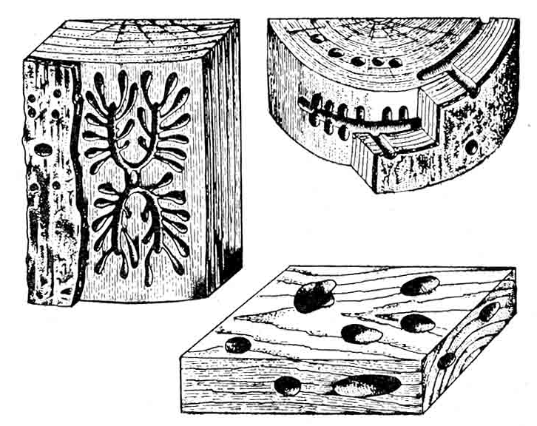
a
b
g
nax. 44. WianaWami: a - zedapiruli; b - Rrma _ mrgval satyeo masalebSi;
g - Rrma _ daxerxil produqciaSi.
arsebobs kidev futuro WianaWami, rodesac Rrma xvrelebis raodenoba imdenad bevria, rom merqani Signidan warmoadgens fu-turo masas. romelSic aris didi raodenobiT merqnis fqvili. Aaseve xSirad gvxvdeba Citebis mier dakenkili merqanic.

6.8. aranormaluri dagrovebani merqanSi, meqanikuri dazianebebi da damuSavebis defeqtebi.

sortimentebSi xSirad gvxvdeba aramerqnuli warmoSobis sxeulebi _ qvebi, mavTulebi, lursmnebi, liTonis namsxvrevebi.
mankebis calke jgufs Seadgens meqanikuri dazianebebi da damuSavebis defeqtebi warmoqmnili xe-tyis damzadebis dros, misi transportirebisas da daxerxvisas. ganasxvaveben qerqgaclilobas, SeTlas da Wdes.
qerqgacliloba warmoadgens zedapirul dazianebas, romlis drosac xis tanze qerqi Semoclilia an SemorCenilia mkvdari sa-xiT. Aam dazianebisas sakuTriv merqani dazianebuli ar aris. Qqer-qgacliloba warmoiSveba mezobeli xeebis vardnisas moWris dros.
SeTla warmoadgens sortimentis zedapirul dazianebas raime mWreli instrumentiT, romlis drosac dazianebulia ara marto qerqi, aramed merqnis gare Sreebic.
Wde warmoadgens najaxiT an xerxiT miyenebul merqnis Rrma dazianebas.
Ddaxerxil xe-tyeSi ganasxvaveben Semdeg defeqtebs: nakawrebi, talRovneba, xavsisebrioba, xaoianoba da naSuri.
nakawrebi warmoadgenen dasaSveb normaze ufro meti sigrZis xerxis kbilebiskvals sortimentis zedapirze.
xaoianoba mdgomareobs sortimentis zedapirze calkeuli boWkoebis nawilebis arsebobaSi, romelic merqans xaoianobas ani-Webs.
talRovneba daxerxili xe-tyis arasworxazovani gaxerxvis Sedegia.
xavsisebrioba warmoadgens sortimentis zedapirze boWkoebis konebis arsebobas.
naSuri warmoadgens daxerxili xe-tyis wiboze moris gauqerqavi zedapiris arsebobas.
ganasxvaveben blagvsa da maxvil naSurs. Bblagbi naSuri miiReba im SemTxvevaSi, rodesac gauxerxavi zedapiri moicavs rogorc wibos, aseve fenobis nawils. Mmaxvili naSuri moicavs mxolod wibos nawils.
aRniSnuli dazianebebi ar moqmedeben merqnis fiziko-meqani-kur Tvisebebze. damuSavebisas SesaZlebelia maTi sruli aRmofxvra. zemoT CamoTvlili mankebi amcireben daxerxili xe-tyis xarisxs.

6.9. dabreciloba.

sortimentebis Srobisas misgan tenis araTanabari aorTqle-bis Sedegad sortimentma SeiZleba Seicvalos sawyisi forma anu daibricos. sortimentis normaluri forma icvleba aseve iseTi morebis daxerxvisas, romelTac gaaCniaT xis zrdis procesSi aRZ-ruli mniSvnelovani Sinagani daZabulobebi. Ddetalis formis cvlileba SeiZleba SevamCnioT agreTve mSrali merqnis meqanikuri damuSavebisas, Tu masSi narCeni deformaciebi mniSvnelovan sidi-des aRweven.
xasiaTis mixedviT ganasxvaveben sami saxis dabrecilobas: ganivs, grZivsa da xraxnuls (nax. 12).
dabreciloba Zalian aZnelebs, xSirad ki saerTod gamori-cxavs sortimentis gamoyenebas daniSnulebis mixedviT.

Tavi VII. satyeo saqonelmcodneobis safuZvlebi.
7.1. satyeo saqonlis klasifikacia.

satyeo saqoneli ewodeba masalebsa da produqtebs, romlebic miRebulia xis tanis, fesvebis da varjis meqanikuri, meqanikur-qimiuri da qimiuri gadamuSavebis Sedegad.
yvela satyeo saqoneli iyofa 7 jgufad:
- satyeo masalebi. Aam jgufSi Sedis xis tanis damuSavebis Sedegad miRebuli saqoneli. amasTan mzaddeba saqmisi merqani da SeSa, romelic vargisia mxolod sawvavad. Mmeqanikuri damuSavebis meTodebis mixedviT satyeo masalebi iyofa 6 klasad:
1. mrgvali satyeo masalebi miiReba xis tanis grZivi danawevrebiT mrgvali formis nawilebad.
2. daxerxili masalebi, anu daxerxili produqcia, miiReba morebis xerxebiT grZivi da ganivi danawevrebis Sedegad.
3. axdili masalebi, romlebic miiReba merqnis spiraluri Wris Sedegad (axdili Sponi).
4. anaTali masalebi miiReba merqnis danebiT damuSavebis Sedegad brtyeli zedapiris miRebis mizniT.
5. daxeTqili masalebi miiReba merqnis gayofiT soliseburi saWrisis saSualebiT.
6. daqucmacebuli merqani, romelic miiReba merqnis specialuri gadamuSavebiT samsxvrev manqanaze, safrezo-saxerx agregatebze, burbuSelis Carxebze da safqvav mowyobilobebze.
Ggarkveuli daniSnulebis satyeo masalebis sxvadasxva saxeobas sortimentebi ewodeba. satyeo taqsaciis erTerT amocanas warmoadgens nargavebis sortimentireba, e.i. saqmiani da saSeSe merqnis maragis, aseve calkeuli sortimentis gamosavlis dadgena.
II.nedleuli satyeo-qimiuri mrewvelobisaTvis. es saqonelic miiReba xis tanis, fesvebis da varjis gadamuSavebis Sedegad, raTa gamomuSavebuli iqnes mTrimlavi nivTierebebi, specialuri naxSiri, merqnis wveni da sxva.
III.kompoziciuri merqnuli masalebi. Aam jgufSi Sedian furclovani, filovani da sxva saxis masalebi, romlebic miiReba SemakavSirebeli, Semkvreli da Semwebi nivTierebebis saSualebiT. Aam jgufis warmomadgenelia fanera, merqanburbuSelovani, merqan-boWkovani da sadurglo filebi.
IV. modificirebuli merqani. Aaq Sedis masiuri merqani, romelsac Secvlili aqvs Tvisebebi garkveuli mimarTulebiT _ dawnexviT, plastifikaciiT, sinTetikuri fisebiT, modifikaciiT da sxva.
V. celuloza da qaRaldi. rogorc dasaxeleba gviCvenebs am jgufs miekuTvneba merqnis qimiuri gadamuSavebis Sedegad miRebuli celuloza da qaRaldi.
VI. hidrolizisa da safuaris warmoebis produqcia. Aaq Sedis dabalxarisxovani merqnidan miRebuli produqcia _ spirti, sakvebi safuari, furfuroli da sxva.
VII. satyeo-qimiuri warmoebis produqcia. Aam jgufSi Sedis sxvadasxva saxis produqcia: skipidari, kanifoli, mTrimlavi eqstraqtebi, merqnis naxSiri, biologiurad aqtiuri nivTierebebi da sxva, miRebuli me - II jgufis saqonlisagan.

7.2. daxerxili produqcia.

jiSis mixedviT daxerxili masalebi iyofian wiwvovan da foTlovan jiSebad. saxeobis mixedviT ganarCeven sami saxis daxerxil produqcias: daxerxili masalebi, daxerxili namzadebi da daxerxili detalebi.
Ddaxerxili masalebi miiReba morebis danawevrebis Sedegad; namzadebi gamomuSavdeba daxerxili masalebisgan, xolo detalebi namzadebisgan an uSualod mrgvali satyeo masalebisgan. Ddaxerxili namzadebi gansxvavdebian daxerxili masalebisagan imiT, rom zomebisa da formis mixedviT isini Seesabamebian momaval konkretul detalebs SeSrobaze da meqanikur damuSa-vebaze nametis gaTvaliswinebiT. Ddaxerxili detalebi namzade-bisgan gansxvavebiT ar saWiroeben Semdgom meqanikur damuSavebas.

7.3. daxerxili masalebi.
G
ganivi kveTis formisa da zomebis mixedviT daxerxili masa-lebi iyofian Zelebad, ficrebad, Zelakebad (nax. 45).
daxerxil masalas, romlis ori mopirdapire zedapiri ga-xerxilia, xolo ori warmoadgens gauxerxav zedapirs da romlis sigane da sisqe metia 100 mm-ze, orkantiani Zeli ewodeba. samkantian ZelSi gaxerxilia sami zedapiri da daculia zomebi, xolo oTxkantiania Zeli, romelzec gaxerxilia oTxive zedapiri da sigane da sisqe 100 mm-ze metia.
daxerxil produqcias, romlis ori mopirdapire zedapiri gaxerxilia, xolo ori warmoadgens gauxerxav zedapirs da amave dros sisqe naklebia100 mm-ze, xolo sigane metia ormag sisqeze, ewodeba Camouganavi ficari. rodesac gaxerxilia oTxive zedapiri da danarCeni pirobebi daculia, gvaqvs Camoganili ficari. Tu daxerxili produqciis sisqe naklebia 100 mm-ze, amave dros sigane naklebia ormag sisqeze da sigrZea ara umetes 3-metrisa, gvaqvs Zelaki. Camoganili ficris Camoganvisas miRebul narCenebs lartya ewodeba.
P
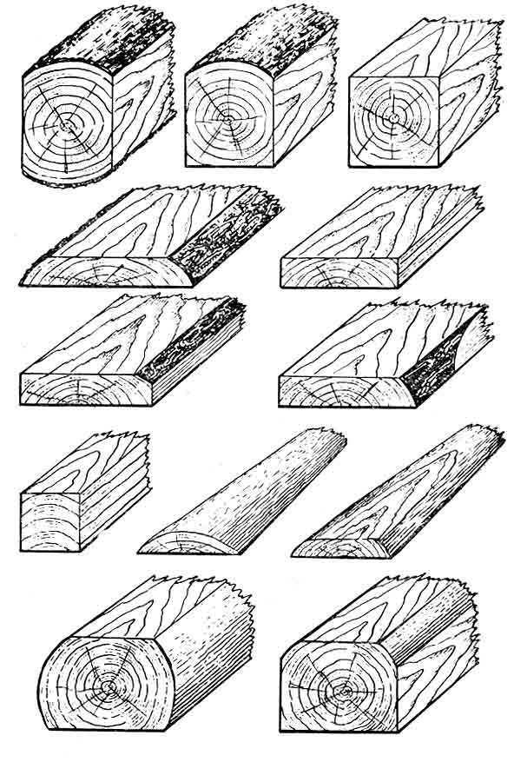
a
b
g
d
e
v
z
T
i
k
l
m
nax. 45. daxerxili produqciis saxeebi:
Zelebi: a - orkantiani; b - samkantiani; g - oTxkantiani;
ficrebi: d - Camouganavi; e - Camoganili; v - blagvi, naSuri; z - maxvili naSuri; T - Zelaki; i - nagverduli; k - yuaficruli, nagverduli; l - Camouganavi Spali; m - Camoganili Spali.

produqcias, romelic miiReba moris grZivi danawevrebisas da romlis erTi zedapiri mTlianad gaxerxilia, meore ki warmoadgens moris gauxerxav zedapirs _ nagverduli ewodeba. nagverduli aris ori saxis: sakuTriv nagverduli da yuaficruli nagverduli. sakuTriv nagverdulSi erTi zedapiri gaxerxilia, xolo meore mTlianad gauxerxavi. Yyuaficrul nagverdulSi Siga fenobi mTlianad gaxerxilia, xolo gareTa _ nawilobriv
Ddaxerxil masalebSi ganier nawils fenobi ewodeba, viwro nawils ki _ wibo, maTi SeerTebis xazs _ nawiburi, maT perpendikularul zedapirs _ torsi.
daxerxil produqcias SeiZleba gaaCndes naSuri _ blagvi an maxvili.
daxerxil masalebs miekuTvneba agreTve Spalebi.
daxerxili xe-tyis sigrZe izomeba m-obiT, rogorc manZili or torss Soris, sisqe _ mm-iT, rogorc manZili or fenobs Soris, sigane _ mm-iT, rogorc manZili or wibos Soris. Camouganav daxerxil xe-tyeSi siganis dasadgenad, ficris sigrZis SuaSi gazomaven Siga da gare fenobebis siganeebs da ficris siganed miiCneven maT naxevarjams.

VIII. xe-tyis damamzadebeli mrewvelobis produqcia

8.1 mrgvali satyeo masalis sortimentebi

mrgval satyeo masalaze SemoRebulia 2 unificirebuli standarti. MmasSi mocemulia moTxovnebi produqciis zomebisa da xarisxis mimarT.
sisqis mixedviT satyeo masala Semdeg jgufebad iyofa:
- wvrili – 8-13 sm-mde 1 sm gradaciiT;
- saSualo _ 14-24 sm 2 sm gradaciiT;
- msxvili _ 26-dan zemoT 2 sm gradaciiT.
mrgval satyeo masalas sigrZeze unda hqondes 3 sm namati, xolo im masalas, romelic gankuTvnilia kotrebad danawevrebisaTvis 2-3 sm yoveli kotris gamomuSavebaze.
xarisxis mixedviT satyeo masala iyofa 4 xarisxad da uxarisxo jgufad. wiwvovani jiSebis I xarisxians miekuTvneba mxolod msxvili zomis masala, foTlovanebisas ki _ saSualoc. II, III da IV xarisxians ganekuTvneba saSualo da wvrili masala, uxarisxos ki mxolod wvrili.
arc erT xarisxSi ar daiSveba gare futuro da TeTri marmarilosebri sidample, wiwvovan masalebSi ar daiSveba cilisa da Siga sidamplis erToblioba. SezRudvis gareSe yvela xarisxSi daiSveba cru guli, laqianoba, Siga cila, Canafisi, fisiani ubeebi da gverdula.

8.2. mrgvali saxiT gamoyenebuli satyeo masala

am qveklass miekuTvneba satyeo sortimentebi, romlebic gankuTvnilia mrgvali saxiT gamoyenebisaTvis Semdgomi damuSavebis gareSe, e.i. maTi formisa da zomebis Seucvlelad. maTSi araviTari sidample ar daiSveba. am sortimentebis gaJRenTa Zalze axangrZlivebs maT moxmarebas. maT miekuTvneba:
a) maRaros bigebi. mrgval satyeo masalas, romelsac iyeneben samagreblad miwisqveSa maRaroebSi da awvdian qvanaxSirisa da samTo mrewvelobas, maRaros bigebi ewodeba. merqnis am miznisaTvis gamoyenebas Semdegi upiratesoba aqvs: mcire gabarituli zomebi, xarisxis maRali koeficienti, romelic samomxmareblo rkinis koeficientis tolia, siiafe, damuSavebis da gadatanis siadvile. Ggarda amisa wnevis gazrdisas tkacaniT atyobinebs momuSaveebs saSiSroebis Sesaxeb. samagrebis gaJRenTa antiseptikebiT 5-6-jer zrdis maTi muSaobis xangrZlivobas, sineste da maRali temperatura SaxtebSi xels uwyobs masalis lpobas (sokoebi), amitom masala, rogorc wesi, unda Srebodes satyeo sawyobebSi.
maRaros bigebi mzaddeba fiWvis, naZvis, lariqsis, kedris, soWis da aryis merqnisagan. maTi minimaluri sigrZe _ 0,5 m, xolo maqsimaluri _ 7 m; minimaluri sisqe _ 7 sm, maqsimaluri ki _ 34 sm. sigrZeSi gadaxra dasaSvebia 2 sm.
b) saeqsporto maRaros bigebs propsebi ewodeba. teqnikuri pirobebi propsebze ufro maRalia, vidre adgilobriv bigebze. saeqsportod ZiriTadad gaaqvT fiWvisa da naZvis propsebi.

.

8.3. garanduli daxerxili masalebi da maTi klasifikacia.

randva daxerxili masalis damuSavebis damatebiTi operaciaa.
Ggaranduli daxerxili masala ganivkveTis mixedviT SeiZleba iyos: I. brtyel profiliani, romelsac SenarCunebuli aqvs gaurandavi daxerxili Mmasalis ganikveTis forma.
II. Spuntiani, rodesac masalas brtyeli profiliT mWidro SeerTebisaTvis erT mxares aqvs kilo (amonaWeri), xolo meore mxares ki Sesabamisi qimi (Sverili). Kkilosa da qimis profili SeiZleba iyos marTkuTxa (1), trapeciuli (2) an ukutrapeciuli (3), segmenturi (4) da samkuTxa (5).

naxazi

Yyvelaze mWidro SeerTebas iZleva ukutrapeciuli SeerTeba, mas ,,mercxliskuda” SeerTebasac uwodeben.
Kkilosa da qimis SeerTeba SeiZleba Seicvalos narimandiT SeerTebiT (6).
III. daxerxili Mmasala figuruli randviT, romelsac daniSnulebis mixedviT kveTis specialuri forma aqvs: kibis saxelurebi, plintusebi.
Spuntiani daxerxili masala gamoiyeneba iatakis, tixrebisa da sxvaTa dasamzadeblad.
Ggaranduli, gverdebis raodenobis mixedviT ficrebi da Zelakebi iyofian calmxriv, ormxriv, samxriv da oTxmxriv garandul masalad.
Ggaranduli masalis zomebad iTvleba is standartuli zomebi, romelic masalas hqonda garandvamde. randvis dros merqnis nawili burbuSelad iqceva, amitom winaswar isazRvreba mosaxsneli Sris sisqe.
mxedvelobaSia misaRebi is garemoeba, rom randvisas masalas zogierTi manki cildeba, aseTebia zedapiruli silurje, naSuri da sxva. Aamrigad, randvisas aseTi ficrebis xarisxi matulobs. randvisTvis gankuTvnili masala, rogorc wesi, mSrali unda iyos, vinaidan damuSavebis Semdeg teniani merqani ganicdis deformacias da kargavs zomebis sizustes, zedapirebi ki xaoiani xdebian.
Nnameti randvaze faqtiurad nameti ki ar aris, aramed mosaxsneli Sris sisqea. standartiT dadgenilia, rom ormxrivi randvisas mosaxsneli Sris sisqe 4 mm unda iyos.

- 4. saaviacio daxerxili xe-tyis gamosamuSvebeli morebi.
saaviacio morebis dasamzadeblad xeebs Wrian koromebSi, aseT pirobebSi gazrdili merqnis fiziko-meqanikuri Tvisebebi akmayofileben saaviacio daxerxili masalisadmi wayenebul moTxovnebs. Aam miznisaTvis iyeneben Semdeg jiSebs: fiWvs, kavkasiur naZvs, kedars, evropul soWs, lariqss, muxas, kopits, wifelsa da cacxvs. saaviacio zona radiusze unda iyos aranakleb 5 sm. wiwvovan jiSebSi wliuri Sreebis raodenoba 1 sm-Si unda iyos 3-dan 30-mde, muxisaTvis 1-10-mde.
saaaviacio daxerxili masala miiReba saaviacio morebis daxerxviT. sisqis mixedviT saaviacio dasaxerxi masala iyofa Txel (30 mm-mde) da sqel (30 mm-ze zemoT) masalad, ris mixedviTac ganisazRvreba maTi xarisxi. sqeli masala ekuTvnis I xarisxs.
Ddaxerxili masalis sigrZe daSvebulia 1 m-dan 6,5 m-mde, ficrebis sisqe 13-dan 100 mm-mde, sigane ki 80- dan 250 mm-mde.
es zomebi dadgenilia 15%-iani tenianobis mqone merqnisaTvis. Mmeti tenianobis dros masalis sisqeze da siganeze aucilebelia nameti SeSrobaze.

Mmrgval satyeo masalas, gankuTvnils randvis gziT sortimentebis warmoebisaTvis warmoadgens:
a) morebi, romlebic gankuTvnilia anaTali Sponis dasamzadeblad. AanaTali (sapirkeTebeli) Sponis dasamzadeblad gamoiyeneba lamazi teqsturis mqone merqani, rogoricaa muxa, kakali, nekerCxali, iafni, wifeli da sxva. morebis sigrZe aiReba 1,5 m, minimaluri diametri 22-26 sm. morebs unda hqondeT 3 sm-ani nameti. gamoyenebuliMmerqani unda iyos I da II xarisxis.
Bb) morebi, romlebic gankuTvnilia burbuSelis warmoebisaTvis, gamoiyeneba wiwvovani da rbili foTlovani jiSebi. Carxis zomebis mixedviT kotrebis sigrZe aiReba 40-53 sm-iT, sisqe ki 10 sm. sidample da msxvili rokebi ar daiSveba. damuSavebis win kotrebi unda gaiqerqos.

5. celuloza – qaRaldis warmoebaSi nedleulad gankuTvnili satyeo masalas warmoadgenen balansebi, romlebic merqnis masis damzadebis unda gaiorTqlos.
merqnisagan celuloza miiReba sulfituri da sulfaturi meTodiT. am miznisaTvis sxva jiSebTan SedarebiT ufro metad gamoyenebulia naZvis merqani. verxvis balansebisagan damzadebuli qaRaldi naklebad mtkiceaa, amitom qaRalds amzadeben foTlovanisa da wiwvovani jiSebis erTmaneTTan SereviT.
balansebis sigrZe dasaSvebia 0,75; 1,0; 1,1; 1,2; 1,25 m da maTi jeradi, sisqe araumetes 18 sm, balansebis minimaluri diametri 5 sm, xolo maqsimaluri ki aiReba SeuzRudavad. balansebisaTvis gamoiyeneba uxarisxo merqani. masSi daSvebulia Siga sidample da gverdela, dauSvebelia cilis sidample.
b) dapobili balansebi. Ddasapobi balansebi aucileblad unda iyvnen gaqerqili. 1 m³ dapobili balansebis misaRebad ixarjeba 1,6-1,8 m³ saSeSe merqani. saeqsporto balansebi naklebad gansxvavdebian teqnikuri pirobebiT.
g) morebi safanqre warmoebisaTvis ixerxeba patara ficrebad.
dasamzadeblad Ggamoiyeneba mSrali ficrebi, maTi tenianoba 3-5%-s ar unda aRematebodes. Mmorebis merqani SeiZleba iyos I, II da III xarisxisa. DdauSvebelia rokebi da gverdela, safanqre morebis xarisxs dabla sweven sidample, iribSriani nabzarebi, WianaWamebi da ormagi gulguli.
d) morebi, romlebic gankuTvnilia sabarJe da xomaldmSeneblobi-saTvis mzaddeba fiWvis, lariqsis, kedaris, muxisa da ifanis merqnisagan. Mmorebis sigrZe 8-14 m-mde unda iyos, sisqe 22-36 sm. merqani unda Seesabamebodes II da III xarsixs.
e) sakarWape da sagembane morebi, daSvebulia yvela wiwvovani jiSi. satyeo masala unda iyos mxolod I xarisxis.
v) morebi, romlebic gankuTvnilia dasaxerxad manqanaTmSeneblobi-saTvis, samSeneblo detalebisa da avejis dasamzadeblad. gamoiyeneba yvela wiwvovani da foTlovani jiSebi. daniSnulebis mixedviT SeiZleba gamoyenebuli iqnes I, II, III da IV xarisxis morebi. .
z) rkinigzis Spalebisa da Zelebis gamosamuSavebeli dasaxerxi morebisaTvis gamoiyeneba yvela wiwvovani jiSi, foTlovanebidan ki – aryi da wifeli. DdaSvebulia III da IV xarisxis merqani. D
T) morebi kondaxis dasamzadeblad. gamoiyeneba aryi, kavakasiuri da evropuli wifeli, morebis minimaluri diametri 0,5 m, maqsimaluri ki – 2,1 m, sisqe 22 sm. satyeo masala mxolod I xarisxisa unda iyos.
i) morebi saTxilamure namzadebisaTvis. Ggamoiyeneba aryi, nekerCxali, wifeli, ifani. Mmorebis sigrZe unda iyos aranakleb 1,5 m, masala I da II xarisxis.
k) sakasre da sayuTe taris gamosamuSaveblad gamoiyeneba yvela wiwvovani jiSi, foTlovanebidan ki – wifeli, aryi, verxvi, cacxvi, Txmela da tirifi. wiwvovani jiSebisaTvis daSvebulia mxolod I da II xarisxis merqani, foTlovanebisaTvis ki – II da III. Rvinisa da ludis kasrebi mzaddeba mxolod I an II xarisxis muxis merqnisagan.

8.4. mrgvali satyeo masalis markireba

Mmarkireba – niSandeba warmoebs niSnebis dasmiT. niSnebi aRniSnaven sortimentis saxeobas, xarisxsa da diametrs. markirebas awarmoeben iseTi saRebavebiT, romlebic xangZlivad rCeba sortimentze. dasacureblad gankuTvnili masalisaTvis ixmareba zeTis saRebavebi, sxva SemTxvevbSi ki – ZneladwaSladi carci. Mmarkas svamen zeda diametris torsis centralur nawilSi. sortimentis daniSnulebis mixedviT SemoRebulia Semdegi niSnebi: saaviacio daxerxili xe-tye – А, sarezonanso – Р, axdili da anaTali Sponis nedleuli - Л, celulozisa da qaRaldis masis gamosamuSavebeli masala _ К, mSeneblobisaTvis gankuTvnili _ С, saeqsporto _ Э. b) xarisxis saCveneblad ixmareba: pirveli xarisxisTvis 1 an I; 2-II, 3-III da a.S. g) sisqis (diametris) saCveneblad miRebulia erTeulebis Cveneba. Aase mag. Tu Д=10-20 sm-ia, torsze iwereba 0-ani, Tu Д=22_32_42 sm torsze iwereba 2-ani, Tu Д=14_24_34..sm –ia, iwerwereba 4-ani.

aq suraTi

markirebas ar awarmoeben im SemTxvevaSi, Tu masalis sisqe 13 sm-ze naklebia, an Tu sigrZe 2 m-ze naklebia.

,
8.5. musikaluri instrumentebisaTvis gankuTvnili sarezonanso namzadebi

sarezonanso morebi gankuTvnilia musikaluri instrumentebis dekebis dasamzadeblad, risTvisac iyeneben naZvis, evropuli da kavkasiuri soWis, mTis boyvisa da rcxilis merqans. AaRniSnuli jiSebis merqans yvelaze maRali akustikuri konstanta gaaCniaT. sarezonanso morebi I xarisxisa unda iyvnen.
musikaluri instrumentebis tipebis mixedviT namzadebi iyofian: saklaviSo, Camosakravi (gitara, Conguri) da simebiani (violino, Celo, kontrabasi) instrumentebis dasamzadeblad.
Nnamzadebi mzaddebian marTkuTxa kveTiT. 15% tenianobisas maTi minimaluri zomebia: sigrZe – 300 mm, sisqe – 13 mm, sigane - 40 mm, maqsimaluri ki Sesabamisad 2500, 50, 145 mm. ufro maRali tenianobis namzadebs unda hqondeT nameti SeSrobaze. sarezonanso namzadebs maRali moTxovnebi waeyenebaT. DdauSvebelia Cazrdili, nawilobriv Cazrdili da burnuTisebri rokebi, sidample, obi, silurje, WianaWami, bzarebi, javarianoba, gverdela, gulgulis mili, amonazardi, wyalmSre da Canafisi. garda amisa, specialur moTxovnebs uyeneben merqnis anatomiur aRnagobas; wliuri Sreebis siganesa da gviana merqnis process ( ara umetes 30%-ze meti).
sarezonanso daxerxili masala radialuri daxerxvis unda iyos. Nnamzadebs 2 gverdi sufTad unda hqondeT damuSavebuli, Pparalelurobidan gadaxra sigrZis 1 m-ze daSvebulia ara umetes 5 mm, saganeze ki _ araumetes 0,5 mm-sa.

.

8.6. Sponis asaxdelad gankuTvnili nedleuli

a) Sewebili faneris gamosamuSavebeli kotrebi. nedleulad iyeneben mrgavl satyeo masalas. FfoTlovanebidan: arys, muryans, wifels, muxas, nekerCxals; wiwvovanebidan – fiWvs, kedars, naZvsa da soWs. Sewebili faneris warmoebisaTvis yvelaze gavrcelebul jiSs warmoadgens aryi. Mmisgan mzaddeba gluvi, Zlier Txeli, an sqeli Sponi, rac aixsneba aryis merqnis erTgvarovani struqturiT. safanqre kotrebis sigrZes Carxebis zomebis Sesabamisad iReben: 1,3; 1,6; 1,9; 2,2 m masalas, unda hqondes 3 sm namati. umciresi diametri foTlovani jiSebisaTvis daiSveba 16 sm, wiwvovanebisaTvis ki 18-20 sm. wiwvovani masala unda akmayofilebdes I da II xarisxis moTxovnebs, foTlovani ki – I, II da III xarisxis.
b) kotrebi, gankuTvnili akumulatoris SponisaTvis. maTgan amzadeben eleqtruli akumulatorebis separatorebs, gamoiyeneba muryani da kedari. Kkotrebis sigrZe 1,3; 1,6; 1,9; 2,2 m da maTi jeradia. DdaiSveba mxolod I xarisxis merqani.
g) kotrebi saasanTe warmoebisaTvis. gamoiyeneba cacxvi, verxvi da muryani. AmaTgan saukeTesoa verxvi, masalis sigrZe aranakleb 2 m-sa unda iyos; xarisxi – I, II da III. Yyovelgvari mankebi daSvebulia.

8.7. sasaTbobo SeSa

abs. mSrali merqnis Tbounarianoba sxvadasxva jiSebisaTvis 4700-5100 kal-mde meryeobs, rac aixsneba merqnis erTgvarovani qimiuri SedgenilobiT. Tbounarianobis mixedviT sasaTbobo SuSa 3 jgufad iyofa: I – aryi, wifeli, rcxila, nekerCxali, muxa, lariqsi; II – fiWvi da muryani; III – naZvi, kedari, soWi, verxvi, cacxvi, tirifi.
SeSis Tburi Tvisebebi damokidebulia tenianobaze, romlis mixedviT SuSa SeiZleba iyos: haermSrali 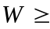25%, naxevrad mSrali 26-50% da teniani 50%-ze meti. SeSis sigrZe dadgenilia: 0,25; 0,33; 0,5; 0,75; sm. sasaTbobo SeSisTvis, sidamplis garda, araviTari manki ar aris SezRuduli. SeSis napobi rokebisgan gasufTavebuli unda iyos. daSvebulia miwodeba qerqiTac da uqerqod. SeSis wyobili marTkuTxedis formiT unda iyos, misi simaRle ki 1 m-is toli. daxarisxeba warmoebs sigrZisa da tenianobis mixedviT. 25%-ze meti tenianobis SeSis sawyobebSi Senaxvisas namati SeSrobaze simaRlis yovel 1 metrze 3 sm-ia. SeSis wyobis simkvrive iangariSeba iseve, rogorc mrgvali satyeo masalisa, oRond im gansxvavebiT, rom yovel torsze diagonals qerqianad zomaven.
SeSis raodenobas angariSoben m³-Si. DdaSvebulia haermSrali SeSis woniT aRricxva, wonis erTeulia tona.

8.8. qerqisgan damzadebuli sortimentebi

mravali jiSis merqnis qerqs didi praqtikuli gamoyeneba aqvs. igi gamoiyeneba rogorc mTrimlavi masala, sacobebisa da Tbosaizolacio filebis dasamzadeblad. qerqisa da naxerxis narevisagan mzaddeba samSeneblo filebi, didi gamoyeneba aqvs medicinaSic (qinaqinis xis qerqi) da sxva.
qerqi gankuTvnilia mTrimlavi eqstraqtebis dasamzadeblad da ganisazRvreba ara marto tanidebis, aramed netanidebis SemcvelobiTac. netanidebi wyalSi xsnadi nivTierebebia (Saqrebi, mRebavi nivTierebebi da sxva). mTrimlav masalaSi tanidebis raodenoba unda iyos aranakleb 50%-isa.
samrewvelo mniSvnelobis mTrimlavebs miekuTvneba muxis merqani, tirifis, naZvisa da lariqsis qerqi.
Mmuxis merqanSi tanidebis raodenoba asakTan erTad izrdeba, xolo qerqSi – mcirdeba. Semoclili qerqis zRvruli asaki muxisaTvis 40 welia, amitom muxis qerqis gamoyeneba am miznisaTvis standartiT ar aris gaTvaliswinebuli.
tirifis qerqis eqstraqti gamoiyeneba tyavis saTrimlavad da gankuTvnilia fexsacmlis zeda nawilisaTvis. misgan miiReba mTeli mTrimlavi nivTierebebis 70%. tanidebis raodenoba damokidebulia tirifis saxeobaze. yvelaze met tanidebs Seicaven nacrisferi, sammtvriani da Txis tirifi.
N
IX. safanere mrewvelobis produqcia

9.1. anaTali Sponi

miiReba faneraasaTlel Carxebze kotrebidan faneris aTliT. igi gankuTvnilia merqnis nakeTobaTa da Sewebili faneris mosapirkeTeblad. Llamazi teqsturis mqone merqnisagan damzadebuli masiuri nakeTobebi Zviria da mZime. Aamitom maT amzadeben farTod gavrcelebuli jiSebis merqnisagan (naZvi, fiWvi da sxva), xolo zemodan ki awebeben lamazi teqsturis mqone anaTal Spons. MmopirkeTebuli nakeToba xSirad ufro kargi Tvisebebis matarebelia, vidre masiuri merqnis nakeToba. garda amisa igi ufro msubuqia, iafi da formamedegi.
AanaTali Sponi mzaddeba Semdegi jiSis merqnisgan: foTlovanebidan _ wifeli, kakali, nekerCxali, Wadari, msxali, vaSli, aryi, muxa, ifani, TelamuSa, TuTa, wabli, akacia da sxva; 3. wiwvovanebidan – erTxmeli da lariqsi.
anaTali Sponis klasifikacia xdeba aTlis mimarTulebis mixedviT, romelic damokidebulia merqnis anatomiur aRnagobaze. lamaz teqsturas radialur Wrilze iZlevian: wifeli, nekerCxali, Tela.
Ddekoraciuli faneris dasamzadeblad gamoiyeneba aryis, muryanisa da cacxvis Sponi. Famzadeben I da II xarisxis faneras. Sponis tenianoba ar unda aRematebodes 10%-s.

9.2. anaTali SponiT mopirkeTebuli fanera

faneris am saxeobas ekuTvnis Sewebili fanera, romlis erTi an orive gare Sre anaTali Sponisgan aris damzadebuli. samosebis masalis mixedviT ganarCeven faneras calmxrivs, romelsac erTi mxridan dawebebuli aqvs anaTali Sponi, xolo meore mxridan ki – axdili Sponi, da ormxrivs – romelsac orive mxares dawebebuli aqvs anaTali Sponi. anaTali Sponis teqsturis mixedviT – radialur, naxevradradialur da tangentalur fanerad; samosebis zedapirebis damuSavebis mixedviT orive an cali mxridan gaxexil da gauxerxav fanerad. faneris tenianoba unda iyos 82%. maTSi dauSvebelia rokebi da qimiuri Seferilobani. Sponis zedapiris sisufTave unda iyos me-6-e an me-7-e klasis. aRricxvis, gazomvis, miRebisa da transportirebis meTodebi iseTivea, rogorc Cveulebrivi Sewebili fanerisa.
Sponis aRricxva xdeba kubursa da kvadratul metrebSi. Sponis furclebi daxarisxebuli unda iyos jiSis, xarisxisa da zomebis mixedviT – paketebad. Ppaketis wona 50 kg-mde unda iyos. pakets zemodan da qvemodan Semowyobili unda hqondes Sewebili faneris furclebi. Ggverdebidanac unda iyos daculi meqanikuri dazianebebisa da gaWuWyianebisgan. paketi mWidrod unda iyos Sekruli. yovel pakets unda hqondes niSandeba, romelic Seicavs Sponis mimwodeblis dasaxelebas, zomebs, jiSs, xarisxsa da standartis nomers.

X. kompoziciuri masalebi

10.1. Sewebili fanera

Pprogresuli ekonomiuri masalaa, romelic gamoiyeneba saaveje mrewvelobaSi, gemTmSeneblobaSi, vagonTmSeneblobaSi, avtomSeneblobaSi, radioteqnikur mrewvelobaSi, mSeneblobaSi da sxva. Ddaxerxil masalebTan SedarebiT mas Semdegi upiratesoba aqvs: Tanabari simtkice sxvadasxva mimarTulebiT, mcire dabreca da daskdoma, ar uCndeba gamWoli bzarebi, faneris furclebi didi zomisaa, rac amcirebs da aadvilebs muSaobas; advilad iRuneba, 1 m³ Sewebili fanera cvlis 3-4 m² daxerxil masalas. Ffaneris farTo gamoyeneba ganapirobebs faneris specialuri sxvadasxvaobis warmoebas. AaseTebia: dabakelitebuli, dekoratiuli fanera mopirkeTebuli anaTali SponiT, aryis fanera da faneris filebi.
Sewebili fanera Sesdgeba 3 an ufro meti axdili Sponis fenebisagan, romlebic erTmaneTTan dawebebulia boWkoebis urTierTperperdikularuli ganlagebiT. Sponis fenebis wyvili ricxvis SemTxvevaSi 2 Suafenas boWkoebis paraleluri mimarTuleba unda hqondeT. Ffaneris gareTa fenebs samosi ewodeba, SigniTa fenebs ki – guli.
Ffanera mzaddeba aryis, muryanis, ifanis, TelamuSis, muxis, wiflis, cacxvis, verxvis, fiWvis, naZvis, kedrisa da soWis merqnisagan. SponSi simetriulad ganlagebuli fenebi erTnairi jiSisa da sisqis unda iyos.Ffanera miekuTvneba im jiSs, romlisganac damzadebulia misi samosebi. ФСФ markis fanera dawebebulia fenolformaldegidis weboebiT, ФК markisa – karbamidis weboebiT, xolo ФВА markisa ki – alumin-kazeinis weboebiT.
samosis damuSavebis mixedviT fanera SeiZleba iyos gaxexili (moastamurebuli) erTi an ori mxridan da gauxexavi. faneris sigrZe ganisazRvreba samosis boWkoebis gaswvriv, sigane ki – boWkoebis ganivi mimarTulebiT. Aaryisa da muryanis faneris minimaluri sisqe 1,5 mm, sxva jiSebisa ki 3 mm. faneris sigrZea 1220; 1525; 1830; 2135 mm. es zomebi dadgenilia Sesawebebeli wnexebis filebis zomebis Sesabamisad.
faneris dasamzadeblad gamoiyeneba 5 xarisxis Sponi: A, AB, B, BB, C da 3 xarisxis guli: I, II da III. Mmerqnis xarisxisa da Sponis damuSavebis mixedviT mzaddeba 5 xarisxis fanera: 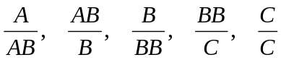 mrixvelSi mocemulia Sponis gareTa fenis piris xarisxi, mniSvnelSi ki amave fenis zurgis xarisxi.
ФСФ da ФК markebis fanrebis tenianoba 5-10% unda iyos. ФВА markisa ki 10-15%. saaveje mrewvelobisaTvis gamoyenebuli faneris tenianoba 6-10% unda iyos.
A xarisxis samosebSi dauSvebelia nawilobriv Cazrdili da Cauzrdeli rokebi da naxvretebi, romlebic darCenilia rokebis amovardnis Sedegad, yovelgvari Seferiloba, cru guli, deformaciebi da daskdoma, WianaWami, amonazardi, fisiani ubeebi..
C xarisxis samosebSi da faneris gulis yvela fenaSi daSvebulia sokovani Seferiloba, cru guli da laqianoba.
damuSavebis defeqtebs ekuTvnis: rokebisa da bzarebis CakeTeba, wiboze Sewebeba, webos gaJonva, naSuri, nakawrebi da sxv. samosebSi amovardnili rokebisgan darCenili naxvretebi aucileblad CakeTebuli unda iyvnen sagozaviT. faneris samosebis zedapiris sisufTave unda iyos – gauxerxavisa me-6, gaxexilisa ki – me-7 klasis.
faneris furclebi SemoWrili unda iyos marTi kuTxiT, Sewebeba-mWidro, ar unda hqondes haeris buStukebi.
faneris aRricxva, daxarisxeba da niSandeba iseve warmoebs, rogorc axali Sponis. faneris dastis wona ar unda aRematebodes 80 kg.

10.2. merqnis boWkos filebi

merqnis boWkos dawnexili da dauwnexavi filebi mzaddeba merqnis an sxva mcenareuli boWkoebisagan, romelTac aqvT specialuri Semadgenlobis danamatebi. isini gamoiyeneba rogorc mosapirkeTebeli an saizolacio masala iseT konstruqciebSi an sawarmoebSi, romlebic daculia tenisgan. saqme imaSia, rom mSral filebs haeridan wylis orTqlis SanTqmis unari aqvT, rac filebis deformacias iwvevs.
DdaniSnulebis mixedviT filebi mzaddeba Semdegi saxis: zemtkice, mtkice, naxevradmtkice, saizolacio–mosapirkeTebeli da saizolacio.
filebis dasamzadeblad gamoiyeneba sxvadasxva jiSis merqani. saizolacio mosapirkeTebeli filebi gamoiyenebian baTqaSis magier, agreTve parketisa da linoleumis qveS dasagebad. mtkice filebi gamoiyenebian kedlebis, Werebis, avtomobilebis, vagonebis, iatakebis da CaSenebuli avejis mosapirkeTeblad. zemtkice filebs iyeneben avejis konstruqciuli detalebis warmoebaSi panelebis dasamzadeblad, elteqnikaSi isini mzaddeba maRali wnevis qveS didi simZlavris wnexebSi. Ffilebi gamoiyeneba agreTve rogorc bgeriT da Tbosaizolacio masala. saizolacio filebis sisqe 12,5 mm.
silamazisTvis filebs cali mxridan Rebaven emalis saRebavebiT, rac saSualebas iZleva miviRoT TeTri, spilos Zvlis, beJi, cisferi, salaTisferi, mwvane da baci lurji feris filebi.

XI. specialuri warmoebis produqcia

11.1. merqnis burbuSelis filebi

mzaddeba merqnis burbuSelisa da Semkvreli nivTierebebis cxeli dawnexviT. maTi warmoebisaTvis amosaval nedleuls warmoadgens saxerxi da merqnis damamuSavebuli sawarmoebis narCenebi da agreTve saSeSe merqani. gamoiyeneba rogorc wiwvovani, aseve foTlovani jiSebi. merqnis burbuSel-filebi SedarebiT axali masalaa. mas bevri upiratesoba aqvs sxva masalebTan SedarebiT, kerZod: sxvadasxva mimarTulebiT Tvisebebis erTgvarovneba, cvladi tenianobisas zomebis ucvleloba, cecxlmedegoba, warmoebis avtomatizaciis saSualeba da misi maRali ekonomiuroba. igi Zvirfas masalas warmoadgens arqiteqturisaTvis da saaveje mrewvelobisaT-vis
teqnologiuri procesi Semdegi operaciebisagan Sesdgeba: 1) merqnis gaqerqva; 2) datenianeba 30-65%-mde; 3) merqnis daqucmaceba; 4) daqucmacebuli merqnis Sroba; 5) daqucmacebuli merqnis daxarisxeba; 6) Semkvrelis momzadeba; 7) daqucmacebuli merqnisa da Semkvrelis dozebis SerCeva; 8) maTi Sereva; 9) paketebis gaformeba; 10) paketebis winaswar SemWidroveba; 11) dawnexva; 12) filebis meqanikuri damuSaveba.
merqnis burbuSelis filebi iyofian brtyeli da eqstruziuli dawnexvis filebad. Ppirvel SemTxvevaSi burbuSela ganlagebulia filis fenobis paralelurad, meoreSi ki – perpendikularulad. brtyeli dawnexvis filebi konstruqciis mixedviT iyofian erTfenovan da samfenovan filebad, eqstruziuli dawnexvisa ki – mTlian da mravalsicarielebian filebad. moculobiTi wonis mixedviT filebi iyofian mZime (moculobiTi wona (0,66-0,80 gr/sm³), saSualo wonis (0,50-0,65 gr/sm³) da msubuq (0,35-0,50 gr/sm³) filebad.
eqstruziuli filebi mzaddeba anaTali da axdili SponiT, anaTali faneriTa an qaRaldiT mopirkeTebuli.
filebis sigrZea: 1525; 2000; 2500 da 3000 mm. sigane – 1250; 1500, 1750 mm, sisqe 10-25 mm-mde 3 mm gradaciiT, xolo 25-50 mm-mde 5 mm gradaciiT. fizikur-meqanikuri Tvisebebis mixedviT filebi 2 jgufis mzaddeba. A – gazrdili simtkiciT da B – normaluri simtkiciT. A jgufis filebisaTvis minimaluri simtkice statistikuri Runvisas aris 60km/sm², xolo B jgufisaTvis ki - 40 km/sm².
merqnis burbuSelis filebi 2 xarisxis mzaddeba. normirebulia: CaRrmavebebi, nakawrebi, qerqis Semcveloba, laqebi. sxva defeqtebi dauSvebelia.

11.2. merqanSreuli plastikebi

MmerqanSereuli plastikebi warmoadgenen Srovan masalas, romelic damzadebulia fenol - an krezolformaldehidis fisebiT gaJRenTili axdili Sponis furclebisagan, romlebic erTmaneTTan dawebebulia Termuli damuSavebis procesSi maRali wnevis gavleniT. plastikebis gamoyeneba Savi da feradi liTonebis ekonomiis saSualebas iZleva. plastikebis 1 t cvlis 3,3 t brinjaos. amave dros maTi gamZleoba 3,3-jer aRemateba brinajaos gamZleobas. igi gamoiyeneba gemTmSeneblobaSi, saavaiacio konstruqciebSi, eleqtroteqnikaSi da sxva.
plastikebis dasamzadeblad gamoiyeneba aryis, wiflisa da cacxvis axdili Sponi. 15 mm-ze naklebi sisqis mqone plastikebs Txelfurclovans uwodeben, meti sisqisas ki – sqelfurclovans. 1500 mm-ze meti sigrZisas – grZels, naklebi sigrZisas ki – mokles. filebis minimaluri da maqsimaluri zomebia: sigrZe 700 da 5600 mm, sigane 800 da 1200 mm, sisqe 1 da 60 mm.
plastikebis aRricxva woniT wamoebs 1 kg sizustiT.

11.3. sayuTe kompleqtebi

sayuTe kompleqtebisaTvis arsebobs standartebi, romlebSic dadgenilia yuTis daniSnuleba, merqnis jiSi, zomebi, damuSavebis saxe, xarisxi da tenianoba, awyobis saSualebebi da sxva.
sayuTe kompleqtebi mzaddeba wiwvovani da rbilfoTlovani jiSebisagan, agreTve aryisa da wiflisagan. yuTebi, romlebic gankuTvnilia iseTi produqtebisaTvis, romlebic advilad iTviseben suns (karaqi, margarini da sxva) mzaddeba mxolod naZvis, soWis, kedris, wiflis da verxvis merqnisagan. xolo yuTebi, romlebic gankuTvnilia arasakvebi produqtebisaTvis mzaddeba fiWvis merqnisagan, radgan naZvTan SedarebiT ufro maRali meqanikuri maCveneblebi aqvs.
SefuTuli saqonlis gafuWebis Tavidan asacileblad yuTebi unda iyos mSrali, Tanac aSroben namzadebs da ara mza detalebs.
tenianoba unda iyos 18-25%-mde.
daniSnulebis mixedviT yuTebi SeiZleba iyos badiseburi – bostneulis SesafuTad an mkvrivi – Saqris SesafuTad da sxva.

sarCevi

gv.
Sesavali -------------------------------------------------------------------------------------------------------------- 2
Tavi I. merqnis aRnagoba ---------------------------------------------------------------------------------- 4
1.1. mozardi xis nawilebi -------------------------------------------------------------------------- 4
1.2. xis tanis mTavari Wrilebi da nawilebi -------------------------------------------- 6
Tavi II. xis tanis makroskopuli aRnagoba ------------------------------------------------------ 7
2.1. guli, cila, mwife merqani ------------------------------------------------------------------- 7
2.2. wliuri Sreebi, adreula da gviana merqani --------------------------------------- 8
2.3. gulgulis sxivebi ------------------------------------------------------------------------------- 10
2.4. WurWlebi ---------------------------------------------------------------------------------------------- 11
2.5. fisis savali milebi ---------------------------------------------------------------------------- 12
Tavi III. merqnis qimiuri Semadgenloba --------------------------------------------------------- 12
Tavi IV. merqnis fizikuri Tvisebebi ------------------------------------------------------------- 13
4.1. merqnis garegani saxe -------------------------------------------------------------------------- 13
4.2. merqnis tenianoba da misi gazomvis meTodebi ---------------------------------- 16
4.3. sorbcia da desorbcia ------------------------------------------------------------------------ 19
4.4. SeSroba da gajirjveba ----------------------------------------------------------------------- 21
4.5. merqnis simkvrive ---------------------------------------------------------------------------------- 23
Tavi V. merqnis meqanikuri Tvisebebi -------------------------------------------------------------- 25
5.1. zogadi cnebebi ------------------------------------------------------------------------------------- 25
5.2. merqnis meqanikuri gamocdebis Taviseburebebi --------------------------------- 26
5.3. gamocdis procedura da gamosacdeli danadgari ---------------------------- 26
5.4. merqnis simtkice gaWimvaze ----------------------------------------------------------------- 28
5.5 merqnis simtkice kumSvaze ------------------------------------------------------------------ 30
5.6. merqnis simtkice statikuri Runvaze ------------------------------------------------- 32
5.7. merqnis sisale ------------------------------------------------------------------------------------- 33
5.8. dartymiTi siblante ---------------------------------------------------------------------------- 34
5.9. merqnis winaRoba cveTisadmi -------------------------------------------------------------- 35
5.10. merqnis unari daimagros liTonis samagrebi --------------------------------- 36
Tavi 6. merqnis mankebi. zogadi cnebebi ---------------------------------------------------------- 37
6.1. rokebi --------------------------------------------------------------------------------------------------- 37
6.2. bzarebi -------------------------------------------------------------------------------------------------- 39
6.3. xis tanis formis mankebi -------------------------------------------------------------------- 42
6.4. merqnis aRnagobis mankebi ------------------------------------------------------------------- 44
6.5. qimiuri Seferilobebi ------------------------------------------------------------------------- 49
6.6. sokovani daavadebebi -------------------------------------------------------------------------- 50
6.7. biologiuri dazianebebi --------------------------------------------------------------------- 53
6.8. aranormaluri dagrovebani merqanSi, meqanikuri dazianebebi da
damuSavebis defeqtebi ------------------------------------------------------------------------ 54
6.9. dabreciloba ---------------------------------------------------------------------------------------- 55
Tavi VII. satyeo saqonelmcodneobis safuZvlebi ---------------------------------------- 55
7.1. satyeo saqonlis klasifikacia --------------------------------------------------------- 55
7.2. daxerxili produqcia ------------------------------------------------------------------------- 57
7.3. daxerxili masalebi --------------------------------------------------------------------------- 57
xe-tyis damamzadebeli mrewvelobis produqcia-------------------------------- 59
8.1. mrgvali satyeo masalis sortimentebi ---------------------------------------------- 59
8.2. mrgvali saxiT gamoyenebuli satyeo masala.------------------------------------- 59
8.3. garanduli daxerxili masalebi da maTi klasifikacia ----------------- 60
8.4. mrgvali satyeo masalis markireba ---------------------------------------------------
8.5. musikaluri instrumentebisaTvis gankuTvnili sarezonanso . namzadebi------------------------------------------------------------------------------------------------
8.6. Sponis asaxdelad gankuTvnili nedleuli-----------------------------------------
8.7. sasaTbobo SeSa--------------------------------------------------------------------------------------
8.8. qerqisagan damzadebuli sortimentebi-------------------------------------------------
safanere warmoebis produqcia ------------------------------------------------------------
9.1. anaTali Sponi ---------------------------------------------------------------------------------------
9.2. anaTali SponiT mopirkeTebuli fanera ---------------------------------------------
kompoziciuri masalebi-----------------------------------------------------------------------
10.1. Sewebili fanera ----------------------------------------------------------------------------------
10.2. merqnis boWkos filebi ----------------------------------------------------------------------
specialuri warmoebis produqcia------------------------------------------------------
11.1. merqnis burbuSelis filebi---------------------------------------------------------------
11.2. merqanSreuli plastikebi------------------------------------------------------------------
11.3. sayuTe kompleqtebi --------------------------------------------------------------------------

