**სალექციო კურსი**

**ბრენდის ტექნოლოგია**

saqarTvelos teqnikuri universiteti

ავტორი . profesori mariam xomasuriZe

2012 weli

**სარჩევი**

**კონიკის და ბრენდის წარმოების ისტორიული მიმოხილვა**

**qarTuli koniakebi**

**Rvinomasalis Sedgenilobis gavlena sabrende spirtis xarisxze**

**alkoholuri duRilis qimizmi**

**sabrede spirti da misi qimiuri Semadgenloba**

**brendis klasifikacia da regulacia saqarTveloSi moqmedi kanomdeblobis Sesabamisad**.

**Rvinis sabrede spirtad gamoxdisas mimdiare fizikur qimiuri procesebi**

**gamoxdis Teoriuli safuZvlebi**

**spirtsaxdeli aparatebi**

**axalgamoxdili sabrende spirtis kondicia da zogierT nivTierebaTa warmoqmna.**

**sabrende spirtebis Sesanaxi tara da Senoba**

**sabrende spirtis daZveleba**

**sabrende spirtis buketis ganviTarebis etapebi**

**brendis momzadeba**

**brendis mdgradobis uzrunvelyofa**

**da gamoyenebuli masalebi**

**gamwebavi nivTierebebi**

**generaluri kupaJis Sedgena**

**brendis Camosxma**

**Sesavali**

daaxloebiT 260 wlis winaT safrangeTis departament SarantSi, koniakis midamoebSi, damzadebuli iqna maRalalkoholiani originaluri gemuri Tvisebebis mqone sasmeli, romelsac qalaqis pativsacemad koniaki Searqves.

koniakis ZiriTad Semadgenel nawils yurZnis Rvinis distilati, e. w. koniakis spirti warmoadgens, romelic muxis kasrebSi Semdgomi daZvelebisas ganicdis sasargeblo qimiur da specifikur damaxasiaTebel mimzidvel gemur Tvisebebs iviTarebs.

XVII saukunidan safrangeTis Sarantis departamentis erT-erT raionSi, romlis centrc qalaqi koniakia, franguli aryis damzadeba da eqsporti farTod ganvirTarda. 1701 wels daiwyo safrangeT-inglisis omi da 13 wels gagrZelda. am xnis ganmavlobaSi safrangeTs ar qonda saSualeba gasuliyo zRvaze da gaetana Rvinis arayi. mwarmoeblebi iZulebulni iyvnen SeenaxaT igi muxis kasriT. 13 wlis Semdeg gasayidad gatanili arayi Zalian moiwones momxmareblebma. SemCneuli iyo, rom muxis kasrebSi ESenaxuli Rvinis arayi siZveleSi Rebulobda sasiamovno sunsa da gemos, qarvis fersa da organoeptikuri TvisebebiT didad gansxvavdebida, rogorc marcveul kulturebidan miRebul aryisagan, ise axlad gamoxdili Rvinis aryisagan.

SarantSi Rvinis spirtad gamoxdis aucilebloba Semdegma garemoebam ganapiroba: cnobilia, rom am periodSi safrangeTis erT-erTi saeqsporto sagani Rvino iyo; igi md. SarantiT igzavneboda inglissa da skandinaviis qveynebSi; Rvinis transporti Tavis mxriv dakavSirebuli iyo did xarjebTan, rac garkveul ekonomikur siZneleebs qmnida. amasTanave, SeniSnul iqna, rom Sarantis midamoebis mciresxeuliani, msubuqi, dabalalkoholiani da SedarebiT maRalmJaviani Rvinoebi Sor manZilze transports ver itandnen da avaddebodnen; amiT mcirdeboda maTi gemuri Tvisebebi da izrdeboda Seuferxebeli realizaciis saSiSroeba.

aRniSnuli uaryofiTi mxareebis asacileblad daibada azri Rvinis gamoxdis Sesaxeb da mis nacvlad, rogorc saeqsporto sagani, mwyobrSi Camdgariyo maRalalkoholiani distilati. amiT mniSvnelovnad mcirdeba satransporto WurWlis odenoba, Tanmdevi xarjebi da rac mTavaria, gansxvavebiT Rvinisa, misgan miRebuli distilati transportabelurobis didi unariT gamoirCeoda. Sor manZilze xangrZlivi transportirebisas daavadebis nacvlad mosalodneli iyo misi gemuri Tvisebebis gaumjobeseba. amdenad, safrangeTSi farTod da dRiTidRe viTardeba da dRiTi dRe ixveweba Rvinis distilaciis procesi. Rvinis nacvlad misi distilatis eqsporti ki masobriv xasiaTs iZens da ganviTarebis maRal safexuramde adis_ gasakuTrebiT XVII sukuneSi. am periodSi safrangeTi _ sakmaod aRiarebuli klasikuri meRvineobis erT-erTi qveyana _ cnobili gaxda agraTve Rvinis distilatiT, romlis mimarT ucxoeTi garkveul dainteresebasa moTxovnilebas iCenda.

safrangeTis mTavrobis 1909 wlis 1 maisis sekretiT aikrZala sxva olqebis aryisTvisac mieniWebinad “koniakis’’ saxelwodeba, im SemTxvevaSic ki Tu is damzadebuli iqneboda imave teqnologiiT, rogoriTac mas koniakis raionSi amzadeben. safrangeTSi dResac sxva olqebis aryebi romlebic koniakis teqnologiiT miiReba “armaniakis’’ an sxva saxelwodebiT gamodis.

maRalxarisxiani sabrende spirits misaRebad vazis jiSebis SerCeva, Rvino masalis miRebis wesi, spirtsaxdeli aparatebis SerCeva da Rvino masalis gamoxda da sabrende spirits zomierad gamdidreba minarevebiT, axali spirits daZveleba muxis kasrebSi da optimaluri pirobebis ukeTesi buketis CamoyalibebisTvis, TviT brendis kupaJi da swori teqnologiuri procesebi naturaluri brendis xarisxs apirobebs.

koniakis klasikur teqnologiaSi gasnsakuTrebiT aRiniSneba:

1. gogirdovani anhidridis akrZalva
2. Rvinomasalis gamoxda mxolod spilenZis qvabSi-alambikSi, romlis moculoba ar unda aRematebodes 85 dals
3. Rvinomasalis orjeradi gamoxda da aqedan meored gamoxdisas fraqciebad dayofa, Tavi da bolo naxadis moSoreba da Sua fraqciis sakoniake spirtad daZveleba
4. daZveleba unda warmoebdes SedarebiT patara moculobis 30-40 dalian muxis kasrebSi, romlebic damzadebuia limuzinis an tronkais muxis jiSisagan.
5. maRalgradusiani spirtis koniakis kondiciamde dayvana unda xdebodes daZvelebis periodSi safexurebiani ganzavebiT, gamoxdili wylis damatebiT
6. ordinaluri koniakebisaTvis sakoniake spirtis daZveleba warmoebdes: 3 varskvlavianisTvis 4-5 weli; 4 varskvlavianisTvis 5-6 weli; 5 varskvlavianisaTvis 7-8 weli. samarko koniakis daZvelebis xangrZlioba ganisazRvreba markis mixedviT.

qarTuli ordinaluri koniakis pirveli Camosxma d. sarajiSvilma ganaxorciela 1891 wels. am wels man Camoasxa 167100 boTli. msi yovelwliuli Camosxma izrdeboda da 1920 wlisaTvis miaRwia 220000 boTls.

**qarTuli koniakebi**

koniaki “**varcixe**” Tbilisis koniakis qarxanam pirvelad Camoasxa 1954 wels. 6-7 wliT daZvelebuli sakoniake spirtidan, Rvinomasala miiReba baRdadis (dimi) da varcixis mikroraionebidan. koniaks aqvs simagre 420, Saqari 1.2%, damaxasiaTebeli oqros feriT, koniaks aaqvs rbili harmoniuli gemo.

“**gremi**” 1961 wels gamouSves, am koniakis kupaJSi Sedis aRmosavleT saqarTvelodan gurjaanisa da yvarlis dasavleT saqarTvelodan saCxeris raionis 8-10 wliani spirtebi. koniaks aaqvs qarvis feri, rbili harmoniuli gemo, yvavilovani aromati, misi simagrea 430, Saqari 0.7%.

“**eniseli**” 1946 wels Tbilisis koniakis qarxanam pirvelad Camoasxa Sildisa da eniselis mikroraionebis 12-14 wlis spirtisagan koniaki “eniseli”. koniakis simagrea 430, Saqari 0.7%. am koniakisaTvis damaxasiaTebelia qarvis feri, nazi buketi, yvavilovani elferi.

“**Tbilisi**” q. Tbilisis daarsebidan 1500 wlis TavTan dakavSirebiT 1958 wels Tbilisis koniakis qarxanam pirvelad Camoasxa koniaki “Tbilisi”. igi mzaddeba 14-17 wlis spirtisagan, kupaJSi Sedis: Sildis spirti _ 20%, gurjaanis _ 10%, yvarlis _ 70%. koniakis simagre 430. damatebuli aqvs Saqari 0.7%, misTvis damaxasiaTebelia muqi qarvis feri, nazi kargad ganviTarebuli buketi, vanilis toni, xaverdovani, harmoniuli gemo.

“**varZia**” pirvelad 1966 wels Camoisxa, SoTa rusTavelis dabadebidan 800 wlisTavTan dakavSirebiT. kupaJSi Sevida: Sildis 1932 wlis spirti 25%, yvarlis 1941 wlis spirti 50% da winandlis 1951 wlis spirti 25%-s raodenobiT, im varaudiT rom saerTo saSualo wlovaneba yofiliyo 25 weli. koniaks aqvs oqros feri, kargad ganviTarebuli oqros feri, sruli sxeuliT, rbili harmoniuli gemoTi, simagre aqvs 430 da Saqari 0.7%.

**sakoniake da sabrende spirtisaTvis gankuTvnili yurZnis jiSebi da** **Rvinomasalebi brendis warmoebisaTvis**

**suraTi 1. Ugni Blanc**

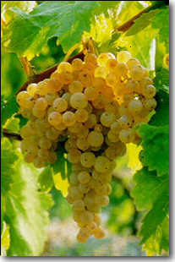  1936 wlis 5 maisis kanoni adgilwarmoSobis dasaxelebis kontrolis kanonmdeblobis Sesabamisad, safrangeTSi gansazRvravs sakoniake Rvinomasalias jiSebs, ZiriTad jiSebad miRebulia: ugni blaki, kolumbari da fol_blanSi. Ggarda am sami jiSis kanonmdebloba iTvaliswinebs sabrede Rvinomasalad blan_ramis, murankonblanis, montelis, lemilionis da savinionis gamoyenebas. mgavsad Rvinisa koniaki warmoeba gansakuTrebul moTxovnebs uyenebs vazis jiSebs. koniakis warmoeba aseT jiSebad aRiara TeTryurZniani saRvine vazis jiSebi, romlebic iZlevian SedarebiT maRalmJavian da dabalakoholian Rvinomasalebs. aseTi kondiciis mqone Rvinomasalebis gamoxdisas warmoiSveba rigi nivTierebisa, romlebic aqtiurad monawileoben koniakis spirtisa da TviT mza koniakis buketis Camoyalbebis saqmeSi.

Sedgomma gamokvlevebma cxadyo, rom aramarto Rvinomasalebis mJavianoba da alkoholianoba wyvets ZiriTadad misgan miRebuli koniakis spirtis xarisxs aramed, yurZnis aromatuli nivTierebanic, romelTa nawilic gadadis RvinomasalebSi, misi gamoxdiT _ distilatSi, aqedan ki bolo produktSi _ brendSi, riTac Zlierdema misi buketi, yovelmxriv mimzidveli da originaluri xdeba igi.

bredis warmoebisaTvis araperspeqtiulia wiTelyurZniani vazis jiSebi, saqarTvelosTvis gasaTvaliswinebelia is faqtori, rom sabrende spirtis misaRebad ar SeiZleba gamoyenebuli iqnes Rvinomasalebi damzadebuli kaxuri wesiT.

saqarTvelos vazis standartuli jiSebidan brendis warmoebisaTvis gamosadeg jiSad iTvleba rqawiTeli, goruli mwane, Cinuri, colikouri, cocqa, kaxuri mwvane.

rqawiTeli adgilobrivi vazis jiSia, d.tabiZis monacemebiT es jiSi unda warmoSobiliyo yvarel-eniselis, lagodexisa da qvemo mxaris pirobebSi javaxiSvilis azriT rqawiTeli warmoSobili unda iyos I-V saukuneSi C.w. aRricxvamde. rqawiTeli yeve-laze meti raodenobiT gavrcelebulia kexeTSi (77.4%)

rqawiTeli warmoadgens vazis unversalur jiSs yurZnis yvela produqcis misaRebad, is saukeTeso masalas iZleva kaxuri da evropuli sufris RvinoebisTvis, Semagrebuli sadeserto RvinoebisTvis, yurZnis Rvinomasalis qimiur Sedgeniloba kaxeTis pirobebSi zRvrebSi meryeobs: simagre 9,60-13,060; eqstraqti 16,3-20,0 %; titruli mJavianoba 5,0-815%, glicerini 4,5-8,0%. am jiSidan miRebuli sabrende spirtebi iyo metad nazi maRalxarisxovani aromatiT siZveleSi siZveleSi inviTareben sasiamovno gemo da nazi buketi.

kaxuri mwvane kaxeTis standartuli vazis JiSia, iZleva maRalxarisxovan evropul da kaxur mSral TeTris sufris Rvinos. Mmwvane ufro Zveli jiSi unda iyos vidre rqawiTeli. mwvanes Rvinis simagre meryeobs 9,4-13,20 mde. titruli mJavianoba 4-5,8% mde. evropulSi titruli mJavianoba 4,5-8,7% mde. glicerini -3,3-8,6%mde.

vazis yvela jiSi da mevenaxeobis yvela raioni ar iZleva Sesaferis masalas brendis warmoebisaTvis. am TvalsazrisiT naklebi perspeqtiva aqvT mkveTrad gamoxatuli jiSuri aromatis mqone (izabela, muskatebi da sxva) da wiTelyurZnian (saferavi, kaberne da sxva) vazis jiSebs.

brendis armoebisaTvis maRalxarisxovan Rvinomasalebs iZlevian: rqawiTeli, cicqa, colikouri, goruli mwvane, Cinuri, pino. maTgan miRebuli spirtebi sawyisidanve maRali gemovnebiTi TvisebebiT xasiaTdebian da saimedo masalebs warmoadgenen maRalxarisxiani brendebisTvis.

Rvinomasalebi unda iyos sruliad jansaRi, gareSe sunisa, gemosagan Tavisufali. avadmyofi Rvinoebis gamoxda sabrende spirtad dauSvebelia.

Rvinomasalebs unda axasiaTebdes SedarebiT maRali mJavianoba (7_9%) da dabali alkoholianoba (8_10%). minimumamde unda iqnas dayvanili Saqris da gogirdovani mJavebis raodenoba sabrende RvinoSi. vinaidan pirveli iwvevs gamoxdis dros saqris karamelizacias, xolo meore warmoSobs merkaptanis rigis naxSirwyalbads, romelic cudad moqmedebs brendis spirtis xarisxze. Aaseve uaryofiTad moqmedebs kaxuri wesiT damzadebuli Rvinoebis gadamuSaveba, vinaidan kaxur RvinoSi didi raodenobiT aris peqtini, romelic ferment peqtazas saSualebiT warmoSobs meTilis spirts da amdidrebs produqts am ukanaskneliT. Ees azri vrceldeba mxolod ordinalur brendebze, siZveleSi ki meTilis spiriti iJangeba da damaxasiaTebeli gemo da suni ikargeba. Bbrendis Rvinomasalis dasayeneblad rTveli unda Catardes maSin, roca yurZnis Saqrianoba miaRwevs 17_18%, xolo mJavianoba 8_10% iqneba. daxarisxebuli da gadarCeuli yurZeni tardeba saWyl;et manqanaSi. TviTnadeni da wnexis pirveli da meore praqciis wveni iwmindeba 12_16 saaTis ganmavlobaSi, gadaaqvT saduRar WurWelSi, sadac mimdinareobs duRilis kontroli da yvela im saSualebis gamoyeneba, romlebic gaTvaliswinebulia maRalxarisxovani evropuli wesiT damzadebuli Rvinis warmoebis instruqciiT. duRilis damTavrebis Semdeg xdeba maTi organoleptikuri Semowmeba, egalizireba. alkoholis, simJavis, gogirdis, Saqris gansazRvra da vargisad cnobili Rvinomasalebi igzavneba brendis spirtsaxdel qarxanaSi gamosaxdelad.

**Rvinomasalis Sedgenilobis gavlena sabrende spirtis xarisxze**

Rvinomasala erT_erTi mniSvnelovani obieqtia xarisxiani brendis misaRebad. Uvargisi an daavadebuli Rvinidan sabrende spiriti ar miiReba. sabrende Rvinomasala imdenad specipikuria, rom kargi xarisxis sufris Rvinidan SeiZleba mxolod saSualo xarisxis sabrende spirtis miReba, maSin rodesac kargi xarisxis sabrende Rvinomasalidan Rebuloben metad uxeS, saSualo xarisxis sufris Rvinos.

sabrende Rvinomasalis Rirsebaze gavlenas axdens is bunebriv_klimaturi pirobebi da agroteqnikuri RonisZiebebi romlebSic ganviTarda da momwifda yurZeni. Aamave dros nayofi ar warmoadgens mxolod mimdinare wlis gareSe faqtorebisa da agroteqnikur RonisZiebaTa gavlenis produqts, masSi asaxulia rogorc vazis jiSuri Tvisebebi, ise wina wlebis bunebriv_klimaturi pirobebi da agroteqnikur RonisZiebaTa gavlenis Sedegebi, gareSe faqtorebi, adgilobrivi pirobebis mixedviT sxvadasxva gavlenas axdens sabrende Rvinomasalis xarisxze.

B brendis nazi buketis miRebas xels uwyobs kiriani niadagebi. rac ufro metadaa niadagSi karbonatuli SenaerTebi, miT ufro nazia brendis buketi, amitom sabrende Rvinomasalis momcemi Rvinomasalis momcemi vazis gaSenebas urCeven kirian qveniadagebze, sadac 20_30sm qvemoT. Nniadags Warbi kiriani karbonatuli fena eqneba, SedarebiT naklebad naz armaniakis tipis brendebs iRleva silnar_Tixnari niadagebi, romlebSic mcireodeni kiria. kargi buketis mqone brendis misaRebad dadebiT rols asrulebs zRvis sanapiro hava, Tbili msubuqi zamTriT, sadac temperatura -4,-8-s da iSviaTad 15gradusze dabla ar ecema.

A azotovan nivTierebaTa Setana normaluri ulufiT aumjobesebs Rvinis xarisxs.misi siWarbe ki amcirebs rogorc aromats, ise fers, amdidrebs Rvinos azotiT da iwvevs Rvinis simRvrives. AazotiTa da kaliumiT Warbad gamokvebilma vazma iseTi Rvinomasala mogvca, romlis sabrende spirtic Seicavda zedmet aldehidebs, acetalebs, umaRles alkoholebs da furfurols,vidre sakontrolo. Mxolod kaliumiT gamokvebam ki zemoxsenebul elementTan erTad gazarda sabrende spirtSi saSualo eTerebic.fosforian niadagebze moweul yurZensa da Rvinos aqvs nazi aromati, sasiamovno xilis gemoTi. kaliumi aumjobesebs Rvinis gemosa da fers,misi siWarbe ki iwvevs RvinoSi Rvinis qvis gamoleqvas da amiT mJavianobis Semcirebas.zedmetad danakelebul niadagebze mosul yurZens aqvs Semcirebuli Saqari,orjer mcire aromati, susti Seferva, ris gamoc Rvino degustaciaze Rebulobs nakleb Sefasebas. vazis yvela jiSi,maSinac ki rodesac isini kultivirebulia erTsa da imave agroklimatur pirobebSi,ar iZleva erTnairi xarisxis sabrende Rvinomasalas. amitom sabrende Rvinomasalis misaRebad arCeven specialur jiSebs.

safrangeTis kanonmdeblobiT sakoniake spirti miRebuli unda iyos mxolod TeTri yurZnis jiSidan, dabalSaqriani da maRalmJaviani mosavliT.

Saqris maRali koncentracia tkbilSi uaryofiTad moqmedebs sabrende spirtis xarisxze, radgan iseTi ori Rvinis masalidan, romlebsac erTi da igive aqroladi aromatuli nivTierebani aqvs, xolo sxvadasxva koncentraciis spirts Seicavs, dabalalkoholian Rvinomasalidan miiReba uwylo spirtze gadaangariSebiT ufro meti minarevebi, vidre maRalalkoholiani Rvinidan. Aamave dros maRalmJaviani Rvinomasalebi gamoxdis dros sabrende spirts matebs met rTul eTerebs.dabalmJaviani Rvinoebi ki sabrende spirtisaTvis uvargisia.

Rvino fol_blanSi saukeTeso sabrende Rvinomasalaa, roca misi simagre 7_8 gradusia, titruli mJavebi 12%; imave raionSi miRebuli fol_blanSi, maRali alkoholiTa da dabali mJavebiT maRali xarisxis sabrende spirts ar iZleva.

safrangeTis saukeTeso sakoniake spirtis Rvinomasalis simagre meryeobs 7,7_10 gradusamde, titruli mJavianoba 7_8%mde, eqstraqti 12_18%mde.

brendis warmoebis teqnikuri wesebis mixedviT, sabrende Rvinomasala unda akmayofilebdes Semdeg moTxovnebs: Rvinomasala unda iyos saRi; aromatic da gemo_sufTa, jiSisaTvis damaxasiaTebeli (ar unda hqondes gareSe suni da gemo), gamWvirvaloba_dawmendili an mcired SemRvreuli safuvris dedosagan; simagre 7_12 gradusi; titruli mJavebi aranakleb 4,5%; mqrolavi mJavebi araumetes 1,5%; safuvris leqi 1%mde; gogirdovani mJava araumetes 20mg/l_ze.

**alkoholuri duRilis qimizmi**

alkoholuri duRilis bioqimiuri procesebis Sedegad yurZnis tkbili iqceva Rvinod. es procesi martivad Semdegnairad warmogvidgeba: Saqari (glukoza) **C**6H12O6 duRilis Sualedi produqtebi: duRili (2 C2H5OH + 2 CO2) , sunTqva (6CO2 + 6H2O)

Rvinis alkoholuri duRili aris egzoTermuli procesi. Saqris daSlis Sedegad gamoyofili siTbo safuars energias matebs. 1 molekula (180 grami) Saqris wvis dros (aerobuli sunTqva) gamoyofs 174 kkal siTbos, igive Saqari safuvrebis moqmedebiT aTavisuflebs mxolod 28kkal siTbos, danarCeni spirtSi rCeba, rac wvis dros gamoiyofa. maSasadame sunTqvis dros 24_jer meti siTbo Tavisufldeba, vidre duRilis dros, energiis kompensaciis mizniT, safuvrebi 24_jer met Saqars Slis, riTac yurZnis tkbili Rvinad iqceva. maSasadame, Saqris daSlas duRilis mimarTulebiT anviTareben garkveuli safuvrebi, romlebic mxolod xelSemwyob pirobebSi momqmedeben da Slian ra Saqars spirtad da CO2_rad  kargaven cxovelmoqmedebas da midian leqSi dabla.

rogorc zemoTaa aRniSnuli Saqris daSlisas warmoiSvebian Sualeduri produqtebi. Tanamedrove Teoria alkoholuri duRilisa aseTia: safuvris fermentTa kompleqsSi Semavali enzini esTeraza xels uwyobs heqsozebis fosformJava eTerebis warmoqmnas :

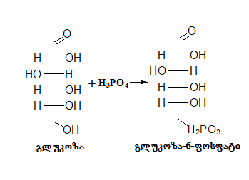

Semdeg glukoza – 6 – fosfati gadadis fruqtoza – 6 – fosfatSi:

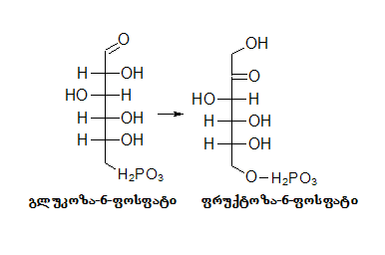

mesame fazaSi miRebuli heqsozis fosforileba grZeldeba da vgebulobT fruqtoza difosfats:

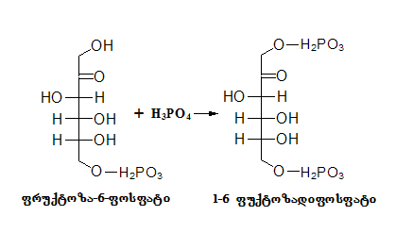

meoTxe fazaSi miRebuli fruqtoza difosfati iSleba fosfo diqsiacetonad da fosforglicerinaldehidad:

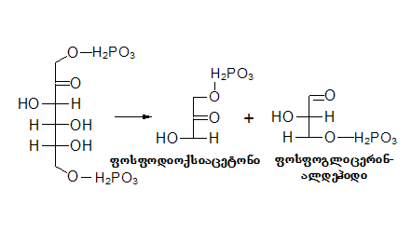

miRebuli fosfodioqsiacetoni da fosforglicerin aldehidi warmoSobs difosforglicerinmJavas.

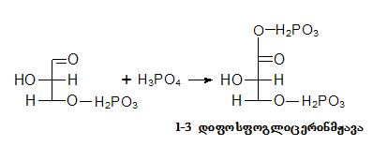

meeqvse da meSvide fazaSi xdeba miRebuli difosforglicerin mJavis fosforglicerin mJavad gadaqceva. merve fazaSi miRebuli fosforglicerin mJava ferment enolazas moqmedebiT gadadis piroyurZen mJavaSi :

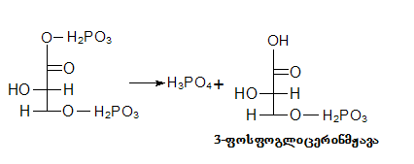

mecxre fazaSi enzimakarboqsilaza piroyurZen mJavas gardaqmnis Zmris aldehidad da naxSirorJangad. jer merve fazaSi migebul glicerin mJavas wylis warTmeviT xdeba piroyurZen mJavaSi gadasvla:

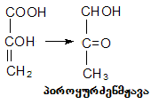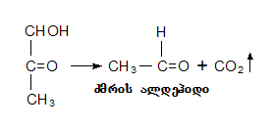

meaTe fazaSi ki xdeba miRebuli aldehidis aRdgena spirtad, risTvisac gamoiyeneba mexuTe fazaSi gamoyofili wyalbadi:

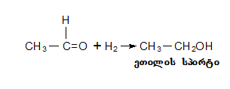

alkoholuri duRilis Sedegad RinoSi warmoiSvebian agreTve Tanauri produqtebi: glicerini, mJavebi, umaglesi spirtebi. amaTgan mniSvnelovania ZmarmJavas warmoqmnis sakiTxi, vinaidan misi arseboba RvinoSi Zalian SezRudulia instruqciiT. RvinoSi ZmarmJavis warmoSobis Semdegi gzebi arsebobs

1 . 2C6H12O6 + H2O 🡪 2C3H5(OH)3 + CH3COOH + C2H5OH + 2CO2

2. Zmaraldehidis daJangviT:

CH3COH + 0,5O2 🡪 CH3COOH

1. spirtis daJangviT:

H3CH2OH + O2 🡪 CH3COOH + H2O

1. rZemJava daJangviT:

CH3CH(OH)-COOH + O2 🡪 CH3COOH + CO2  + H2O

aRsaniSnavia, rom safuvrisaTvis Saqari warmoadgens sazrdos, magram es aris koncentraciis garkveuli raodenobisas. Tu Saqris koncentracia 30 %_ ze maRalia duRili wynardeba. amitom aris rom Saqris maRali procentis Semcvelobis produqtebi ar fuWdebian. Rvinis safuvrebi mJave ares ukeT umklavdeba, vidre obi da baqteria, amitom mJave areSi (8\10) duRili ukeT mimdinareobs.

**sabrede spirti da misi qimiuri Semadgenloba**

brendis da sabrende spirtis qimiuri Sedgeniloba sakmaod cvalebadia. es cvalebadoba didad aris damokidebuli rogorc gamoxdis meTodze, ise gamosaxdeli Rvinis qimiur Semadgenlobaze. Rvinis Semadgeneli komponentebidan zogi duRs ufro dabal tempereturaze, vidre wyali da amitom naxadSi pirvel rigSi gadadis, zogierTi duRs SedarebiT maRal tempereturaze, magram advilad misdevs spirt-wylian orTqls naxadSi, zogic naxadSi uSualod ar gadadis, magram gamoxdis procesSi gardaiqmneba an daiSleba, daSlis produqti misdevs naxads da amiT gavlenas axdens sabrende spirtis xarisxze.

Rvinis gamoxdis procesSi naxadSi SeiZleba metnaklebad gadavides Rvinis Semdegi komponentebi: glicerini, meTilis spirti, eTilis spirti; umaRlesi alkoholebidan: amilis, izobutilis, propilis, heqsilis da heptilis spirtebi; dasaxelebuli spirtebis Sesabamisi mJavebi, maTi eTerebi, furfuroli, aldehidebi. gamoxdis dros zogierTi elementi (eTerebi, aldehidebi, furfuroli da sxv.) warmoiSoba da naxadSi gadadis. am komponentTa sidide damokidebulia Rvinomasalis Sedgenilobaze da gamoxdis reJimze. gamomxdelma es elementebi Rvinodan naxadSi zomierad unda gadaiyvanos da minarevebiT sakmaod mdidari sabrenede spirti mogvces. rogori srulyofilic ar unda iyos axlad gamoxdili spirti _ brendi ar miiReba, Tu is ramodenime wliT dayovnebuli ar iqna muxis kasrSi. daZvelebis periodSi spirti SeiZens eqstraqts da sxeuls, gazrdis eTerebs, mJavebs aldehidebs, acetals da sxva elementebs, ganiviTarebs bukets da gaaumjobesebs gemos.

brendis gemo da buketi didad aris damokidebuli Semadgenel komponentTa sidideze da maT urTierT Sefardebaze.

**sabrende spirtebisadmi wayenebuli moTxovnebi:**

1. sabrende spirtebi iyofa nedl spirtebad, romlebic ar imyofebodnen kontaqtSi muxis merqanTan da daZvelebuli, romelic daZvelebis periodSi imyofeboda muxis tkeCTan kontaqtSi. suraT 2 ze naCveebia sabrede spirtis feris cvalebadoba daZvelebis sxvadasxva etapebze:

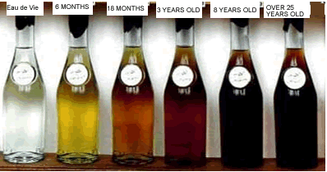

1. nedl sabrende spirts Rebuloben sakoniake Rvinomasalis fraqciuli gamoxdiT.
2. daZvelebul sabrende spirts Rebuloben nedli spirtis daZvelebiT muxis kasrebSi, an emalis rezervuarebSi romlebSic moTavsebulia muxis tkeCebi.

**cxrili 1 sabrende spirtis organoleptikuri maCveneblebi**

|  |  |  |
| --- | --- | --- |
| maCveneblis dasaxeleba | sabrende spirtis maxasiaTeblebi | |
| nedli | daZvelebuli |
| feri | Uuferulidan Ria Calisframde | Calisferidan muq yavisframde |
| gamWvirvaleba | gamWvirvale, naleqis gareSe | |
| buketi(aromati) | rTuli, gamoxatuli Rvinis da msubuqi yvavilovani buketi | rTuli, msubuqi muxis Semadgeneli komponentebis tonebidan ufro kargad gamoxatuli yvavilovani, vanilis da Sokoladis tonebamde |
| gemo | sufTa, mwveli, eTilis spirtis msubuqi gemoTi | mwveli, muxis, spirtis gemodan rbil, harmoniul gemommde |
| SeniSvna: gemosa da aromatSi ar daiSveba mkveTri eTer-aldehidebis, ZmarmJavis, mimwvari, gogirdwyalbadis da da sxva ucxo tonebi. | | |

sabrende spirtebis qimiuri SemadgenlobiT unda pasuxobdnen Semdeg moTxovnebs**:**

**cxrili 2 sabrende spirtebisadmi wayenebuli moTxovnebi:**

|  |  |  |
| --- | --- | --- |
| maCveneblis dasaxeleba | Nnorma spirtisTvis | |
| nedli | daZvelebuli |
| eTilis spirtis moculobiTi wili %  umaRlesi spirtebis Semcveloba izoamilis spirtze gadaangariSebiT, mg/100sm3 uwylo spirtSi  aldehidebis Semcveloba ZmarmJavaaldehidze gadaangariSebiT, mg/100sm3 uwylo spirtSi  saSualo eTerebis Semcveloba ZmarmJavaeTileTerze gadaangariSebiT, mg/100sm3 uwylo spirtSi  aqroladi mJavebis Semcveloba ZmarmJavaze gadaangariSebiT, mg/100sm3 uwylo spirtSi  furfurolis Semcveloba, mg/100sm3 uwylo spirtSi, ara umetes  meTilis spirtis Semcveloba, g/dm3, ara umetes  spilenZis Semcveloba, mg/dm3, ara umetes  saerTo gogirdis dioqsidi, mg/dm3, ara umetes  rkinis Semcveloba, mg/dm3, ara umetes | 62.0-70.0  180-600  3-50  50-250  80  3.0  1.2  8.0  45  1.0 | 55.0-70.0  170-500  5-50  50-270  250  3.0  1.2  8.0  40  1.0 |

**brendis klasifikacia da regulacia saqarTveloSi moqmedi kanomdeblobis Sesabamisad**.

* sabrende Rvinis moculobiTi spirtSemcvleloba ar unda iyos 9,0%-ze naklebi, titruli mJavinoba 5g/l naklebi
* sabrende spirtSi aqroladi mJavebis Semcvleloba ar unda aRematebodes 0,8 g/l-s.
* sabrende spirtebis gamosaxdelad dasaSvebia mxolod sabrende Rvinis gamoyeneba.

xarisxis mixedviT dadgenilia Rvinis brendis da adgilwarmoSobis dasaxelbis Rvinis brendis Semdegi kategoriebi:

a) Rvinis brendi

b) Rvinis brendi Zveli

g) Rvinis brendi Zalian Zveli

d)Rvinis brendi sakoleqcio

Rvinis brendi mzaddeba mzadeba muxis kasrebSi, mominanqrebul avzSi Cawyobil, gauaqtivebul an gaaqtivibeul muxis tkeCebze da davargebuli sabrende spirtebisgan, kerZod:

a)Rvino brendi samwliani-arnakleb samwliani davrgebis sabrende spirtebisgan.

b)Rvinis brendi oTxwliani-arankleb oTxwliani davrgebis sabrende spirtebisgan.

g)Rvinis brendi xuTwliani-arnakleb xuT wliani davrgebis sabrende spirtebisgan.

Rvinis brendebs SeiZleba qondeT sakuTari dasaxelebebi. Ggvinis brendis etiketze aucileblad unda iyos miTiTebuli sabrende spirtis davargebis asaki. etiketze varsklevebis gamoyenebis SemTxvevaSi maTi raodenoba unda Sesabamebodes kupaJSi gamoyenebli sabrende spirtis davrgebis asaks. maRali xarsixis Rvinis brendi mzaddeba muxis kasrebSi, arnakleb eqvs wliani davrgebis sabrende spirtebisagan dam as unda hqondes sakuTari dasaxelba.

sabrende spirtis davrgebis asakis mixedviT dadgenilia umaRlesi xarisxis Rvinis brendi Semdegi jgufbi:

a)I jgufi-Zveli, romelic mzadeba 6-7 wliani davrgebis sabrende spirtisgan

b)II jgufi-Zveli, umaRlesi xarisxis, romelic mzaddeba 8-10 wliani davrgebis sabrende spirtebisgan.

g)III jgufi-Zveli, romelic mzadeba 10-20 wliani davrgebis spirtebisgan.

d)IV jgufi-Zalian Zveli, romelic mzadeba 20 da meti davrgebis sabrende spirtebisgan.

IV jgufis Rvinis brendis damzadebisas neba darTulia kupaJSi xuT-wliani davrgebis sabrende spirtis gamoyeneba ara umetes 10%-is odenobiT. II jgufis Rvinis brendis damzadebisas neba darTulia kupaJSi 6 wliani davrgebis sabrende spirtis gamoyeneba ara umets 10% odneobiT.

adgilwarmoSobis dasaxlebis Rvinis brends miekuTneba adgilwarmoSobis dasaxelebis Rvinis sabrende spirtebisagn damzadebuli umaRlesi xarisxis Rvinis brendi romlis asakia ara nakleb 6 weli.

sakoleqcio Rvinis brendaT iTvleba I, II, III da IV jgufis Rvinis brendebi, romlebic kupaJis Semdgomi dasvenebis Semdeg muxis kasrebSi gagrZelebs

**Rvinis sabrede spirtad gamoxdisas mimdiare fizikur qimiuri procesebi**

Rvinis gamoxda da misgan maRalxarisxovani naxadis miReba brendis warmoebaSi Zalian sapasuxismgeblo operaciad iTvleba. wyalalkoholiani xsnarebis gacxelebiT maduRari siTxidan gamoiyofa orTqli, romelic ufro mdidaria alkoholiT, vidre maduRari siTxe. duRilis dros maduRari siTxe Raribdeba alkoholiT da imatebs duRilis temperatura . maduRari siTxidan Sordeba alkoholis ukanaskneli niSnebic ufro adre vidre wylis ukanaskneli ulufa, warmoSobili orTqlis gaciebiT miiReba naxadi,romelic Seicavs gacilebiT met spirts, vidre Seicavda gamosaxdeli masa.

sabrende spirtis gamoxdisas sabrende spirti cota naklebi simagris miiReba, radgan Tavnaxadis simagre, romelic mocilda sabrende spirts ufro maRalia, vidre sabrende spirtis simagre. koncentrirebuli spirtis misaRebad sakmarisi ar aris Rvinis erTxel gamoxda, saWiroa naxadis ganmeorebiTi gamoxda. Tu gamosaxdeli Rvinis simagre udris 11,3% pirveli naxadis simagre iqneba_ 32,3% (woniT); meore naxadis_55,0%; mesame naxadis_70,3%; meoTxe naxadis_78,5%; mexuTe naxadis_83,0%. Rvinis gamoxdis dros saqme gvaqvs ZiriTadad erTmaneTSi xsnad or komponentTan (wyali da eTilalkoholi), agreTve iseT komponentebTan romlebic marTalia sufTa saxiT duRs, magram ufro maRal temperaturaze, vidre spirtwyliani xsnarebi, magram Znelad ixsneba wyalSi da ukeTesad eTilalkoholSi, ris gamoc advilad misdevs naxadSi spirtwyliani xsnaris orTqls. maRali xarisxis sabrende spirtis misaRebad awarmoeben Rvinomasalis orjerad gamoxdas martiv gamosaxdel qvabSi. sabrende Rvinomasalidan pirveladi gamoxdiT iReben spirtis nedleuls, rodesac sabrende Rvinomasalis simagre 7dan 12 gradusamdea, sabrende spirtis nedleuli miiReba simagriT 22_35gradusi, moculobiT ki igi Seadgens gamosaxdeli Rvinomasalis 25_35%, buyis darCenil naSTs iyeneben RvinomJava nedleulis misaRebad.

Aam ukanasknelis gamoyeneba gamoyeneba SeiZleba jer mZime, surnelovani wylebis dasamzadeblad risTvisac buys axlad gamoxdili sabrende spirtiT 10gradusamde azaveben. Semdeg gamoxdian da bolonaxadis im fraqcias, romlis simagrec 0_20 gradusamde meryeobda calke Seagroveben. Bbuyi Seicavs metad rTul eTerebs, umaRles alkoholebs, organul mJavebs da aqvs sasiamovno aromati risTvisac zogierTi qarxana ordinaruli brendis kupaJSi iyenebs. sabrende spirtis nedleuls, fraqciuli dayofiT, ganmeorebiT xdian, pirvelad Rebuloben Tavnaxads,misi miReba grZeldeba 20_40wuTi da Seadgens gamosaxdeli masis 1_3%. rodesac faranSi spirtis nakadi miiRebs gamWvirvale fers daiwyeben gulnaxadis Segrovebas. Ppirvelad naxadis simagre 74_77%_ia, gamoxdas agrZeleben sanam simagre 45_50gradusamde ar daecema. igi Seadgens gamosaxdeli masis moculobis 30_35%. Naxadis miReba iwyeba 50_40gradusidan da grZeldeba 0 gradusamde. igi Seadgens gamosaxdeli masis moculobis 17_23%.danarCeni masa rCeba kubSi. Gamosaxdeli Rvino cecxlze duRs 10_18 saaTis ganmavlobaSi. Eqsperimentuli monacemebiT Rvinis gamoxdis dros aldehidebis matebis ZiriTadi mizezi RvinoSi myopi kondensirebuli aldehidi unda iyos. spirtidan misi warmoSoba metad umniSvneloa. minarevTa aorTqlebis koeficienti damokidebulia gamosaxdel masalaSi eTilalkoholis koncentraciaze.

Rvinomasalis gamoxdisas naxadSi SeiZleba met naklebad gadavides Semdegi elementebi: glicerini, meTilalkoholi, eTilalkoholi. umaRlesi alkoholebidan: amilis, butilis, izobuTilis, propilis, heqlishilis da heptilis alkoholebi. Semdeg am alkoholebis Sesabamisi mJavebi, maTi eTerebi, ferfuruli, aldehidebi, aqrolad mJavaTa eTerebis nawili, bukeTovani da aromatul nivTierebaTa daSlis produqtebi. am elementebis nawilebi rogoricaa, eTerebi aldehidebi, furfuruli warmodgebian xdis procesSi da gadadian distilatSi. amitomac xdis procesis normaluri msvleloba saSualebas moqmedebas yvela sasargeblo nivTierebebis gadasvlas distilatSi.

Rvino-masalis gamoxdisas miRebul distilatidan ansxvaveben erTmaneTisgan sam fraqcias: Tavnaxads, Suanaxads (sakoniake spirts) da bolonaxads.

Tavnaxadi mniSvnelovani raodenobiT Secavs aldehidebs, eTerebs da umaRles spirtebs. masSia agreTve mJavebi, furfuroli da meTilis spirti. es fraqcia mkveTri, arasasiamovno gemoTi da suniT xasiaTdeba. Tavnaxadis aReba xdeba manamde, sanam spirtis simagre miaRwevdes 75% – 80%. Mmoc: amis Semdeg eTerebis da adehidebis mwvave suni mcirdeba da distilati iZens ufro rbil da sasiamovno suns. Aamis Semdeg iwyeba Suanaxadis aReba manamde sanam spirtis simagre miaRwevdes 50%-55%moc. Ees fraqcia aris masala sakoniake spirtis misaRebad. Semdeg iwyeba bolonaxadis aReba sanam simagre daecema 0%-mde. bolonaxadSi gadadis is mqrolavi minarevebi, romelTa gamoxdis koeficienti 1 ze naklebia. Aaq ZiriTadad warmodgenilia umaRlesi spirtebi, eTerebi da mJavebi. Mmcire raodenobiTaa masSi aldehidebi, furfuroli da meTilis spirti. bolonaxadi amaT garda Seicavs spirtebis daJangvis produqtebs: propionis, valerianis, kapronis da enantis mJavebs. distilatSi arsebul nivTierebebze rom ukeTes warmodgena viqonioT, moviyvanoT qimiuri da fizikuri maCveneblebi:

distilatSi eTilis spirtis garda, gadadian mqrolavi komponentebi, romlebic mniSvnelovan rols TamaSoben brendis damaxasiaTebeli buketisa da gemos formirebisaTvis. duRilis wertilTan damokidebulebiT es nivTierebani iyofa sam jgufad: dabalmduRar, Sualedur da maRalmduRare komponentebad. sabrede spirtSi gadasuli mqrolav nivTierebaTa ZiriTadi maCveneblebi mocemulia cxrilSi 4:

**cxrili 4 sabrede spirtSi gadasuli mqrolav nivTierebaTa ZiriTadi maCveneblebi**

|  |  |  |  |
| --- | --- | --- | --- |
| nivTiereba | duRilis temp. 0**C** | qimiuri formula | organoleptikuri Tvisebebi |
| spirtebi  meTilis  eTilis  propilis  buTilis  izobuTilis  amilis  izoamilis  heqsilis  aldehidebi  Zmris  propilis  erbos  furfuroli  eTerebi  WianWvelmJavaeTilis  ZmarmJavaeTilis  izoerboeTilis  izovalerianeTilis  mJavebi  Zmris  propionis  erbos  izovalerianis  kapronis  enantis  kaprilis | 65.0  78.3  97.4  117.5  108.4  128.0  132.0  157.2  20.8  50.0  75.0  162.0  54.1  77.0  110.1  134.3  118.1  140.9  162.8  177.0  205.0  223.5  237.5 | CH3OH  C2H5OH  C3H7OH  C4H9OH  C4H9OH  C5H11OH  C5H11OH  C6H13OH  C2H4O  C3H6O  C4H3O  C5H4O2  C3H6O2  C4H8O2  C6H12O2  C7H14O2  C2H4O2  C3H6O2  C4H8O2  C5H10O2  C6H12O2  C7H14O2  C8H16O2 | cxare gemo, TiTqmis usuno  cxare gemo sasiamovno suni  sasiamovno suni  sasiamovno suni  cxare gemo, specifiuri suni  arasasiamovno suni  arasasiamovno suni  sasiamovno suni  ufero siTxe, arasasiamovno  mkveTri suni  arasasiamovno suni  mware nuSis suni  sasiamovno suni  sasiamovno suni  sasiamovno suni  sasiamovno suni  arasasiamovno suni  arasasiamovno suni  arasasiamovno suni  arasasiamovno suni  arasasiamovno suni  arasasiamovno suni  arasasiamovno suni |

pirvel jgufSi erTiandebian nivTierebebi, romelTa duRilis temperatura dabalia eTilis spirtisaze, maT ekuTvnian aldehidebi, eTerebi da meTilis spirti. maRalmduRare nivTierebebs _ umaRlesi spirtebi, furfuroli, eTerebi da mJavebi. spirtwylis narevis duRilis temperatura damokidebulia masSi eTilis spirtis Semcvelobaze, misi koncentraciis gazrdiT narevis duRilis temperatura mcirdeba.

spirtsaxdeli aparatebi iyofa periodul, uwyveti moqmedebis da vakuumsaxdel aparatebad. perioduli moqmedebisas miekuTvneba aparatebi: martivi sadeflegmacio mowyobolobis gareSe, Sarantis tipis cecxliT gamaTbobeli, Sarantis tipis orTqliT gamaTbobeli, aparatebi sadeflegmacio TefSebiT, deruas sistemis da orqvabiani aparatebi.

bredis spirtad Rvinomasalis gamoxda rTuli fiziko-qimiuri procesia, romlis Catarebis reJimze bevradaa damokidebuli distilatis gamdidreba sasargeblo mqrolavi komponentebiT da aqedan gamomdinare misi xarisxi. rac ar unda maRalxarisxovani Rvinomasala gvqondes, Tu gamoxdis romelime teqnologiuri procesi dairRva an arasworad warimarTa, miviRebT sasargeblo mqrolavi komponentebiT Rarib, SedarebiT dabali xarisxis sabrede spirts. erT-erTi mTavari piroba maRalxarisxovani sabrede spirtis miRebisa es aris Rvinomasalis gamoxdis reJimis sizuste.

**GAMOLgamoxdis Teoriuli safuZvlebi**

gamoxda __ es aris rTuli fiziko-qimiuri procesi, romlis drosac xdeba siTxeSi Semavali nawilebis dayofa, maTi orTqlad gadaqcevis gziT, Semdgomi kondensaciisTvis.

aseTi dayofa SesaZlebelia im pirobiT Tu siTxeSi Semavali nawilebis orTqli sxvadasxva simkvrivisaa. Sedegad miiReba siTxe romlis Semadgenlobac Zalian gansxvavdeba ZiriTadi, anu pirveladi siTxisagan. gamoxdis dros xdeba rogorc mTliani aseve nawilobrivi dayofa, Semadgenel komponentebad. cnobilia martivi gamoxda da reqtifikacia.

martivi gamoxda __ rodesac xdeba narevidan advilad aqroladi nivTierebis gamoyofa, rodesac minarevSi aris aqroladi da Znelad aqroladi nivTierebebi, aseve xdeba nawilobrivi gamoyofa komponentebis. koniakis warmoebaSi martivi gamoxdis dros xdeba Rvinisgan spirtis miReba 23-32%moc. da gadamuSavebuli siTxis.

reqtifikacia __ es aris gamoxda, rodesac xdeba metad sruli dayofa narevis aqrolad siTxeebad da mimdinareobs es procesi aqroladi nivTierebebis urTierTqmedebiT mimdinare flegmasTan.

nawilobrivi reqtifikacia SeiniSneba svetebian aparatebze, romlebic uzrunvelyofen gamonaxadis mniSvnelovan gamagrebas. am aparatebSi xdeba mravaljeradi ganmeorebiTi martivi gamoxda, romlis drosac miiReba susti koncentraciis siTxisgan gamdidrebuli gamonaxadi _ sufTa saxiT koniakis spirti.

nebismieri gamoxdis dros orTqlSi aqroladi komponentebis Semcveloba damokidebulia gamosaxdeli siTxis koncentraciaze. orTqlSi xsnarTan wonasworobaSi yovelTvis Seicavs mets vidre is komponenti romelic damatebulia temperatures cvlilebis gareSe da zrdis orTqlis saerTo wnevas.

spirtis orTqlis simkvrive nebismier temperaturaze mniSvnelovnad uswrebs wylis orTqlis simkvrives anu spirtis Semcveloba orTqlSi metia, vidre asaorTqlebel siTxeSi. spirtis da wylis narevis duRilis temperatura damokidebulia maT raodenobriv TanafardobasTan. vinaidan wylis duRilis temperature udris 1000c, sufTa eTilis spirtis ki 78,30c amis mixedviT siZlieris dasustebis xarjz Rvino masalis duRilis temperaturac gaizrdeba 100 gradusamde. duRilis temperaturasTan dawevasTan erTad 33 gradusze qveviT dabali wnevis dros SeiZleba miviRod uwylo spirti. gamosaxdel qvabSi gamonaxadis simagre umniSvneloa da koniakis spirtis simagre araumetes 22-35%moc.

deflegmaciiT gamoxda anu nawilobrivi dayofa orTqlis, siTxis nawilze naklebi simagris (flegmis), mihyveba im mizans, rom moxdes spirtis koncentraciis amaRleba anu gamonaxadis simagris aweva.

**spirtsaxdeli aparatebi**

**Sarantis tipis spirtsaxdeli aparatebi.**

Sarantis tipis spirtsaxdeli aparatebi SeiZleba iyos cecxliT an orTqliT gasaxurebeli.

orTqliT gasaxurebeli aparatis qvabSi Seyvanilia klaknila mili cxeli orTqlis gasatareblad. Ziris sisqe ar gansxvavdeba gverdis sisqisgan. cecxliT gasaxurebel aparatis qvabs Ziri ufro sqeli aqvs vidre gverdebi. cecxliT gasaxurebeli qvabis gacxeleba moiTxovs ufro met xarjebs, vidre orTqliT gaxureba. amitom bolo wlebSi cecxli orTqliT Seicvala. Sarantis aparatian spirtsaxdel danadgaris aRweriloba ixileT suraTi 3-ze.

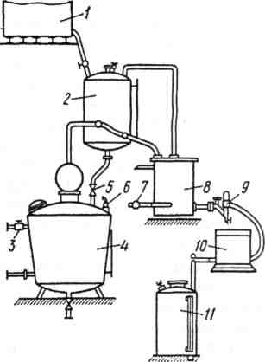suraTi 3 Saratis tipis aparatis sqema

1. sawneo baki; 2; gamacxelebeli; 3;7 ventili 4.Sarantis qvabi 5. onkani; 6.sahaero 8. macivari; 9 fanari; 10 sakontrolo spirtmricxveli; 11 spirtis mimRebi rezervuari

Sarantis qvabi cilindruli formis spilenZis rezervuaria, amoburculi ZiriT da saxuraviT romlebic SeduRebulia kedelTan. ixileT suraTi 4.suraTi 4 alambiki; Saratis tipis spirtsaxdeli mowyobiloba

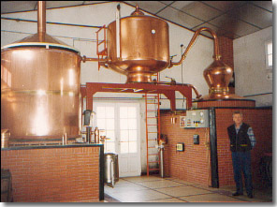

Amoburcul Ziriani qvabebi sayrden fexebze dgeba da dawola xdeba Ziris centrSi sadac ukeTdeba 50mm_iani diametris milyeli onkaniT, buyis gamosaSvebad. qvabs zemoT gakeTebuli aqvs sahaero onkani haeris gamosaSvebad. saxuravze CarTuli onkanis daniSnulebaa gamosaxdeli masa miiRos qvabSi, qvabs Tavze gakeTebuli aqvs mili, gverdit datanebuli aqvs milyeli, romelSic Cadgmulia SuSis mili. am milSi Sesuli siTxis done gviCvenebs QvabSi moTavsebuli siTxis dones.

M muzaradi. burTisebri deflegmatori odnav acivebs spirtwylian orTqls da nawilobriv amagrebs naxads spirtiT. Mmopirdapire mxares gakeTebuli aqvs milyeli, (ixileT suraTi 5) erTi uerTdeba qvabs, meore orTqlgamtar komunikacias.

suraTi 5 alambiki; Saratis tipis spirtsaxedeli

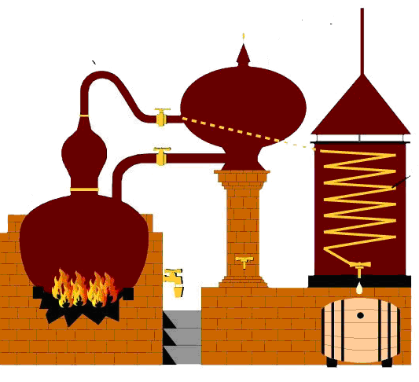

salufe gamacxelebeli. misi daniSnulebaa qvabSi mosaTavsebeli siTxis moculobis zustad gazomva. Ggamacxelebeli warmoadgens spilenZis mokalul cilindrs, romelsic Sedis spirtwyliani ortqlis gamtari mili. G gamacxelebels datanebuli aqvs gamosaSvebi onkani, romliTac uerTdeba gamosaxdel qvabs. Ggamacxelebels gverdze gakeTebuli aqvs milyeli, romelzec damagrebulia SuSis danayofebiani mili, saxuravze damagrebulia sahaero onkani.

sawneo rezervuari. misi daniSnulebaa gamosaxdeli masalis moTavseba da saWiroebis SemTxvevaSi spirtsaxdeli aparatebisaTvis miwodeba. rezervuars muxis xisgan akeTeben, gverdze ukeTeben SuSis grZel mils, romelic SeerTebulia siTxis ZirTan.

sawnevi rezervuari saulufe gamacxelebels uerTdeba saerTo miliT, TiToeul gamacxelebels calcalke aqvs siTxis CasaSvebi onkani da agreTve saerTo onkani siTxis gadasaketad.

macivari. Mmacivris daniSnulebaa spirtwyliani orTqlis gacieba, misi temperaturis dayvana 15gradusamde da orTqlis kondensacia. Mmacivari Sedgeba foladis cilindruli korpusisagan, romlis SigniT moTavsebulia spilenZis klaknila, macivris korpuss aqbs ori milyeli. wylis gamosaSvebad macivars gakeTebuli aqvs milyeli, klaknili mils macivris korpusSi gamoyofili aqvs ori milyeli, erTiT SeerTebulia qvabidan mimdinare spirtwylian orTqlTan, meoriT ki uerTdeba farans.

spirtfarani. Misi daniSnulebaa moiTavsos mimdinare nakadis axal_axali ulufebi. Farani Sedgeba jamisagan, romelSic Casmulia Wiqa. WiqaSi Tavisuflad tivtivebs SuSis spirtmzomi da mimagrebulia Termometri. macivridan spiriti gadmodis miliT., igi sahaero mils uerTdeba, am milidan zeviT amodis haeri da naxSirorJangi. Am milis Ziri uerTdeba faranis Wiqas. spiriti milidan gadadis faranis WiqaSi da gadaiRvreba jamSi,romelsac zevidan daxuruli aqvs SuSis xufi.

spirtmricxveli. misi daniSnulebaa gazomos spirtis moculoba da aiRos gamoxdis saSualo nimuSi yvela ulufidan spirtis simagris gansazRvrisaTvis. Gavrcelebulia ori saxis spirtmricxveli: spirtgamzomi da nimuSamRebi_spirtmricxveli.

spirtgamzomi_spirtmricxveli Sedgeba: dolisa da cilindrisagan. Doli Tavis mxriv gatixrulia sam nawilid, gverdiT moTavsebulia 3 rezervuari, romelic SeerTebulia dolTan miliT, rezervuarSi moTavsebulia tivtiva romelic savsea acetoniT, igi uerTdeba mricxvelis im sistemas, romelic aRricxavs naxadis raodenobas uwylo spirtze gadaangariSebiT. mricxvelSi spiriti Sedis miliT da meore miliT gadadis sistemaSi da xvdeba rezervuarSi.

nimuSamRebi_spirtmricxveli_Sedgeba ori nawilisgan: doli da saSualo nimuSis amRebi meqanizmi, romelic moTavsebulia garsacavis SigniT. Doli dayofilia sam Tanabar seqciad, TiToeul seqcias Signidan mikruli aqvs TiTberis mili, romlis erTi bolo daketilia, meore Riaa. rodesac dolis romelime seqcia gaivseba spirtiT, spiriti daiwyebs meore seqciaSi denas. saSualo nimuSi milidan gadaisxmeba sakanSi, sakani mTavrdeba gamtari miliT, romlis saSualebiTac spiriti gadava mimRebSi. Gatarebuli spirtis moculoba ki aRiricxeba mricxvelze, saidanac uwylo spirtis raodenoba iangariSeba naxadSi.

spirtSemkrebi anu spirtmimRebi rezervuari. misi daniSnulebaa spirtis nedleulisa da misi gamoxdis fraqciebis calcalke Segroveba. Igi warmoadgens cilindrul WurWels, Signidan datanebuli aqvs spirtmimRebi, milyeli da gamcleli onkani, igi mimagrebulia spilenZis spirtgamtar milze, saxuravze gakeTebuli aqvs sahaero mili da gverdiT mTels simaRleze minis mili, siTxis simaRlis saCveneblad.Semkrebi ise unda daidgas, rom spiriti masSi TviTdinebiT Cadiodes.

**zarubianis tipis pirdapiri gamoxdis aparati**

zarubianis tipis aparati:

am aparatis warmadobaa saSualod 100.0 dalia dRe Ramis ganmavlobaSi. saidanac daaxloebiT 70-75% sakoniake spirtia. Aaparatis muSaobis teqnologiuri sqema mocemulia suraTze #6 Rvino masala emalirebuli rezervuaridan tumbis saSualebiT gadaiqaCeba Rvinis gamacxelebelSi 500.0 dal odenobiT, romelic Tavdapirvelad Sedis gamosaxdel aparatSi. Semdeg daiketeba onkani da morigi ulufa Rvinisa 500.0 dal-is raodenobiT isxmeba gamacxelebelSi, saxdel kubSi klaklinad milis saSualebiT SeuSveben gamaxurebel orTqls 3 at.-mde wneviT, da iwyeben Rvinis gacxelebas. Aam dros deflegmatori da macivari savsea gamacivebeli wyliT. saxdel aparatSi duRilis dros warmoSobili gadadis deflagmatorSi mimarTulebiT maRlidan dabla, aq spirtwyliani orTqlis nawili kondensirdeba da rotameris saSualebiT ubrundeba Semsamagrebeli svetis TefSebs. saxdeli aparatidan wamosuli morigi ulufa spirtwyliani oTqlisa gaivlis TefSebze moTavsebul kondensats spirtwyliani orTqli gadis macivrisaken. aq igi mTlianad kondensirdeba, civdeba da gamodis spirtis fanarSi saidanac nawildeba fraqciebis mixedviT spirtis Semkreb rezervuarebSi. saxdel aparatSi orTqlis SeSvebidan mandamde, sanam spirtis fanarSi gamoCndebodes pirveli ulufa distilatisa. saWiro dro daaxloebiT1,5 sT-ia. am dros Semcirebis mizniT xdis damTavrebamde erTi saaTiT adre deflegmatoridan gamosul spirtwylian orTqls gadarTaven gamacxeleblisaken romelic mowyobilia klaknili miliT. cxeli spirtwyliani orTqli gaivlis ra klaknil mils kondensirdeba, gadascems Tavis siTbos gamacxelebelSi moTavsebul Rvino-masalebs da Semdeg gadis macivris klaknil milSi. gamacxelebelSi Rvinis temperatura mihyavT 50-60 gradusamde, aseT temperaturamde miyvanili Rvino male, daaxloebiT 20-30 wT-Si wamoduRdeba da ditilati gamova spirits fanarSi.

saxdel aparatSi da gamacxelebelSi wnevis gazrda Rvinis duRiliT an vakuumis Seqmna cxel aparatSi civi Rvinis CaSvebis SemTxvevaSi kontroldeba maTze SeerTebuli vakuumSemwyvetebiT gamacivebeli wylis miwodebis regulireba xdeba rotometris tivtivis mdgomareobis mixedviT.

suraTi #6: zarubianis tipis pirdapiri gamoxdis aparatis sqema

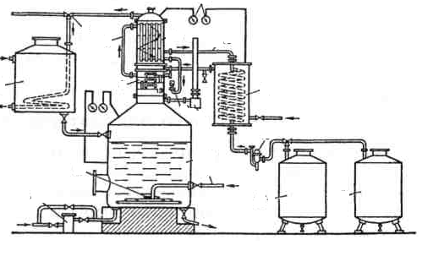

**axalgamoxdili sabrende spirtis kondicia da zogierT nivTierebaTa warmoqmna.**

A axalgamoxdili sabrende spirti unda akmayofilebdes Semdeg moTxovnebs: unda iyos gamWvirvale-ufero, ar unda hqondes araviTari gareSe minarevi, gemoze unda iyos sufTa, aromatuli, yvavilovani an odnav vanilinis toniT, ar unda hqondes mkveTrad gamoxatuli aldehidebis, eTerebis da umaRlesi alkoholebis toni. simagre unda meryeobdes 62-70%-is farglebSi, 100-ml uwylo spirti unda moicavdes: umaRles alkoholebs 180-600-mg, aldehidebs 10-50-mg ,rTul eTerebs 50-250-mg, mqrolav mJavebs araumetes 80-mg, furfurols araumetes 3-mg. 1-litri spirtSi ar unda iyos meTilakoholi 1-5g ze meti, saerTo gogirdmJava 10-mg mde, spilenZi 8-mg, rkina 1-mg-mde, ar unda iyos tyviis niSnebi. Rvinis gamoxdisas nawili am nivTierebebisa gadadis distilatSi Rvinidan, nawili ki axlad warmoiqmnebian. magaliTad naxadSi aldegidebis matebis mizezia an spirtis daJanagva aldehidebamde, an RvinoSi arsebuli aldehidebis dekondensacia, an sxvadasxva organul naerTebTan dakavSirebuli aldehidebis ganTavisufleba.

G gamoxdisas upirvelesad warmoiqmneba furfuroli, ZmarmJava, aldehidi da eTerebi. RvinoSi furfuroli ar moipoveba. igi warmoiSveba distilaciis Sedegad RvinoSi arsebuli pentozis xarjze, xdeba pentozis dehidrireba mJavebTan gacxelebis Sedegad.

**sabrende spirtebis Sesanaxi tara da Senoba**

Sesanax WurWelze didadaa damokidebuli sabrende spirtisa da misgan miRebuli produqciis – brendis xarisxi. koniakis Sesanax tarad iyeneben muxas; maRali xarisxis muxisgan damzadebuli Sesaferisi tevadobis WurWeli ekeTilSobilebs sabrende spirts, mimzidvel fers, sirbile, xaverdovnebas da harmonias sZens.

kasrebis damzadebisas didi yuradReba unda mieqces tkeCis damzadebis saqmes. tkeCi unda iyos saRi ar unda axasiaTebdes futuro, sidample, lorwovaneba. saWiroa tkeCi winaswar kargad iyos mSrali. gasaSrobad tkeCebs awyoben jvaredinad fardulis qveSD da inaxaven ramodenime weliwads. mniSvneloba aqvs agreTve muxis xnovanebasac. kargia 80-100 wliani muxis tkeCebisagan damzadebuli kasrebi. rogorc cnobilia muxa didi raodenoba Seicavs mTrimlav nivTierebebs da Tu am nivTierebis Warb raodenobas ar movacilebT kasrebs masSi moTavsebuli spirtebi uxeS suns dam ware gemos SeiZenen.

garecxvis mizniT axal WurWelSi asxamen civ wyals da toveben ori kviris ganmavlobaSi. wyali rom ar aSmordes saWiroa misi gamocvla or sam dReSi erTxel. amis Semdeg WurWeli irecxeba cxeli 10%_iani codiani cwliT, Semdeg cxeli wyliT da bolos civi wyliT.

amJamad spirtebis SenaxviT gamowveuli aSroba danakargebis Semcirebis mizniT gamoyenebulia didi tevadobis emalirebuli rezervuarebi, romelSic ewyoba muxis damuSavebuli tkeCebi, im raodenobiT rom yovel litr sakoniake spirtze movides 80-90 sm2 tkeCis farTobi.

imasTan dakavSirebiT, rom qarxnis dagegmarebisas saWiroa 60% miRebuli sakoniake masalebisa unda Calagdes sam wlian daZvelebaze, mominanqrebul rezervuarebSi, ganvixiloT masSi gamoyenebli tkeCebis damuSavebis sxvadasxva meTodebi:

pirveli meTodi, civi wyliT amuSaveben 20-30 wuTiT orTqliT da Semdeg alageben rezervuarebSi, asxaven spirts da toveben sahaero baliSs 1-2% mde. rezervuarSi Seyvanilia daxvretili milebi romlis saSualebiT weliwadD orjer axdenen Jngbadis Seyvanas.

meore meTodi tkeCebis damuSavebisa aris muxis tkeCebis cxeli da civi wyliT damuSavebis Sedegad aSroben 10 -12 % tenianobis Semcvelobamde da 3-7 dRiT acxeleben 115-140 C cxeli haeris nakadiT Semdeg alageben rezervuarebSi.

mesame meTodi iTvaliswinebs tkeCebis damuSavebas 0,3-0,6% NaOH-iT an 0,5-1% KOH 2 dRis ganmavlobaSi 10-15 C. Semdeg ramodenimejer recxaven gamdinare wyliT. Semdeg iseve rogorc zemoT aris moxseniebuli.

**muxis merqani koniakis warmoebis TvalsazrisiT**

sabrende spirti Zveldeba muxis kasrebSi Zveldeba muxis kasrSi an rezervuarSi, romlebSic awyvia muxis tkeCebi romlebisac axasiaTebT keTilSobiluri Tvisebebi spirtis dasaZveleblad.

muxis qerqi Sedgeba ligninisagan (14-30%) hemicelulozisagan (32-56%). wliuri rgolebis warmoSobisas mcirdeba celuloza da izrdeba ligninis procenti muxis simaRleze zrdis dros ki xdeba piriqiT. ligninis struqturuli formulaSi ZiriTadia koniferilis da singilis spirtebi da maTi nawarmebze. sabrende spiertSi gadmosuli ligninisa 70% wyalSi xsnadia. daaxloebiT 30 % sabrende spirtis moSorebiT eleqeba da wyalSi Znelad ixsneba. daZvelebis periodSi ligninis Semadgeneli komponentebi iJangebian da vRebulobT aromatuli rigis aldehidebs; magaliTad koniferolis spirti iJangeba vanililamde.

**koniferilis spirti**

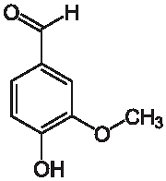

**vanilini**



JangviTi procesebsi Semdegi produqtebia, sinapisaldehidi (C11H12O4), iasamnisaldehidi (C9H10O4), paraoqsibenzaldehidi (C7H6O2) es aldehidebi sabrende spirtebis siZveleSi matulobs.

meore konponenti hemiceluloza ZirTadaT qsilozisagan Sedgeba. mas mosdevs arabani, galqtani da saxamebeli.

advilad xsanadi celuloza ki Seadgens saerTo celulozis 10% romelsac hidroliziT SeZulia mogvces glukoza. sakoniake spirtSi aris naxSirwylebis monosaqaridebis saxiT, glukozis, fruqtozis, qsilozis, arabinozis da ramnozis saxiT, romlebic ueWvelia celulozaSi Semavlia jaWvebis qimiuri gardaqmniT Cndeba. es Saqrebi daZvelbis periodSi ganicdian dehidrirebas, kargavs 3 molekula wyals da furanis rigis aldehidebs: furfurols, meTilfurfurols da oqromeTilfurfurols warmoSobs.

furfuroli warmoiSveba qsilozis dehidrataciT; meTilfu-rfuroli, meTilpentozis dehidartaciT, oqsilmeTilfurfuroli heqsozebis dehidrataciT.

**furfuroli**

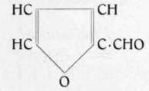

am rigis aldehidebis dajangvis Semdeg warmoiSveba vanilinis mjava, sinapis da iasamnis mjava da sxva.

**sabrende spirtis daZveleba**

rogorc zemod avRniSneT, axlad gamoxdili spirti aris uferuli da gamWirvale, araharoniuli. muxis kasrSi an liTonis rezervuarSi tkeCebiT daZvelbis Semdeg igi iZens sasamovno Tvisebebs, moyviTalo fers, uviTardeba buketi, xdeaba harmoniuli da haverdovani gemoze.

sabrende spirtebis daZvelbisas izrdeba umaRlesi alkoholebis odenoba romelic gamowveulia ufro advilad aqroladi nivTierebebis aorTqlebiT da umaRlesi alkoholebis gazrdiT. izrdeba acetalebis raodenoba rac spirtebis da aldehidebis urTierTqmedebiT xdeba. daZvelebisas agreTve xdeba aqroladi da saerTo mJavianobis zrda. aqroladi maJvebis gazrdas iwvevs spirtebis daJangva, qrolavi mjavebis daJangviT izrdeba sarTo simJave:

sabrende spirtebis daZvelbisas saWiroa Cavatarod Semdegi teqno-logiuri procesebi:

1. **egalizacia**. igi gulisxmobs erTi da imave raionis an qarxnis iseTi spirtebis Serevas romlebisganac mosalodnelia ukeTesi xarisxis spirtis miReba.
2. **meTvalyureoba**. brendis specialistebi ganuwyvetliv adevneben Tvalyurs spirtis daZvelebas, icaven saTavsos sisufTaves. aTeTreben kedlebs da iatakis im nawils romelzedac wolebia ganlagebuli. icaven sasurvel temperaturas, tenianobas, TviToeuli WurWlidan kvartalSi erTxel amoiReben nimuSs, amowmeben fers da gemos.

g) **areva**. spirti romelic ufro axlosaa SexebaSi muxis WurWelTan an tkeCTan ufro metad Rebulobs eqstraqtul nivTierebebs, Jangbads amitom saWiroa weliwadSi erTxel (kasrebSi) da orjer rezervuarebSi spirtis fenebis gadaadgileba, areva specialuri sarevelaTi an tumboTi.

d) **Sevseba**. dasaZveleblad Calagebuli spirti droTa ganmavlobaSi orTqldeba da moculobaSi klebulobs. amitom dekemberSi aRricxvis win saWiroa Seivsos imave xarisxis da simagris spirti, rogoric WurWelSia moTavsebuli, Semdeg moakleben daaxloebiT tevadobis 1%-s.

e) **Senaxvis xangrZlivoba**. spirtis simagre yvelanairad 1%_mde klebulobs, amitom spitris Senaxva daZveleba SeiZleba manmade sanam simagre ar daecema 500_mde. Semdeg axdenen ufro maRali gradusis (imave tipis) mqone spirtTan Serevas.

v) **spirtis SerCeva**. qarxanaSi dasaZveleblad Cawyobili partiebidan arCeven samwliani daZvelebis spirtebs, romlebic nakleb perspeqtiulia dasaZveleblad. ganapirobeben samvarskvlaviani brendis Camosasxmelad. aseve iqcevian meoTxe welsac da a.S.

**Rvinis saWiro raodenobis gansazRvra**

Rvinomasalis saWiro raodenobis gasazRvrisTvis saWiroa vicodeT sxvadasxva danakargebis raodenobeba.

1. danakargi cisternidan saTavsoSi gadatanis 0,09%;
2. danakargi saTavsodan gamacxelebelSi gadatanis 0,09%;
3. danakargi gamoxdaze 2%.

aseve mxedvelobaSi unda iqnes miRebuli Tavnaxadis gamoTiSva sakoniake spirtis raodenobidan 1% a\a-dan, e.i. 1600 dali spirtis misaRebad dagvWirdeba

800\0,9982*0.98*0.99*0.1=16520 dali. 10%-iani Rvinomasala.

Rvinomasalad SerCeuli iqna ,,rqawiTeli”-s yurZnis jiSidan damzadebuli Rvinomasalas

**muxis tkeCis, Cifsis, kasris saWiro raodenobis gaangariSeba**

rogorc ukve aRvniSneT sabrende spirtis daZveleba, garda muxis kasrebisa SesaZlebelia muxis tkeCebze, cisternaSi CalagebiT. muxis tkeCis raodenobis gansazRvrisTvis saWiroa tkeCis zedapiris farTis gansazRvra. tkeCis zomebi saSualod aviRod 3.5 sm simaRle; 7,5sm sigane; 71sm sigrZe. gavigoT gverdiTi zedapiris farTobi:

F=2T1+2T2+2T3

2T1=(3,5*7.5)*2=52 sm2

2T2=(7.5*71)*2=1065 sm2

2T3=(3.5*71)*2=497 sm2

saerTo farTi iqneba F=52+1065+497=1614 sm2  cdebiT dadgenilia, rom erT litr sabrende spirtze unda modiodes 80-100 sm2 muxis tkeCis zedapiris farTi. erTi eseTi tkeCi sakmarisia 20 litri 2 dali sabrende spirtisTvis, radgan

20 – 1 X= 3200

1600 – X

sul dagvWirdeba 1600 cali aseTi tkeCi

**saWiro cisternebis raodnoba**. Cvens mier dasaZveleblad gaTvaliswinebuli cisternebis tevadoba aris 4 tona (800 dali). 800 tkeCi sWirdeba erT cisternaSi Casalageblad. saWiro iqneba 4 aseTi cisterna.

suraTi 6 Cifsebi da tkeCebi suraTi 7. cisterna

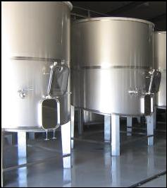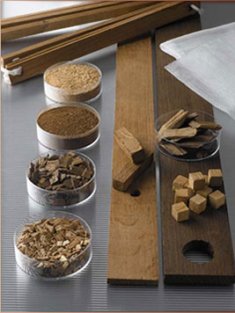 **muxis Cifsebis gamoyeneba sabrende spirtis daZvelebisTvis.** magaliTisTvis aviRoT Sampanis enologiis institutis mier warmoebuli Cifsebis botanikuri saxeoba: Quercus robus an Quercus Sessiliflora. Cifsebi aris samnairi saxeobis: mcire gamowviT, saSualo da Zlieri gamowviT. dabalanseburi gemos misaRebad Cven aviReT Cifsebis saSualo gamowviT, rekomendirebuli doza aris 4 grami litrze. TiToeul cisternaSi dagvWirdeba

1600 == X X=62 kg

1 – 40

anu Cifsis gamoyenebis SemTxvevaSi dagvCirdeba 16kg Cifsi TiToeul cisternaze, xolo sul 62kg. Cifsze an muxis tkeCze brends vaZvelebT erTnaxevari wlis ganmavlobaSi, xolo kasris gamoyenebis SemTxvevaSi sami wlis ganmavlobaSi.

**muxis kasrebis saWiro raodenobis gaangariSeba**

**suraTi 8 muxis kasrebi**

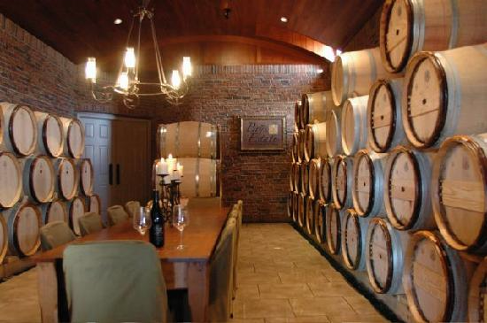

muxis kasris tevadoba 100l anu 10 dali. 1600 dalisTvis dagvWirdeba 16 cali kasri.

**saxdeli aparatis raodenobis angariSi da spirtis gamoxdis drois angariSi**

sarubianis tipis aparatis gamoyenebisas. sawarmoSi zarubianis tipis saxdeli aparatis gamoyenebis SemTxvevaSi sakmarisi iqneba erTi saxdeli aparati. zarubianis tipis aparati dRe-RameSi amuSavebs 1000 dal Rvino masalas, rodesac Rvinomasalis simagres 10%-ia vRebulobT 100 litr alkohols, aqedan sabrende spirtis raodenoba 65-75%-ia. saSualod aviRoT 70% e.i. dRe-RameSi miviRebT 100*70/100=70 dalis.

1600 dali spirtis damzadebisas dagvWirdeba

1 – 70 X=1600/70=23 samuSao dRes.

X – 1600

**Sarantis tipis aparatis gamoyenebisas**

alambikSi erT CatvirTvaze daSvebulia 300 litri Rvinis CatvirTva. pirvel gamoxdas esaWiroeba 8-10 saaTi, meores 10-12 sT, anu sul maqsimum 22 saaTi. Tu aviRebT rom sawarmoSi damontaJebulia aseTi tipis ori saxdeli aparati maSin 16520 dal Rvinis spirtis gamoxdas daWirdeba

60 dali – 22sT X=16520*22/60=6057sT

16520 dali – X

**sabrende spirtis buketis ganviTarebis etapebi**

literaturulu wyaroebis Sejameba sabrende spirtis cvlilebis Sesaxeb, daZvelebis periodSi Semdeg suraTs iZleva.

pirveli periodi. 1=dan 5 wlamde, xasiaTdeba muxis tkeCis Zlieri exstraqciiT, spirtis eqstraqtis gamdidrebiT. maRali ph-iT (5.5=5) intensiuri daJangviTi reaqciebiT. am periodSi adgili aqvs daJanguli taninis warmoSobas, izrdeba mJavianoba, mTrimlavi nivTiereba, eronis rZisa da Zmris mJava.

iwyeba hemicelulozis eqstraqcia da hidrolizi, Cndeba qsiloza, arabinoza da glukoza. warmoiSveba furfuroli, iwyeba ligninis eqstraqcia.

SedarebiT maRali ph-is gamo intensiurad mimdinareobs mZime metalebis, rkinis da spilenZis gamoleqva. erTmaneTs aqtiurad ukavSirdeba muxis merqnisa da sabrende spirtis Semadgeneli komponentebi. spirti Rebulobs Ria yviTel fers, SeigrZneba mcire vanilinis elferi, raxis toniT.

meore etapi. 5-dan 10 wlamde. mTrimlavi nivTierebaTa eqstraqcia neldeba, izrdeba daJanguli eqstraqtis procenti, saerTo eqstraqtSi, adgili aqvs aromatuli rigis aldehidebis zrdas, intensiurad yviTldeba, gemo rbildeba sasiamovno vanilinis toniT.

mesame periodi. 10 welze mzeviT. mTrimlav nivTierebaTa eqstraqcia tkeCidan neldeba, daJanguli taninis raodenoba izrdeba, grZeldeba ligninissa da hemicelulozis gamowvlilva tkeCidan, spirti Rebulobs yviTel-oqrosfers.

brendis spirtis daZvelebisas icvleba Semadgenel komponenTTa urTierTSefardeba, romelic gavlenas axdens brendis sunsa da gemoze da icvleba misi buketic.

**brendis momzadeba**

dabalgradusiani spirti.

maRalgradusiani sabrende spirtis simagris Semcireba brendis kondiciamde Tu generalur kupaJSi wylis SetaniT moxdeba maSin eTerebi isapneba. ganTavisuflebuli umaRlesi alkoholebi iwvevs spirtis amRvrevas, Slis Zveli sabrende spirtis bukets da amcirebs mis aromats. axali spirtis Sereva gamoxdil wyalTan ar iwvevs spirtis xarisxis mkacr gauaresebas. aseTi spirtis Setana generalur kupaJSi maRalxarisxovani samarko brendis misaRebad ar iwvevs eTerebis gasapvnas da umaRlesi alkoholebis ganTavisuflebas.

dabalgradusiani spirtis dasamzadeblad axlad gamoxdil sabrende spirts gaazaveben 22-260-mde; 3,5 gradusamde Serbilebul an gamoxdili wyliT moaTavseben kasrSi. kasrs moakleben 4-5 procentis raodenobiT, axuraven sacobs da ori wlis ganmavlobaSi aZveleben. aseTi spirti SeaqvT samarko brendis generalur kupaJSi. dabalgradusian spirts ayeneben burbuSelazec.

**Saqris sirofi**

Saqris sirofs amzadeben rafirinebuli saqarozisgan cxeli wesiT. sirofSi Saqris koncentracia sxvadasxva sididisaa 25-dan 75%-mde. dabali koncentraciis sirofi ufro metad eqvemdebareba sokovan daacadebebs da xSirad masze obi viTardeba. koncentruli sirofi naklebad eqvemdebareba mikroorganizmiT gamowveul daavadebebs. magram igi SeiZleba ,,daSaqrdes”. es movlena ufro metadaa mosalodneli roca sirofis dasamzadeblad ixmareba sufTa saqaroza da gamxnelad spirtwyliani xsnari.

inversuli Saqris xsnadoba ufro didia saqarozis xsnadobasTan SedarebiT.

**sirofis saxarSi qvabi**

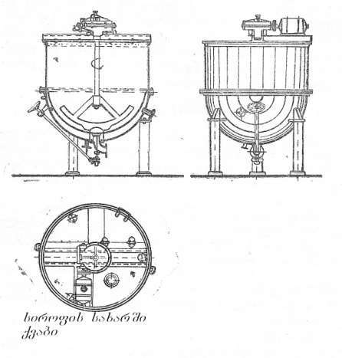

sirofis damzadebis dros saWiro wylis raodenobas Semdegi wesiT angariSoben: cnobilia rom Saqris xvedriTi wona 1.6-ia da 100kg Saqars aqvs 62.5 litri moculoba. Tu 100 litr Saqaris sirofSi unda iyos 100kg Saqari da am ukanasknes ki 62.5 litri moculoba uWiravs, maSin 100 litramde Sesavsebad saWiro iqneba 37,5 litri wylis damateba, Saqris xarSvis dros aorTqleba 4-5 litri wyali. ris gamoc umjobesia aviRoT 42 litri wyali da masSi gavxsnaT 100kg Saqari. 10-15 wuTis xarSvis Semdeg miviRebT 100 litr sirofs, romelic 100kg Saqars Seicavs.

137,5 – 100 X=100*100/137.5=72.7%

100 = X

aRebul sirofSi Saqris koncentracia udris 72.7%. aseTi konc. inversuli Saqari 200-ze daSaqrdeba, radgan saqarozis xsnadobis maqsimumi 20 gradusze aRwevs 66.92%.

sirofis daSaqrebis asacileblad mimarTaven saqarozis inversias, risTvisac sirofis xarSvis win yovel 100kg Saqarze umateben 80gram limonmJavas. cxeli wesiT Saqris sirofis mosamzadeblad xmaroben sxvadasxva qvabebs, samosiani gamacxelebliT, an klaknila milebiT specialuri sarevelaTi.

15-16 dalian qvabSi aTavseben 42 litr gamoxdil wyals, nelnela acxeleben da ganuwyveteli moreviT umateben 100 kg Saqars. aduRebamde cxeleba 15-20 wuTi grZeldeba. Semdeg umateben sami kvercxis cilas, kargad ureven da duRils kidev agrZeleben 10-15 wuTi da qafs aSoreben.

aqedan gamomdinare Saqris sirofis momzadebis ingredientebia: 100kg Saqari, 80gr limonmjava da 42litri wyali. miviRebT 70%-ian Saqris sirofs. aseTi Saqris sirofis duRilis temperatura 105,30C-ia moxarSuli sirofis gamosaSvebad onkans xsnian da sirofs Sesabamis WurWelSi uSveben. sirofs umateben 68moc. % simagris nedl wpirts. aseT mdgomareobaSi sirofi kargad inaxeba da ar kristaldeba. aseTi 100ml sirofi Seicavs 33gram Saqars.

**brendis mdgradobis uzrunvelyofa**

**da gamoyenebuli masalebi**

gansazRvruli periodiT spirtebis daZvelebis Semdeg, brendis mosamzadeblad atareben generalur kupaJs, romelSic Sedis daZvelebuli spirti, simagris dasayvanad dabalgradusiani spirti an wyali, Saqris sirofi da mcireodeni koleri, ordinaluri koniakebis feris misayvanad kondiciamde.

generaluri kupaJis ganxorcielebis Semdeg irRveva wonasworoba spirtis Semadgenel komponentTa Soris. maRalgradusiani sakoniake spirtis simagris Semcireba koniakis kondiciamde rodesac generalur kupaJi wyliT xdeba, maSin eTerebi isapneba, ganTavisuflebuli umaRlesi alkoholebi iwvevs spirtis amRvrevas, icvleba aromati da buketi. gemoze SeigrZnoba disharmonia spirtis. koleris Setana kupaJSi koniaks Tavdapirvelad aZlevs damwvari Saqris gemos, amitom wonasworobis aRsadgenad saWiroa koniakis Senaxva 3-6 Tve da am periodSi misi gawebva. koniakidan naleqvis gamoyofa xSirad gamowveulia wylis sixistiT, karameliTa da liTonis marilebiT. n. t. semenko 1965 w.

gamoyofil naleqSi nanaxia 3%-mde meToqsilis jgufi, romelic miRebuli unda iyos ligninis daSlis Sedegad. mza koniakis amRvreva-gamoleqvis Tavidan asacileblad mimarTaven koniakis kupaJis Semdeg mis gawebvas ise, rom ar moxdes misi gadawebva. am mimarTulebiT ufro saSiSia Jelatini da Semdeg Tevzis webo, naklebad saSiSia kvercxis cila. gawebvis dros mniSvnelovnad mcirdeba eqstraqti, feri, mTrimlavi nivTierebani da nacris elementebi; mcired iklebs spirti, rkina, spilenZi. JelatinTan da Tevzis webosTan pirvel rigSi reaqciaSi Sedis daJanguli mTrimlavi nivTierebebi, ligninTan - azotovani da aromatuli nivTierebebi, ris gamoc klebulobs buketis intensivoba. am komponentebs SedarebiT naklebad amcirebs bentoniti. aromatul ngivTierebebs bentoniti ufro naklebad amcirebs, vidre Jelatini da Tevzis webo, magram gawebvis Semdegac adgili aqvs koniakis amRvrevasac. n. semenenko 1964 w.

gawebva koniakis gawmendis erT-erTi saukeTeso saSualebaa. am procesis arsi mdgomareobs imaSi, rom koniakSi Setanili gamwebavi nivTierebani ganicdian koagulacias, waritaceben Sewonil sxeulebs da maTTan erTad leqis saxiT gamoiyofian WurWlis fskerze – gawebvis SemweobiT ara marto siwmindes da gamWvirvalobas Rebulobs koniaki, aramed umjobesdeba misi gemovnuri Tvisebebic igi rbili da harmoniuli xdeba. arsebobs gawebvis qimiuri da fizikuri procesi, qimiur procesTagan aRsaniSnavia gamwebav da mTrimlav nivTierebaTa urTierTqmedebiT tanidebis warmoSoba da maTi koagulacia, simZimis Zalis moqmedebiT tanidebis gamoyofa naleqSi gawebvisas mimdinare fizikur process warmoadgens. gawebvis procesi bevradaa damokidebuli koniakis qimiur Semadgenlobasa da rig faqtorebze.

didi raodenobiT gamwebav nivTierebaTa Setana koniakSi uaryofiTi SedegiT mTavrdeba, amitom aucileblobas warmoadgens, winaswar sacdeli gawebvis Catareba da gamwebavi naerTebis optimaluri pirobebis dadgena.

**gamwebavi nivTierebebi**

n. semenenko 1964 w _ Jelatini kargi gamwebavi nivTierebaa igi farToT gamoiyeneba koniakis gasawebad, Jelatini wyalSi fuvdeba, mJavebisa da spirtis moqmedebiT igi iWreba magram ara energiulad. tanins kargad uerTdeba da sakmao msxvil nafleTebs warmoqmnis, ufro intensiurad moqmedebs maSin, rodesac Jelatinis wonis naxevari tanini winaswaraa Setanili, am SemTxvavaSi tanin-Jelatinis koloiduri bade TandaTanobiT mWidrovdeba, nel-nela fskerisaken eSveba da Tan miaqvs simRvrivis momcemi nawilakebi. tanin-Jelatinis optimaluri dozis dasadgenad sawarmoSi aucilebelia ganxorcieldes laboratoriul pirobebSi sacdeli gawebva. maRal temperaturul pirobebSi ar aris rekomendirebuli Jelatinisa da Tevzis webos gamoyeneba.

Tevzis webos Rebuloben Turijis, TarTisa da loqos Tevzis buStebisagan. Tevzis webo mzaddeba da gayidvaSia burbuSelis an firfitebis saxiT, spirtSi Setanamde misi gamoyeneba xsnaris momzadebas saWiroebs, rogorc Jelatini aseve Tevzis webo moklebulia universaluri gamwebavobis unars, koniakis gawebva xorcieldeba aseve bentonitiT, bentonitovani Tixebis 80% Seicaven koloidur fraqcias, ris gamoc isini adsorbirebis kargi unariT xasiaTdebian da koniaks aTavsiufleben ammRvrevi sxeulebisagan. bentonitis dadebiT Tvisebad unda CaiTvalos isic, rom igi ar fuWdeba da masze didi xniT dayovnebuli koniaki ar Rebulobs gareSe sunsa da gemos. bentonitiT gawmenda wlis yvela periodSia rekomendirebuli. a. sirbilaZe 1964 w.

**tanini**

tanini warmoadgens amorful fxvnils moyviTalo-moyavisfro SeferilobiT. xsnadia spirtsa da wyalSi, xasiaTdeba mwklarte gemoTi. tanini TavisTavad ar warmoadgens gamwebav saSualebas, rogoricaa Jelatini, Tevzis webo, albumini da a.S. igi gamoiyeneba rogorc damxmare faqtori gamoleqvis procesisaTvis da xels uwyobs dawmendis process. taninis gamoyenebiT teqnologi siTxes azRvevs gadawebvis saSiSroebisagan. is gamoiyeneba Tevzis webosa da Jelatinis Setanis dros da siTxeSi SeaqvT 6-12 sT-iT adre.

g. valuiko; v. zinCenko, n. mexuzla 1999 w.

**kvercxis cila**

imisaTvis rom kvercxis cila efeqturi gamwebavi saSualebad iqnas gamoyenebuli, saWiroa siTxe mdidari iyos fenoluri naerTebiT, aqedan gamomdinare, misi gamoyeneba rekomendirebulia maRaleqtsraqtuli, davargebuli spirtebis stabilizaciisaTvis. 100 dalze saSualo doza gaxlavT 1-2 kvercxis cila, rekomendirebulia sacdeli gawebvis Catareba.

1965 w n. semenenko

**silikageli**

silikazoli anu siliciumis (kaJbadis) dioqsidis sferuli nawilakebis wyliani suspenzia, gankuTvnilia swrafi stabiliza-ciisaTvis, gamoiyeneba JelatinTan da Tevzis webosTan erTad. kaJbadis nawilakebi, urTierTqmedeben areSi arsebul Setivnarebul nawilakebTan da warmoqmnian fifqebs, romlebic Jelatinis da Tevzis webos moqmedebis efeqts aswrafebs da aumjobesebs stabilizaciis process. J. bareti Samanis enologiis instituti 2006 weli.

n. semenenko 1965 weli, rekomendacias iZleva koniakis gawebva Seicvalos misi siciveze gaCerebiT _ 100C 10 dRis ganmavlobaSi da Semdeg igi civadve gaifiltros. misive rCeviT, aseT pirobebSi odnav mcirdeba eqstraqti, mTrimlavi nivTiereba. sacdeli nimuSebi romlebic ganTavsebuli iyo 10-200C cxra Tvis ganmavlobaSi, gamWvirvaleni gaxdnen, sakontroloni ki aimRvra da xuTjer met simRvrives gamomwvev nivTierebebs Seicavda, magram organoleptikuri Sefasebebisas dadginda, rom gawebva ufro sasargebloa gemovnuri Tvisebebis harmonizaciisaTvis.

a. korotkeviCis, J. bekirovis, l. kekirovas mier 1957w. rekomendirebulia koniakebis gaciveba fizikur qimiuri da biologiuri cvlilebebis mxriv. umjobesdeba produqciis gemuri Tvisebebic. Camosxmis win koniakis dayovnebT 5-10 dRiT 60C temperaturaze da 150C 3-7 dRe-RamiT. amiT koniaki iZens gamWvirvalobas da iviTarebs mimzidvel gemos.

s. petrovi (1903 w). koniakis gafiltvra xelovnurad gawmendis erT-erTi ZiriTadi meTodia. gafiltvris Sedegi koniakis gamWvirvalobis mxriv bevradaa damokidebuli am procesis Teoriul da praqtikul mniSvnelobaze. gafiltvriT odnav mcirdeba koniakis Seferva, rac gasaTvaliswinebelia miRebuli kupaJis damzadebisas.

sakoniake spirtisa da koniakis eqstraqtis ZiriTadi Semadgeneli nawilebia tanini da lignini, isini datvirTuli arian uaryofiTi muxtiT da unari aqvT SeuerTdnen zogierT amfolitur koloidebs, romlebic mocemul pH-ze dadebiT muxts atareben, Seqmnan maTTan badisebri zedapiri. es zedapiri Tavisi simZimiT nel-nela daeSveba fskerisaken da Tan gaiyoliebs spirtSi myof uwvriles nawilakebs. aseT koloidTa Soris ufro SesaniSnavia Tevzis webo da Jelatini, amis Semdeg kvercxis cila, kazeini da sxva. am nivTierebebs mJave areSi tute Tviseba aqvT da dadebiTad arian datvirTuli, tute areSi ki mJave Tvisebas iCenen da uaryofiTad imuxtebian. TiTeul maTgan gansazRvrul pH-ze aqvs izoleqtruli wertili, magaliTad Jelatins izoeleqtruli wertili aqvs 4,80-4,85 pH-ze kvercxis albumins 4,84-4,90, koniakis spirtis pH oTxi an oTxze naklebia, ris gamoc zemoT dasaxelebuli nivTierebaTa Setana koniaksa da sakoniake spritSi gamoiwvevs cilatanatis badis Seqmnas da spirtis dawmendas. spirtis koncentracia Tavis mxriv aCqarebs cilis koagulacias da qmnis ufro msxvil nafleTebs, vidre es RvinoSia SesaZlebeli. es movlena xels uwyobs spirtis dawmendas, magram aRaribebs spirts eqtsraqtisagan da amcirebs buketis intensivobas. aqedan gamomdinare sasurvelia maqsimalurad efeqturi zusti da mcire optimaluri dozis dadgena sacdeli gawebvis Catarebis safuZvelze a.laSxi 1973 w.

**koleri**

sakoniake spirti wyalTan ganzavebiT nawilobriv kargavs fers da koniakis damaxasiaTebel fers. sagrZnoblad CamorCeba, feris aRsadgenad ordinalur koniakebs daJangul tanins, an mcireoden damwvar Saqars anu kolers umateben

1000C-ze gacxelebiT saqaroza iSleba glukozad da fruqtozis anhidridad Semdegi gantolebiT:

C12H22O11 = C6H12O6 + C6H16O5

Semdegi cxelebiT (1700C) glukozidanac ayavrdeba erTi molekula wyali da warmoiSveba glukozis anhidridi:

C6H12O6 🡪 H2O – C6H10O5

1800C – 1850C-ze dacxelebiT anhidridebi: leuzani da glukozani Sedis reaqciaSi da iZleva izosaqarozans:

C6H10O5 + C6H10O5 = C12H20O10

am etapze masas gadakravs oqrosferi da iwyeba afueba Semdegi cxelebiT mimdinareobs izosaqarozanis kondensacia, kargavs or molekula wyals da iZleva karamelins:

2C12H20O10 🡪 2H2O = C24H36O18

amis Semdeg karamelanis masa sqeldeba da Rebulobs jer bac mere muq alublis fers.

rodesac temperatura 190-2000C-s miaRwevs karamelans uerTdeba erTi molekula izosaqarozani, yavrdeba sami molekula wyali da warmoiSveba karameli.

C24H36O18 + C12H20O10 🡪 3H2O – C36H50O25

am etapze mTavrdeba saqarozas karamelizacia. miiReba yvelaze muqi alublisferi masa, romelsac (,,fers”) eZaxian. ufro xangrZlivi cxelebiT 2000C zeviT iwyeba koleris danaxSireba. masa qafdeba didi raodenobiT webovani nivTierebebi da gazebi – maxrCobela suniT, romelic iwvevs koleris gamwarebas.

damwvar Saqars anu kolers Semdegi wesiT amzadeben: 2.5-3 dalian moculobiT mokalul qvabSi aT kilogram rafinirebul da 0.5 litr gamoxdil wyals moaTavseben da qvabs acxeleben, mokaluli cicxviT, Saqars ganuwyvetliv ureven. pirvelad cxeleba intensiurad midis. jer Saqari lRobas iwyebs, wiTel fers Rebulobs da Semdeg muq alublisfers gadadis. es procesi sul 15-20 wuTi grZeldeba da roca temperatura 1950-mde miaRwevs xarSva damTavrebulad iTvleba. xarSvis sisrulis Sesamowmeblad gaTxierebul SaqarSi sufTa xis Cxirs Cayofen da frTxilad amoiRben, Cxirs amoyveba webovani Saqris lolua, romelsac CxiriTve gadaitanen Tbil wyalSi, aq lolua gacivdeba da ufro metad Seikvris, loluas xeliT moRunaven, Tu igi moiRuna da ar gatyda, xarSvas agZelben, Tu gadatyda xarSva damTavrebulia, cecxls Seanelben, kolers 600-700 C-mde aciveben 4 l. gamoxdil wayls dasxaven, wamoaduRben da spilenZis mokaluli vedrobiT, mokaluli spilenZi9save bakSi gaditanen. 10 kg Saqari 4l walTan 10 l. kolers iZleva. 1 ml. gaxsnili 1l. unda iZlevodes iseTive Sfervas, rogorsac gvadzlevs 0,01niods.

axlad damzadebuli koleris Sdetana kupaJSi koniaks pirvelad adZlevs damwvari Saqris gemos, amitom umjobesia koleri daZvelon, risTvisac 1 dal. kolers umateben 4 dal 200-250-ian axlad gamoxdil spirts, gadaitanen muxis kasrSi da aZvelben 6-12 Tvemde. daZvelebis periodSi koleri kargad egueba dabalgradusian spirts da koniakSi Setanis Semdeg aRar emCneva karamelis speci-fikuri gemo. sakoniake spirti misi Sefervis mixedviT, koleris sxvadasxva raodenobis damtebas moiTxovs, mag.:100 dal axalgazrda konikze daxolebiT 5l-mde ganzavebuli (anu 1 l. ganuzavebeli) koleris damatebaa saWiro. 4-5 wlian koniakis spirtebSi ki SeiZleba misi raodenoba 5-jer an 10-jer Semcirdes. muq spirtebs ki koleris damteba sruliadac ar daWirdebaT. yvela SemTxvevaSi mekupaJe kolers umatebs TvalTaxedviT kondicuri feris miRebamde.

**generaluri kupaJis Sedgena**

generaluri kupaJis Catarebamde winaswar dgeba sacdeli kupaJis ramodenime varianti, ris mixedviTac angariSoben generalur kupaJs.

koleris raodenobis angariSi sacdeli kupaJidan saSualod 1000 dal brendisTvis saWiroa 3 dali koleri. koleris es doza teqnologs SeuZlia Secvalos Sexedulebis Sesabamisad.

**Saqris sirofis raodenobis gaangariSeba**

Vc=(1000*K-ACK)/Cc

Vc – aris Saqris sirofis raodenoba;

K – Saqris sirofis raodenoba koniakSi %-obiT. 1%;

A – koleris raodenoba kupaJSi dalobiT. 3 dali;

CK – Saqris raodenoba kupaJSi %-obiT. 10%;

Cc – Saqris raodenoba sirofSi %-obiT. 33%;

Vc=(1000*1-3*10)/33=29.3

Cvens mier damzadebulia 1000 dali xarisxovani brendis damzadebisTvis ukeTess Sedegs iZleva sxvadasxva partiis Zveli spirtebis Setana. pirveli partiidan Segvaqvs saerTo moculobis 50%, saerTo simagre 68%. meore partiidan 64%, simagre 25%. mesame partiidan 25% - 63.8%.

**kupaJSi Semavali spirtebis simagre**

K=(68.1*50*64*25)+(63*25)/100=66

kupaJSi Sesatani Zveli spirtebis raodenobas angariSoben formuliT

Vk=(1000(K-a))-K2(1000-(Vc+Vc1))/(K1-K2)

Vk – sakupaJe spirtis moculoba dalobiT;

K – koniakis kondiciuri simagre 400;

a – koniakis simagre romelsac miscems Saqris sirofi da koleri;

K1 – sakoniake spirtis saSualo simagre 660;

K2 – dabalgradusiani spirtis simagre 250;

Vc – sirofis moculoba dalobiT 29 dali;

Vc1 – koleris moculoba dalobiT, 3 dali.

dabalgradusiani spirtis moculoba iangariSeba formuliT

Vm=1000-(V-Vc+Vc1).

Vm – dabalgradusiani spirtis moculoba dalebiT.

dauSvaT rom 1000 dal 40%-ian brendis dasamzadeblad saWiro iyo 29.3 spirtSi gaxsnili sirofi, spirtis simagre iyo 450. amasTan vixmareT 3 dali koleri, simagre 200. a=(K3*Vc)+(K4+Vc1)/1000

a – brendis simagre, romelsac miscems kupaJSi Setanili Saqris sirofi da koleri;

K3 – spirtis koncentracia sirofSi, 45%;

K4 – spirtis koncentracia kolerSi, 20%;

Vc – sirofis moculoba, 29.3;

Vc1 – koleris moculoba dalobiT, 3 dali;

a=1.37

Vk=352.1

dabalgradusiani spirtis raodenobis angariSi

Vm= 615.6

* Saqris sirofi Vc=29.3
* koleri Vc1=3
* dabalgradusiani spirti Vm=615.6
* sakoniake spirtebis raodenoba Vk=357.1
* brendis simagre, koleriT da sirofiT a=1.37

**wylis raodenobis angariSi**

66%-iani ZiriTadi spirti;-

25% - dabalgradusiani spirti;

20% - koleri;

45% - Saqris sirofi.

cxrilis mixedviT 100 dal spirtwylian xsnarSi wyali Sedis dalobiT.

66-dan 37.5 wyali

25-dan 77..217 wyali

45-dan 58.522 wyali

20-dan 81.719 wyali

400-ian 1000 dalSi unda iyos 633.47 wyali, xolo Cven aRebuli gvaqvs 627,165 dali.e.i. kidev saWiroa 6,305 dali gamoxdili wylis damateba

**1000 dali brendis dasamzadeblad saWiroa**

6,305 dali gamoxdili wyali

29.5 dali Saqris sirofi

3 dali koleri

344.7 dali 66 % spirti

615,6 dali 22 % spirti

**brendis Camosxma**

**suraTi 10 tribloki**

brendis boTlebSi Camosxma da maTi gaformeba xdeba sarecx-Camosasxmel saamqroSi, nakadis avtomatur xazebSi, gansazRvruli TanmimdevrobiT: Camosxma, boTlebis dacoba, dacobili boTlebis brokeraJi Suqis ekranis win da maTi SigTavsis daTvaliereba; etiketebis miwebeba, mza produqciis yuTebSi Calageba.

brokeraJis procesSi, cudad garecxil an dazianebul boTlebSi Camosxmuli brendi romelSic aRmoCenilia minarevebi, iwuneba da isxmeba gansakuTrebul SemkrebSi.

brendis sawarmoebSi sxvadasxva warmadobisa da markis Camosasxmeli xazebia damontaJebuli. Sesabamisad, sxvadasxvagvaria operirebis sqemac. Tanamedrove qarxnebSi aryis CamosxmisaTvis iyeneben triblokebs. tribloki erT danadgarSi moicavs minis taris mosamzadebel (savleb-sadezinfeqcio), Camomsxmel da dasaxuf mowyobilobas. triblokSi Seqmnilia erTiani steriluri zona, kompaqturia, saWiroebs mcire farTobsa da nakleb muSaxels.

Camosasxmel xazs amontaJeben calke oTaxSi, romelic mzis SuqiT ganaTebulia da niavdeba. aryis Camosxma warmoebs sxvadasxva tevadobis minis boTlebSi _ 0,25, 0,5, 0.75 da 1 l tevadobis.

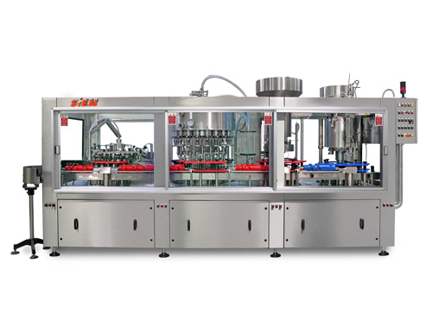

10-e suraTze naCvenebia firma ,,Siem"-is mier warmoebuli tribloki. igi avtomaturad akontrolebs siTxis dones da moculobas, agreTve boTlisa da saxuravis xarisxs, vinaidan operirebisas warmoebs vakuumuri an barometruli (gravitaciuli) Camosxma. erT sistemaSi moqceuli boTlis savlebi, Camomsxmeli da dasaxufi mowyobiloba garantirebulad uzrunvelyofs maqsimalur higienas da hermetulobas, rac xels uwyobs brendis saWiro simagris SenarCunebas da gamoricxavs produqciis moculobiT danakargs. dasaxuf danadgars mierTebuli aqvs saxuravis mimwodebeli elevatori. operirebis procesSi SesaZlebelia danadgaris siCqaris regulireba. triblokis warmadobaa 3000-dan 7200 boTlamde saaTSi. boTlis daxufva SesaZlebelia rogorc aluminisa da plastmasis xraxniani saxuraviT, ise ,,kronopropkiT~, sinTeturi da naturaluri sacobiT. aryis boTlebi triblokidan transportiriT gadaewodeba (suraTi11 -12) gasaformebel manqanas.

**suraTi 11 Camosxmuli boTlebis transportireba**

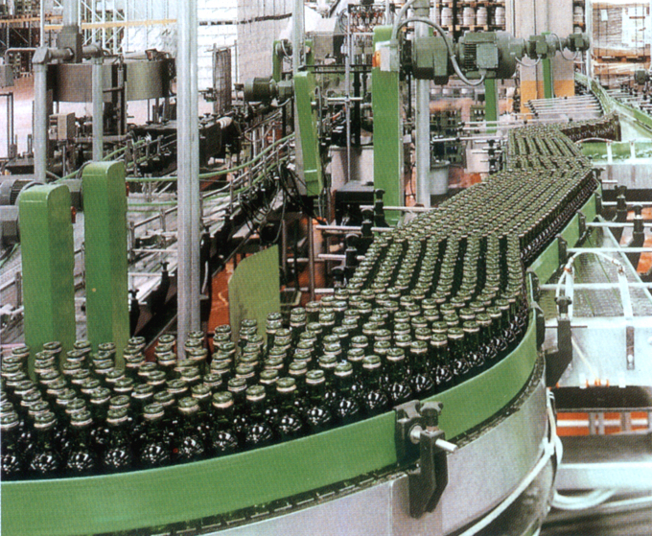gasaformebeli manqana (suraTi 12) boTlze awebebs etikets, kontretikets da aqcizur markas. Tanamedrove warmoebaSi iyeneben TviTwebad etiketebsa da aqcizur markebs. im SemTxvevaSi, Tu gasaformeblad araTviTwebadi qaRaldi gamoiyeneba, gasaformebeli aparatis specialur avzSi asxamen webos.

**suraTi 12 inglisuri kompania ,,PackLab"-is mier warmoebuli, boTlis gasaformebeli manqana**

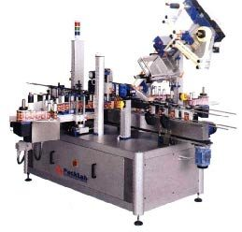

**suraTi 13**

**paletis mosamzadebeli manqana**

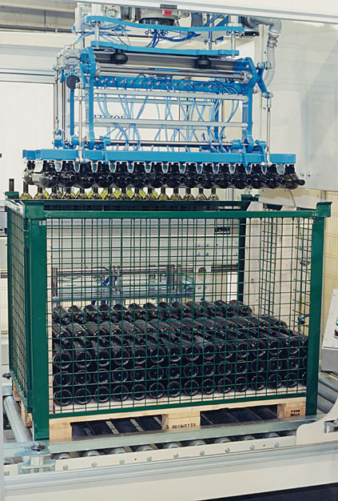

**suraTi 14 firma ,,Siem"-is mier warmoebuli, boTlis SesafuTi manqana**

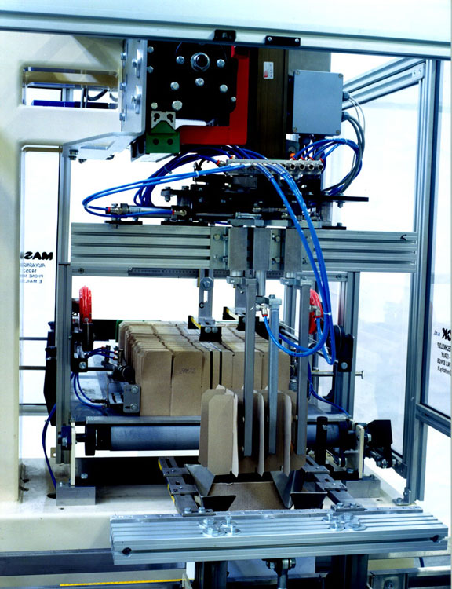

**suraTi 12 firma ,,Siem"-is mie warmoebuli,**

**muyaos kolofebSi boTlebis Casawyobi manqana**

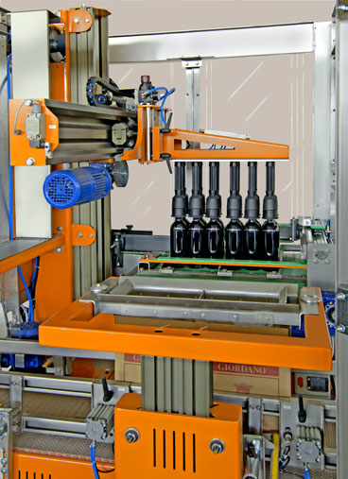

mcire warmadobis qarxnebSi, zog SemTxvevaSi, gaformebul boTlebs yuTebSi xeliT awyoben. uaxlesi teqnikiT aRWurvil sawarmoebSi damontaJebulia SesafuTi manqanebi: paletis mosamzadebeli (suraTi 12), erTeuli boTlis SesafuTi (suraTi 13), muyaos kolofebSi Casalagebeli mowyobilobebi (suraTi 14).

brendis Camosxma, SefuTva, niSandeba, transportireba da Senaxva xdeba gost 12545-is mixedviT.

**გამოყენებული ლიტერატურა**

1. საფრანგეთის კონიაკის წარმოების ეროვნული ბიუროს ოფიციალური ვებ გვერდი [www.bnic.fr](http://www.bnic.fr)
2. საფრანგეთის კონიაკის რეგიონის ოფიციალური ვებ გვერდი [www.cognac.com](http://www.cognac.com)
3. Robinson J. ,,Wine” The oxford companion to wine; Oxford New York; Oxford University Press-1994; pp1088. 663(2)55
4. Priew J. ,,Wine From Grape To Glass” Abbeville Press Publishers. New york-1998; pp 256. 663.2,(54)
5. ა. სირბილაძე ,,კონიაკის ტექნოლოგია „ თბილისი 1973 წელი;
6. ა.ლაშხი ,,კონიაის წარმოება” ქ.თბილისი 1967წ;
7. გ. გუჯეჯიანი, ,, ღვინის კუპაჟების გაანგარიშების თეორია და პრაქტიკა“ თბილისი 1996წ;