**საქართველოს ტექნიკური უნივერსიტეტი**

**Hჰidroინჟინერiis departamenti**

**saleqcio kursi**

**irigacia**

**Tbilisi – 2014**

**Sesavali**

dedamiwis mosaxleobis swrafi zrda, bunebrivi resursebis TandaTanobiT gamoleva, adamianis uaryofiTi zemoqmedeba garemo pirobebze, msoflios udides nawilSi sakvebi produqtebis nakleboba - ai is problemebi, romlebic dRes awuxebs mTel kacobriobas.

dedamiwa didia, misi mTliani farTobi Seadgens 510 mln km, aqedan xmeleTi mxolod 150 mln km-ia. aRniSnuli farTobidan daaxloebiT 40,5 mln km (27%) ukaviaT tyeebs, 27mln km (18%) mdeloebs da saZovrebs, 67,5 mln km (45%) - udabnoebsa da naxevrad udabnoens, myinvarebs, dasaxlebul punqtebs, samrewvelo sawarmoebsa da sxva sameurneo obieqtebs, gzebsa da sxva. da mxolod 15,0 mln km (10%) gamoiyeneba soflis meurneobis miznebisaTvis.

sasursaTo da soflis meurneobis saerTaSoriso organizaciis (fao) monacemebiT, aRniSnuli farTobi maqsimum SeiZleba gaormagdes udabnoebis morwyvis, Waobebis daSrobisa da sxva radikaluri RonisZiebebis gatarebis Sedegad, magram amave dros unda gaTvaliswinebuli iqnas, rom yovelwliurad planetis mosaxleoba izrdeba 2,5.....3,0%, anu 75....80 milioni adamianiT (amJamad, planetis mosaxleoba Seadgens daaxloebiT 6,5 miliards), rac imaze miuTiTebs, rom yoveli 30...50 wlis ganmavlobaSi mosalodnelia mosaxleobis gaormageba, Sesabamisad, moTxovnebis zrda kvebis produqtebze, saxalxo meurneobis aRmavloba, miwis axal-axal farTobebs moiTxovs ara marto miwaTmoqmedebisTvis, aramed nagebobebisa da sxvadasxva komunikaciebisaTvis, amitom miwebis dacva da racionaluri gamoyeneba Tanamedroveobis erT-erTi umniSvnelovanesi problemaTagania.

meore mxriv, akad. v.kovdas monacemebiT, msoflio miwis resursebis danakargma istoriul droSi miaRwia 20 mlnkm, rac aRemateba planetis Tanamedrove saxnav farTobs. yovelwliurad brunvidan gamodis sxvadasxva sasoflo-sameurneo savargulebis asiaTasobiT farTobi. danakargis ZiriTadi nawili modis axal qalaqebsa da dasaxlebebze, navTobsadenebis, gzebisa da sxva komunikaciebisaTvis gamoyenebul miwebze, mniSvnelovania agreTve eroziiT, damlaSebiTa da sxva procesebiT gamowveuli danakargebi. samwuxarod, miwis resursebis danakargebis es arasasurveli procesi mTel msoflioSi ara Tu mcirdeba, izrdeba kidec. eqspertebis azriT, 2020 wlisaTvis sasoflo-sameurneo warmoebas kidev 650-700 mln ha daakldeba, xolo 100 wlis Semdeg, Tu amgvari gzebiT miwebis dakargvis Tanamedrove tempi iqna SenarCunebuli, savargulebis farTobi kidev 3-jer Semcirdeba.

amjamad soflis meirneobis produqtebis sawarmoeblad erT sul mosaxleze saxnavi miwis norma Seadgens 0,4 ha-s. dReisaTvis igi kanadaSi Seadgens 2,5 ha-s, aSS-Si-s 1,18 ha-s, xolo iaponiasa da indoeTSi, Sesabamisad, 0,06 da 0,04 ha-s. postsabWoTa sivrceSi erT sul mosaxleze modis 0,9 ha.

saqarTvelo, romlis farTobia 69,4 aTasi km, xolo mosaxleoba 5 milionamde aRwevs, mciremiwian saxelmwifoTa ricxvs miekuTvneba da erT sul mosaxleze aq modis sul 0,15 ha saxnavi miwa.

dRes, msoflio sasursaTo problemis gadaWris ori gza arsebobs: erTi - axali farTobebis aTviseba da meore - sasoflo sameurneo kulturebis mosavlianobis gadideba erTeul farTobze. pirveli gza, rogorc avRniSneT, SedarebiT naklebad perspeqtiulia da, amrigad, rCeba meore da umTavresi gza-erTeul farTobze sasoflo sameurneo kulturebis mosavlianobis gadideba, anu, rogorc cnobili mecnieri k.timiriazevi miuTiTebda –“moviyvanoT ori TavTvavi iq, sadac mogvyavda erTi”.

mcenarisagan maqsimaluri produqciis miReba SesaZlebelia mxolod da mxolod maSin, rodesac igi uzrunvelyofili iqneba misi zrda-ganviTarebis etapze yvela sasicocxlo faqtorebiT. es faqtorebia: sinaTle, siTbo, wyali, haeri da sakvebi nivTierebebi.

pirvel or faqtors - sinaTlesa da siTbos- mcenare iRebs mzisagan. mzis sxivebis zemoqmedebiT mcenare iTvisebs Jangbads, azotsa da sxva elementebs, romlebsac gardaqmnis organul nivTierebebad: cilebad, cximebad, naxSirwylebad.

mesame faqtori - haeri, warmoadgens im garemos, saidanac mcenare da niadagis baqteriebi iReben Jangbadsa da naxSirorJangs, romlebic aucilebelia sunTqvisa da fotosinTezisaTvis.

wyali da sakvebi nivTierebebi is aucilebeli nivTierebebia, romelsac mcenare iRebs niadagidan. SemTxveviTi ar aris, rom maT uwodeben niadagis nayofierebis elementebs.

maRali mosavlis misaRebad niadagi unda iyos mcenarisaTvis aucilebeli am elementebis udidesi da universaluri sacavi, magram xSir SemTxvevaSi es piroba darRveulia. Tu niadags wyali aklia, mcenare sakvebs ver miiRebs, Tu niadagSi wyali Warbadaa, maSin mcenare ver miiRebs haers.

ai swored es aris naklebi mosavlis erT-erTi ZiriTadi mizezi. yovel konkretul mcenares aqvs Tavisi gansakuTrebuli moTxovnebi sakvebi nivTierebebisadmi.

niadagi Tundac Seicavdes mcenaris kvebisaTvis saWiro yvela aucilebel elements da Tanac saWiro raodenobiT, es kidev ar aris sakmarisi maRali mosavlis misaRebad. mcenaris mier am nivTierebebis SesaTviseblad unda Seiqmnas optimaluri pirobebi. amisaTvis ki aucilebelia niadagSi garkveuli raodenobiT arsebobdes wyali, romelic uzrunvelyofs am sakvebi nivTierebebis gaxsnas da mcenarisaTvis SeuTvisebeli formidan SesaTvisebelSi gadasvlas.

aqedan gamomdinare, wyali da sakvebi nivTierebebi aucilebelia maRali mosavlis misaRebad. mcenaris mier sakvebi nivTierebebis SeTvisebasa da gamoyenebis sakiTxebi iswavleba agroqimikosebis mier. rac Seexeba niadagSi wylis optimaluri reJimis Seqmnisa da sasoflo-sameurneo kulturebis wyliT uzrunvelyofis sakiTxebs, mas Seiswavlis sagani -,,sasoflo-sameurneo hidroteqnikuri melioracia", anu hidromelioracia.

1**. melioraciis sagani da amocanebi**

melioracia laTinuri sityvaa da niSnavs gaumjobesebas melioratio miwebis melioracia klasikuri ganmartebiT, es aris sistema organizaciuli, sameurneo da teqnikuri RonisZiebebisa, romlis mizansac warmoadgens gamouyenebeli an naklebad gamoyenebuli niadagebis araxelsayreli pirobebis gaumjobeseba da misi nayofierebis amaRleba sasoflo-sameurneo kulturebis maRali mosavlis misaRebad.

niadagsa da mcnareze zemoqmedebis mixedviT arCeven melioraciis Semdeg saxeebs: agroteqnikuri, satyeo-teqnikuri, qimiuri da hidroteqnikuri melioracia.

agroteqnikuri anu agromelioracia gulisxmobs niadagSi wylisa da haeris regulirebas agroteqnikuri RonisZiebebis saSualebiT, rogoricaa; xvnis mimarTulebisa da siRrmis sworad SerCeva, niadagis Rrma gafxviereba niadagis wyalSTanTqmiTi unarianobis gasadideblad adgilobrivi zedapiruli Camonadenis dakaveba-gamoyenebisa da agreTve mZime Warbteniani miwebis heraciis gaumjobesebisa da Signiadaguri Camonadenis daCqarebis mizniT niadagis daxvrelva, danapraleba da sxva.

aRniSnuli RonisZiebebi Tavis zemoqmedebas niadagsa da mcenareze inarCuneben ramodenime wlis ganmavlobaSi, Semdeg ki saWiroeben ganaxlebas.

satyeo - teqnikuri melioraciis qveS igulisxmeba sasoflo-sameurneo savargulebis bunebrivi pirobebis gaumjobeseba, tyis nargavebis gaSenebisa da balaxeuli mcenareulobis daTesvis gziT; cicabo ferdobebis gamdeloeba, mindorsacavi tyis zolebis gaSeneba; wyalmaregulirebeli tyis nargavebis gaSeneba, wyalsacavebis gatyianeba da sxva.

qimuri melioracia cvlis niadagis qimuir Sedgenilobas da amasTan erTad mis wylovan-fizikur Tvisebebs da nayofierebas. amisaTvis iyeeneben kirs, TabaSirs, defekaciur talaxs, gogirdmJavas, sinTetikur kaiCuks. qimiur melioracias miekiTvneba agreTve niadagSi fosforitis Setana, sxvadsxva herbicidebis gamoyeneba arxebsa da mimdebare mindvrebze sarevelebis mosaspobad, polimeruli masalebis gamoyeneba arxebidan da wyalsacavebidan filtraciis Sesamcireblad da sxva.

hidroteqnikuri melioraciis dros miwebis gaumjobeseba xorcieldeba niadagSi wylisa da haeris regulirebis gziT. amisaTvis ki saWiroa rTuli hidroteqnikuri nagebobebisa da melioraciuli sistemebis mSenebloba, erTis mxriv, wylis resursebis gonivruli gamoyenebisa da meore mxriv, wylis mavne zemoqmedebis Tavidan asacileblad (kaSxlebi, wyalmimRebebi da sxva.)

amrigad, hidromelioracia - es aris sxvadsxva nagebobebisa da RonisZiebebis erToblioba sasoflo-sameurneo savargulebis xangrZlivi droiT gasaumjobeseblad niadagSi wylis reJimis regulirebis gziT. igi Txoulobs did kapitaldabandebebs, riTac igi gamoirCeva melioraciis sxva saxeebisagan.

**2. melioraciis ganviTarebis istoriuli cnobebi**

kacobriobis istoriis manZilze mecnierebam ar icis damiani, romelic ar iyenebda miwebis morwyvasa da melioraciis sxva saxeebs. didxans igi primitiuli iyo, magram yvela kontinentis civilizaciis yovel safexurze melioraciis ganviTareba adamianis saqmianobis sxva dargebs met wilad win uswrebda.

magaliTad, Zvel asureTsa da babilonSi (Semdeg arabeTi, irani da sxva qveynebi), saidanac momdinareobs adamianis meurneobrivi saqmianobis pirveli cnobebi, daaxloebiT 10000 wlis winaT Cvens welTaRricxvamde ganviTarebuli iyo sarwyavi sistemebi da zogierTi sxva hidroteqnikuri nagebobebi.

md.md evfriatisa da tibrosis dablobSi 5 aTasi wlis winaT awarmoebdnen miwebis morwyva-amoSrobas Ria sarwyavi da damSrobi arxebiT, xolo 4 aTasi wlis winaT Tixis milebiT akeTebdnen daxurul drenaJs. amave periodidan rwyvas awarmoebdnen Sua aziis md. md. tejenisa da murgabis raionebSi.

egvipteSi melioracias atarebdnen 6 aTasi wlis winaT, roca nilosis dablobi Waobs warmoadgenda, misi amoSrobis Semdeg aucilebeli gaxda morwyva, risTvisac gatarda 420 km sigrZis arxi da moewyo 1200 m farTobze wyalsacavi 3-4 mlrdm wylis tevadobiT. meoTxe da mesame saukuneebSi Zveli welTaRricxviT es nagebobebi moiSala.

indoeTSi rwyva cnobili iyo 5000 wlis winaT Cvens welTaRricxvamde, e.i ufro adre, vidre egvipteSi. didi xnis istoria aqvs miwebis melioracias CineTSi. CineTis didi arxi, romelic Cvens droSic moqmedebda 1280 km sigrZisaa. misi mSenebloba daiwyo 605 wels Zveli welTaRricxviT da damTavrda 1283 wels Cvens eraSi, e.i gagrZwelda 1888 weliwads. ufro axalia melioracia iaponiaSi. aq hidromelioraciasTan erTad didi farTobze, mTagorian mkveTrad daqanebul kalTebze awyobdnen terasebs.

momdevno xanebsSi irigaciasa da drenaJs farTod mimarTavdnen koreaSi, alJirsa da meqsikaSi. amave xanebSi farTod daiwyo gamoyeneba melioraciam evropaSi; italiaSi, espaneTSi, safrangeTSi, inglisSi, daniaSi da holandiaSi.

zemoTxsenebul qveynebSi materialuri kulturis erT-erTi yvelaze Zveli Zeglebia sarwyavi arxebi. ruseTSi melioraciuli RonisZiebebis sawyisad SeiZleba CaiTvalos me-19 saukunis dasawyisi petre pirvelis mefobis dros. am dros Catarda didi samelioracio samuSaoebi fineTis yuris mimdebare daWaobebuli masivebis dasaSrobad, sadac SemdgomSi aSenda qalaqi sankt-peterburgi.

aRmosavleT saqarTvelos miwaTmoqmedeba uZvelesi droidanve rwyvasTan aris dakavSirebuli. sarwyavi arxebis mSenebloba da, saerTod, irigaciuli teqnika ZvelaTac maRal doneze idga.

saqarTvelos soflis meurneobaSi wyals rom gadamwyveti mniSvneloba hqonda, amas adasturebs isic, rom wylis mflobelobis Sesaxeb mtkice kanonic arsebobda. amis naTel magaliTs warmoadgens mefe vaxtang VI-is kanonmdebloba. morwyvis sakiTxs mis dros saqveyno mniSvneloba hqonda da am saqmes TviT mefe edga saTaveSi. didi arxis meTvalyureebs TviT mefe an misi SerCeuli piri niSnavda da mas Tanamdebobrivi saxelwodeba (merabe) hqonda darqmeuli.

saqarTvelos Zveli sarwyavi arxebis Sesaxeb metad mdidar da Zvirfas masalas warmoadgens vaxuSti batoniSvilis SesaniSnavi naSromi -,,aRwera samefosa saqarTvelosai". saqarTveloSi sarwyavi qselis mravalferovnebasa da originalobaze miuTiTebs erTi detali. TbilisTan axlos, sof. diRomSi gzis gaswvriv gaWimuli iyo qviTkiris galavani, romelic gars uvlida muxran batonis mamulebs. erTi SexedviT, am galavans hqonda zRudaris roli da igi miyveboda reliefs misi damaxasiaTebeli aRmarT-daRmarTiT. droTa ganmavlobaSi es galavani daingra da aRmoCnda, rom igi garda galavnisa iyo kargad Cafiqrebuli irigaciuli sistemis elementi sarwyavi arxi, romelic galavans xan zedapirze moeqceoda ( aq mas qviTkiris kargad amolesili Raruli arxis forma hqonda), xan ki galavnis siRrmeSi ikargeboda, sadac wyalsaden xazze CaduRabebuli iyo Tixis mokle milebi. es arxi saTaves iRebda mdinare diRmuladan.

XII saukuneSi Tamar mefis TaosnobiT aragvidan gayvanili iyo arxi, romelic cnobilia, rogorc Tamaris arxi. igi saTaves duSeTis zeviT, sof.Jinvalidan iwyeboda - rwyavda aragvis marcxena napirze SedarebiT viwro zols, Semdeg saguramos vels, avWalis mindvrebs, gadadioda Tbilisis zemoT da gardabnis vels aRwevda. arxis kvali amJamadac aris zogierT adgilas SerCenili. amave periods ekuTvnis alaznis sarwyavi arxis mSeneblobac, romlis saTavec mowyobili iyo mdinare alaznis marcxena napirze.

saqarTveloSi mravali sarwyavi sistemaa aSenebuli zemo da qvemo samgoris sarwyavi sistemebi, romelTa saSualebiTac irwyveba Tbilisis Semogarenis, mcxeTis, gardabnis, marneulisa da gare-kaxeTis sasoflo-sameurneo savargulebis 900aTasi ha farTobi; zemo-alaznis sarwyavi sistema, romliTac irwyveba kaxeTis miwebis 150,0aTasi ha; muxranis, tirifonis, salTvisis taSiskaris, gardabnisa da sxv. sarwyavi sistemebi.

yvela es sarwyavi sistema ganlagebulia aRmosavleT saqarTveloSi, sadac mkveTrad aris gamosaxuli wylis bunebrivi resursebis (ZiriTadad atmosferuli naleqebis) deficiti, rac Seexeba dasavleT saqarTvelos, aq piriqiT, wlis ganmavlobaSi didi raodenobiT mosuli atmosferuli naleqebis gamo adgili aqvs niadagis gadatenianebas da amitom saWiro xdeba Warbi wylis farTobidan mocileba, e.i. daSrobiTi RonisZiebebis gatareba. am TvalsazrisiT gansakuTrebul interess warmoadgens kolxeTis dablobi, vinaidan igi, Tavisi bunebrivi da geografiuli pirobebis mixedviT warmoadgens Cvens qveyanaSi subtropikuli memcenareobis ganviTarebis erTaderT rezervs, xolo am miznebisaTvis gamoyenebuli miwebis xarjze unda gadawydes Savi zRvis pireTis sakurorto zonis uzrunvelyofa bostneuli, xiliTa da mecxoveleobis produqtebiT.

saqarTvelos aRmosavleT nawilSia ganlagebuli qveynis sarwyavi miwebis fondis 84%. dasavleT saqarTveloSi arsebuli daSrobiTi miwebi Seadgens qveynis dasaSrobi miwebis mTeli maragis 84%, sarwyavisa ki- 16%.

1980-iani wlebis meore naxevrisaTvis saqarTveloSi sarwyavi miwebis farTobma miaRwia 470,0 aTas he-s, xolo daSrobilma teritoriebma - 150,0 aTas he-s. dawyebuli 1990-iani wlebidan saqarTveloSi ganviTarebuli cnobili movlenebis gamo ara mxolod Sewyda dargis Semdgomi ganviTareba, aramed gaWirda arsebuli mdgomareobis SenarCunebac ki moxda meliorirebuli farTobebis mniSvnelovani kleba da dReisaTvis 470 he aTasi ha-dan aRar irwyveba 180-200 aTasi ha, ris gamoc qveyana yovelwliurad kargavs 150-200 milion laris Rirebulebis sasoflo-sameurneo produqcias.

sistemis reabilitaciisa da misi gamarTul mdgomareobaSi moyvanis Sedegad qveyanaSi sarwyavi farTobebi SeiZleba gaizardos 650,0 aTas ha-mde, xolo daSrobilisa 220,0 aTas ha-mde.

meliorirebuli miwebis raodenobrivi zrda es mxolod sakiTxis erTi mxarea. aranakleb mniSvnelovania meore mxare-maTi gamoyenebis efeqturobis amaRleba, vinaidan amis gareSe SeuZlebelia masze gaweuli xarjebis gamarTleba da Sesabamisi ukugebis miReba. aqedan gamomdinare, gansakuTrebiT unda gamaxvildes yuradReba iseTi problemebis gadaWraze, rogoricaa sarwyavi wlis ekonomia da racionaluri gamoyeneba, irigaciuli eroziis Tavidan acileba, melioraciuli sistemebis teqnikuri srulyofa, daproeqtebis, mSenevlobisa da eqspluataciis gaumjobeseba, morwyvis wesebis da teqnikis srulyofa da sxva.

wylis resursebis gonivruli gamoyeneba erT-erTi mTavari mimarTulebaa wyalTa meurneobaSi. imisaTvis, rom wylis resursebi rac SeiZleba meti sargeblobiT iqnas gamoyenebuli saxalxo meurneobaSi aucilebelia wyalTa meurneobis xaziT gatardes kompleqsuri RonisZiebebi. yoveli konktretuli wyalsameurneo obieqti iseTnairad unda daproeqtdes, rom iTvaliswinebdes gansaxilvel regionSi ganlagebul yvela wyalmomxmareblis interesebs. ase, magaliTad, md.mtkvris daregulirebiT orTaWalhesis ubanSi SesaZlebeli gaxda ara marto hidroeleqtrosadguris aSeneba, aramed aman Tavis mxriv mTlianad gardaqmna md.mtkvris gawylovanebis sakiTxi q.Tbilisis farglebSi md.aragvze, sof-JinvalTan aSenda mZlavri wyalsacaviani hidrokvanZi Jinvalhesi, romelic saSualebas iZleva md.aragvis Camonadenis regulirebis xarjze erTdroulad gadaiWras energetikis, morwyvis da q.Tbilisis sasmeli wyliT momaragebis sakiTxi; zemo-samgoris sarwyavi sistema gamoiyeneba komplequrad: miwebis sarwyavad, energetikisaTvis da wyalmomaragebisaTvis. zemo magistralur arxze martyofTan da TeTraxevTan gamoyenebulia hidroeleqtrsadgurebiT eleqtroenergiiis gamosamuSaveblad. Tbilisis wyalsacavidan xdeba 1m wm wylis aReba Tbilisis sasmel-sameurneo wyalsadenis damatebiTi kvebisaTvis. garda amisa sionisa da Tbilisis wyalsacavebi gamoiyeneba Tevzis meurneobis ganviTarebisaTvis da rekreaciis miznebisaTvis. kompleqsuri melioraciis dros erT-erT mniSvnelovan faqtors warmoadgens mcenaris kvebis reJimis regulireba. ukanasknel xanebSi sul ufro da ufro ikidebs fexs mineraluri sasuqebis Setana niadagSi sarwyav wyalTan erTad.

**3. hidroteqnikuri melioraciis saxeebi**

**da maTi gamoyenebis pirobebi**

**hidroteqnikuri melioraciis saxeebia:**

**I. morwyviTi melioracia (irigacia)**

farTobebis morwyvas mivmarTavT im SemTxvevaSi, rodesac niadagSi wylis dagrovebis procesi gacilebiT sustia, vidre jamuri aorTqleba niadagis zedapirTan da mcenaris mier, e.i adgili aqvas niadagSi tenis deficits.

saqarTveloSi morwyviTi melioracia farTod aris ganviTarebuli aRmosavleT saqarTveloSi, sadac mkveTrad aris gamosaxuli atmosferuli naleqebis nakleboba.

**II. daSrobiTi melioracia**

am saxis melioracias, piriqiT, mimarTaven maSin, rodesac niadagSi wylis dagrovebis procesi Warbobs da masSi minimaluri raodenobiTaa haeri. aseT movlenas Cvens qveyanaSi, umeteswilad, adgili aqvs dasavleT saqarTveloSi, sadac wlis ganmavlobaSi mosuli Warbi raodenobiT atmosferuli naleqebis gamo adgili aqvs niadagis gatenianebas da saWiro xdeba Warbi wylis teritoriidan mocileba, e.i daSrobiTi melioracia.

**III. mlaSe niadagebis melioracia**

am saxis melioracias mimarTaven damlaSebuli niadagebis gavrcelebis zonaSi, niadagis zeda fenebSi didi raodenobiT adviladxsnadi marilebis arsebobis SemTxvevaSi saqarTveloSi aseTi niadagebi gvxvdeba aRmosavleT nawilSi: alaznis vakeze, gardabnis, krwanisis da marneulis miwebze.

**IV. brZola wylis meqanikur moqmedebasTan (erozia)**

rogorc zedapiruli, ise gruntis wylebi xSirad uaryofiT zegavlenas axdenen niadagze Tavisi meqanikuri moqmedebiTac. amis gamo, pirvel SemTxvevaSi ferdobebze Camonadeni wyali advilad iwvevs niadagis zeda fenebis Carecxvas, niaRvrebis warmoSobas, daxramvas, xolo meore SemTxvevaSi, qveniadaguri wylebi xels uwyoben mewyerebis warmoSobas.

eroziul movlenebs ZiriTadad adgili aqvs mTagorian, gansakuTrebiT atmosferuli naleqebiT mdidar adgilebSi.

yoveli konkretuli regionisaTvis melioraciis saxis dadgena, sxva zemoT aRniSnul faqtorebTan erTad, gansakuTrebiT damokidebilia am regionis wylis reJimze, anu wylis balansze.

akad. a. kostiavovi teritoriis wylis reJimis Sesafaseblad iZleva Semdeg formulas:

 Erasac man ,,mocemuli teritoriis wylis balansis koeficienti uwoda.

aRniSnul formulaSi:

P - aris gansaxilvel periodSi mosuli atmosferuli naleqebis raodenoba, mm:

 - dakavebis koeficienti romelic, gamosaxavs mosuli naleqebis im nawils, romlis dakavebac SeuZlia niadags da daaxloebiT Seadgens 0,5....0,7; mTagorian adgilebSi igi gacilebiT naklebia, vidre vake adgilebSi, Tixnar adgilebSi, sadac wyalJonvadoba naklebia, es koeficienti ufro mcirea, vidre msubiqi Sedgenilibis niadagSi.

E - gviCvenebs imave periodSi niadagidan aorTqlebuli wylis raodenobas, mm;

, mm

sadac t- mocemuli periodis saSualo wliuri temperatura;

r - amave periodSi haeris SefardebiTi tenianoba, %;

rodesac , niadagis mier wylis dakaveba aRemateba xarjvas da aq Warbobs niadagSi wylis daRmavali deni, anu niadagi mdidaria wyliTa da Raribi haeriT. aseT zonas ewodeba Warbi tenianobis zona da am SemTxvevaSi niadagi saWiroebs daSrobiT melioracias.

rodesac  piriqiT, niadagis mier wylis dakaveba naklebia, vidre xarjva, da adgili aqvs niadagSi wylis aRmaval dens. aseT zonas ewodeba arasakmarisis tenianobis zona da am SemTxvevaSi saWiroa morwyviTi RonisZiebebis Catareba.

rodesac , am SemTxvevaSi niadagis mier wylis dakaveba da xarjva met-naklebad gaTanabrebulia da wylis siWarbes an naklebobas SeiZleba adgili hqondes zogierT calkeul wlebSi. es zona warmoadgens gardamaval zonas zemoT aRweril or zonas Soris da mas aramyari tenianobis zona ewodeba.

**4. dedamiwis wylis balansis zogadi gantoleba**

dedamiwis zedapirze mtknari wylis ZiriTad wyaros warmoagdgens atmosferuli naleqebi. miwis zedapirze moxvedrili naleqebis nawili iJoneba niadagSi, nawili Caedineba mdinareebSi da aqedan zRvebsa da okeaneebSi, xolo danarCeni nawili, mzis radiaciis gavleniT orTqldeba atmosferos zeda fenebSi. tenis es orTqliseburi masa gadaadgildeba kontinentze aseuli da aTaseuli kilometris manzilze, ikribeba cal-calke masivebad Rrublebis saxiT da sabolood brundeba isev dedamiwis zedapirze wvimis, Tovlisa da setyvis saxiT. wylis masis mimoqcevis aseTi cikli mudmivad meordeba da mas bunebaSi wyalbrunvas uwodeben.

imisaTvis, rim warmodgena viqonioT am procesze, unda vicodeT Tu ra ZiriTadi elementebisagan Sedgeba xmeleTis wylis balansi.

sqematurad, wyalbrunvis sqema bunebaSi SeiZleba Semdegnairad warmovidginoT:

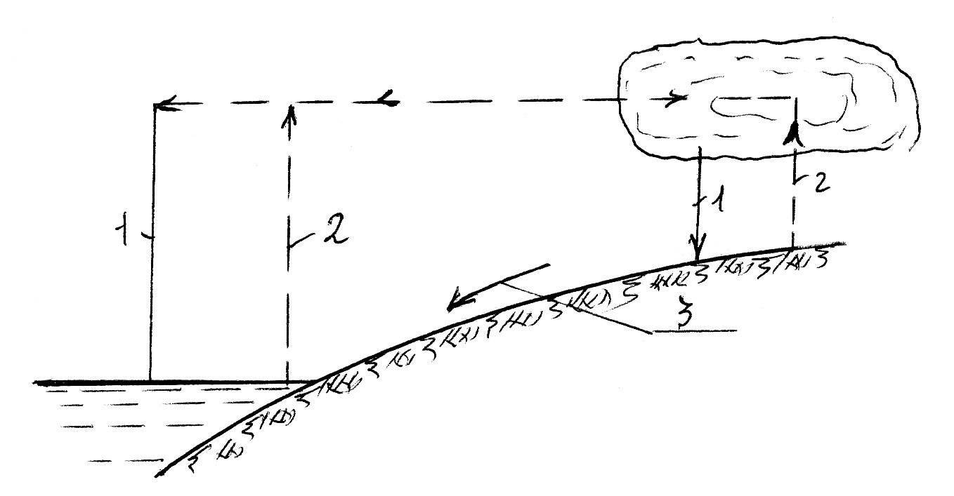

**nax.1 1-atmosferuli naleqebi; 2-aorTqleba; 3-Camonadeni xmeleTidan**

xmeleTis wylis balansi gamoisaxeba Semdegi damokidebulebiT:

,

sadac: P - atmosferuli naleqebi, mm;

E - aorTqleba, mm;

 - zedapiruli Camonadeni.

amrigad, xmeleTis wylis balansis ZiriTadi elementebia: atmosferuli naleqebi, aorTqleba da zedapiruli Camonadeni. samive am elements didi mniSvneloba aqvs rogorc hidrologiuri, aseve sasoflo-sameurneo da melioraciuli TvalsazrisiTac, vinaidan saboloo jamSi mniSvnelovan gavlenas axdenen niadagis tenis dinamikaze.

**5. atmosferuli naleqebis gavlena niadagis**

**tenis dinamikaze**

atmosferuli naleqebi xasiaTdeba metad araTanabari teritoriuli gadanawilebiT. arsebobs regionebi, sadac atmosferuli naleqebis raodenoba aWarbebs 12000 mm-s weliwadSi, magaliTad, indoneziis zogierT regionSi, xolo ekvatoruli zonis rig raionSi mosuli wliuri naleqebis jami Seadgens mxolod 10...15 mm, rac niadagis dasvelebisaTvisac ki ar aris sakmarisi, xolo perusa da libis udabnoebSi naleqebi saerTod ar aris.

atmosferuli naleqebis wliuri raodenoba farTo diapazonSi meryeobs saqarTvelos farglebSic qveynis aRmosavleTi da dasavleTi nawilebi mkveTrad gansxvavdebian erTmaneTisagan klimaturi pirobebiT, rac asaxvas hpovebs atmosferul naleqebzec. dasavleT-saqarTvelo xasiaTdeba atmosferuli naleqebis wliuri raodenobiT, 1500...2700 mm, xolo aRmosavleT saqarTvelo 500...1000 mm, rac pirvel SemTxvevaSi ganapirobebs naleqebis siWarbes (gansakuTrebiT soflis meurneobisaTvis), xolo meore SemTxvevaSi mis deficits.

aqve unda aRiniSnos, rom naleqebis jamuri raodnoba srulad ar asaxavs teritoriis wyliT uzrunvelyofis realur suraTs, gansakuTrebiT es exeba soflis meurneobisaTvis saWiro wyals, sadac mTavaria ara atmosferuli naleqebis mosvlis saerTo suraTi, aramed misi ganawileba wlis periodebis mixedviT.

roca ufro Tanabradaa ganawilebuli naleqebi mTeli wlis ganmavlobaSi, miT ufro naklebad meryeobs niadagis tenic da miT ufro ukeTesi pirobebi iqmneba mcenarisaTvis. sasoflo-sameurneo sameurneo TvalsazrisiT, atmosferuli naleqebis ganawileba wlis ganmavlobaSi iyofa or periodad: pirveli periodi daaxloebiT pirveli oqtombridan pirvel martamdea, rodesac mcenare wyals ar iyenebs am periods ewodeba dagrovebis periodi; meore periodia pirveli martidan pirvel oqtombramde, rodesac mcenare wyals iyenebs, da am periods ewodeba moxmarebis periodi.

sarwyav zonebSi wliuri naleqebis rac ufro meti nawili modis moxmarebis periodSi, miT ukeTesi pirobebia mcenarisaTvis.

aRmosavleT saqarTveloSi naleqebis umetesi nawili modis swored moxmarebis periodSi (wliuri raodenobis 47.5...81.9%,aqedan mxolod 11.0...18.0%) modis ivlis-agvistoze,rac mcenarisaTvis araxelsayrel pirobebs cvlis, da aucilebelia am periodSi rwyvis Catareba.

**6. aorTqlebis gavlena niadagis tanis dinamikaze**

niadagis tenianobis reJimze did gavlenas axdens wylis aorTqleba niadagis zedapiridan.

bunebaSi aorTqleba ganuwyvetliv mimdinareobs. amasTan, igi cvalebadobs dRe-Ramisa da wlis ganmavlobaSi da damokidebulia haeris temperaturasa da haeris SefardebiT tenianobaze.

garda aRniSnulisa aorTqlebis cvalebadobaze gavlenas axdens niadagSi wylis Semcveloba, misi fizikuri Tvisebebi, niadagis zedapiris mdgomareoba, reliefi, mcenareuli safari. yvela es faqtori zdris an amcirebs aorTqlebas.

aorTqleba miT ufro didia, rac ufro teniania niadagis zeda fena da zeda pirTan axlos mdebareobs gruntis wyali; rac ufro borcviania, xorkliania da muqia niadagis zedapiri, rac meti kapilaroba axasiaTebs niadags.

niadagidan aorTqlebas adidebs mcenareulis safari; balaxiT dafaruli farTobi ufro met wyals xarjavs aorTqlebaze da transpiraciaze erTad aRebuli, vidre SiSveli niadagi. mcenareulobiT dafaruli niadagidan aorTqleba 3 mimarTulebiT mimdinareobs: TviT niadagidan,mcenaris garegani zedapiridan, da transipiraciis saSualebiT. aorTqleba TviT niadagidan, Tu igi daCrdilulia mcenareulobiT, gacielebiT naklebia, vidre SiSveli niadagidan, vinaidan aseT pirobebSi qarisa da temperaturis moqmedeba naklebia, xolo SefardebiTi tenianoba -meti.

wyliT gaJRenTili niadagidan gacilebiT meti wyali orTqldeba vidre wylis zedapiridan, xolo niadagis gaSrobis Semdeg aorTqleba mkveTrad ecema.

dRe-Ramis ganmavlobaSi aorTqlebis maqsimumi modis 13-14 saaTze, rodesac maRalia amaorTqlebeli zedapiris temperatura, tenis deficiti da qaris siswrafe. RamiT ki zemoT CamoTvlili faqtorebis minimalurad arsebobis gamo, aorTqleba mkveTrad ecema.

aorTqlebis wliuri raodenobis maqsimumi aRiniSneba ivlisSi, minimumi-noember-dekemberSi.

**7. zedapiruli Camonadenis gavlena niadagis**

**tenis dinamikaze**

atmosferuli naleqebis umetesi nawili zedapirs xvdeba, aqedan nawili uSualod niadagSi iJoneba, xolo nawili miedineba niadagis zedapirze Camonadenis saxiT da warmoadgens mdinareebisa da sxva saxis nakadebis kvebis mTavar wyaros. zedapiruli Camonadenis warmoSoba da raodenoba damokidebulia :

1. naleqebis raodenobasa da intesivobaze;

2. naleqebis mosvlis droze;

3. reliefsa da qanobze;

4. mcenareul safarze;

5. adamianis zemoqmedebaze;

aRniSnuli faqtorebidan gadamwyvet rols klimaturi faqtori-naleqi da aorTqleba asrulebs, rac metia atmosferuli naleqebi da naklebia aorTqleba miT meti iqneba zedapiruli Camonadeni.

zedapiruli Camonadeni gavlenas axdens niadagis tenis reJimze, im SemTxvevaSi, rodesac atmosferuli naleqebi mcire intensivobisaa, zedapirs mcire daqaneba aqvs, da niadagi msubuqi meqanikuri Sedgenilobsaa, zedapiruli Camonadeni Senelebulia da niadagi maqsimaluradaa gatenianebuli, xolo rodesac wvimebi xSiria da didi intensivobiT xasiaTdeba, teritorias didi qanobi aqvs, da niadagebi mZime meqanikuri Sedgenilobisaa zedapiruli Camonadeni maqsimums aRwevs.

zedapirul Camonadenze gavlenas axdens mcenareuli safaric, vinaidan igi anawilebs wylis dinebas zedapirze da amiT izrdeba niadagSi wylis CaJonva. garda amisa, mcenareulobiT dafaruli niadagebidan aorTqlebaze da mcenareTa transpiraciaze ufro meti wyali ixarjeba, vidre mcenaris safaris gareSe arsebuli niadagis zedapiridan.

Camonadenze adamianis zemoqmedeba gulisxmobs mdinareebze wyalsacavebis mowyobas Camonadenis regulirebis mizniT; zedapiruli Camonadenis reJimze gavlenas axdens agreTve tyis gaCexva, romelic aZlierebs Camonadenis araTanabar ganawilebas wlis ganmavlobaSi.

zedapiruli Camonadeni xasiaTdeba ori sididiT - Camonadenis koeficientiTa da Camonadenis moduliT.

Camonadenis koeficienti ewodeba wyalSemkreb auzze Camonadeni wylis raodenobis Sefardebas amave farTobze mosuli atmosferuli naleqebis jamTan.

Camonadenis moduli ewodeba wylis im raodenobas, romelic moedineba wyalSemkrebi farTobis erTeulidan drois erTeulSi misi ganzomilebaa l\wm ha-dan an l\w km-dan.

**8. sarwyavi wylis wyaro**

miwis farTobebis mosarwyavad gamoiyeneba mdinareebis, tbebis, miwisqveSa, adgilobrivi zedapiruli Camonadenis da Camdinare wylebi.

wylis wyaroebis mimarT ZiriTadi moTxovnebia: wyali gamosadegi unda iyos sasoflo-sameurneo kulturebis mosarwyavad, wylis maragi da xarjebi maTSi srulad da yovelTvis uzrunvelyofdes moTxovnebs wyalze, wylis wyaro maqsimalurad axlos unda imyofebodes mosarwyav masivTan da masze maRal niSnulebze unda mdebareobdes, raTa wyali mowodebuli iqnas TviTnebiT.

zemodCamoTvlil SesaZlebel wylis wyaroeebidan umeteswilad gamoiyeneba mdinare, romlis reJimic mniSvnelovnad icvleba rogorc yovelwliurad, aseve wlis calkeul periodebSi, klimaturi pirobebis cvalebadobis gamo. amitom sarwyavi sistemis daproeqtebisas saWiroa gvqondes rac SeiZleba meti wlis monacemebi mdinareSi wylis xarjebisa da horizontebis cvalebadobis Sesaxeb, raTa SevarCioT saangariSi weliwadi, romelic uzrunvelyofs sarwyav sistemas wylis optimaluri raodenobiT.

imisaTvis, rom sarwyavi sistemebi optimalurad iyos uzrunvelyofili savegetacio periodSi wyliT, xSirad saWiro xdeba mdinareTa reJimis saTanado regulireba wyalsacavebis mowyobis gziT, rac imaSi mdgomareobs, rom wyalmetobis periodSi xdeba maTSi wylis dagroveba, romelic Semdeg gamoiyeneba sarwyav sistemebSi wylis deficitis dros. aseT regulirebas eqvemdebarebian saqarTvelos ZiriTadi mdinareebi, romlebic ZiriTadad ikvebebian atmosferuli naleqebiT da aprilidan ivnisamde axasiaTebT wyaldidobebi, xolo ivlisidan maTSi wylis xarjebi mniSvnelovnad mcirdeba. e.i. xarjis Semcireba im periodze modis, rodesac soflis meurneobaSi wylis didi moTxovnebia.

sul sxva suraTs iZleva iseTi mdinareebis reJimi, romelTa kvebac xdeba myinvarebis wylebiT. maTi dnoba maqsimums aRwevs zafxulis cxel TveebSi, rodesac CvenSi atmosferuli naleqebis minimalur raodenobas aqvs adgili.

Tu SevadarebT am ori kategoriis mdinareebs maT mier soflis meurneobis moTxovnilebis dakmayofilebis mxriv (nax ), aq upiratesoba ekuTvnis myinvarebis wylebiT mkvebav mdinareebs, vinaidan zafxulis cxel TveebSi mdinareSi wylis nakleboba aq iSviaTia.

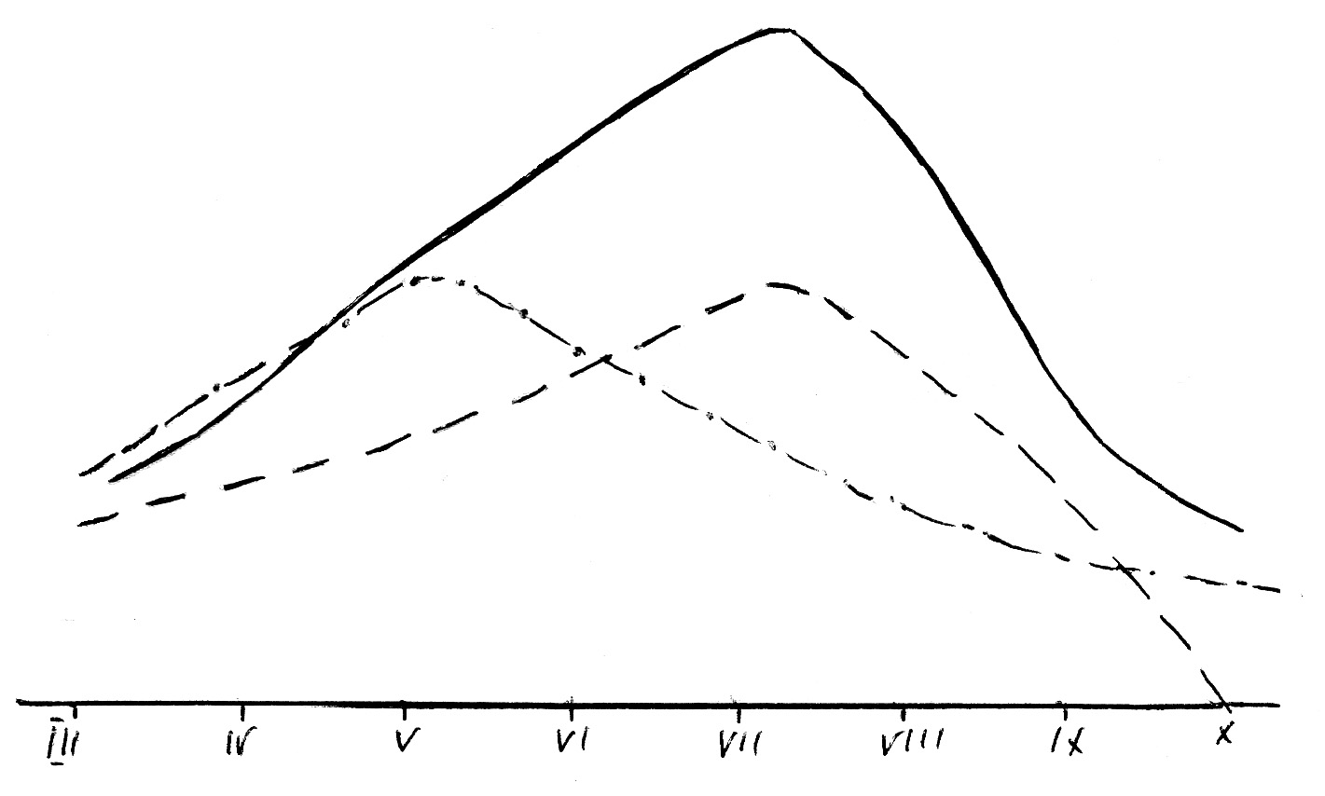

**nax. 2.**

**myinvarebis wylebiT mkvebavi mdinare**

**atmosferuli naleqebiT mkvebavi mdinare**

**mcenaris wyalmoTxovnileba**

**9. niadagis teni**

niadagis teni warmoadgens mcenarisa da niadagis mikroflorisa da mikrofaunasTvis misawvdomi wylis ZiriTad wyaros da amitom igi niadagis nayofierebis ganmsazRvreli erT-erTi umniSvnelovanesi faqtoria. amasTan, niadagSi wyali sxvadasxva Zalebis zegavleniT, araerTgvarovan mdgomareobaSi imyofeba da aqedan gamomdinare, icvleba misi Tvisebebi, moZraoba niadagSi da mcenarisTvis misawvdomoba.

niadagis wylis Tanamedrove klasifikaciebs daedo prof. lebedevis klasifikacia romlis mixedviTac gamoyofen niadagis wylis Semdeg formebs:

1. **orTqlisebri wyali.**

orTqlisebri wyali warmoadgens niadagis forebSi moTavsebuli haeris Semadgenel nawils da Seadgens saSualod haeris 0.5... 2.3%

orTqlisebri wylis wyaroebia, erTi mxriv, atmosferuli haeris orTqli, meore mxriv-niadagis tenis yvela forma orTqlis mdgomareobaSi gadasvlis Semdeg. orTqlisebri teni niadagSi mudmiv dinamikur cvlilebebs ganicdis da misi gadaadgileba emorCileba haeris drekadobis kanons - orTqlis maRali drekadobis aridan naklebi drekadobis mimarTulebiT, an kidev maRalidan dabali temperaturis mqone fenebisaken.

orTqlisebri wyali warmoadgens niadagidan wylis aorTqlebis ZiriTad nawils.

orTqlisebri teni mcenarisTvis miuwvdomelia.

**II. higroskopiuli wyali.**

niadagis Tvisebas moaxdinos haeridan wylis orTqlis adsorbacia (STanTqma) ewodeba higroskopiuloba, xolod wyals, romelic STainTqmeba niadagis nawilakebis zedapiris mier-higroskopiuli wyali. igi niadagis nawilakebis garSemo qmnis Txel fenas apkis saxiT da zedapiruli daWimulobis ZaliT Seikaveba mis zedapirze. am wylis mosacileblad niadagis nawilakebisagan saWiroa maRali temperatura (105C) 6-8 saaTis ganmavlobaSi.

higroskopiuli wylis raodenoba damokidebulia niadaggruntebis meqanikur Sedgenilobaze-metia Tixnar niadagebSi da bevrad naklebi msubuq niadagebze; damokidebulia agreTve haeris SefardebiT tenianobaze, rodesac niadagis Semxebi haeris fardobiTi tenianoba 100%-s miuaxlovndeba (94...96%) maSin niadagSi adsorbirebuli teni maqsimums aRwevs, rasac maqsimaluri higroskopiuloba ewodeba. am wyals gadaadgileba SeuZlia mxolod orTqlebisebr mdgomareobaSi gadasvlis Semdeg.

mcenare am wyliTac ver sargeblobs.

**III. apkisebri wyali.**

maqsmilalur higroskopiulamde datenianebuli niadagis Semdgomi dasvelebiT warmoiqmeneba e.w. apkisebri wyali, romelic warmoqmnis ufro sqel fenas niadagis nawilakebis garSemo da wylis mere es nawilakebi niadagis masasTan gacilebiT naklebi ZaliT arian dakavebuli, vidre higroskopiuli wylis SemTxvevaSi. apkisebri wyali, Tavis mxriv, Seicavs higroskopiul da maqsimalur higroskopiul wyalsac. wylis es formac Zneli mosaSorebelia. niadagis nawilakebidan da mcenaris zrda-ganviTarebaSi misi monawileoba SezRudulia.

**IV. kapilaruli wyali**

kapilaruli wyali ewodeba niadag-gruntis kapilaruls forebSi moTavsebul wyals, romlis dakavebac niadags SeuZlia. wylis meniskebis ZaliT. igi moZraobs niadagis kapilarebSi sxvadasxva mimarTulebiT, maT Soris qvevidan zeviT. wylis kapilaruli aweva xdeba zedapiruli daWimulobis ZaliT.

niadagis kapilarebSi wylis moZraobis siCqare miT metia, rac ufro didia kapilaruli forebis diametri, xolo awevis simaRle mit ufro metia, rac naklebia forebis diametri, e.i. kapilaruli awevis simaRle, meqanikuri Sedgenilbis niadagebSi metia, vidre msubuq niadagebSi.

kapilaruli wyali mcenaris kvebis mTavari wyaroa.

**V. gravitaciuli wyali**

rodesac niadagis yvela fori Seivseba wyliT, igi Tavisi simZimis ZaliT iwyebs moZraobas da miiswrafvis Rrma fenebisaken zemodan qvemoT. wylis aseT moZraobas ewodeba gravitaciuli moZraoba

gravitaciuli wyali niadagSi warmoiqmneba atmosferuli naleqebis da sarwyavi wlis meSveobiT da nawilobriv, niadag-gruntis wylebis orTqlis kondensaciis Sedegad. gravitaciuli wyali mcenarisaTvis misawvdomia magram misi gamoyeneba, garkveul wilad, SezRudulia misi swrafad gadaadgilebis gamo. amitom mcenare am wyliT sargeblobs sanam is ar gascildeba fesvTa sistemis gavrcelebis ares.

**10. niadagis wyaltevadoba**

mcenare wyals niadagidan iTvisebs Tavisi fesvTa sistemis saSualebiT, amitom mcenaris zrda-ganviTareba damokidebulia niadagSi arsebul wylis maragze anu tenianobaze.

niadagi, rogorc forovani sxeuli, xasiaTdeba wyalSeRwevadobiT da wylis Sekavebis unariT.

niadagis unars daikavos wylis garkveuli raodenoba, ewodeba wyaltevadoba, romelic damokidebulia niadagis meqanikur Sedgenilobaze, da sxva.

niadagSi arsebuli tenis raodenobisa da mdgomareobis mixedviT arCeven kapilarul, srul da zRvrul wyaltevadobas.

niadagis gatenianobis dros varCevT ramodenime moments : upirveles yovlisa xdeba wylis miwodeba niadagis zedapirze rasac Tan sdevs niadagSi wylis SeJonva. amis Semdeg iwyeba wylis ganawileba sxvadasxva saxis napralebsa da forebSi. im SemTxvevaSi, rodesac teni daikavebs wvril da saSualo forebs, tenis aseT mdgomareobas Seesabameba kapilaruli wyaltevadoba. rodesac tens uWiravs yvela saxis forebi, agregatSorisi sicariele da napralebi, vRebulobT srul wyaltevadobas. niadagis gaJRenTis Semdeg iwyeba tenis CaJonva filtracia zevidan qveviT. rodesac CaJonva Sewydeba niadagSi damyardeba tenis erTgvari wonasworuli mdgomareoba, rac mis zRvrul wyaltevadobas Seesabameba.

amrigad, zRvruli wyaltevadoba aris wylis is raodenoba, romlis dakavebac niadags SeuZlia da, romelic simZimis Zalis gavleniT ar gadaadgildeba zeda fenebidan qveda fenebisaken. zRvrul wyaltevadobaze meti raodenobiT miwodebuli wyali ukve aRar Cerdeba zeda fenebSi da Tavisi simZimis ZaliT Caedineba qvemoT.

niadagis zRvruli wyaltevadoba niadagis Tvisebebis mixedviT sruli wyaltevadobis 90%-s aRwevs.

miwaTmoqmedebasa da melioraciaSi zRvrul wyaltevadobas metad didi mniSvneloba aqvs, radgan am TvisebiT niadagi Seakavebs da Semdeg amaragebs mcenares sasargeblo teniT. niadags rom es unari ar hqondes, maSin tenis mTeli maragi siRrmeSi CaiJoneba da mcenarisaTvis usargeblo iqneboda. mcenarisaTvis optimaluri tenianobis zeda sazRvrad miRebulia swored zRvruli wyaltevadoba, xolo qveda sazRvrad misi 70%...80% saWiroa morwyvis Catareba, vinaidan mcenare TandaTanobiT kargavs tenis SeTvisebis unars da iwyebs Wknobas.

niadagSi mcenarisaTvis miuwvdomeli wylis raodenobas, romlis gamoyenebac mcenares ar SeuZlia da romlis arsebobis dros igi Wknobas iwyebs ewodeba Wknobis koeficienti.

sxvadasxva meqanikuri Sedgenilobis niadagSi Wknobis tenianoba sxvadasxvaa: qviSnarebSi 1...3%, TixnarebSi 3...10%, TixebSi 10...15%, niadagis zRvruli wyaltevadobidan.

mcenaris zrda-ganviTarebisaTvis saWiro wylis raodenobaze warmodgenas gvaZlevs transpiraciis koeficienti, anu wylis is raodenoba, romelsac xarjavs mcenare gansazRvrul pirobebSi Tavisi mSrali nivTierebis erTeuli wonis Sesaqmnelad.

**11. niadagis tenis maragis gansazRvra**

niadagis garkveul fenaSi tenis maragis gansazRvrisaTvis saWiroa vicodeT niadagis tenianoba R, gamosaxuli %-Si niadagis mSrali masidan da niadagis moculobiTi wona γ. Tu niadagis fenis sisqes avRniSnavT H-iT, maSin am fenaSi tenis maragi W ganisazRvreba Semdegnairad:

1 ha farTobi Seadgens 10000 m2. H m sisqis niadagis moculoba iqneba 10000·H; imave niadagis wona mSral mdgomareobaSi iqneba 10000·H·γ, xolo masSi wylis raodenoba wona:





 t/ha.

**Tavi I**

**morwyviTi melioracia**

**12. sasoflo-sameurneo kulturebis morwyvis saxeebi**

melioraciul praqtikaSi moqmedebis xasiaTis mixedviT arCeven melioraciis Semdeg saxeebs:

**1.** **regularul-savegatacio rwyva.** vegetaciuri rwyva warmoadgens ZiriTad rwyvas sasoflo-sameurneo kulturebisaTvis. igi tardeba vegetaciis periodSi mcenaris wyalmoTxovnilebis Sesabamisad dadgenili morwyvis normebisa da rwyvis vadebis mixedviT.

morwyvis es saxe gavrcelebulia daaxloebiT mTeli sarwyavi farTobebis 85%-ze.

**2. erTjeradi-tendamagrovebeli rwyva**. igi tardeba gvian Semodgomaze an zamTarSi niadagSi garkveuli tenis maragis Sesaqmnelad, rac xels uwyobs gazafxulze sasoflo-sameurneo samuSaoebis dawesebul vadebSi Catarebas. tendamagrovebeli rwyva gamoiyeneba sarwyavi wyliT Rarib regionebSi, xolo iseTi regionebisaTvis, sadac gazafxulis periodi mdidaria naleqebiT, igi sazianoa, vinaidan zamTris rwyva niadags zedmetad atenianebs, miwa droze ar Sreba da Tesva Wianurdeba. tendamagrovebeli rwyva karg Sedegs iZleva xexilisa da vazis nargavebisaTvis.

**3. xvniswina rwyva** – tardeba xvnis win niadagis dasamuSaveblad xelsayreli pirobebis Sesaqmnelad.

**4. Tesviswina rwyva** – Teslis drouli da normaluri aRmocenebisaTvis saWiroa Catardes specialuri rwyva Tesvis damTavrebisTanave, romelsac Tesvis an rgvis rwyvas uwodeben.

zogjer morwyvas Tesvamde atareben, roca niadagi Zlier Raribia teniT, agreTve roca sarwyavi wylis naklebobaa, ramac SeiZleba gamoiwvios Tesvis win rwyvis gaWianureba. garda amisa, Tesvis win morwyvis Catareba SeiZleba gamowveuli iyos mlaSe niadagebis arsebobiT. aseT SemTxvevaSi Tesvis win rwyvas Zlieri morwyvis normiT atareben (1000-2000 m3/ha) da adviladxsnad marilebs qveda fenaSi Carecxaven.

CvenSi, umetes SemTxvevaSi rwyvas Tesvis damTavrebis Semdeg awarmoeben, vinaidan sarwyavi wylis nakleboba rwyvis periodSi iSviaTia.

**5. gamanoyierebeli rwyva.** gamanoyierebeli rwyva gamoiyeneba niadagSi sasuqis Setanisa da misi Tanabrad ganawilebis mizniT. vegetaciis periodSi, naTes-nargavebis damatebiTi gamokvebis dros Sesatanad gankuTvnili sasuqebi, umetesad mineraluri, jer moibneva naTesebSi niadagis zedapirze mwkrivTaSorisebis kultivaciis win da Semdeg amas mohyveba rwyva. SeiZleba kidev sasuqebis Sesatani norma jer gaixsnas wyalSi saTanado koncentraciiT da Semdeg specialuri gamomkvebi manqaniT rwyvis saxiT Setanili iqnas niadagSi.

mdinaris wyalSi molivlive nivTierebebis sasuqad gamoyeneba uZvelesi droidan aris cnobili. mdinaris naleqi mdidaria mcenarisaTvis saWiro nivTierebebiT da am naleqis farTobze xelovnurad dagroveba niadagis ganoyierebis erT-erT saxes warmoadgens.

xSirad mosaxleoba arxebSi dagrovil naleqs iyenebs, romelic gaaqvT farTobze Cveulebrivi wesiT Casaxnavad.

rwyvis niadagis gasanoyiereblad, Cveulebriv, Semodgoma-zamTris periodSi mimarTaven, gansakuTrebiT ki, zamTris bolos da gazafxulis dasawyisSi, rodesac farTobebi jer kidev ar aris daTesili da sarwyav wyalSi naleqebis didi raodenobaa.

rwyvas, farTobze datborebis wesiT awarmoeben. farTobi winaswar iyofa calkeul sarwyav farTobebad im varaudiT, rom SesaZlebeli iqnes mTel farTobze wylis datboreba. yoveli aseTi sarwyavi farTobi yovelmxriv SemosazRvrulia beqobiT da gadamuSavebeli wyali, SedarebiT ganTavisuflebuli naleqebisagan, gadaiSveba farTobidan mis udables mxareze arsebuli buqobis erT an or adgilas gaxsnis saSualebiT.

rac ufro Tanabarzomierad mimdinareobs wylis miwodeba da farTobidan misi gadaSveba, miT ufro met naleqs datovebs wyali.

xSirad mimarTaven naleqebis winaswar dagrovebas specialurad damzadebul ormoebSi. ormo drogamoSvebiT icleba da naleqi xvnis win gaaqvT mindorSi. ormo, Cveulebriv, arxis maxloblad mzaddeba, rac aadvilebs arxidan wylis miRebas da gadamuSavebuli wylis arxSive gadaSvebas.

rwyvis saSualebiT naleqebis dagroveba gansakuTrebiT aucileblobas warmoadgens qviani niadagisaTvis (quTaisis r-ni), sadac niadagis ganoyierebasTan erTad naleqebis dagrovebiT wvrilmiwis raodenobas vadidebT. am SemTxvevaSi naleqis didi raodenobaa saWiro.

**6. rwyva niadagis gaTbobis mizniT.** gaTbobis mizniT rwyvas vawarmoebT adre gazafxulze, risTvisac iyeneben Termul wylebs, qarxnebidan gadamuSavebul wyals da sxv. romelTa temperaturac metia niadagis temperaturaze.

rwyvis am saxes ZiriTadad iyeneben saTburebSi, oranJereebSi da sxv.

**7. rwyva niadagis Carecxvis mizniT** – tardeba niadagSi adviladxsnadi marilebis (NaCl, Na2CO3, K2SO4) mosacileblad. rwyvis es saxe gamoiyeneba damlaSebeli niadagebis gamomlaSebisaTvis da tardeba Tesvis win, Semodgoma-zamTris periodSi.

**8. provokaciuli rwyva.** rwyvis am saxes iyeneben sarevelebis aRmosaceneblad, romelic SemdgomSi mospobili iqneba qimikatebiT an kidev niadagis saTanado damuSavebiT. rwyvas awarmoeben, Cveulebriv, Semodgomaze, mosavlis aRebis Semdeg.

**9. gamagrilebeli rwyva** – tardeba yvelaze cxel periodSi mcenaris gasagrileblad. rwyva tardeba dawvimebiT. es rwyva adidebs haeris absolutur tenianobas da amcirebs haeris temperaturas. garda amisa, dawvimeba uaxlovdeba bunebrivi naleqebis moqmedebis pirobebs niadagis datenianebis mxriv.

**13. sasoflo-sameurneo kulturebis rwyvis reJimi**

sasoflo-sameurneo kulturaTa rwyvis reJimi safuZvlad udevs sarwyavi sistemebis daproeqtebas da moicavs Semdegi sakiTxebis damuSavebas: jamuri wyalmoTxovnilebis gansazRvra, sarwyavi normis dadgena, morwyvis normis dadgena, morwyvis vadebisa da morwyvaTa raodenobis dadgena.

**1. jamuri wyalmoTxovnileba**

sasoflo-sameurneo kulturebiT dakavebuli mindvridan niadagis teni ixarjeba zedapiridan fizikur aorTqlebasa da transpiraciaze, anu fiziologiur aorTqlebaze. orive saxis aorTqlebas erTad jamuri aorTqleba, anu jamuri wyalmoTxovnileba ewodeba, rasac agreTve evapotranspiraciasac uwodeben.

fizikuri aorTqlebisa da transpiraciis urTierTTanafardoba saerTo wyalmoTxovnilebaSi damokidebulia klimatur pirobebze, mcenaris saxeobaze da misi ganviTarebis fazebze, agreTve mTel rig sxva faqtorebze. sasoflo-sameurneo kulturebis ganviTarebis sawyis periodSi fizikuri aorTqleba, Cveulebriv, Warbobs transpiracias. Semdeg es Tanafardoba SebrunebiT icvleba.

melioraciuli TvalsazrisiT maTi cal-calke gamoyofa TiTqmis saWiro ar aris da amitom ganisazRvreba erTianad, rogorc saerTo aorTqleba.

sarwyavi miwaTmoqmedebis pirobebSi arsebobs sasoflo-sameurneo kulturebis wyalmoTxovnilebis gansazRvris mravali meTodi Teoriuli xasiaTisa, magram yvelaze utyuari monacemebis miReba SesaZlebelia empiriuli meTodebis gamoyenebis saSualebiT, romelic eyrdnoba uSualo dakvirvebebs.

a. kostiakovi pirveli iyo, romelmac jamuri wyalmoTxovnileba daukavSira mosavlianobas empiriuli formuliT.

,

sadac: E - kulturis wyalmoTxovnileba 1 ha-ze mTel savegetacio periodis ganmavlobaSi, m3/ha;

Υ – kulturis saproeqto mosavlianoba, m3/ha;

Km – wyalmoTxovnilebis koeficienti, anu xvedriTi jamuri wyalmoTxovnileba mosavlis erTeulze, m3/t.

mcenaris jamuri wyalmoTxovnilebis gansazRvrisaTvis arsebobs mTeli rigi formulebi, romlebsac regionaluri mniSvneloba aqvT. magaliTad, saqarTvelos pirobebisaTvis prof. i. Cxenkelma SemogvTavaza Semdegi formula:

 mm,

sadac:  - aris haerSi tenianobis deficitis jami mm-obiT saangariSo periodSi;

*K*w – wyalmoTxovnilebis koeficienti, romelic ganisazRvreba savele eqsperimentebis safuZvelze.

**2. sarwyavi norma**

sasoflo-sameurneo kulturaTa wyalmoTxovnileba bunebriv pirobebSi SeiZleba dakmayofilebuli iqnas niadagSi arsebuli tenisa da atmosferuli naleqebis xarjze, magram mSral periodebSi tenis es raodenoba xSirad sakmarisi ar aris da amitom saWiroa rwyvis Catareba.

sarwyavi norma aris wylis is raodenoba, romelic unda mivawodoT 1 ha farTobs mTeli savegetacio periodis ganmavlobaSi.

sarwyavi norma iangariSeba formuliT:

,

sadac: M - sarwyavi norma, m3/ha;

E - sasoflo-sameurneo kulturebis wyalmoTxovnileba savegetacio periodis ganmavlobaSi, m3/ha;

P - mosuli atmosferuli naleqebis raodenoba savegetacio periodSi, mm;

 - atmosferuli naleqebis dakavebis koeficienti;

 - niadagSi arsebuli wylis maragidan gamoyenebuli wyali,

m3/ha;

- savegetacio periodSi mcenaris mier gamoyenebuli gruntis wyali, m3/ha.

sarwyavi norma sxvadasxva kulturisaTvis cvalebadia. magaliTad, marcvlovanebisaTvis igi Seadgens 2700-3500 m3/ha; simindi – 2100-4000 m3/ha; venaxi – 2200-4800 m3/ha; baRi – 2200-4800 m3/ha; bostani – 1000-5000 m3/ha.

**3. morwyvis norma**

sarwyavi normiT gaTvaliswinebuli wylis raodenoba savegetacio periodSi nawil-nawil, drois garkveul monakveTebSi, rwyvis normebis saxiT miewodeba niadags, ise, rom niadagSi ar dairRves haeraciis normaluri pirobebi da mcenaris kvebis reJimi.

, m3/ha

sadac: M - sarwyavi norma, m3/ha;

m - morwyvis norma, m3/ha.

amrigad, morwyvis norma aris wylis is raodenoba, romelic unda mivawodoT sasoflo-sameurneo kulturiT dakavebuli 1 ha farTobs erTi morigi morwyvis dros.

morwyvis normis gaangariSebisaTvis saWiroa vicodeT:

1. aqtiuri fenis sisqe sarwyavi kulturisaTvis;
2. niadagis moculobiTi wona;
3. niadagis zRvruli wyaltevadoba woniTi procentebiT;
4. mcenarisaTvis tenis maragis qveda sasurveli minimumi.

aRniSnuli moTxovnebis gaTvaliswinebiT morwyvis normis saangariSo damokidebuleba gamoisaxeba Semdegnairad:

,

sadac: H – aris niadagis aqtiuri fena, anu is fena sadac fesvTa sistemis ZiriTadi masaa ganlagebuli da, romelic eqvemdebareba gatenianebas saWiro morwyvis normiT, m;

aqtiuri fena sxvadasxva kulturebisaTvis sxvadasxvaa da Seadgens:

bostneuli kulturebisaTvis – 0,3...0,50

mindvris kulturebisaTvis – 0,6...0,80

mravalwliani kulturebisaTvis – 0,7...1,0 m.

erTidaigive mcenarisaTvis aqtiuri fena icvleba ganviTarebis fazebis mixedviT da aRniSnuli gradaciebi aqtiuri fenis siRrmeebisa damaxasiaTebelia mcenaris maqsimaluri ganviTarebis periodisaTvis.

 - niadagis moculobiTi wona g/sm3 da meryeobs 0,5...1,5 farglebSi.

 - niadagis zRvruli tendevadoba (niadagis optimaluri tenianoba aqtiur fenaSi, %);

 - niadagSi tenis sasurveli minimumi.

morwyvis normaze gavlenas axdenen sxvadasxva faqtorebi da amitom am formuliT gamoTvlili sidideebi saWiroeben koreqtirebas.

ase, magaliTad, morwyvis norma unda Semcirdes im SemTxvevaSi, rodesac:

a) gruntis wyali mdebareobs aqtiuri fenis axlos, raTa am SemTxvevaSi Tavidan aviciloT sarwyavi da gruntis wylebis SeerTeba, rasac SeiZleba moyves niadagis daWaobeba;

b) niadagis qveda fena Zlier mariliania, radgan saSiSia marilebi wylis saSualebiT zeda fenaSi ar amovidnen;

g) aqtiuri fenis qveda nawili an uSualod mis qvemoT mdebare fena aris Zlier mCate meqanikuri Sedgenilobis, vinaidan es fena garkveul raodenobaze met wyals ver daitevs da igi usargeblod Cava siRrmeSi.

morwyvis norma unda gadiddes im SemTxvevaSi, rodesac mTeli aqtiuri fena ramdenamde damlaSebulia. am SemTxvevaSi gadidebuli morwyvis normiT warmoebs marilebis Carecxva qveda fenaSi.

saqarTvelos pirobebSi, sadac sarwyavi miwebi, upiratesad, mZime meqanikuri Sedgenilobisaa, morwyvis normebs saerTod esaWiroeba gadideba, rac ganpirobebulia imiT, rom aseTi niadagebi xasiaTdeba mcire wyalJonvadobiT da gaangariSebiT miRebuli rwyvis normiT miwodebuli wyali droulad ver Cadis gaTvaliswinebul siRrmemde, umetesi nawili ferxdeba zeda fenebSi, saidanac iwyeba wylis intensiuri xarjva da qveda fenebi rCeba naklebad gatenianebuli.

amitom, aRniSnuli garemoebis gaTvaliswinebiT, Tavidanve vaZlevT niadags 10...15%-iT met wyals da, Sesabamisad morwyvis normebis formulaSi Segvaqvs Semasworebeli koeficienti da formula iRebs Semdeg saxes:

, m3/ha

morwyvis normebi mniSvnelovanwiladaa damokidebuli rwyvis teqnikasa da agroteqnikur RonisZiebebze. maTi srulyofa morwyvis normebis Semcirebis saSualebas iZleva maT optimalur sididemde.

**4. rwyvis vadebi**

rwyvis vadebis dadgena xorcieldeba niadagis aqtiur fenaSi wylis balansis dinamikis monacemebis mixedviT, amisaTvis ki saWiroa vicodeT:

a) niadagis aqtiur fenaSi arsebuli wylis maragi pirveli morwyvis win – W0;

b) niadagis sasurveli maqsimaluri zRvari (zRvruli tentevadoba), Ws.m.;

g) rwyvaTaSorisi periodis saSualo dRiuri xarjva – jamuri aorTqleba, *l*, mm;

d) rwyvaTaSoris periodSi mosalodneli atmosferuli naleqebis raodenoba, P, mm.

niadagis wylis sasurveli maqsimaluri zRvarisa da arsebuli wylis maragis sxvaoba mogvcems morwyvis normas, romlis xarjvac mimdinareobs Semdeg morwyvamde.

Tu rwyvaTaSoris periodSi movida garkveuli raodenobis atmosferuli naleqebi, maTi garkveuli raodenoba CaiJoneba niadagSi da gaadidebs masSi wylis marags. am SemTxvevaSi rwyvaTaSoris periodSi sul daixarjeba  m3 wyali, sadac P – atmosferuli naleqebi,  - atmosferuli naleqebis dakavebis koeficienti; 10 - gadasayvani koeficienti mm-dan m3-Si. Tu wylis saSualo dRiur xarjvas aRvniSnavT *l*–iT. maSin rwyvaTaSorisi periodi iqneba:

.

e.i. morwyva unda Catardes *t* dRis Semdeg.

rwyvis dadgenis saukeTeso da zust wesad iTvleba vegetaciis periodis ganmavlobaSi niadagSi aqtiuri fenis farglebSi tenianobis dinamikaze dakvirveba tensazomis saSualebiT da rogorc ki igi miuaxlovdeba zRvruli wyaltevadobis 80% saWiroa rwyvis Catareba. Tu garkveuli regionSi sasoflo-sameurneo kulturas didi farTobi ukavia, misi erT dReSi morwyva SeuZlebelia da am SemTxvevaSi unda davadginoT rwyvis periodi, e.i. dReTa is raodenoba, romlis ganmavlobaSic unda Catardes morigi morwyva kulturiT dakavebul mTel farTobze. cxadia, rac ufro mcirea rwyvis periodis xangrZlivoba, miT ukeTesia kulturisaTvis, vinaidan igi Tanabrad ganviTardeba mTel farTobze.

rwyvis xangrZlivoba damokidebulia Semdeg faqtorebze:

a) sarwyavi wylis wyaros reJimi, e.i. rac ufro metia wylis maragi, miT ufro metad SeiZleba rwyvis periodis Semcireba da erTdroulad meti farTobis morwyva;

b) sarwyavi qselis gamtarunarianobaze da muSaxeliT uzrunvelyofaze;

g) erTdroulad mosarwyavi farTobis sidideze, rac ufro didia kulturiT dakavebuli farTobi, maT metia rwyvis periodi. Cveulebriv, rwyvis periodis xangrZlivoba miRebulia 10-15 dRe, zog SemTxvevaSi – 20 dRe.

rwyvis periodTan dakavSirebulia **rwyvaTaSorisi periodi**, romelic warmoadgens dros erTi rwyvis pirveli dRidan Semdegi rwyvis pirvel dRemde.

rwyvisa da rwyvaTaSorisi periodebis garda aris kidev **sarwyavi periodi**, romelic aris dro pirveli rwyvis pirveli dRidan ukanaskneli rwyvis bolo dRemde.

**14. rwyvis aucilebloba dRe-Ramis ganmavlobaSi**

morwyva, rogorc wesi, dRe-Ramis ganmavlobaSi unda warmoebdes. Cven rom dauSvaT dRe-RameSi sarwyavis wylis, magaliTad, 12 saaTis ganmavlobaSi gamoyeneba, es imas niSnavs, rom meore 12 saaTi wyali uqmed unda daikargos, anda specialuri wyalsacavi unda moewyos am wylis dasagroveblad. garda amisa, sarwyavi farTobi rom igive davtovoT, saWiro iqneba qselis gamtarunarianoba orjer gavzardoT, rac mniSvnelovnad gaaZvirebs sistemis Rirebulebas.

aqedan gamomdinare, sadReRamiso rwyva efeqturia da ekonomiuradac gamarTlebuli. miuxedavad amisa, aris mosazreba, TiTqos zafxulis cxeli dReebis pirobebSi rwyva sazianoa da amitom igi mxolod dilisa da saRamos saaTebSi unda warmoebdes.

cnobilia, rom sicxeSi rwyva iwvevs mcenaris droebiT, e.w. “fiziologiur Wknobas” imis gamo, rom rwyvis dros niadagSi Casuli wyali iwvevs temperaturis dawevas, rac amcirebs fesvTa sistemis mier wylis SeTvisebas, foTlebi ki am dros ganagrZnoben normalur transpiracias. maSasadame, aseT pirobebSi mcenaris mier wylis xarjva Warbobs wylis SeTvisebas. es garemoeba ki iwvevs droebiT “fiziologiur Wknobis” process. magram am movlenas adgili aqvs mcire drois ganmavlobaSi, Semdeg myardeba normaluri fardoba transpiraciasa da SeTvisebas Soris.

amrigad, dRis saaTebSi rwyvis Catarebis uaryofiTi gavlena praqtikulad umniSvneloa im siZneleebTan SedarebiT, rac Seiqmneba dRis saaTebSi sarwyavi wylis gamouyeneblobiT.

**15. sarwyavi hidromodulis gaangariSeba**

calkeuli sasoflo-sameurneo kulturis rwyvis reJimis gaangariSebis Semdeg unda ganisazRvros mTliani sarwyavi farTobis rwyvis reJimi TviTeuli kulturis wyalmoTxovnilebis gaTvaliswinebiT. amis Sedegad miviRebT sarwyavi wylis saWiro moculobas, romelic unda miewodos mTel sarwyav farTobs periodulad garkveul intervalebSi. magram iseTi sainJinro melioraciuli sakiTxebis gadasawyvetad, rogoricaa: yvela kulturis mosarwyavad saWiro wylis raodenoba, drois ama Tu im momentSi drois erTeulSi saWiro wyali, rogori unda iyos arxebis gamtarunarianoba da, maSasadame, maTi zomebi, ramdenad akmayofilebs kvebis wyaro sarwyavi wylis moTxovnebs da a.S., saWiroa gvqondes sarwyavi wylis moTxovnilebis saerTo suraTi, romelic gviCvenebs Tu ra raodenobis wyalia saWiro calkeuli periodebis drois erTeulSi da romeli kultura Tu kulturebi rwyvis am dros.

am moTxovnebis gamosaxva xdeba e.w. hidromodulis grafikis saxiT, romlis asagebad aucilebelia vicodeT: sarwyavi farTobis kulturebis Semadgenloba, saproeqto morwyvis norma, TviTeuli kulturis mier dakavebuli farTobi ω, misi morwyvis xangrZlivoba, *t*. abscisaTa RerZze gadaideba rwyvis periodi TviTeuli kulturisaTvis, ordinatTa RerZze ki – hidromodulis mniSvneloba. aRniSnuli grafiki gviCvenebs wylis saWiro raodenobas drois erTeulSi meurneobis mTel farTobze da mis cvalebadobas rwyvis periodis mTel manZilze. amrigad, hidromoduli aris wylis is raodenoba, romelic saWiroa 1 ha farTobis mosarwyavad drois erTeulSi, l/wm ha.

hidromoduli iangariSeba formuliT:

 l/wm ha,

sadac: q - hidromoduli, w/wm ha;

m - morwyvis norma, m3/ha;

1000 – gadasayvani koeficienti m3-dan litrebSi;

t - kulturaTa rwyvis periodi dRe-RameSi;

86400 – wamebis raodenoba dRe-RameSi;

a% - TviTeuli kulturiT dakavebuli farTobi, %

,

sadac:  - TviTeuli kulturiT dakavebuli farTobi, ha;

 - meurneobis mTliani farTobi, ha.

formulas aseTi saxe aqvs im SemTxvevaSi, rodesac rwyvas awarmoeben dRe-Ramis ganmavlobaSi, xolo Tu dRe-Ramis ganmavlobaSi ar xdeba rwyva, aramed dauSvaT mxolod 16 saaTs dRe-RameSi, maSin hidromoduli da, Sesabamisad, saangariSo xarji gaizrdeba 1,5-jer SedarebiT dRe-Ramur rwyvasTan. amasTan dakavSirebiT unda gaizardos sarwyavi sistemis elementebisa da masze arsebuli nagebobebis parametrebic.

hidromoduli safuZvlad udevs sarwyavi sistemis saangariSo xarjisa da hidravlikur gaangariSebebs.

sarwyavi sistemis saangariSo xarji iangariSeba formuliT:

 m3/wm,

sadac: Q – sarwyavi sistemis saangariSo xarji m3/wm;

q - hidromodulis maqsimaluri mniSvneloba, w/wm ha;

 - sarwyavi sistemis momsaxure mTliani farTobi, ha.

e.i. sarwyavis sistemis gamtarunarianoba damokidebulia hidromodulis grafikis maqsimalur ordinataze. magram wylis aseTi moTxovnileba SedarebiT xanmoklea. cxadia, rom aseTi sistema mTeli rwyvis periodSi araTanabrad iqneba datvirTuli da mis mSeneblobaze gaweuli xarjebi araracionalurad unda CaiTvalos, amitom hidromodulis aseTi grafikiT rwyvis Catareba ararentabeluria da saWiroa hidromodulis grafikis Sesworeba, e.w. dakompleqteba, rac gulisxmobs misi ordinatebis Semcirebasa da maqsimalurad gaTanabrebas da mxolod amis Semdeg SeiZleba hidromodulis grafiki safuZvlad daedos yivelgvar saproeqto samuSaos da gadaeces is warmoebas praqtikuli gamoyenebisaTvis.

hidromodulis grafikis dakompleqtebis mizniT mivmarTavT or ZiriTad saSualebas:

1. rwyvis periodis gaxangrZliveba an Semcireba;

2. rwyvis periodis gadaweva marjvniv an marcxniv.

rwyvis periodis gaxangrZliveba an Semcireba, agreTve rwyvis periodis gadaweva marjvniv an marcxniv, dasaSvebia 5-6 dRiT.

hidromodulis saangariSo formulidan naTlad Cans, rom rwyvis periodis gadidebiT igi mcirdeba da piriqiT.

rwyvis vadebis marjvniv an marcxniv gadaweva saSualebas iZleva Tavidan aviciloT sxvadasxva kulturebis rwyvis vadebis erTmaneTze damTxveva, an SevamciroT aseTi SemTxvevebi.

**16. calkeuli kulturebis rwyva**

**1. saSemodgomo pureuli (xorbali, qeri)**

saqarTvelos sarwyav raionTa umetes nawilSi SemodgomisaTvis niadagi uzrunvelyofili ar aris wylis saWiro maragiT, amitom Semodgomis pureulis daTesvisTanave saWiroa Catardes rwyva. Semodgomis rwyva seqtembris bolo ricxvebidan oqtombris Sua ricxvamde unda Catardes da Tesvis Semdeg 5-7 dRis ganmavlobaSi unda damTavrdes.

Semodgomis rwyviT da zamTarSi dagrovili wylis maragiT Semodgomis pureuli mTlianad ar aris uzrunvelyofili wyliT da gazafxulze is saWiroebs erT an or savegetacio rwyvas – aprilis Sua ricxvebisaTvis da maisis meore naxevarSi.

pureulis rwyva moRvarvis wesiT warmoebs. rwyvis norma saSualo da mZime meqanikuri Sedgenilobis niadagebSi, 800 m3/ha-s aRwevs; msubuqi meqanikuri Sedgenilobis niadagebSi – 700 m3/ha-s.

niadagis qveda fenebSi wylis erTgvari maragis dagrovebis mizniT TesvisTanave morwyvis norma 1000 m3/ha-mde unda gadiddes.

**2. sagazafxulo pureuli**

sagazafxulo pureuli sarwyav raionebSi iSviaTad iTeseba, amasTan Tesva adre gazafxulze warmoebs. TesvisTanave rwyva aqac saWiroa, savegetacio rwyva tardeba Semodgomis pureulis meore morigi rwyvis Semdeg, e.i. maisis mesame dekadaSi.

morwyvis norma, teqnika da farTobis momzadebis wesi igivea, rac saSemodgomo pureulisaTvis.

**3. simindi**

simindis daTesvisTanave rwyva aucilebel RonisZiebas warmoadgens. simindis ganviTarebis periodSi rwyvisaTvis mTavari fazaa yvavilobis dawyeba da taros gamosaxva normalur pirobebSi simindi yvavilobas iwyebs ivlisis pirveli dekadidan, amitom savegetacio rwyva uSualod yvavilobis win, daaxlovebiT 15-20 ivnisidan unda Catardes. yvavilobidan simwifemde, raionebis mixedviT, unda Catardes 2-4 morwyva. ukanaskneli morwyva im varaudiT unda Catardes, rom dro darCes damwifebisaTvis. es rwyva daaxloebiT agvistos Sua ricxvebSi da ufro adrec unda damTavrdes.

morwyvis norma 700 m3/ha-s Seadgens. TesvisTanave rwyvis norma – 800 m3/ha.

**4. lobio da soia**

es kulturebi, Cveulebriv, simindTan erTad iTeseba mis mwkrivebSi an mwkrivTaSoris farTobSi mwkrivebad. am SemTxvevaS, lobio da soia simindTan erTad irwyvis, magram radgan es kulturebi ufro xSir rwyvas saWiroeben, amitom unda daematos kidev erTi rwyva im varaudiT, rom ivlisis damlevamde 3 savegetacio rwyva Catardes.

amis garda lobio da soia calkec iTeseba. am SemTxvevaSi isini aseve irwyvian, rogorc simindi SeTesvis dros. ukanaskneli rwyva mosavlis aRebamde 15 dRiT adre unda damTavrdes.

**5. mzesumzira**

mzesumzira gavrcelebulia siRnaRis, gurjaanis, dedofliswyarosa da lagodexis raionebSi. iTeseba adre gazafxulze, simindze adre.

TesvisTanave rwyva aucileblad gaTvaliswinebuli unda iqnes. vegetaciis periodSi karg Sedegs iZleva erTi rwyva, daaxlovebiT ivnisis Sua ricxvebSi (yvavilobis dasawyisSi).

**6. mravalwliani balaxebis narevi (ionja)**

sxva mindvris kulturebisagan gansxvavebiT ionja Rrma aqtiuri feniT da wlis ganmavlobaSi ramdenime mosavliT xasiaTdeba. misi aqtiuri fena daaxlovebiT 0,8 metrs udris, xolo mosavlis odenobas gansazRvravs raionisaTvis damaxasiaTebeli temperaturaTa jami.

ionjis rwyvis vadebs ukavSireben misi mosavlis aRebis vadebs da rwyvas mosavlis aRebisTanave awarmoeben.

pirveli mosavlis misaRebad, Cveulebriv, mSrali da qariani zamTris Semdeg rwyva aprilis pirvel naxevarSi unda Catardes.mCate meqanikuri Sedgenilobis niadagebs SesaZlebelia meore morwyvac dasWirdes maisis Sua ricxvebSi. mosavlis aRebisa da mindvridan misi gatanisTanave tardeba morigi rwyva meore mosavlis misaRebad. meoTxe rwyva tardeba meore mosavlis aRebisTanave, mesame mosavlis misaRebad da a.S.

morwyvis norma heqtarze daaxlovebiT Seadgens 800 m3/ha-s.

**7. kartofili**

karg Sedegs iZleva kartofilis mogvianebiT rgva, daaxlovebiT ivnisis bolo ricxvebSi. aseT SemTxvevaSi kartofilis morwyva aucilebelia dargvisTanave, xolo Semdeg daaxloebiT 2-3 jer rwyva 20 dRiani intervalebiT. morwyvis norma aRwevs 500-600 m3/ha-s.

**8. bostnis kulturebi**

bostnis kulturebs, sxva kulturebTan SedarebiT, nakleb siRrmeze ganviTarebuli fesvTa sistema axasiaTebs (0,3-0,5 m) da amasTan dakavSirebiT maTTvis saWiroa xSiri da mcire morwyvis normiT rwyva.

bostnis kulturebi iyova or jgufad:

1. saTesi kulturebi – kitri, boloki, stafilo, sxvadasxva mwvanili;
2. sargavi kulturebi – kombosto, pamidori, badrijani da sxv.

morwyvis norma 400-500 m3/ha farglebSi meryeobs. rwyvis vadebi kulturis Tesvaze an dargvaze da, sabolood, aRebis vadebzea damokidebuli. bostneuli kulturebi daTesvis an dargvisTanave irwyveba da Semdeg, kulturebis mixedviT 10-20 dReSi erTxel unda moirwyvas.

**9. Tambaqo**

aRmosavleT saqarTveloSi Tambaqos morwyva unda Catardes 6-jer. aqedan, pirveli rwyva unda Catardes dargvisTanave, romelic aprilis 20-dan maisis bolomde mimdinareobs. danarCeni xuTi rwyva tardeba Semdeg vadebSi: ganviTarebis pirvel periodSi – rgvidan, daaxloebiT 5 maisidan ivnisis pirvel ricxvamde 2-jer; intensiuri zrdis periodSi, ivlisis pirvel ricxvebamde – erTxel; yvavilobisa da pirveli sami Setexvis periodSi – erTxel; teqnikuri simwifis periodSi, agvistos bolomde – erTxel.

morwyvis norma heqtarze Seadgens 600 m3/ha-s, rgvasTan dakavSirebuli morwyvis norma – 500 m3/ha.

**baRebis rwyva**

garda saerTod miRebuli wesebisa baRebis rwyvis dros iyeneben agreTve rwyvis specialur wess.

**a) jamebSi datborebiT rwyva**. am wess iyeneben xexilis baRis mosarwyavad. rwyvis procesi Semdegnairad mimdinareobs: TiToeuli xexilis tanis irgvliv damzadebul jams wyals awvdian nargavTa mwkrivis erT-erT mxares gakeTebuli sarwyavi kvlidan. amisaTvis xsnian kvlis gverds da mokle mimwodebeli kvliT atboreben wyals jamSi.

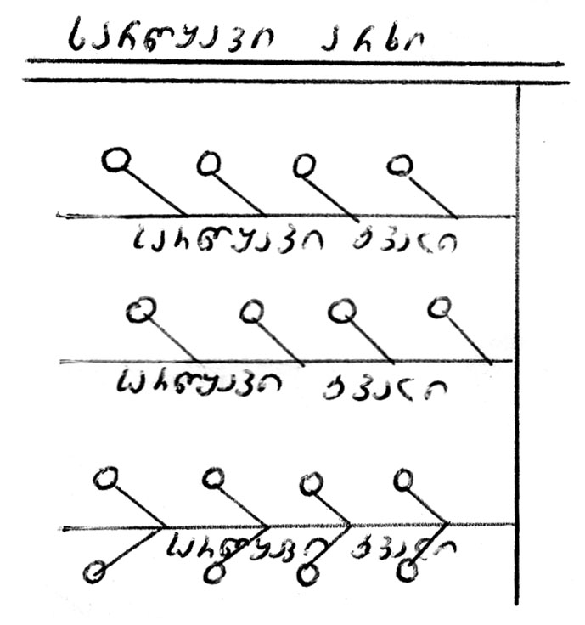

**nax.3. jamebSi datborebiT rwyva**

ukanasknelSi sakmao raodenobis wylis datborebis Semdeg, ketaven sarwyavi kvlidan wyalgamosaSvebs. nakadi miyavT Semdeg jamSi da ase TandaTanobiT, sarwyavi kvali, Cveulebriv, jamebidan 0,5-1,0 metriT aris daSorebuli. wylis nakadi am SemTxvevaSi 5 l/wm-s ar aRemateba.

ukeTesia sarwyavi kvali gatardes nargavTa mwkrivebs Soris da erTma mrwyvelma awarmoos ormxrivi rwyva 10 litriani nakadiT (nax.3).

jamebiT rwyva ukeTesia daviwyoT sarwyavi kvlis bolodan, rac Zalian aadvilebs muSaobas. sanam erTi wyvili jami irwyvis, mrwyveli gadadis meore wertilSi, amzadebs meore wyvilSi wyalgadasaSvebs, wyvets wylis miwodebas qveda jamebSi dasatboreblad da gadauSvebs zemoTa wyvilSi. aseTi rwyviT mrwyveli 8 saaTSi daaxloebiT erT ha-s rwyavs.

jamebSi wylis datborebiT farTobi irwyvis mxolod xexilis irgvliv, xolo nargavTa Soris farTobi mourwyavi rCeba. sinamdvileSi ki Zveli nargavebis fesvTa sistemis aqtiuri nawili mTavari fesvidan sakmaod Sors mdebareobs da TiTqmis urwyavi rCeba. amitom, es wesi unda gamoviyenoT 1-5 wlis nargavebSi, xolo, ufro Zvel nargavebSi, piriqiT, mTavari yuradReba nargavTa mwkrivTaSorisi farTobis rwyvas unda mivaqcioT.

**b) baRebis rwyva kvlebis saSualebiT.** Zvelnargavebiani baRi aucileblad unda moirwyas ise, rom mTeli farTobi dateniandes. aseT wess warmoadgens moRvarva an kvlebSi miSveba. ukeTesia rwyva kvlebSi miSvebiT. amisaTvis mwkrivebs Soris vamzadebT ara TiTo kvals, aramed ramdenimes – mwkrivebs Soris datovebuli manZilis mixedviT niadagis Tvisebebis gaTvaliswinebiT, kvlebs Soris vtovebT 1,0-1,5 metrs, xolo ganapira kvlebs vatarebT araumetes 1 m daSorebiT nargavebis mwkrivebidan.

**bostneulis morwyva mcire moednebSi datborebiT**

cnobilia zogierTi bostneulis mcire moednebze Tesva. yoveli aseTi farTobi, romelic 2-3 m2-dan ramdenime aTeul m2-mde (50-60 m2) meryeobs, yovelmxriv SemosazRvrulia bazoebiT. aq moednebis gamoyofa warmoebs ara Tesvis Semdeg, rogorc es saerTod aris miRebuli, aramed Tesvis win da ukve damzadebul moednebze iTeseba esa Tu is kultura.

erTdroulad, Cveulebriv, ramdenime moedani irwyvis, vinaidan TiTo moedanSi saWiroa 3-5 l/wm da rwyvis nakadi bostnebSi, daaxloebiT, udris 12-15 l-s wamSi.

es wesi gamarTlebulia mxolod mCate meqanikuri Sedgenilobis niadagebze da yovlad dauSvebelia misi gamoyeneba saSualo da mZime meqanikuri Sedgenilobis niadagebisaTvis. aseT niadagebze aucileblad gamoyenebuli unda iqnas kvlebSi miSvebis wesi.

**17. sarwyavi sistemis elementebi**

sarwyav sistemaSi igulisxmeba sxvadasxva rigis betonisa dam miwis arxebi, hidroteqnikuri nagebobebi, romelTa daniSnulebasac warmoadgens miiRos wyali sarwyavi wylis wyarodan da moaxdinos misi transportireba sarwyav teritoriaze sasoflo-sameurneo kultirebisaTvis saWiro raodenobiTa da dadgenil vadebSi.

zedapiruli rwyvis SemTxvevaSi sarwyavi sistema Sedgeba Semdegi ZiriTadi elementebisagan (nax. 4)

* 1. sarwyavi sistemis mkvebavi wyaro;
  2. saTave nageboba (wyalmimRebi);
  3. magistraluri arxi;
  4. sarwyav arxTa qseli;
  5. wyalSemkrebi qseli;
  6. xelovnuri nagebobebi qselze.

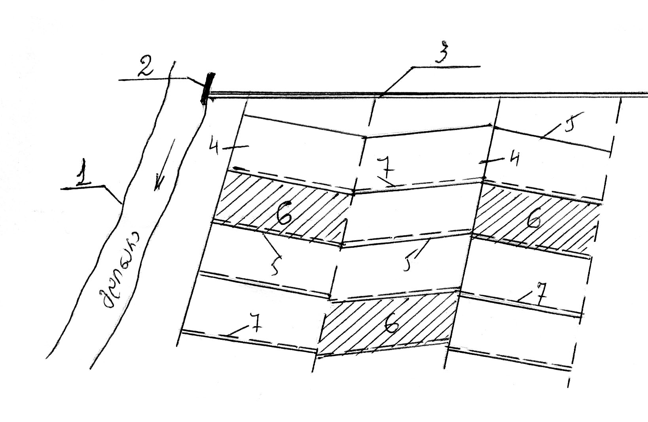

**nax.4.**

**1 – sarwyavi sistemis mkvebavi wyaro;**

**2 – saTave nageboba (wyalmimRebi);**

**3 – magistraluri arxi;**

**4 – I rigis ganmanawilebeli;**

**5 – II rigis ganmanawilebeli;**

**6 – droebiTi sarwyavi qseli;**

**7 – wyalSemkrebi qseli.**

**18. sarwyavi sistemis wyalmimRebi**

sarwyavi sistema, romelic mdinaridan ikvebeba, saWiroebs saTave nagebobis anu wyalmimRebis mowyobas.

wylis aReba mdinaridan warmoebs uSualod, anda specialuri Semgubebeli kaSxlis meSveobiT. Tu mdinaris reJimi uzrunvelyofs wlis ganmavlobaSi sarwyavi farTobis wyalsargeblobis grafiks da, amasTan, wylis miwodeba sarwyav farTobze SesaZlebelia TviTdinebiT, maSin Camonadenis ganxorcieleba SeiZleba ukaSxalo wyalmimRebiT, winaaRmdeg SemTxvevaSi saWiroa kaSxalis mowyoba.

yvelaze primitiuli saxe ukaSxalo wyalmimRebisa aris mimmarTveli damba. igi keTdeba mrudi moxazulobis, mdinaris dinebis sawinaaRmdegod (nax. ) ise, rom nawili mdinaris nakadisa mimarTuli iyos arxSi. amgvarad, dambisa da mdinaris napiriT iqmneba mimyvani kalapoti, romelic Semfeg arxSi gadadis.

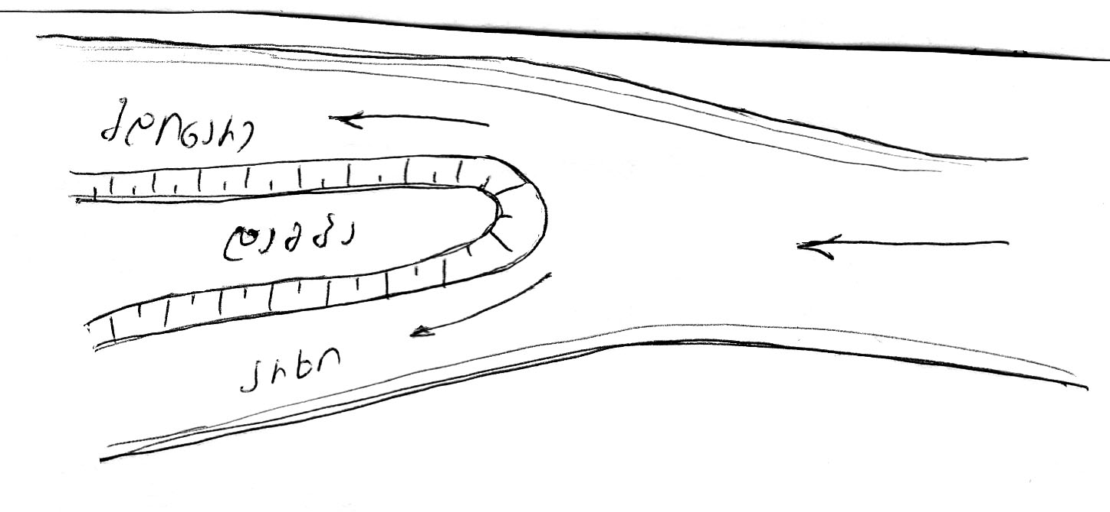

**nax.5**

**mdinaridan wylis aReba dambis saSualebiT**

ufro srulyofili saxis ukaSxalo wyalmimRebia rabi-regulatori, romelic ewyoba mdinaris napirze da magistralur arxs mdinaresTan aerTebs (nax. 6).

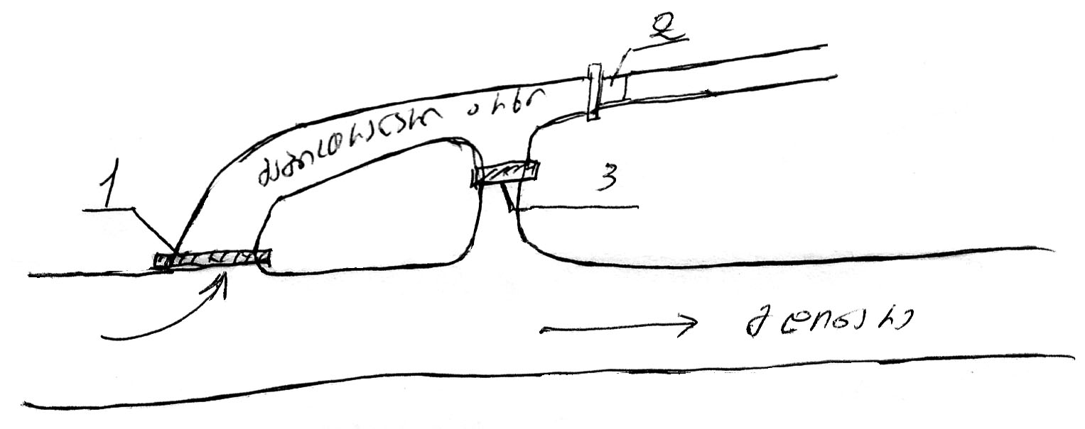

**nax.6.**

**1 – rab-regulatori; 2 – wyal-Semtbori; 3 – wyalsagdebi**

regulators zRurbli ukeTdeba iseT niSnulze, romelic uzrunvelyofs mdinaridan wylis TviTdinebiT miRebas vegetaciis periodSi yvelaze dabali horizontis drosac. arxSi Setanili naleqebis wasarecxad, regulatoris qvemoT 1-2 kilometrze Sendeba wyalsagdebi nageboba, romelic saSualebas iZleva arxSi Semosuli zedmeti wyali da natani isev mdinareSi CauSvaT.

aris SemTxvevebi, rodesac wylis horizonti mdinareSi imdenad ecema, rom saWiro xarjis miReba SeuZlebeli xdeba, maSin mimarTaven RonisZiebebs wyalmimRebTan wylis donis xelovnurad awevis mizniT, rac xorcieldeba kaSxalis saSualebiT (nax. 7).

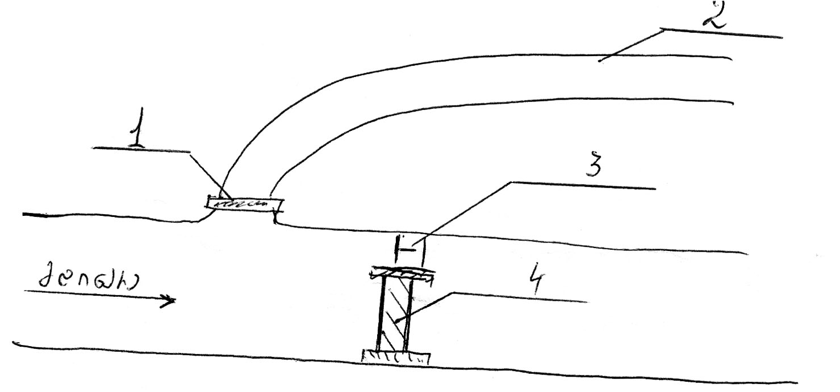

**nax.7.**

**1 – rab-regulatori; 2 – magistraluri arxi;**

**3 – gamrecxi rabi; 4 – kaSxali**

**19. sarwyavi sistemis arxebis klasifikacia**

Tavisi daniSnulebis mixedviT sarwyavi sistema iyofa or nawilad – gamtari qseli da maregulirebeli qseli. gamtari qseli Seicavs didi gabaritebis arxebs, maT Soris mTavar magistralur arxs, romelic iRebs wyals sarwyavi wylis wyarodan da anawilebs mas sarwyav sistemaSi. imisaTvis rom man mosarwyavad moicvas rac SeiZleba meti farTobi da, amasTan, rwyva ganxorcieldes TviTdinebiT, magistralur arxs atareben teritoriis SemaRlebul adgilebSi.

magistraluri arxidan wyali gadaecema e.w. mTavar, anu I rigis ganmanawileblebs, xolo aqedan – II rigis ganmanawileblebs, saidanac wyali nawildeba droebiT sarwyav qselSi.

magistraluri arxi, I da II rigis ganmanawileblebi Seadgenen gamtar qsels, romelTa daniSnulebaa sarwyavi wylis gatareba sarwyavi wylis wyarodan sarwyav farTobamde. isini farTobs uSualod wyals ar ewvdian, am daniSnulebas asrulebs droebiTi sarwyavi qseli, romlis saSualebiTac xdeba niadagis wylis regulireba da amitom mas maregulirebeli qseli ewodeba. es qseli droebiTia, vinaidan yovelwliurad gadaixvneba farTobTan erTad da Tesvis win xdeba misi aRdgena. gamtari qseli mudmivia, xangrZlivad moqmedebs da periodulad saWiroebs mxolod wmendasa da SekeTebas.

sarwyavi qselis yovel mudmiv arxs emsaxureba saTanado Semkrebi arxebi, romelTa daniSnulebac aris rwyvis Semdeg farTobze darCenili zedmeti wylis Segroveba da sarwyavi farTobidan mocileba – es qseli wylis ukeT Sekrebis mizniT unda ganlagdes Cadablebul adgilebSi.

**20. droebiTi sarwyavi qseli**

wylis uSualo ganawileba farTobze xdebadroebiTi sarwyavi qselis saSualebiT. droebiTi sarwyavi qseli TesvisTanave mzaddeba, maTi momsaxureoba mxolod erTi savegetacio periodiT amoiwureba da mosavlis aRebis Semdeg kvlav gadaixvneba.

droebiTi qselis SemadgenlobaSi Sedis: droebiTi sarwyavi arxebi, (droebiTi mrwyvelebi), gamomyvani kvlebi da sarwyavi kvlebi.

sarwyavi farTobis qanobis mixedviT arCeven droebiTi sarwyavi qselis ganlagebis or sqemas – grZivsa da ganivs.

Tu farTobis zedapiris qanobi ar aRemateba 0,001-s, maSin viyenebT grZiv sqemas (e.i. horizontalebis marTobulad).

grZivi sqemis dros (nax. 8) droebiTi sarwyavi arxebi iWreba grZivi mimarTulebiT. isini wyals ireben meore rigis ganmanawileblidan anu saubno arxidan da gadascemen misgan gamomaval gamomyvan kvlebs, xolo am ukanasknelidan wyals awvdian sarwyav kvlebs.

droebiTi sarwyavi arxebi SeiZleba iyos rogorc calmxrivi, ise ormxrivi moqmedebisa. maTi sigrZe 400-dan 1200 m-is farglebSi aiReba, maT Soris manZili anu gamomyvani kvlebis sigrZe Seadgens 50-200 m; gamomyvan kvlebs Soris manZili ki sarwyavi kvlebis sigrZis tolia, romelic gaangariSebiT ganisazRvreba.

Tu farTobis zedapiris qanobi aRemateba 0,001-s, da mosalodnelia arxebis daxramva, droebiTi arxebi ewyoba horizontalebis gaswvriv, anu

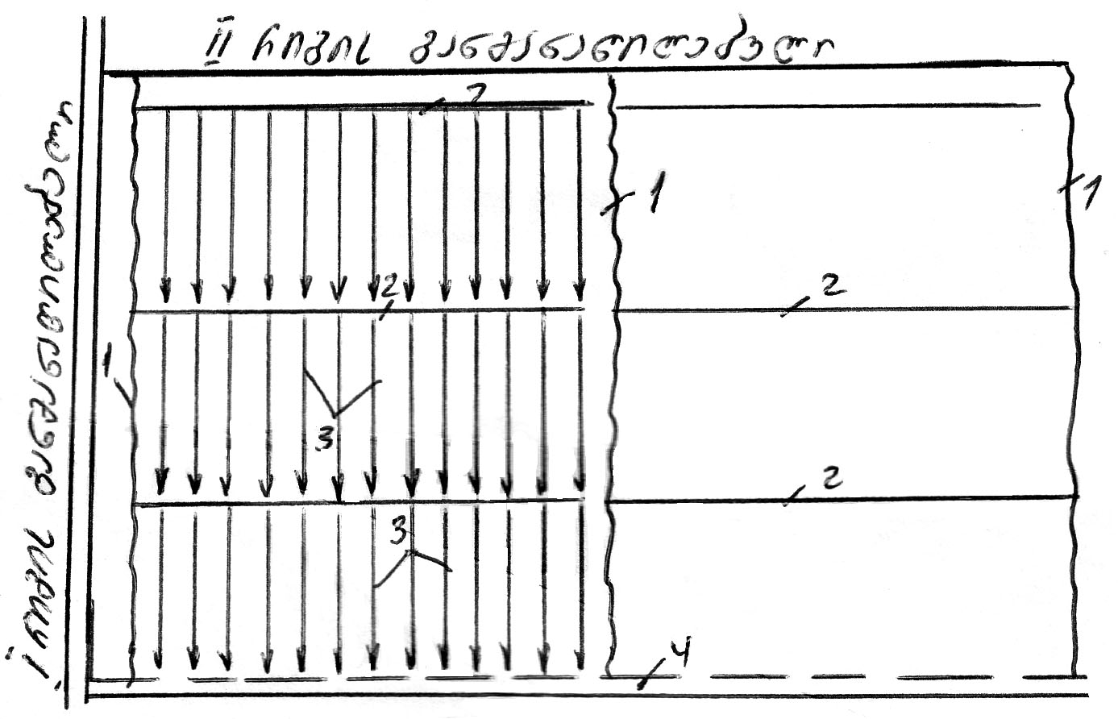

**nax.8. 1 – droebiTi sarwyavi arxi; 2 – gamomyvani kvlebi;**

**3 – sarwyavi kvlebi; 4 – wyalSemkrebi arxi**

ganivi sqemiT (nax. 9). am SemTxvevaSi gamomyvani kvlebi saWiro aRar aris, vinaidan sarwyavi kvlebi aRaraa droebiTi sarwyavi arxis paraleluri da masTan TiTqmis swor kuTxes qmnis. am SemTxvevaSi droebiTi arxebis sigrZe SedarebiT naklebi aiReba – 400-dan 1000 metramde. droebiTi arxebis gamtarunarianoba rwyvis nakadis anu 20 l/wm-is jeradi unda iyos, xolo gamomyvani kvlebisa erTi an ori rwyvis nakadis tolia da udris 20-40 l/wm-s.

garda zemoT aRniSnuli ori ZiriTadi sqemisa, praqtikaSi xSirad gvxvdeba droebiTi sarwyavi qselis ganlagebis Sualeduri SemTxvevebi, rodesac droebiT sarwyav arxebs Sualeduri mdgomareoba ukaviaT farTobis udides da umcires qanobebis mimarTulebebs Soris.

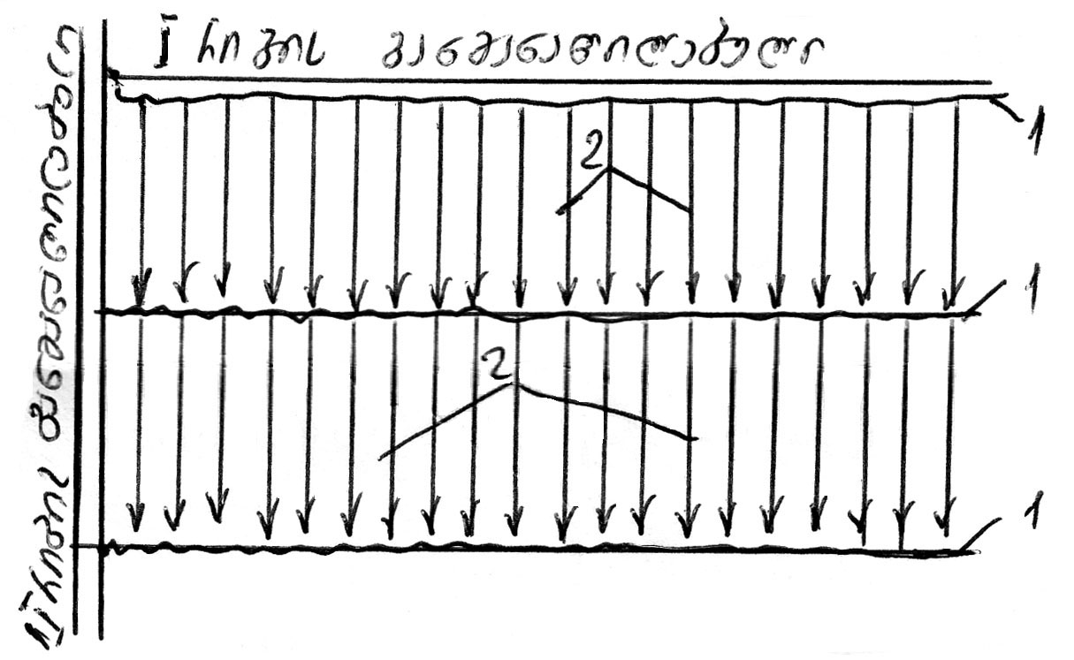

**nax.9**

**1 – droebiTi sarwyavi arxi; 2 – sarwyavi kvlebi**

**21. nagebobebi da gzebi sarwyav qselze**

sarwyavi qselis aucilebel nawils warmoadgens nagebobaTa sistema. erT-erT aseT nagebobas warmoadgens rabi Tavisi fariT rabis daniSnulebaa arxSi wylis regulireba da arxidan, saWiroebis mixedviT, gansazRvruli raodenobiT gadaSveba. igi Sedgeba uZravi nawilisagan, rkina-betonis an xis kedlebisagan da moZravi nawilisagan. igi, Cveulebriv, rkinisaa, xolo zogierT SemTxvevaSi xisganac keTdeba. faris awev-daweviT xdeba arxSi saWiro raodenobis wylis gaSveba (nax. 10)

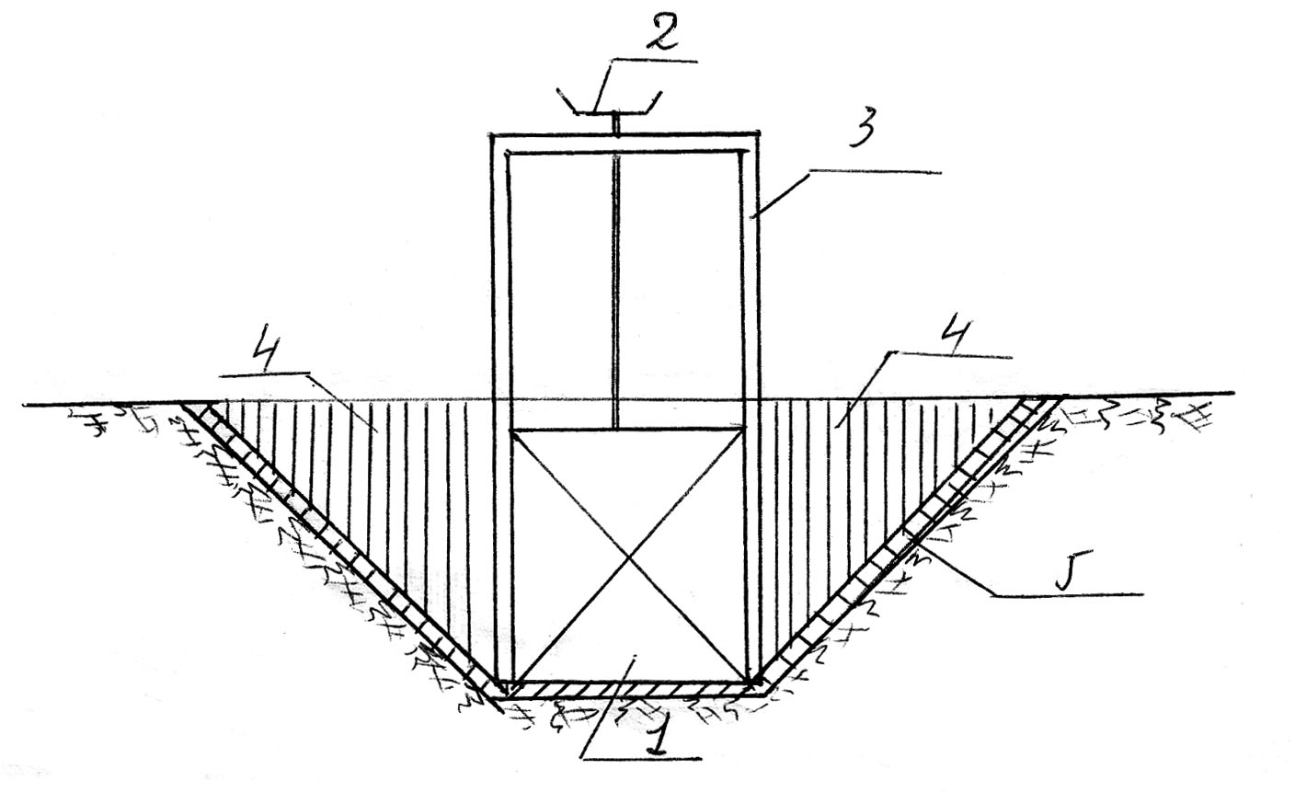

**nax.10. rab-regulatori**

**1 – fari; 2 – amwe; 3 – CarCo; 4 – kedeli; 5 – betonis filebi**

sarwyavi qselis nagebobaTa erT-erTi saxea akveduki, romlis daniSnulebaa xevze an sxva Cadablebul adgilebze wylis gadayvana. akveduki warmoadgens xids, romelzedac moTavsebulia rkinis, betonis an xis Rari romelsac wyali gadahyavs erTi napiridan meoreze (nax.11).

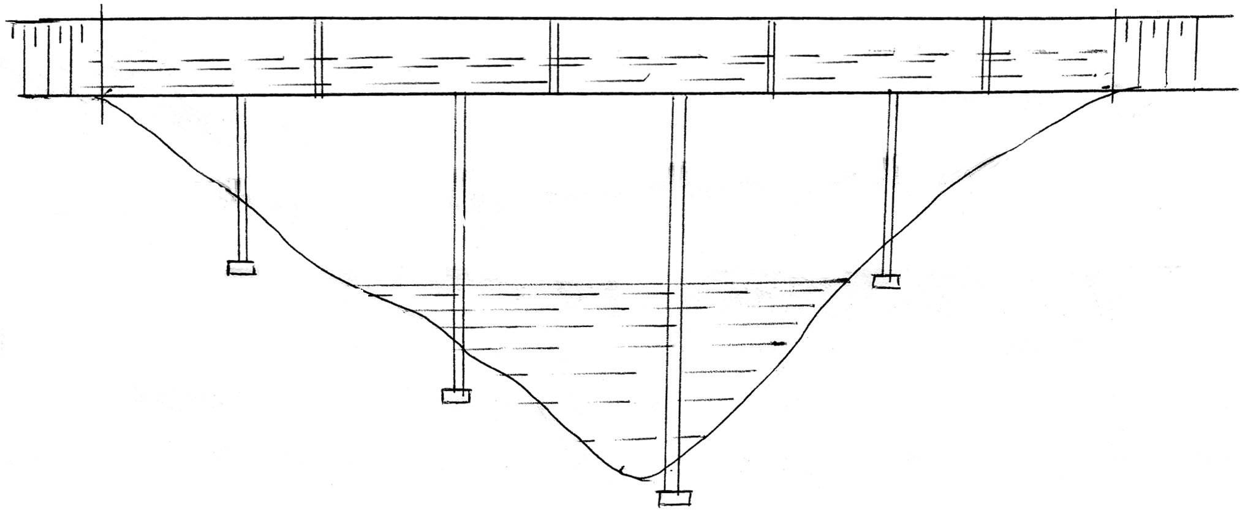

**nax.11. akveduki xevze**

zogjer, mdinaris, xevis da gzis erTi napiridan meoreze wylis gadasayvanad maT qveS gayavT betonis an rkinis sifonis msgavsi mili, romelsac diukeri ewodeba.

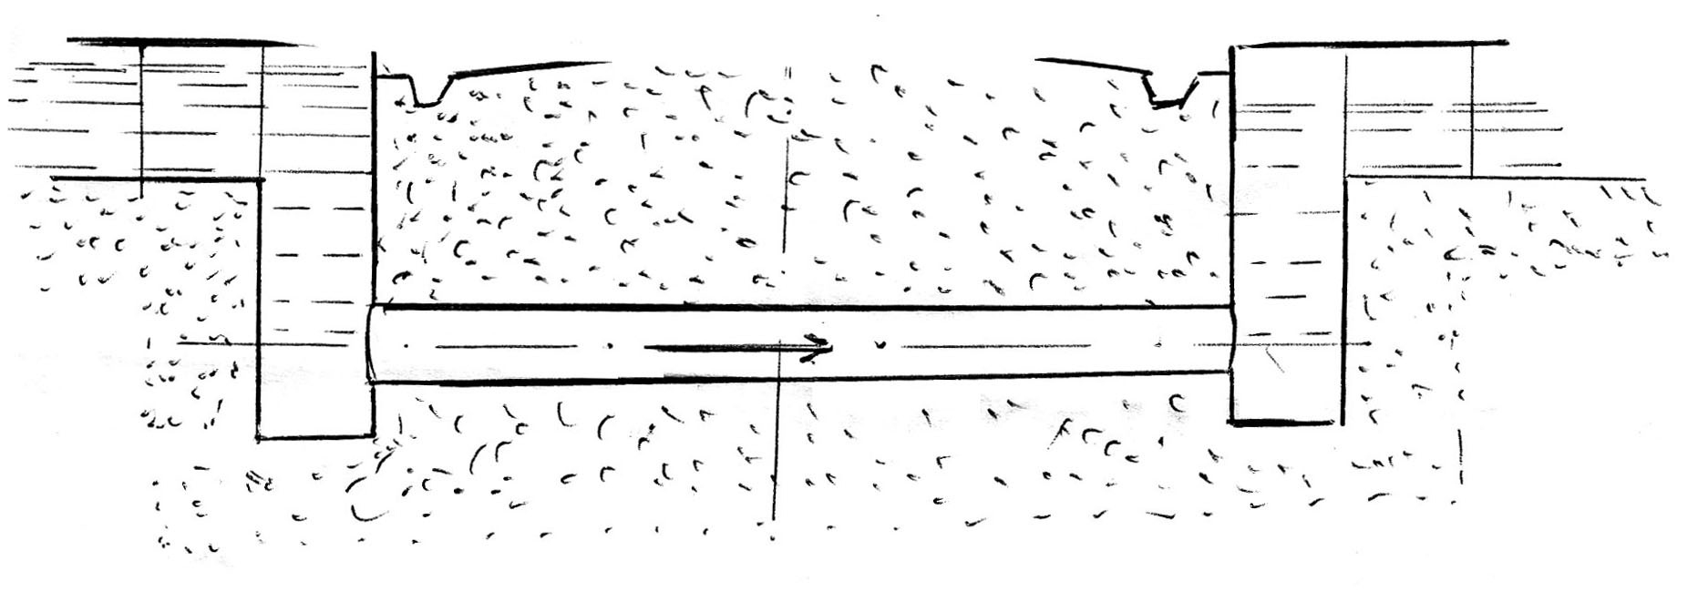

**nax.12. diukeri gzis qveS**

Tu arxs dasaSvebze meti qanobi aqvs, ramac SeiZleba gamoiwvios misi garecxva, akeTeben safexurian wyalvardnils, romlis yoveli safexuris boloSi ewyoba wyalCamqrobi Webi.

didi daqanebis adgilebSi xSirad akeTeben agreTve swrafdens, romlis boloSi keTdeba wylis energiis Camqrobi Wa.

garda zemodaRniSnuli nagebobebisa, sarwyav qselze gvxvdeba agreTve milxidebi, xidebi da RvarsaSvebebi.

sarwyavi sistemis eqspluataciisa da miwebis racionalurad gamoyenebisaTvis saWiroa sagzao qseli, romelic oTxi saxisaa:

1. mindvris gzebi – ubnis sarwyavi da Semkrebis arxebis gaswvriv;
2. Sigasameurneo gzebi, romlebic meurneobis calkeul ubnebs aerTeben;
3. mTavari gzebi, romlebic meurneobas gare centrTan – rkinis – gzasTan, satvirTo punqtebTan da sxv. aerTeben;
4. saeqspluatacio gzebi, romlebic saWiroa sistemis ZiriTadi arteriebis movla-SenaxvisaTvis, arxebisa da nagebobebis remontis Casatareblad. isini gahyavT magistraluri da msxvili gamanawileblebis gaswvriv. gzis erT mxares traqtoris gasavlelad toveben 2,5 m siganis zols.

**22. rwyvis teqnika**

yvela teqnikur saSualebas, romlis meSveobiTac xorcieldeba wylis miwodeba-ganawileba da niadagis gatenianeba ewodeba morwyvis teqnika. igi moicavs sam ZiriTad sakiTxs: rwyvis wesebi, sarwyavi wylis teqnologiuri ganawileba da swori organizacia. morwyvis teqnika ise unda SeirCes, rom minimumamde iqnes dayvanili wylis uaryofiTi gavlena niadagsa da mcenareze.

rwyvis teqnikis dadgena unda moxdes Semdegi moTxovnebis gaTvaliswinebiT:

1. uzrunvelyofili iqnes niadagSi wylis, haeraciisa da siTbos reJimi;
2. Seiqmnas koSkovani struqtura;
3. SesaZlebeli iqnes sasoflo-sameurneo samuSaoebis maqsimaluri meqanizacia;

d) rac SeiZleba maRali iyos mrwyvelTa Sromis nayofiereba;

1. minimumamde iqnas dayvanili sarwyavi wylis danakargebi, gaizardos sistemis margi qmedebis koeficienti.

amJamad, teqnikuri ganxorcielebis mixedviT, arCeven rwyvis Semdeg saSualebebs:

1. wylis TviTdinebiT miwodeba (zedapiruli morwyva);
2. dawvimebiT morwyva;
3. qveniadagidan morwyva.

garda aRniSnulisa, gamoyofen aerozolur morwyvas, wveTur morwyvasa da subirigacias, Tumca aerozoluri morwyva SeiZleba mivakuTvnoT dawvimebiT morwyvis, xolo wveTuri morwyva da subirigacia – niadagqveSa morwyvis saxeobebs.

**I. wylis TviTdinebiT miwodeba (zedapiruli morwyva)**

rwyvis aRniSnuli wesi yvelaze uZvelesi da gavrcelebuli rwyvis saSualebaa. am SemTxvevaSi wylis miwodeba-ganawileba xdeba TviTdinebiT, uSualod farTobis zedapirze, rac xorcieldeba droebiTi sarwyavi kvlebis, zolebis, Cekebisa da sxva teqnikuri saSualebebis gamoyenebiT. zedapirulis morwyvisaTvis damaxasiaTebelia: niadagis gatenianebis SesaZlebloba sxvadasxva siRrmeze; niadagis zeda fenebis met-naklebad Zlieri gravitaciuli gatenianeba da wylis garkveuli maragis akumulireba am fenebSi, romelsac Semdeg xarjavs niadagi rwyvaTaSoris periodebSi. zedapiruli morwyvis upiratesoba rwyvis sxva meTodebTan SedarebiT agreTveis aris, rom naklebad saWiroebs deficitur masalebs da teqnikur saSualebebs, martivia, iafi jdeba da advilad xelmisawvdomia.

amave dros, zedapirul morwyvas Tan axlavs mTeli rigi naklovanebebi: metad Sromatevadia, Txoulobs gacilebiT met muSaxels; adgili aqvs sarwyav qselSi wylis mniSvnelovan danakargebs, ris gamoc sasoflo-sameurneo kulturebis morwyvisaTvis saWiroa morwyvis gadidebuli normebis gamoyeneba; didi qanobebis SemTxvevaSi xSirad adgili aqvs niadagis gadarecxvas da eroziuli movlenebis ganviTarebas; rig SemTxvevebSi morwyvis Semdeg warmoiqmneba niadaguri qerqi mTel svel perimetrze, romelic amcirebs niadagis haeracias da aZlierebs aorTqlebas niadagis zedapiridan; morwyvis sxva wesebTan SedarebiT arxTa qsels didi sixSire arTulebs sarwyav farTobze meqanizaciis farTod gamoyenebas.

**II. dawvimebiT morwyva**

dawvimebiT morwyvis dros wylis miwodeba-ganawileba xdeba farTobis zedapirze mosuli xelovnuri wvimis saxiT, rac xorcieldeba dasawvimi aparatebis, agregatebisa da sxva teqnikuri saSualebis gamoyenebiT.

dawvimebiT morwyvis gansakuTrebuli Rirsebaa is, rom igi meqanizirebuli morwyvis wesia. mas sruli avtomatizaciis farTo SesaZleblobebi gaaCnia, rac mTlianad gamoricxavs xeliT Sromas. garda amisa, mis dadebiT mxareebs warmoadgens is, rom wvrili sarwyavi qseli saWiro ar aris; maqsimalurad SesaZlebelia sasoflo-sameurneo samuSaoebis meqanizirebuli wesiT Catareba; sarwyavi farTobi mTlianad gamoyenebulia; adgili ara aqvs sarwyavi qselidan wylis usargeblo kargvas filtraciasa da aorTqlebaze, e.i. maRalia rogorc miwis gamoyenebis koeficienti, aseve sistemis margi qmedebis koeficienti; morwyvis normebi gacilebiT naklebia, vidre zedapiruli rwyvis SemTxvevaSi; dawvimebiT rwyva karg efeqts iZleva didi qanobebisa da rTuli mTagoriani reliefis pirobebSi, sadac zedapiruli morwyva SeuZlebelia, anda cud Sedegs iZleva eroziuli procesebis ganviTarebis gamo.

gansakuTrebiT rentabeluria dawvimebiT morwyva periodulad gvalvian raionebSi, sadac morwyva warmoadgens bunebrivi atmosferuli naleqebis damatebas da rwyvis normebi TavisTavad mcirea.

did efeqts iZleva dawvimebiT rwyva damlaSebul niadagebze, sadac zedapiruli rwyva, xSirad, xels uwyobs zeda fenebSi marilebis amotanas da niadagis am fenebis damlaSebas. dawvimebis wesiT farTobis zedapirze mcire morwyvis normiT miwodebuli wyali Rrma mlaSe fenebs ver aRwevs da, amrigad, zeda fenebSi marilebis dagrovebas adgili ar eqneba.

dawvimeba SeiZleba gamoyenebuli iqnas mineraluri sasuqis Setanis drosac. wyalSi gaxsnili sasuqis wvimis saxiT Setanis procesi mTlianad meqanizirebulia, xolo sasuqi farTobze Tanabrad nawildeba.

dawvimeba metad efeqturia im SemTxvevaSic, rodesac qveniadagis wyali zedapirTan axlos mdebareobs. am SemTxvevaSi, mcire morwyvis normebis gamo, Tavidanaa acilebuli daWaobebis SesaZlebloba.

zedapiruli morwyvis dros teniandeba mxolod niadagi, dawvimebis SemTxvevaSi ki teniandeba ara mxolod niadagi, aramed mcenarec, rac iwvevs fiziologiuri procesebis aqtivizacias.

miuxedavad zemoT aRniSnuli dadebiTi Tvisebebisa, dawvimebiT rwyvas aqvs naklovanebebic.

dawvimebiT rwyvis erT-erT naklad SeiZleba CaiTvalos is, rom mZime meqanikuri Sedgenilobis, susti wyalgamtari niadagebis pirobebSi, gaZnelebulia niadagSi wylis SeRweva da fesvSemcveli fenis gatenianeba saWiro donemde. gaZnelebulia agreTve rwyva qarian amindSic, rodesac qari itacebs wvimis wveTebs da farTobi araTanabrad irwyvis, an saerTod mourwyavi rCeba.

dawvimebis mTavar naklad unda CaiTvalos is, rom igi sakmaod did kapitaldabandebasTan aris dakavSirebuli da didi raodenobis foladis milebs saWiroebs. magram saboloo jamSi es wesi mainc progresulia, vinaidan igi mniSvnelovnad amcirebs mrwyvelTa raodenobas da aumjobesebs morwyvis xarisxs.

**II.a. aerozoluri morwyva**

rogorc ukve aRvniSneT, dawvimebiT morwyvis qvesaxeobas warmoadgens aerozoluri morwyva. am SemTxvevaSi wylis miwodeba-ganawileba xdeba miwispira haeris fenaSi xelovnurad warmoqmnili nisliseburi wvrildispersuli wylis wveTebis saxiT, ris Sedegadac mcenarisa da niadagis zedapiri sveldeba, mikroklimati umjobesdeba da, Sesabamisad, mosavlianobac mniSvnelovnad izrdeba. specialuri manqana-danadgarebis saSualebiT wyals iReben arxebidan an milsadenebidan da didi dawneviT afrqveven mas haerSi. qaris siCqarisa da mimarTulebis mixedviT wvimis wveTebi burusis saxiT vrceldeba 200-300 metrze da metad. wylis miwodeba xdeba yoveldRiurad 4-5 saaTis ganmavlobaSi yvelaze maRali temperaturis periodSi dRis pirveli saaTidan 4-5 saaTamde, rodesac dabalia haeris SedarebiTi tenianoba.

rwyvis es saxeoba ZiriTadad gamoiyeneba bostneuli kulturebisa da Cais plantaciebisaTvis.

**III. niadagqveSa morwyva**

niadagqveSa morwyvis dros wyals awodeben ara niadagis zedapiridan, aramed qveniadagidan, miwaSi Cawyobili milebis saSualebiT (nax. 13).

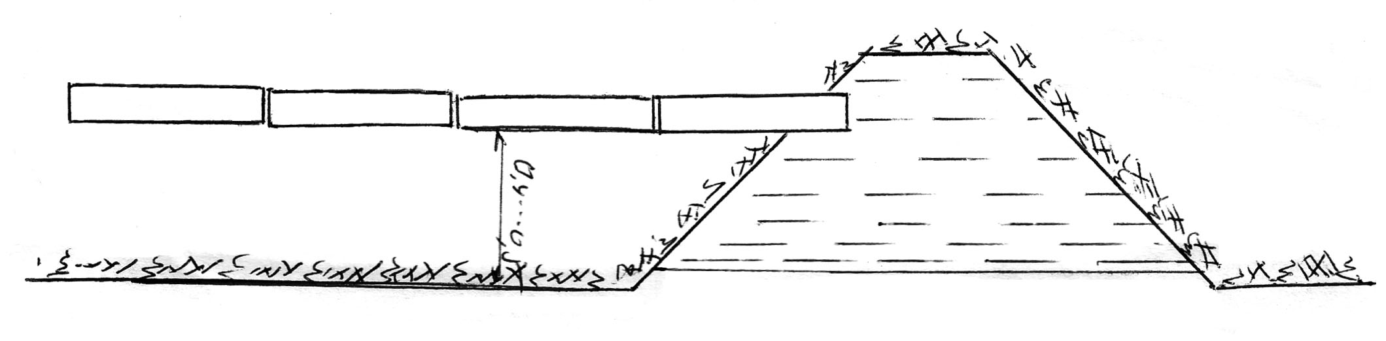

**nax.13. qveniadagidan morwyvis sqema**

qveniadagidan morwyva gamoiyeneba iseTi niadagebisaTvis, romelSic kargadaa ganviTarebuli kapilarebi, e.i. mZime meqanikuri Sedgenilobis niadagebze. es wesi ar gamoiyeneba mCate meqanikuri Sedgenilobis niadagebze, vinaidan aq naklebi kapilarobisa da didi wyalJonvadobis gamo wylis umetesi nawili Rrma fenebSi iJoneba da horizontaluri da vertikaluri mimarTulebiT naklebad moZraobs.

niadagqveSa morwyvis wess, ise, rogorc dawvimebas, gaaCnia analogiuri Rirsebebi – maRalia miwisa da wylis gamoyenebis koeficientebi, maqsimalurad akmayofilebs meqanizaciis moTxovnebs, da, rac mTavaria, SesaZlebelia savegetacio periodSi saukeTeso tenianobis reJimis damyareba niadagSi, rac ganapirobebs sarwyavi wylis uaRresad ekonomiur xarjvas.

morwyvis am wesis uaryofiT mxareebs warmoadgens:

a) zedapiruli fenis SedarebiT simSrale, rac arTulebs mdgomareobas axlad daTesili an darguli farTobis gatenianebis dros.

qveniadagidan miwodebuli wyali xSirad ar aris sakmarisi mcenaris aRmocenebisaTvis.

b) am wesis gamoyeneba SeuZlebelia mlaSe niadagebSi.

morwyvis es wesi jerjerobiT iSviaTad gamoiyeneba da isic mcire farTobebze. amis erT-erTi mTavari mizezia Sesabamisi teqnikuri saSualebebis arasrulyofiloba da siZvire.

**III.a. wveTuri morwyva**

wveTuri morwyva erT-erTi axali da progresuli morwyvis wesia Cvens planetaze. igi ZiriTadad gamoiyeneba cxel da mSral klimatian qveynebSi (israeli, egvipte, avstralia, arabeTis qveynebi, aSS, axali zelandia, Sua aziis qveynebi da sxv.).

rwyvis aseTi wesi gulisxmobs sarwyavi wylis miwodebas uSualod fesvTa sistemis zonaSi, rac xorcieldeba miwaSi an mis zedapirze ganlagebuli polieTilenis milebis saSualebiT.

am wesiT rwyva saSualebas gvaZlevs mudmivad SevinarCunoT niadagSi tenis sasurveli reJimi, Tavidan aviciloT misi zedmetad gatenianeba rwyvis dros an gamoSroba morig morwyvamde. amis garda, gamoricxulia rigTaSorisebis morwyvis aucilebloba, filtraciaze danakargebi, aorTqleba, zedapiruli Camodineba da qaris mier wylis wveTebis motaceba.

wveTuri rwyvis moqmedebis principi SemdegSi mdgomareobs: morwyvis wyarodan mcire moculobis tumboTi wyali magistralur milsadenSi Semodis, aqedan ganmanawilebelSi da Semdeg sarwyav milsadenebSi, romlebzedac damontaJebulia mwveTarebi.

mwveTarebis wylis xarji saSualod 4-12 w/sT-ia. wveTuri morwyvis SemTxvevaSi SesaZlebelia mosavlianobis gazrda 60%-iT da ufro metad. amasTan, igi iZleva sarwyavi wylis ekonomias 50%-s dawvimebasTan da 2-3-jer zedapirul morwyvasTan SedarebiT.

wveTuri morwyvis uaryofiTi Tvisebebia:

* mikroklimatis regulirebis SeuZlebloba;
* gatenianebis zonis sazRvrebSi niadagis TandaTanobiTi damlaSebis SesaZlebloba;
* wyalmcenareebiT mwveTarebis dacobis saSiSroeba;
* didi samSeneblo Rirsebebi da sxv.

**III.b. subirigacia**

subirigacia gulisxmobs gruntis wylis doneebis regulirebas Semtboravi rabebiT da sxva teqnikuri saSualebebiT, ris Sedegadac qvemodan zemoT mimarTuli kapilaruli wylis nakadi aRwevs niadagis zeda fenamde da atenianebs mas, e.i. wylis mowodeba-ganawileba xdeba qveniadagidan kapilaruli wylis saxiT.

subirigaciis gamoyeneba mizanSewonilia niadagis tenis ormxrivi regulirebis melioraciul sistemebSi (damSrob-sarwyavi).

zemoT aRniSnul rwyvis saSualebebs Taviseburi maregulirebeli sarwyavi qseli sWirdebaT da, maSasadame, rwyvis teqnikac, romelic uzrunvelyofs niadagis Tanabarzomier gatenianebas.

**23. rwyvis teqnikis elementebi zedapiruli**

**morwyvis SemTxvevaSi**

zedapiruli morwyvis SemTxvevaSi rwyvis normalurad Casatareblad sarwyavi farTobi iyofa calkeul ubnebad, romlebic erTdroulad irwyveba. am ubans sarwyavi moedani ewodeba. xolo am moedanze miSvebuli wylis xarjs, romelsac, Cveulebriv, erTi mrwyveli ganagebs, rwyvis nakadi hqvia. orive erTad ki Seadgens rwyvis teqnikis elementebs. am rwyvis teqnikis elementebis swor SerCevazea damokidebuli rwyvis xarisxi. isini ise unda SeirCes, rom adgili ar hqondes zedapiris zedmetad gadarecxvas.

sarwyavi moednis farTobi did farglebSi meryeobs, dawyebuli ramodenime kvadratuli metridan 0,2÷0,25 ha-mde, xolo zogierT SemTxvevaSi ufro metic. didad meryeobs agreTve sarwyavi moednis sigrZe siganesTan SedarebiT. Tu sigrZe ramodenime metridan dawyebuli 100-150 m-s aRwevs, sigane, saSualod 20-30 metrs ar aRemateba.

rac Seexeba rwyvis nakads, isic did farglebSi meryeobs – dawyebuli ramodenime litridan wamSi, igi SeiZleba 100 litrsac aRwevdes, xolo, Cveulebriv, Seadgens 10-40 l/wm.

saqarTvelosTvis rwyvis nakadi miRebulia 10-15 l/wm.

**24. rwyvis wesebi da maTi SerCeva zedapiruli**

**rwyvis dros**

niadagis zedapirze TviTdinebiT miwodebuli wylis ganawilebis sxvadasxva wesi arsebobs. es wesebi urTierTSoris gansxvavdeba niadagis zedapirze wylis ganawilebis teqnikiTa da TviT niadagSi wylis gavrcelebis xasiaTiT.

niadagis zedapirze moxvedrili wyali Tavisi simZimis ZaliT moZraobs da igi maRali adgilidan dablobisken miedineba, qanobis mimarTulebiT.

niadagSi moxvedrili wylis moZraoba ki gapirobebulia rogorc simZimis ZaliT – zemodan qvemoT, aseve niadagis kapilaruli TvisebebiT, rac iwvevs gverdiT moZraobasac – horizontalur filtracias. amrigad, zedapirze wylis moZraoba damokidebulia farTobis qanobze, xolo niadagSi – mis meqanikur Sedgenilobaze. ase, magaliTad, mCate meqanikuri Sedgenilobisa da SedarebiT fxvier niadagebSi wylis vertikaluri moZraobis siCqare ufro metia, vidre mZime niadagebSi, samagierod, am ukanasknelsi didadaa gavrcelebuli kapilarebi, ris gamoc met manZilze xdeba wylis gavrceleba horizontaluri mimarTulebiT.

maSasadame, zemoT aRniSnuli pirobebis codna da maTi gaTvaliswineba aucilebeli da saWiroa, raTa farTobze rwyva normalurad Catardes.

morwyvasTan dakavSirebiT niadagi SeiZleba davyoT sam ZiriTad jgufad:

* 1. mZime meqanikuri Sedgenilobis niadagi, romelic xasiaTdeba wylis SeTvisebis neli tempiT, didi wyaltevadobiT da mcire wyalJonvadobiT;
  2. saSualo meqanikuri Sedgenilobis niadagi, romelic sakmaod swrafad iTviseba da ufro metad atarebs wyals;
  3. mCate meqanikuri Sedgenilobis niadagi, romelic xasiaTdeba Zlieri wyalJonvadobiT da mcire wyaltevadobiT.

agreTve sam jgufad iyofa sarwyavi farTobi qanobis mixedviT:

* 1. Zlieri qanobi, rodesac *i* > 0.001;
  2. saSualo qanobi, rodesac *i* = 0.01...0.001;
  3. mcire qanobi, rodesac *i* < 0.001

Zlieri da saSualo qanobis mqone farTobze miSvebuli wylis nakadi SedarebiT Tavisuflad moZraobs. SeiZleba aq iseTi nakadi SevarCioT, rom vertikaluri filtracia da wylis moZraobis siCqare farTobis zedapirze erTmaneTs daemTxves, ris Sedegadac farTobi Tanabrad moirwyveba. am SemTxvevaSi rwyva mimdinareobs nakadis moZraobis procesSi. sul sxva suraTi gveqneba mcire qanobis SemTxvevaSi. mcireqanobian farTobze miSvebuli wylis igive nakadi metad nela moZraobs, farTobi SedarebiT mokle manZilze irwyvis da TviT rwyvac araTanabarzomieria. imisaTvis, rom mivaRwioT morwyvis Tanabarzomierebas, saWiroa nakadis maqsimaluri gadideba, raTa SevqmnaT wylis moZraobis meti siCqare da swrafad mivawodoT wyali gamoyofil sarwyav moedans, davatboroT wyali masze im varaudiT, rom niadagSi misi CaJonva, umTavresad, wylis datborebis Sedegad Catardes.

amrigad, nakadis mdgomareobis mixedviT arsebuli rwyvis wesebi SeiZleba davyoT or jgufad.

* 1. rwyva moZravi nakadiT, rodesac Zlieri an saSualo qanobia;
  2. rwyva damdgari wyliT, rodesac mcire qanobi gvaqvs.

aRniSnuli dajgufebis garda, rwyvis wesebs yofen or jgufad niadagis zedapirze da TviT niadagSi wylis ganawilebis mixedviT.

mZime meqanikuri Sedgenilobis niadagis rwyvis dros wyali SeiZleba gavataroT ara mTel farTobze, aramed winaswar damzadebul kvlebSi, sadac vertikalurad Casuli wyali, niadagis didi kapilarobis gamo, sakmao manZilze gavrceldeba gverdiTi mimarTulebiT da Tanabrad ganawildeba mTel moedanze. imave Sedegs miviRebT saSualo meqanikuri Sedgenilobis niadagSi, mxolod iq wylis gverdiTi mimarTulebiT gavrceleba SedarebiT naklebi iqneba da amitom, saWiroa kvlebs Soris manZilis Semcireba. msubuq niadagebze es manZili minimumamde mcirdeba da amitom aseT niadagebze wyali mTel farTobze unda gatardes. aqedan gamomdinareobs rwyvis wesebis or jgufad dayofa niadagSi wylis gavrcelebis saxis mixedviT:

* 1. vertikaluri filtraciis wesi;
  2. horizontaluri filtraciis wesi.

pirvel SemTxvevaSi wyals moednis mTel farTobze vatarebT da rwyva mimdinareobs niadagSi wylis vertikaluri filtraciis saSualebiT, xolo meore SemTxvevaSi wyals mxolod kvlebSi vatarebT. vertikalurad Casuli wyali niadagSi gverdiTi mimarTulebiT vrceldeba farTobis umetesi nawili irwyvis e.w. horizontaluri filtraciis saSualebiT.

sabolood, rogorc nakadis mdgomareobis, aseve mis zedapirze ganawilebisa da niadagSi gavrcelebis xasiaTis mixedviT ganarCeven rwyvis Semdeg oTx ZiriTad wess:

1. rwyva kvlebSi miSvebis wesiT, anu horizontaluri filtraciiT da mozravi nakadiT. rwyvis am wess viyenebT mZime an saSualo meqanikuri Sedgenilobis niadagze, rodesac qanobi *i* > 0.001;
2. rwyva kvlebSi datborebis wesiT, anu horizontaluri filtraciiTa da mdgari wyliT, rodesac isev mZime an saSualo meqanikuri Sedgenilobis niadagi gvaqvs da qanobi *i* < 0.001;
3. rwyva moRvarvis wesiT, anu vertikaluri filtraciis da moZravi nakadiT, romelic gamoiyeneba yvela saxis niadagSi, mxolod saSualo an Zlieri qanobis pirobebSi, e.i. rodesac > 0.001;
4. rwyva mTliani datborebiT, romelic gamoiyeneba agreTve yvela saxis nakadSi, mxolod mcire qanobis pirobebSi, e.i. rodesac *i* < 0.001.

horizontaluri filtraciiT rwyvis wess mTeli rigi upiratesoba aqvs vertikaluri rwyvis wesTan SedarebiT. rodesac wyals farTobis mTel zedapirze vatarebT, rasac adgili aqvs vertikaluri filtraciiT rwyvis SemTxvevaSi, wylis uSualo zemoqmedebis Sedegad iSleba niadagis struqtura, mcirdeba yorovneba, uaresdeba aeracia. rwyvis Semdeg warmoiqmneba qerqi, rac adidebs tenis danakargebs niadagis zedapiridan aorTqlebaze da agreTve aZnelebs Teslis aRmocenebas, horizontaluri filtraciis wesiT rwyvis SemTxvevaSi ki wyali uSualod exeba zedapiris mxolod mcire ares – mxolod kvlis zedapiris nawilis da amitom wylis uaryofiTi zegavlena niadagis Tvisebebze minimumamdea dayvanili. farTobis umetesi nawili fxvier mdgomareobaSi rCeba, niadagi inarCunebs struqturas, wyali grovdeba kapilarul firebSi, xolo arakapilaruli forebi haers ukavia.

saqarTvelos sarwyavi raionebis umetesi nawili saWiroebs horizontaluri filtraciiT rwyvas, e.i. rwyvas kvlebSi miSvebiT an kvlebSi datborebiT, xolo SedarebiT mcire farTobze aucilebelia morvarviT rwyva. datborviT rwyva yvelaze dabali rwyvis wesia da gamoiyeneba mxolod brinjis ganuwyveteli rwyvisas.

**25. dawvimebiT morwyvis sistemebi**

iseT sarwyav sistemebs, romlebSic niadagis gatenianeba dawvimebiT morwyvis wesiT warmoebs, dawvimebis sistemas uwodeben.

dawvimebiT morwyvis dros wyals sarwyav farTobs awvdian wvimis saxiT sxvadasxva dasawvimi aparatebis saSualebiT. isini wyals haerSi afrqveven bunebrivi an xelovnuri wnevis saSualebiT. haerSi gafrqveuli wyali wvimis saxiT ecema mcenaresa da sarwyav farTobs da Tanabazomierad rwyavs s/s kulturebs.

dasawvimi sarwyavi sistema Sedgeba Semdegi ZiriTadi elementebisagan: sarwyavi wylis wyaro; mudmivi da gadasaadgilebeli satumbi danadgarebi; mudmivi Ria sarwyavi arxebi da milsadenebi, droebiTi arxTa qseli an advilad dasaSleli mrwyvelebi da milsadenebi; stacionaruli da moZravi dasawvimi manqanebi da danadgarebi, aRWurvili Sesabamisi nacmebiTa da dasaSvebi Wavliani aparatebiT, romelTa saSualebiTac warmoiqmneba xelovnuri wvima. am ZiriTadi elementebis sxvadasxvagvari SeTanawyobiT ganisazRvreba dawvimebis mowyobilobis konstruqciebisa da sistemebis nairsaxeoba.

sarwyavi wylis wyarod SeiZleba gamoyenebuli iqnas mdinare, tba, arxi da sxv. wylis wyaros siRrme unda aRematebodes 50 sm-s im varaudiT, rom wylis Semwovi mili wyalSi moTavsebuli iyos aranakleb 30 sm siRrmeze da milis Ziramde rCebodes kidev aranakleb 30 sm. wylis dawnevis Semqmnel saSualebas, Cveulebriv, warmoadgens sxvadasxva saxis tumbo (centridanuli, propeleriani, dguSoni da sxv.), romelic moqmedebaSi modis eleqtro an Sigawvis Zravis saSualebiT.

dasawvimi sistemebis mowyobis principis mixedviT varCevT morwyvis sistemis Semdeg saxeebs:

* + 1. stacionaruli sistema;
    2. naxevrad stacionaruli sistema;
    3. gadasatani sarwyavi sistema.

**a) stacionaruli sarwyavi sistema** – Sedgeba wylis wyaros, satumbo danadgaris, ganmanawilebeli qselisa da dasawvimi aparatisagan (nax. 14)

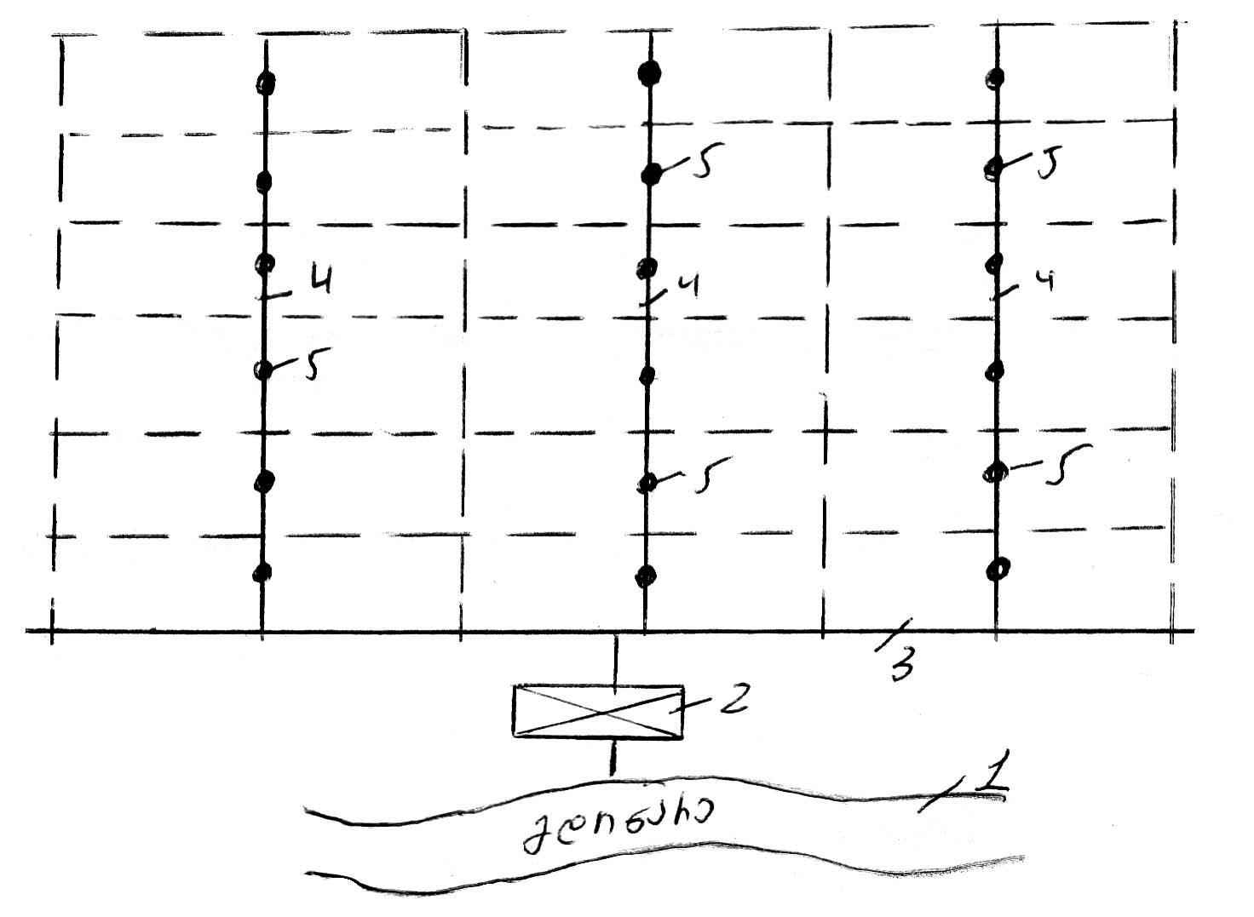

**nax.14. dawvimebis stacionaruli sistema**

**1 – sarwyavi wylis wyaro; 2 – satumbi danadgari;**

**3 – magistraluri (mTavari) milsadeni;**

**4 – meore rigis ganmawilebeli; 5 – hidranti**

ZiriTad ZarRvs stacionarul dasawvim sistemebSi, ise rogorc tviTdinebiT morwyvis sistemaSi, warmoadgens magistraluri milsadeni; magistraluri arxidan gamodis meore rigis ganmanawilebeli da am ukanasknelze ki dadgenilia calkeuli hidrantebi – dgaraTi. dgaras simaRles iReben 0,5...2,0 metrs, romelzec wamocmulia dasawvimi aparati.

**b) naxevrad stacionaruli** sistemebSi mTavari milsadeni (magistraluri) da satumbi sadguri stacionaruli mdgomareobaSia, xolo ganmanawilebeli da mastan erTad mTeli dasawvimi mowyobiloba unda gadaadgildes erTi poziciidan meoreze.

dawvimebiT rwyvis stacionarul sistemasTan SedarebiT naxevradstacionaruli sistemebis mSenebloba 2-3- jer iafi jdeba, vinaidan am SemTxvevaSi milebis raodenoba sakmao mcirdeba – xSir SemTxvevaSi sakmarisia gadasatani milebis mxolod ori kompleqti da zogjer SeiZleba ori sruli kompleqtic ar iyos saWiro, magram misi nakli is aris, rom milebis gadatana erTi poziciidan meore poziciaze rwyvis mTeli ciklis ganmavlobaSi xeliT sruldeba da Zalze Sromatevadia.

**g) gadasatani sarwyavi sistemebi** ewodeba iseT sarwyav sistemebs, romelTa yvela elementi: satumbi danadgari, magistraluri ganmanawilebeli da mrwyveli milsadenebi, agreTve dasawvimi danadgarebi mosarwyav farTobze poziciidan poziciaze gadaadgileba rwyvis mTeli sezonis ganmavlobaSi. dawvimebiT rwyvis gadasatani sistemebis naklad miiCneva milsadenebis xeliT gadaadgilebaze daxarjuli Sromatevadi samuSaoebi. amis gamo gadasatani sistemebis danergva ramdenadme SezRudulia, isini gamoiyeneba mxolod mcire farTobebis (50...150 ha) mosarwyavad.

Cvens respublikaSi dawvimebiT rwyvis gadasatani sistemebis gamoyeneba gansakutrebiT perspeqtiulia mTiswina da mTis ferdobebze ganlagebuli miwis nakveTebis mosarwyavad.

zemoT aRniSnul dawvimebiT rwyvis sistemebSi danarCen sistemebs Soris didi upiratesoba aqvs standartul sistemas, vinaidan moiTxovs nakleb muSaxels, magram masze kapitaluri dabandeba (saamseneblo Rirebuleba) yvelaze didia da amitom stacionaruli sistemis gamoyeneba SeiZleba jer-jerobiT, mxolod maRali Rirebulebis kulturebSi (Cai, venaxi, baRi da sxv.).

dawvimebis sistemis erT-erT ZiriTad muSa organos warmoadgens sawvimari nacmebi da dasawvimi aparatebi. xelovnuri wvimis warmomqmnel iseT sawvimars, romelsac ara aqvs moZravi nawilebi, nacmi ewodeba, xolo imas, romelic wvimis warmomqmnel da farTobze mis gasanawileblad moZrav elementebs Seicavs – dasawvimi aparati.

wvimis wveTebis haerSi gatyorcnis siSoris , anu moqmedebis radiusis mixedviT ganarCeven mokleWavlian, saSualoWavlian da grZelWavlian dasawvim aparatebs. mokleWavliani anu dabaldawneviani aparatebis moqmedebis radiusi 10 metramde, saSualoWavlianisa – 35 metramde, xolo grZelWavlianisa – 100 metramde da metic.

dasawvimi nacmebi, Cveulebriv, mokleWavliania, xolo aparatebi ki, umetesad saSualo da grZelWavlianebi.

pirveli grZelWavliani dasawvimi aparati postsabWour sivrceSi Seiqmna saqarTvelos hidroteqnikis da melioraciis samecniero-kvleviT institutSi akademikos a. didebuliZis mier. aparatis moqmedebis radiusia 70 m., xolo wylis xarji – 32 l/wm-Si.

dasawvimi aparatebis garda arsebobs dasawvimi danadgarebi, agregatebi da manqanebi.

dasawvimi danadgari warmoadgens dasawvimi aRWurvilobis kompleqts, romelSic Sedis milsadeni masze gawyobili sawvimari nacmebiT an aparatebiT. igi wyals rebulobs sadawneo sarwyavi qselidan da rwyavs poziciurad. poziciidan poziciaze gadaadgileba, Cveulebriv xeliT xdeba. aseTi tipis dasawvim mowyobilobebs miekuTvneba, magaliTad mokleWavliani dasawvimi danadgari ДКШ-04 “volJanka”, romelic gamoiyeneba yvela sasoflo-sameurneo kulturebis mosarwyavad, romelTa simaRle ar aRemateba 1,2 m-s (garda baRebisa, venaxebis, Cais plantaciebi da citrusebisa); КИ-50 “raduga”; “sigma”-3-50-ДПЗ (Cexoslovakia) da sxv.

dasawvimi agregatebi warmoadgenen CarCoze damontaJebul dasawvim mowyobilobas an grZelWavlian dasawvim aparats, romelic Camokidebulia traqtorze, anda dadgmulia Tvlian urikaze, romlis gadaadgileba xdeba traqtoris an raime sxva gamwevi Zalis meSveobiT. aseTi tipis dasawvim mowyobilobas miekuTvneba magaliTad, orkonsoliani dasawvimi agregati ДДА-100М da ДДА-100МА. aRniSnuli agregatebi gamiznulia bostneuli, baxCeuli, marcvleuli da teqnikuri kulturebis, agreTve mravalwliani balaxebis dawvimebis wesiT mosarwyavad, farTobebze, romelta zedapiris qanobi ar aRemateba 0,0003-s. dasawvimi agregatia agreTve ДЧП-30, romelic gamoiyeneba Cais plantaciebis, teqnikuri kulturebis baRebis mosarwyavad da sxv.

dasawvimi manqanebi warmoadgenen TviTmavali sayrdenis an sayrdenebis mqone dasawvim mowyobilobas. isini wyals iReben sadawneo sarwyavi qselidan. dasawvim manqanebs miekuTvneba: “fregati”, “dnepri”, “kubani”, ДДН-70, ДДН-100 da sxv.

saqarTveloSi dawvimebiT rwyvas gansakuTrebuli mniSvneloba aqvs, rac ganpirobebulia misi reliefuri pirobebiT. saqarTveloSi, rogorc uaRresad mTagorian da didi qanobebis mqone mxareSi, xSir SemTxvevaSi Cveulebrivi TviTdinebiT rwyva yovlad SeuZlebelia an metad cud Sedegs iZleva eroziuli movlenebis warmoSobis gamo, amitom aq ZiriTadad gamoyenebuli unda iqnas dawvimebiT rwyva.

**26. limanuri morwyva**

limani berZnuli sityvaa da niSnavs yures. limanuri rwyva xdeba datborebiT, risTvisac iyeneben Tovlis, wvimebisa da wyaldidobis wylebs.

limanuri rwyva mxolod gazafxulze tardeba da umTavresad iseT regionebSi, sadac atmosferuli naleqebis simcires adgili aqvs savegetacio periodis dasawyisSi.

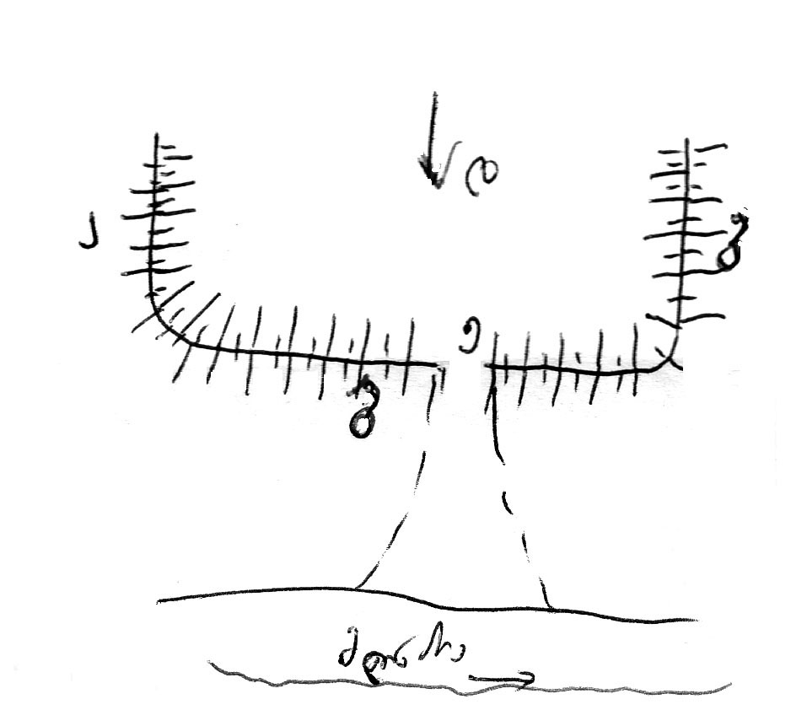

**nax.15. xelovnuri erTiarusiani limani**

xelovnuri limani warmoadgens sami mxridan (a, b, g) Semofarglul farTobs, romelic wyals Rebulobs amaRlebul meoTxe (d) mxridan. aq wyali dgeba Semofarglul farTobSi da atenianebs niadags. niadagis gatenianebis Semdeg narCen wyals, sagdebis “e” saSualebiT gadauSveben wyalmimRebSi an qveda limanSi.

ganlagebis mixedviT SeiZleba iyos erTiarusiani da mravaliuarusiani limani. erTsarTuliani iseTi limania, romelic Semofarglulia dambebis erTi wyebiT, mravalsarTuliani ki, dambebis ramodenime wyebiT, romlebic ganlagebuli arian erTmaneTis zemoT da wyali TanmimdevrobiT gadadis zeda iarusidan qvedaSi.

limanuri morwyvis uaryofiTi mxareebia: limanuri morwyviT niadagi savegetacio periodSi teniandeba mxolod erTxel; limanSi wylis sxvadasxva siRrmeze dgomis gamo mis SigniT gatenianeba araTanabaria; limanuri morwyva gamoiyeneba mxolod mcire qanobebze; mizanSewonili ar aris misi gamoyeneba msubuq niadagebze.

limanur morwyvas aqvs mTeli rigi dadebiTi Tvisebebic: igi gacilebiT iafi RonisZiebaa Cveulebriv rwyvasTan SedarebiT; urwyav raionebSi ferdobebis morwyvis SesaZlebloba wylis meqanikuri awevis gareSe; minimumamdea dayvanili eroziuli procesebi.

**27. sarwyavi teritoriis organizacia**

sarwyavi sistemis farglebSi mdebare mTliani farTobi (bruto), Sedgeba namdvilad sarwyavi farTobebisagan (neto) plius arxebiT, gzebiTa da SenobebiT dakavebuli farTobi, yvela uvargisi miwa da sxv.

sarwyavi farTobisa da mTliani farTobis Sefardebas uwodeben farTobis gamoyenebis koeficients da igi 90%-dan 25%-mde meryeobs. mTeli sarwyavi farTobi calkeul ubnebad iyofa, xolo isini, Tavis mxriv, calkeul Teslbrunvis mindvrebad iyofian.

sarwyavi teritoriis organizaciisa da sasoflo-sameurneo aTvisebis proeqtis Sedgenis dros unda ganisazRvros TviTeuli sarwyavi ubnis farTobi meurneobis specifikisa da reliefis gaTvaliswinebiT; SesaZlebeli unda iyos samuSaoTa meqanizirebuli wesiT Catareba.

mTel rig SemTxvevebSi sarwyavi qseli jer kidev mTlianad ver akmayofilebs aRniSnul moTxovnebs. mudmivi arxebis xSiri qseli metad abrkolebs sasoflo-sameurneo manqanebis maqsimalurad gamoyenebas da sasargeblo farTobis danakargi zogjer 10-12%-s Seadgens. mudmivi sarwyavi qseli xels uwyobs arxebis gayolebiT sarevela mcenareebisa da sasoflo-sameurneo kulturaTa mavneblebis gavrcelebas.

gamomdinare aqedan, maqsimalurad unda Semcirdes sarwyav sistemebSi mudmiv arxTa raodenoba, maqsimalurad unda iqnas gamoyenebuli droebiTi qseli, rac mkveTrad gazrdis sarwyavi sistemis efeqts.

**28. sarwyavi farTobis mosworeba (moSandakeba)**

rwyvis swori organizaciis erT-erTi damabrkolebeli faqtoria reliefis uswormasworoba, rac metad aZnelebs rwyvis wesierad Catarebas. aseTi reliefis mqone farTobi aucileblad saWiroebs mosworebas.

im SemTxvevaSi, rodesac qanobi erTgvarovania da miwis zedapiris uTanasworoba mxolod 5-7 sm-s aRwevs, specialuri mosworeba saWiro ar aris. aseT SemTxvevaSi sruliad sakmarisia xnulis Cveulebrivi dafarsaxva. danarCen SemTxvevaSi aucilebelia farTobis zedapiris specialuri mosworeba.

farTobis specialuri mosworeba SeiZleba iyos msubuqi da kapitaluri. msubuqi mosworeba gulisxmobs moxnul farTobze 7-10 sm farglebSi arsebuli uTanasworobis mospobas greideriT. rac Seexeba kapitalur mosworebas, igi 10 sm-ze meti uTanasworobis mospobas gulisxmobs da misi CatarebisaTvis saWiroa winaswar specialuri proeqtis Sedgena.

**29. wylis danakargebi sarwyav qselSi da sarwyavi sistemis margi qmedebis koeficienti (m.q.k.)**

yovelgvari saxis qsels axasiaTebs wylis danakargi ama Tu im raodenobiT. arxSi wylis danakargi damokidebulia gruntis Sedgenilobaze. rac ufro msubuqi meqanikuri Sedgenilobisaa grunti, miT ufro metia wylis danakargi filtraciis saxiT da, piriqiT, garda amisa, danakargs adgili aqvs wylis zedapiridan aorTqlebis saxiTac.

orive saxis danakargi aucilebelia da amitom filtraciiTa da aorTqlebiT gamowveul danakargs aucilebel danakargs uwodeben. filtraciis saxiT danakargi, aorTqlebasTan SedarebiT, sakmaod did sazRvrebs aRwevs, xolo aorTqlebis saxiT danakargi SedarebiT mcirea da amitom gaangariSebebis dros igi mxedvelobaSi ar miiReba.

zemoaRniSnuli danakargebis garda, adgili aqvs agreTve sarwyavi sistemis farglebSi mTel rig, e.w. SemTxveviT danakargebs, rogoricaa – dazianebuli arxidan wylis usargeblo gadaSveba, sarwyav farTobze zedmeti wylis gaSveba da sxv. yovelgvari aseTi saxis danakargi amcirebs sistemis margi qmedebis koeficients. m.q.k. mTeli sistemis farglebSi, Cveulebriv, 0,3-0,6-mde meryeobs. sainJinro sistemebSi igi gacilebiT metia, vidre arainJinrul sistemebSi. margi qmedebis koeficientze gavlenas axdens niadagis Sedgeniloba da sarwyavi qselis mdgomareoba. margi qmedebis koeficientis gansazRvras metad didi mniSvneloba aqvs, igi aucilebelia wyliT sargeblobis gegmis Sedgenis dros.

**Tavi II**

**daSrobiTi melioracia**

**30. daWaobebis gamomwvevi mizezebi da dasaSrobi niadagebis saxeebi**

rogorc zemoT aRvniSneT, daSrobiT melioracias mivmarTavT maSin, roesac niadagSi Warbadaa wyali da minimaluria masSi haeri.

niadagis daWaobebas iwvevs rogorc zedapiruli wylis didi raodenoba, ise gruntis wyali.

zedapiruli wyliT daWaobebas xels uwyobs farTobis umniSvnelo qanobi, atmosferuli naleqebis didi raodenoba da intensivoba, zedapiruli Camonadenis neli dineba da mZime meqanikuri Sedgenilobis niadagebi.

gruntis wyali daWaobebas iwvevs Tu is zedapirTan axlos mdebareobs.

Warbteniani miwebi iyofa or tipad – torfebad da mineralur Warbtenian niadagebad.

Warbteniani miwebis klasifikaciis mixedviT gamoiyofian Waobebi, daWaobebuli miwebi da mineraluri Warbteniani niadagebi. gansxvaveba maT Soris ganisazRvreba torfis fenis sisqiT (m) daSrobamde.

**Waobi** – es aris organuli nivTierebebiT mdidari da mineraluri nivTierebebiT Raribi niadagi, romelic daSrobamde Seicavs 30 sm-ze meti sisqis torfs.

**daWaobebuli miwebi** – es aris mudmivad Warbteniani niadagebi daSrobamde 30 sm-ze naklebi torfis sisqiT da,

**periodulad Warbteniani mineraluri niadagebi**, sadac torfi saerTod ar aris.

**31. sasoflo-sameurneo kulturebis moTxovna dasaSrobi miwebis wylis reJimze, daSrobis norma**

miwebis daSroba uSualo zemoqmedebs axdens niadagSi wylisa da haeris Semcvelobaze.

wyali da haeri niadagSi yovelTvisaa, isini avseben niadagis forebs, magram xSirad isini iseT SeTanawyobaSi arian, rom saTanado regulirebis gareSe farTobis aTviseba sasoflo-sameurneo kulturebiT SeuZlebelia. rodesac niadagis forebi mTlianadaa Sevsebuli wyliT, niadagSi Jangbadis naklebobis gamo mimdinareobs anaerobuli procesebi, mineraluri sakvebi elementebi imyofeba mcenarisaTvis naklebad SesaTvisebel an saerTod SeuTvisebel formebSi, sustad mimdinareobs mikrobiologiuri procesebi, rac uaryofiTad moqmedebs niadagis nayofierebaze. haeris raodenobis regulireba daWaobebul niadagebSi warmoebs daSrobiTi RonisZiebebis gatarebis Sedegad, romlis drosac xdeba niadagidan zedmeti tenis mocileba da gamonTavisuflebuli forebis Sevseba haeriT.

haeraciis optimaluri done, niadagis aqtiur fenaSi, sasoflo-sameurneo kulturis mixedviT Seadgens niadagis forianobis 15-40%-s, e.i. niadagis am fenaSi 15-40% forebisa Tavisufali unda iyos tenisagan da Sevsebuli iyos haeriT, xolo 60-85% dakavebuli unda iqnes wyliT. aRniSnulidan nebismieri gadaxris SemTxvevaSi mcenareebi ziandebian tenis an naklebobis, an siWarbisagan.

sxvadasxva sasoflo-sameurneo kulturebi niadagis tenianobis mimarT sxvadasxva momTxovnelebisa arian. Tavis mxriv, niadagis tenianoba damokidebulia gruntis wylis doneze, e.i. mcenarisaTvis optimaluri pirobebis Sesaqmnelad saWiroa movaxdinoT gruntis wylis regulireba.

gruntis wylis optimalur siRrmes, romelic unda davicvaT dasaSrob farTobze kulturis ganviTarebis sxvadasxva fazaSi vegetaciisa da agreTve arasavegetacio periodSi ewodeba daSrobis norma.

**32. damSrobi sistemis ZiriTadi elementebi**

damSrobi sistema moicavs Semdeg ZiriTad elementebs:

1. maregulirebeli qseli, romlis daniSnulebasa warmoadgens uSualod dasaSrobi farTobidan Warbi zedapiruli da gruntis wylebis Sekreba da dasaSrobi teritoriidan gayvana;
2. gadamRobi qseli – gankuTvnilia dasaSrobi teritoriis dasacavad gareSe zedapiruli da gruntis wylebisagan;
3. gamtari qseli, romlis daniSnulebaa miiRos maregulirebeli da gadamRobi qselidan Warbi zedapiruli da gruntis wylebi da droulad gaiyvanos isini farTobidan. igi moicavs magistralur arxsa da sxvadasxva rigis koleqtorebs;
4. wyalmimRebi (mdinareebi, zRvevbi, tbebi da sxv. – uzrunvelyofs gamtari qselidan wylis miRebas da mis gatarebas (nax. 16).

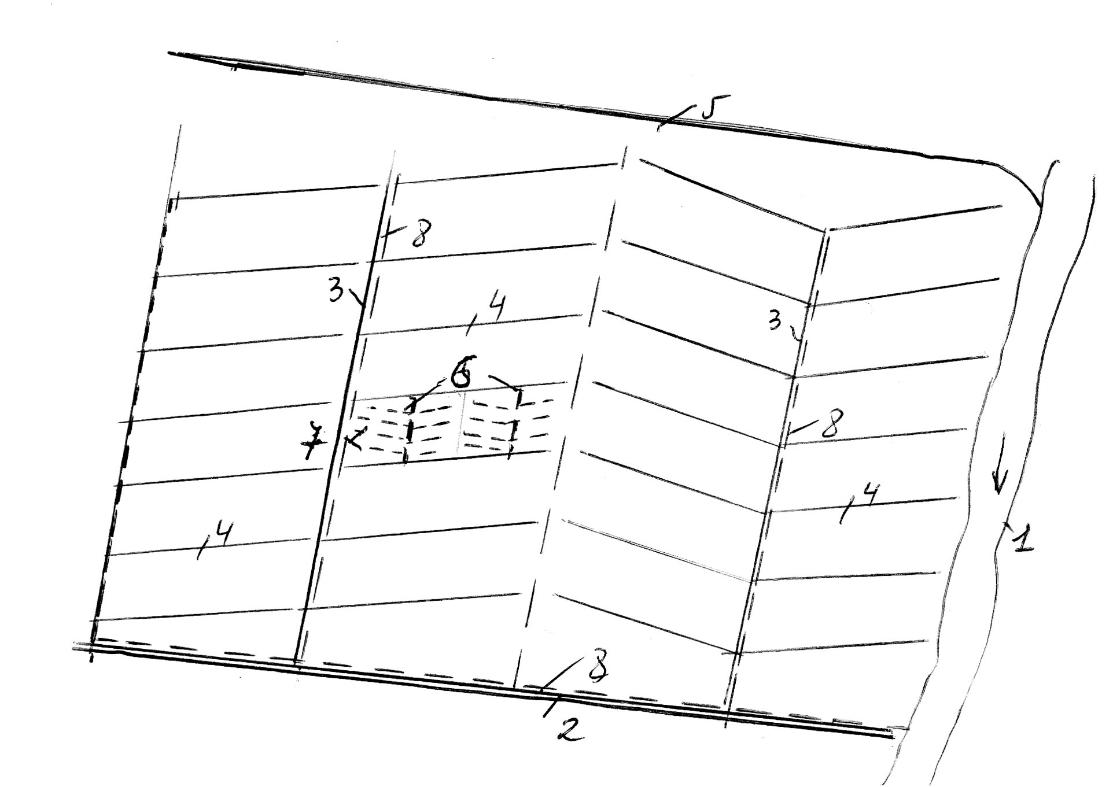

**nax.16. 1 – wRalmimRebi (mdinare); 2 – magistraluri arxi;**

**3 – koleqtori; 4 – maregulirebeli arxi;**

**5 – samTo arxi; 6 – daxuruli koleqtori;**

**7 – daxuruli drenaJi; 8 – wyalSemkrebi arxebi**

vinaidan damSrobi qselis daniSnulebaa Warbi zedapiruli da gruntis wylebis teritoriidan gayvana, is yovelTvis farTobis udables adgilebSi unda gadiodes, sarwyavi qseli ki, piriqiT, unda mdebareobdes yvelaze maRal niSnulebze, vinaidan am SemTxvevaSi xdeba farTobze wylis miwodeba. es aris ZiriTadi gansxvaveba damSrob da sarwyav qselTa gegmaze ganlagebas Soris.

damSrobi sistema SeiZleba iyos Ria da daxuruli. Ria sistemebSi maregulirebeli qseli warmodgenilia Ria arxebiT, xolo daxurulSi – daxuruli drenaJiT.

daSroba SeiZleba ganxorcieldes TviTdinebiT da wylis meqanikuri gadaqaCviT satumbi sadguris meSveobiT.

damSrobi sistemebi SeiZleba iyos erTmxrivi moqmedebis, rodesac damSrobi sistemebi gankuTvnilia mxolod Warbi tenis gasayvanad da, ormxrivi moqmedebis, rodesac daSrobis garda, calkeul gvalvian periodebSi SeiZleba ganxorcieldes morwyvac.

**33. daSroba Ria qseliT – Ria maregulirebeli qseli**

maregulirebeli qselis daniSnuleba zedapiruli wylebiT daWaobebis dros, rogorc zemoT aRvniSneT, aris am wylebis rac SeiZleba swrafad miReba, raTa acilebuli iqnes farTobze misi xangrZlivad dagroveba.

Ria maregulirebeli arxebi farTobze iseTi mimarTulebiT unda gatardes, rom maqsimalurad da Seuferxeblad miiRos zedapiruli wylebi, garda amisa man unda uzrunvelyos sasoflo-sameurneo manqanebisa da meqanizmebis Seuferxebeli gamoyeneba. am pirobis dasacavad, farTobi or maregulirebel arxs Soris ar unda iyos 20 heqtarze naklebi, xolo manZili or maregulirebel arxs Soris – 200 m-ze naklebi. aris SemTxvevebi, rodesac arxTa Soris manZili – 200 m ver uzrunvelyofs farTobze tenis saWiro reJims, amitom ufro xSiri qselis Tavidan asacileblad mimarTaven arxTaSoris farTobze agromelioraciuli RonisZiebebis gatarebas – kvlebis mowyoba, niadagis Rrma gafxviereba, daxvrelva, danapraleba da sxv.

saerTod, maregulirebel arxebs Soris manZili iseTnairad unda SeirCes, rom rac SeiZleba swrafad moxdes farTobidan wylis mocileba, e.i. dasaSrob teritoriaze wylis datboreba gansazRvrul droze metad ar gagrZeldes. es dro damokidebulia TviT mcenareze, ramdenadac esa Tu is mcenare sxvadasxvanairad itans farTobze wylis datborebas. am dros xangrZlivoba daaxloebiT 5 saaTidan (wylis ufro naklebad amtani kulturebisaTvis) 36 saaTamde (SedarebiT amtani kulturebisaTvis) meryeobs.

**34. daSroba daxuruli qseliT – daxuruli maregulirebeli qseli**

gruntis wyliT daWaobebuli farTobis dasaSrobad gamoiyeneba daxuruli qseli anu daxuruli drenaJi, romelic gayvanilia niadagqveS sxvadasxva masalis milebis saxiT garkveul siRrmeze da manZilze.

gamoyenebuli masalis mixedviT arCeven drenaJis Semdeg sexeeba:

* 1. **Tunis drenaJi.** daxuruli drenaJis yvelaze gavrcelebul saxes warmoadgens Tunis milebis drenaJi. Tunis drenaJi warmoadgens gamomwvari Tixis mils, romlis diametri sxvadasxva SeiZleba iyos – 50, 75, 100 mm da a.S., rac Seexeba sigrZes, nebismieri diametris SemTxvevaSi igi standartulia da Seadgens 33 sm. Tunis milebs amzadeben rogorc cilindruls, ise waxnagovans. Tixis milebs miwaSi awyoben specialuri sadrenaJo manqanebiT. mas axasiaTebs sakmao gamZleoba – 40-50 weli.
  2. **plastmasis milebi.** plastmasis milebis dasamzadeblad iyeneben polimerul masalebs – polieTilens, viniplasts da a.S. plastmasis milebi gacilebiT msubuqia Tunis milebze, ar imtvrevian transportirebisas. misi Cawyoba mTlianad meqanizirebulia.
  3. **xis drenaJi.** im raionebSi, sadac xe deficiti ar aris, iyeneben xis drenaJs. igi ZiriTadad gamoiyeneba torfiani Waobebis daSrobis dros, mudmivi tenianobis arsebobis pirobebSi, sadac xe didxans Zlebs. Cawyobis win xis masalas JRinTaven antiseptikuri nivTierebebiT.
  4. **qvis drenaJi.** qvi drenaJia, rodesac arxis ZirSi vyriT RorRs, an fila qvas daaxloebiT 30 sm-is fenad, zed vayriT wvril RorRs, Semdeg beltebs da bolos fxvier miwas. SeiZleba qva ise CavawyoT, rom marTxuTxa an samkuTxa mili miviRoT, sadac wyali idens.
  5. **bambukis drenaJi.** saqarTveloSi kolxeTis dakavSirebiT gamocdilia bambukis drenaJi. bambukis milma rom wyali miiRos, amisaTvis saWiroa TiToeuli milis sigrZeze gakveTa, xolo milebi rom miwiT ar amoivsos, milebis SeerTebis adgili daculi unda iyos.

**Tavi III**

**brZola wylis meqanikur moqmedebasTan (wylismieri erozia)**

cnobilia, rom atmosferuli naleqebis erTi nawili, romelic ver aswrebs niadagSi CaJonvas, Camoedineba niadagis zedapirze Camonadenis saxiT.

zedapiruli Camonadeni wyali Tavisi moZraobis dros meqanikurad moqmedebs niadagis zedapirze, rac niadagis gadarecxvasa da daxramvas iwvevs. niadagis gadarecxva TvaliT TiTqos SeumCnevelia da misi SemCneva aucileblad specialur dakvirvebas saWiroebs, xolo rac Seexeba daxramvas, mas Cven vxvdebiT xramebis, xevebisa da Releebis saxiT. amrigad, gadarecxva Sedegia wylis SedarebiT susti moqmedebisa, xolo daxramva – ufro Zlieri moqmedebisa.

miuxedavad imisa, rom gadarecxvis procesi Zneli SesamCnevia, igi sakmaod uaryofiT gavlenas axdens soflis meurneobaze.

gadarecxvis Sesamcireblad saWiroa Semcirdes zedapiruli Camonadenis koeficienti da farTobis qanobi.

gadarecxvis winaaRmdeg arsebuli RonisZiebebi SeiZleba davyoT 3 jgufad: agroteqnikur, fitomelioraciul da hidroteqnikur RonisZiebebad.

agroteqnikur RonisZiebebSi Sedis:

* 1. SiSveli adgilebis mcenareuliT dafarva;
  2. Rrma xvna;
  3. organuli sasuqebis Setana;
  4. xvna ganivi mimarTulebiT.

fitomelioraciul RonisZiebebs ekuTvnis: tyis zolebis gaSeneba da maRlobebis gamwvaneba.

rac Seexeba hidroteqnikur RonisZiebebs, maT ricxvs ekuTvnis radikaluri RonisZieba – dateraseba.

**dateraseba**

daterasebis mizani mdgomareobs imaSi, rom ZiriTadad Semcirdes da minimumamde iqnes dayvanili niadagis zedapiris gadarecxva.

arsebobs daterasebis ori saxe:

* 1. safexurisebri dateraseba;
  2. beqobebis saSualebiT dateraseba.

**beqobebiT dateraseba**

beqobebis saSualebiT dateraseba metad martivi da iafi RonisZiebaa. am dros farTobs ar ecvleba bunebrivi qanobi, mxolod horizontalebis mimarTulebiT gakeTebuli beqobebiT farTobi iyofa 20-50 m siganis terasebad (nax. 17). beqobTa saSualebiT dateraseba misaRebia, rodesac zedapiris qanobi 50-dan 100-mde meryeobs. daaxloebiT es is sazRvaria, romlis Semdeg ukve meqanizaciis gamoyeneba SeuZlebelia (nax. ). 100-ze zeviT ukve saWiroa qanobis Semcireba da amitom, gamoiyeneba safexurisebri dateraseba.

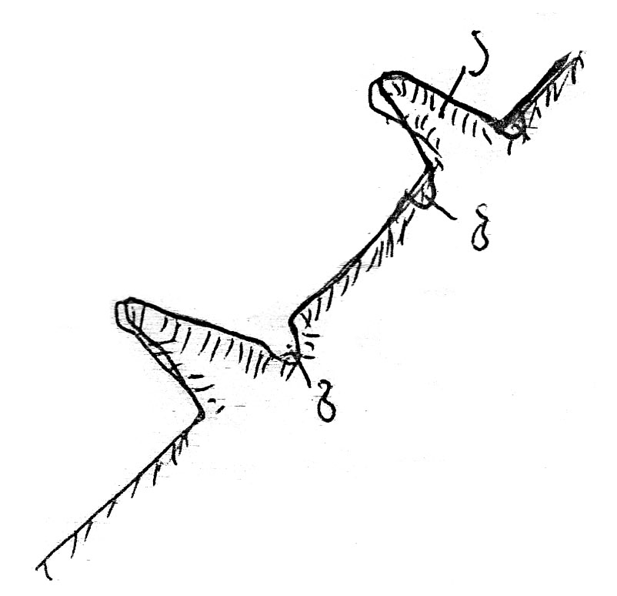

**nax.17. beqobebiT dateraseba**

1. **beqobi;**

**b) sarwyavi Txrili;**

**g) wyalSemkrebi Txrili**

rogorc suraTidan Cans, terasis boloSi gayvanilia Txrili, romlis daniSnulebaa terasis farglebSi warmoSobili zedapiruli Camonadeni wylis dagroveba da wyalmimRebSi gadagdeba.

im SemTxvevaSi, rodesac daterasebasTan ertad farTobi saWiroebs morwyvas, terasis TavSi, e.i. zeda beqobis qveda mxares gayvanili unda iqnes sarwyavi Txrili (b), xolo terasis boloSi gatarebuli Txrili (g) Semkrebi Txrilis rols Seasrulebs. aseTi terasebis rwyva umetes SemTxvevaSi Tavisufali moRvarvis wesiT warmoebs.

**safexurisebri dateraseba**

safexurisebri dateraseba ise unda Catardes, rom farTobi maqsimalurad iqnes daculi gadarecxvisagan. am SemTxvevaSi farTobis qanobi icvleba da misi zusti SerCeva xdeba niadagis Tvisebebis mixedviT.

am TvalsazrisiT terasebs SeiZleba mieces sami saxis mdebareoba (nax. 18):

* 1. horizontaluri mdebareoba;
  2. mdebareoba pirdapiri qanobiT;
  3. mdebareoba Sebrunebuli qanobiT.

horizontaluri mdebareobis terasi gamoiyeneba saSualo meqanikuri Sedgenilobis niadagebSi, romelic SedarebiT kargi wyalgamtarunarianobiTa da susti wyalSeTvisebis unariT xasiaTdeba. e.i. mosuli naleqebis raodenoba terasis zedapirze rCeba da Camonadens adgili ar eqneba.

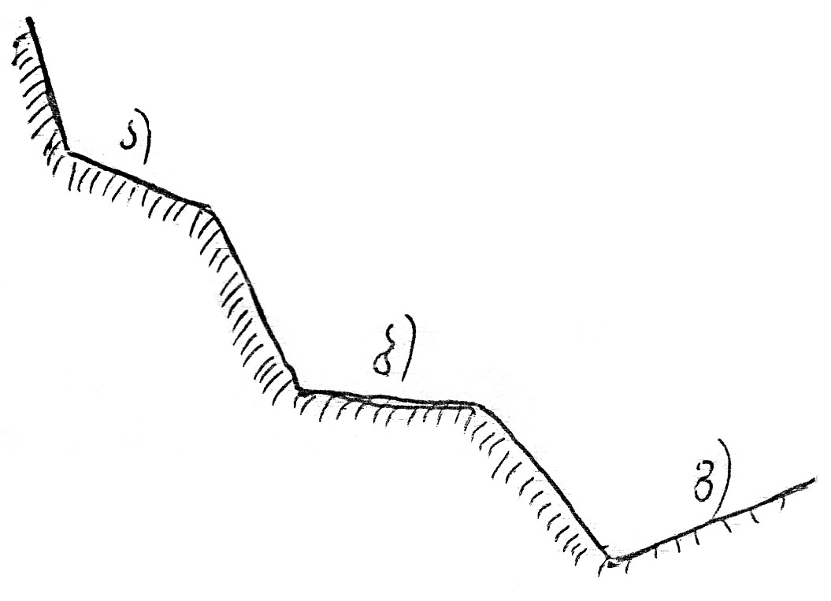

**nax.18. safexurisebri dateraseba**

1. **pirdapiri qanobi;**

**b) horizontaluri qanobi;**

**g) Sebrunebuli qanobi**

terasi pirdapiri qanobiT keTdeba mCate meqanikuri Sedgenilobis niadagebze, romelsac axasiaTebs mcire wyaltevadoba da didi wyalgamtarunarianoba, amitom mosuli naleqebi Tavisuflad aswrebs niadagSi CaJonvas da adgili ara aqvs zedapirul Camonadens.

terasi ukuqanobiT keTdeba mZime niadagebze, romelsac axasiaTebs naklebi wyalSeTvisebis da didi wyaltevadobis unari, amdenad, saWiroa terasis zedapirze SevaCeroT wyali, raTa igi TandaTanobiT CaiJonos da gaatenianos niadagi.

terasebis damzadebis dros, niadagis zeda fena calke unda daiyaros da SemdgomSi, terasis gasworebis dros es fena zedapirze dalagdes. calke unda daiwyos agreTve meore da mesame fenebi, romlebic SemdegSi iseTive TanmimdevrobiT unda dalagdes.

**Tavi IV**

**damlaSebuli niadagis melioracis**

damlaSebuli ewodeba iseT niadagebs, romlebic Seicaven adviladxsnadi marilebis maRal koncentracias (NaCl, Na2CO3, Na2SO4 da sxv.). aseTi niadagebi umTavresad gavrcelebulia aridul (mSral) zonaSi. saqarTveloSi aseTi niadagebi gvxvdeba aRmosavleT nawilSi: siRnaRis, gardabnis, marneulis da sxv. raionebSi. warmoSobis mixedviT damlaSebuli niadagebi SeiZleba iyos pirveladi an meoradi damlaSebis.

pirveladi damlaSebis niadagebi warmoiqmnebian teritoriaze mimdinare bunebrivi procesebis gavleniT, ris Sedegadac xdeba marilebis sistematuri dagroveba niadagSi, gruntSi da gruntis wylebSi, saidanac kapilarebis saSualebiT xdeba misi amosvla niadagis zedapirze, wyali orTqldeba, marilebi ki niadagis zeda fenaSi rCeba. am SemTxvevaSi niadagis damlaSeba xdeba, roca gruntis wyali miwis zedapiridan 1-3 m siRrmeze mdebareobs. roca gruntis wyali ufro Rrmadaa, marilebi kapilarebis saSualebiT zedapirze ver aRwevs da niadagis damlaSebas adgili ara aqvcs.

meoradi damlaSeba umTavresad vitardeba miwebis gasarwyavebis pirobebSi, rodesac adgili aqvs gruntis wylis doneebis awevas, rac SeiZleba gamowveuli iqnas arxebidan wylis filtraciis, gadidebuli morwyvis normebiT rwyvis Sedegad da sxv.

mlaSe niadagebi or ZiriTad saxed iyofa – bici da bicobi niadagi.

bici niadagebi Seicaven adviladxsnadi marilebis didi raodenobas, rogorc zedapirze, ise qveda fenaSi, e.i. mTel profilSi.

bicobi niadagi Seicavs advilad xsnad marilebs garkveul siRrmeze (20-25 sm), aq Warbobs didi raodenobiT STanTqmuli natriumi (5%), riTac igi ZiriTadad gansxvavdeba bici niadagisagan.

bici niadagebis damlaSebis xarisxis mixedviT maTi gamomlaSeba sxvadasxva meTodebiT warmoebs. erT-erTi aseTi RonisZiebaa morwyvis normebis racionalizacia, e.i. optimaluri morwyvis normiT rwyva, vinaidan zedmetad miwodebuli wyali Rrma fenebSi Cadis da, Tu gruntis wyali zedapirTan axlos mdebareobs, misi done TandaTan zeviT iwevs, kapilarebis saSualebiT zeviT amoaqvs marilebi da xels uwyobs damlaSebas.

didi mniSvneloba aqvs agreTve sarwyav qselSi filtraciuli danakargebis Semcirebas, vinaidan isini warmoadgenen gruntis wylebis mkvebav wyaros, xels uwyoben maTi doneebis awevas da marilebis zeda fenebSi amotanas. am mizniT didi yuradReba unda mieqces miwis arxebis mopirkeTebas, gansakuTrebiT mCate meqanikuri Sedgenilobis gruntebSi.

damlaSebis sawinaaRmdego aucilebel RonisZiebas warmoadgens wyalSemkrebi qselis mowyoba, romlis daniSnulebacaa rwyvis dros warmoSobili zedmeti wylis swrafad mocileba farTobidan.

Tu niadagi imdenad damlaSebulia, rom zemoT aRniSnuli RonisZiebebi arasakmarisia sasoflo-sameurneo kulturebis normaluri ganviTarebisaTvis, maSin mimarTaven niadagis gamorecxvas da gaTabaSirebas.

gamorecxvas Semdegnairad awarmoeben: farTobs jer awodeben imden wyals ramdenis dakavebac mas SeuZlia, e.i. srul wyaltevadobamde. ucdian ramodenime dRes, sanam marilebi wyalSi gaixsnebodes da Semdeg gadidebuli morwyvis normiT wyals awvdian 2-3 jerad datborebis wesiT. am SemTxvevaSi iqmneba Zlieri daRmavali deni, romelsac Caaqvs gaxsnili marilebi qveda fenebSi.

mlaSe niadagebis gamorecxva aucileblad saWiroebs niadagSi Casuli wylis farTobidan gayvanas da meoradi damlaSebis sawinaaRmdego RonisZiebebis gatarebas, Tu garecxvis dros Rrmad Casuli wyali farTobidan bunebrivad ar iwriteba, aucileblad mosalodnelia farTobis xelmeored damlaSeba. amitom mlaSe niadagebis gamorecxvis paralelurad Rrma fenaSi Casuli wylis mosaSoreblad saWiroa sadrenaJo qselis Rrmad (2,0-3,5 m) gatareba, SemdgomSi misi saSualebiT am wylis Ria wyalSemkreb arxebSi da am ukanasknelidan ki, wyalmimRebSi gayvana.

mlaSe niadagebis gamorecxvas gvian Semodgomaze da zamTarSi awarmoeben, vinaidan sarwyavi farTobi am dros Tavisufalia da adgili ara aqvs niadagidan aorTqlebas. gamomlaSebis normas niadagis Tvisebebisa da adgilobrivi pirobebis mixedviT iReben 2000-5000 m3/ha-s, xolo calkeul SemTxvevaSi mn SeiZleba miaRwios 10000 m3/ha-s.

bicobiani niadagebi, ise, rogorc bicobebi, metad uaryofiTi fizikuri TvisebebiT xasiaTdeba.

bicobebis melioraciis mizniT upirveles yovlisa mocilebuli unda iqnes bicobianobis gamomwvevi mTavari mizezi – STanTqmuli natriumi. Tu STanTqmul natriums STanTqmis moculobis 10%-mde ukavia, sakmarisia mxolod agroteqnikuri RonisZiebebis Catareba /Rrma melioraciuli xvna, mravalwliani balaxebis daTesva, niadagis damuSaveba beltis gadmoubruneblad da sxv../.

Tu STanTqmul natriums STanTqmis moculobis 10%-ze meti ukavia, saWiroa qimiuri melioraciis gamoyeneba. saWiroa jer STanTqmuli kompleqsis natriumis Secvla kalciumiT da Semdeg gamorecxva. natriumis Sesacvlelad iyeneben TabaSirs. es reaqcia Semdegnairad mimdinareobs:

.

TabaSiri saSualod xsnadi marilia. is TandaTanobiT aZevebs natriumis ions, romlis ganmeorebiTi STanTqma ukve SeuZlebelia. amis gamo bicobianobis procesic wydeba, reaqciis Sedegad warmoSobili gogirdmJava natriumi unda gamorecxili iqnas fesvTa sistemis gavrcelebis aredan.

bicobebis qimiuri melioraciis mizniT gamoyenebuli unda iqnas adgilobrivi saxis iseTi qimiuri sasuqi, rogoricaa gaji, romelic 60-90% TabaSirs Seicavs. TabaSiris garda an masTan erTad SeiZleba gamoyenebuli iqnas mJave reaqciis mqone mineraluri sasuqi. maT Soris yvelaze met efeqts iZleva superfosfatis gadidebuli doziT Setana.

**გამოყენებული ლიტერატურა**

1. **შ. კუპრეიშვილი** - ირიგაცია. თბილისი, 2014წ. სალექციო კურსი. ელ.ვერსია. 76გვ. საქართველოს ტექნიკური უნივერსიტეტის ცენტრალური ბიბლიოთეკა. CD(1279).
2. **ო.** **ნათიშვილი -** მელიორატორის ცნობარი. 1986წ. 335გვ. საქართველოს ტექნიკური უნივერსიტეტის ცენტრალური ბიბლიოთეკა. 626.8(083)/1
3. **ი. ანჯაფარიძე** - მელიორაციული ნიადაგმცოდნეობა. თბილისი, განათლება, 1977 წ. 307გვ. საქართველოს ტექნიკური უნივერსიტეტის ცენტრალური ბიბლიოთეკა. 631.4(02)/2
4. **გ. ტუღუში** - სასოფლო-სამეურნეო კულტურების მორწყვის წესები და მათი სრულყოფის გზები. თბილისი, 1986 წ. 240გვ. საქართველოს ტექნიკური უნივერსიტეტის ცენტრალური ბიბლიოთეკა. 631.6/32
5. **პ. სიჭინავა** -ჰიდროტექნიკური მელიორაცია. თბილისი, განათლება, 1983 წ. 484გვ. საქართველოს ტექნიკური უნივერსიტეტის ცენტრალური ბიბლიოთეკა. 626.8(02)/9
6. **ხურცილავა ა.დ.** - ჰიდრომელიორაციული სისტემების ექსპლუატაცია. თბილისი, გამომცემლობა „განათლება“, 1982წ. 233გვ. საქართველოს ტექნიკური უნივერსიტეტის ცენტრალური ბიბლიოთეკა. 626.8(02)/11
7. **ჩიკვაშვილი ბ. მ.** - ჰიდროლოგია, ჰიდრომეტრია, ჩამონადენის რეგულირება. თბილისი, გამომცემლობა „განათლება“, 1976წ. საქართველოს ტექნიკური უნივერსიტეტის ცენტრალური ბიბლიოთეკა. 551.49(02)/20
8. **ჩიკვაშვილი ბ. მ.** - ზედაპირული მორწყვა. თბილისი, გამომცემლობა „საბჭოთა საქართველო“, 1979წ.