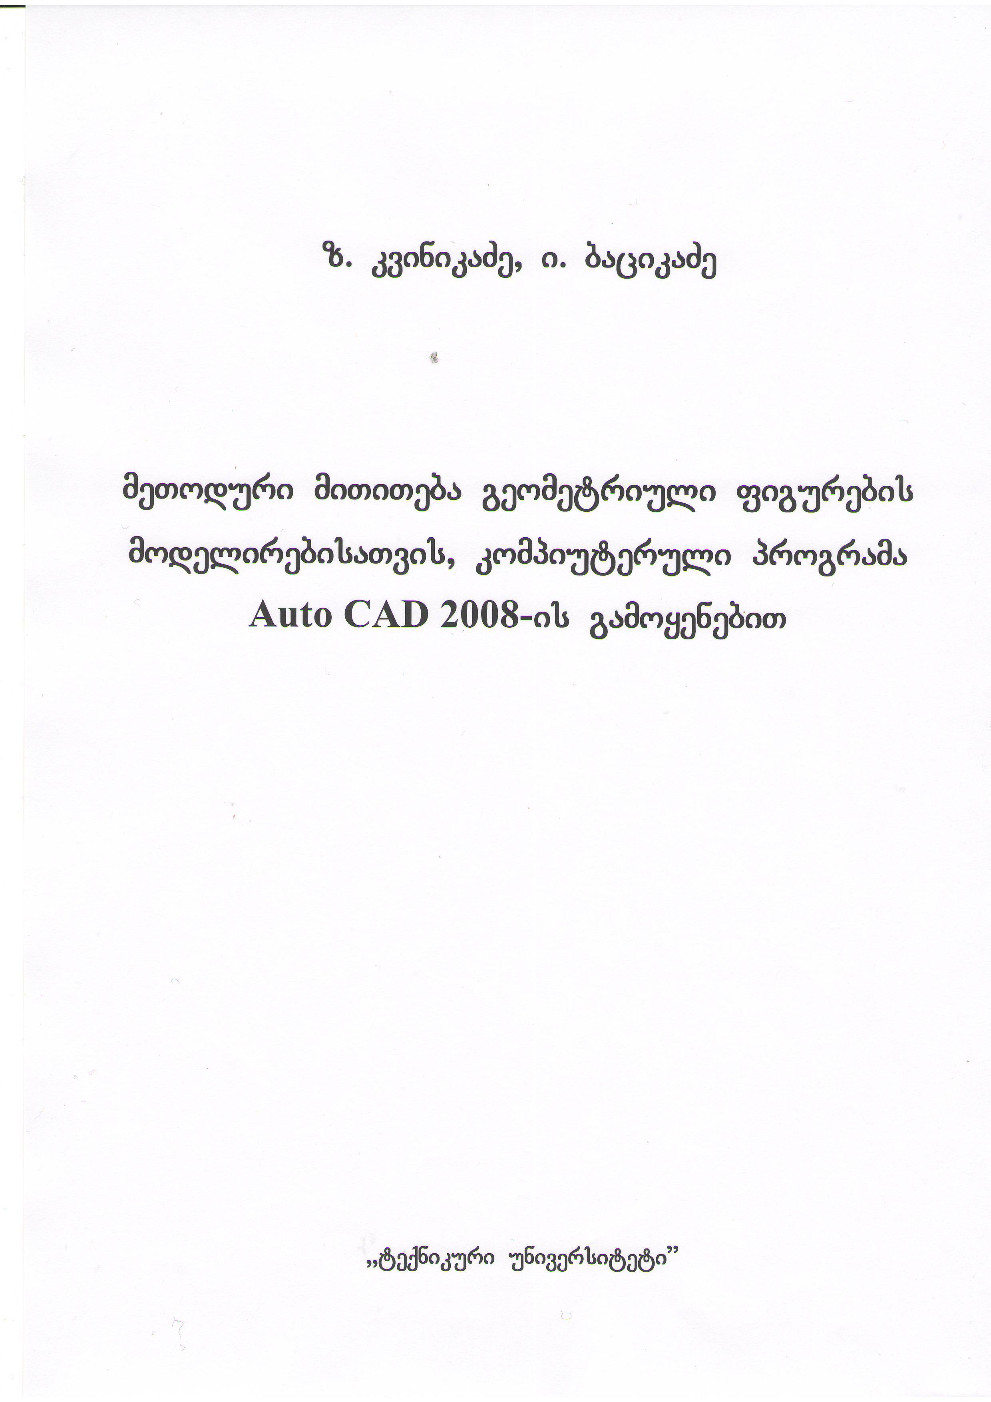

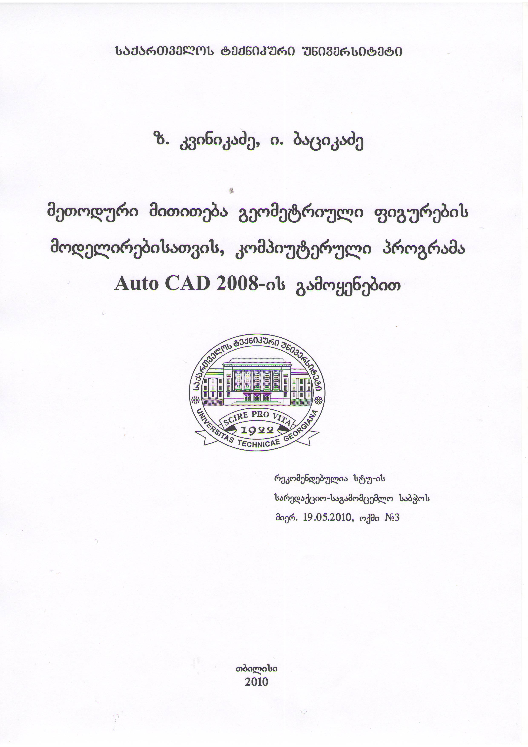

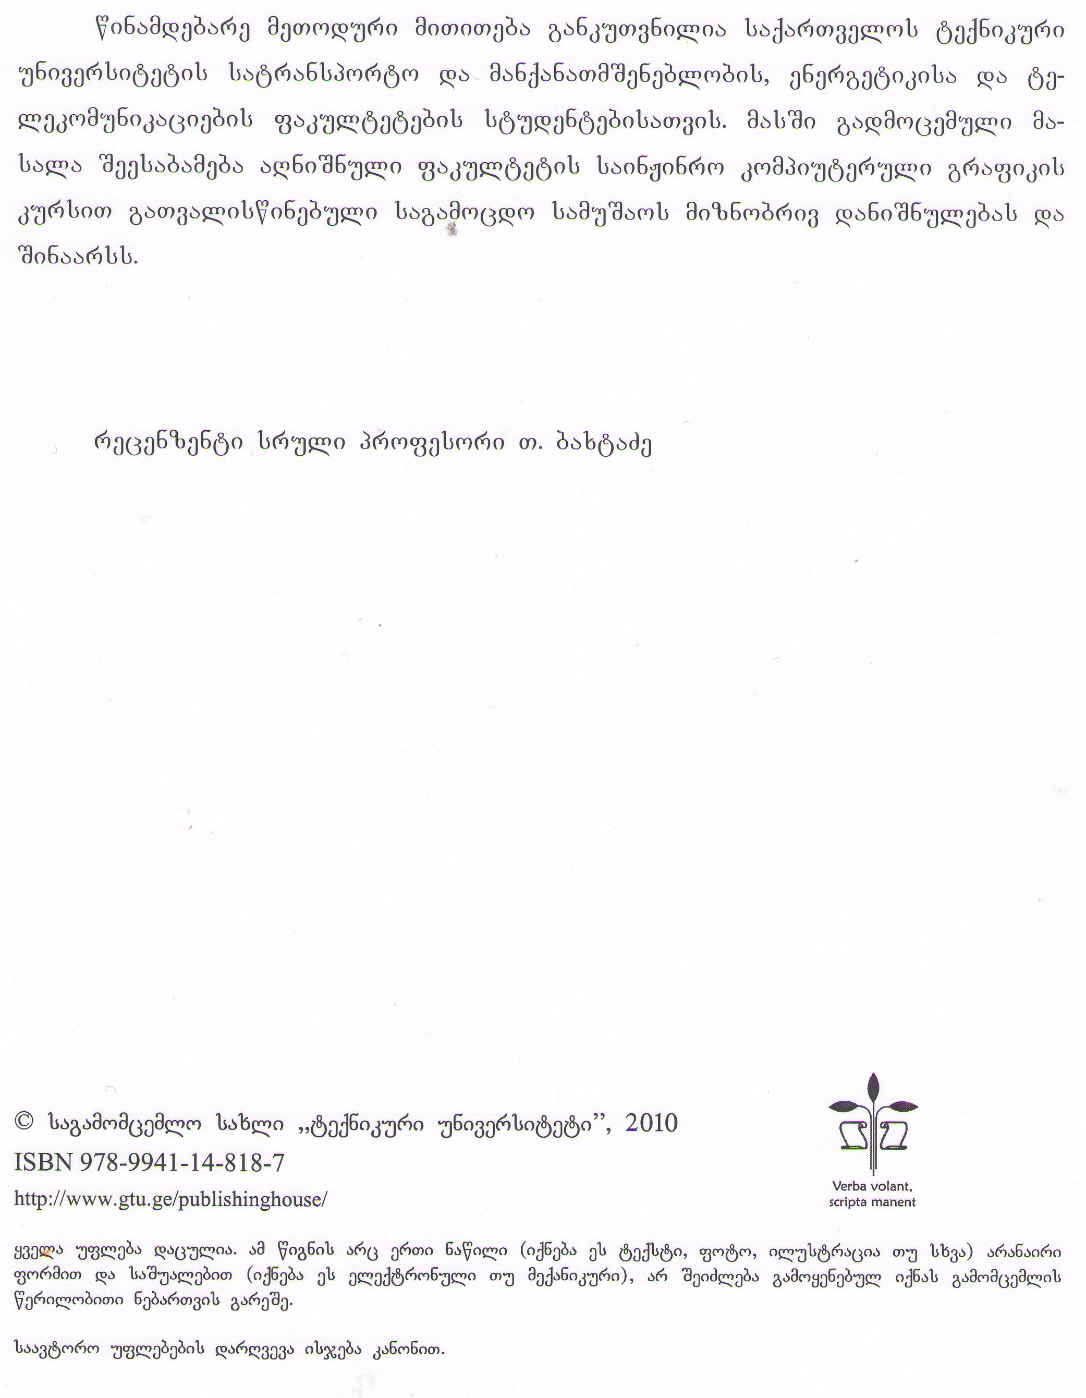

S e s a v a l i
ukanaskneli wlebSi saqarTvelos teqnikur universitetSi xorciel-deba teqnikuri disciplinebis swavlebaSi kompiuteris danergvisa da gamo-yenebis farTo programa.
am mizniT sainJinro grafikisa da teqnikuri meqanikis departamentis, sainJinro grafikis mimarTulebaze, satransporto da manqanaTmSeneblobis, energetikisa da telekomunikaciebis fakultetebis studentebisaTvis Seiq-mna sainJinro grafikis kursis axali samuSao programa (Semdgeneli a. Sav-guliZe, z. kvinikaZe, i. bacikaZe), romelic am sagnis swavlebas iTvaliswi-nebs swavlis I kursis II semestrSi.
programis umTavresi siaxle isaa, rom sainJinro grafikis kursi Seis-wavleba da sagamocdo namuSevari sruldeba kompiuteruli programa Auto CAD 2008– is gamoyenebiT.
es meToduri miTiTebebi gankuTvnilia satransporto da manqanaTmSe-neblobis, energetikisa da telekomunikaciebis fakultetebis studentebis, sagamocdo samuSaos SesrulebisaTvis, mosamzadeblad.

samganzomilebiani geometriuli figuris modelireba

1. samuSaos Tema
naxazis formireba samganzomilebiani geometriuli figuris modeli-rebis gamoyenebiT.
2. samuSaos mizani
samuSaos mizania gamoavlinos studentis momzadeba kompiuteruli pr-ograma Auto CAD 2008–is gamoyenebiT samganzomilebiani geometriuli figu-ris modelirebasTan dakavSirebuli sakiTxebis codnaSi.
3. samuSaos Sinaarsi da gaformeba
samuSao iTvaliswinebs kompiuteris saSualebiT samganzomilebiani ge-ometriuli figuris modelirebas, mis failSi Senaxvas da naxazis myari as-lis miRebas.
4. samuSaos amocanis Sinaarsi
geometriuli figuris TvalsaCino gamosaxulebis mixedviT avagoT mi-si samganzomilebiani modeli, am modelis mixedviT ki - figuris sami xedi, naxazi gavaformoT standartebis mixedviT. amocana unda Sesruldes kompiu-teruli programa Auto CAD 2008 –is gamoyenebiT.
5. samuSaos Sesrulebas rekomendebulia win uZRodes Sesabamisi Teo-riuli da praqtikuli masalis damuSaveba sagnis qvemoT mocemuli saxelm-ZRvaneloebidan:
1. a. SavguliZe, i. xatiskaci, n. nikvaSvili, z. kvinikaZe. sainJinro da kompiuteruli grafika (I nawili). `teqnikuri universiteti~, Tbilisi, 2009;
2. z. kvinikaZe. sainJinro da kompiuteruli grafika (II nawili). `teqni-kuri universiteti~, Tbilisi, 2010;
3. Вернер Зоммер. Auto CAD 2008. Руководство конструктора. Издательство БИНОМ, Москва, 2008;
4.Виктор Погорелов. AutoCAD 2005 для начинающих. Санкт-Петербург ≪БХВ-Петер-бург≫. 2004;
5.i. bacikaZe, z. kvinikaZe, m. arabiZe. sainJinro grafika (gegmiluri xaz-va). `teqnikuri universiteti~, Tbilisi, 2009.

naxazis Seqmna
nebismieri naxazis Seqmna SesaZlebelia daviwyoT sul Tavidan, rog-orc es ganxilulia saxelmZRvaneloSi (z. kvinikaZe. sainJinro da kompiute-ruli grafika (II nawili). `teqnikuri universiteti~, Tbilisi, 2010), magram, radgan programa AutoCAD 2008–Si Senaxulia ukve Seqmnili naxazebi, SegviZ-lia gamoviZaxoT Cveni Seqmnili, Senaxuli furclebidan erT-erT an AutoCAD 2008–Si Cawerili sxva nebismieri Sabloni.
ekranze sawyisi dialoguri fanjara Tu ar Cans, igi unda gamoviZa-xoT. amisaTvis saWiroa brZanebis striqonSi SevitanoT `Startup 1~ da dava-WiroT Enter klaviSs. amis Semdeg Auto CAD 2008 programis gaxsnisas ekranze yovelTvis gamoCndeba sawyisi dialoguri fanjara.
mivaniWoT naxazs raime saxeli, magaliTad `detali 1~.
- File – New – Create New drawing – Use a wizard am fanjris Select a wizard siaSi virCevT Quick setap (swrafi momzadeba) + Ok.
- Quick setap fanjaraSi sigrZis erTeulad virCevT Decimal + Next, xazvis sazRvrebs ganvsazRvravT Area zonaSi + Finish.
Format – units – drawing units – Length – type – decimal
Format – drawing limits da brZ. striq. Segvyavs xazvis sazRvrebis zomebi.
- avsaxoT naxazis mTeli are ekranze. view – zoom – All.

samganzomilebiani geometriuli figuris modelireba
TvalsaCino gamosaxuleba, romlis mixedviTac unda avagoT geometri-uli figuris modeli mocemulia 1-l naxazze. mocemulobidan gamomdinare es figura SeiZleba warmovidginoT ori paralelepipedis erTobliobad.
nax. 1
20
30
10
15
9
4
1
22
02
5
62
7
0
2
0
4
0
4
0
6
0
2xvr. Ø16
2
0
10

pirvelad avagoT paralelepipedi zomebiT 120 x 60 x 20 (nax. 2a), ([2] TaviX,10.3.1). am paralelepipedSi 56 x 60 x 10 zomis marTkuTxa Raris gasake-Teblad gamoviyenoT Prespul brZaneba. ([2] Tavi X, 10.3.1). amisaTvis winxedSi avagoT 56 x 10 zomis marTkuTxedi (nax. 2a) da Prespul brZanebis gamoyenebiT miviRebT me-2b naxazze gamosaxul figuras.
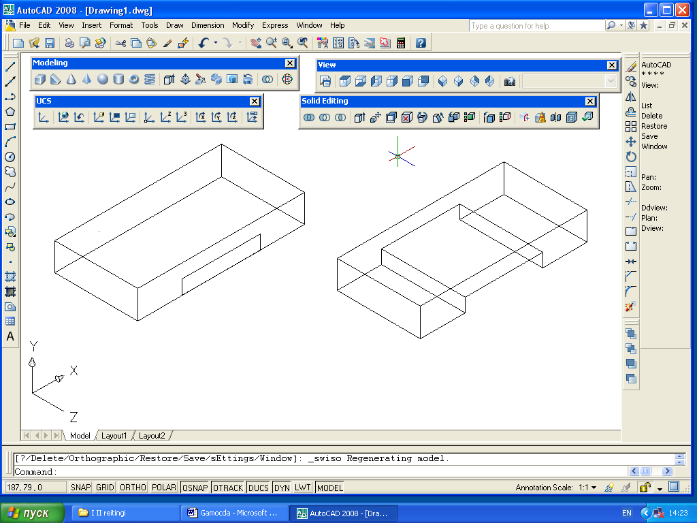
nax. 2
a)
b)

avagoT marTkuTxa paralelepipedi 70 x 40 x 30 zomebiT (nax. 3a). Cham-fer brZanebis ([2] Tavi VI, 6.6.2) brZanebis gamoyenebiT CamovaWraT solis for-mis nawilebi, 15 x 40 x 30 zomebiT, rogorc marcxena ise marjvena mxares. mi-
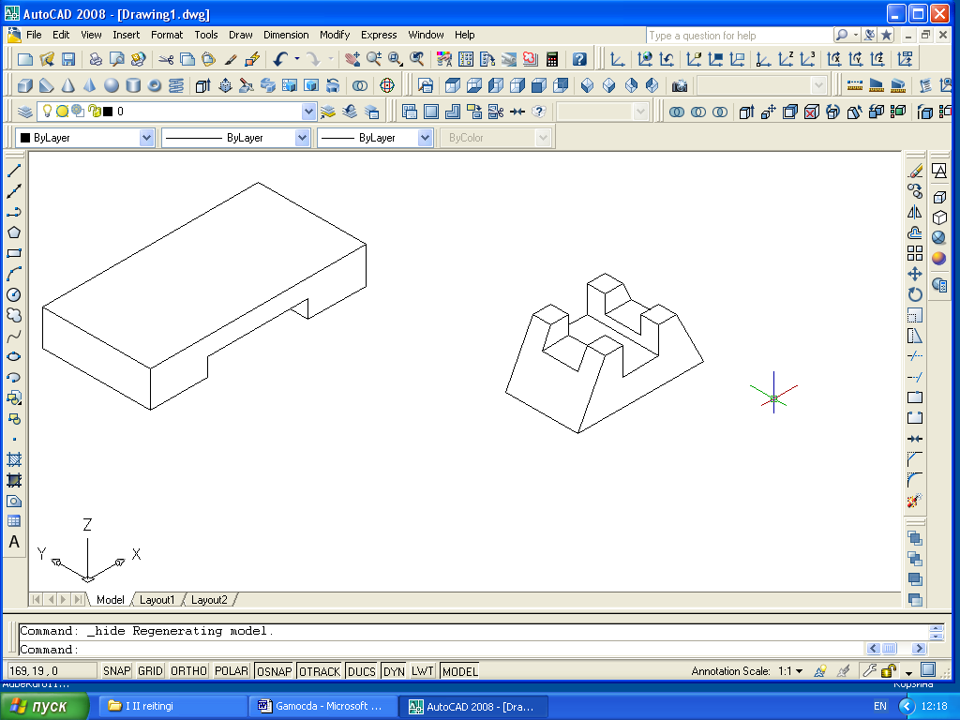
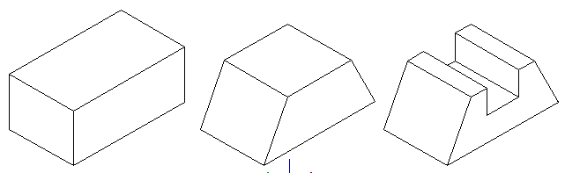
viRebT me-3b naxazze gamosaxul figuras. amis Semdeg, rogorc zemoT iyo gan-xiluli Prespul brZanebis gamoyenebiT miRebul figuras gavukeToT Rari 20 x 40 x 15 zomebiT, miviRebT me-3g naxazze gamosaxul figuras. aseve gavukeToT ga-nivi Rarebi (nax. 3d).
nax. 3
g)
b)
a)
d)

miRebuli figura Move brZanebiT ([2] Tavi VI,6.8) gadavaadgiloT da 1-l naxazze miRebuli figuris zeda fuZeze, centrSi davdgaT. UUnion brZanebiT ([2] Tavi X, 10.3.3) es ori figura gavaerTianoT. miviRebT me-4 naxazze gamosaxul figuras.
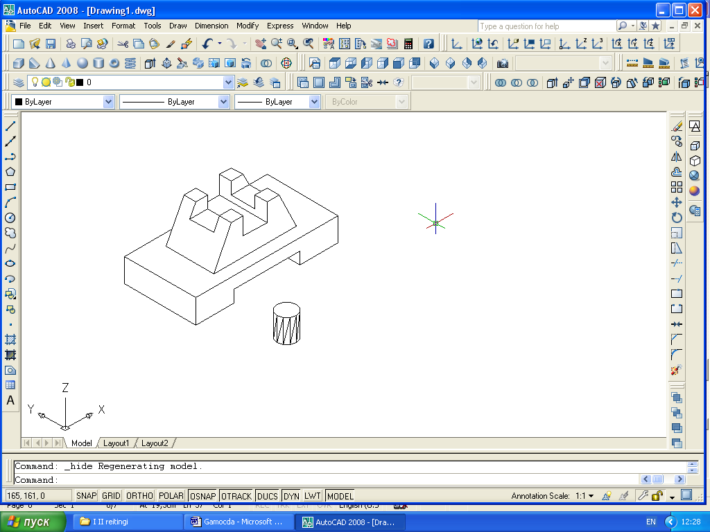
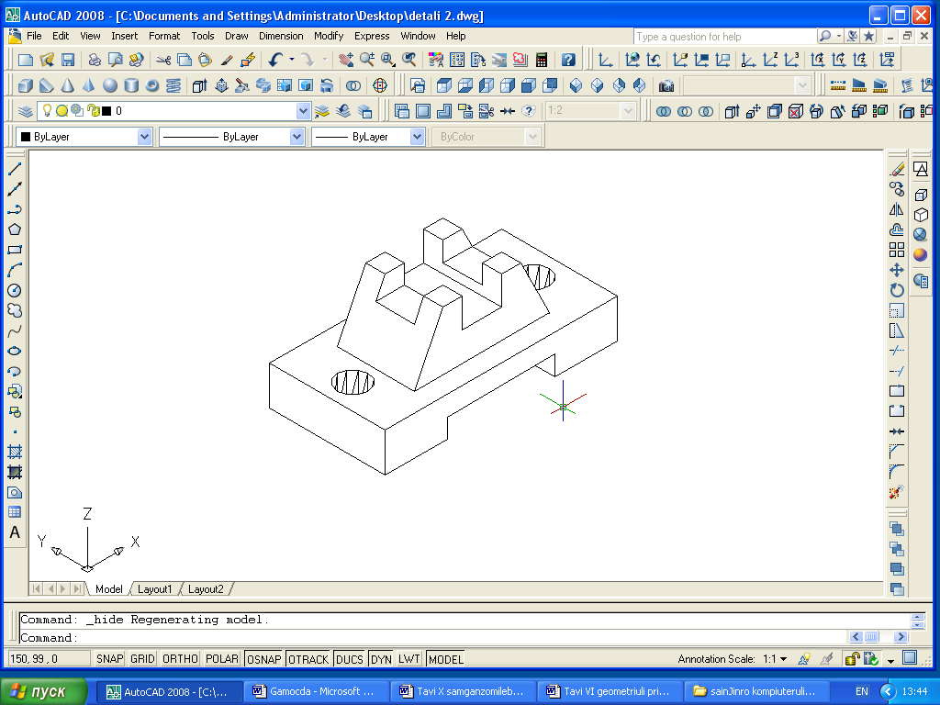
nax. 4
nax. 5

mocemulobis mixedviT darCenilia Ø16-iT ori cilindruli xvreli. am xvrelebis ageba SesaZlebelia sxvadasxva brZanebebis gamoyenebiT. maga-liTad, SesaZlebelia ukve gamoyenebuli Prespul brZanebiT. amisaTvis saWiroa miTiTebul adgilebze wrewirebis ageba da am brZanebis gamoyeneba.
sxvanairad ki – avagoT cilindri Ø16-iT da simaRliT 20 erTeuli (nax. 4), ([2] Tavi X, 10.3.1), Move brZanebiT gadavaadgiloT da CavayenoT moce-mulobis mixedviT miTiTebul adgilze. Semdeg Copy brZanebiT ([2] Tavi VI, 6.7) cilindris asli CavayenoT mocemulobis mixedviT, meore adgilze. yovelive amis Semdeg Subtract brZanebis ([2] Tavi X, 10.3.3) saSualebiT mTlian figuras gamovakloT orive cilindri, miviReb figuraSi or cilindrul xvrels. miRebuli figura gamosaxulia me-5 naxazze.
ekranuli xedebis gaformeba
miRebuli modelis mixedviT SesaZlebelia miviRoT am figuris xedebi (winxedi, zedxedi, gverdxedi). es SesaZlebelia sxvadasxva midgomiT ([2] Tavi IX). ganvixiloT erT-erTi.
modulis sivrcidan sadac agebulia geometriuli figuris modeli gadavideT Layout 1 CanarTze. aq ekranuli xedebi jer ar aris gamosaxuli.
gamoviZaxoT Solview brZaneba, romelsac Seesabameba Modeling panelis setup, view knopi, romlis daniSnulebaa samganzomilebiani sxeulis xedebis ekranul xedebTn SeTanxmebis momzadeba. Tu am panelze es knopi ar aris, igi unda SevqmnaT ([2] Tavi I, 1.2.2).
Solview brZanebis SekiTxva brZaneba striqonSi:
Enter an option [Ucs/ ortho/ Auxiliary/ Section]:
- Ucs (s.k.s.) – Seiqmnas ekranuli xedi mocemuli s.k.s. xediT.
- Ortho (orTo) – Seiqmnas ekranuli xedi, orTogonalur xedTan miTiTe-buli ekranuli xediT.
- Auxiliary (damatebiT) - Seiqmnas ekranuli xedi damatebiTi kveTis xedis xaziT.
- Section (kveTa) – Seiqmnas ekranuli xedi kveTiTurT.
avirCioT Ucs. gamoCndeba SekiTxva:
[Named/ world/ ?/ current]<current>:
avirCioT world – i zedxedisaTvis. Semdegi kiTxva
Enter view scale <1.0>:
mivuTiToT 0,2 (1:5) programa iwyebs xedis agebas da gvekiTxeba.
Specify view center: xedis centri.
mivuTiToT xedis centris wertili furclis marcxena qveda meoTxed-Si, wertilis ganlageba Tu ar mogewona SegviZlia gadavaadgiloT da Enter –iT davafiqsiroT. amis Semdeg gaCndeba kiTxva marTkuTxa ekranuli xedis sazRvrebis pirvel da mis mopirdapire kuTxeebis Sesaxeb. sazRvrebis miTi-Tebis Semdeg saWiroa xedis saxeli SeviyvanoT. axla ki kiTxva gameordeba.
Enter an option [Ucs/ ortho/ Auxiliary/ Section]:
winxedis asagebad, romelic zedxedTan mibmuli iqneba, avirCioT ortho. gaCndeba kiTxva, mivuTiToT ekranuli xedis gverdi gegmilisaTvis. aq unda mivuTiToT zedxedis qveda gverdi, winaaRmdeg SemTxvevaSi naxazi gadabrune-
buli gamoCndeba.
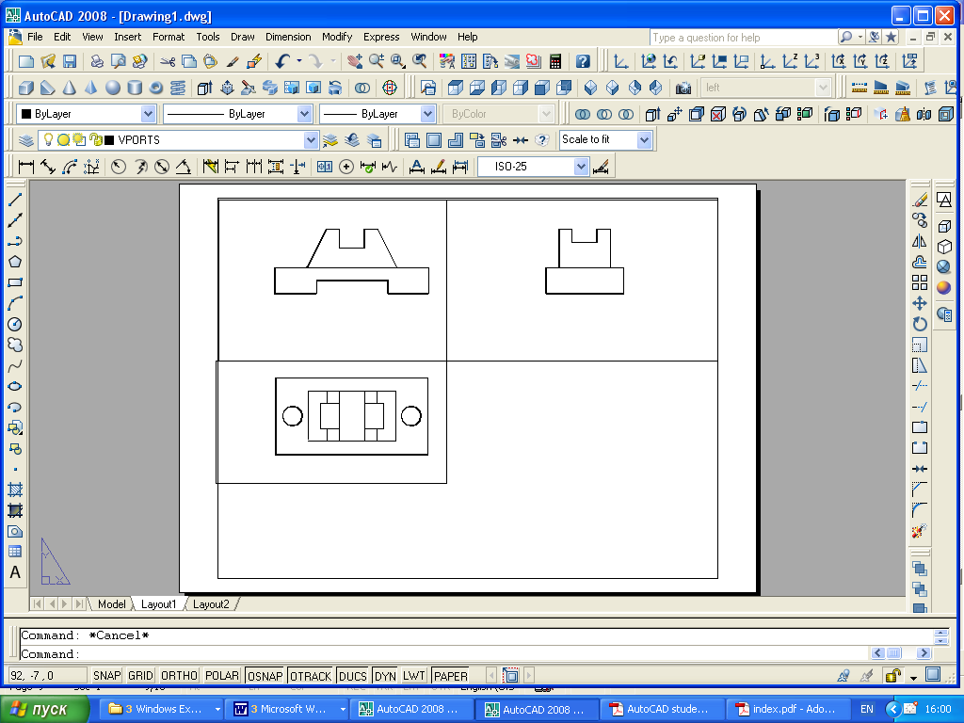
amis Semdeg vimeorebT imas rac zedxedisaTvis gavakeTeT, aseve ava-gebT gverdxedsac (nax. 6).
nax. 6

figuris Siga formebis saCveneblad gamoiyeneba Wrebi, romelTa Ses-ruleba Slice brZanebiT ([2] Tavi X, 10.3.2) aris SesaZlebeli. cnobilia, rom simetriuli figuris SemTxvevaSi Wris Cveneba winxedsa da gverdxedSi xdeba. amitom sanam figuris models gavWrideT, SevqmnaT zedxedis pro-fili. es operacia sruldeba Modeling – Profile brZanebiT. es brZaneba Tu ar aris instrumentebis Modeling panelze, maSin igi unda SevqmnaT ([2] Tavi I, 1.2.2). es brZaneba muSaobs nebismier ekranul xedSi. igi gankuTvnilia samganzomilebiani sxeulebis profilebis Sesaqmnelad da xazTa tipebis dasacavad. brZanebis Sesasruleblad saWiroa gadavideT furclis sivrcis Model reJimSi da gavaaqtiuroT saWiro ekranuli xedi.
Tavidan programa SegvekiTxeba modelis dasamuSavebel obieqtze, xo-lo Semdeg gamoCndeba kiTxva: profilis uxilavi xazebi calke Sreze aisa-xos? [Yes/ No] <Y>:
Yes pasuxze iqmneba calke Sre xilvad da uxilav xazebisaTvis (maga-liTad PV-7A xilvadi, PH-7A uxilavi, sadac 7A – aris damRa an obieqtis Siga nomeri, romelic SeiZleba gavigoT List (sia) brZanebis daxmarebiT. Cveulebriv pasuxoben Yes- iT, rodesac uxilavi xazebis gamoCena ar gvinda da pasuxoben No –Ti Tu uxilavi xazebis gamoCena gvinda.
Semdeg gamoCndeba kiTxva: davagegmiloT profilis xazebi sibrtyeze?
[Yes/ No] <Y>: am momentSi gansxvaveba Yes da No pasuxebs Soris aisaxeba imaSi,
rom pirvel SemTxvevaSi xedis sibrtyeze iqmneba obieqtis profilis organ-
zomilebiani gegmili, xolo meore SemTxvevaSi profilis xazebi samganzom-ilebiani rCeba.
Solview brZanebiT Seqmnil ekranul xedebs gaaCniaT gansakuTrebuli Tvisebebi. maTSi ganlagebuli saxelebiT, xedebi dakavSirebulia avtomatu-rad Seqmnil fenebTan, romelTa danaxva SesaZlebelia Layer properties manager fanjris gamoZaxebiT. aq Cans, rom Seqmnilia Vports fena. am fenaze ganlage-bulia ekranuli xedebis konturebi (Tu am fenas gamovrTavT konturebi uxilavi gaxdeba). sami xedis saxelebiT (zedxedi, winxedi da gverdxedi) gaCndeba fenaTa sameuli, romelTa saxelebis daboloebebi iqneba DIM, HID da VIS. am fenebs specialuri daniSnulebebi aqvT: DIM – gvinaxavs xedis Sesa-bamis zomaTa primitivebs, VIS – xilvad xazebs, xolo HID – uxilav xazebs.
am operaciis Sesrulebis Semdeg gadavideT Model sivrceSi da SevasruloT Wra. radgan modeli simetriulia movaWraT wina marjvena meoTxedi, Tu davbrundebiT furclis sivrceSi davinaxavT, rom Wra win-xedsa da gverdxedSic Sesrulebulia (nax. 7).
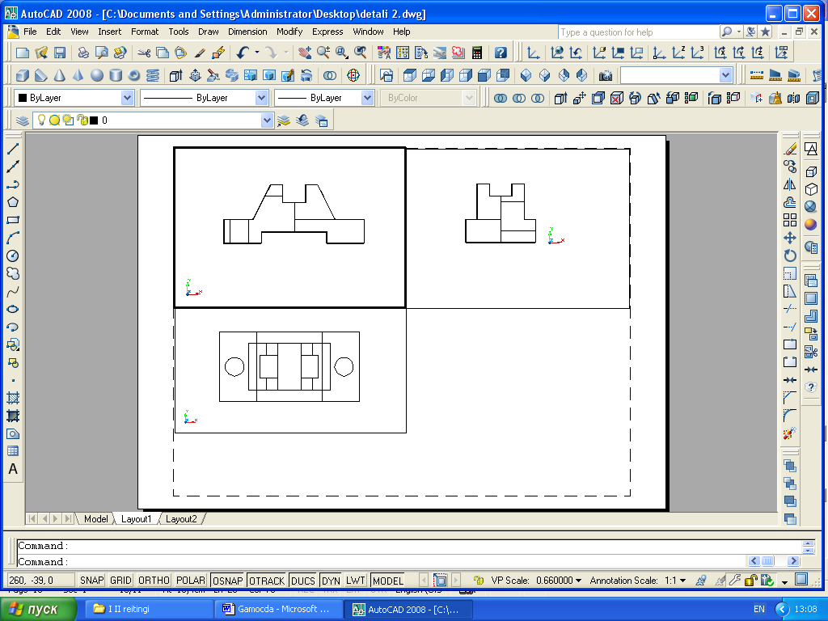
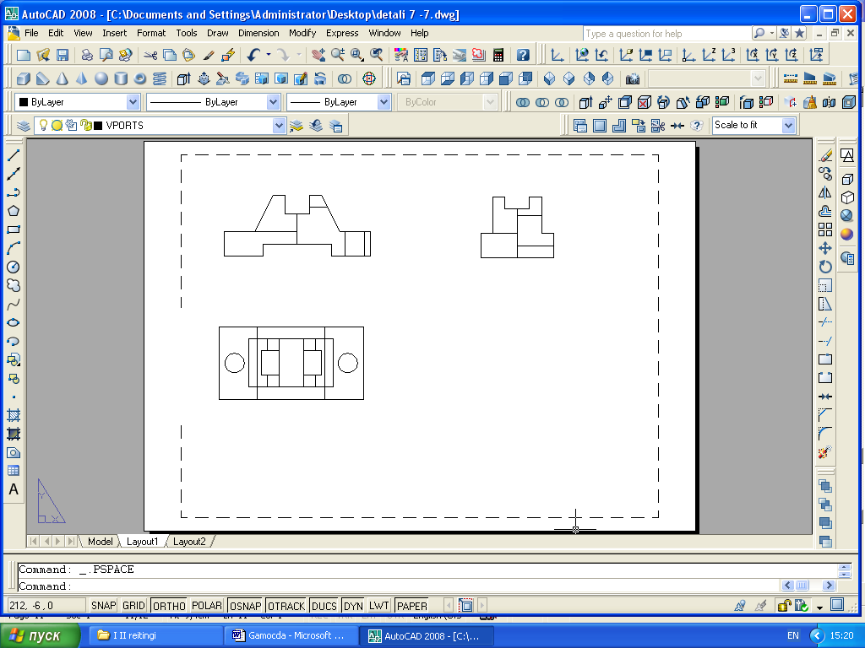
nax. 7
nax. 8

xazTa tipebis marTva SesaZlebelia SOLDRAW brZanebis daxmarebiT.
SOLDRAW brZanebas ekranze Seesabameba Modeling – Setup - drawing knopi, romlis daniSnulebaa solview brZanebiT Seqmnil ekranul xedebTan muSaoba. Tu es brZaneba ar aris instrumentebis Modeling panelze, maSin igi unda Sev-qmnaT ([2] Tavi I, 1.2.2).
am brZanebis gamoZaxebis Semdeg programa iTxovs gavaaqtiuroT dasa-muSavebeli ekranuli xedi da movniSnoT obieqti. unda mieTiTos is ekranu-
li xedebi (am SemTxvevaSi winxedi da gverdxedi), romlebSic saWiroa ganvasxvaoT xilvadi da uxilavi xazebi. amis Semdeg programa miTiTebul

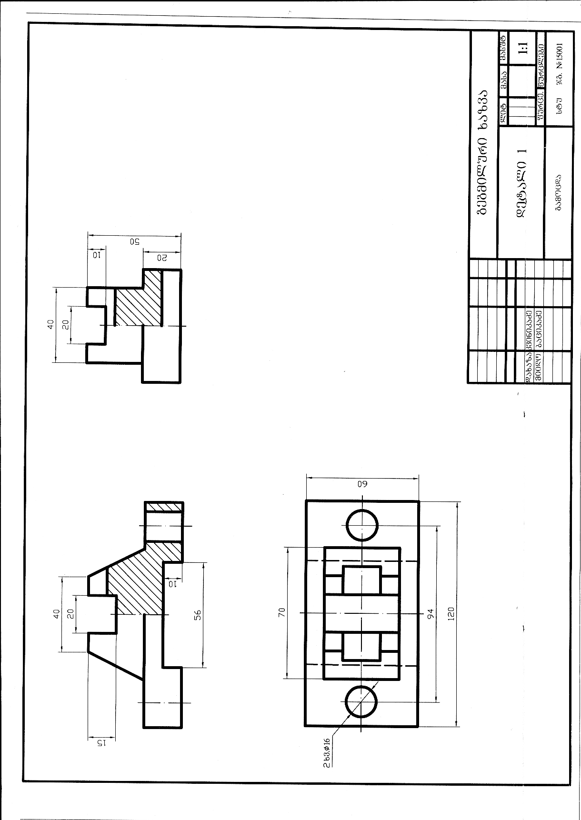

nax. 9

ekranebze obieqtis arsebul xazebTan erTad qmnis xilvad da uxilav xa-zebs, romlebic warmoadgenen obieqtze arsebuli xazebis aslebs da gan-Tavsdebian xedebis saxelebis mixedviT Solview brZanebiT formirebul Sre-ebze. (magaliTad zedxedi VIS Sreze ganTavsdeba zedxedis xilvadi xazebi, zedxedi HID – zedxedis uxilavi xazebi). uxilavi xazebis swori asaxvisaT-vis aucilebelia an HID –iT daboloebuli Sre gavyinoT an am Sreebs miv-ceT DASHED xazis tipi.
winxedSi Wra marcxena mxaresaa Sesrulebuli, Tu saWiroa, rom igi marjvena mxares iyos, es SesaZlebelia Modify – Mirror brZanebiT Sesruldes (nax. 8).
zedxedSi soldraw brZanebas ver viyenebT, amitom xazTa tipebis dasaca-vad es xedi Modeling – Explode brZanebiT davSaloT calkeul monakveTebad.
konturis xazis sisqed miviRoT 1.00 mm.
simetriis RerZis xazis asagebad SevirCioT ACAD ISO 4W100 xazis tipi sisqiT 0.25 mm. RerZis xazi konturis xazidan 2 : 3 mm-iT unda iyos gadaci-lebuli. amis Sesruleba SesaZlebelia Modify – Lengthen brZanebiT ([2] Tavi VI, 6.12).
wyvetili xazebis asagebad SevirCioT ACAD ISO 2W100 xazis tipi sis-qiT 0.50 mm.
winxedsa da gverdxedSi gaWrili nawilebi wavxazoT (davStrixoT) Draw – Hatch brZanebis saSualebiT ([2] Tavi VII, 7.1).
Dimension brZanebis saSualebiT davsvaT yvela saWiro zoma ([2] Tavi VII, 7.3).
yovelive amis Semdeg Insert – Block brZanebiT ([2] Tavi VIII) SesaZlebelia CavsvaT Senaxuli naxazis CarCo da ZiriTadi warwera, Semdeg ki SevavsoT igi ([2] Tavi VII, 7.2).
samuSaos saboloo Sedegi asaxulia me-9 naxazze.

savarjiSo magaliTebi

3
4
5
6
2
25
20
40
60
70
0
8
0
1
0
0
4
O
O
0
5
50
O
0
3
2
0
5
0
1
0
0
4
0
7
20
Ø40
0
6
0
5
2
1
0
30
60
50
1
00
1
55
70
10
20
6
0
4
0
30
Ø40
5
1
0
1
0
5
20
8
1
7
7
O
0
6
70
0
1
0
2
0
40
20
4
0
70
30
Ø40
70
40
Ø40
1
0
2
0
5
0
70
50
35
10
1
5
0

11
12
7
8
10
9
R20
R25
40
80
100
25
20
15
3
0
5
0
10
40
90
80
5
0
1
0
3
0
Ø50
20
10
300
70
40
100
35
Ø50
80
70
3
0
5
0
15
40
4
0
6
0
4
0
Ø
25
05
35
55
75
05
25
05
70
30
75
05
45
05
6
0
Ø
3
0
Ø
5
0
3
0
45
25
10
20
40
70
R25
55
0
70
35
05
20

gamW. xvr. ∅30
gamW. xvr.∅20
6
0
60
25
10
8
1
2
0
8
2
0
6
0
4
0
8
60
6
0
0
20
gamW. xvr. ∅30
O
4
0
1
6
1000
5
8
0
5
0
30
200
45
0
4
8
1
71
0
6
0
01
50
R15
8
0
5
0
1
8
12
5
R
0
30
0
4
30
20
40
3
ØØ

0
0
0
1
0
0
1
0
0
1
60
0
30
0
50
81
0
7
0
31
0
71
0
6
0
R30
45
15
6
0
3
0
O
2
6
10
30
50
35
15
4
0
5
0
0
0
1
81
4
0
200000000000000
4
2
0
O
4
0
13
14
15
16
17
18

7
Ø36
0
Ø26
6
6
30
0
1
8
1
0
Ø
2
2
10
10
1
5
2
5
1
6
8
Ø
2
1
2
2
0
20
10
3
0
50
25
gamW. xvr.Ø20
0
3
15
20
6
40
20
4
0
0
Ø
4
7
4
2
R
1
5
3
3
0
14
1
2
40
7
1
0
0
3
5
O
3
0
O
4
8
1
8
16
38
2
4
O
1
8
24
24
4
1
0
3
5
3
0
8
2
4
O
0
O
24
O18
6
8
3
8
2
0
1
0
2
1
4
0
4
4
2
6
2
0
Ø
16
18
50
7
R
1
8
8
1
8
23
24
22
21
20
19
2
0
3
4
1
1
0
2
4

30
29
28
27
26
25
4
0
3
6
6
0
5
0
16
12
20
5
0
R
5
2
O
5
60
5
0
4
0
40
25
10
20
2
0
5
4
0
028
0
128
3
0
6
0
1
5
R
5
0
3
0
028
0
128
6
0
4
0
2
0
1
5
R
23
15
40
20
2
0
R
5
Ø
0
2
0
128
50
R28
6
0
028
0
128
20
40
15
628
0
25
5
0
4
0
50
20
0
2
0
20
12
028
0
128
228
50
R28
5
O
0
028
0
128
8
0
7
0
5
0
3
O
0
2
O
0
4
0
2
0
40
30
10
R
1
5

0
10
R
2
5
0
3
0
Ø
50
15
2
0
2
6
5
0
12
20
6
0
4
0
3
2
36
16
1
4
2
ØØ

4
50
01
0
11
01
0
11
6
0
5
0
3
6
1
6
3
ØØ

0
50
01
0
11
5
0
2
0
30
60
4
ØØ

0
6
0
6
0
3
0
40
10
20
01
0
11
7
0
6
0
5
ØØ

0
3
ØØ

0
1
6
15
01
0
11
R
2
0
R
2
0
5
0
2
0
6
0
4
0
2
6
35
25
15
25
35
36
34
33
32
31
0
0
1
4
0
0
6

6
0
5
10
0
2
Ø
15
Ø
4
0
3
0
17
50
0
4
0
6
70
0
6
1
0
0
Ø
6
0
0
1
Ø
7
0
5
1
5
1
30
25
5
2
Ø
7
0
5
2
5
1
0
8
0
6
1
0
0
15
20
70
0
6
70
35
25
45
10
0
7
0
5
0
3
5
1
Ø
6
0
0
3
5
0
8
0
1
0
0
0
2
0
2
0
6
0
1
0
6
0
7
0
4
25
20
50
70
25
20
25
0
1
5
3
0
6
1
0
0
Ø
6
0
5
0
3
0
37
38
39
40
41
42
0
6
Ø

