http://www.biology.iastate.edu/Courses/Leon/212L%20Docs/Nerve&Sensory/nerve%20and%20sensory%20index.htm
Lab Topic 31
Investigating Nervous and Sensory Sytems
General Background
What are the 3 functions of the nervous system?
Microanatomy of the Nervous System

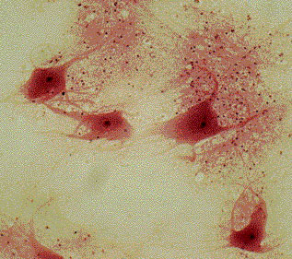 | 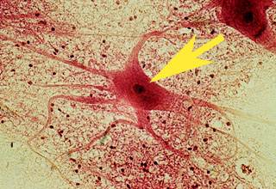
Low and high magnification views of cow spinal cord smear showing neurons and glial cells
- What are the long, narrow, string-like extensions from the cell bodies (somas) of these neurons?
- How does a neuron's shape reflect its function?
- Why is white matter white?
- What type of cell is at the end of the pointer? What are the dark-stained dots outside of this cell?
- Which direction to axons conduct action potentials - toward their cell body or away from their cell body? How about dendrites?
- Where is the soma and what function does it serve?
- If you observed neurites on a slide, how can you tell which are axons and which are dendrites?
- What does an action potential have to do with a nerve impulse?
- Name three types of neurons, and identify the function of each.
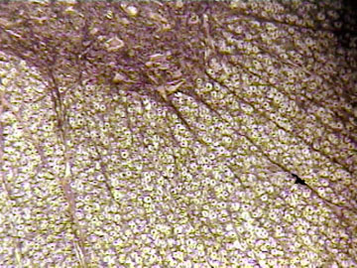
High magnification of cross section of spinal cord, showing white and gray matter with nerve tracts leaving gray matter.
- Where in this photo is the gray matter? White matter?
- Identify an axon, and its surrounding myelin sheath in this picture.
• What is the general organization of the spinal cord?
• What is the structural difference between white and gray matter?
• What is myelin?
• What is an afferent nerve? Efferent? Motor? Sensory?
• What is the difference between a neuron and a nerve?
• What is a ganglion?
• Describe a cross section of spinal cord.
• Do sensory nerves enter the spinal cord in the ventral or dorsal horn?
• Do motor nerves leave the spinal cord through the ventral or dorsal horn?
• Why is gray matter gray and not white?
• Mammals are considered chordates. Why?
• Would the speed of neural transmission in a neuron increase, decrease, or stay the same if the myelin was removed from the axon?
• How does the dorsal horn differ from the ventral horn?
• In a knee jerk reflex (or reflex arc) which is the correct sequence:
sensory nerve -- spinal cord -- motor nerve
sensory nerve -- spinal cord -- brain -- spinal cord -- interneuron -- motor nerve
motor nerve -- spinal cord -- interneuron -- sensory nerve
sensory nerve -- interneuron -- motor nerve -- spinal cord -- motor nerve
• Which is NOT included in a pain reflex arc? a) interneuron b)sensory nerve c) cerebral cortex d) motor nerve e) gray matter
Mammalian Nervous System

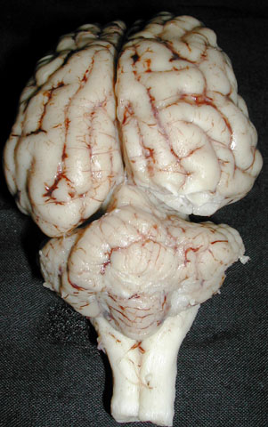 | 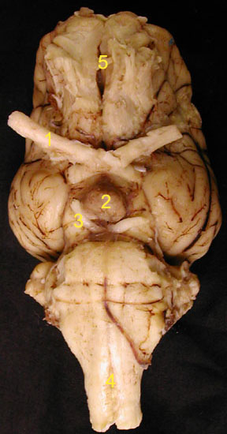
Dorsal view of pig brain | Ventral view of pig brain

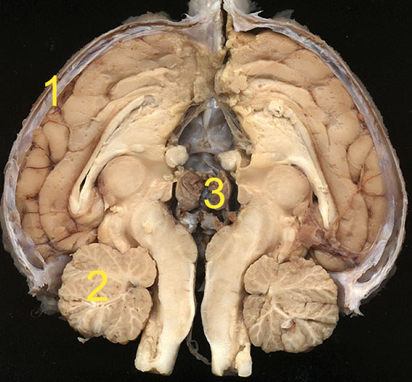
Sagitally sectioned pig brain
- Is the cerebellum anterior or posterior to the cerebrum?
- In the above photos, identify the cerebrum, cerebellum, medulla obongata, spinal cord, pons, pituitary, ventricles of brain, hypothalamus, and meninges. What are their functions?
- The brain and the spinal cord are surrounded by a membranous layer. What are these membranes called and what purpose do they serve?
- What region of the brain contains the cardiac and respiratory centers?
- What region of the brain controls the interpretation of sensory impulses and coordination of voluntary movements?
- Higher functions such as memory and learning are located in which brain region?
- The _______ controls skeletal muscle movements, coordination and balance.
- A brain tumor affecting the medulla oblongata might manifest what kind of symptoms in a patient?
- Describe the difference between peripheral and central nervous systems.
- In which of these images can you see cranial nerves? What cranial nerves can you identify, and what are the remaining cranial nerves that are not shown clearly?
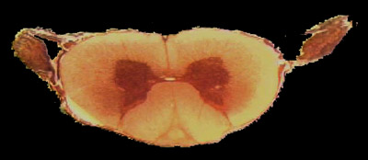
Cross section of mammalian spinal cord, low magnification
- What is the difference between gray(dark) area and white(light) area of the spinal cord?
- If you wanted to study myelinated cells where would you look in the spinal cord?
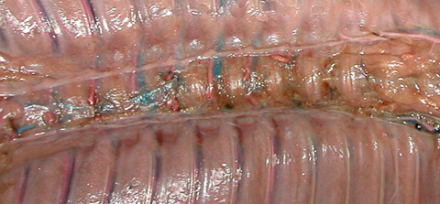
View inside fetal pig body cavity showing sympathetic trunks to either side of vertebral column.
• Where in this image is the spinal cord located? Can you see it, or is it covered up? If it is covered, by what is it covered?
• Locate the sympathetic trunk in the photo above.
• Locate at least two spinal nerves on each side of the spinal cord.
- How is the vertebrate nervous system conventionally divided?
- What is the difference between the central and peripheral nervous systems? What elements belong to each?
- How do the somatic (voluntary) and autonomic nervous systems differ in anatomy and in what they control?
- Why is the somatic nervous system often called voluntary?
- What 2 systems make up the autonomic nervous system?
- Sympathetic and parasympathetic systems control what?
- Locate the sympathetic trunk in the diagram above.

Sensory Systems

Eye Anatomy

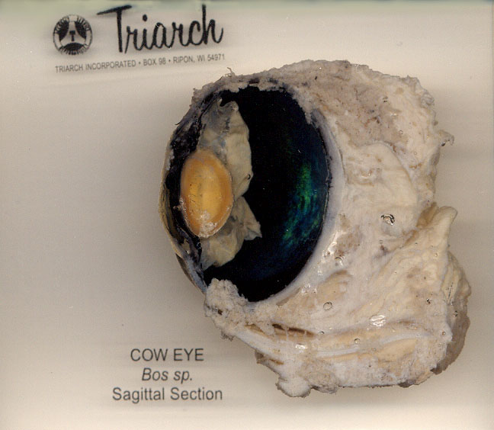 | 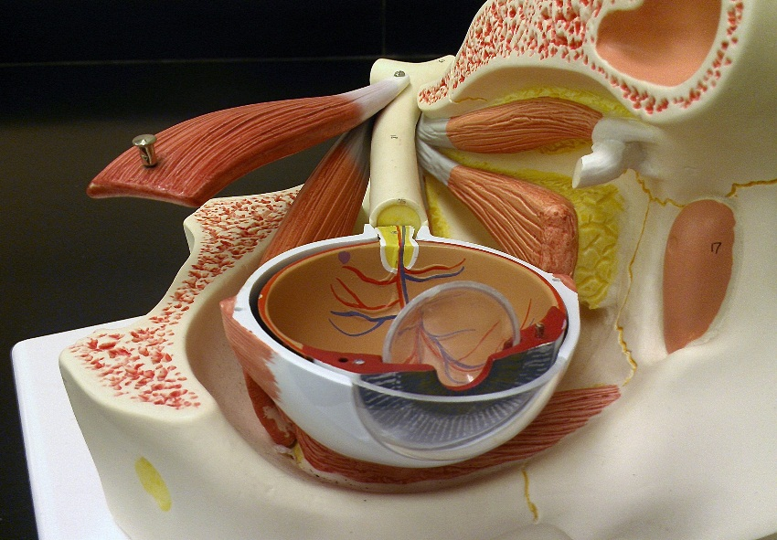 | 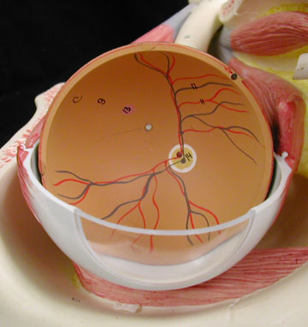  Color Vision

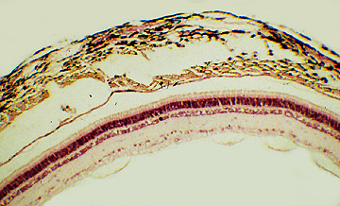
Cross section of eye wall at back of eye
What three layers are visible in this section? Point out the sclera and choroid, the sensory cells (rods and cones) and nerve cells (mostly bipolar and ganglion cells
- Sketch a cross-section of a mammalian eye. Label the cornea, the anterior chamber, the lens, the posterior chamber, the retina, and the sclera.
- Does light pass through the iris? What is the pupil of your eye?
- Create a flow chart tracing the structures that a photon of light passes through before striking the retina. What eye structures did the light not pass through? What are their functions?
- What structures focuses images on the retina? What structure is responsible for adjusting focus in your eyes?
- What two general kinds of sensory cells in the retina of animals detect light?
- How do rods and cones differ in the wavelengths of light (colors) to which they respond?
- How do the neural connections of rods and cones differ? What is meant by convergence in discussions of such neural connections?
- How do rods and cones differ in sensitivity to light, and in resolution of objects very close together? What are the mechanisms that result in those differences in performance?
- What kind of photoreceptor cells are responsible for color vision? Why can't rod cells tell us about the color of incoming light?
- How are rods and cones distributed in your retina? What is the functional significance of that distribution?
- Why can't you see when you walk from a bright street into a dark theater? After a short period you can see. Why?
- I've been in a movie theater and I walk out into the bright light. Why can't I see well for a minute or so?
- What is the name of the layer of tissue in which rods and cones are found?
- In the retina, light first hits which layer of cells? a) cones and rods b) ganglion cells c) bipolar cells d) pigmented epithelium
- Why do you have a blind spot?

Color Vision Physiology- after images

- How can you explain afterimages of different colors?
- What color is the afterimage which forms after staring at something red and then something white?
- How many different kinds of cone cells does a person with normal color vision have?
- How do we identify colors that do not match the most sensitive wavelengths of any of the 3 kinds of cone cells?
General and Comparative Questions
- How does a neuron's form reflect its function?
- Discuss functions of the major parts (cerebrum, cerebellum, medulla) of the brain.
- What is a transducer? Give an example. Identify the transducers in your visual system, hearing system, and balance system. Which of these are mechanoreceptors, and which are not?
- Differentiate between sensory cells that are transducers and nerve cells that are conductors.
- An amputee may feels "phantom pain" which they interpret as coming from the missing limb. How do you explain this?
- If you wanted to study nerve cell bodies, where would you look?
- If nerve cells conduct action potentials in an all or none fashion, how is it that we can distinguish the intensity of light sound, odor, taste, and temperature?
- How is the nervous system of hydra different from that of an earthworm and a human?
- Explain the difference between a nerve net and a nerve tract or nerve center. Give examples.
- Describe how sound waves pass from the outer to the inner ear.
- Briefly describe what happens when light enters the eye and strikes the retina.
- Draw a neuron. Label clearly the soma, an axon, and a dendrite. Show in which directions signals move in the axon and dendrite.

Credits
Photos and Layout by Linda Westgate, Warren D. Dolphin, and Mark A. Mangum

BACK TO 212L HOME PAGE

