http://www.biology.iastate.edu/Courses/Leon/212L%20Docs/Muscl%3ASkel/muscle%20skeletal%20index.htm
Lab Topic 30
Investigating the Properties of Muscle and Skeletal Systems

Overview of Muscles
- Muscles that increase the angle between two bones at a joint are called ____________.
- What are muscles that decrease the angle between two bones called?
- How do extensor and flexor muscles work in the human arm?
- Name 3 types of muscle that differ in cell architecture and explain where each can be found.
- Which type of muscle is most prominent in the mammalian body mass?
- How could you tell the difference between cardiac muscle and skeletal muscle on a slide?
- When referring to skeletal muscles, what is meant by the term antagonistic?
- How do muscles shorten? Do actin and myosin proteins shrink when a muscle contracts?
- What proteins make up the thick filaments in muscle? The thin filaments?
- What is a sarcomere?
- What is a motor unit?
- What is a tendon?
Muscular System

Microscopic Anatomy of Muscle

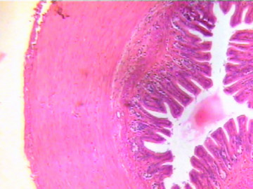 | 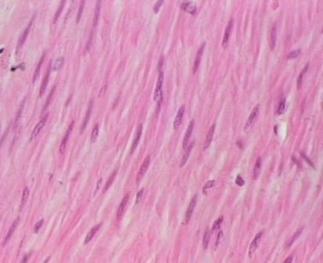
Cross section of intestinal muscle | closer view of smooth muscle (40x)
- Why is smooth muscle called smooth? What are the functional consequences of the organization of contractile proteins in smooth muscle?
- How would you describe the shape of smooth muscle cells?
- Where would you expect to find smooth muscle in your body?
- What controls smooth muscle? Which of the following control systems can play a role: somatic (voluntary) nervous system; autonomic nervous system; sympathetic nervous system, parasympathetic nervous system, hormonal controls.
Skeletal Muscle

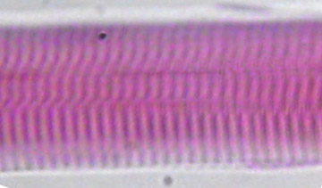 | 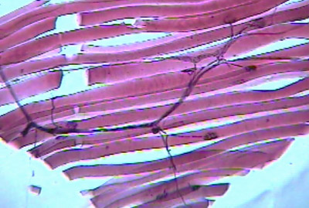
A skeletal muscle fiber  Are skeletal muscle fibers multi- or uni-nucleated at maturity?  This slide is representative of which muscle type?  Where in the body would you find this muscle type?  What is the shape of a skeletal muscle cell, and how is that related to its function? | Muscle innervation: motor end plates on muscle cell  What are motor end plates and why are they important?  How do motor end plates function?  Does the electrical nature of a nerve impulse or a chemical cause muscle contraction?  Does a single neuron innervate only a single muscle cell, several muscle cells, or all of the cells in a whole muscle? What is a meant by the term motor unit?
- What are the proteins responsible for contraction in a muscle cell?
- What is the importance of the sarcoplasmic reticulum in a muscle cell?
- How do myofibril, sarcomere, and filamentous proteins (actin and myosin) in a muscle cell (fiber) relate to the whole muscle?
- How many nuclei are typically in a single skeletal muscle cell? A cardiac muscle cell? A smooth muscle cell?
- What shortens during a skeletal muscle contraction? Briefly describe the sliding filament model of muscle contraction .
- Why are skeletal muscles considered to be voluntary?
Cardiac Muscle

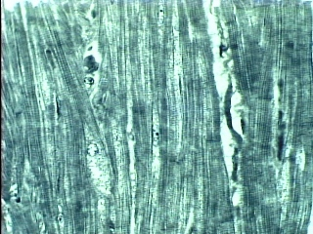
- How is cardiac muscle like both smooth and skeletal muscle? How is it different?
- What microscopic features would allow you to distinguish cardiac muscle from skeletal muscle? What is the functional importance of each?
- Where would you find cardiac muscle?
- How is contraction of cardiac muscle controlled?
Muscle Physiology

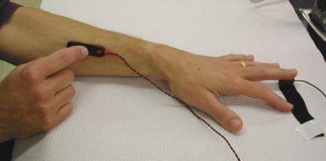
Testing threshold and motor recruitment. The stimulating electrode is over the median nerve, and the middle finger is resting on the force transducer. The forearm is supported on the table top.
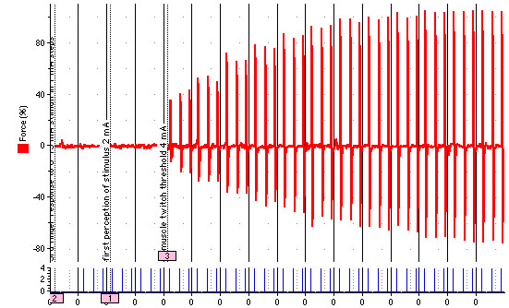
The graph above shows raw data for muscle twitch force (expressed as % of maximum) for a finger stimulated at one second intervals. Stimulus amplitude started on the left at 0 and increased by 1 mAmp in each successive block. Data blocks are separated by black vertical lines. Blue lines show the times when stimuli were delivered.
- What was the threshold stimulus for muscle contraction? Is there any evidence that some neurons were activated by stimuli below this threshold?
- Write a sentence or two that describes what this graph tells you.
- What features of muscle organization account for the observed pattern of change in force of contraction?
- In discussion of muscle performance, what is meant by recruitment? Does this graph provide evidence of recruitment, and if so, what is it that is being recruited?
- If you measured the time of a stimulus and the time a contraction started, would they be the same, or would there be some delay? What do you think would be responsible for such a delay?
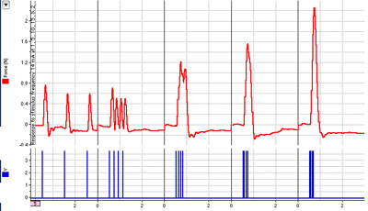
The graph above shows raw data for muscle twitch force (measured in Newtons, N) for a finger stimulated at a current (14 mAmp) adequate to produce a maximal twitch. Stimuli were delivered in groups of four, at a frequencies of 1, 5, 10, 15, and 20 Hz (1 Hz = 1 stimulus/sec) in the 5 blocks from left to right.
- What happened to muscle contraction force as the muscle was stimulated at higher and higher frequencies?
- What term is used to describe this pattern?
- How does temporal summation differ from recruitment, and how do you know that the results of this experiment do not just represent recruitment of additional motor units?
- What is the mechanism that is responsible for temporal summation in your muscles?
- Under what circumstances would you want your nervous system to stimulate your motor neurons with a burst of action potentials at high frequency rather than a single action potential?
- What is meant by tetany when talking about muscle contraction? Did a tetanic contraction occur in the data set illustrated above?
- Motor nerves innervate muscles and their activity regulates normal muscle movement. If nerve impulses are an all or none phenomena, how is it possible to have a graded muscle response?
- Which is NOT included in a reflex arc (knee jerk response)? a) interneuron b) sensory neuron c) cerebral cortex d) motor neuron.
- What is the sequence of events from the time an action potential arrives at a myoneural junction at the end of a motor neuron and the time the muscle contracts?
- What is meant by a twitch when we talk about muscle contraction? What happens when two twitches overlap in time?

Skeletal Systems

Hydrostatic Skeletons

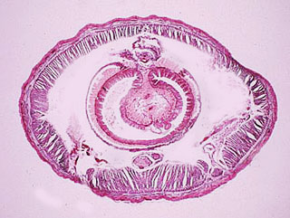 | 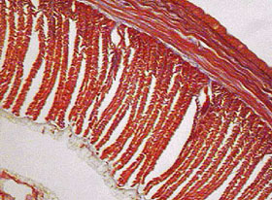
Earthworm c.s. low magnification | Earthworm c.s. high magnification
- What is a hydrostatic skeleton? How does it differ from an endoskeleton or exoskeletion?
- In the earthworm cross-section above, the space between the muscles of the body wall and the digestive tract is fluid-filled in life. How is that fluid important in earthworm locomotion?
- What kinds of organisms use hydrostatic skeletons?
- What are the antagonistic muscles in an earthworm's body wall?
- Explain how the circular and longitudinal muscles help an earthworm to move.
Exoskeleton

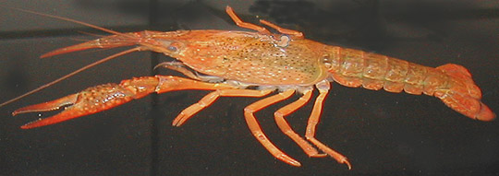 | 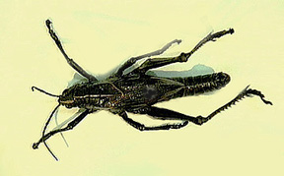
Crayfish (a crustacean) | Grasshopper (an insect)
- What is an exoskeletion, and how can you tell that these animals have exoskeletons?
- What material makes up the exoskeleton of insects? How is it different from bone?
- How do animals with exoskeletons grow in size?
- Where on the grasshopper would you find a sclerite? Where would you find a pleural membrane? How do these two structures differ, and what is the functional importance of those differences?
- What are the functions of the exoskeletons? Which of those functions is not shared by most elements of endoskeletons?
Endoskeleton

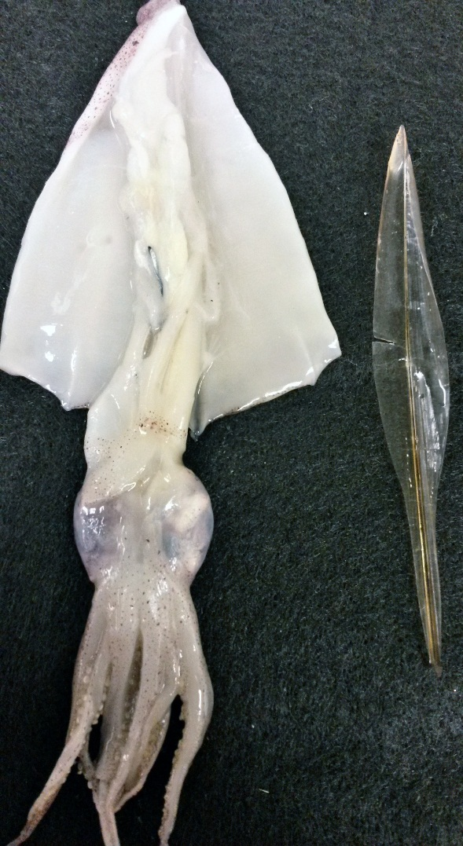
- What kinds of animals have endoskeletons?
- How do endoskeletons differ from exoskeletons?
- What kinds of structures in vertebrate animals make up the skeleton?
Bone Structure

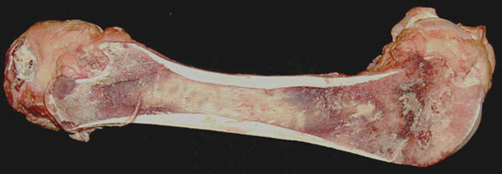
Beef long bone sectioned to reveal marrow
- Point out the diaphysis and the two epiphyses of this bone.
- What is an epiphyseal disk, and what is its functional importance. Can you see an epiphyseal disk here?
- Where would you find spongy bone and the compact bone in this image and why are they different?
- What is the function of the marrow?
- What is the periostium?
- Is the bone of the diaphysis compact or cancellous?
- What makes bone hard?
- What makes bone somewhat flexible?
- What protein do you find in bone?
- What is the area in the middle of the bone called? What does it contain?
- Where in compact bone woudl you expect to find living cells? What is their function?
- What is the differences between bone and cartilage (in both structure and function)?
- What is the functional importance of crests on bones?
- What are the structures called condoyles, and what is their function?
Microanatomy of Bone

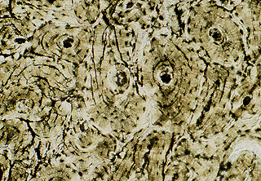 | 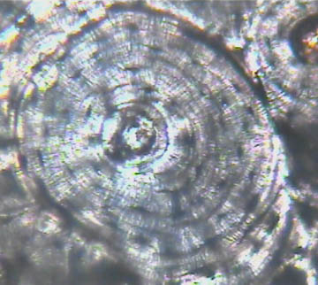 | 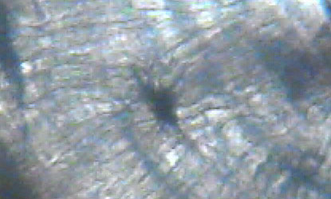
Cross-section of compact bone | Close-up of Halversian canal system | Close-up of osteocyte in lacuna in Haversian canal system of compact bone.
- What is a Haversian canal, and what would you find in the canal space in life?
- What is an osteocyte, and where in the photo on the left above would you expect to find an osteocyte?
- What is the material that makes bone hard? Is its location extracellular or intracellular?

Comparative Vertebrate Endoskeletons

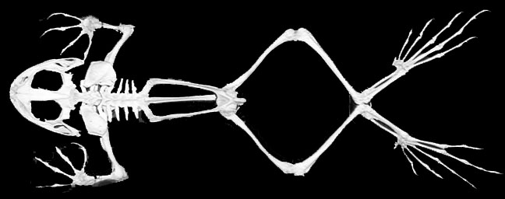
Frog Skeleton
- In the frog, how does the leg bones (tibia/fibula) differ from that in humans and how is it beneficial to the frog?
- What is unusual about the phalanges of the frog? What is the functional significance of that feature?
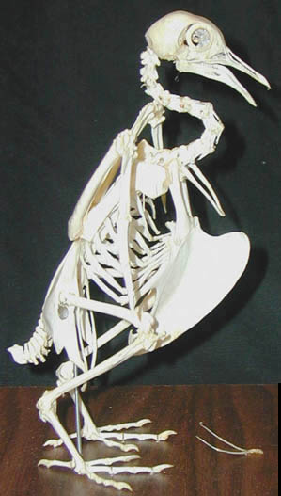 | 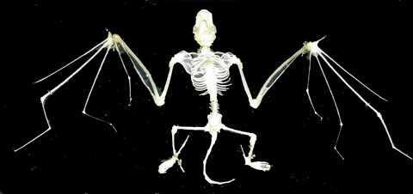
Bird Skeleton | Bat Skeleton
- What adaptations for flight can you see in these two skeletons?
- How do bird's adaptations for flight differ from those of a bat?
- How do the phalanges in a bird, bat and human differ, and what is the functional significance of those differences?
- How do the sternums of birds, bats and humans differ? What is the functional significance of those differences?
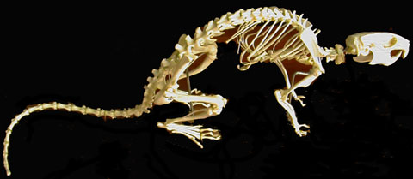 | 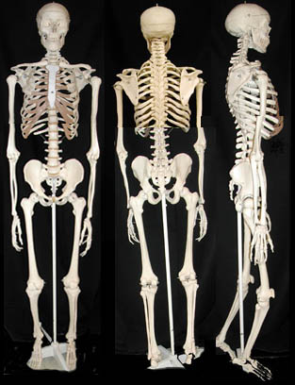
Rat Skeleton | Human Skeleton
- Does a human have any bones that are lacking in a rat?
- What skeletal changes are associated with a shift from quadripedal locomotion to bipedal locomotion in mammals?
- Name two functions of the skeletal system.
- Which structures of the skeleton protects the central nervous system? Are any other features of these skeletons important for protection?
- Which of the five skeletons illustrated above have reduced numbers of bones (caudal vertebrae) in the tail? What is the functional significance of those differences? What bones in the human skeleton represent the tail?
- Identify the pelvic girdle, and the femur, tibia and fibula, tarsals and metatarsals, and phalanges of each of the skeletons above.
- Identify the clavicle in a skeleton of a human, bird, frog and bat.
- In birds, the sternum has a huge crest of bone where the pectoralis muscles that power flight attach. Can you identify a region of the human skeleton similarly specialized for muscle attachment?
- Distinguish between the axial and appendicular parts of the skeletons in each of the 5 skeletons shown above.
- List 5 different bones that belong to the axial skeleton, and 5 that belong to the appendicular skeleton.
General and Comparative Questions
  - Discuss the nervous control of the muscles, and how muscle contraction force can be modified.
  - Why are skeletal muscles called skeletal? What is the functional relationship between skeletons and muscles?
  - What are the functions of skeletal systems, and how do they differ between hydrostatic skeletons, exoskeletons and endoskeletons?
  - Explain why skeletal similarities are thought to reflect evolutionary relationships.
  - Are bones living or dead in an adult animal? What evidence did you see in lab that supports your answer?
  - What is the relative size of the eye socket in the vertebrate skeletons you examined? What does that suggest about the relative importance of vision to each? Is that suggestion related to their mode of locomotion? What do you think the visual advantage of having a big eye socket might be?

Credits
Photos and Layout by Linda Westgate, Warren Dolphin, and Mark A. Mangum

BACK TO 212L HOME PAGE

