http://www.biology.iastate.edu/Courses/Leon/212L%20Docs/Gas%20Exchange/29-Gas%20Exchange.html
Lab Topic 29
Investigating Gas Exchange Systems

Student Prep

Key Words [note: this may not be a complete list]
Abdominal Cavity
Alveoli
Bronchi
Bronchioles
Dead Space
Diaphragm
Expiratory/Inspiratory Reserve
Gills
Glottis
Hemoglobin
Inhalation/Exhalation
Inspiratory Capacity
Larynx
Lung
Nasopharynx
Operculum
Pharynx
Residual Volume
Spiracles
Thymus
Thyroid glands
Tidal Volume
Total Lung Capacity
Trachea
Tracheole
Vital Capacity

Be familiar with:
- Fetal pig respiratory system
- Mammal lung histology
- Insect and fish respiratory system
- Describe pathway of air flow in mammalian lungs
- Mechanics of breathing
- Respiratory function
- How exchange of gases occurs

Pig Anatomy

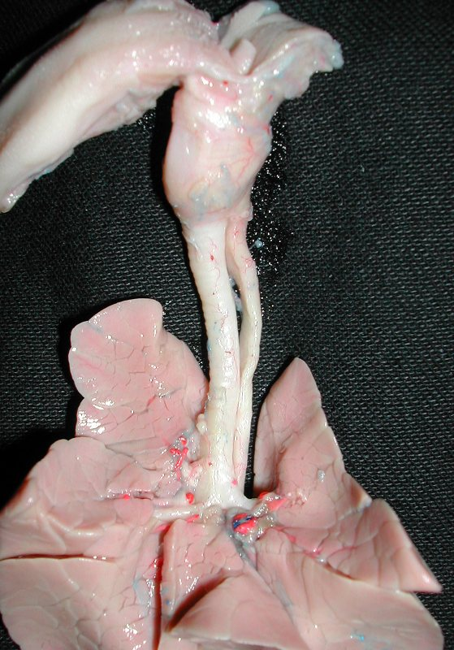
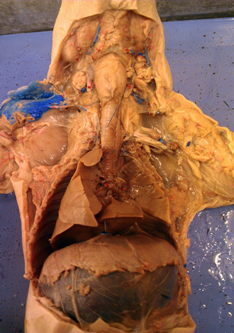
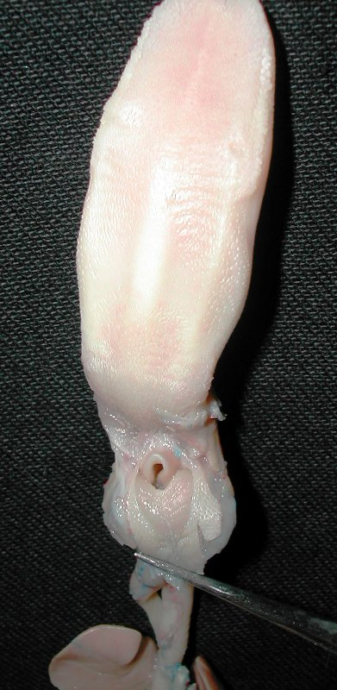
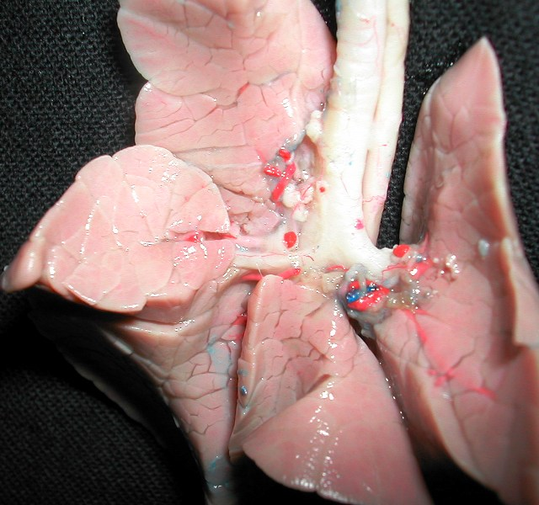

- How do we get air and food/water through the same space?
- What are the structures of the pharynx and the respiratory tree?
- What muscles power breathing in mammals?
- Why does the trachea but not the esophagus have cartilaginous rings on its walls?
- Where does gas exchange occur in mammals?

Mammal Lung Histology

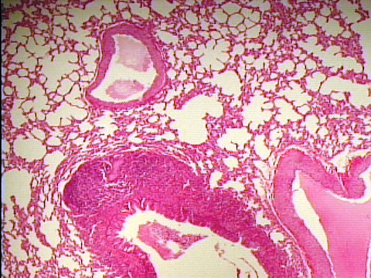
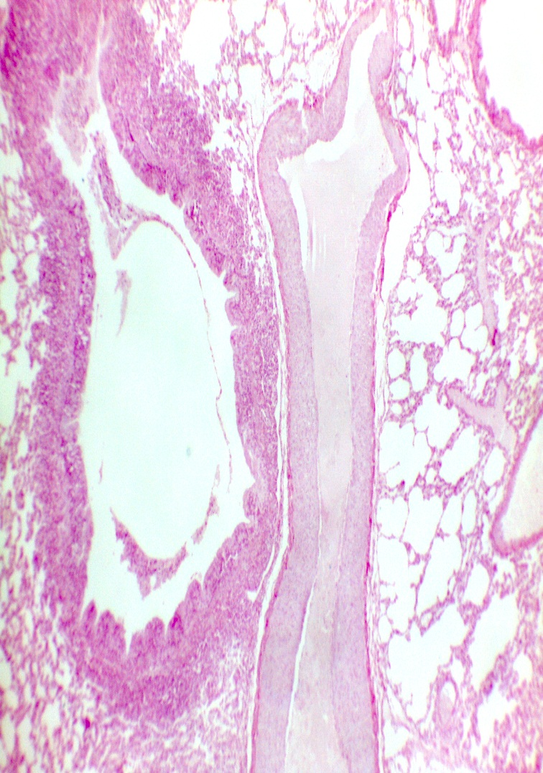

Insect/Fish Respiratory System

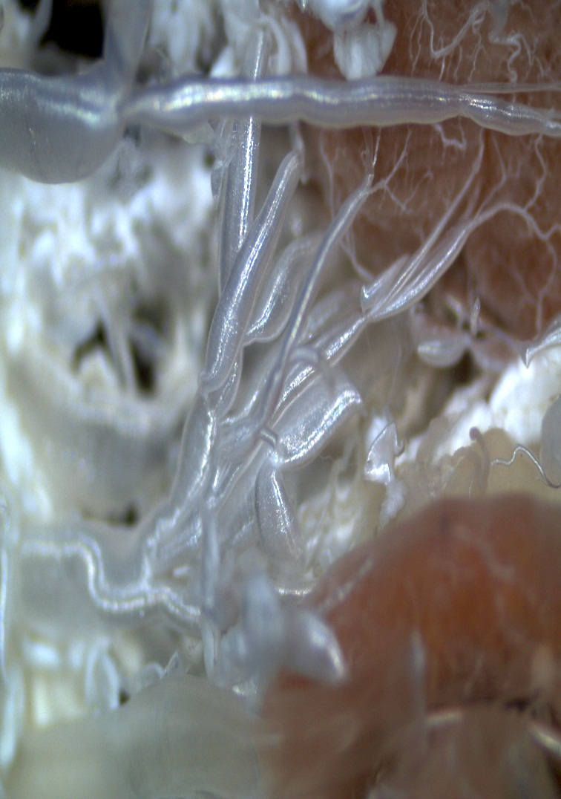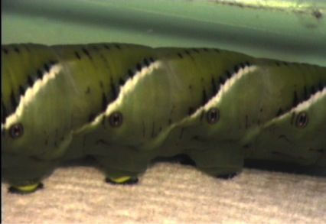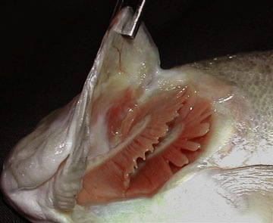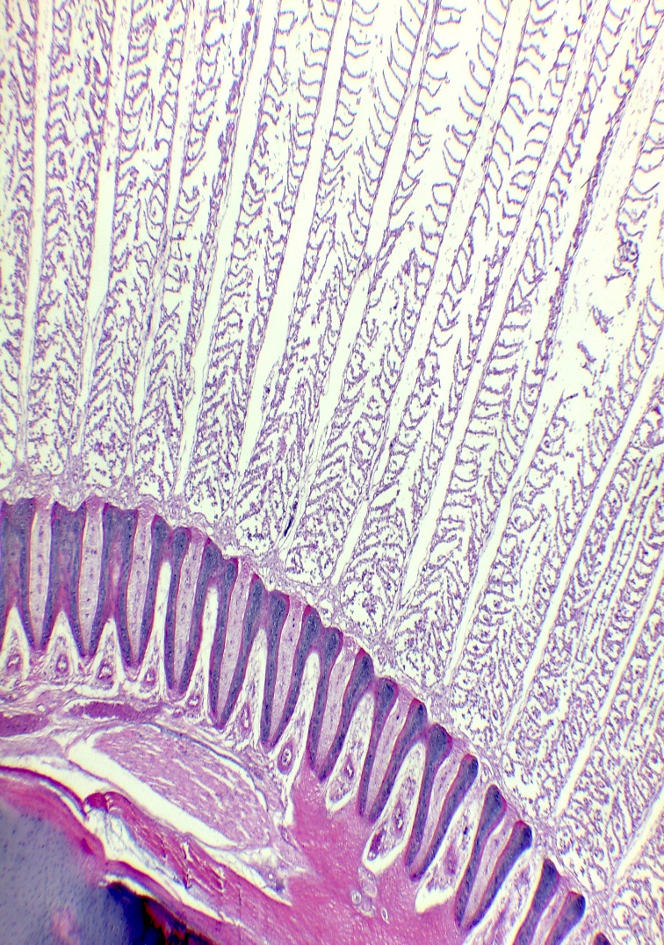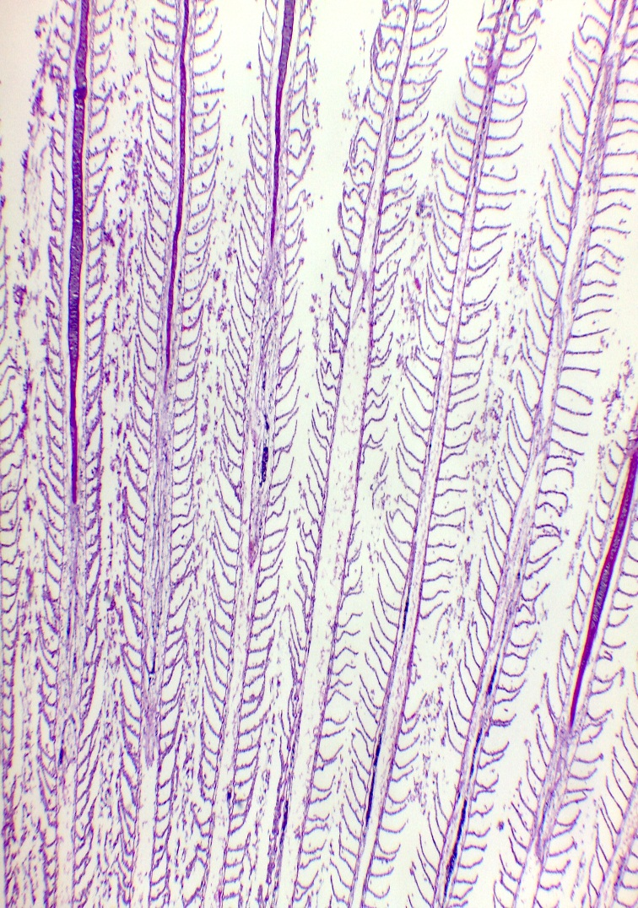

- Compare fish gills, insect tracheal system, and mammal lungs.
  - How do structures compare?
  - What muscles are used for ventilation?
  - How do ventilation patterns (air or water flow) differ?
  - Why don't fish gills work well in air?
  - Why don't lungs work well in water?

Mechanics of Breathing

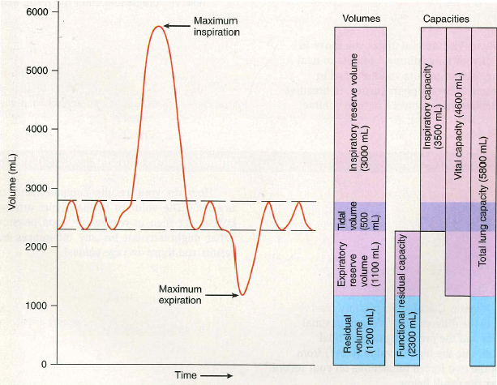

Table from Biological Investigations Lab Manual by Warren D. Dolphin

- What is tidal volume?
- What are inspiratory and expiratory reserve volumes?
- What is meant by vital capacity?
- What is respiratory dead space and how does it affect ventilation and gas exchange?
- What is residual volume?

Lab Topic Page
Biology Home Page

