http://www.biology.iastate.edu/Courses/Leon/212L%20Docs/Digestive/digestion%20index.htm
Lab Topic 27
Investigating Digestive, Renal, and Reproductive Systems

Pig Anatomy

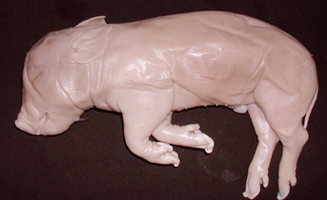 | 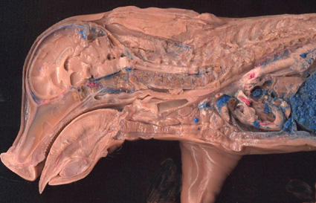
- Locate these regions: Anterior, posterior, caudal, cephalic, dorsal, ventral.
- What is a sagittal section? Where would a sagittal section in the median plane pass through your body?
- Point out the proximal and distal ends of the forelimb on the intact pig above. Are your fingers proximal or distal to your elbow?
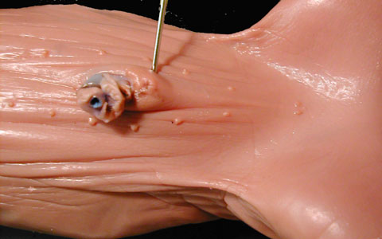
Ventral abdominal view of male fetal pig
- Where is the umbilical cord on this pig? Where is the urogenital opening?
- What are the functions of the umbilical cord?
- How can you tell the difference between a male and female fetal pig?
- In the above photos of the male, differentiate between the umbilical cord and the urogenital opening.
- What function does the umbilical cord on the fetal pig serve?

Mammalian Digestive System

Anatomy of the Mouth

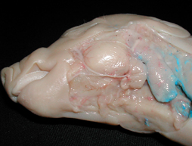 | 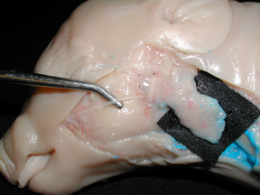 | 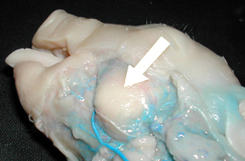

The cheek region of the pig you dissected contained 3 digestive glands. What are these glands called, and what is their function? | What gland is lying on top of the black cloth?  What is the major duct leading from the parotid gland? Where does it end and what function does it serve? |  | Chewing requires a strong cheek muscle. What is this major chewing muscle called?  The facial nerve, visible in all 3 pictures, runs over this muscle. Why does it look white?
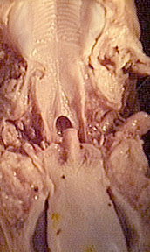
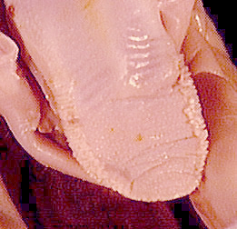 |  | 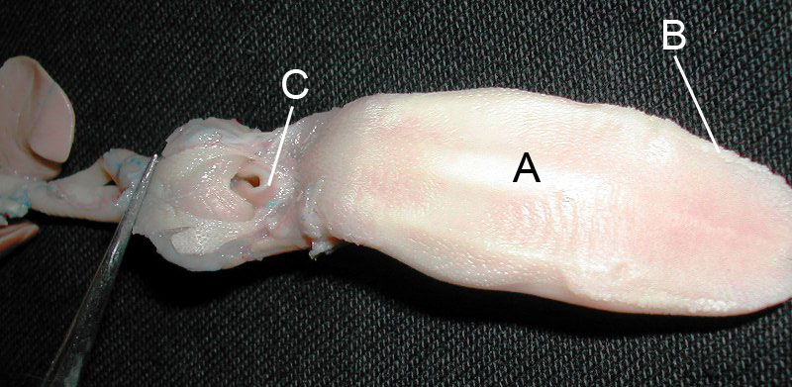
- Identify the structures of the mouth and pharynx visible in these photos.
- What is the differences between the hard palate and the soft palate?
- Where is the epiglottis and what is its function? What happens if food enters the glottis?
- Where are the trachea and the esophagus, and what are their functions?
Throat Anatomy

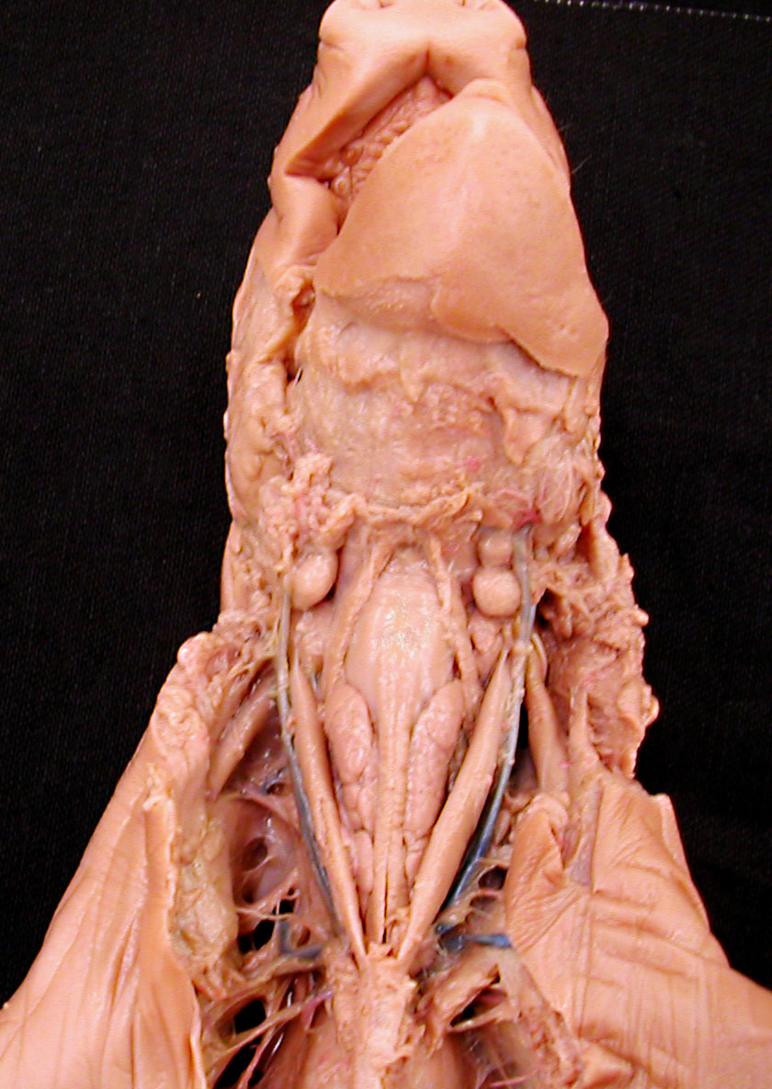
Larynx and thymus gland in throat (ventral view)
- Where is the larynx? What is its function?
- What gland structure was removed to reveal the larynx clearly?
- Point out the thymus, the masses of soft tissue that flank the esophagus below the larynx. What is the function of the thymus gland?
- What keeps the larynx and trachea from collapsing when you (or a pig) bend your neck?
- Is the esophagus protected from collapse by cartilage rings? Why or why not?

Fetal Pig Open Abdominal Cavity

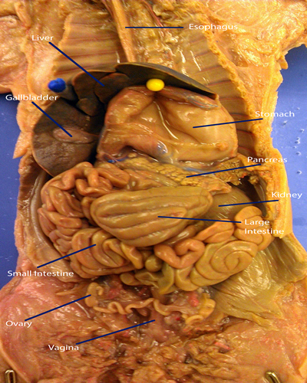

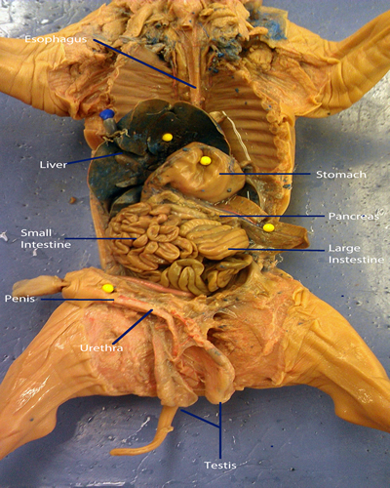

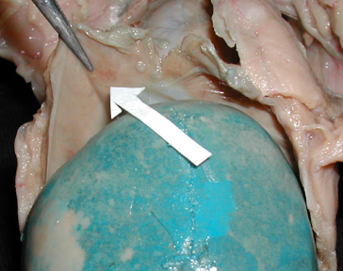 | 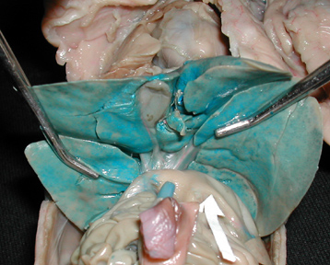
What is the structure indicated by the arrow? The blue organ is the liver, and the anterior end of the pig is up. | What is the greenish-brown organ visible just above the center of this picture on the undersurface of the liver? What is the function of this organ? Where is the umbilicus? How about the umbilical vein? What part of the digestive tract is the arrow pointing to?

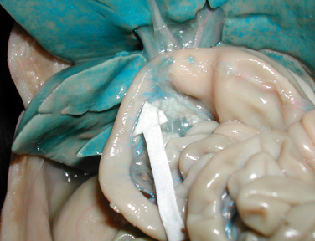 | 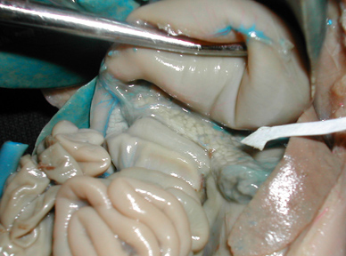
What is this region of the small intestine called? What are the next two regions of the small intestine, before it becomes the large intestine? | What organ is the probe lifting out of the way? What is the organ indicated by the arrow, and what is its function?

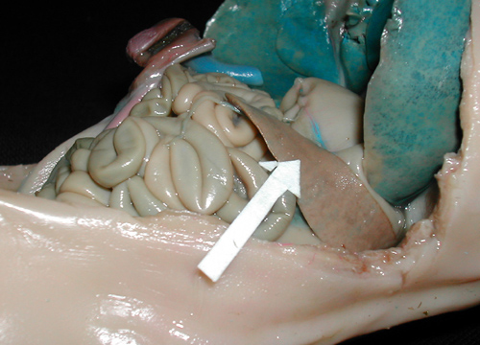 | 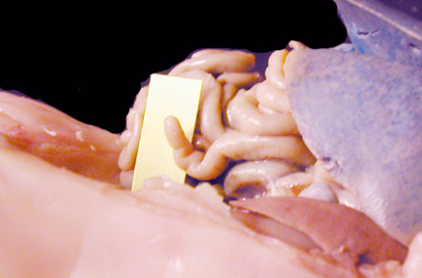
On the pigs left side you can find the spleen. What function does it serve? What parts of the digestive tract can you see in this photo? | This small pouch is at the junction of the small and large intestines. What is called and what is its function?
How is food changed in the stomach? What term is used to label the liquid suspension of partly digested food and digestive fluids leaving the stomach.
Damage to the gastric mucosa, usually a result of bacterial (Helicobacter pylori) infection plus stomach acid, cause what kind of health problem?
Pig Dissection Revealing Digestive System Structures

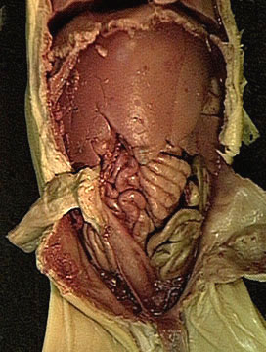 | 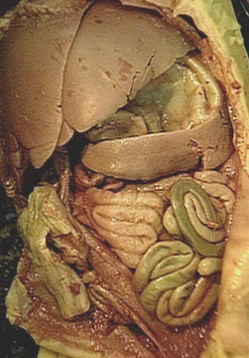
- Point out the liver, spleen, stomach, small intestine, and large intestine. Why do you think the liver does not look blue in this pig?
- What part of the small intestine connects to the large intestine?
- The region where a common passageway is shared by the digestive and respiratory systems is called the ________.
- Where does the common bile duct drain into the alimentary tract?
- Where in the alimentary tract does most digestion (=hydrolysis of food macromolecules) occur? Where else does some digestion occur?
- What is the name of the region of the small intestine directly posterior to the duodenum?
- Where is the gall bladder and what purpose does it serve?
- What role does the liver play in digestion?
- What is bile and what is its functional importance? Where is bile manufactured, where is it stored, and where does it go from there?
- Does the spleen in a fetal pig viewed in a ventral dissection overlay the small or large intestine?
- Where in the gastrointestinal system (= alimentary tract) are most food nutrients absorbed into the body?
- Where is the duodenum and why is it important in digestion?
- Where is the pancreas and why is it important in digestion?
- What are the three regions of the small intestine?
- What are mesenteries, and what is their functional importance?
- What are sphincters and why are they important in the digestive system? Where would you find the cardiac sphincter?
- What are the functions of the large intestine? How are those functions likely to differ between a herbivore like a horse and a carnivore like a cat?
- If you were told that an animal had a duodenal ulcer, where would you look to find it?
Histology of Small Intestine

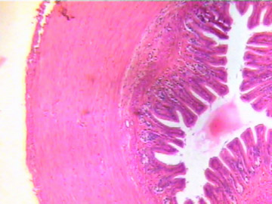 | 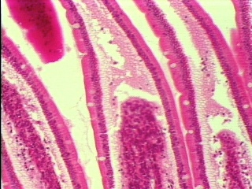 | 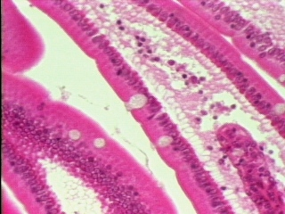
Slide of cross section of small intestine (4x) | Higher magnification 20X | Cells of the intestinal lining (40X)
- What is a lumen, and where is the lumen of the small intestine in this picture?  - Where would you expect to find chyme?  - What kind of muscles are visible in the wall of the digestive tract? What is their function?  - Which directions do smooth muscle fibers in the inner and outer layers of smooth muscle run in this picture?  - What is peristalsis and what layers of the small intestine does it involve? | • Where is are the mucosal, submucosal, longitudinal smooth muscle, and circular smooth muscle layers in this slide?  • Why is the small intestine, especially the submucosa, highly vascularized?  • How does the structure of the inner wall of the small intestine reflect its function?  • Where in this photo are villi located? What is their structure and functional importance?  • Can you see microvilli in this picture? Why not? | - Point out columnar epithelial cells and goblet cells. What are the functions of each?  - How are the epithelial cells specialized for their function? What are microvilli and how do they differ from villi?  - In the membranes of which cells would you expect to find transport proteins for the active transport of amino acids?

Photos and Layout by Warren D. Dolphin, Linda Westgate, Maria Oehler, and Mark A. Mangum
BACK TO 212L HOME PAGE

