http://www.biology.iastate.edu/Courses/Leon/212L%20Docs/25rtstm%20index.html
Lab Topic 25
Investigating Primary and Secondary Growth in
Roots and Stems

Whole Roots

Tap Root Systems
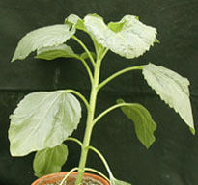 | 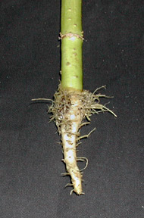

Fibrous Root Systems
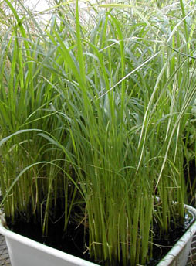 | 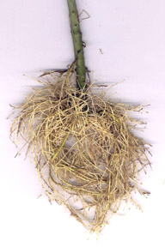

Adventitious Root Systems
Plant with Adventitious root | 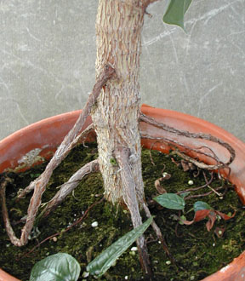

- What kind of root is a monocot (dicot) most likely to have?
- How are adventitious roots different from fibrous or tap roots? How are they similar?
- Draw and label 3 type of root systems.

- What is the function of a root?
- Why do plants need roots?
- Name 5 tissue types found in roots and give their function.
- What is protoplast?
- Discuss how a root grows in length using the concept of primary growth.

- Name 3 functions of roots.

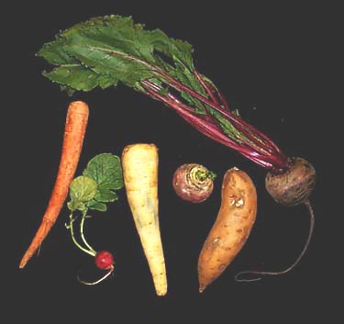
Edible Roots
- Are the edible roots in the photo fibrous roots or taproots?
- What is it about roots that makes them good food sources?
- Why do we eat roots?
- What do they contain and how does it benefit the plant?

Root Histology

Longitudinal Section of a Young Raphanus Root

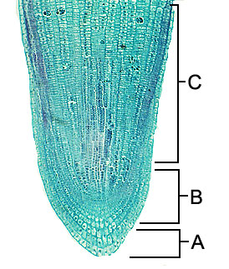 | 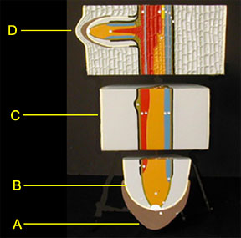 | 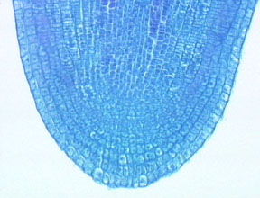  Close up of radish (Raphanus) root showing root cap and meristem tissue

- In this longitudinal section, name the regions of the root.
- Where is the root cap and what is its function?
- Indicate the region of the apical meristem.
- What two special tissues are found in roots that affect transport throughout the plant?
- What is the function of the root cap and how does it work?
- What occurs in the root apical meristem?
- In plants without well developed root hairs, how does a plant enhance its absorptive ability?
- Where is the cortex and what tissues are found there?
- Where is the stele and what tissues are found there?
- In region D of the root model, what is indicated and how does it form?
- What region protects the root tip and what is it called? How does it provide protection?
- Locate the root tip meristem. What is its function?
- What is the name of the specialized root epidermal cells and what are their function?

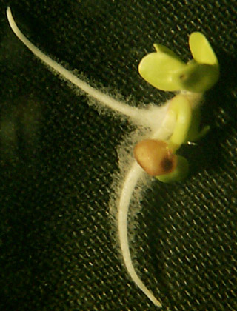  Raphanus (radish) seedling |  | fresh root cap
•Observe the root hairs. What is their function?
•Are root hairs present along the entire length of the root? Why or why not?
•Root hairs are what type of cell?

Cross Section of Roots

Dicot Roots

- How would you describe the vascular arrangement of this dicot root in Ranunculus?  - How is the arrangement different from a monocot root? | 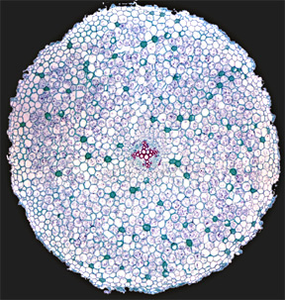
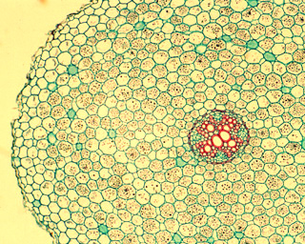 | 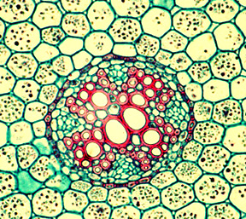 | 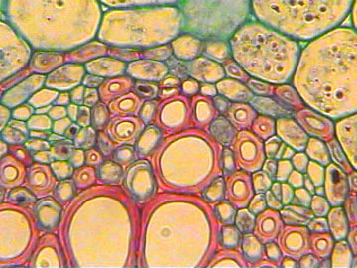
Mature Buttercup (Ranunculus) root c.s.Scanning | Mature Buttercup (Ranunculus) root c.s.40X | Mature Buttercup (Ranunculus) root c.s.100X
- Locate the epidermis, cortex, and vascular cylinder.  - Are the cells in the cortex living or dead?  - What function does the cortex serve?  - What region of the root is outside the vascular tissues?  - What is the difference between the stele and the vascular cylinder?  - In what region of the root would you find proxylem poles (metaxylem poles)? | - Are the phloem cells in the vascular cylinder living or dead at maturity?  - What is the function of the dark red stained cells?  - What function does the stele serve?  - How many protoxylem poles does this stele have?  - Where is the endodermis and what is its function? | - What tissue surrounds the xylem?  - What is a casparian strip and what function does it serve?  - What is the pericycle and where is it found?  - What is the importance of the endodermis and how does its shape reflect its function?

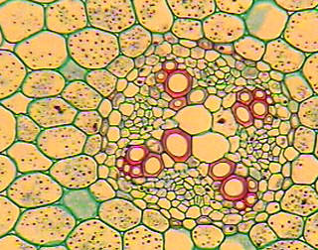
Immature dicot root stele, c.s. | Mature dicot root stele,c.s.
- Compare and contrast the structure of a young vs mature dicot root cross section. Discuss the relationship between the xylem, phloem, pericycle, endodermis, and casparian strip.

Monocot Roots

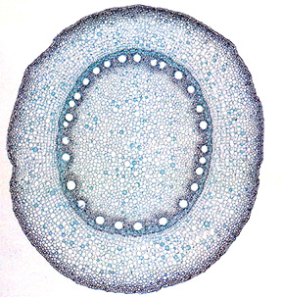 | 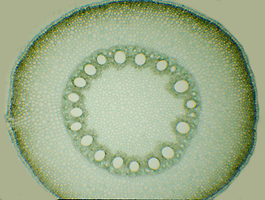  Fresh cross section of corn (Maize) root.
- How would you describe the vascular arrangement of this monocot root in Maize?  - What is the central area of the stele in a monocot root called? | - How is the arrangement different from a dicot root?  - Locate the vascular cylinder, pith, cortex, endodermis, and epidermis.
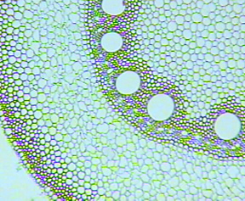 | 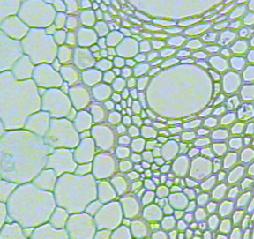
Cross section of mature monocot root | Casparian strip in endodermis of mature  monocot root.
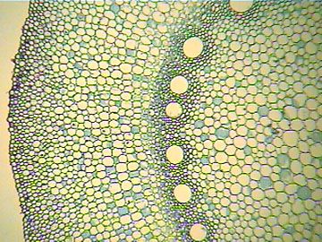 | 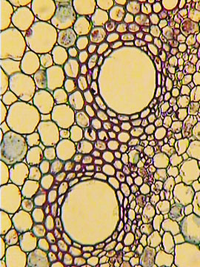
Immature cross section of corn (Maize) root | High magnification of immature monocot root lacking casparian strip.
- What tissues are outside the ring of vascular tisues?  - What region is inside the ring of vascular tissue?  - What is the function of the endodermis?  - Can you locate the vascular cambium between the xylem and phloem? | - Locate the pericycle. What are the large cells inside the pericycle?  - What is the function of the pericycle?  - Compare and contrast a cross section of the mature and immature root.

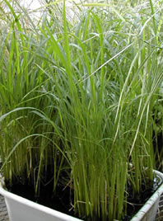 | B. Show a corn plant here
- What root type morphology would you expect these plants to have?
 |  | Fresh section of dicot root coming later.
- Which is a monocot and which is a dicot root?
- What identifying features indictates a monocot or dicot?
- In what root region is the organization different in monocots and dicots?

Short answer or comparitive questions regarding roots.
- Explain why transplanted plants often wilt at first.
- Distinquish between primary and secondary growth in roots.
- Do roots absorb along their entire length? Why or why not.
- Draw and label three types of root systems.
- What structures in roots facilitate water uptake?
- Describe the casparian strip and the role it plays in water and mineral absorption.
- Describe the pathway of water from the soil into the xylem of the vascular cylinder in a dicot root.

Stem Structure

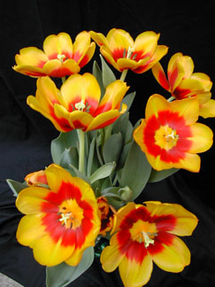 | leaves | 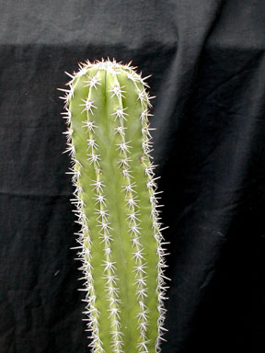

External Dicot Stem Structure
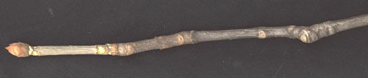
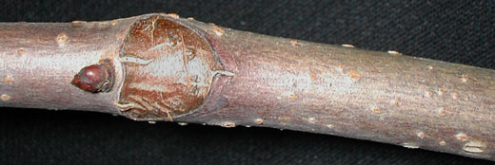
A buckeye twig
- Where is this year's growth on this twig. Last year's? How can you tell?
- Where is the terminal bud scars?
- Is the terminal bud responsible for primary or secondary growth?
- Why should plants need stems and branches?

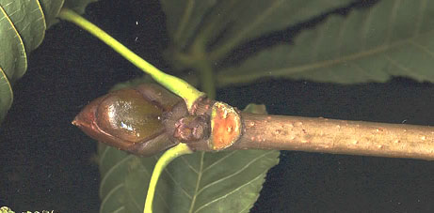  Terminal bud | 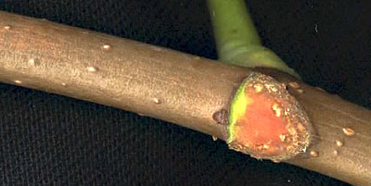  Lenticels and leaf scar
- Where is the terminal bud, leaf scar, lenticels, lateral bud, and vascular bundle scars in the above photo?
- What function occurs in the terminal bud?
- What do you call the structures that allow for gas exchange in the periderm of the stem?

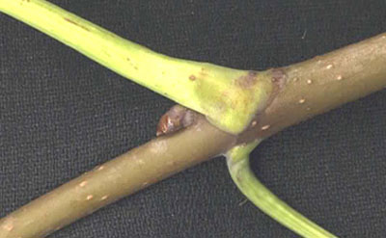
Lateral buds arise in angle between stem and leaf petiole
- Is the lateral bud responsible for primary or secondary growth? Explain.
- If gardeners clipped shoot tips from a bush or a tree, what would the result be and why?
- If gardeners clipped lateral branches from a bush or tree, what would the result be and why?
- Where are the lenticels and whay function do they serve?
- What develops from axillary buds?

Microscopic Herbaceous Dicot Stem Structure

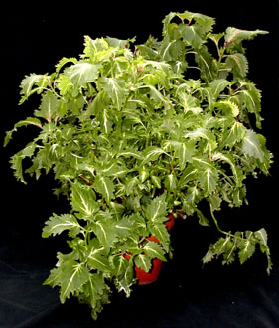 | 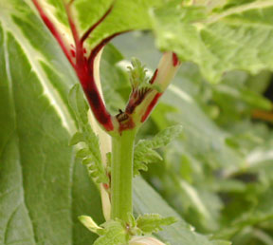 | 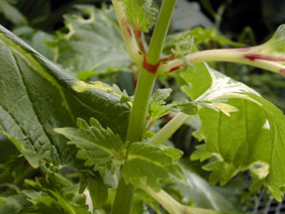
Coleus | Coleus terminal bud | Coleus lateral buds

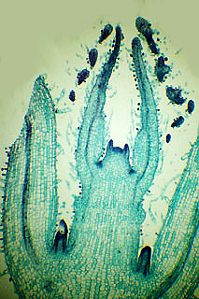 | 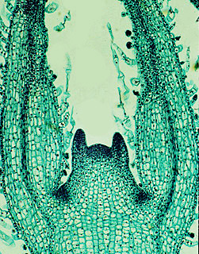
Coleus l.s. at low power | Coleus l.s. at medium power
- Identify the different stuctures on this stem tip and indicate what structure they become.  - Describe primary growth in Coleus using the figure above to illustrate your points.  - Does primary or secondary growth occur at the apical meristem? | - Locate the apical meristem. What is its function?  - Locate the axillary buds. What is their function?  - Where does differentiation occur in the stem?

Internal Anatomy of Alphalpha Medicago Stems

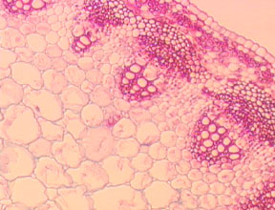 | 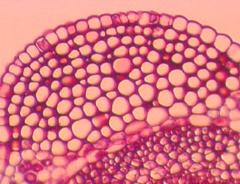 | 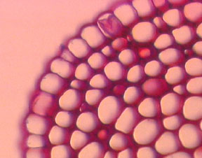
- What are the dark staining structures in the cross section of this herbaceous stem?
- What tissues would you expect to find in a vascular bundle?
- Give the specific function of tissues found in a vascular bundle.
- What mechanisms are involved in transporting water through the xylem?
- Need questions on primary and secondary growth
- The production of secondary xylem and secondary phloem increases ________ of the plant body?

Internal Anatomy of Sunflower Stem

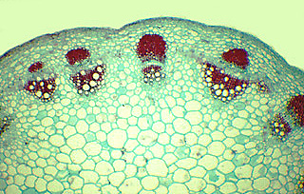 | 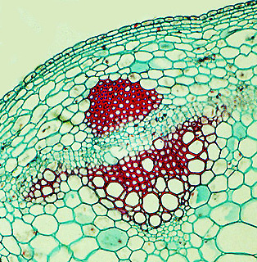
questions

Internal Anatomy of Woody Dicot Stem Structure

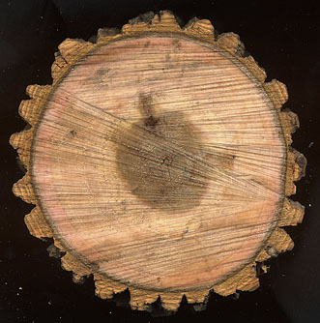 | 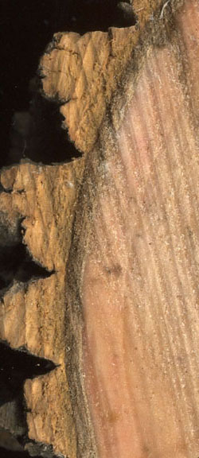 | 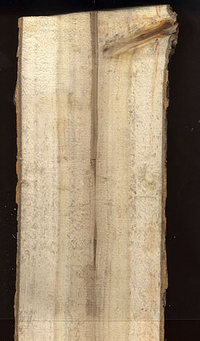

Tilia c.s. 1 year stem
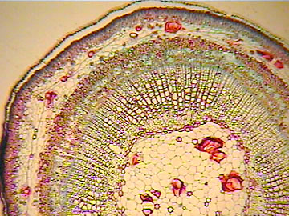 | 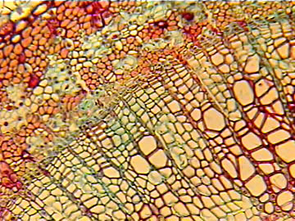 | 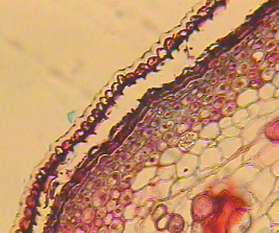
•Point to the location of the following: pith, xylem, vascular cambium, phloem, epidermis.
•Describe secondary growth using these photos to illustrate your points.

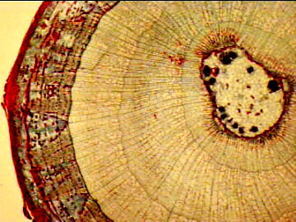  Tilia c.s. 3 yr. stem | 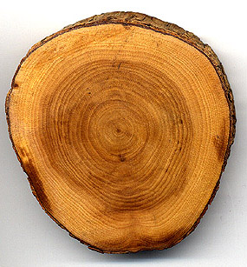  C.s. tree
•Which tissue gives an indication of the age of the stem?  •How old was this stem when it was used to prepare this section?  •In which region would you find secondary phloem?  •Where is the vascular cambium?  •Where is the cork cambium? | •Estimate the age of the tree from the wood section.  •In which region would you find secondary phloem?  •What produces secondary xylem?

Structure of Wood

new images | new images | new images
•Locate the part of wood c.s. called heartwood, and sapwood.
•Which is younger growth, heartwood or sapwood?

Internal Monocot Stem Structures

Corn plant | fresh c.s. | 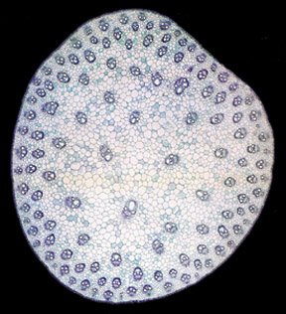

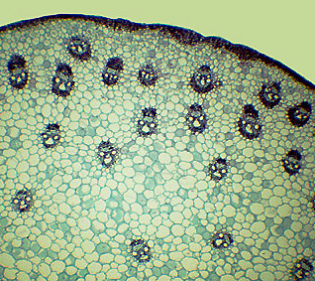 | 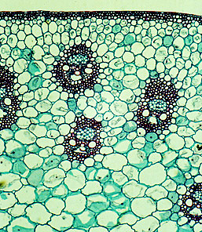 | 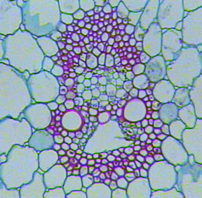
Low power | Medium power | High power
•What is one basic difference between a monocot stem and a dicot stem?  •Is this a root or a stem?  •Is this a cross section of a monocot or a dicot stem?  •The pith of monocot stems is composed of what tissue? | •Why doesn't secondary xylem and secondary phloem occur in monocot stems?  •If we cut the tip of grass with a mower, why does it still grow? | •What are the darkly staining structures?  •What is their function?  •What tissue is the outermost layer of the stem?  •What type of cell makes up most of the cross section of a stem such as this?

Testing the Water Tension Hypothesis-
Why did the blue dye travel up the "stressed" sunflower stem faster than the "non-stressed" stem? What is the main function of the collenchyma cells found in this stem?

- You are walking in the woods and come across a large tree which someone has cut down. Draw a diagram of the different tissue layers starting from the very middle of the trunk and work you way outward. Be sure to label the following: periderm, phloem, pith, primary xylem, secondary xylem, vascular cambium.-- STEM QUESTION

General and Comparative Questions about Stems-
•Discuss the various functions of vascular tissues in stems.
•How does the arrangement of vascular tissue differ for monocot compared to dicot stems?
•What is the advantage of secondary growth?
•What are the principle distinctions between herbaceous dicot and monocot stems?
•How would you distinguish between a monocot stem and a monocot root?
•How would you distinguish between a dicot stem and a dicot root?
•What tissue is commonly called "wood"?
•What is the role of the vascular cambium? Cork cambium?
•Distinguish between primary and secondary growth in stems.
•What are three functions of stems?
•In a log taken from a large tree, are most of the cells dead or alive? What tissue is most common?

BACK TO 212L HOME PAGE

