http://www.biology.iastate.edu/Courses/Leon/212L%20Docs/24cells%20index.html
Lab Topic 24
Investigating Plant Cells, Tissues, and
Primary Growth

Student Topic Guide for Cells and Tissue Discovery

Cell Walls

Primary Cell Walls
Pear (Pyrus) Parenchyma | Celery (Apium) Parenchyma | Alfalfa (Medicago) Parenchyma
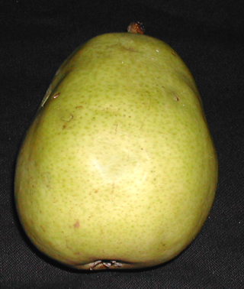 | 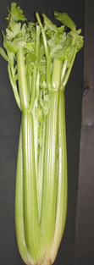 | 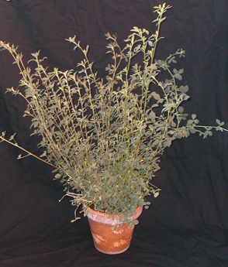
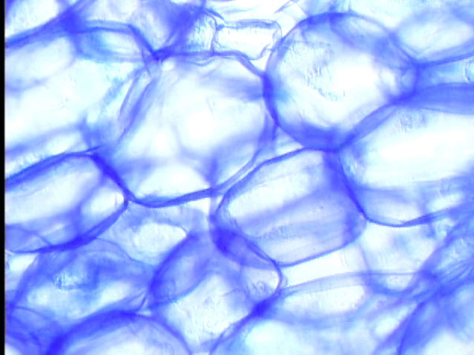 | 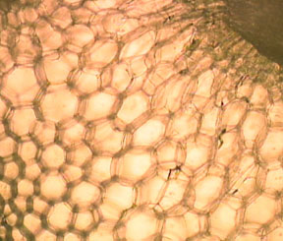 | 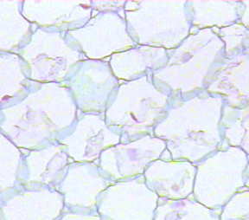

- What affect does the pattern of cellulose microfibrils have on the function in cell walls?
- Do cells with primary cell walls have living or dead protoplasts?
- Describe how a primary cell wall is formed.

Secondary Cell Walls
Pear (Pyrus) Sclereids
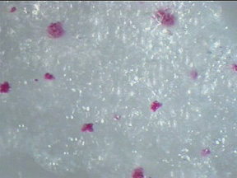 | 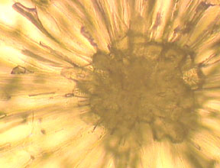 | 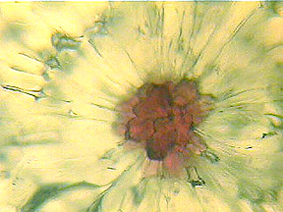
A  Stained sclereids against a background of parenechyma cells. | B  Unstained sclereid | C  Phloroglucinol stained cells

- What is the function of sclereids?
- Why do sclereids stain red with phloroglucinol?
- What phenolic polymer in plant tissue is stained by phloroglucinol?
- Are the cell walls stained red in image C primary or secondary cell walls?
- In what tissues are sclereids found?
- What is the function of lignin in secondary cell walls?
- Describe two differences between primary and secondary cell walls.

Plasmodesmata and Middle Lamella
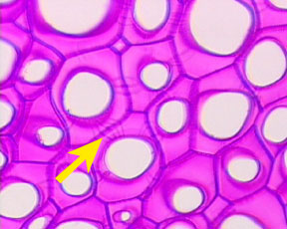 | 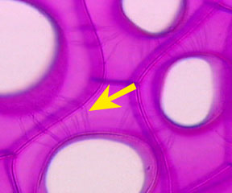
Diospyros (persimmon) high power | Diospyros (persimmon)  (oil immersion)

- What structure is indicated by the arrow?
- What advantage is there in having conduits between cytoplasms of adjacent cells?
- What is the function of plasmodesmata?
- What is the function of the middle lamella?

Vacuoles
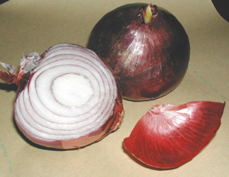  Red Onion (Allium) | 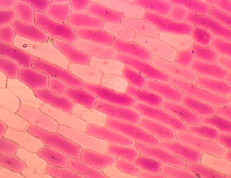 | 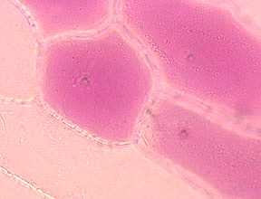
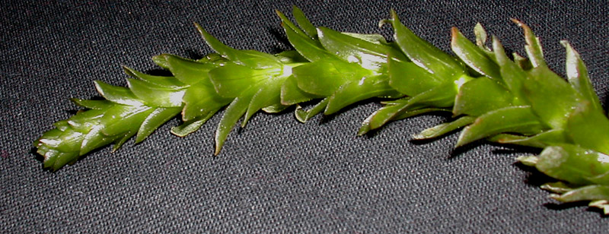  Elodea | 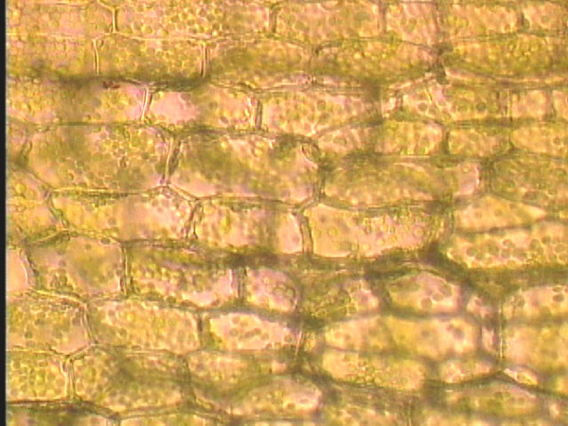 | 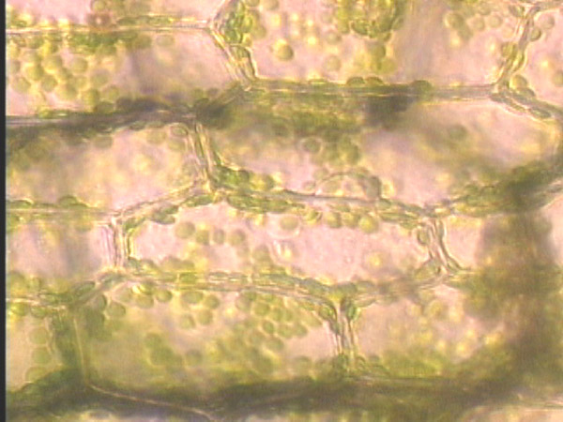

- What is a vacuole?
- What functions do vacuoles serve?
- In the images above, locate the vacuole, cytoplasm, nucleus, and chloroplasts.

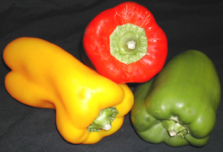
Peppers (Capsicum)
Plastids
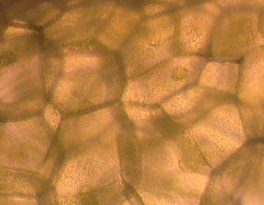 | 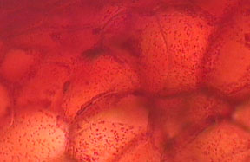 | 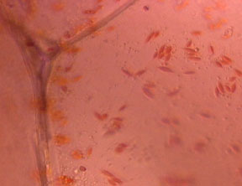
Green pepper parenchyma cells with plastids and nucleus. (medium magnification) | Red pepper parenchyma cells with plastids and nucleus. (medium magnification) | Red pepper parenchyma cells with plastids and nucleus. (high magnification)

- What is the function of a plastid?
- In what cellular organelles is pigment in plant tissues often located?
- What is the relationship between chloroplasts and plastids?
- Can non-photosynthetic cells contain plastids?
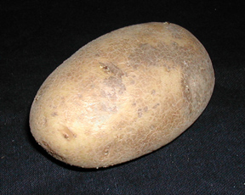
Leucoplasts
Potato cross-section. unstained | 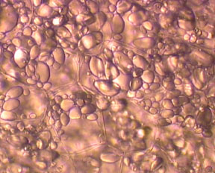 | 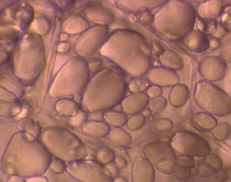
Potato cross-section. Stained with I2KI | 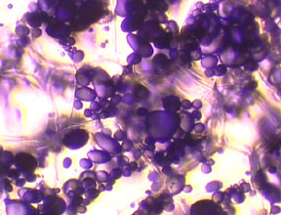 | 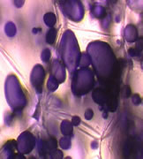

- What material is stored in leucoplasts? What is its function?
- How are leucoplasts and plastids different? How are they the same?

Investigating the Structure of Plant Tissues

Meristematic Tissue

Apical Meristem
Stem tip | 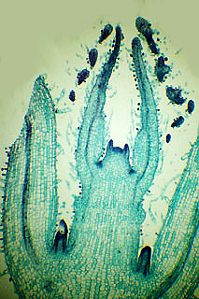  low magnification | 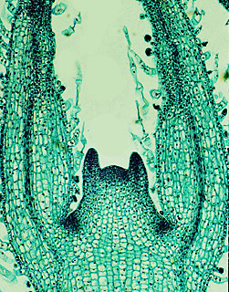  high magnification
Root tip | 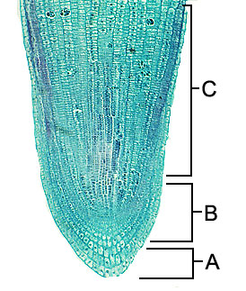  low magnification | 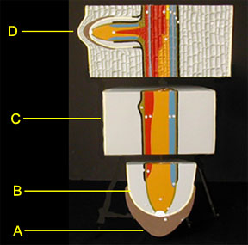  Root model

- Where is the region of the apical meristem in the root? the shoot?
- What is the function of meristematic tissue?
- What is fundamentally important about meristematic tissues?
- What are the 3 types of primary meristems?
- Where do you find each type of meristematic tissue?
- What is meant by differentiation?

Tissue Systems

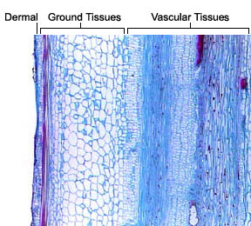

Epidermal Tissue System

Basic Epidermal Cells
Red Onion (Allium)

- Where in a plant do you find dermal tissue?
- What is the function of dermal tissue?
- What is the epidermis?
- How does the shape of the epidermal cells reflect function?
- At maturity are epidermal cells living or dead?
- Can you locate the nucleus one of the epidermal cells above?
- Describe where you would find the vacuole.
- Name 3 types of epidermal cells.
- What type of cells do you find in the epidermas?
- Typically, how many cell layers will you find in the epidermas?
- In the image above, why are some cells red and others not?
- What is the typical shape of epidermal cells?

Guard Cells
Zebrina leaf peel | 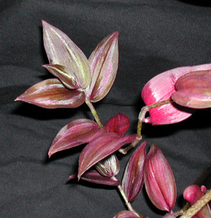
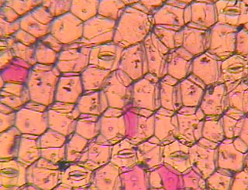 | 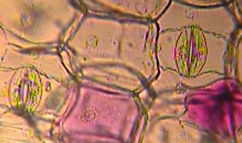 | 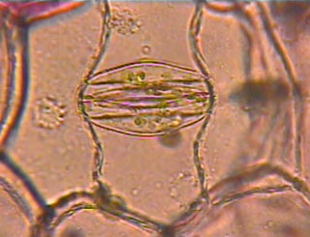

- Can you locate a guard cell?
- What 2 types of cells are visible in this image?
- What are the narrow, elongated cells called?
- What is the region surrounded by the 2 narrow, elongated cells called?
- What are the green structures in the guard cells?
- What is the function of guard cells?
- What gases move in and out of the stomata?
- What would happen to a plant if there were not guard cells?
- What causes guard cells to change shape?
- Would you expect a desert plant to have many or few guard cells? What about a rainforest plant?

African violet (Saintpaulia)
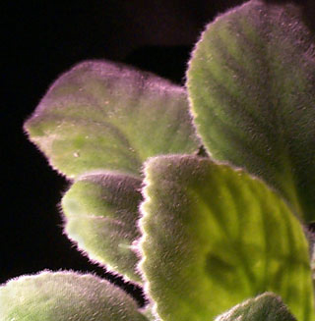

- What is the name of the structures that give a hairy appearance to the leaf surface of these plants?

Trichomes
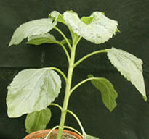 | 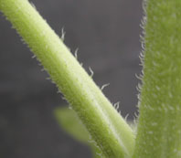 | 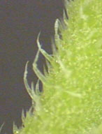 | 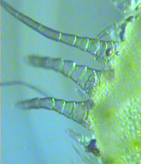
Trichomes on sunflower (Helianthus)
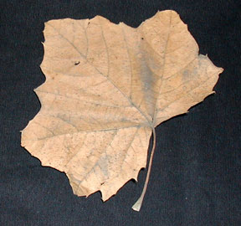 | 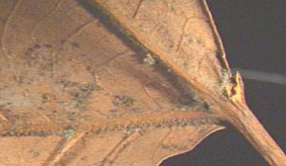 | 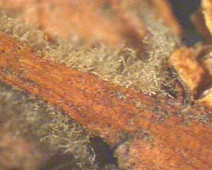 | 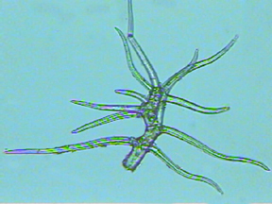
Trichomes on sycamore (Platanus) leaf

- What functions do the trichomes on these leaf surfaces perform?
- In what plant tissues will you find trichomes?
- What are trichomes?
- Disregarding shape, what other functions do trichomes serve?
- How does the shape of trichomes reflect its function?

Root Hairs
Radish (Raphanus) Seedling showing root hairs and magnified view of root epidermis
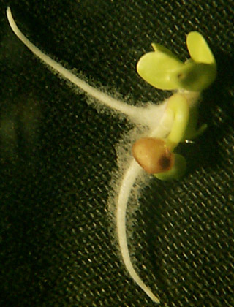 | 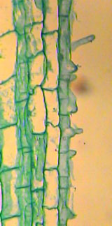

- What are root hairs?
- What function do root hairs serve?
- Why aren't root hairs covered in a waxy cuticle?

Ground Tissue System

Tissue Systems | Ground Tissues

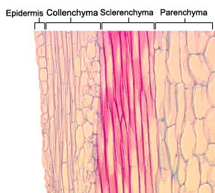

- What are the 3 tissue types in the ground tissue system?
- What are the 3 main functions of ground tissue?
- If you were to draw a section of ground tissue what cells would you include and what would they look like?

Parenchyma Tissue
Sunflower stem (Helianthus) c.s .
Parenchyma cells | 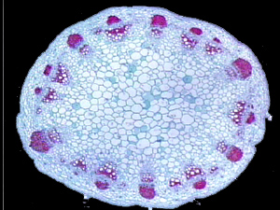 | 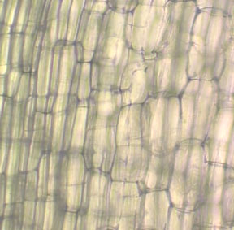  fresh sunflower stem showing parenchyma cells in l.s.

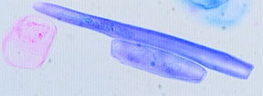  whole section of parenchyma cells | 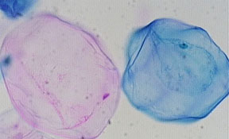

- What cells do you find in parenchyma tissue?
- Describe the shape and characteristics of parenchyma cells.
- What function do the air spaces between parenchyma cells perform?
- What function do parenchyma cells perform?
- Name three functions of parenchyma cells.
- Parenchyma cells do not stain with pholoroglucinol. What does this tell you about the cell walls?
- Where might you find parenchyma cells in a plant?
- At maturity, are parenchyma cells alive or dead?
- Why would we want to eat parenchyma cells in a pear?

Collenchyma Tissue
 | whole section | Celery (Apium)c.s. | high power
Collenchyma cells c.s | 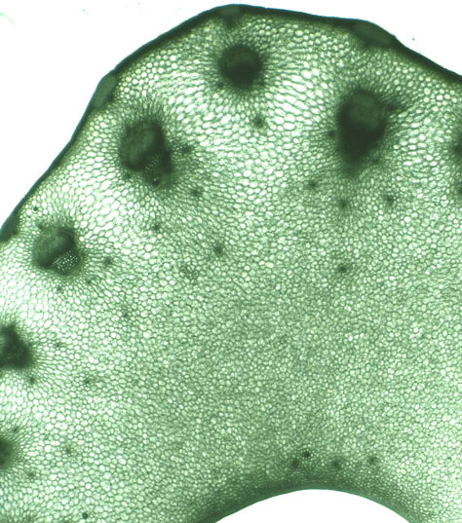 | 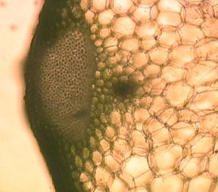 | 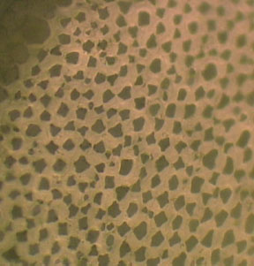
Collenchyma cells l.s. | 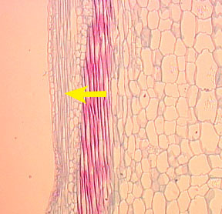 | 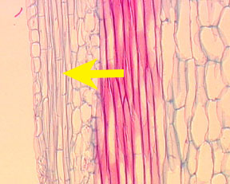 | 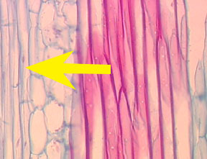

- What support tissue is visible at the edge of the petiole?
- What is the function of collenchyma tissue type?
- Where do you usually find collenchyma?
- Describe the shape of collenchyma cells.
- What type of cells do you find in collenchyma tissue?
- Are collenchyma cells living or dead at maturity?
- Where would you be likely to find collenchyma cells that are lignified?
- If water was prevented from entering collenchyma cells, what would happen to the plant?
- Through what mechanism might collenchyma provide support to the plant?

Sclerenchyma Tissues
Fibers from ground tissue in Sclerenchyma | 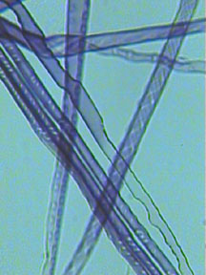 | 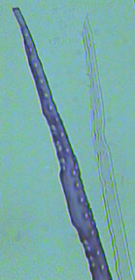

Sclerenchyma fibers and pits l.s.
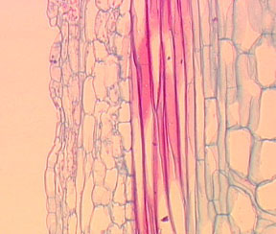 | 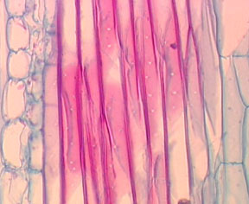 | 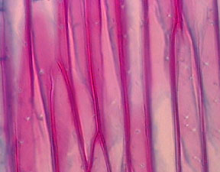
low magnification | medium magnification | high magnification

Sclereids

- Why do you suppose these cells are so much longer than they are wide?
- Where would you find fibers, in collenchyma, parenchyma, or sclerenchyma tissue?
- What is the function of fiber cells?
- Are fibers living cells or simply dead cell walls that have lost their cytoplasm(protoplast)?
- Describe the cell walls of sclerenchyma cells.
- What function does sclerenchyma tissue serve?
- Name two types of sclerenchyma cells.
- In what commercial products would you find primarily sclerenchyma fibers?
- Are sclerenchyma living or non-living at maturity?
- Where would you find sclereids? In collenchyma, parenchyma, or sclerenchyma tissue?
- How are collenchyma and sclerenchyma cells different? How are they the same?
- Would you likely find lignin in the cells walls of sclerenchyma tissue?
- What 3 cell types are found in ground tissue?

Vascular Tissue System

Tissue Systems | Vascular Tissues
 | 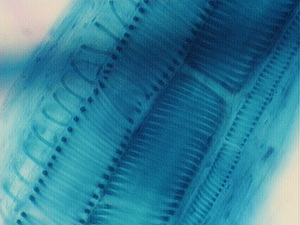

Vascular Bundles in c.s of sunflower (Helianus) | 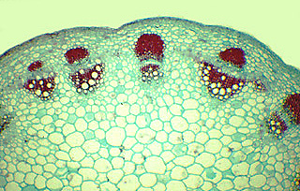 | 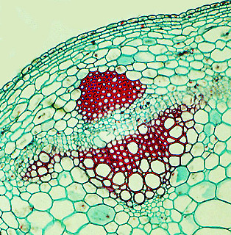

- What types of cells do you find in a vascular bundle?
- What is the function of vascular tissue?

Xylem
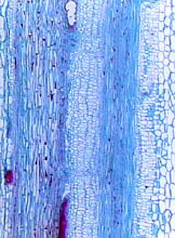 |  | 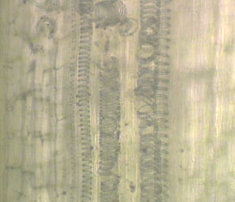
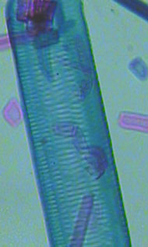 | 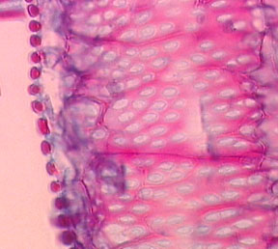 | 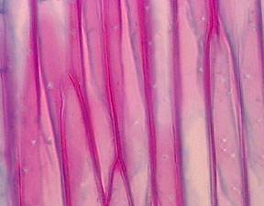
Vessel | Vessel element close-up view | Tracheid

- In what tissue system do you find tracheids and vessel elements?
- What are the two types of cells found in xylem tissues?
- How are vessels and tracheids the same? How are they different?
- Describe the shape of tracheids. How does this shape affect its function?
- Describe the shape of vessels.How does this shape affect their function?
- Are vessels living or dead at maturity?
- Are tracheids living or dead at maturity?
- How are fibers in ground tissue different from and similar to tracheids in vascular tissue?

Phloem

- What cells do you find only in phloem?

Pumpkin (Cucurbita) l.s. | Pumpkin (Cucurbita) l.s. (oil immersion) | Pumpkin (Cucurbita) c.s.
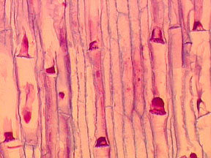 | 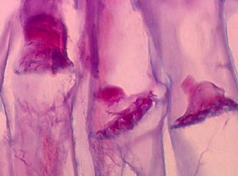 | 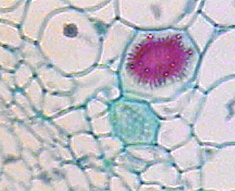
Phloem with p-proteins concentrated at sieve plates | Magnified view of sieve plates and companion cell | Sieve tube Member, sieve plate, and companion cell in l.s.

- What function does a sieve tube element perform?
- Where would you find companion cells?
- What purpose do companion cells serve?
- Describe the purpose of a sieve plate?
- What does a sieve plate look like?
- Are sieve tube elements living or dead cells at maturity?
- If the probiscus of an insect injures a plant cell how does the plant respond?

This lab topic has presented an overview of plant cells, tissues, and their function. Use what you have learned to create a new botanical organism. You may use (or not use) any of the cells presented here as well as the plant systems. Describe the environment in which the plant would live and why the cells you chose would help the plant survive. Since you are the explorer, don't forget to name your organism.

