Tavi II inovaciaTa menejmenti
TavSi ganxilulia inovaciis da inovaciuri procesis, teqnologiaTa sasicocxlo ciklis cnebebi, aRwerilia inovaciuri procesis saerTo mimdinareoba, misi Semadgeneli etapebi da warmodgena S-mrudis meSveobiT. warmodgenilia teqnologiur siaxleTa kvlevis modeli, moyvanilia teqnologiaTa sasicocxlo ciklis magaliTebi da maTi raodenobrivi aRwera gompercis da perlis mrudebis meSveobiT. calke yuradReba eTmoba inovaciuri procesebis zegavlenas ganviTarebadi qveynebis ekonomikur miRwevebze da codnis ganviTarebis aucileblobas, rogorc maTi winsvlis mTavari pirobisa.

2.1. inovaciis gansazRvra
inovaciiaSi vgulisxmobT gamokveTilad axal sagans an process, romlis danergva inovaciuri procesebis moqmedebis Sedegia. samewarmeo sferoSi inovaciebis aTviseba bazarze arsebuli moTxovnilebebis axali produqciiT an momsaxurebis axali nairsaxeobiT dakmayofilebas niSnavs, an iwvevs arsebuli nawarmis (servisis) axali wesiT warmoebas. procesuli TvalsazrisiT, inovaciis cneba Semdegnairad SeiZleba ganimartos: inovacia, iseTi sazogadoebriv-teqnikur-ekonomikuri procesia, romelsac ideebisa da gamogonebebis praqtikuli gamoyenebis Sedegad, ukeTesi Tvisebebis mqone nawarmis an procesebis damkvidrebisken mivyavarT [52].
ras gvaZlevs inovacia? [53]–is mixedviT, inovacia qmnis samuSao adgilebs, amaRlebs cxovrebis dones, zrdis dovlaTs. vrceldeba ra farTod ekonomikasa da sazogadoebaSi, inovacia qmnis winapirobas rogorc arsebuli codnis da teqnologiebis sayovelTaod gavrcelebisTvis, aseve axlis generirebisTvis.
Tu ra Sedegi moyveba inovaciis aTvisebas, didwilad damokidebulia imaze, Tu sad inergeba igi. rodesac saqme exeba inovaciebs samomxmareblo nakeTobaTa warmoebis sferoSi, siaxlis kvlevas da damuSavebas safuZvlad udevs mewarmis survili- miiRos damatebiTi mogeba. samxedro mrewvelobaSi ki inovaciis aTvisebis mTavari mizania sasurveli maxasiaTeblebis mqone axali nawarmis miReba, Tundac misi warmoebis komerciuli araracionalurobis fasad. amitom, samxedro sferoSi SesaZlebelia ufro swrafi teqniur-teqnologiuri ganviTarebis miRweva, vidre samoqalaqo warmoebaSi.
samxedro mrewvelobaSi mimdinare inovaciuri procesebi produqciis Taobebis Secvlas iwvevs. axali nawarmi (iaraRi), rogorc wesi, ufro efeqturia, amitom mis gamoSvebaze gadasvlis Semdeg warmoebis moculoba an ucvleli rCeba, an zogjer klebulobs kidevac. Sedegad, axali nawarmis TviTRirebuleba umetes SemTxvevebSi matulobs. samomxmareblo produqciis warmoebisas ki, Tu axali nakeToba da misi damzadebis teqnologia Camoyalibda, "gaiyina" Tavis ganviTarebaSi, Sesabamisi inovaciebis aTvisebis sixSire klebulobs. samagierod, siaxlis bazarze warmatebis SemTxvevaSi, misi gamoSvebis fizikuri moculoba swrafad izrdeba, TviTRirebuleba ki piriqiT mcirdeba, warmoebis masStabebisgan miRebuli ekonomiis gamo.
inovaciuri procesebis xasiaTSi garkveva maT sistematizebas da Sesabamisi cnebebis Semotanas moiTxovs. e.w. srulyofis inovaciebi adaptaciis, nawarmis an teqnologiis rafinirebis procesebTanaa dakavSirebuli da arsebuli produqtis, an sawarmoo sistemis gaumjobesebas iwvevs. radikalur inovaciebs sruliad axali produqtis, an sawarmoo procesis damkvidrebisken mivyavarT. inovaciis warmatebuli danergvis kriteriumebi ekonomikuri xasiaTisaa: Sedegiani inovacia iseTia, romelic firmas garkveuli danamatiT ubrunebs mis damuSavebasa da aTvisebaSi Cadebul investirebas.
ganasxvaveben inovacia-produqts da inovacia-process (nax. 25). axali nawarmis aTvisebisas, danergili inovaciebis pirveli Taoba (mas bazurs uwodeben) ayalibebs produqts,Mfaqtobrivad igi warmoebis mimarTulebis arCevas ganapirobebs. inovaciebis momdevno Taobebis daniSnulebaa nawarmis srulyofa, misi maxasiaTeblebis met SesabamisobaSi moyvana momxmarebelTa moTxovnilebebTan. amitom, maTi aTvisebiT gamowveuli teqnikur-teqnologiuri cvlilebebi ufro metad sawarmoo procesebs Seexeba, vidre TviT produqts.
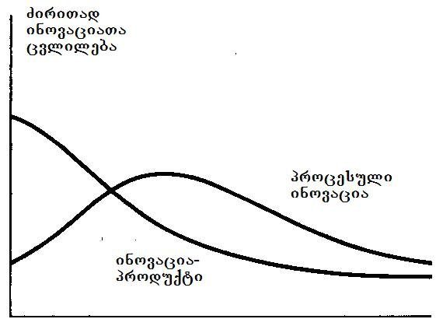
nax. 25
axali produqtis sasicocxlo ciklis dasawyisSi, bazarze warmatebis ganmsazRvreli kritikuli faqtori misi dizaini - principuli konstruqciuli gadawyveta xdeba [43]. saqme isaa, rom siaxlis pirvel momxmareblebs ufro misi gamoyenebadoba da axali SesaZleblobebi ainteresebT, vidre fasi. amitom, produqtis samomxmareblo Tvisebebis srulyofis da mimzidvelobis zrdis mizniT, sakmaod xSirad xdeba misi xelaxali daproeqteba da axal-axali inovaciuri modifikaciebis damuSaveba. ase grZeldeba manam, sanam produqti ar ganviTardeba e.w. “dominanturi dizainis” mdgomareobamde, ris Semdegac igi mocemul bazarze wamyvan mdgomareobas iWers.
mTeli zemoaRwerili drois ganmavlobaSi, axali produqtis gamoSvebisTvis gamoyenebuli sawarmoo procesi mewarmis gankargvaSi ukve arsebuli SesaZleblobebiT ganisazRvreba da naklebad icvleba. amitom am periodSi inovacia-procesebis gamoCenis sixSire mcirea. produqtis “dominanturi dizainis” miRwevis Semdeg, mkveTrad iwyebs zrdas mewarmis miswrafeba Seamciros sawarmoo danaxarjebi da gazardos gamoSvebis moculoba da siCqare. Sesabamisad, misi yuradRebis centrSi axla procesuli inovaciebi eqceva, rasac mosdevs maTi aTvisebis sixSiris mkveTri mateba. droTa ganmavlobaSi clilebebi rogorc produqtSi, ise misi warmoebis procesSi sul ufro iSviaTi xdeba, bolos ki orive met-naklebad standartizebul saxes iRebs.
sazogadod, inovaciebis gareSe Sedegiani mewarmeoba warmoudgenelia. amasTan, arsebobs e.w. inovaciuri mewarmeoba, romelic raime nawarmis an momsaxurebis Seqmnis procesSi resursebis da SesaZleblobebis axal, iqamde gamouyenebel, an adre ararsebul kombinacias iyenebs komerciuli TvalsazrisiT misaRebi mimarTulebiT. aRsaniSnavia, rom nebismieri mewarmeoba aucileblad gulisxmobs mewarmis mier finansuri riskis gawevas.
inovacia xSirad dakavSirebulia gamogonebis an aRmoCenis gamoyenebasTan. erTic da meorec SemoqmedebiTi procesebis Sedegia da umravles SemTxvevaSi, sabunebismetyvelo mecnierebaTa axal miRwevebs asaxavs. gansxvavebiT inovaciebisgan, gamogonebebis da aRmoCenebis Sedegianobis kriteriumebi ufro samecniero-teqnikuri xasiaTisaa da ara ekonomikuri. aucilebelia vasxvavebdeT gamogonebas misi teqnologiuri ganviTarebisgan, romelsac samecniero Sedegebis praqtikuli gamoyenebisken mivyavarT. magaliTad, eleqtronul mrewvelobaSi 3 mTavari gamogonebis - tranzistoris (1947 w.), integraluri sqemis (1959 w.) da mikroprocesoris (1971 w.) damuSavebam, uamravi axali teqnologiuri gadawyvetilebis danergva ganapiroba iseTi mimarTulebebiT, rogoricaa monacemTa damuSavebis procesorebi, damamaxsovrebeli mowyobilobebi da sxv.
aRsaniSnavia, rom xSirad gamogonebis an aRmoCenis moqmed teqnologiaSi asaxvamde mniSvnelovani dro gadis, risi magaliTicaa genetikuri inJineria da lazeruli teqnologiebi. Cveulebriv iTvleba, rom bazisuri mecnieruli kvlevis warmatebuli dasrulebidan 10 an meti weli unda gavides, raTa moxerxdes misi Sedegebis sruli asaxva inovaciebSi.
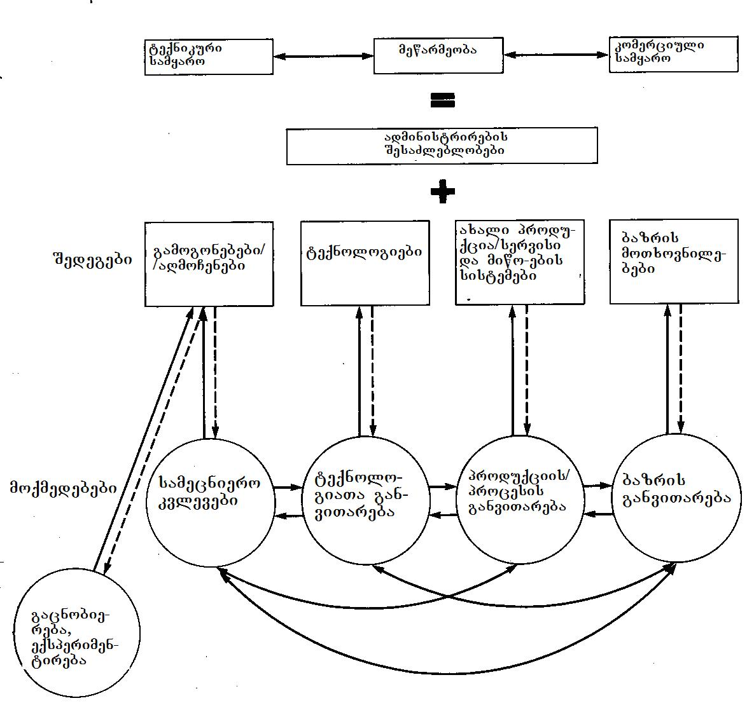
Nnax. 26
teqnologiuri inovacia aris inovaciaTa calke kategoria. igi aerTianebs praqtikul codnas, nou-haus, xelovnebas da artefaqtebs∗, romlebic SeiZleba gamoyenebul iqnes axali nawarmis, an servisis misaRebad an arsebuli produqtis warmoebaSi axali procesis dasanergad. teqnologia ki SeiZleba ganisazRvros Semdegnairad: teqnologia aris praqtikuli miznebis miRwevis teqnikuri meTodi, adamianis arsebobisTvis aucilebeli sagnebis da misTvis xelsayreli pirobebis SeqmnisTvis saWiro saSualebebisa da midgomebis erToblioba. igi praqtikaSi, upirveles yovlisa ki warmoebis sferoSi, codnis mizanmimarTuli gamoyenebis Sedegia. teqnologia aisaxeba adamianebSi, informaciasa da masalebSi, SemecnebiT da fizikur procesebSi, qarxnebSi, mowyobilobebsa da instrumentariumSi. teqnologiis Sedegianobis Sefaseba teqnikuri maxasiaTeblebis mixedviT xdeba.
[54]-dan aRebul 26-e naxazze, mocemulia inovaciuri mewarmeobis saerTo suraTi, romelic mis mimdinareobaze zegavlenis mqone ZiriTadi faqtorebis da movlenebis urTierTmimarTebas asaxavs. qvemodan pirvel Sreze CamoTvlilia is moqmedebebi (aqtivobebi), romelTac meore Sreze naCveneb Sedegebamde mivyevarT. maTi gaerTianeba mewarmis mier mis gankargvaSi arsebul administraciul, teqnikur da komerciul SesaZleblobebTan, inovaciuri biznesis safuZvels qmnis.
mniSvnelovania procesze zegavlenis mqone mizez-Sedegobrivi kavSirebis kompleqsurobis xazgasma. magaliTad, is SeiZleba rogorc bazris moTxovnilebebidan samecniero kvlevebisken iyos mimarTuli, aseve piriqiT - kvlevebidan bazrisken. Tumca praqtikaSi inovaciuri procesebi TiTqmis yovelTvis iteraciul xasiaTs atareben, amitom Znelia maTi gamomwvevi mizezebis garkveul mimarTulebasa da Tanamimdevrulobaze laparaki.
26-e naxazidan cxadia, rom inovacia – yvela tipis codnis gamoyeneba sasurveli socialuri da ekonomikuri Sedegebis misaRebad – ufro tevadi cnebaa, vidre mecniereba da teqnologia. umetes SemTxvevebSi igi teqnikuri, organizaciuli da sxva saxis cvlilebebis kombinaciaa. inovacia Cndeba maSin, rodesac mewarmeoba samecniero da teqnologiur aqtivebTan gadaikveTeba. amisTvis ki aucilebelia etapurobis dacva inovaciaTa ganviTarebaSi.

2.2. inovaciaTa danergvis etapebi
arc erTi teqnologiuri procesi, an mowyobiloba ar gadadis farTo gamoyenebis sferoSi uSualod gamomgoneblis gonebidan, am gzaze igi ganviTarebis garkveul fazebs gaivlis. inovaciaTa danergvis procesis etapebad dayofa mosaxerxebelia maTi gamokvlevis mizniT. igi Semdegnairad SeiZleba warmovidginoT:
- mecnieruli aRmoCena;
- laboratoriuli gamokvleva;
- samuSao nimuSebis damzadeba;
- komerciuli danergva an sawarmoo pirobebSi gamoyeneba;
- farTo gavrceleba ekonomikis mocemul dargSi;
- meurneobis sxva dargebSi gamoyeneba;
- siaxleTa danergvis socialuri da ekonomikuri Sedegebis miReba.
davaxasiaToT isini ufro detalurad.
mecnieruli aRmoCena - inovacia am etapze arsebobs raime movlenaze an faqtze mecnieruli Sexedulebis saxiT.
laboratoriuli gamokvleva - am etapze moiZebneba problemis konkretuli gadawyveta da muSavdeba laboratoriuli modeli; Seiqmneba CvenTvis saintereso amocanis gadaWris, an garkveuli funqciis Sesrulebis teqnikuri SesaZlebloba, jerjerobiT mxolod laboratoriul pirobebSi moqmedi. ueWvelia, am dros siaxlem unda aCvenos, rom ar modis winaaRmdegobaSi bunebis romelime kanonis moqmedebasTan;
samuSao nimuSebis damzadeba - am etapze Seiqmneba siaxlis iseTi prototipi, romelic gankuTvnilia realur viTarebaSi warmatebuli funqcionirebisTvis. aseT pirobebSi misma gamocdam unda aCvenos, Tu rogori mdgradoba da saimedooba aqvs axal nawarms an process, rom igi kargad asrulebs Tavis daniSnulebas da misi momsaxureba advilia, anu mas SeuZlia sakuTari funqciis Sesruleba rigiTi momxmareblis xelSic;
komerciuli danergva an sawarmoo pirobebSi gamoyeneba - am etapze inovaciam unda daamtkicos ara marto Tavisi teqnikuri da konstruqciuli qmediToba, aramed misi msxvilmasStabiani warmoebis da komerciuli realizebis SesaZleblobac;
meurneobis mocemul dargSi farTo gavrceleba - am etapze unda damtkicdes, rom inovacia Tavisi teqnikuri da ekonomikuri maCveneblebiT sjobs dargSi aqamde arsebul yvela msgavs nawarms an process da mas SeuZlia Secvalos adre gamoyenebuli yvela msgavsi meTodi, mowyobiloba da a. S;
meurneobis sxva dargebSi gamoyeneba - am etapze inovacia gamoyenebas povebs iseT funqciaTa SesrulebaSic, romlebisTvis misi analogi gamousadegari iyo;
siaxleTa danergvis socialuri da ekonomikuri Sedegebi - rodesac inovaciis danergva am stadiasa da saTanado masStabebs aRwevs, igi an garkveulad cvlis sazogadoebis qcevas, an cxadi xdeba, rom qveynis ekonomikis mniSvnelovani nawili ukve maszea damokidebuli. Sesabamisi magaliTebia televiziis da avtogadazidvebis gavrcelebis zegavlena aSS-s sazogadoebaze. amasTan, avtomobili ara marto gadaiqca sayovelTao moxmarebis samrewvelo produqtad, aramed gamoiwvia isic, rom am qveynis mTliani erovnuli produqtis 10% ukavSirdeba avtomobilebis warmoebas, realizebas, eqspluataciasa da momsaxurebas.
cxadia, sulac ar aris aucilebeli, rom yovelma inovaciurma procesma srulad moicvas yvela CamoTvlili etapi. magaliTad, yofila SemTxvevebi, rodesac gamogonebis pirvelive laboratoriuli modelebi sawarmoo nimuSebadac gamomdgara. Tumca, es iSviaTobaa, rogorc wesi pirvel modelebs seriozuli defeqtebi axasiaTebs, romelTa aRmofxvra mxolod sawarmoo nimuSebis mravalricxovani gamocdebisa da konstruqciuli, an damzadebis defeqtebis gasworebis Sedegad xerxdeba.
rasakvirvelia, inovaciaTa Seqmnis sawyisi faza samecniero-kvleviTi saqmianobaa, romelsac umetesad organizaciebis SigniT arsebuli samecniero-kvleviTi laboratoriebi axorcieleben. rogorc wesi, maTSi mimdinareobs grZelvadiani samecniero kvlevebi ganyenebuli, abstraqtuli xasiaTis sakiTxebze. aseT kvlevebs axal ideebTan mivyavarT, romlebic dasawyisSi ar ukavSirdeba asaxvas raime produqtSi, an procesSi. Semdeg, es ideebi uSualo gamoyenebisTvis SeiZleba gadaeces gunds, romelic “gazrdis” maTgan inovaciur produqts (nax. 27).

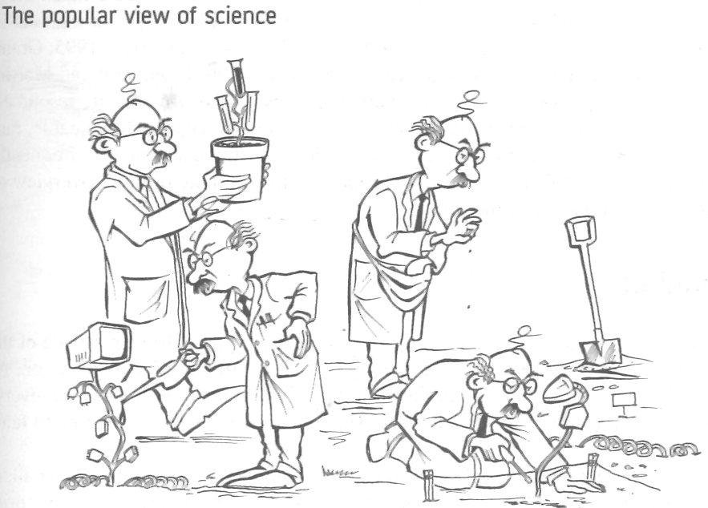
nax. 27
Tanamedrove gamoyenebiT samecniero-kvleviT procesSi Semdeg sam komponents gamoyofen:
- xangrZlivvadiani kvleva – romlis msvlelobaSi warmoiSveba ideebi, maT momaval gamoyenebaze winaswari warmodgenebis gareSe;
- mowinave produqtis damuSaveba – romelic mimarTulia ukve konkretul nawarmze da aviTarebs mxolod iseT ideebs, romlebic mocemul produqts Seesabameba. amasTanave ar eRobeba analogiuri produqtebis Seqmnis sxva koncefciebsac;
- sawarmoo produqtis damuSaveba – aq ukve kvlevaSia mxolod is idea, romelic warmoebis inJinrebis mier aris gaziarebuli da romelic maTi azriT SeiZleba produqciis konkretuli nairsaxeobis gamoSvebis safuZveli gaxdes.
gamartivebulad, inovaciuri procesi sami etapisgan Sedgeba, esenia: ideis generireba, misi ganviTareba, komercializacia anu samewarmeo xorcSesxma. msgavsi midgomis safuZvelze kanadelma mecnierma r. kuperma daamuSava "NewProd" – inovaciuri procesis erT-erTi yvelaze ufro gavrcelebuli modeli [48].
100-ze meti axali da warmatebuli produqtis Seqmnis procesis analizis safuZvelze, igi mivida daskvnamde, rom bazarze maTi Sedegiani damkvidreba samma sakvanZo faqtorma ganapiroba, esenia: produqtis upiratesoba (product advantage), gawafuloba winaswar damuSavebaSi (proficiency of pre-development) da e.w. protokoli (protocol).
produqtis upiratesobaSi igulisxmeba axali Tvisebebi, romelTa meSveobiT mas SeuZlia SesTavazos momxmarebels sakuTari unikaluri SesaZleblobebi; davuSvaT iyos ufro maRali xarisxis, vidre konkurentebis msgavsi nawarmi; Seamciros myidvelis danaxarjebi mis SeZenaze an moutanos mas raime sxva saxis sargebeli.
gawafuloba winaswar damuSavebaSi aisaxeba inovaciuri ciklis winmswrebi procesebis karg marTvaSi. aseT procesebs miekuTvneba: proeqtis sawyisi (pirveladi) testireba, bazrisa da teqnologiis Tavdapirveli Sefaseba, marketinguli kvlevis da finansuri analizis Catareba.
sanam inovaciuri proeqtiT daiwyeboda produqtis ganviTareba, SemsrulebelTa gundma mkafiod unda gamokveTos bazris miznobrivi segmenti, momxmarebelTa moTxovnilebebi, survilebi da preferenciebi, Camoayalibos produqtis koncefcia, saerTo specifikacia - moTxovnebi mis maxasiaTeblebisadmi da dagegmos inovaciis warmatebuli danergvisTvis aucilebeli RonisZiebebi. imas, raSic yvelaferi es erToblivad fiqsirdeba, kuperi pirobiTad protokols uwodebs.
inovaciuri procesis modelSi am sami faqtoris gaerTianebis Semdeg, kuperi Semdeg daskvnebs akeTebs:
produqtis upiratesoba – misi yvelaze mniSvnelovani Tvisebaa momxmareblis TvalSi. amitom, inovaciuri procesis pirveli amocanaa iseTi produqtis Seqmna, romelSic momxmarebeli realur upiratesobebs dainaxavs sargeblianobis, xarisxis, fasis, siaxlis, Rirsebis an problemis axleburi gadawyvetis unaris saxiT. am amocanis gadaWris gasaRebi momxmarebelTa survilebis da molodinebis SeswavlaSia: proeqtma naTlad unda aCvenos, rom momxmareblebs marTlac surT is, rasac maT inovacia uqadis.
proeqtis amocanebis gansazRvra da sxva winaswari procesebi, ukiduresad mniSvnelovania. menejmenti mzad unda iyos, rom arsebuli resursebis nawili bazris Seswavlas, teqnikur Sefasebebs, finansur analizsa da sawyis gamocdebs dauTmos. yvelaferma aman unda Camoayalibos mkafio warmodgenebi inovaciuri procesis mimarTebaze miznobriv bazarTan, momxmarebelTa moTxovnilebebTan, mogebasTan, romelsac moitans axali produqti da a.S.
urTierTanamSromloba, warmatebis ZiriTadi faqtoria. proeqti unda idealurad “jdebodes” kompaniis strategiasa da mis mimdinare operaciebSi. marketingiT da gayidvebiT dasaqmebuli TanamSromlebi iseve unda iyvnen kmayofili inovaciebiT, rogorc uSualod is specialistebi, romlebic aviTareben maT.
protokolis zusti dacva, inovaciuri proeqtis warmatebis aucilebeli pirobaa, romlis Sesruleba gapirobebulia imiT, Tu romeli funqciebis Sesrulebas akontrolebs proeqtis xelmZRvaneli da rogor. esenia: inovaciis damuSaveba-ganviTareba, bazarTan dakavSirebuli saqmianoba, teqnikuri saqmianoba, produqtis unikaluri maxasiaTeblebis da upiratesobebis ganviTareba. am saqmianobis kontroli exmareba proeqtis xelmZRvanels marTos inovaciuri procesi maRali gaurkvevlobis pirobebSi. inovaciebi xom Zalian xSirad icvlis Tavisi ganviTarebis mimarTulebas da Tuki procesi CixSi moeqceva, kuperis modeli karnaxobs inovaciuri procesis monawileebs, ras unda mieqces yuradReba, raTa warmatebis Sansi gaizardos.

2.3. inovaciaTa kvleva da inteleqtualuri
produqti
aq gvinda moviyvanoT piter drakeris mier [56]-Si formulirebuli “efeqturi kvlevebis aTi wesi”, romliTac, misi azriT, unda isargeblon inovaciurma samewarmeo firmebma, raTa Seamciron riskebi da gazardon inovaciuri saqmianobis efeqtianoba:
- nebismieri axali nawarmi, procesi an momsaxureba im dResve iwyebs moZvelebas, ra dResac aRwevs pirvelad bazarze momgebianobas.
- is, rom swored Tqvenve aRiaroT sakuTari nawarmis, procesis an momsaxurebis moZveleba, erTaderTi gzaa, raTa ar misceT konkurents SesaZlebloba Tavad gaakeTos es.
- ukeTesi iqneba Tuki daiviwyebT me-19 saukuneSi Mdamkvidrebul gansxvavebas “fundamentur” da “gamoyenebiT” kvlevebs Soris. amis gakeTeba kidev SeiZleba “wminda” mecnierebaSi, magram mrewvelobasa da mewarmeobSi uazrobaa.
- efeqtian kvlevebSi fizika, qimia, biologia, maTamatika, ekonomika da sxva msgavsi, disciplinebi ki araa, aramed iaraRebia. efeqtiani kvlevebi moiTxovs, rom inovaciuri proeqtis xelmZRvanelma icodes rogor, rodis da romeli specialisti unda miiwvios proeqtis realizaciisTvis.
- kvleva sami mimarTulebiT: srulyofis, marTvadi evoluciis da siaxlis Seqmnis, ganviTarebuli Zalisxmevaa. isini avseben urTierTs, magram imavdroulad mniSvnelovnad gansxvavdebian kidec. srulyofa mimarTulia iqiTken, rom kidev ufro daixvewos isedac warmatebuli ram, es aris saqmianoba, romelic arasdros mTavrdeba. marTvadi evoluciis devizia: ”nebismieri warmatebuli axali nawarmi nabijia momdevno nawarmisken”.
CamoTvlili xuTi wesi exeba imas, Tu ra unda gakeTdes, Semdegi xuTi ki imis axsnaa, Tu rogor unda gakeTdes:
- dasaxeT maRali miznebi. wvrilmani Sesworebebi Cveulebriv aranakleb Zneli Sesatania da isini iseTive medgar winaaRmdegobas awydebian, rogorc fundamenturi cvlilebebi. iaponurma kompaniebma swored imitom moaxerxes videomagnitofonebis da faqsimiluri aparatebis bazris dapatroneba, rom sakuTari Tavis winaSe ufro maRal kvleviT miznebs iyenebdnen, vidre am orive mowyobilobis gamomgonebeli amerikelebi;
- imisda miuxedavad, saWiroebs efeqtiani kvleva moklevadian, Tu grZelvadian Sedegebs, aucilebelia maT Soris wonasworobis miRweva retrospeqtiuli analizis Catarebis meSveobiT;
- kvleva (research) calke dasrulebuli samuSaoa da ara calkeuli funqcia. ganviTareba (development) - kvlevis Sedegebis gardaqmna nawarmad, procesad an momsaxurebad, romlebic SesaZlebelia damzaddes, gaiyidos, miewodos da momsaxurdes, kvlevis paralelurad unda mimdinareobdes. warmoeba, marketingi da momsaxureba Tavidanve iseve moqmedeben kvlevaze, rogorc Tavis mxriv, kvlevis Sedegebi moqmedeben maTze.
- efeqtiani kvleva moiTxovs organizebul uaris Tqmas ara mxolod nawarmze, processa, Tu momsaxurebaze, aramed araefeqtur kvleviT proeqtebzec. nebismieri nawarmi, procesi, momsaxureba da kvleviTi proeqti, garkveuli periodulobiT unda gadamowmdes sicocxlisunarianobaze, raTa pasuxi gaeces kiTxvas: daviwyebdiT saerTod am nawarmis gamoSvebas, procesis gamoyenebas, momsaxurebis SeTavazebas, an kvleviTi proeqtis ganviTarebas, Tuki imdenive gvecodineboda, rac viciT axla? Aarsebobs kvleviT proeqtze xelis drouli aRebis momentis gansazRvris sami kargi miniSneba: jer erTi maSin, rodesac ar arsebobs SesamCnevi gaumjobesebebi; meore - rodesac marTvad eolucias aRar mivyevarT axal nawarmTan, procesTan, bazrebze gasvlasTan da gamoyenebasTan; mesame - rodesac mravalwliani kvlevebi mxolod cnobismoyvareTaTvis “saintereso” SedegebiT sruldeba.
- kvlevebis Sedegianobis gazomva iseve unda xdebodes, rogorc nebismieri sxva ramis. srulyofis miznebis dadgena da Semdeg gazomva, SedarebiT martivia. marTvadi evoluciis SemTxvevaSic SesaZlebelia miznebis dasaxva, magaliTad, yovelwliurad erTi mniSvnelovani nawarmis Seqmna, bazris dapyroba an gamoyenebis sferos moZieba. magram nebismieri siaxle Sefasebas moiTxovs, ra mizniTac misi damnergavi kompania garkveuli periodulobiT unda msjelobdes inovaciis Sedegianobaze: ra siaxleebi iqna Setanili warmoebaSi, Seesabamebodnen Tu ara isini raodenobrivad, xarisxobrivad da Sedegebis mixedviT, sawarmos mier bazarze da dargSi mowinave poziciis dakavebis mizans, rogori unda iyos siaxleebis danergvis Sedegebi.
inovaciuri miznis mqone kvlevis da ganviTarebis Sedegs inteleqtualuri produqti warmoadgens, romelic SeiZleba ganisazRvros, rogorc sulier sferoSi “sawarmoo saqmianobis” rezultati, gamiznuli misi momxmareblebis sasaqonlo an arasasaqonlo moTxovnilebaTa dasakmayofileblad [57]. inteleqtualur produqts miekuTvneba: samecniero–teqnikuri produqcia, anu aRmoCenebi, hipoTezebi, Teoriebi, koncefciebi, modelebi - fundamenturi kvlevis produqti, gamogonebebi, samecniero da sakonstruqtoro proeqtebi, axali teqnikis sacdeli nimuSebi, axali nawarmi, informatikis produqcia - programuli produqti, radio-teleprogramebi da kulturis sxva produqtebi.
Uufro detalurad ganvixiloT samecniero-teqnikuri produqciis mdgeneli. Agamogonebas miekuTvneba samecniero kvlevis - SemoqmedebiTi xasiaTis saqmianobis produqti, romelSic ganxorcilebulia teqnikuri sistemebis konstruirebis da moqmedebis axali principebi. Ggamogonebebis obieqtebs warmoadgens mowyobilobebi (manqanebi, xelsawyoebi, iaraRebi da a.S.); xerxebi (meTodebi, procesebi, midgomebi da a.S.); nivTierebebi (masalebi, Senadnoebebi da a.S.); cnobili mowyobilobebis, meTodebisa da nivTierebebis axali daniSnulebisTvis gamoyeneba. axal teqnikas miekuTvneba materializebuli samecniero codna, rac ama Tu im sferoSi SromiTi saqmianobis efeqtianobis zrdas emsaxureba. viwro gagebiT, axal teqnikas miekuTvneba Sromis axali, ufro efeqturi saSualebebi, xolo farTo gagebiT - axali masalebi, energiis wyaroebi, teqnologiuri procesebi, samedicino, sayofacxovrebo, ekologiuri da sxva teqnika. saWiroa erTmaneTisgan ganvasxvaoT siaxleebis bazaze miRebuli gaumjobesebuli teqnika da principulad axali teqnika, romelSic realizebulia msxvili gamogonebebi, bazisuri siaxleebi da romlebic erTgvar naxtoms warmoadgens efeqtianobis da siaxlis TvalsazrisiT.
axali nawarmi esaa produqcia, romelsac gaaCnia gaumjobesebuli, an principulad axali samomxmareblo Tvisebebi da romelic Seqmnilia samecniero kvlevis, sakonstruqtoro da saproeqto samuSaoebis safuZvelze. SeiZleba gamovyoT siaxlis ori ZiriTadi done: saqonlis sruliad axali saxeoba, romelic adre bazarze ar arsebobda da bazarze ukve arsebul produqtSi axali komponentebis Setana.
gamogoneba, samecniero idea da misi ganviTareba, axali produqciis da teqnologiis gamoyenebis SesaZlebloba, misi avtoris inteleqtualur sakuTrebas ukavSirdeba, romelzec uflebebs icavs saxelmwifo. inteleqtualuri sakuTrebis dacvis meqanizmi inovaciebis xelSemwyobi ekonomikuri, socialuri, samarTlebrivi meTodebis da saSulebebis sistemis Seqmnas da amoqmedebas iTvaliswinebs. Tavad termini- “inteleqtualuri sakuTreba” gulisxmobs aramaterialur aqtivze sakuTrebis uflebas, romlis gamoyenebas SeuZlia Semosavlis motana misi mflobelisTvis. igi moicavs patentebs, nou-haus, sasaqonlo (savaWro) niSnebs, saavtoro uflebebs, uflebebs dizainze da ase Semdeg.
patenti (patent) adasturebs avtoris prioritets da gamoyenebis erTpirovnul uflebas gamogonebaze, romelic gvTavazobs raimes keTebis axal gzas an problemis axlebur gadawyvetas. Ggamogonebis sagani SeiZleba iyos produqti an procesi. patenti registrirdeba im qveynis saTanado samsaxuris mier, romelSic surs gamomgonebels sakuTari uflebebis dacva. sapatento uflebebi gamomgonebels mieniWeba mxolod sazogadoebisTvis misi gamogonebis sruli “gaxsnis” Semdeg sapatento ganacxadSi. patentmflobels SeuZlia misi gamoyenebis uflebis licenziis meSveobiT gadacema sxva fizikuri an iuridiuli pirisTvis, ormxrivmomgebian pirobebze. mas SeuZlia agreTve patentze uflebis sxvisTvis miyidva, ris Sedegadac patentmflobeli axla es ukanaskneli xdeba.
imisTvis, rom gaices patenti, gamogoneba Semdeg kriteriumebs unda akmayofilebdes:
- igi unda iyos arsebiTad axali, e.i. gaaCndes erTi an ramdenime iseTi axali maxasiaTebeli, romelic ar iyo iqamde asaxuli saTanado teqnikuri sferos “codnaTa jamSi”;
- igive gamogonebamde martivad misvla ar unda SeeZlos am sferoSi saSualo kvalifikaciis mqone pirovnebas, e.i. igi ar unda iyos “TavisTavad nagulisxmebi”;
- igi unda iyos xelmisawvdomi industriuli gamoyenebisTvis.
erTi SexedviT, samecniero-teqnikuri miRwevebis dacvis sapatento forma ewinaaRmdegeba antimonopolur tendenciebs, aniWebs ra patentis mflobels gamogonebis gamoyenebis monopolur uflebas. sinamdvileSi ki sapatento sistema warmoebis, mecnierebisa da teqnikis dargSi monopolizmis mospobis safuZvels qmnis. marTalia, aravis aqvs ufleba patentis mflobelis nebis (licenziis) gareSe gamoiyenos igi, magram patentis gamoCena erTgvari signalia yvela dainteresebuli mxarisTvis - mewarmeebisTvis da momxmareblebisTvis, rom Seqmnilia axali teqnologia, an axali produqcia. amiT patenti axdens sazogadoebrivi resursebis mobilizebas da stimuls aZlevs samecniero-teqnikur progressa da warmoebis efeqtianobis zrdas.
inteleqtulur produqts miekuTvneba agreTve nou-hau - teqnikuri, komerciuli da sxva saxis codnis erToblioba, romlebic gaformebulia teqnikuri dokumentaciis, unar-Cvevebis da sawarmoo gamocdilebis saxiT, rac aucilebelia ama Tu im warmoebis organizebisTvis, magram ar aris dapatentebuli. inglisuri know-how–s Targmani niSnavs “icode rogor” an “icode, rogor gaakeTo”. nou-haus cnebis Sinaarsi metad farToa, man SeiZleba moicvas yvelanairi informacia, rac ki aucilebelia warmoebis Sedegiani muSaobisa da garkveuli produqciis gasaRebisTvis. nou-haus SeiZleba mivakuTvnoT teqnikuri gadawyvetilebebi, romlebic gamogonebebis doneze Sesrulda, magram garkveuli mizezebis gamo ar aris dapatentebuli. amgvarad, am cnebas axasiaTebs teqnikuri codnis da gamocdilebis siaxle, maTi sargeblianoba konkretuli sawarmoo da komerciuli amocanebis gadawyvetis saqmeSi. nou hau-s erTerT ZiriTad damaxasiaTebel niSans konfedencialuroba, anu informaciis, dokumentaciis, naxazebis da a.S. saidumlo xasiaTi warmoadgens.
savaWro niSnebi (trademarks) gamoiyeneba imis dasadastureblad, rom Sesabamisi sagnebi da/an momsaxureba warmoebulia garkveuli piovnebis an sawarmos mier. savaWro niSani SeiZleba Sedgebodes calke sityvisgan, sityvebis kombinaciisgan, asoebisgan, abreviaturisa da saxelebisgan. misi warmodgena xdeba agreTve Canaxatis, samganzomilebiani sivrciTi formis, saqonlis specifiuri SefuTvis, ferTa kombinaciis an calkeuli feris meSveobiTac. “uxilavi signalebi”, iseTi, rogoric aris musikaluri fragmenti an suni, aseve SeiZleba iyos gamoyenebuli, rogorc savaWro niSani.
yvela SemTxvevaSi savaWro niSani unda iyos gamorCeuli da iZleodes Sesabamisi produqciis an momsaxurebis mkafio identificirebis SesaZleblobas. savaWro niSnebis dacvis yvelaze martivi da imavdroulad efeqturi saSualeba maTi registrirebaa. savaWro niSani teritoriul uflebas gansazRvravs: igi SeiZleba Tavisuflad iyos gamoyenebuli mesame mxaris mier, Tu ki ar aris registrirebuli mis qveyanaSi.
saavtoro ufleba (copyright) aris samarTlebrivi termini, romelic gulisxmobs garkveuli samuSaos SemsruleblisTvis (avtorisTvis) miniWebul uflebebs. saavtoro uflebebi vrceldeba kompiuterul programebze, monacemTa orginalur bazebze, orginalur literaturul, dramatul, musikalur, an saxviTi xelovnebis nawarmoebze, filmebsa da xmovan Canawerebze, tele da sakabelo gadacemebze, gamocemebis tipograful “gaformebaze” da a.S. vinaidan saavtoro ufleba sakuTrebis garkveul formas warmoadgens, igi SeiZleba avtoris mier sxva pirs gadaeces. Tu ki saavtoro ufleba gaCnda daqiravebuli piris mier samuSaos Sesrulebis Sedegad, misi damqiravebeli avtomaturad xdeba saTanado saavtoro uflebis mflobeli, maSinac ki, rodesac es ar aris gaTvaliswinebuli saTanado kontraqtiT.
registrirebuli dizaini e.w. “industriuli sakuTrebis” (industrial property) nairsaxeobas warmoadgens, romelic SeiZleba iyos xeldebuli, gadacemuli, licenzirebuli, an gamoyenebuli patronis mier. igi asaxavs mTliani produqtis, an misi nawilis saxis Taviseburebas, gamoxatuls, xazebSi, konturebSi, formebSi, teqsturebsa da masalebSi, an mis ornamentirebaSi. dizainis zogierTi aspeqti SeiZleba daculi iyo saavtoro uflebebiT.
2.4. inovaciuri procesebis zegavlena
ganviTarebad qveynebze
araerTxel aRvniSneT, rom industriaSi inovaciebis Tanamimdevrul aTvisebasTan dakavSirebuli ganviTarebis gza gansakuTrebiT mimzidvelia im qveynisTvis, romelsac surs erTis mxriv ukeT gamoiyenos adgilobrivi sazogadoebis mflobelobaSi arsebuli aqtivebi, meore mxriv ki, globaluri codnis da teqnologiis aTvisebisken iswrafvis. ganviTarebad qveynebTan mimarTebaSi, Sesabamis inovaciur politikas ori mniSvnelovani funqcia gaaCnia: teqnologiebis difuziis uzrunvelyofa da mrewvelobis saeqsporto potencialis ganviTarebis xelSewyoba.
rasakvirvelia qveynebma, romlebic jerjerobiT teqnologiuri frontis “wina xazze” ar imyofebian, SeiZleba adgilobrivi industriis mwarmoeblurobis da mosaxleobis keTildReobis amaRleba, sakuTari kvlevebis gafarToebis da axali codnis damoukideblad SeZenis gziT scadon. magram ganviTarebis aseTi gziT forsireba bevrad ufro rTuli da riskiani saqmea, vidre ukve arsebuli codnis SeTviseba da adaptacia. amasTan, igi mniSvnelovani teqnologiuri SesaZleblobebis winaswar arsebobasac moiTxovs.
inovaciuri procesebis potenciali mrewvelobis ganviTarebasTan mimarTebaSi, xazgasmulia [58]-dan aRebul Semdeg gansazRvraSi: “inovaciis damuSaveba aris procesi, romlis meSveobiT organizaciebi da sawarmoebi axdenen maTTvis ucxo nawarmis da momsaxurebis daproeqtebas da iTviseben mis warmoebas; amasTan, ara aqvs mniSvneloba, Tu ramdenad axalia igi maTi konkurentebisTvis, qveynisTvis, Tu danarCeni msofliosTvis.” ganviTarebadi qveynebis konteqstSi es niSnavs, rom inovaciur procesad CaiTvleba adgilobrivi mewarmeebis mier axali teqnologiebis an samuSao praqtikis nebismieri aTviseba, miuxedavad imisa, damoukidebladaa igi SemuSavebuli, Tu SeZenilia transferis meSveobiT. am process sam doneze SeiZleba hqondes adgili:
- adgilobrivi bazris moTxovnilebebis dakmayofileba an produqtebis/servisis gaumjobeseba, miRweuli xelmisawvdomi teqnologiebis adaptirebis meSveobiT;
- ganviTarebul qveynebSi damuSavebuli teqnologiebis gamoyenebis safuZvelze, axali dargebis Seqmna adgilobriv industriaSi;
- globaluri konkurentunarianobis SeZena damoukideblad ganviTarebuli inovaciebis samewarmeo aTvisebis Sedegad.
amocanebi, romlebic aRniSnulTan dakavSirebiT dgeba ganviTarebadi qveynebis winaSe, Sesabamisi teqnikuri kulturis damkvidrebas, mewarmeobisTvis xelSemwyobi da mastimulirebeli iniciativebis ganviTarebas ukavSirdeba. aq xazgasasmelia, rom sulac ar aris aucilebeli, ganviTarebadi qveyana brmad misdevdes industrializebuli qveynebis praqtikidan aRebul models, romlis mixedviTac inovacia iwyeba da viTardeba originaluri kvlevebidan. 28-e naxazze naCvenebia, rom kvleva da misi Sedegebis safuZvelze teqnologiebis ganviTareba, ZiriTadad ganviTarebuli ekonomikebis da axali industriuli dargebis Seqmnis potencialis mqone qveynebis saqmea. ganviTarebad qveynebSi ki es teqnologiebi transferis procesebis Sedegad “gadaedineba”, romelTa SedegianobisTvis maT saTanado teqnikuri kultura da garemo unda daxvdes.
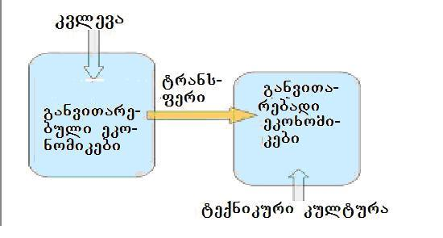
nax. 28
amiT, dabalSemosavlian qveynebs SesaZlebloba eZlevaT sxvebis industriuli miRwevebis aTvisebiT, miaRwion samrewvelo teqnologiebis TandaTanobiT Canacvlebas da gaumjobesebas, rogorc mikro, aseve makro doneebze [16]. teqnikuri kulturis da ganaTlebis roli am procesSi gansakuTrebiT mniSvnelovania, radgan igi gansazRvravs mgrZnobelobas axali teqnologiebis mimarT da teqnologiis difuziis meqanizmis qmediTobas. amasTanave, qmnis globalur codnasTan mierTebis, teqnologiur aliansebSi, saerTo kvlevebsa, sainformacio-sakomunikacio da sxva saxis qselebSi monawileobis SesaZleblobas.
samrewvelo firmebi sakuTari teqnologiuri mwarmoeblurobis “akrefas” operaciuli da saxelobo kvalifikaciis SeZenidan iwyeben. Semdeg stadiaze ukve nawarmis damoukidebel daproeqtebas da inJinrul damuSavebas euflebian. axali teqnologiebis SeqmnisTvis aucilebeli kvleva da ganviTareba maTSi bevrad ufro gvian iwyeba, maSin, rodesac dagrovdeba amisTvis aucilebeli inteleqtualuri da finansuri kapitali. Tvisebrivad msgavsi TanamimdevrobiT viTardebian mTlianad ekonomikebic, rac naCvenebia 29-e naxazze.

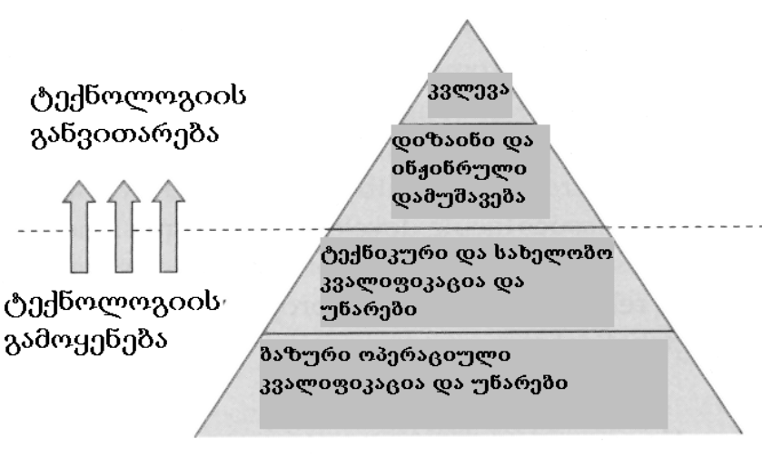
nax. 29

2.5 saxelmwifo inovaciuri politikis
mdgenelebi
inovaciaTa ganviTareba gansakuTrebiT nayofierad iq mimdinareobs, sadac amisTvis, saTanado saxelmwifo politikis meSveobiT, Seqmnilia Sesabamisi niadagi. arsebobs inovaciuri politikis sxvadasxva modelebi: tradiciuli, implicituri (nagulisxmebi), eqsplisituri (mkafiod formulirebuli). tradiciul modelSi inovaciebis aTviseba SedarebiT viwro amocanis gadawyvetas ukavSirdeba: mrewvelobis da kvlevis SekavSirebas sagangebo programebis meSveobiT. implicitur models iyeneben, magaliTad, amerikis SeerTebul StatebSi, sadac miswrafeba inovaciebisadmi yvela samTavrobo struqturis muSaobas Tan sdevs. amasTanave, igi ar aris “xilvadi” im TvalsazrisiT, rom ar ukavSirdeba saxelmwifos saTanado Carevaas mrewvelobis ganviTarebaSi. warmatebuli eqsplisituri modeli Seqmna fineTma: inovaciuri politika, am qveynis ganviTarebis strategiis safuZvlad aris aRebuli. igi saTanadod aerTianebs da mimarTavs saxelmwifo marTvis organoebis, profkavSirebis, sxva sazogadoebrivi instituciebis da biznesis Zalisxmevas.
saxelmwifo politika unda iTvaliswinebdes Sesabamisi samarTlebrivi regulaciebis ganviTarebas, Tavisufali konkurenciis pirobebis da inteleqtualuri sakuTrebis dacvas, standartebis Seqmnas da Sesrulebas, iuridiuli sistemis mudmiv srulyofas, biurokratiis Semcirebas da mewarmeTaTvis xelis SemSleli sxva garemoebebis moxsnas. igi xels unda uwyobdes mecnierebasa da mrewvelobas Soris kavSirebis ganmtkicebas, uzrunvelyofdes samewarmeo kompaniebs sawyisi da sarisko kapitalis wyaroebiT, adaptirebadi da maRali xarisxis nou-hauTi, monacemebiT bazrebis, teqnologiebis da daxmarebis SesaZleblobebis Taobaze, uqmnides maT saTanado materialur, informaciul da kulturul garemos.
inovatori mewarmeebisTvis teqnikuri, finansuri, komerciuli, iuridiuli da sxva msgavsi xasiaTis daxmarebis gawevisTvis, didi mniSvneloba aqvs qveyanaSi saWiro infrastruqturis Camoyalibebas – mcire biznesis inkubatorebs, teqnologiur parkebs, mudmivmoqmed sainformacio RonisZiebebs, romlebic eqspertul momsaxurebas da sxva saWiro resursebs miawvdis damwyeb firmebs. gansakuTrebiT mniSvnelovania finansuri daxmarebis sxvadasxva formebis arseboba, dawyebuli mikrodafinansebidan, venCuruli (sarisko) kapitalis firmebiT da fondebiT damTavrebuli. amasTan, gasaTvaliswinebelia inovaciis momwifebis kvelobaze, finansuri moTxovnilebebis cvlilebis xasiaTi. Tu simartivisTvis inovaciur process warmovidgenT, rogorc Semdgars Semdegi sami stadiisgan: ideis formulireba, axali produqciis warmoebis aTviseba da farTomasStabiani realizeba, maSin finansuri moTxovnilebebis etapuri cvlileba SeiZleba miaxloebiT gamoixatos proporciiT - 1:10:100.
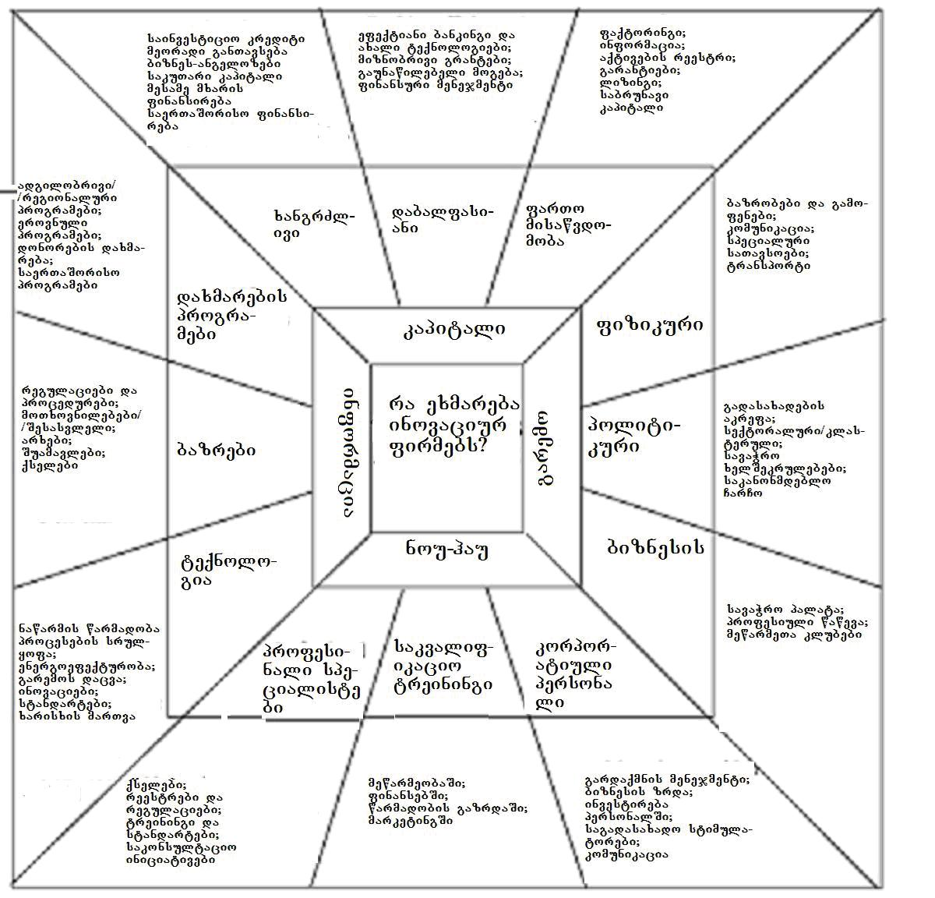
nax. 30
Yyvela zemoaRniSnulis uzrunvelmyofel saxelmwifo politikis elementebis da kerZo iniciativaTa sistema sqematurad warmodgenilia 30-e naxazze. daxmarebis gawevas igi Semdegi ZiriTadi mimarTulebebiT iTvaliswinebs: kapitali, garemo, nou-hau da informacia. TiToeuli mimarTuleba Sesabamis RonisZiebaTa sam-sam jgufad iyofa. yoveli jgufisTvis naCvenebia is ZiriTadi Sedegebi, romlebic Tan sdevs saTanado RonisZiebebis realizebas.
kapitaliT daxmarebis saWiroeba ganpirobebulia imiT, rom damwyeb samrewvelo firmebs, gansakuTrebiT ganviTarebadi qveynebis lokalur TemebSi, rogorc wesi ar gaaCniaT nawarmis daproeqtebis, gamocdis da warmoebis mosawyobad saWiro finansuri resursebi. garemoTi daxmareba gulisxmobs zemoxsenebuli infrastruqturis (inkubatorebi, teqnoparkebi, sakonsultacio centrebi da a.S.) elementebis an qselis Seqmnas. maTi meSveobiT damwyeb mewarmeebs ofisebiT da saofise momsaxurebiT uzrunvelyofen, uqmnian gamocdilebis gaziarebis da erToblivi moqmedebebis SesaZleblobebs.
aseTi qselis pirveli magaliTi iyo aSS-s soflis meurneobis saministros mier 1914 wels Seqmnili danergvis kooperatiuli samsaxuri (Cooperative Extension Service of the Department of Agriculture, U.S.), romelic Tavdapirvelad fermerebs exmareboda uaxlesi agroteqnologiebis aTvisebaSi. dRes mas danergvis samsaxuri ewodeba da misi funqciaa mewarmeebisTvis daxmarebis gaweva saqmianobis axali meTodebis da axali nawarmis aTvisebaSi, teqnikis da teqnologiis danergvaSi.
nou-hauTi daxmareba iTvaliswinebs gamocdili eqspertebis konsultaciebis miRebas, maT aqtiur monawileobas axali nawarmis daproeqtebasa da gamocdaSi, misi sabazro potencialis kvlevaSi, damwyebi firmebis personalis treiningSi, daxmarebas prezentaciebis Catarebasa da sacdeli (piloturi) proeqtebis realizebaSi da a.S.
informaciulma daxmarebam unda gaarkvios mewarmeebi specialuri programebis SesaZleblobebSi, maTTvis xelmisawvdomi gaxados Sesabamisi monacemebi, magaliTad sabazro moTxovnilebebis da axali teqnologiebis Sesaxeb. specialuri programebis daniSnulebaa saTanado RonisZiebebis gatareba, raTa adgilobrivma mewarmeebma maqsimaluri efeqtianobiT gamoiyenon lokalurad arsebuli resursebi da globaluri bazrebis SesaZleblobebi. maT Soris, erT-erTi mTavaria ucxouri kreditebis miRebaSi xelSewyoba im firmebisa da calkeuli pirebisTvis, romelTac rig mizezTa gamo, ar SeuZliaT maTi Cveulebrivi gziT miReba adgilobrivi sabanko sistemisgan.
informaciuli daxmarebis mniSvnelovani nawili iseTi moqmedebebis ganviTarebas ukavSirdeba, romelTa mizania metrologiuri momsaxurebis Seqmna, standartebis damuSaveba, maTi dacvis da samrewvelo produqciis xarisxis kontroli. Sesabamisi saqmianobis uzrunvelmyofeli struqturebi yvela qveyanaSi sasicocxlo sazogadoebriv aqtivadaa miCneuli. aRniSnuli gansakuTrebiT samarTliania teqnikur standartebTan da normebTan mimarTebaSi, romelTa SemmuSavebeli da makontrolebeli organizaciebi ar unda warmoadgendnen kerZo samarTlis iuridiul pirebs.
saxelmwifo politika gamokveTil yuradRebas unda uTmobdes im faqts, rom inovaciebi stimulirebas uwevs axal kvlevebs, xels uwyobs maTi warmoebisTvis saWiro resursebis generirebas. kvleva ganviTarebis procesis nawilia da am TvalsazrisiT samecniero-kvleviTi saqmianobis mimdinareoba qveynis winsvlis maniSnebeli kriteriumi xdeba. originaluri codnis warmoqmna kvleviTi procesebis Sedegad, maTi maRali xarisxis maCvenebelia. amitom inovaciuri procesebis mimdinareobisTvis xelSemwyob umaRles Sres e.w. “rbili infrastruqtura” Seadgens - kvleviTi organizaciebi, saswavlo dawesebulebebi, samecniero Sedegebis komercializaciis centrebi da a.S. efeqtiani inovaciuri politikis gatarebis Sedegad, aqcenti maT saqmianobaSi bazuri (fundamenturi) kvlevebidan unda gadavides gamoyenebiT sakiTxebze, romelTa Tematika unda Seesabamebodes adgilobriv moTxovnilebebs da SesaZleblobebs.
ganviTarebadi qveynebis umravlesobisTvis damaxasiaTebelia mecnierebis distancireba adgilobrivi sazogadoebis moTxovnilebebisgan. am problemis daZlevis gza ukavSirdeba kvleviTi organizaciebis dafinansebaSi saTanado meqanizmebis gamoyenebas. industrializebuli qveynebis magaliTi aCvenebs, rom misasalmebelia mecnierebis fondirebis iseTi modelis gamoyeneba, rodesac misi bazuri dafinanseba - biujetis daaxloebiT 50-70 procenti garantirebuli resursebisgan momdinareobs, magaliTad saxelmwifosgan, xolo darCenili 30-50 procenti – sarisko resursebisgan sakontraqto bazaze, magaliTad kerZo biznesisgan.
Sesabamisi saxelmwifo politikis arsebobis aucileblobaze is faqtic migvaniSnebs, rom mecnierebis da teqnologiebis ganviTarebis potenciali sxvadasxva qveynebs Soris metad araTanabrad aris ganawilebuli. im jamuri saxsrebidan, romlebic kvlevasa da ganviTarebaze ixarjeba msoflioSi, ganviTarebadi qveynebis wilad mxolod 4 procenti modis. aseTive asimetrias vxedavT patentebis registrirebis statistikaSic: industrializebul qveynebs ekuTvnis sapatento uflebebis 97 procentamde [50].
amasTan, moyolebuli 1970-iani wlebidan dawyebuli, am qveynebSi mudmivad izrdeba kerZo biznesis wili kvlevis da ganviTarebis dafinansebaSi. magaliTad, fineTSi kvlevasa da ganviTarebaze bolo periodSi investirebuli saxsrebis naxevarze meti mxolod erTi kompaniisgan – Nokia-sgan momdinareobda. gasagebia, rom dafinansebis msgavsi wyaroebis gamoyeneba ganviTarebadi qveynebis samecniero potencialis ganviTarebisTvis, naklebad SesaZlebelia. amitom Sesabamisi daxmarebis gaweva saxelmwifos mxridan, aq gansakuTrebiT mniSvnelovani xdeba.

2.6. S-mrudi – teqnologiuri progresis
traeqtoria
teqnologiuri progresi SemTxveviTi movlenebis mimdevrobisgan rom Sedgebodes, romelSic SeuZlebelia gamoikveTos ganviTarebis saerTo mimarTuleba da tempi, momavlis prognozirebis nebismieri mcdeloba uazroba iqneboda. sabednierod, uamravi faqtis analizi gviCvenebs, rom teqnologiuri winsvla ar aris SemTxveviTi da izolirebuli procesi, igi misdevs garkveul regularul models, romelSic funqciuri maxasiaTeblebi, teqnikuri parametrebi an ekonomikuri efeqturobis maCvenebelebi drois cvlilebas ukavSirdeba.
ufro xSirad, aseTi kavSiri 31-naxazze warmodgenili e.w. S-mrudiT gamoixateba [46]. igi Seesabameba process, romelSic maxasiaTeblis dasawyisSi nel zrdas (ubani 1), TiTqmis eqsponenciuri aRmasvla cvlis (ubani 2). sabolood ki, procesis maxasiaTebeli garkveuli fizikuri SezRudvebiT ganpirobebul zeda zRvrisken miiswrafvis (punqtiri), romlis miRwevis Semdeg SeiZleba daiwyos neli dacema (ubani 3).
S-mrudis formidan gamomdinare, ori daskvnis gakeTeba SeiZleba:
- adamianebma, romlebic progress gamartivebulad, “wrfivad” warmoidgenen, SeiZleba jerovnad ver Seafason ganviTarebis potenciali, gansakuTrebiT eqsponentis Sua welSi;
- teqnologiis ganviTarebis fizikuri zRvris miRweva imas moaswavebs, rom misi gamoyenebisgan ukugeba uciloblad daiwyebs klebas.
unda aRiniSnos, rom teqnologiebis ganviTarebasTan mimarTebaSi, es mrudi mxolod miaxloebaa realur procesTan, romlis gamoyeneba grZelvadiani prognozebis Sedgenisas Tu aris SesaZlebeli. inovaciuri procesebis analizisas, uwyvetad da mdovred mimdinare ganviTarebis magaliTebs iSviaTad vxvdebiT. metic, Tuki inovaciuri procesis cvlilebas drois sakmaod xangrZlivi SualedebisTvis ganvixilavT, SevniSnavT masSi garkveul ciklurobas, romelic mis wyvetas da Semdeg axali, ufro maRali donidan gagrZelebas ukavSirdeba.

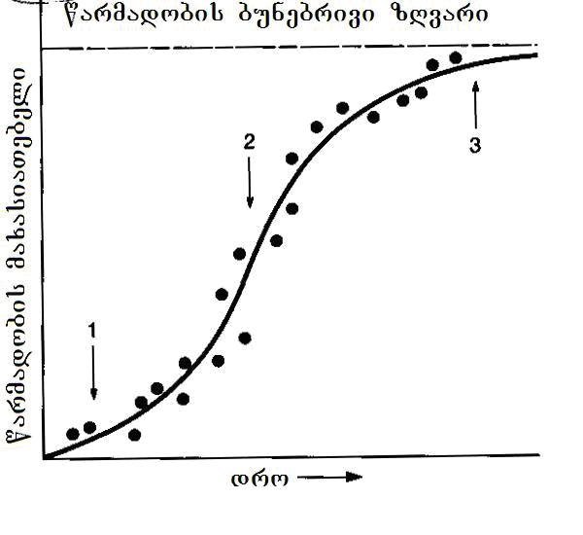
nax. 31
realobaSi, teqnologiis maxasiaTeblebis swrafi aRmasvlis Sesabamisi procesi ar mimdinareobs ise mdovred, rogorc idealizebuli mrudidan Cans. igi xSirad yovndeba, vinaidan aucilebeli xdeba im mravalricxovan kiTxvebze pasuxebis moZieba, romlebic axali produqtis an teqnologiis ganviTarebisas Cndeba. garda amisa, ZiriTadma procesma SeiZleba im adre ararealizebadad miCneul ideebTan dabrunebis saWiroeba gamoiwvios, romlebsac axalma gamocdilebam praqtikuli mniSvneloba SesZina.
rodesac teqnologia simwifis stadias aRwevs, imave Sinaarsis kiTxvebi da problemebi ibadeba, romlebmac biZgi misca mis ganviTarebas sawyis, koncefciis SemuSavebis etapze. maTi gamoCena axali SesaZleblobebis moZiebas uwyobs xels da Tuki “Zveli” S-mrudis pikze miRweul Sedegebs teqnologiis realizebis done gansazRvravs da ara bunebis kanonebiT dadebuli SezRudvebi, iwyeba axali ciklis Sesabamisi aRmasvla. aRniSnuli SeiZleba mravaljer ganmeordes (nax. 32).
teqnologiis srulyofis fizikuri zRvris miRweva, dRis wesrigidan ar xsnis ganviTarebis prognozirebis saWiroebas, vinaidan am droisTvis, rogorc wesi, horizontze axali teqnologia Cndeba. mas ganviTarebis sxva, ufro maRali fizikuri zRvari da mwarmoeblurobis meti potenciali aqvs. es ukve gansxvavebul principul sawyisebze moqmedi e.w. “gamrRvevi teqnologiaa”, romelic arsebulze gacilebiT met efeqtianobas gvpirdeba xarisxis an komerciuli ukugebis TvalsazrisiT da amiT safuZvels aclis manamde gabatonebuli teqnologiis evoluciur ganviTarebas.
rogorc wesi, wyvetis momentisTvis gamrRvevi teqnologiis upiratesoba ukve mkafiod fiqsirdeba bazris axal mcire segmentze, romelic jerjerobiT gavrcelebuli teqnologiis ZiriTadi bazris siaxloves imyofeba. amis Semdeg siaxle cdilobs gacilebiT ufro did bazarze gadanacvlebas da “dawevas” iq gabatonebuli teqnologiisa da produqtisTvis. saboloo jamSi, igi gamodevnis Zvel teqnologias misi gamoyenebis yvela mimarTulebidan, pirvel rigSi ki iqidan, sadac arsebulze ufro maRali mwarmoeblobaa saWiro. am garemoebiT gaCenil S-mrudebis ojaxs (nax. 31) saerTo momvlebi aqvs (punqtiri naxazze), romelic aseve S-mrudis formisaa.
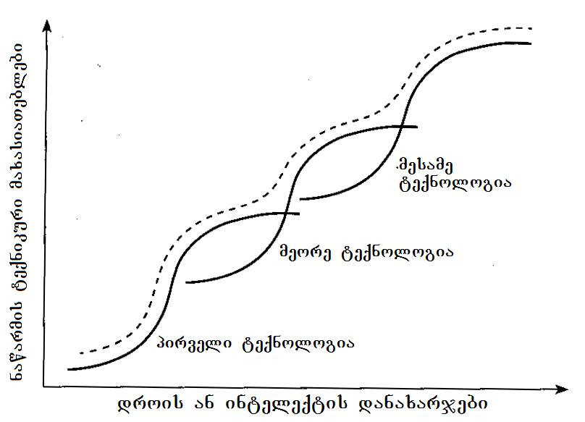
nax. 32
airesma (Ayres) gaaanaliza ra Tburi manqanebis evolucia, dawyebuli seiveridan (1698 w.) da niukomenidan (1712 w.), damTavrebuli Cveni drois maRali wnevis turbinebiT, gamoyo gansxvavebuli teqnologiuri midgomis gamoyenebis Svidi periodi da aCvena, rom TiToeulis cvlileba drosTan mimarTebaSi erTsa da imave kanonzomierebas emorCileboda [47]. magaliTad, korniSis manqanis margi qmedebis koeficienti 1820-1850-ian wlebSi gaizrda 5 procentidan 15 procentamde. Semdeg 1890-iani wlebis dadgomamde, progresi TiTqmis sul SeCerda e.w. samsafexurovani gafarToebis orTqlis manqanis∗ gamoCenamde, romlis margi qmedebis koeficienti (mqk) 1910 wlisTvis 22 procentamde gaizrda.
am droisTvis ukve gamoCnda parsonsis turbina, romelmac uzrunvelyo Tburi manqanebis efeqtianobis Semdgomi mkveTri zrda. mTlianobaSi, 270 weliwadis ganmavlobaSi Tburi manqanebis efeqtianoba nulTan metad axlo myof mniSvnelobidan 50 procentamde gaizarda. cvlilebebis Svidive mrudis saerTo momvlebs S-mrudis forma hqonda. Semdeg airesma aCvena, rom kompiuterebis mwarmoeblurobis zrdaze msgavsi zegavlena iqonia oTxi teqnologiis: eleqtrovakuumuri milakebis, tranzistorebis, maTi hibridebisa da integraluri sqemebis Tanamimdevrulma ganviTarebam. ZiriTadi gansxvaveba is iyo, rom axla movlenebi gacilebiT nakleb periodSi – 30 weliwadSi ganviTarda.

2.7. investirebis pirobebis zegavlena
S-mrudze
tempi, romliTac viTardeba teqnologia, damokidebulia imazec, Tu rogor mimdinareobs investireba mis progresirebaSi. amis gamo, erTsa da imave teqnologiis ganviTarebas realur praqtikaSi ramdenime S-mrudi SeiZleba Seesabamebodes, romelTac sxvadasxva daxriloba eqnebaT (nax. 33). Tu teqnologiis mwarmoeblurobis gazrdis stimuli dabalia, mrudi iqneba OB-s Sesabamisi. M OC₂ mrudi swraf progresirebas Seesabameba, rodesac bazris maRali moTxovnebi xels uwyobs mniSvnelovani saxsrebis dabandebas Sesabamis kvlevasa da ganviTarebaSi.
investirebis pirobebis SecvliT, SesaZlebelia mrudis formis regulireba. magaliTad, Tu teqnologiam A₁ wertilTan (mrudi OA₂) miRwevis Semdeg, sakuTar Tavze didi moTxovnileba aRZra, misi Semdgomi ganviTareba SeiZleba warimarTos A₁C₁C₂ gziT. amasTan, gadasvlis daxriloba damokidebulia xelmisawvdomi finansuri resursebis raodenobasa da tempze, romliTac xdeba maTi dabandeba teqnologiis srulyofisTvis.

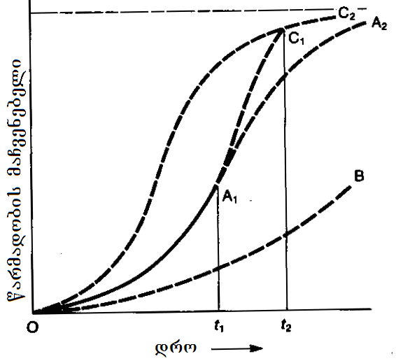
nax. 33
teqnologiis miaxloeba sakuTari ganviTarebis bunebriv fizikur zRvarTan menejerisTvis imis maniSnebelia, rom mosalodnelia misi alternativis gamoCena. magram swori reagireba am faqtze yovelTvis ar aris martivi da calsaxa. Camnacvlebeli axali teqnologia dasawyisSi nela viTardeba. amis mizezi is aris, rom misi SesaZleblobebi praqtikulad yovelTvis naklebia gabatonebuli, kargad aTvisebuli teqnologiis SesaZleblobebze. Mmagram, rogorc ki orive teqnologiis mwarmoebluroba gaTanabrdeba, siaxlis meti potenciali investirebis saswors Tavis sasargeblod gadawonis. aRniSnuli gansakuTrebiT SesamCnevi xdeba maSin, rodesac axali teqnologia Tavisi eqsponencialuri zrdis zRurbls gadaabijebs.
TiTqos logikuria, rom kvleviTi Zalisxmeva, mimarTuli arsebuli teqnologiis SesaZleblobebis zeda zRvris miRwevaze, aseT viTarebaSi unda mcirdebodes. ufro xSirad ki adgili aqvs sapirispiro reaqcias da kapitalis zrdadi raodenobiT investirebas, arsebuli teqnologiuri sistemebis “reanimirebaSi”.
aseTi TavdacviTi reagirebis mizanSewoniloba mocemulia 34-e naxazze, sadac arsebul teqnologias 1 emuqreba saSiSroeba progresirebadi teqnologiis 2 mxridan. orives ganviTarebis trendebis eqstrapolireba gvaZlevs maTi mrudebis gadakveTas t₂ wertilSi. bunebrivi zRvris miRwevis daCqarebisTvis, SesaZlebelia teqnologiis 1 ganviTarebaSi investirebis mkveTri gazrda. maSin misi srulyofis mrudi gadainacvlebs X ganStoebaze, rac gamoiwvevs gadakveTis Seyovnebas t₃ momentis dadgomamde. grZelvadian perspeqtivaSi Seyovnebis periodi (t₂-t₃) umniSvneloa, magram teqnologia 1-is ganviTarebaSi mainvestirebeli biznesis mokle an saSualovadiani strategiisTvis, SeiZleba gadamwyveti mniSvneloba miiRos, vinaidan mas miscems ZalTa gadanawilebisTvis saWiro dros.
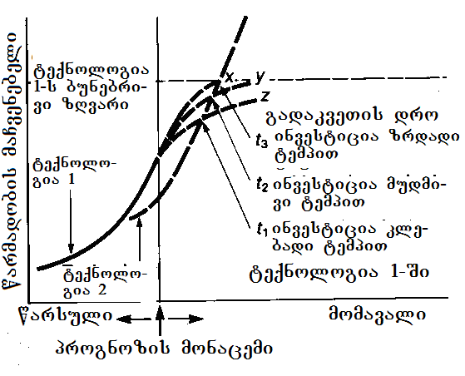
nax. 34
aRniSulis kargi magaliTia eleqtroenergiis magenerirebel sadgu-rebSi Cveulebrivi sawvavis atomuriT Canacvlebis istoria. prognozi, romlis mixedviTac am ori sistemis ekonomikuri maCvenebelebi 20 weliwadSi unda gaTanabrebuliyo, sabolood zedmetad optimisturi aRmoCnda. realurad ki moxda Cveulebriv sawvavze momuSave eleqtrosadgurebis mwarmoeblurobis araprognozirebuli zrda, romelic stimulirebuli iyo SeyovnebiT birTvuli energetikis ganviTarebaSi, am ukanasknelisTvis damaxasiaTebeli ekologiuri safrTxeebis gamo.

2.8. teqnologiis sasicocxlo cikli
teqnologiis ganviTarebis analizisas gasaTvaliswinebelia, rom igi ara marto produqciis warmoebis SesaZleblobas qmnis, aramed Tavadac warmoadgens mniSvnelovan sabazro Rirebulebas. amitomKkompania, romelsac surs sakuTari teqnologiis SesaZleblobebis sruli realizeba, didi yuradRebiT unda aanalizebdes misi komerciuli potencialis cvlilebas teqnologiis sasicocxlo ciklis (tsc) yvela stadiaze.
35-e naxazze mocemulia tsc-s cvlilebis tipur suraTi, romelic srulad Seesabameba zemoaRweril (nax. 31) S-magvar mruds. [51]-s avtorebis mixedviT, teqnologiis cvlilebis aseTi suraTi mudmivad meordeboda maT mier iseTi gansxvavebuli industriuli dargebis ganviTarebis Seswavlisas, rogoricaa: eleqtronuli komponentebis warmoeba, samomxmareblo eleqtronika, manqanaTmSenebloba, fexsacmlis warmoeba, mSenebloba, samTamadno aRWurvilobis warmoeba da haeris kondicireba.
35-e naxazze moyvanilia teqnologiis evoluciis Tvisebrivi suraTi im zegavlenis miniSnebiT, romelsac teqnologiis ganviTareba samrewvelo kompaniis politikaze axdens. bunebrivia, rom tsc-s TiToeul stadiaze igi icvleba, zogjer raodenobrivad, zogjer ki Tvisebrivadac. gavecnoT am stadiebs ufro detalurad.

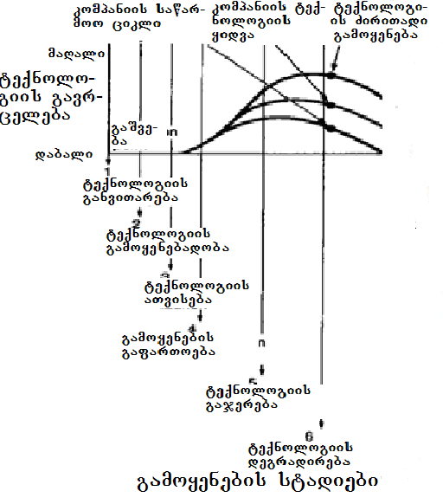

nax. 35
teqnologiis ganviTareba iwyeba maSinve, rogorc ki kvlevebis Sedegebi potenciurad Rirebuli teqnologiis gamoCenas gvamcnobs anu manam, sanam daiwyeboda sakuTriv warmoeba. am stadiis dasawyisSi kompaniam unda gadawyvitos, Tu ramdenad uRirs mas axali teqnologiis ganviTareba. rog-orc wesi, teqnologiis ganviTarebas xels kideben Tuki:
- teqnologias aqvs advilad identificirebad bazarze gamoyenebis mkafio potenciali, romelic winaaRmdegobaSi ar modis kompaniis ZiriTad strategiasTan;
- kompania flobs an SeuZlia moipovos teqnologiis ganviTarebisTvis sakmarisi resursebi, xolo Tavad teqnologia Tavsebadia kompaniis sawarmoo da sabazro praqtikasTan;
- mocemuli teqnologiuri siaxlis ganviTarebidan mosalodnel ukugebas upiratesoba aqvs investirebis sxva alternativebTan SedarebiT.
samwuxarod, viTareba yovelTvis ar iZleva am kiTxvebze mkafio pasuxebis miRebis SesaZleblobas. teqnologias potenciali SeiZleba hqondes erTdroulad ramdenime mimarTulebiT, romelTagan umetesoba arc iyos cnobili misi gamoyenebis dasawyisSi. magaliTad, farmacevtul industriaSi hormonebis msgavsi kompleqsuri qimiuri SenaerTebis – prostaglandinebis miRebisTvis gankuTvnili teqnologiebi, SemdgomSi warmatebiT iqna gamoyenebuli soflis meurneobasa da bioteqnologiaSi [46].
dasawyisSi rTulia imis Tqma, Tu teqnologiis gamoyenebis romeli mimarTuleba gaxdeba wamyvani an romeli aRmoCndeba yvelaze mosaxerxebeli misi realizebisTvis. maSinac ki, rodesac siaxlis potenciali naTlad aris gamovlenili, misi gamoyeneba SeiZleba arc Seesabamebodes kompaniis saerTo strategias an mis gankargvaSi arsebul resursebs.
msgavsi saxis gaurkvevloba kompaniebis winaSe sakmaod rTul kiTxvebs ayenebs, rogoricaa:
- xom ar moiZios partniori, visTan erTadac ganagrZobs teqnologiis ganviTarebas, rac gansakuTrebiT mniSvnelovania maSin, rodesac saWiroa damatebiTi finansuri an sxva saxis resursebis mozidva?
- xom ar scados mis xelT arsebuli teqnologiuri “Canasaxis” gayidva, Tu perspeqtiva ara aqvs ukve arsebul bazarze mis swraf gatanas, an samewarmeo strategiaSi dauyovnebliv gamoyenebas?
Mmagram, rodesac kompania gadawyvets teqnologiis gayidvas misi ganviTarebis adreul stadiebze, igi SeiZleba garkveul problemebs waawydes, Tuki misi gamoyenebis samomavlo perspeqtivebi an sabazro kondiciamde miyvanis xarjebi ar aris mkafiod dadgenili. kompaniebi xSirad ver acnobiereben saTanadod im faqts, rom maT teqnologias SeiZleba principSi hqondes sabazro potenciali, mxolod ara misi amJamindeli mdgomareobiT. Tuki momavalSi igi kidev daixveweba da miT umetes, Tuki produqciaSi “aisaxeba”, misi SeZena sxva kompaniebisTvisac gaxdeba mimzidveli. zogjer axali teqnologiebis ganviTarebaze Tavidanve uars amboben, vinaidan ar Seesabameba kompaniis samewarmeo strategias da es miuxedavad imisa, rom Semdomma srulyofam SeiZleba mniSvnelovani komerciuli potenciali SesZinos maT.
msgavsi Secdomebis mizezi xSirad is garemoebaa, rom adamianebi, romelTac uwevT teqnologiis momavalze adreuli gadawyvetilebebis miReba, rogorc wesi sakmarisad ar icnoben saTanado (teqnologiaTa) bazris moTxovnilebebs. teqnologiis momavalze isini mxolod misi meSveobiT axali produqciis warmoebis SesaZleblobidan gamomdinare msjeloben da ara misi, rogorc sabazro produqtis potencialis mixedviT. miT umetes, rom axali teqnologiis myidvelebi SeiZleba misi Semqmneli kompaniis konkurentebi aRmoCndnen da teqnologiis momavalze gadawyvetilebebis mimReb TanamSromlebs uWirT am kompaniebis potenciur momxmareblebad aRqma.
rogorc ki kompania miiRebs gadawyvetilebas gamoiyenos axali, an modernizebuli teqnologia arsebuli, an gaumjobesebuli produqtis sawarmoeblad, igi mniSvnelovani danaxarjebis gawevis aucileblobis winaSe dgeba. amitom , daiwyos mocemuli teqnologiis daxvewa, Tu gayidos igi, es sakiTxi kompaniaSi mosalodneli danaxarjebis odenobasTan mimarTebaSi ganixileba. gasaTvaliswinebelia isic, rom kompaniaTa aqcionerebi iSviaTad Tanxmdebian iseTi teqnologiebis srulyofis mxardaWeras, romelTa ganviTareba Zviri, xangrZlivi da maRalriskiani saqmea.
Kaxali teqnologiiT axali produqtis warmoebis momzadebis procesSi, kompania SeiZleba sxva mimarTulebebiTac mniSvnelovani xarjebis gawevis aucileblobis winaSe aRmoCndes. magaliTad, aseTi mdgomareoba iqmneba maSin, rodesac saWiroa Tanmxlebi teqnologiuri procesis an specifiuri makompleqtebeli detalebis da kvanZebis damoukidebeli warmoebis aTviseba, an sxva mewarmeTaTvis dakveTa. amisTvis kompanias SeiZleba dasWirdes saTanado licenziis SeZena, an misi daufleba sxva, ufro maRalriskiani gzebiT.
tsc-s ganviTarebis am stadiaze dauSvebelia teqnologiis daxvewis gagrZelebaze gadawyvetilebis miReba mxolod misi meSveobiT warmoebuli produqciis savaraudo sabazro potencialis mixedviT. samewarmeo ukugeba teqnologiidan ganxilul unda iqnes mTlianobaSi, masze licenziis gayidvidan da “sagasaRebo” fizikur mdgomareobaSi misi gadacemidan mosalodneli Semosavlebis gaTvaliswinebiTac.
Sesabamisi gadawyvetilebebis miReba martivdeba, Tuki teqnologiam ukve ganvlo gza ideis formulirebidan sakuTari praqtikuli SesaZleblobebis demonstrirebis fazamde. licenziac myidvelisTvis ufro mimzidveli maSin xdeba, rodesac teqnologia da misi meSveobiT damzadebuli produqciis prototipi, winasawarmoo mdgomareobamdea miyvanili. qvemoT moyvanili magaliTi aCvenebs problemebs, romlebic msgavsi gadawyvetilebebis miRebisas Cndeba.

Dolby Laboratories
rei dolbim (Ray Dolby) Tavdapirvelad Tavisi kompania Dolby Laboratories daaarsa, rogorc kvleviTi laboratoria, romelic eleqtronuli mrewvelobis profesionalebs, magnitur firze xmis Caweris Tanmxlebi xmauris donis SemcirebisTvis gankuTvnil mis mierve Seqmnil teqnologias miawodebda. igi moeloda Tavisi Canafiqris warmatebul realizebas, vinaidan sargeblobda maRali reputaciiT xmis Caweris specialistebs Soris. daiwyo ra 25000 dolaris sawyisi investiciiT (sakuTari danazogi plus megobrebis saxsrebi), man Zalian swrafad aRmoaCina, rom kompaniis gadarCenisTvis aucilebeli iyo Semosavlebis iseTi odenobis uzrunvelyofa, romlis miRwevac mxolod mza nawarmis da ara marto teqnologiis (licenziis saxiT) gayidviT iyo SesaZlebeli. amitom, rei dolbim gadawyvita moewyo xmauris CamxSobi eleqtronuli modulebis sakuTari warmoeba da gayidva, romlebic gamoyenebuli iqneboda xmis Camwer profesiul aparaturasTan erTad.
erTi mxriv, vinaidan profesiuli eleqtronikis Sesabamisi bazris moculoba mcire iyo, masze licenziebis gayidvas ar SeeZlo moetana sawyisi investiciis dasabruneblad saWiro Semosavali dolbis kompaniisTvis. Magram, meore mxriv, swored bazris simcire aZlevs sazogadod Dolby Laboratories-s msgavs mcire kompaniebs Sanss, warmatebiT aawyon biznesi sakuTari teqnologiis gamoyenebis safuZvelze, didi kapitaldabandebebis Cadebis da msxvili konkurentebis mxridan zewolis gareSe. misi teqnologiis mierMam bazarze mopovebulma maRalma reputaciam, dolbis SesaZlebloba misca momdevno etapze warmatebiT gaetana igi ukve ara profesiuli, aramed saerTo-samomxmareblo xmis Camweri mowyobilobebis masobriv bazarze.
amasTanave, man Secvala sakuTari sabazro strategia. profesiuli gamoyenebisTvis gankuTvnil, xmauris CamxSob sakuTar teqnologias, igi mxolod mza mowyobilobebis (dolbis modulebis) saxiT yidda da xmis Camweri aparaturis mwarmoeblebs uflebas ar aZlevda “CaeSenebinaT” es teqnologia maT produqtebSi. bazari xom imdenad mcire iyo, rom sxvanairad moqcevis SemTxvevaSi (licenziis gayidva da a.S.), igi sakuTar poziciebze mniSvnelovan konkurentul zewolas warmoqmnida.
Magram, rodesac dolbim scada igive strategia gamoeyenebina kaseturi samomxmareblo firCamwerebis TiTqmis ukidegano masobriv bazarze, man dauyovnebliv miiRo umwvavesi uaryofiTi Sedegi sakuTari teqnologiis arasanqcirebuli kopirebis saxiT. amitom rei dolbim gadawyvita SeeTavazebina am bazarze moqmedi yvela mwarmoeblisTvis Sesabamisi licenziis SeZena, aucilebeli moTxovniT, rom maTi produqciis yovel erTeulze ganTavsebuli yofiliyo misi saxeli da logo. garda amisa, licenziis myidvelebs, yovelgvari damatebiTi gadaxdis gareSe, SeeZloT sakuTari axali nawarmis eqspertizisTvis wardgena Dolby Laboratories-Si, raTa misi detaluri ganxilvis Semdeg, mieRoT rCevebi, Tu rogor daexvewaT maT firCamwerSi gamoyenebuli xmauris CaxSobis sqema.
inovaciebis ganviTarebis perspeqtiva da sabazro realizacia, mniSvnelovnad aris damokidebuli imaze, Tu sakuTari sasicocxlo ciklis (Casaxva, zrda da mowifuloba) romel stadiaze imyofeba igi. Teoriulad, rac ufro swrafad xdeba inovaciuri procesis ganxorcieleba, miT ufro didia imis albaToba, rom siaxle warmatebas moitans. zogjer inovaciuri produqtis Seqmnas mravali weli sWirdeba. am periodSi siaxle SesaZloa moZveldes, gamoCndes axali inovaciebi da mas fasi daekargos. rac ufro “axalgazrdaa” is faza, romelSic siaxle imyofeba, miT ufro didi perspeqtivebi gaaCnia mas bazarze.
is inovaciebi, romlebic mowifulobis stadiaSia, SesaZloa gamoyenebul iqnes Siga bazris dasakmayofileblad deficituri saqonliT. amis magaliTia inovaciebi sayofacxovrebo teqnikis warmoebis sferoSi, romlebic xSirad samxedro-sawarmoo kompleqsis teqnologiuri miRwevebis konversiis Sedegs warmoadgens. Tu warmatebuli inovacia zrdis fazaSi imyofeba, mas garantirebuli aqvs “Siga” moTxovna, aseve realuria misi msoflio bazarze gasvla. arsebul viTarebaSi aseTi ram SesaZlebelia, magaliTad, saavtomobilo warmoebasa da mikroelqtronikaSi. im SemTxvevaSi, Tu inovacia Casaxvis stadiaSia, mosalodnelia misi garRveva msoflio samecniero-teqnikur sferoSi, romlis magaliTia kosmosuri industria.

2.9. teqnologiis ganviTarebis sawyisi
etapebi
am stadiaze arsebiTad iwyeba axali teqnologiis mwarmoeblurobis maqsimizeba. mTeli am periodis manZilze, kompania cdilobs sakuTari teqnologiis daxvewas, misi meSveobiT warmoebuli produqciis modificirebas da sxva sferoebSi gamoyenebis gafarToebas. am stadiaze gansakuTrebiT mniSvnelovani xdeba gadawyvetilebebis miReba momxmareblebis TanamonawileobiT, raTa teqnologiis momdevno ganviTarebisTvis saWiro danaxarjebis sididem ar daafrTxos kompania da ar ubiZgos mas cdunebisken licenzirebis meSveobiT mTlianad Tu ara, nawilobriv mainc, daibrunos teqnologiis srulyofaSi investirebuli saxsrebi.
licenziis naCqareb da moufiqrebel gayidvas didi zianis miyeneba SeuZlia axali teqnologiis mflobeli kompaniisTvis. magaliTad, misi reputacia SeiZleba Seiryes, Tuki teqnologiis SemZenebs ar aRmoaCndebaT misi saTanadod gamoyenebis unari da sakuTar warumateblobas axali teqnologiis dauxvewaobiT axsnian.
SedarebiT “nedli” teqnologiis gayidvis mcdeloba SeiZleba warumatebeli aRmoCndes, Tuki myidvels didi dro dasWirdeba misi samuSao kondiciamde dayvanisTvis. ganviTarebis mesame stadiaze myofi teqnologiis gavrcelebas zogjer mTavrobis saTanado politikac uSlis xels. magaliTad, teqnologiaTa transferis akrZalviT 1978 wlis aqtiT (The Technology Transfer Ban Act), aSS-ma didi xniT veto daado e.w. komunisturi qveynebisTvis iseTi axali teqnologiebis an produqtebis gadacemas, romelTac TavdacviT an kriminalur viTarebaze zegavlenis potenciali hqondaT.
teqnologiis “garedan” SeZenis SesaZleblobis ganxilvas, SeiZleba mwvave reaqcia mohyves maTi mxridan, vinc kompaniaTa SigniT pasuxismgebelni arian teqnologiaTa ganviTarebaze. sxvisgan teqnologiis SeZena, maT SeiZleba sakuTari warumateblobis niSnad aRiqvan da erTis mxriv dablokon saTanado gadawyvetilebis realizeba, meore mxriv ki, gazardon zewola xelmZRvanelobaze, raTa moxdes sakuTari teqnologiis Seqmnis intensificireba. sainteresoa, rom “ucxo teqnologiis armiRebis” aseTi sindromi, sxvadasxva qveynebSi gansxvavebulad vlindeba. magaliTad, iaponur kompaniebSi licenziis gayidvebiT Semosuli Tanxebis fardoba maT SeZenaze warmoebul danaxarjebTan, saSualod 1:8–is tolia. germaniaSi es maCvenebeli 1-dan 2,5-mde meryeobs, did britaneTSi igi daaxloebiT 1:1, xolo aSS-Si - 10:1-is farglebSia [46].
kidev erTi faqtori, romelic xSirad win eRobeba ganviTarebis am stadiaze myofi teqnologiis gayidvas, aris Seusabamoba im gzebTan, romelTa meSveobiT kompania-myidveli sakuTar saqmianobas eweva. man SeiZleba ar isurvos saTanado cvlilebebze wasvla manam, sanam teqnologia gamosadegi ar gaxdeba produqciis ufro farTo speqtris warmoebisTvis an vidre misi sakuTari teqnologia sruliad gamouyenebadi ar gaxdeba.
Tavis mxriv, teqnologiis “patronma” kompaniam SeiZleba TviTonac Tavi Seikavos misi gayidvisgan, imis molodinSi, rom teqnologiaze moTxovnilebis zrdis kvalobaze, gaizrdeba misi sabazro fasic. es xdeba maSinac, rodesac igi grZnobs, rom advilad SeZlebs teqnologiis ganviTarebaze gaweuli xarjebis mogebiT dabrunebas, Tuki SeinarCunebs monopolur mdgomareobas misi meSveobiT warmoebuli produqciis bazarze.
am stadiaze gadasvlamde, teqnologiis ganviTarebaze gaweuli da kidev gasawevi xarjebi, misi meSveobiT miRebul Semosavlebze bevrad naklebi rCeba. meoTxe stadiaze iwyeba Semosavlebis maqsimizeba; axali teqnologiis mflobeli kompania sul ufro met amonagebs iRebs misi gamoyenebiT, rac warmoebuli produqciis gayidvebis moculobis zrdas ukavSirdeba. Cndeba moTxovnileba teqnologiis SeZenazec, magram gamarjvebulis ganwyoba, romelic xSirad Tan sdevs axali teqnologiis warmatebas, ubiZgebs kompanias Tavi Seikavos teqnologiis gayidvisgan.
aseT pirobebSi, dro aris ZiriTadi kritikuli faqtori, romelic zegavlenas axdens am stadiaze miRebuli gadawyvetilebebis Sinaarssa da sisworeze. Sesabamisad, did mniSvnelobas iZens teqnologiis gayidvis momentis swori SerCeva: Seyovneba gayidvaSi SeiZleba gaiwelos teqnologiis fasis dacemamde. es garemoeba ubiZgebs teqnologiaze uflebebis mqone kompanias, misi pikuri Rirebulebis drouli gamoyenebisken.
momxmarebelTa moTxovnilebis zrdas mocemul nawarmze, rogorc wesi, Tan sdevs konkurentebis interesis gaCena misi damzadebis teqnologiis mimarT. amasTan mosalodnelia, rom maTi umravlesoba ecdeba Tavidan aicilos is maRali danaxarjebi, romelTa gawevac mouwevs imave teqnologiis sakuTari variantebis damoukideblad damuSavebis SemTxvevaSi. amitom savaraudoa, rom axali teqnologiis sabazro fasi, misi ganviTarebis am stadiaze Tavis maqsimums miaRwevs. Sesabamisad, teqnologiis dammuSavebel kompanias uCndeba misi gayidvisken mimarTuli metad seriozuli mosazrebebi. amave dros, sakuTari nawarmis komerciuli warmateba, iseve rogorc diskomforti, romelsac misi konkurentebi teqnologiis uqonlobis gamo ganicdian, teqnologiis gayidvisgan TavSekavebisken ubiZgebs kompanias. magram teqnologiis gayidvis gadadebas SeiZleba mohyves misi sabazro fasis dacema, rogorc momxmarebelTa mxridan interesis Semcirebis gamo, aseve konkurentebis mier alternatiuli da SesaZlebelia ufro mwarmoebluri teqnologiis ganviTarebis kvalobaze.
amitom iTvleba, rom swori gadawyvetilebis miReba, sasicocxlo ciklis meoTxe stadiaze myofi teqnologiis gavrcelebasTan mimarTebaSi, samewarmeo praqtikaSi erT-erTi yvelaze Zneli gdawyvetilebaa. Secdomis gamoricxvis mizniT, kompaniebi xSirad iReben gadawyvetilebas daiwyon sakuTari teqnologiis gayidva ukve maSin, rodesac maTi produqciis realizacia jer kidev izrdeba, anu manam, sanam bazari gajerdeba saTanado nawarmiT. rasakvirvelia, aseT gadawyvetilebas win uswrebs saTanado garemoebebis analizi. esenia:
- bazris tevadoba. teqnologiaze licenziebis geografiuli principiT ganawilebam, SeiZleba mniSvnelovnad gaafarToos teqnologiis gamoyenebis areali da sagrZnoblad gazardos licenziati kompaniis Semosavlebi. Mmagram, amasTanave gasaTvaliswinebelia, rom kompanias, romelmac am teqnologiis meSveobiT arsebul bazarze moTxovnilebis mkveTri zrda gamoiwvia an Seqmna axali mniSvnelovani bazari, unda eyos sakuTari sawarmoo potenciali, mis mierve warmoqmnili samewarmeo SesaZleblobebis swrafi realizebisTvis.
- teqnologiuri lideroba. kompaniis mzadyofna - uwilados sxvebs sakuTari teqnologia, asustebs konkurentebis miswrafebas damoukideblad ganaviTaron misi analogebi, rac sazogadod mniSvnelovani danaxarjebis gawevas moiTxovs. amitom, teqnologiis “patrons”, Tu ki igi mzadaa momdevno kvlevasa da ganviTarebaSi damatebiTi investirebisTvis, uCndeba sakuTari teqnologiuri liderobis xangrZlivad SenarCunebis mniSvnelovani Sansi. rasakvirvelia, am midgomis gamoyenebis SesaZlebloba damokidebulia imaze, Tu ra Seadgens kompaniis Zlier mxares: axali ideebis damoukidebeli generirebis, Tu sxvaTa samecniero miRwevebis praqtikaSi implementaciis unari.
- standartizacia. tsc-s meoTxe etapze metad mniSvnelovani xdeba saxelmwifo da dargobrivi standartebis zegavlena teqnologiis momdevno bed-iRbalze. originaluri teqnologiis mflobeli metad mniSvnelovani upiratesobiT sargeblobs: bazarze sxvebze adre mis mier gatanili produqti, xSirad xdeba mocemuli tipis nawarmis standarti. magram es upiratesoba xanmokle aRmoCndeba, Tuki zogierTi konkurenti sakmaris sawarmoo SesaZlebloblebs flobs da SeuZlia imave standartis Sesabamisi sakuTari produqciiT bazarze gasvla.
saukeTeso strategia rasakvirvelia is aris, rom moiZebnos rogorc teqnologiis farTo gamoyenebis, aseve misi standartizaciis SesaZlebloba, rac sxva kompaniebs xels aaRebinebs Camnacvlebeli teqnologiebis damuSavebaze. licenziis aqtiuri gayidvis meSveobiT, teqnologiis mflobels SeuZlia miaRwios misi teqnologiis CarTvas sxva kompaniaTa sawarmoo procesebSi. vinaidan am kompaniaTa damxmare teqnologiebi SeiZleba masTan araTavsebadi aRmoCndes, amitom bazarze pirvelad gasul kompanias aqvs Sansi, rom gaxdes sruli sawarmoo ciklis mimwodebeli, rac misTvis metad momgebiani iqneba. magaliTad, Tavis droze holandiurma kompania Philips-ma miaRwia imas, rom portatiuli magnitofonebisTvis gankuTvnili mis mier Seqmnili konstruqciis kaseta, standartad gadaiqca saTanado bazarze. igi ar uSvebda TviTon im milionobiT kasetas, romlebic mTels msoflioSi moixmareboda, magram am produqciis praqtikulad yvela mwarmoebeli iyenebda mis teqnologias da amaSi saTanado gadasaxads – roialtis (royalty) uxdida Philips-s.

2.10. teqnologiis gajereba da
degradireba
rodesac teqnologia ganviTarebis am stadias miaRwevs, igi ukve srulad modificirebuli da daxvewilia rogorc misi Semqmneli kompaniis, aseve konkurentebis ZalisxmeviT. sakiTxi- gaiyidos, Tu ara am etapze myofi teqnologia, kargavs aqtualurobas. gayidvaze ufro arsebiTi xdeba teqnologiis “patronis” yuradRebis koncentrireba sakuTari sawarmoo danaxarjebis Semcirebaze. aRniSnulis aqtualuroba ganpirobebulia im faqtiT, rom teqnologiis stabilizebis pirobebSi misi erTdrouli gamoyeneba ramdenime konkurentis mier, gaaTanabrebs an SeiZleba daswevs kidevac misi meSveobiT warmoebuli produqtis sabazro fass. Tumca, am SemTxvevaSic SeiZleba moiZebnos bazris gafarToebis SesaZlebloba, mxolod es ukve moxerxdeba naklebad ganviTarebul qveynebSi, romlebsac sakuTari industriuli bazis modernizeba da misi importis amocanebisTvis morgeba surT.
teqnologiis transferi aseT, e.w. mesame msoflios qveynebSi, ZiriTadad “sagasaRebo” garigebebis meSveobiT xorcieldeba, rodesac momxmarebels srulad gamarTul sawarmoo obieqts, an teqnologiur kompleqss gadascemen. zogierTi ganviTarebadi qveyana ufro rTul urTierTobebsac amyarebs teqnologiis momwodeblebTan. magaliTad, alJiri cdilobs teqnologiis transferisTvis paralelurad sami gza gamoiyenos: mas pirobiTad uwodeben “gasaRebiT xelSi”, “nawarmiT xelSi” da “bazriT xelSi” [46]. pirveli Seesabameba zemoxsenebul “sagasaRebo” garigebas, rodesac teqnologiis mimwodeblis saqmeSi monawileoba grZeldeba sawarmos Seqmnis da srulad amoqmedebis dasrulebamde, mis muSakTa profesiuli momzadebis CaTvliT. meore tipis garigebebiT gamyidveli myidvels teqnologiasTan erTad, uSualod produqciasac awvdis manam, sanam axlad Seqmnili sawarmo ar amoqmeddeba sruli masStabiT. garigebebis mesame tipSi ki pirveli orisTvis damaxasiaTebel valdebulebebs, axali sawarmos produqciisTvis teqnologiis gamyidvelis mier garantirebuli bazris Seqmnis valdebulebac emateba.
mexuTe stadiis ganmavlobaSi, romelsac danaxarjebis Semcirebis periodsac uwodeben, bazarze konkurentunarianobis SenarCunebisTvis, teqnologiis “patronma” aucileblad unda Seamciros Tavisi sawarmoo xarjebi. miuxedavad imisa, rom arsebobs am stadiaze myofi teqnologiis praqtikulad nebismier fasad gayidvis seriozuli motivacia, man unda sifrTxile gamoiCinos teqnologiis dabali danaxarjebis mqone sxva sawarmosTvis gadacemisas da gaaanalizos, Tu ra zegavlenas moaxdens es misi kompaniis sakuTar samewarmeo gegmebze. arc erT mewarmes ar surs imave Secdomis gameoreba, romelic Tavis droze dauSva italiurma Fiat-ma [46]. am kompaniam msubuqi avtomobilebis ramdenime modelis gamoSvebaze sabWoTa kavSirisa da poloneTisTvis saTanado licenziebis miyidvis Sedegad, srulad daukarga sakuTar produqcias aRmosavleTi evropis mniSvnelovani bazari.
sazogadod, rTuli teqnologiuri procesebis SeZeniT, ganviTarebadi qveynebi cdiloben gauzardon damatebuli Rirebulebis Seqmnis unari sakuTari bunebrivi resursebis gamoyenebis samrewvelo potencials. aseTi survili amoZravebda Tavis droze brazilias, rodesac man gadawyvita daewyo foladis eqsportireba. es gadawyvetileba karg SesaZleblobad moeCvena britanul Davy International–s, romelsac am qveyanaSi didi metalurgiuli sawarmo ekuTvnoda da romlis SeZenac man SesTavaza brazilielebs. magram saTanadod ver gaiTvaliswina, rom iafi muSaxelis da sakuTari nedleulis xarjze, brazilielebi SeZlebdnen saerTaSoriso bazrebze fasiT seriozuli konkurenciis gawevas, ramac mniSvnelovani problemebi Seuqmna am kompaniis sxva sawarmoebs [46].
tsc-s finaluri stadia dgeba maSin, rodesac teqnologia praqtikulad universalur gamoyenebas povebs. salicenzio xelSekrulebebis moqmedebis vadebi am droisTvis, rogorc wesi, amowurulia, teqnologiis farTo gavrcelebas aRaraferi zRudavs da misi pirdapiri gayidvis komerciuli Rirebuleba mkveTrad ecema.
Magram, am pirobebSic mravali “Zveli” teqnologiisTvis arsebobs bazrebi e.w. mesame msoflios qveynebSi. magaliTad, axlo aRmosavleTis zogierTi qveyana didi xnis ganmavlobaSi eweoda asawyobi saventilacio arxebis importirebas dasavleT evropidan. mza saxiT aseTi produqcia liTonis Txelkedlian da didi moculobis mqone garsacmebs warmoadgenda. maTi transportireba faqtobrivad haeris gadanacvlebis tolfasi iyo da gaumarTleblad aZvirebda nawarms. am qveynebis mier liTonis SeduRebis tradiciuli teqnologiis SeZenam da aTvisebam, bolo mouRo mza garsacmebis imports, romlis sanacvlod axla naxevarfabrikatebis SeZena daiwyes.
aseTi procesi masSi monawile orive mxarisTvis Tanabrad momgebiania: gamyidveli sakuTar teqnologiur “Zvelmanebs” iSorebs, xolo myidveli “myisierad” iZens misTvis saWiro samrewvelo SesaZleblobebs, romelTa damoukideblad ganviTarebisTvis mas ramdenime weli dasWirdeboda. aRsaniSnavia, rom dRes Sesabamisi garigebebi sul ufro xSirad xorcieldeba Suamavlebis, e.w. teqnologiuri brokerebis meSveobiT, romlebic cdiloben urTierTmomgebianad daabalanson gamyidvelebisa da myidvelebis interesebi.

2.11. teqnologiaTa sasicocxlo ciklis
magaliTebi
rogorc zemoT aRvniSneT, teqnologiaTa ganviTarebis trendebi xSirad arawrfiv xasiaTs atarebs, rac gansakuTrebiT drois xangrZlivi periodis ganmavlobaSi iCens Tavs. teqnikis da teqnologiis sasicocxlo ciklebi, dawyebuli maTi pirveli nimuSebis Seqmnidan, maxasiaTeblebis sruli SesaZlo gaumjobesebiT damTavrebuli, drois 10–15 wlian an ufro xangrZliv periodebs moicavs. amitom arawrfivi trendebis safuZvelze damuSavebuli ganviTarebis prognozebis gamoyeneba mxolod grZelvadiani samewarmeo gegmebis Sedgenisas aris SesaZlebeli.
Seswavlil mravalricxovan magaliTebs Soris, yvelaze xSirad S-mrudebis formis trendebi gvxdeba. 36–e naxazze mocemulia aseTi trendis nimuSi, warmodgenili ori mrudiT [59]. isini gansxvavebuli principebis gamoyenebis safuZvelze momuSave eleqtronaTurebis: fluoriscenciuris (”dRis sinaTlis”) da varvarebis, ganviTarebis ”istorias” asaxaven.
Cans, rom Tvisebrivi TvalsazrisiT orive mrudi msgavsia: rogorc varvarebis, ise fluoriscenciuri naTurebis pirvel nimuSebs funqciuri maCveneblebis dabali done axasiaTebda. naTurebis momdevno srulyofis Sedegad, maTi maxasiaTeblebi jer nela, Semdeg swrafad, bolos ki isev nela umjobesdeboda, sanam ar miaRwevda gajerebas. am momentisTvis naTurebis Semdgomi daxvewis yvela SesaZlebloba gamoyenebuli iyo da maTi ganviTareba wydeboda. aRsaniSnavia, rom fluoriscenciuri naTurebis pirvelive konkurentunarian nimuSebs daaxloebiT imave donis funqciuri maCveneblebi hqondaT, rogorc varvarebis naTurebis saukeTeso nimuSebs. 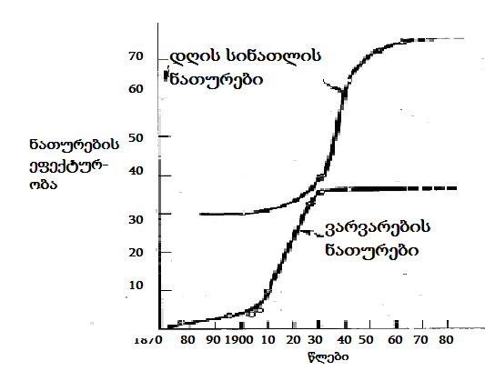
nax. 36
aseTi mdgomareoba tipuria e.w. teqnologiuri wyvetebis dadgomisas, rodesac arsebuls mkveTrad gansxvavebuli principis gamoyenebiT moqmedi axali teqnika an procesi enacvleba. aRsaniSnavia, rom igive suraTs viRebT maSinac, rodesac saqme gvaqvs ara marto imave samomxmareblo funqciis Sesrulebis gaumjobesebasTan axali teqnikis gamoyenebis xarjze, aramed maSinac, rodesac Camnacvlebel teqnologias sruliad axali funqciuri SesaZleblobebi gaaCnia. Sesabamisi magaliTi naCvenebia 37–e naxazze, romelic eqsponencialur masStabSi aCvenebs aSS-Si eleqtrificirebuli saxlebis raodenobis zrdas 1907-1955 wlebSi.
eleqtroenergiis SeRwevam, navTis sanTurebi bevrad ufro efeqtiani eleqtronaTurebiT, xolo sayinuleebi - eleqtromacivrebiT Secvala. paralelurad manve uzrunvelyo iseTi meqanizmebis amoqmedebac, rogoricaa magaliTad, sarecxi manqanebi da mtversasrutebi, romlebmac gamodevna adre xeliT Sesasrulebeli operaciebi. da metic, gaCnda sruliad axali, manamde saerTod ararsebuli operaciebis Sesrulebis SesaZlebloba eleqtrofenis (gaSroba), kondicioneris (haeris damuSaveba), radiomimRebis (informaciis miReba) meSveobiT.
36–e naxazis monacemebi adasturebd, rom amas moyva energomoxmarebis jer SedarebiT neli, Semdeg ki, zemoxsenebuli axali mowyobilobebis Seqmnis da bazarze gamoCenis kvalobaze, swrafi zrda. sabolood, sacxovrebeli saxlebis eleqtrificirebis dasrulebis da samomxmareblo mowyobilobebiT maTi sruli aRWurvis Semdeg, energomoxmarebis zrda gajerebiT Seicvala.
garegnulad msgavsi procesebi viTardeba sruliad axali an mniSvnelovnad saxeSecvlili nawarmis bazarze gatanis Semdegac. dasawyisSi igi jer ar aris sakmarisad srulyofili, momxmarebelma icis es da ar Cqarobs axali produqtis, an momsaxurebis SeZenas. es gasagebicaa, vinaidan SedarebiT rTuli axali nawarmis eqspluataciaSi Seyvanisas, yovelTvis arsebobs garkveuli riski da bevr potenciur myidvels urCevnia sxvam aiRos igi sakuTar Tavze.
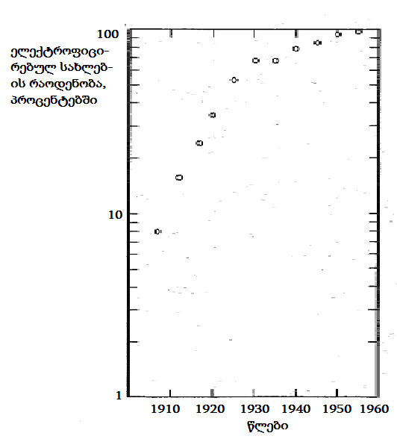
Nnax. 37
aseTi momxmareblebi iqamde Seikaveben Tavs siaxlis SeZenisgan, sanam sxvebis mier axlis gamoyenebis gamocdileba sakmarisad ar daadasturebs mis samomxmareblo upiratesobebs. amitom, momxmarebelTa moTxovnileba siaxleze izrdeba jer nela, Semdeg ki, misi srulyofis da reputaciis SeZenis fexdafex, sul ufro swrafad. ase grZeldeba manam, sanam bazari ar gajerdeba, anu miwodeba masze ar gautoldeba moTxovnilebas. amis Semdeg gayidvebi stabilur doneze darCeba bazarze alternatiuli axali produqtis gamoCenamde, rasac, rogorc wesi, arsebulze moTxovnilebis dacema Tan sdevs.

2.12. perlis da gompercis mrudebi
realuri S-mrudebis analitikur eqstrapolirebas yvelaze xSirad e.w. logistikuri mrudis, an ubralod perlis mrudis meSveobiT axdenen [59]. amerikelma demografma da biologma raimond perlim (Raymond Pearl) gamoikvlia organizmebisa da populaciebis zrda da aRmoaCina, rom mrudi, romelic axla mis saxels atarebs (nax. 38a da 38b) kargad asaxavs am procesis Taviseburebebs. perlis mrudi aRiwereba ase:
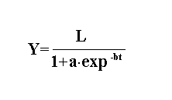
sadac L aris y cvladis zeda zRvari, xolo a da b parametrebia. rodesac t=-∞, mruds aqvs sawyisi mniSvneloba y=0. igi aRwevs zRvrul L mniSvnelobas, rodesac t=+∞. Tu y-is sawyisi mniSvneloba ar udris 0-s, maSin igi emateba gantolebis marjvena mxares, rogorc mudmiva. Tu ganvsazRvravT y-is drois mixedviT meore warmoebuls, miviRebT mrudis gadatexis wertils koordinatebiT t=ln(a/b) da y=0,5L.

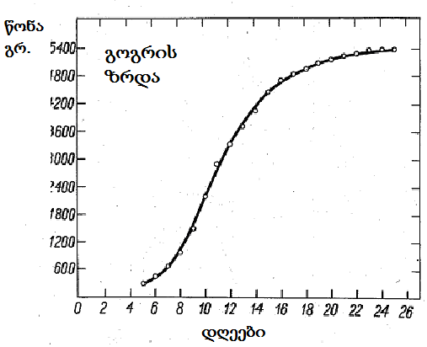
nax. 38a
y-is zeda L zRvars subieqturad gansazRvraven arsebuli fizikuri SezRudvebis, ekonomikuri viTarebis, socialuri mdgomareobis da/an sxva msgavsi faqtorebis zegavlenis mixedviT. perlis gantolebis gamoyenebisTvis, raime movlenis, an procesis ganviTarebis prognozirebis mizniT, saWiroa dadgindes a-sa da b-s is mniSvnelobebi, romlebic warsulidan aRebul monacemebs daakmayofilebs. zogjer arsebuli monacemebis mixedviT L-sac gansazRvraven, rogorc im mniSvnelobas, romelic mocemuli a da b-sTvis, perlis gantolebiT gamoTvlili monacemebis, arsebulTan saukeTeso miaxloebas iZleva.
magram, aseTi midgomis gamoyeneba, rogorc wesi, ar aris mizanSewonili, vinaidan ar iTvaliswinebs procesze zegavlenis mqone faqtorebis cvlilebis xasiaTs. raimes ganviTarebis adreul stadiaze, zrdis ZiriTad determinants axlis aTvisebis sawyisi siZneleebis daZlevis Zalisxmeva gansazRvravs. is, Tu rogori maqsimaluri zeda zRvari iqneba miRweuli srulyofis Sedegad, am stadiaze nakleb zegavlenas axdens ganviTarebaze da damgegmavi ar unda ecados mis gansazRvras sawyisi etapebis Sedegebis mixedviT.

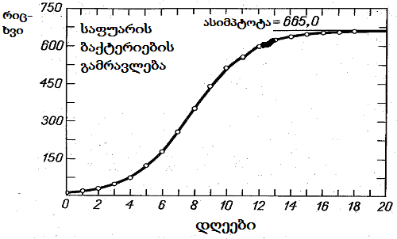
ნახ. 38ბ
ganvixiloT a da b parametrebis gansazRvra umcires kvadratTa meTodiT. davuSvaT, gvaqvs y-ze N dakvirvebaTa raodenoba, romlebic t drois ganmavlobaSi Sesrulda. Cveni amocanaa qvemoT moyvanili gamosaxulebis minimizeba:

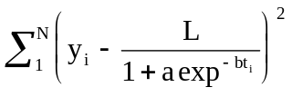.

am gziT moqmedebas transcendenturi gantolebis amoxsnis aucileblobamde mivyavarT. amisTvis Tavis asarideblad, Semdegnairad iqcevian: jer gantolebas warmoadgenen Semdegi saxiT:
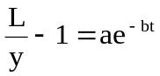
Semdeg dauSveben, rom
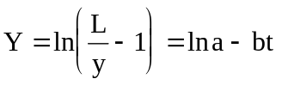 .
arsebuli monacemebidan SegviZlia ganvsazRvroT Y_{i} – is mniSvnelobebi, romlebic drois garkveul t_{i} momentebs Seesabameba. axla SegviZlia gamosaxulebis
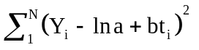
minimizeba, Y-is t-ze regresiis misaRebad. regresiis gantolebis Tavisufal wevrs warmoadgens ln a, xolo regresiis koeficients ki – b.
gompercis mrudi aseve arawrfiv trends aRwers. igi xSirad gamoiyeneba zrdis procesebis aRsawerad da raimes ganviTarebis prognozirebisTvis. mas ingliseli statistikosis benjamin gompercis (Benjamin Gompertz) saxeli hqvia, man pirvelma SemogvTavaza es mrudi, rogorc sikvdilianobis donis aRmweri kanoni. SemdgomSi dadginda, rom imave mrudiT kargad aRiwereba Semosavlebis ganawileba da mravali sxva arawrfivi procesi. gompercis gantolebas aqvs Semdegi saxe:

y=Lexp(-be^{-kt}) .

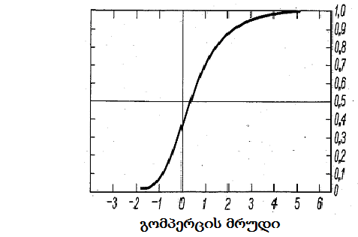
nax. 39
rogorc perlis mrudi, gompercis mrudic minus usasrulobis toli t-sTvis, icvleba y=0-dan zeda L zRvramde, romelsac t=+∞ Seesabameba. magram perlis mrudisgan gansxvavebiT, igi aRar aris simetriuli. gardatexis wertili modis t=lnb/k-ze, romlisTvisac y=L/e.
39–e naxazze naCvenebia gompercis mrudi, romlisTvisac, gamartivebis mizniT, L, b da k koeficientebi erTis toladaa aRebuli. perlis mrudisTvis gamoviyenoT igive midgoma, rogorc zemoT da gardavqmnaT gantoleba Semdegi saxiT:
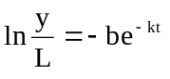
saidanac
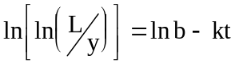

zeda zRvris dadgenis da monacemebis saTanado gardaqmnis Semdeg, miviRebT Y=ln[ln(L/y)]–s da gamosaxulebis
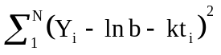
minimizebiT vpoulobT a-s da b-s. es ki ukve Y-is t-ze regresiis gantolebis gansazRvris saSualebas gvaZlevs.

2.13. teqnologiur siaxleTa kvlevis
modeli
rogorc ukve aRvniSneT, inovaciuri procesis marTvis meTodebis damuSavebam, sagrZnoblad daaCqara maTi mimdinareoba. dResdReobiT periodi, romelic aucilebelia bazrebis umetesobaze axali produqtis miwodebisTvis, 3-5 wels ar aRemateba, 20 wlis winaT ki am process 15-20 weli sWirdeboda. inovaciuri procesis daCqarebisTvis metad nayofieri aRmoCnda samecniero kvlevebis inovaciuri marTvis modelebis gamoyeneba, rogorc axali produqtis kvleva-damuSavebis, ise misi bazarze damkvidrebis stadiebze. aseT modelebs sakmaosd Tanamimdevrulad iyeneben kompaniis Nortel Networks kvleviT qvedanayofSi “harlous laboratoriebi” (Harlow Laboratories) [48].
harlous inJinrebma mraval inovaciur warmatebas miaRwies, maT axali orientirebi Seqmnes Tanamedrove telekomunikaciis ganviTarebis saqmeSi. ase magaliTad, aleqs rivzis mier impulsur-koduri modulaciis gamogonebam 1937 wels safuZveli Cauyara informaciis gadacemis kodur formats - Tanamedrove cifruli samyaros fundamentur teqnologias. Carlz kaos da jorj xokmanis winadadebam signalis gadacemisTvis optikuri boWkos da lazeris sxivis SesaZleblobebis gamoyenebis Taobaze, revolucia moaxdina optikuri komunikaciis sferoSi. 1970-ian wlebSi harlous inJinrebma Seqmnes pirveli “erTCipiani” radiogadamcemi, ramac usadeno mobilur kavSirs gauxsna gza. dResac, harlous inJinrebi yovelwliurad aregistrireben da apatenteben 150-mde axal gamogonebas.
“harlous laboratoriebis” inovaciuri siZliere aramarto samecniero-kvleviTi procesis kargi organizebiT aris ganpirobebuli, aramed im siswrafiTac, romliTac Nortel Networks-Si inergeba, mowinave teqnologia axali produqtis Seqmnis TiToeul etapze. es ki Tvisebriv safuZvels uqmnis am kompaniis winswrebas konkurentebTan SedarebiT.
sakuTari samecniero-kvleviTi saqmianobis klasificirebas “harlous laboratoriebSi” produqtis teqnologiis “simwifis” doneebis mixedviT axdenen. am niSniT ganarCeven: arsebuli produqtis teqnologias, ganviTarebad teqnologias, “gajerebad” teqnologias (teqnologia, romelic Zalze miuaxlovda bunebis kanonebiT ganpirobebul sakuTari SesaZleblobebis sazRvrebs) dabolos, alternatiuli produqtis gamrRvev teqnologias.
am teqnologiebis Sesabamisi nawarmis rigs Seadgens: amJamad warmoebaSi myofi produqti, misi modernizebuli nairsaxeoba, momdevno Taobis msgavsi nawarmi, arsebulisgan principulad gansxvavebuli perspeqtiuli nakeToba. warmoebaSi myof da modernizebul produqtebze momuSaveTa kvleviTi Zalisxmeva ZiriTadad mimarTulia sawarmoo danaxarjebis Semcirebasa da produqciis maxasiaTeblebis gaumjobesebaze. isini, vinc momdevno Taobis nawarmze muSaoben, orientirebulni arian im axlad gamoCenili teqnologiebis ganviTarebaze, romelTa potenciali aRemateba amJamad gamoyenebulis SesaZleblobebs. xolo saqmianoba, romelic mimarTulia metad sarisko, magram warmatebis SemTxvevaSi maRali ukugebis momtan principulad axali produqtebisa da Sesabamisi gamrRevi teqnologiebis damuSavebisken, ZiriTadad kompaniis samomavlo ganviTarebis “traeqtoriis”prognozirebas eTmoba.
axali produqtebis damuSavebisa da bazarze damkvidrebisTvis, Nortel Networks ZiriTad sam standartul process iyenebs. Pirvels, produqtis bazarze TandaTanobiTi “gawurvas” (gate process) uwodeben, igi rigi Tanamimdevruli fazebisgan Sedgeba. esenia: produqtis konstruireba, ganviTareba, gamocda, warmoeba da misi bazarze arsebobis mxardaWera.
imisTvis, rom procesi erTi fazidan momdevnoze gadavides, aucilebeli xdeba “filtris” gadalaxva, romlis rols asrulebs produqtis damuSavebaze pasuxismgebeli gundis TaTbiri-ganxilva. aq xdeba produqtis ganviTarebis mdgomareobis Sefaseba iseTi parametrebis mixedviT, rogoricaa produqtis da teqnologiis Sesabamisoba CanafiqrTan, biznes-gegmis Sesruleba da a.S. Tu TaTbirze gadawyda, rom produqti akmayofilebs yvela sadReiso moTxovnas, “filtri” gadalaxulia da misi damuSaveba momdevno fazaze gadadis.
Mmagram, axali produqtis bazarze damkvidrebis daCqarebis TvalsazrisiT, am process aqvs ramdenime xarvezi, romelTa Soris mTavaria:
- etapuri midgoma anelebs produqtis damuSavebas da amuxruWebs sarisko iniciativebis gamovlenas; mas ar ZaluZs produqtis damuSavebis drois Semcireba, procesis momijnave fazebis gaerTianebis meSveobiT;
- produqtis damuSavebasa da bazarze damkvidrebaSi ar arian sakmarisad CarTulni momxmareblebi. amitom SesaZlebelia, rom miRebuli Sedegi gansxvavdebodes maTi molodinebisgan.
- procesis sxvadasxva etapebis Sesrulebas monawileTa gansxvavebuli gundebi uzrunvelyofen. amitom Semsruleblebidan cota vinme Tu xedavs process mTlianobaSi, produqtis ganviTarebis dawyebidan mis dasrulebamde.
Nortel Networks-Si axali produqtebis damuSavebis meore standartuli procesi, mniSvnelovanwilad Tavisufalia aRniSnuli xarvezebisgan. igi cnobilia “alfa/beta gadagzavnis” (Alpha/Beta Ship) saxeliT. gansxvavebiT pirveli procesisgan, igi “itans” fazebis ricxvis Semcirebas, gulisxmobs momxmareblis sistematur CarTulobas mTel mis mimdinareobaSi da bolos, mTlianad xorcieldeba erTi gundis mier, romelic sagangebod iqmneba procesis sruli uzrunvelyofisTvis.
aRniSnuli procesi iwyeba momxmareblebTan dialogiT, romlis Sedegad unda dadgindes, Tu ra surs mas. Semdeg dgeba e.w. alfa faza, romlis dasawyisSi iqmneba produqtis pirveli varianti, yvelaze martivi maCveneblebiT. momxmareblebTan momdevno muSaobisa da produqtis srulyofis seriebis Sedegad, procesi gadadis fazaSi beta, romelzec xdeba ukve sakmaod maRali funqciuri maxasiaTeblebis da xarisxis mqone produqtis warmoebis aTviseba da bazarze gatana. xSirad, saboloo warmatebis miRwevisTvis erTi beta-cikli ar aris sakmarisi da igi meordeba (SeiZleba ramdenimejerac), produqtis gaumjobesebis mizniT.
axali produqtis bazarze damkvidrebas kidev ufro aCqarebs Nortel Networks-is praqtikaSi gamoyenebuli inovaciuri procesis mesame modelic, romelsac Time To Market, TTM (dro bazramde) ewodeba. modelis gamoyeneba uzrunvelyofs saTanado saqmian urTierTobebs da dialogs procesSi CarTul yvela eqsperts Soris da amiT mkveTrad zrdis inovaciuri ideebis ganviTarebis efeqtianobas.
Mme-40 naxazze igi simbolurad, Zabrisebri arxis saxiT aris warmodgenili. arxis SesasvlelSi “miewodeba” axali produqtebis Seqmnis potencialis mqone mravalricxovani idea. maTTan Tanmimdevruli muSaobis Sedegad (moZraoba arxis gaswvriv), mis gamosasvlelze erTi an sul ramdenime rCeba, romelTaTvis gamovlinda rogorc warmoebaSi realizebis SesaZlebloba, ise sabazro potenciali.
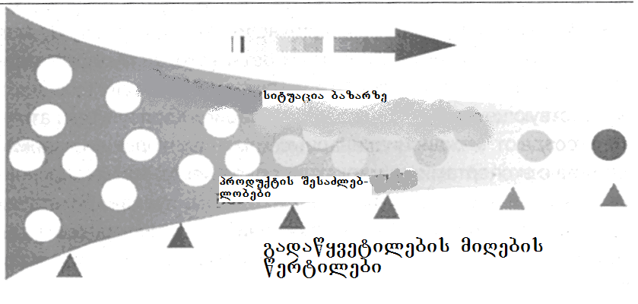
nax. 40
arxis gaswvriv ganlagebuli samkuTxedebiT aRniSnulia e.w. gadawyvetilebebis miRebis wertilebi, romlebSic xdeba ararealisturi da zedmetad sarisko ideebis gamoxSirva. amisTvis arsebobs saTanadod struqturirebuli procesi, romlis msvlelobaSi ori samuSao jgufi erTdroulad msjelobs damuSavebaSi myofi TiToeuli ideis av-kargianobaze. maTgan erT-erTia marketologebis, menejerebisa da teqnikuri eqspertebisgan Semdgari e.w. portfeluri investiciebis marTvis disciplinaTSorisi jgufi, მeore კი konkretuli ideis damuSavebaze pasuxismgebeli gaerTianebuli saproeqto jgufiა.
Harlow Laboratories-Si iyeneben agreTve zemoaRwerili procesis nairsaxeobas. igi samecniero kvlevebis Sedegebidan im mimarTulebebis gamokveTas emsaxureba, romelic msxvili sainvesticio proeqtebis safuZveli xdeba (ix. nax. 41). aq procesi samecniero-teqnikuri SemoqmedebiTobiT “Sobili” iseTi masStaburi ideebis ganxilvidan iwyeba, rogoric aris: winadadebebi axali sawarmoebis Seqmnaze, warmoebis axali bazuri mimarTulebebis ganviTarebaze, kvlevebis fundamenturi Sedegebis amsaxveli inteleqtualuri sakuTrebis realizebaze da a.S.

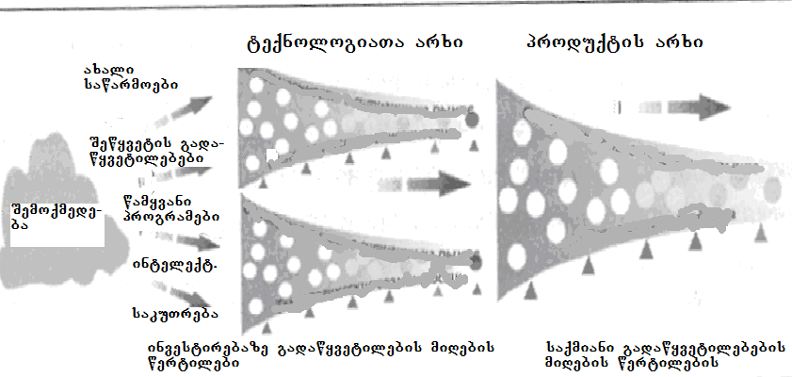
Nnax. 41
maTi damuSaveba jer e.w. teqnologiur arxSi mimdinareobs, ris Sedegadac unda gamovlindes mniSvnelovani investirebisTvis rekomendebuli erTi an ramodenime inovaciuri idea. Sefaseba sainvesticio da teqnologieri moTxovnebis donis, axali produqtis funqciuri SesaZleblobebis, sainvesticio proeqtis Sesrulebis rigiTobis da savaraudo danaxarjebis mixedviT xdeba. Sedegad, inovaciuri procesis momdevno etapze gadadian SemoqmedebiT procesebSi warmoqmnili mxolod is ideebi, romlebmac warmatebiT gaiara Sefaseba teqnologiuri da sabazro amocanebis TvalTaxedviT. amis Semdeg iwyeba maTi Sesabamisi produqtis (produqtebis) da teqnologiebis ganviTareba e.w. produqtis arxSi, rac TTM-is zemoaRweril procesTan srul SesatyvisobaSi mimdinareobs.
Yyvela zemoaRweril modelSi teqnologiuri aspeqtebis ganxilvas Taviseburebebis rigi axasiaTebs. upirveles yovlisa, es aris teqnologiuri gadawyvetilebebis miRebisTvis gamoyofili drois simcire: ramodenime Tve, an ramdenime kvirac ki. meore Taviseburebaa amocanis sakmarisad “Riad” dayenebis moTxovna, raTa momavali produqtis zedmetad detalurma aRwerilobam misi Seqmnis sawyis stadiaze, ar SezRudos teqnologiis dammuSaveblebis SemoqmedebiTi Tavisufleba da ar mospos adre dawunebul ideebTan xelaxali dabrunebis SesaZlebloba. es ukanaskneli garemoeba metad mniSvnelovania, vinaidan zogierTi teqnologiuri mosazrebis realizeba, mxolod garkveul pirobebSi xdeba SesaZlebeli, romlebic inovaciuri proeqtis Sesrulebis dasawyisSi SeiZleba arc ki arsebobdes.
im jgufebis garda, romlebic axali produqtebis damuSavebas uZRvebian, Harlow Laboratories-Si moqmedeben gundebic, romelTa Zalisxmeva kompaniis Nortel Networks strategiuli ganviTarebis sxvadasxva mimarTulebaze arian koncentrirebuli. maTi saqmianobis mimdinareobac struqturirebulia da inovaciuri procesis ciklur bunebas eyrdnoba. Tumca ganxilva, rasakvirvelia, Soreul perspeqtivasTan mimarTebaSi xdeba, drois gaxsnili sazRvrebiT.
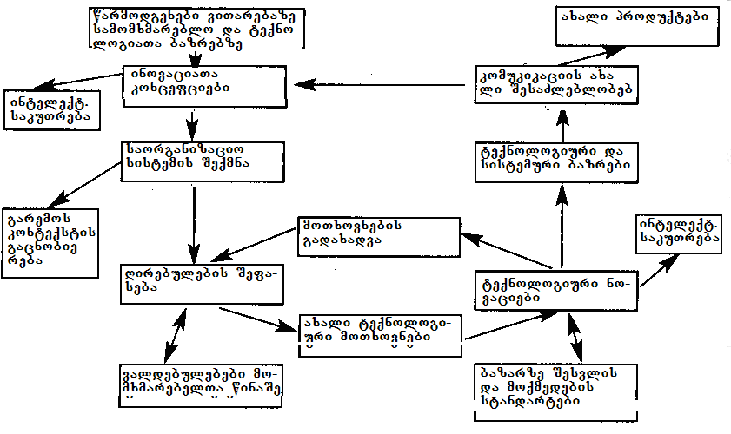
nax. 42
strategiuli inovaciuri cikli (nax. 42) bazarze da teqnologiur sferoSi arsebul situaciaSi garkvevidan iwyeba. mas Semdeg, rac ganisazRvra momxmarebelTa moTxovnilebebi da mizezebi, romelTa gamo ar moxda maTi dakmayofileba, Harlow Laboratories inJinrebi amuSaveben saTanado inovaciaTa koncefciebs da aformeben inteleqtualur uflebebs sakuTar ideebze. aRniSnuls mohyveba SexedulebaTa ganviTareba maTi aTvisebisTvis aucilebel saorganizacio sistemebze, romlebic garemosTan urTierTobis aspeqtebsac asaxavs.
Semdeg etapze muSavdeba inovaciuri Canafiqris ekonomikuri maCveneblebi, romelTa dazusteba potenciuri momxmareblebis Sefasebebis gavaliswinebiT xdeba. aqve yalibdeba inovaciiT gaCenili axali moTxovnebi teqnologiis mimarT da fasdeba maTi dakmayofilebis SesaZlebloba. Tu inovacia ararealizebad pirobebs uyenebs warmoebas an bazars, moxdeba procesis wina etapze dabruneba da teqnologiuri moTxovnebis koreqtireba.
teqnologiuri moTxovnebis dadgenis stadiaze iwyeba muSaoba samrewvelo standartebis dacvaze pasuxismgebel organoebTan. bevr sferoSi, romelTac telekomunikaciac miekuTvneba, mniSvnelovania, rom inovaciebi dargSi ukve gavrcelebul teqnologiebSi “ewerebodes” da ar iwvevdnen maTTan SeuTavseblobis problemas. swored saTanado Sesabamisobis miRweva aris standartizaciis mizani, romelic agreTve moicavs axali standartebis damuSavebas da maTze inteleqtualuri sakuTrebis uflebebis (isu) dafiqsirebas.
amis Semdeg xdeba inovaciis potenciali Sefasdeba araZiriTad momxmarebelTa TvalTaxedviT, romlebic teqnologiuri da sistemuri produqtebis bazrebis momxmareblebi arian. maTi moTxovnilebebis gaTvaliswinebis survilma, SeiZleba gamoiwvios Tavdapirveli inovaciuri koncefciis garkveuli koreqtirebis aucilebloba. aRniSnuls moyveba ganxilvis Tvalsawieris gafarToeba, damuSavebul produqtebsa teqnologiebSi usafrTxoebis sistemebis CarTviT da maTi moxmarebis praqtikulobis SefasebiT. amis Semdeg xdeba inovaciiT gaCenili axali sakomunikacio SesaZleblobebis sruli Sefaseba da bazarze Sesabamisi produqtebis gatana-damkvidreba. amiT erTi inovaciuri cikli sruldeba da iqmneba safuZveli momdevno ciklisTvis, romelic, winamorbedis msgavsad, aseve momxmareblebis daukmayofilebeli moTxovnilebebis gamovlenidan iwyeba.

2.14 codna – inovaciuri ganviTarebis
safuZveli
teqnikisa da teqnologiis ganviTareba sazogadoebaSi mimdinare cvlilebebis mniSvnelovani stimulia. metic, SeiZleba iTqvas, rom ukanasknel or saukuneSi, teqnikis da teqnologiis ganviTarebis Sedegebis gamoyenebam mrewvelobaSi, adamianebis cxovrebis xarisxi (materialuri ganzomilebiT) uprecedento simaRleebamde aiyvana. Tumca, gverds ver ar avuvliT im faqts, rom primitiuli iaraRebis gamogonebas, cecxlisa da borblis gamoyenebis aTvisebas kacobriobisTvis meti mniSvneloba hqonda, vidre nebismier dRevandel teqnikur, Tu teqnologiur miRwevas.
aseTi ganviTarebis safuZvels samyaros Sesaxeb Cveni codnis gafarToeba qmnis, rasac yovelTvis umniSvnelovanesi roli eniWeboda kacobriobis ganviTarebaSi [16]. pirvelyofili sazogadoebebi aTasobiT wlebis ganmavlobaSi agrovebdnen codnas mcenareebs, cxovelebsa da mineralebze, rac aucilebeli iyo maTi usafrTxoebis uzrunvelsayofad. neoliTis periodSi (qristeSobamde welTaRricxvis 10.000-5.000 wlebi), am codnam soflis meurneobis mwarmoeblurobis mkveTri zrda gamoiwvia mesopotamiaSi, samxreT CineTSi, centralur amerikasa da dasavleT afrikaSi, rac mcenareTa dargva-daTesvis aTvisebaSi, xvnis teqnikis damuSavebaSi, metalurgiisa da iaraRTmSeneblobis ganviTarebaSi gamoixata. am periodisTvis codna ukve CanawerebSi fiqsirdeboda, ramac misi Taobidan TaobisTvis gadacemis SesaZlebloba Seqmna.
yvelaferma aman, msoflios ZiriTadi civilizaciebis ganviTarebas Seuqmna safuZveli. antikur xanaSi berZnebma ganaviTares bunebismetyveleba, samyarosadmi kvleviTi damokidebuleba, gaakeTes umniSvnelovanesi samecniero aRmoCenebi astronomiaSi, fizikasa da maTematikaSi. am codnis safuZvelze, romaelebma mogvianebiT Seqmnes da ganaviTares mTeli rigi gamoyenebiTi meTodologiebi. romis imperiis dangrevis Semdeg, evropa e.w. bneleTis saukuneebSi (adrindeli Sua saukuneebi) CaiZira da am codnis dakargvis realuri saSiSroeba Seiqmna.
sabednierod, CineTsa da indoeTSi akumulirebul codnasTan erTad, igi kacobriobas gadaurCines arabma mecnierebma da irlandielma ber-monazvnebma, romlebmac ara marto Seinaxes antikuri xanis mravali xelnaweri, aramed mravalgzis gadaweris Sedegad, xelic Seuwyes maT gavrcelebas. swored, aman Seqmna Sua saukuneebSi evropuli renesansis safuZveli, romelsac Tan sdevda mecnierebis da xelovnebis saocari masStabebiT da dinamikiT afeTqebis msgavsi ganviTareba. antikuri xanis berZnebis mier dagrovili codnis xelaxalma “aRmoCenam”, biZgi misca samecniero revolucias, romelmac evropaSi ramdenime saukunis gavlis Semdeg samrewvelo revoluciebis saxe miiRo.
orTqlis Zravis da teqstilis warmoebisTvis gankuTvnili manqanebis ganviTarebam e.w. pirvel samrewvelo revolucias daudo dasabami. igi agreTve samewarmeo dinamizmis Casaxvasac ukavSirdeboda, romelmac Tavis zegavlena moaxdina codnis wyaroebis da gamomgoneblobis ganviTarebaze. amaSi lideris rols asrulebda britaneTi, romelsac sul male evropis sxva qveynebic miyvnen fexdafex.
meore samrewvelo revoluciis msvlelobaSi (igi qimiis da meqanikis ganviTarebas eyrdnoboda) germaniam, ganamtkica ra kavSirebi saswavlo da samrewvelo organizaciebs Soris, moaxerxa industriuli qveynebis teqnologiuri lideris poziciis dakaveba. yvela am miRwevis warmatebuli aTvisebis da ganaTlebis sistemis Tvisebrivi da raodenobrivi TvalsazrisiT uprecedento ganviTarebis kvalobaze, Tanamedrove qarxnebsa da teqnologiur procesebSi msxvilmasStabiani investirebis Sedegad, amerikis SeerTebulma Statebma me-19 da me-20 saukuneebis gasayarze metad swraf da efeqtian industriul ganviTarebas miaRwies.
analogiurad viTardeboda procesebi aziaSic. aq iaponiam dasavluri teqnologiebis adaptirebis gziT moaxerxa Tanamedrove ekonomikis swrafi aSeneba. meore msoflio omis dasrulebisTanave, aqtiuri saeqsporto strategiis realizebis mizniT, iaponiam daiwyo sakuTari ganaTlebis sistemis da industriis Rrma rekonstruireba. teqnologiuri donis TandaTanobiTi awevis Sedegad, iaponiaSi izrdeboda kvlevis da ganviTarebis sakuTari potencialic. saboloo jamSi, yvelaferma aman qveyana msoflio liderad gadaaqcia avtomobilmSeneblobaSi, eleqtronikis, Tu sxva samomxmareblo maRalteqnologiuri produqciis masobriv warmoebaSi. ufro mogvianebiT ki ganviTarebis imave gzas, Tanac metad warmatebulad, daadgnen koreis respublika (samxreT korea) da taivani (CineTi).
dRes CvenSi, iseve rogorc msoflios mraval sxva qveyanaSi, sruldeba e.w. industriuli sazogadoebis Camoyalibeba. rogorc zemoT ukve aRiniSna, mas safuZveli daudo samrewvelo revoluciam, romlis msvlelobaSi adamianebma iswavles sawarmoo procesebSi bunebis energiis gamoyeneba. amasTan, pirveli nabijebi samrewvelo revoluciis msvlelobaSi sawarmoo procesebis srulyofas ukavSirdeboda, Tavad nawarmi ki am periodSi naklebad icvleboda. mxolod wina aswleulSi daiwyo Tvisebrivad gansxvavebuli axali samrewvelo produqtebis gamoCena. swored aseTma nawarmma, mikroeleqtronikis da informatikis ganviTarebasTan erTad, ganapiroba Cvens droSi sazogadoebis Tvisebrivad gansxvavebul, e.w. postindustriul mdgomareobaSi gadasvla.
tranzistoris gamogonebam dasabami daudo revolucias mikroeleqtronikaSi, rasac mohyva manamde warmoudgeneli tempiT mimdinare progresi informaciis damuSavebis da warmoebis avtomatizaciis sferoebSi. kompiuterebis swrafqmedebis da mexsierebis zrdam eleqtronikis ganviTarebis kvaldakval, teqnologiebis naxtomiseburi ganviTareba gamoiwvia mravali mimarTulebiT.
codnis dagrovebas genetikaSi da masTan dakavSirebuli bioteqnologiis ganviTarebas, sicocxlis Sesaxeb mecnierebaTa gamoyenebiTi aspeqtebis swrafi winsvla mohyva. materiis Seswavlisas dagrovili codnis progresi, axali masalebis Seqmnasa da nanoteqnologiebis gamoCenaSi aisaxa. saTanado codnis akumulirebasTan dakavSirebulma rigma aRmoCenebma, metad mniSvnelovani cvlilebebi gamoiwvia energetikis sferoSic.

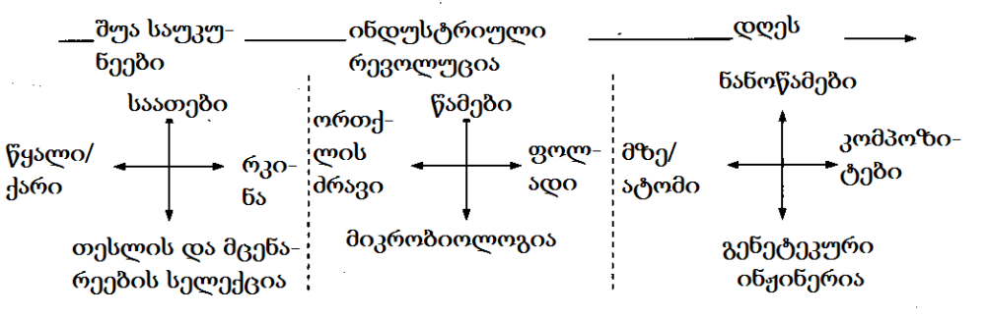
nax. 43
Tu vecdebiT kacobriobis mier drois, cocxali bunebis, nivTierebisa da energiis gamoyenebaSi miRweul maCveneblebSi garkvevas davinaxavT, rom codnis yvela zemoaRniSnuli cvlileba im teqnologiur tendenciebSi ikribeboda, romlebic safuZvlianad cvlida ekonomikur da socialur garemos (nax. 43) [52].
rasakvirvelia, codnis warmatebuli gamoyenebis yvela am da mravalricxovan sxva SemTxvevas, yovelTvis win uswrebda saTanado inovaciuri procesebi, rac safuZvels gvaZlevs vilaparakoT maT kavSirze ekonomikis ganviTarebasTan.

2.15. inovaciis kavSiri ekonomikur
progresTan
teqnikuri inovacia, rogorc ekonomikuri ganviTarebis mamoZravebeli, pirvelad avstrielma ekonomistma Sumpeterma warmoaCina 1912 wels [44]. SemdgomSi solousa da abramovitcis SromebSi naCvenebi iyo, rom teqnologiuri cvlilebebis ekonomikuri zegavlena 90%-s aRwevs. 60-iani wlebis dasawyisSi denisonma scada daemtkicebina, rom ekonomikuri ganviTarebis mizezi codnis progresia. igi gadamwyvet mniSvnelobas aniWebda ganaTlebis da muSaZalis kvalifikaciaze zegavlenis mqone sxva faqtorebis rols sazogadoebis progresirebaSi. misi SefasebebiT, am faqtorebis erToblivi ekonomikuri zegavlena erovnuli produqtis nazrdis 40%-s uzrunvelyofs.
aRniSnuli sakiTxebis gaSuqebaSi gansakuTrebuli mniSvneloba amerikeli mecnieris kaleckis Sromebma SeiZina. kaleckim, fon neimanis da xarodis adreul SromebSi warmoCenili da maT mier efeqturi moTxovnilebis faqtorebis zegavleniT axsnili, ekonomikis mdovre da uwyveti ganviTareba scada daekavSirebina teqnologiur cvlilebebTan. kaleckic moTxovnilebis faqtorebs eyrdnoba, magram amasTan operirebs ara uwyveti zrdis xangrZlivi tendenciiT, aramed saqonelbrunvis ciklebiT. kaleckis mixedviT, moTxovnileba ganapirobebs mudmiv zrdas ciklis SigniT, xolo garegan pirobaTa sistemaSi cvlilebebi, iwvevs ganviTarebis mimarTulebis Secvlas da naxtomisebr winsvlas [53].
kalecki Tvlis, rom ganviTarebis rogorc cikluri, ise xangrZliv- vadiani algoriTmebi urTierTdakavSirebuli da erTmaneTis Semavsebelia. ganviTarebas ciklis SigniT endogenuri, anu Siga bunebis faqtorebis moqmedeba iwvevs, magaliTad, warmoebaSi reinvestireba. Teoriulad, aman SeiZleba uwyveti eqsponencialuri zrda gamoiwvios. egzogenuri (garegani) faqtorebis, magaliTad inovaciebis, zemoqmedeba xangrZliv tendenciaSi, e.w. trendiseul ganviTarebaSi jamdeba. vinaidan misi uzrunvelmyofeli kapitaldabandeba miznad isaxavs damatebiTi mogebis miRebas siaxleTa aTvisebis da ara arsebuli gamocdilebis gamoyenebis xarjze, trendiseuli ganviTareba moiTxovs inovaciaTa uwyveti nakadis arsebobas.
kalecki Tavis koncefcias or inovaciur efeqts ukavSirebs. pirveli Seesabameba mewarmis gadawyvetilebas - inovaciis aTvisebis meSveobiT miiRos damatebiTi mogeba, meore ki im faqts, rom sakuTari gavrcelebis kvalobaze, axali teqnikuri gadawyvetileba garkveulad zRudavs momdevno samewarmeo iniciativebs. magram imis gamo, rom aseTi zegavlena SedarebiT gvian iCens Tavs da Tuki axal-axali inovaciebi sakmarisi sixSiriT «Cndeba», yalibdeba maTi uwyveti nakadi, teqnikuri siaxle progresis ganmsazRvreli xdeba da misi pozitiuri zegavlena swraf ekonomikur zrdas iwvevs. maSasadame, trendiseuli ganviTareba damokidebulia rogorc ekonomikis zrdis adrindel tempze, ise teqnologiuri progresis siCqarezec.
kaleckis mixedviT, axali teqnikuri gadawyvetilebebi warmoebaze mastimulirebel, «Sokur» zemoqmedebas axdens. xangrZlivvadian perspeqtivaSi, isini amcireben ekonomikuri vardnis periodebis xangrZlivobas da zrdian aRmavlobis periodebs. kaleckis koncefcias eTanxmeba Smukleris kvlevebis Sedegebi, romelmSic ganxilulia kavSiri ekonomikur maCveneblebs, magaliTad fasebsa da teqnologiur cvlilebebs Soris [44]. 100-wliani retrospeqtiviT, Smuklerma gaaanaliza samomxmareblo fasebis meryeoba. miRebuli saerTo suraTis mailustrirebelia, magaliTad, Semdegi faqti: 100 wlis ganmavlobaSi xorblis warmoeba aSS-Si gaizarda 6-jer, amasTanave samomxmareblo fasebi masze am periodSi praqtikulad ucvleli darCa. aqedan gamomdinareobs, rom damatebiTi mogebis miRebis SesaZlebloba, romelic mewarmeebs ubiZgebda xorblis warmoebis gafarToebisken, warmoiqmneboda ara fasebis zrdis, aramed xorblis TviTRirebulebis Semcirebis xarjze, mis warmoebaSi axali samecniero da teqnikuri gadawyvetilebebis gamoyenebis Sedegad.
aRwerili da sxva msgavsi koncefciebis mniSvneloba, upirveles yovlisa is aris, rom isini ganviTarebis prognozirebis garkveul safuZvels qmnian. am saqmeSi gamoyenebuli midgomebis raodenoba aseuls aWarbebs, Tumca aRsaniSnavia, rom prognozirebis safuZvlad aRebuli maTematikuri, statistikuri da eqspertuli meTodebi, yovelTvis gulisxmobs adamianis intuiciaze dayrdnobis aucileblobas, ris gamoc miRebuli Sedegebi met-naklebad subieqturia. amdenad, samecniero teqnikuri ganviTarebis da misi ekonomikuri zegavlenis prognozirebis safuZvelze miRebuli gadawyvetilebebi, momavlis mxolod zogadi SefasebebisTvisaa gamosadegi, isic drois xangrZlivi periodebisTvis. SedarebiT moklevadian perspeqtivaSi, samecniero-teqnikuri ganviTarebis SesaZlo variantebs xSirad analogiebis safuZvelze adgenen, magaliTad samxedro-samrewvelo kvlevebis da "avangarduli" (vTqvaT, kosmosuri) teqnologiebis damuSavebis Sedegebis mixedviT.
ganviTarebis SesaZlo variantebis SepirispirebiT im mosalodnel winaaRmdegobebTan, romlebic prognozebis Tanaxmad zegavlenas moaxdens momavali teqnologiuri sistemebis struqturebsa da Tvisebebze, SesaZlebelia samewarmeo saqmianobis marTvis strategiis mTavari mimarTulebebis dadgena. aRniSnul winaaRmdegobebs miekuTvneba: sawarmoo simZlavreebis Seusabamoba moTxovnilTan; gansxvaveba moTxovnilebasa da miwodebas, moTxovnilebasa da warmoebis teqnologiur dones Soris; danaxarjebsa da produqciis fass Soris; nawarmis eqspluatacis xangrZlivobasa da momxmareblebis molodinebs Soris; msoflios da sakuTari samecniero-teqnikur ganviTarebis doneebs Soris da a.S.

2.16. inovacia da ganviTarebis cikluroba
sazogadoebriv-ekonomikuri ganviTarebis TeoriebSi, romlebic inovaciaTa zegavlenas asaxavs, garkveuli mxardaWera “grZel talRaTa” koncefciebma poves. maTi idea pirvelad rusma mecnierma kondratievma wamoayena XX saukunis 20-an wlebSi. ekonomikuri maCveneblebis retrospeqtuli analizis safuZvelze, man aRmoaCina ganviTarebis ganmeorebadi ciklebis, e.w. “grZeli talRebis” arseboba, romelTa saSualo xangrZlivoba misi SefasebiT 50-60 welia. TiToeul aseT ciklSi ikveTeboda ekonomikuri aRmavlobis periodi, romelic Rrma vardniT icvleboda. kondratievma yuradReba miaqcia im faqts, rom cnobili adrindeli depresiebi 1814 da 1873 wlebSi daiwyo, anu daaxloebiT 60-wliani intervaliT. amitom man ivarauda, rom morigi depresia 1930 wlis maxloblobaSi unda dawyebuliyo. asec moxda: uol-stritis kraxma 1929 wels, dasabami misca e.w. “did depresias”, romelmac mniSvnelovnad daazarala msoflio ekonomika.
ufro gvian Sesrulebul Tavis SromebSi, Sumpeterma grZeli talRebis warmoqmnis mizezad teqnikur-teqnologiuri gardaqmnebi daasaxela. man Semoitana «teqnikuri revoluciis» cneba, romelic kondratievis ciklebis mamoZravebel Zalad CaTvala. Sumpeterma gamoyo ganviTarebis gamomwvevi ramdenime inovaciuri «paketi» da maTi gamoCeniT ganpirobebuli sami talRa.
Pirveli, man orTqlis manqanis gamogonebasa da gavrcelebas (1790-1840 ww.) daukavSira. meore talRa moicavs 1840-1890 w-is periods, igi rkinigzis transportis ganviTarebasa da warmoebis meqanizaciis miRwevebs asaxavs. mesame talRa (1890-1940 ww.) ganapiroba eleqtroenergetikis ganviTarebam, qimiuri teqnologiis miRwevebma da Sigawvis Zravebis gavrcelebam. dRes mravali analitikosi Tvlis, rom dasrulda ganviTarebis meoTxe e.w. eleqtronuli talRa da viTardeba mexuTe talRa, romlis safuZvelSia bioteqnologiis da molekuluri inJineriis miRwevebi (nax. 44).
ra aris damaxasiaTebeli Cveni droisTvis zemoaRniSnulis konteqstSi? stefen r. barli, kornelis universitetis (aSS) sawarmoo da SromiTi urTierTobebis skolis profesori, sakuTari da sxvebis kvlevebis Sedegebis analizis safuZvelze am kiTxvas Semdegnairad pasuxobs [22]: ”bolo dromde mowinave qveynebis ekonomikebis ganviTarebis safuZvelSi eleqtroenergetikis miRwevebi, eleqtruli da Sigawvis Zravebis srulyofa, satelefono komunikaciis daxvewa iyo”. am da sxva e.w. ”infrastruqturuli teqnologiebis” ganviTarebam urbanizaciis, korporaciaTa zrdis da profesiuli menejmentis procesebis srulyofis pirobebSi, SesaZlebeli gaxada agrokulturuli ekonomikis Canacvleba manufaqturuli (samrewvelo) ekonomikiT.
amJamad - wers barli, TvalnaTelia, rom adgili aqvs sxva cvlilebebs, romlebic zegavlenis masStaburobiT da gavrcelebis siswrafiT Seudarebelia: ”Cveni codna imaze, Tu rogor gadavaqcioT eleqtruli da meqanikuri impulsebi kodirebul informaciad da rogor gadavceT es informacia usazRvro manZilebze, TandaTanobiT gardaqmnis mrewvelobis eleqtromeqanikur infrastruqturas kompiuterizebul infrastruqturad”. Sesabamisad, informacia sul ufro faseuli resursi xdeba da is organizaciebi, romlebic iyeneben saTanado teqnologiebs sworad SerCeuli adamianebisTvis adakveturi informaciis saWiro dros gadasacemad, mniSvnelovan konkurentul upiratesobas iZens.

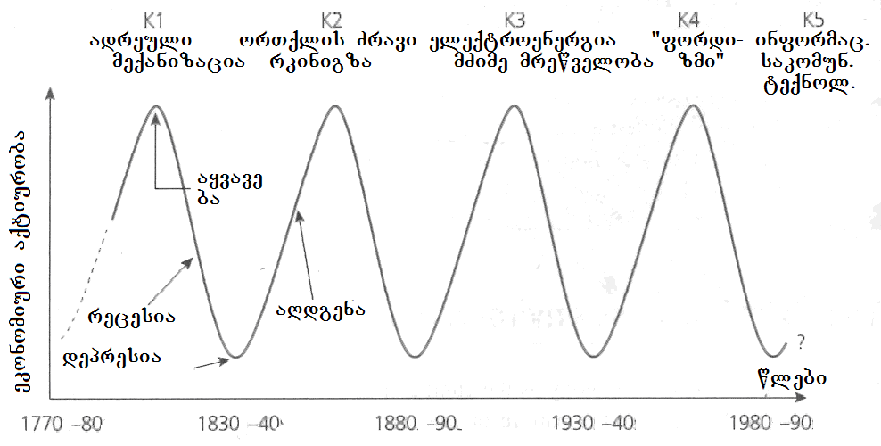
ნახ. 44
ekonomikuri ganviTarebis grZeli talRebi inovaciaTa cikluri bunebis asaxvaa. isini mniSvnelovani aRmoCenebis e.w. “gamSveb” efeqts Seesabameba, romlis Sedegad bazuri inovaciebis gamomwvev aRmoCenebs aucileblad mohyveba sxva, metad an naklebad mniSvnelovani teqnikuri siaxleebi. amis gamo, ekonomikis aRmavlobis periodebSi axali teqnika monaTesave jgufebad – klasterebad Cndeba da teqnikur-teqnologiuri evolucia jaWvuri reaqciis msgavsad viTardeba.
zogierTi Sefasebis mixedviT depresiebs, romlebic talRebis daRmaval nawilebSi viTardeba, arsebuli teqnologiebis, maTi Sesabamisi produqtebis da momsaxurebis daZveleba iwvevs. aseT periodebSi, bazari gadajerebuli xdeba "gadamwifebuli" produqciiT. eyrdnobian ra gazviadebulad optimistur prognozebs, mewarmeebi inerciiT agrZeleben investirebas daZvelebuli nawarmis gamoSvebaSi. masze moTxovnilebis jer stabilizebas, xolo Semdeg ki Semcirebas, mosdevs mogebis kleba da bazrebis SezRudva. Cndeba zedmeti Sroma da warmoebis gamouyenebeli SesaZleblobebi, romelTa SekveciT mewarmeebi cdiloben sakuTari danaxarjebis Semcirebas. yovelive amis Sedegad, ecema saqmiani aqtiuroba, iwyeba umuSevrobis zrda da deflacia, rasac mosdevs qarxnebis daxurva.
Tavi III. samewarmeo inovaciuri proeqtebis
marTva
Tavi ganixilavs proeqtebis menejmentis sakiTxebs: saproeqto samuSaoTa dekompozicias, SemsrulebelTa gundebis Seqmnas, drois grafikebis Sedgenas, realizebis monitorings da a.S., inovaciuri procesebis realizebasTan mimarTebaSi. aRwerilia inovaciuri da saproeqto saqmianobis kavSiri samrewvelo kompaniis operaciul saqmianobasTan da misi efeqtianobis uzrunvelmyofeli organizaciuli struqturebi. warmodgenilia proeqtebis dagegmvis da Sesrulebis kontrolis instrumentariumi: PERT-meTodi, hantis grafikebi da nakaduri ruqebi.

3.1. inovacia rogorc gardaqmnis procesi
inovaciuri procesis TiToeuli etapi sakuTar kiTxvebs badebs. dasawyisSi esenia: sad unda moiZebnos axali ideebi? rogor unda amovicnoT maT Soris iseTi, romelic imsaxurebs xorcSesxmas? procesis ganviTarebis kvalobaze axali kiTxvebi Cndeba: rogor unda gadavaqcioT ideebi axal produqtebad an momsaxurebad? rogor unda viwinaswarmetyveloT, Tu rodis dasWirdeba inovaciur proeqts axali resursebi da ra raodenobiT? vTqvaT Tu ara uari proeqtis Sesrulebaze, Tuki igi navaraudevze met resurs moixmars? rogor vmarToT novator-Semsruleblebis saqmianoba? proeqtis damasrulebeli fazis moaxloeba Semdegi kiTxvebis dayenebas moaswavebs: rogor gadavaqcioT inovaciebi arsebuli samuSao procesis da strategiis ganuyofel nawilad? rogor mivusadagoT organizaciis saerTo strategia inovaciebs?
yvela es kiTxva inovaciis damnergavi organizaciis wiaRSi ibadeba, magram Tavis namdvil Semowmebas inovacia mis miRma gadis. aq aseTi kiTxvebi Cndeba: Tu grZnoben gansxvavebas axalsa da Zvels Soris inovatori-kompaniis partniorebi da momxmareblebi? rogor unda gaizomos inovaciuri procesis warmateba?
SeiZleba iTqvas, rom am da sxva msgavs kiTxvebze pasuxebis moZieba inovaciuri procesis marTvis Sinaarss Seadgens. rogorc wesi, inovaciaTa saboloo zegavlenis zusti winaswarmetyveleba SeuZlebelia, Tumca, erTi ram Tavidanvea cnobili: maTi didi umravlesoba warumatebeli aRmoCndeba. aRniSnuli gvkarnaxobs, rom nebismieri inovaciuri strategia dabali ukugebis molodiniT unda igegmebodes. es garemoeba ki inovaciuri procesis mimdinareobis gansakuTrebulad unariani marTvis aucileblobas warmoSobs.
zemoT araerTxel aRiniSna is garemoeba, rom inovaciuri saqmianobis warmatebuloba biznesis Sedegianobis zrdaSi unda aisaxos. biznes-cikli, anu samewarmeo cikli SeiZleba aRiweros, rogorc nedleulis da sxva masalebis nawarmad gardaqmnis procesi. nawarmi SemdgomSi iqceva fulad, misi momxmareblebisTvis miyidvis gziT iseT fasSi, romelic sawarmoo xarjebs aRemateba.
daaxloebiT 1950-ian wlebamde es procesi pirvel rigSi nawarmze iyo orientirebuli, misTvis garkveuli niSan-Tvisebebis micemas isaxavda mTavar miznad da naklebad iTvaliswinebda momxmarebelTa interesebs. momdevno periodSi marketinguli midgomebis gavrcelebasTan erTad, mewarmeobaSi gabatonda Sexeduleba, rom produqti ar aris TviTRirebuli ram, igi mxolod momxmareblis moTxovnilebaTa dakmayofilebis saSualebaa.
es xedva principulad moiTxovs, rom rogorc mewarme, ise gadawyvetilebebis miRebis uflebis mqone yvela misi muSaki, sakuTar qmedebebSi ganuwyvetliv orientirebulni unda iyvnen SesaZlo momxmarebelTa interesebze. Tu adre konstruqtori axali nawarmis damuSavebisas, an teqnologi misi warmoebis procesis dagegmarebisas izolirebulni iyvnen komerciuli problemebisgan, ar evalebodaT maT mier SeTavazebuli teqnikur siaxleTa saTanado SesaZleblobebis ganxilva, axla maTgan moelian Semdgom damuSavebaSi mxolod iseTi profesiuli mosazrebebis da gadawyvetilebebis datovebas, romelTac Sesabamisi sabazro potenciali gaaCniaT.
amis misaRwevad, inovaciuri procesebi saTanadod unda imarTebodes. cnobilia, rom inovaciis Sedegiani realizebis ganmsazRvreli faqtorebia:
- misi bazarze orientireba;
- damnergavi organizaciis miznebisadmi Sesabamisoba;
- inovaciuri proeqtebis SerCevis da Sefasebis sistemis efeqturoba;
- proeqtebis Sesrulebis qmediTi kontroli;
- inovaciur ideaTa SemoqmedebiTi wyaroebis arseboba;
- damnergavi organizaciis midrekileba inovaciebisadmi;
- misi wevrebis individualuri da koleqtiuri pasuxismgebloba inovaciuri procesebis mimdinareobaze.
rogorc zemoT araerTgzis iTqva, xSir SemTxvevaSi inovaciis safuZvelia gamogoneba an aRmoCena. gamogoneba ideis formurileba, misi Camoyalibebaa, inovacia ki am ideis praqtikul xorcSesxmas warmoadgens. inovaciuri procesis dasrulebis Sedegad, idea ekonomikur Sinaarss iZens, ris uzrunvelsayofadac mas saTanado potenciali unda gaaCndes. aRniSnulis misaRwevad aucilebelia rac SeiZleba adreuli kavSiris damyareba inovaciis kvleva-damuSavebasa da siaxlis sabazro SesaZleblobebis marketingul Seswavlas Soris. swored am moTxovnis Sesrulebas ukavSirdeba erT-erTi mTavari sirTule inovaciuri procesebis realizebaSi.
axali nawarmis SeqmnasTan dakavSirebuli mosazrebebi rogorc mecnieruli kvlevis, aseve bazris moTxovnilebebis Seswavlis procesSi ibadeba. amasTan, zogierTi SefasebebiT, samewarmeo firmebis kvleviTi ganyofilebebidan gamodis inovaciuri ideebis saerTo raodenobis mxolod erTi meoTxedidan erT mesamedamde. Samagierod, swored es ideebi xdeba yvelaze radikaluri da msxvili inovaciebis safuZveli. ideebis orive am wyaros Sedegiani gamoyenebisTvis, saWiroa im qvedanayofebs Soris saTanado urTierTkavSiris damyareba, romlebic maTi ganviTarebiTaa dakavebuli. marketologebis da inJinrebis winaSe mdgomi profesiuli amocanebis formulireba iseTnairad unda xdebodes, rom maT sakuTari saqmianobis ganxilva biznesmenis, saqmiani adamianis poziciidanac uwevdeT.
RonisZiebebi, romelTa meSveobiTac samrewvelo firmebs SeuZliaT sakuTari personalis yuradRebis mimarTva bazrisken, Semdegia:
- Sesabamisi problemebis erToblivi gaazrebis uzrunvelyofa, swavlebis saTanado programebSi TanamSromlebis erTdrouli monawileobis meSveobiT;
- e.w. “horizontaluri” struqturebis Seqmna (samuSao jgufebi, komisiebi da a.S.), romlebic moxsnian formalur barierebs bazris problematikasTan SexebaSi myofi ganyofilebebis SeTanxmebuli muSaobis gzaze;
- personalis gadanacvleba, romelic ZiriTadad kvleviTi ganyofilebebidan marketingul samsaxurebSi im TanamSromlebis gadayvaniT xorcieldeba, romlebmac ukve gaiares Tavisi SemoqmedebiTi aqtiurobis piki;
- kvleviTi ganyofilebebis winaSe mdgomi amocanebis da marketingis ganyofilebebis miznebis saTanado formulireba;
- kvleviTi da marketingis ganyofilebebis xelmZRvanelebis erTdrouli monawileoba kompaniis strategiis SemuSavebaSi, inovaciuri proeqtebis Sefasebasa da SerCevaSi.
inovaciuri saqmianoba Sedegiani mxolod saTanado potencialis mqone ideebis da winadadebebis arsebobis pirobebSi iqneba. maTi raodenoba ki sxvadasxva garemoebebiT, pirvel rigSi, teqnologiis ganviTarebis saerTo doniT aris ganpirobebuli.
zemoT aRiniSna, rom teqnologiis ganviTareba garkveuli ciklurobiT mimdinareobs. pirvel xanebSi arsebobs ganviTarebis farTo SesaZleblobebi, magram droTa ganmavlobaSi im codnis meti wili, romelic SeiZleba efeqturad iqnes gamoyenebuli teqnologiis srulyofisTvis, realizebuli xdeba. amis gamo, mrewvelobis “Zveli” dargebi, arsebuli teqnologiebis da teqnikuri gadawyvetilebebis farglebSi, radikaluri inovaciebis naklebobas ganicdis. progresi maTSi mxolod mciredi gaumjobesebebis danergvis meSveobiT mimdinareobs da sul ufro ZviradRirebuli xdeba. Tuki teqnologia jer kidev sakmaod Sedegiania, momxmarebelTa moTxovnilebebis dakmayofileba nawarmis modificirebiT an misi iseTi axali nairsaxeobebis aTvisebis meSveobiT xdeba, romelTa warmoebas ar sWirdeba sawyisi teqnologiis sagrZnobi cvlileba. aseT pirobebSi moTxovnileba inovaciebze naklebia.
e.w. teqnologiurad aqtiur dargebSi ki (eleqtronika, farmacevtika, qimiuri mrewveloba da sxv.), teqnologias jer kidev srulyofis mniSvnelovani potenciali aqvs. Sesabamisad, moTxovnileba inovaciebze maTSi maRalia. arsebobs e.w. saSualo teqnologiuri aqtiurobis dargebic, magaliTad, manqanaTmSenebloba, romlebSic naklebad mosalodnelia radikaluri inovaciebis gamoCena, Tumca arsebobs bazuri teqnologiebis Semdgomi ganviTarebis mniSvnelovani SesaZleblobebi.
inovacia im axlis damkvidrebas moaswavebs, romelTanac SeTviseba masTan SexebaSi myofT xSirad uZneldebaT. es ki zogjer gaazrebul an gaucnobierebul winaaRmdegobas badebs maTSi. mis dasaZlevad saWiroa xelmZRvanelobis mizanmimarTuli moqmedeba, rac frTxilad da saTanado taqtiT unda tardebodes, vinaidan ZaliT Tavs moxveuli nebismieri cvlileba, zogjer sabotaJsac ki iwvevs.
yoveli realizebuli inovaciis ukan dgas iniciatori - pirovneba, an jgufi, romelic pasuxismgebelia garkveuli ideis praqtikul kalapotSi gadayvanaze. inovaciis warmatebisTvis mas unda nergavdnen sakmarisi pasuxismgeblobiT gamorCeuli muSakebi, romlebic Tavisi saqmianobis pirvel planze inovaciuri proeqtis realizebis miznebs daayeneben, mzad iqnebian gariskon sakuTari karieriT da piradi interesebiT.
imaze, Tu ramdens kargaven mewarmeebi aseTi figurebis daufaseblobis gamo, [12]-Si aRwerili Semdegi faqti metyvelebs. eleqtronuli sistemebis mwarmoebeli erT-erTi msxvili kompania garkveuli drois ganmavlobaSi datova 44-ma muSakma im mizeziT, rom kompaniam ar dauWira mxari maTi iniciativebis realizebas. sakuTari Canafiqris xorcSesxmisTvis, kompaniis am yofilma TanamSromlebma Camoayalibes 39 axali firma. 1966 wels, dafuZnebidan ramodenime wlis gasvlis Semdeg, amaTgan 34 warmatebiT ganagrZobda moqmedebas gayidvebis 72 mln dolaris toli saerTo moculobiT. im kompaniam ki, romelic datoves am firmebis damfuZneblebma, imave wels mxolod 30 mln dolaris produqciis gayidva SeZlo.

3.2. inovaciuri ideebis wyaroebi
inovaciuri winadadebebi da ideebi SeiZleba rogorc firmis Signidan, ise garedanac momdinareobdes. firmaSi axal nawarmze gadasvlis iniciatori SeiZleba umaRlesi xelmZRvaneloba da marketingis ganyofileba gaxdes, teqnologiuri cvlilebebisa ki - sawarmoo da kvleviTi ganyofilebebi. ideebis gare wyaroebia konkurentebi, masalebis da makompleqtebeli detalebis mimwodeblebi da momxmareblebi. xSirad konkurentebis nawarmSi asaxulia ideebi, romlebic ar aris saTanadod daculi da sruliad kanonierad SeiZleba maTi gamoyeneba sakuTari produqciisKK warmoebisTvis. inovaciuri ideebis metad mniSvnelovan wyaros warmoadgenen momxmareblebi: zogierTi SefasebebiT eleqtronuli komponentebis warmoebaSi danergil inovaciaTa daaxloebiT ori mesamedi momxmarebelTa karnaxiT iqna damuSavebuli.
inovaciebze orientirebuli samrewvelo mewarmeoba, rogorc procesi, oTx stadias moicavs: axali ideis moZieba da Sefaseba; samewarmeo gegmis Sedgena; aucilebeli resursebis mozidva; Seqmnili sawarmos marTva. gansakuTrebiT didi mniSvneloba swored pirvel stadias _ axali ideis moZiebas aqvs, rasac qvemoT ufro detalurad ganvixilavT.
samewarmeo idea, romlis safuZvelSia TviT mewarmis aqtiuri da gabeduli, yvela detalSi kargad mofiqrebuli inovaciuri iniciativa, SeiZleba Seexebodes rogorc sawarmoo process mTlianobaSi, ise mis erT, an ramdenime nawils. Tu yuradRebas samewarmeo ideis swored fragmentul formaze gavamaxvilebT, mewarmis saqmianobaSi SeiZleba Semdegi mimarTulebebi gamoiyos, romlebic sawarmos srul an nawilobriv ganaxlebas emsaxureba:
  - sawarmos marTvis sistemis Secvla;
  - axali teqnikis an teqnologiis gamoyeneba;
  - ufro ekonomiuri an sxva mosazrebiT gamosadegi masalebis gamoyeneba;
  - nawarmis dizainis da/an SefuTvis gaumjobeseba;
  - sawarmos sareklamo kompaniis organizebis principulad axali sqemis gamoyeneba.
amgvarad, inovaciuri samewarmeo idea SeiZleba ganvsazRvroT, rogorc originaluri saqonlis, momsaxurebis an maTi gaumjobesebuli variantebis da modifikaciebis, agreTve axali markebis warmoebis realurad arsebuli SesaZlebloba. mewarmisTvis mniSvnelovania TavisTvis gamoyos is informaciuli segmentebi, romlebic garkveuli inovaciuri ideis moZebnaSi daexmareba mas. aseTebs SeiZleba ayalibebdes konkretuli codna bazris da misi moTxovnilebebis Sesaxeb; warmoebis axali meTodebis, teqnologiebis, masalebis gamoCena; struqturuli an geografiuli wyveta romelime saqonliT uzrunvelyofaSi da a.S. amitom, konkretuli inovaciuri ideebisTvis biZgis mimcemebad SeiZleba dasaxeldnen:
- momxmareblebi, anu samomxmareblo moTxovnilebebis Seswavla;
- gamogonebebiT, axali masalebis da sasaqonlo maxasiaTeblebis moZiebiT dakavebuli mecnierebi, romlebsac SeuZliaT sasaqonlo produqciis da/an momsaxurebis axali orginaluri, an gaumjobesebuli variantis ganviTareba;
- konkurentebi: zog SemTxvevaSi, momxmareblis moTxovnilebebis Seswavlaze orientirebul maT saqmianobas, SeuZlia sakuTari inovaciuri ideis formirebisken ubiZgos mewarmes;
- savaWro agentebi, dilerebi da sxva Suamavlebi;
- mewarmis konsultantebi inovaciuri saqmianobis garkveul sakiTxebSi;
- uSualod misi sawarmos muSakebi.
sainteresoa piter drakeris mier SemuSavebuli klasifikacia, romlis mixedviT arsebobs inovaciuri ideebis Svidi wyaro [83]:
- moulodneli SemTxveva: sawarmos an dargisTvis - uecari warmateba, an warumatebloba, gauTvaliswinebeli gareSe movlena da a.S.;
- arakongruentuloba - Seusabamoba realobasa da masze Cvens Sexedulebebs Soris;
- procesis moTxovnilebebis Sesatyvisi siaxleebi (procesis moTxovilebebSi igulisxmeba misi is naklovanebebi da “susti adgilebi”, romelTa gamoricxva SesaZlebelia da romlebic unda iyos kidec gamoricxuli);
- bazris an dargis struqturuli cvlileba;
- demografiuli cvlilebebi;
- faseulobebis aRqmis, ganwyobebisa da mizanmimarTulebebis cvlilebebi;
- axali codna rogorc samecniero, ise arasamacniero.
drakeris azriT, sistematiuri inovaciuri procesi cvlilebebis mizanmimarTul da organizebul Ziebasa da maTi socialuri da ekonomikuri siaxleebis safuZvlad gamoyenebis SesaZleblobis analizSi mdgomareobs. inovaciuri ideebis pirvel oTx wyaros zemomoyvanili CamonaTvalidan, drakeri Siga sferos miakuTvnebs, vinaidan isini mocemuli sawarmos, mrewvelobis dargis, an momsaxurebis CarCoebSi imyofebian. aseTi wyaroebi xelmisawvdomia am sawarmoSi an dargSi momuSaveTaTvis. Bxolo danarCeni sami inovaciuri ideis gare wyaroebs miekuTvneba, vinaidan maTi warmomavloba mocemuli sawarmos an dargis miRma iwyeba. aRsaniSnavia, rom Svidive wyaros Soris ar arsebobs mkafio sazRvrebi da SesaZlebelia maTi urTierTgadakveTa.
Mmoulodneli SemTxvevis da misi, rogorc warmatebis Sansis gamoyenebis klasikur magaliTia kompania IBM–is reaqcia personaluri kompiuterebis gamoCenaze. IBM–Si didxans miiCnevdnen, rom momavali ekuTvnoda koleqtiuri sargeblobis eleqtronul gamomTvlel manqanebs da personaluri kompiuterebis ideas absurdulad Tvlidnen. Mmagram amas xeli ar |DSeuSlia kompaniisTvis, raTa droulad gamosuliyo personaluri kompiuterebis warmatebiT gamowveul Sokuri mdgomareobidan da maTi warmoebis lideri gamxdariyo. rogorc drakeri Tvlis, es wyaro ufro mniSvnelovania msxvili kompaniebisTvis, vinaidan isini ukeT xedaven saerTo suraTs da maT saWiro resursebis mobilizebis didi SesaZleblobebi aqvT.
Semdegi wyaroa _ realobis da masze warmodgenebis (imis, rac unda iyos) arakongruentuloba (Seusabamoba). igi qmnis uwonasworobas, romlis pirobebSi sul mcire Zalisxmevasac ki SeuZlia mTeli ekonomikuri meqanizmis amoqmedeba. Aamgvari arakongruentuloba biZgis mimcemia siaxlisTvis, magram misi gamovlena sakmaod Znelia, vinaidan ufro xarisxobriv xasiaTs atarebs, vidre raodenobrivs.
warmodgenebis da realobis Seusabamobis magaliTad gamodgeba 1950-ian wlebSi gavrcelebuli Sexeduleba, rom zRviT gadazidvebs male bolo moeReboda, tvirTebis miwodebis dauSveblad didi drois gamo. amitom,Mmwvave problemad gemebiT momsaxurebis siswrafis gazrda dasaxelda. sul ufro meti saxsrebi ideboda gemebis srulyofaSi, maSin, rodesac saWiro iyo aqcentis gadatana maTi datvirTva-gadmotvirTvis teqnologiebis srulyofaze. Ees problema gadaiWra kidevac konteinerebisa da specializebuli gemebis gamoyenebis meSveobiT.
realobasa da masze Sexedulebis analogiuri arakongurentulobiT aixsneba televizorebis gayidvis moulodneli warmateba omis Semdgom iaponiaSi. iTvleboda, rom gaRaribebul adamianebs ar SeeZloT maTi masobrivi SeZena. magram am SemTxvevaSi ar iqna gaTvaliswinebuli is, rom televizori ara ubralod samomxmareblo nivTia, aramed “fanjaraa samyaroSi”, ris gamoc sxva, socialuri statusic aqvs.
axasiaTebs ra Siga procesebis gaumjobesebis moTxovnilebas, rogorc inovaciuri ideebis wyaros, drakeri gvaxsenebs, rom “aucilebloba badebs gamogonebebs”. siaxlisTvis fexis mokidebis Sansis mimcemi situacia, SemdegSi mdgomareobs: organizaciaSi yvelam icis susti rgolis arsebobis Sesaxeb, magram aravin arafers akeTebs mis gamosasworeblad. rogorc ki siaxle dainergeba, mas maSinve TavisTavad cxad ramed aRiqvamen da igi maleve iqceva normad. aRwerili moTxovnilebis dakmayofilebisTvis saWiro arsebiTad axali codnis miRebis aucilebloba, mniSvnelovani momentia am wyaros gamoyenebaSi.
kompaniis, an dargisTvis siaxlis bolo Siga wyaros warmoadgens bazris an dargis struqturis cvlileba. Eigi SesaZloa mravali wlis ganmavlobaSi ar icvlebodes da sakmaod stabiluradac gamoiyurebodes, magram sinamdvileSi metad myife iyos. dargis struqturaSi cvlilebebis moaxloebis maniSnebelia teqnologiebis swrafi ganviTareba da Serwyma.
inovaciuri ideebisTvis erT-erTi mniSvnelovani biZgis mimcemia cvlilebebi mosaxleobis SemadgenlobaSi, sqesobriv-asakobriv struqturebSi, dasaqmebaSi, ganaTlebis doneSi, SemosavlebSi da a.S. miuxedavad imisa, rom demografiuli cvlilebebis aRricxvis aucilebloba sayovelTaod cnobilia, zogierTi mewarme jer kidev darwmunebulia, rom yoveldRiuri saqmiani praqtikis maTTan SekavSireba SeuZlebelia. magram swored demografiuli cvlilebebi qmnis xSirad nayofier niadags im mewarmeTaTvis, vinc saTanadod aRiqvams maT dadgomas. magaliTad, biznesis marTvis sferoSi dasaqmebul axalgazrda mamakacTa nakadis Semcirebam, rac demografiuli situaciiT iyo gamowveuli, Tavis droze mniSvnelovani sirTuleebi Seuqmna mraval amerikul kompanias. maT daiwyes erTmaneTTan gamalebuli brZola axali kadrebis mozidvisTvis, maSin rodesac problema sxvanairad unda gadawyvetiliyo - axalgazrda qalebis dasaqmebiT. amas pirvelad niu-iorkis “City Bank”-Si mixvdenen, ris gamoc SesaZlebloba SeeqmnaT ukonkurentod da, Sesabamisad, bankisTvis xelsayreli pirobebiT mieRoT samuSaod biznes-skolebis saukeTeso kursdamTavrebuli gogonebi.
inovaciurobis Semdeg, mniSvnelovani wyaroa miRebuli faseulobebisa da Sexedulebebis cvlileba. rogorc drakeri xatovnad aRniSnavs, Semdegi ori gamoTqma: ”Wiqa naxevramde savsea” da “Wiqa sanaxevrod carielia”, maTematikis TvalTaxedviT erTmaneTisgan ar gansxvavdeba, magram biznesisa da sazogadoebisTvis sxvadasxvaa. Tu aRqma pirvelidan meoris mimarTulebiT icvleba, maSin realuri Sansi iqmneba siaxlisTvis. moulodneli warmateba an marcxi xSirad xdeba ganwyobebSi cvlilebis mizezi. rodesac aseTi cvlileba dgeba, faqtebi ar icvleba, aramed icvleba mxolod maT mimarT damokidebuleba. aRsaniSnavia, rom am wyaros gamoyenebisas didi mniSvneloba eniWeba drois faqtors.
gamoyofs ra inovaciebis kidev erT wyaros - “axal codnas”, anu gamogonebebis da aRmoCenebisTvis biZgis mimcem ideebs, drakeri mas mewarmeobis “supervarskvlavs” uwodebs. axal codnaze dafuZnebuli siaxleebi sxvebisgan iseTi ZiriTadi maxasiaTeblebiT gamoirCeva, rogoricaa aTvisebisTvis saWiro drois Sualedis, warumateblobis Sansis da Sedegis ganWvretebadoba, TviT mewarmis mimarT wayenebuli moTxovnebis done da a.S.
drois Sualedi, romelic axal aRmoCenas an gamogonebas maT safuZvelze damuSavebul gamoyenebiT teqnologias da misi bazris aTvisebas aSorebs, xSirad 20-25 welia. aseTi wyveta Sinaganad damaxasiaTebelia axal codnaze dafuZnebuli siaxleebisTvis. Ddrakeris azriT, aseTi siaxleebis meore damaxasiaTebel niSans ramdenime axali ideis gaerTianeba warmoadgens, romelTaganac zogi SesaZloa sulac ar iyos mecnieruli kvlevis Sedegi. dabolos, axal codnaze dafuZnebuli siaxleebi, sxvebTan SedarebiT ufro meti riskis Semcvelia.
drakeris azriT, axali codnis integracias mudmivad kontrolirebadi inovaciuri ideebis sistemaSi da inovaciuri marTvis sistematur gamoyenebas, SeuZlia ufro warmatebuli gaxados inovaciuri procesi. siaxleebi, romelTa safuZvels ZiriTadad brwyinvale ideebi warmoadgenen, yvelaze ufro revoluciuria.

3.3. inovaciuri procesis dagegmva
arcTu Soreul warsulSi, mewarmeebs ar uWirdaT gare, kerZod bazarze arsebuli pirobebis cvlilebebze drouli reagireba. dRes ki, ekonomikur garemocvaSi mimdinare swrafi gardaqmnebi, maTgan adre warmoudgeneli dinamizmis mqone samewarmeo politikis SemuSavebas da gatarebas moiTxovs. am gamowvevis sapasuxod, 1960-iani wlebidan samrewvelo korporaciebma daiwyes dagegmvis formaluri meTodebis farTo gamoyeneba.
nebismieri samewarmeo gegmis mTavari amocanaa im nawarmisa da bazrebis gansazRvra, romlebmac unda uzrunvelyon firmis Semdgomi zrda. gegmis Sedgenisas aucilebelia rogorc sakuTari potencialis gaTvla, ise samewarmeo garemos mosalodneli cvlilebebis Sefaseba, masTan urTierTobis SesaZleblobebis da siZneleebis gaTvaliswineba. yovelTvis arsebobs iseTi situaciebis warmoqmnis albaToba, rodesac TavisTavad mimzidveli produqti raime mizezis gamo miuRebeli xdeba konkretuli firmisTvis. dagegmvis procesSi unda gamoiricxos aseTi viTareba.
aRsaniSnavia, rom im SemTxvevebSic ki, rodesac firmas ar gaaCnia formaluri gegma, misi marTvis umaRles eSelonebSi mainc unda iyos Camoyalibebuli strategiuli mosazrebani, vinaidan warmatebuli ganviTareba spontanurad, SemTxveviT, praqtikulad SeuZlebelia. korporaciuli gegmis ararsebobisas, marTvis qveda doneebs uWirT sakuTari gadawyvetilebebis zeda eSelonebis miznebTan SesabamisobaSi moyvana. es ki mkveTrad zrdis maT mier gadadgmuli nabijebis araadekvaturobis SesaZleblobas. yuradsaRebia isic, rom mouqnelma dagegmvam SeiZleba inovaciuri aqtiurobis dacemac ki gamoiwvios.
im inovaciuri proeqtebis analizi, romlebmac warumatebloba ganicada, an ar iyo bolomde miyvanili, aCvenebs, rom xSirad marcxis mizezia winaswar arsebuli informaciis gauTvaliswinebloba. niSnadi informacia dasawyisSive iyo cnobili, magram igi ar iyo droulad da sworad gaanalizebuli saTanado Semfasebeli procedurebis meSveobiT. Amitom, inovaciuri procesis sawyis etapebze gansakuTrebul mniSvnelobas iZens proeqtebis SerCevis da Sefasebis meTodebis gamoyeneba, romelTa speqtri metad farToa - umartivesi sakontrolo furclebidan dawyebuli, operaciaTa kvlevis rTuli maTematikuri midgomebiT damTavrebuli. amasTan gasaTvaliswinebelia, rom meTodis swori arCevisTvis aucilebelia misi realizebisTvis saWiro relevanturi monacemebis miRebis SesaZleblobis Sefaseba. vargisiani sawyisi monacemebis pirobebSi, praqtikulad yvela meTodi proeqtebis gaazrebuli amorCevis sakmaris SesaZleblobas iZleva.
inovaciis warmateba dakavSirebulia ara marto proeqtis swor SedgenasTan, aramed misi xorcSesxmis mimdinareobis saTanado marTvasa da kontrolTanac. arasakmarisma kontrolma SesaZloa gamoiwvios saerTo danaxarjebis da proeqtis Sesrulebis vadebis gaumarTlebeli gadaWarbeba. inovaciis damuSavebis da aTvisebis TiToeuli stadia moiTxovs marTvis sakuTari stilis da meTodebis gamoyenebas, romlebic procesis sxva fazebisTvis SeiZleba gamousadegaric ki aRmoCndes.
ase, magaliTad, gamoyenebiTi kvlevebis Catarebisas proeqtze mxolod specialistTa mcirericxovani jgufi muSaobs, romlebic maRali gaurkvevlobis pirobebSi moqmedeben. am SemTxvevaSi misaRebia menejmentis araformaluri meTodebis gamoyeneba, romlebic marTvaSi koleqtiur monawileobas gulisxmobs. proeqtis ganviTarebis im stadiebze ki, rodesac SesaZlebelia materialuri danaxarjebis da realizebis drois dasabuTebuli Sefaseba, iwyeben marTvis formaluri procedurebis gamoyenebas, biujetis damuSaveba-damtkicebiT, Sesrulebis mimdinareobis monitoringiT da a.S.
zemoTqmuli adasturebs, rom inovaciuri procesis Sedegiani warmarTvisTvis, saWiroa proeqtebis marTvis saTanado sistemis gamoyeneba. igi moqnilad unda moergos proeqtis realizebis sxvadasxva etapis Sinaarssa da daniSnulebas. aseTi sistemis Seqmna inovaciuri procesis erT-erTi aucilebeli amocanaa, swored misi da Sesabamisi mmarTvelobiTi informaciis uqonlobaa xSirad inovaciaTa warumateblobis mizezi.

3.4. inovaciuri procesis SeTavseba operaciul
saqmianobasTan
nebismier ganviTarebul firmasa Tu kompaniaSi, inovaciuri saqmianoba yoveldRiuri operaciuli moqmedebis fonze mimdinareobs. saqmianobis orive am nairsaxeobis Sesruleba, organizebis gansxvavebuli formebis gamoyenebas moiTxovs. Tu operaciuli saqmianoba samuSao amocanas etapebad hyofs, inovaciur procesi erT mTlianobad aRiqmeba misi Semsruleblis mier. Tu operaciaTa Semsrulebelebi funqciur ganyofilebebSi arian ganawilebulni, inovaciuri process erTiani mravalprofiliani gundi uZRveba. rogorc wesi, operaciuli amocana im funqciaTa Tanamimdevruli rigis realizebis meSveobiT wydeba, romelSic Sesasrulebeli samuSao "inacvlebs" funqciidan funqciisken. inovaciuri amocana ki piriqiT, "adgilze rCeba" da gundis sxvadasxva codnis da profesiuli unar-Cvevebis mqone wevrebi, pirobiTad, rom vTqvaT, misken moZraoben.
inovaciuri procesis marTvaze msjeloba imis ganxilviT unda iwyebodes, Tu ra ganasxvavebs mas operaciuli saqmianobisgan. operaciebis Sesruleba im yoveldRiuri rutinuli samuSaos Sinaarss Seadgens, romlis meSveobiTac aRwevs sawarmo Tavis arsebobis mizans – uSvebs materialur produqcias an eweva momsaxurebas. operaciul da inovaciur saqmianobas Soris dinamikuri kavSiri arsebobs. swored, inovaciaTa danergvis wyalobiT iZens axal Sinaarss operaciuli moqmedebebi, xdeba ufro mwarmoebluri, efeqtiani da SesrulebisTvis sasiamovno. Tavis mxriv, operaciuli saqmianoba ayalibebs inovaciuri procesebis safuZvels da ganviTarebis kalapots, sxva SemTxvevaSi, inovatorTa SemoqmedebiTi muSaoba arafers SesZenda realur samyaros da misi Sedegebi mxolod xorcSesxmul ocnebebad darCeboda.
Tanamedrove SromiT koleqtivebSi samuSaos es ori nairsaxeoba cal-calke sruldeba, mas xom sxvadasxva miznebi, gansxvavebuli moTxovnebi da resursuli saWiroebebi aqvT. magram eWvgareSea, rom orive cikli ara marto damoukidebeli, aramed urTierTSekavSirebulic aris.
rogorc zemoT iTqva, operaciuli saqmianoba mdgomareobs Cveulebrivi da yoveldRiuri funqciuri samuSaos SesrulebaSi, romelsac mkafiod Camoyalibebuli mizani aqvs da romelic dadgenili standartebisa da wesebis Sesabamisad unda mimdinareobdes. operaciuli cikli SeiZleba 4 stadiiT warmovidginoT:
- dagegmva – raimes gakeTebis, Secvlis, an gamocdis;
- Sesruleba – imisi, rac daigegma;
- Sefaseba – Sesrulebulis Seswavla;
- moqmedeba – samive dasaxelebulis gameoreba ucvlelad an axleburad gakeTeba, axali codnis safuZvelze.
aseTi ciklis mTavari Tavisebureba mis ganmeorebadobaSia, rac rasakvirvelia, ar gamoricxavs erTi ciklidan momdevnoze gadasvlisas Sesrulebis TandaTanobiT daxvewas, ris gamoc operaciuli saqmianobis mwarmoebluroba izrdeba. amitom aRweril cikls xSirad, Seswavlis modelsac uwodeben.
operaciuli ciklisgan gansxvavebiT, inovaciur ciklSi sruliad axali ramis Seqmnas cdiloben. Sesabamisad icvleba misi calkeuli stadiebis Sinaarsic, esenia:
- kvleva – axlis Zieba, SeiZleba ubralo cnobismoyvareobis safuZvelzec ki;
- aRmoCena – garkveuli kriteriumis (kriteriumebis) TvalsazrisiT saintereso raimes povna;
- ganviTareba – aRmoCenilze muSaoba, raTa Seiqmnas praqtikuli sargeblobis momtani nivTi, procesi an codna;
- dadastureba – aRmoCenilis ganviTarebiT miRebuli Sedegis vargisianobis Semowmeba.
warmoebaSi inovaciur ciklze gadasvlas ZiriTadad ori mizezi ganapirobebs. erTia krizisi, romelmac SeiZleba axali ideebis gamalebuli Ziebisken ubiZgos mis liderebs. samwuxarod, aseT situacias iSviaTad aqvs adgili SemoqmedebiTi aqtiurobis pikze; xolo, rodesac krizisi TvalnaTelia, ukve dro aRar rCebaT arsebulisgan mkveTrad gansxvavebuli gamosavlis ZiebisTvis. meore mizezi subieqturia, es SeiZleba iyos xelmZRvanelTa gadawyvetileba garkveuli droiT mTlianad, an nawilobriv SeaCeron operaciuli cikli da sanacvlod inovaciuri procesi “gauSvan”.
orive SemTxvevaSi saTanado gadawyvetilebebis miReba gaazrebulad unda xdebodes, Sesabamisi safuZvlis momzadebis fonze. inovaciur procesze gadasvlis saukeTeso droa operaciuli ciklis stadia “moqmedeba”. swored misi dasrulebisTvis SesaZlebelia adrindel moqmedebaTa Sedegebis Seswavla da imis dadgena, rom igi ukve gamousadegari an axali viTarebis araadekvaturia. frTxil damokidebulebas moiTxovs inovaciuri ciklidan operaciulSi dabrunebis drois SerCevac. inovaciis CarTva samoqmedo gegmebSi ise unda xdebodes, rom erTis mxriv mas hqondes warmatebis Sansi, xolo meore mxriv amiT umniSvnelod, mxolod minimaluri aucileblobis doneze irRveodes danarCeni saqmianobis msvleloba.
operaciuli saqmianobis Sinaarsi da mimdinareobis xasiaTi, organizaciis funqciur struqturas warmoSobs. misi Camoyalibebisas, operaciuli saqmianobis Semadgenel procesebs yofen nawilebad da TiToeulisTvis niSnaven pasuxismgebel funqciur ganyofilebas. zogadi xasiaTis funqciebi – adamianuri resursebis gamoyeneba, finansebis marTva da a.S., an sruldeba funqciur ganyofilebebSi, an erTiandeba saerTo uzrunvelyofis funqciaSi, romlis Sesrulebas administraciuli ganyofileba uZRveba.
aseT struqturas aqvs mTeli rigi upiratesobani. vinaidan funqciuri Semsruleblebi mravaljer atareben erTsa da imave operaciebs, maT eqmnebaT sakuTari SesaZleblobis ganviTarebisa da SedarebiT, stabilur viTarebaSi saqmianobisTvis saWiro pirobebi. es garemoeba, maTi muSaobis ekonomikuri efeqtianobis zrdis mniSvnelovan winapirobas warmoadgens. vinaidan Sesasrulebeli operaciuli samuSao sakmarisad zustad aris gansazRvruli, SesaZlebelia misi efeqturobis da efeqtianobis Sefaseba miRebuli Sedegebis dadgenil standartebTan SedarebiT.
magram, muSaobis organizebis am wess garkveuli xarvezebic aqvs. Semsruleblebi “ver xedaven tyes xeebs miRma” - maT uWirT imis warmodgena, rom sakuTari wvlili SeaqvT kompaniis miznebis miRwevaSi. es erT-erTi mizezia sxvadasxva funqciur ganyofilebebs Soris warmoqmnili xSiri konfliqtebisa. funqciuri struqtura mouqnelia, samuSaos Sinaarsis da Semadgenlobis cvlilebis saWiroeba organizaciuli struqturis gardaqmnis mniSvnelovan da rTulad realizebad amocanas warmoSobs. funqciuri struqtura xels uSlis kvalifikaciis srulyofas, personalis “swavlas momavlisTvis”, masSi dasaqmebuli adamianebi sakuTar TavSi mxolod im unar-Cvevebis ganviTarebisTvis arian stimulirebulni, romlebic maTi mimdinare samsaxurebrivi movaleobebis Sesrulebas ukavSirdeba.
funqciuri struqtura gamousadegaria inovaciaTa ganviTarebisTvis. igi ver egueba im siaxleTa danergvas, romlebic mis arsebul monoliTurobas angrevs. naklebad savaraudoa, rom yoveldRiur problemebTan gamkvlavebiT daRlilma operaciulma menejerma aitacos axali ideebi da xeli Seuwyos maT xorcSesxmas. maSinac ki, rodesac ukve Cans arsebuli operaciuli procesis daSlis tendencia, igi inovacias, mxolod am daSlis damaCqarebel faqtorad aRiqvams. bunebrivia, am TvalsazrisiT inovaciis yvelaze didi mteri warmatebis momtani muSaobaa, icis ra, raoden didi SromiT iqna miRweuli warmateba, operaciuli menejeri yovelmxriv Tavs aaridebs axal ideebs.

3.5. inovaciaTa xelSemwyobi organizaciuli
struqtura
menejerebi xSirad cdebian, rodesac SemoqmedebiT da inovaciur saqmianobas TavisTavad, bunebrivad mimdinare spontanur procesebad miiCneven. Tuki maT organizaciaSi inovaciebi ver imkvidrebs fexs, isini amaSi gare mizezebs adanaSauleben, romelTa moxsna, maTi azriT, gzas gaukafavda organizaciis TanamSromelTa inovaciurobas. sinamdvileSi ki adamianebis Semoqmedebisken miswrafebis amoqmedebas, iseve rogorc TviTgadarCenis instiqts, Sesabamisi biZgis micema da kalapotis gaWra esaWiroeba, rasac xels uwyobs organizaciis saTanado struqturireba.
organizaciaSi arsebuli moTxovnileba Semoqmedebaze, damokidebulia mis winaSe mdgar amocanebsa da Sesasrulebeli samuSaos xasiaTze. Zaldataneba am saqmeSi dauSvebelia, adamianebi unda akeTebdnen gacnobierebul arCevans Semoqmedebis sasargeblod, iseve rogorc organizaciebi unda irCevdnen inovaciebs. Tuki siaxleebis aTviseba ar aris Cadebuli organizaciis strategiaSi, igi ver mouZebnis Tavis wiaRSi adgils inovaciur procesebs. Sesabamisad savaraudoa, rom mis muSakebSi arasdros gaiRviZebs SemoqmedebiTi Jini, inovaciebi ki mxolod stabilurobis winaaRmdeg mimarTul safrTxed iqneba aRqmuli organizaciis SigniT.
Orogorc ukve aRvniSneT, inovaciuri saqmianoba unda iyos gamoyofili (SeiZleba daculic ki) operaciuli saqmianobisgan. es garemoeba garkveul moTxovnebs uyenebs inovaciur strategies, esenia:
- inovaciuri procesi unda imarTebodes calke. organizaciis sididis mixedviT, igi SeiZleba mimdinareobdes amisTvis sagangebod gamoyofili menejeris, gundis, ganyofilebis an praqtikulad damoukidebeli kompaniis pasuxismgeblobis qveS;
- inovaciuri saqmianoba unda iyos organizaciis politikis da praqtikis nawili. inovaciebi iSviaTad muSaobs “gverdze”, ganyenebulad.
- siaxlis danergva moiTxovs koncentrirebul moqmedebebs. raRac axlis aTviseba sakuTar sferoSic ki sakmaod Znelia, rom ar vTqvaT mis kidev sadme danergvaze;
- unda arsebobdes maRali pasuxismgebloba. inovaciebze pasuxs unda agebdes sagangebod daniSnuli warmomadgeneli umaRlesi menejmentis wridan;
- inovaciebze gaweuli xarjebi biujetSi calke striqonad unda fiqsirdebodes. inovaciuri saqmianobis gansxvaveba operaciuli saqmianobisgan aisaxeba adamianTa dasjis da waxalisebisTvis gamoyenebul midgomebSi, ukugebebis SefasebebSi da a.S. yvelaferi es, inovaciuri proeqtebis maRalriskianobasTan erTad, zust angariSgebas da yuradRebian marTvas moiTxovs.
- unda arsebobdes inovaciebze pasuxismgebeli adamianebis, an ganyofilebebis angariSvaldebuleba xelmZRvanelobis winaSe. swored angariSvaldebulebis mixedviT gansazRvravs sakuTar adgils organizaciaSi inovaciuri ganyofileba.
marTvis tradiciuli ierarqiuli sqemebiT moqmed korporaciebs didi energiis xarjva uwevT sakuTari Siga saqmianobis saTanadod warmarTvis uzrunvelsayofad. problemebi, romlebic Cndeba, magaliTad, ierarqiis sxvadasxva doneebs Soris informaciis gadacemisas an marTvis gansxvavebul vertikalebs mikuTvnebuli qvedanayofebis erToblivi muSaobis organizebisas, gansakuTrebiT mwvaved inovaciuri procesebis warmarTvisas iCens Tavs. amis gamo. organizaciuli ierarqiis sanacvlod, msxvili kompaniebi xSirad horizontaluri korporaciis koncefciaze agebul marTvis struqturebs iyeneben.
horizontaluri struqtura gamoricxavs Siga saqmianobis mamuxruWebel@mraval process, an asustebs maT zegavlenas da kompaniis yvela resurss momxmareblis dakmayofilebisken mimarTavs. igi angrevs mmarTvelobiT ierarqias, xsnis sazRvrebs organizaciis qvedanayofebs da funqciebs Soris. horizontaluri korporaciis saorganizacio safuZvelia mravalprofiliani gundebi, romlebic Zireuli procesebis realizebiT arian dasaqmebuli [56]. aseTi procesebis magaliTebia axali produqciis ganviTareba, gayidvebis uzrunvelyofa da sxva msgavsi procesebi. horizontaluri organizaciis umaRles xelmZRvanelobasa da uSualod sawarmoo procesebSi CarTul personals Soris marTvis sul sami-oTxi done arsebobs.
horizontaluri organizaciis koncefcia udides zegavlenas axdens inovaciuri procesebis mimdinareobis uklebliv yvela aspeqtze. magaliTad, axali nawarmis damuSaveba iwyeba ara saTanado qvedanayofebis winaSe viwro amocanebis dayenebiT, aramed kompaniaSi Sesabamisi im “gamWoli” procesis momzadebiT da realizebiT, romelic yvela saWiro funqciis Sesrulebas moicavs. sawarmoo miznebi, upirveles yovlisa, momxmareblis dakmayofilebiskenaa mimarTuli, iseTi amocanebi ki, rogoricaa warmoebis rentabelobis zrda, an aqcionerTa interesebis gaTvaliswineba, meore planze gadadis. specialistebis SefasebiT, aseTi midgomebis gamoyeneba daaxloebiT samjer amcirebs konkretuli produqtis damuSavebisa da bazarze gatanis periods.
inovaciuri procesis miznis misaRwevad, horizontalur organizaciaSi mravalprofilian gundebs iyeneben. isini aerTianeben rogorc farTo kompetenciis mqone menejerebs, ise viwro specialistebsac. swored pirvelebs ekuTvniT gundSi lideroba, saWiro resursebis mozidvis da gundis wevrebis saqmianobis saTanado koordinirebis pasuxismgebloba. specialuri sakiTxebis gadawyvetisas jgufis wevrebi praqtikulad sruliad damoukidebelni arian.
muSaobis aseTi pirobebi kardinalurad cvlis momuSaveTa individualur miznebs da damokidebulebas saqmisadmi. maT axali warmodgenebi uCndebaT karieraze, isini axla ukeT xedaven kompaniis saerTo miznebs da imas, Tu ra zegavlenas moaxdens maT miRwevaze konkretuli amocanebis gadawyveta. samsaxurebriv saqmianobaSi maTTvis mTavaria partniorebTan TanamSromloba, gunduri Sedegebis miRweva da ara ierarqiul vertikalze “aRmasvla”.

3.6 proeqti – inovaciuri procesis
realizebis forma
yvela zemoTqmulis gaTvaliswinebiT SeiZleba davaskvnaT, rom inovaciuri amocanis Sinaarsis formulirebis da Sesrulebis uzrunvelyofis saukeTeso formaa proeqti. proeqtebi xom samuSaos avtonomiuri, calke dafinansebuli da marTuli “atomebia”, romelTagan TiToeuli sakuTari Sedegis miRebis mizniT aris wamowyebuli. proeqtis formati saocrad moxerxebulia inovaciaTa gasaviTareblad. igi Sesasrulebeli samuSaos calke ciklad gamoyofis SesaZleblobas iZleva, amasTanave, proeqti organizaciis sakuTari farTo strategiis nawilad rCeba. proeqtiT Sesasrulebeli samuSao calke striqonad aisaxeba organizaciis biujetSi da sagangebod gamoyofili menejeris meTvalyureobis qveS eqceva.
proeqtis warmatebuli dasrulebis albaTobas mkveTrad zrdis gunduri pasuxismgeblobis arseboba mis Sesrulebaze. proeqti organizaciulad moqnilia: rodesac amocana Sesrulebulia an piriqiT - rodesac masze sabolood iTqva uari, gundi SeiZleba ubralod daiSalos yovelgvari organizaciuli problemebis da pasuxismgeblobebis gareSe. proeqtebze muSaoba xels uwyobs mis SemsrulebelTa realur swavlebas, vinaidan TiToeul axal amocanas sakuTari unikaluri Taviseburebebi aqvs.
rasakvirvelia, proeqtis organizaciul formas potenciuri problemebic axasiaTebs. misi realizebisas Sesasrulebeli amocanebis mizani SeiZleba bundovani iyos. saSiSia proeqtis moqnilobis gadazrda arastabilurobaSi, romlidanac gamosvlas damatebiTi mxardaWera SeiZleba dasWirdes SemsrulebelTa mxridan.
proeqtis Semsrulebeli gundis muSaoba moiTxovs koleqtivSi samuSao viTarebis Seqmnas da SenarCunebas, rasac sakmao Zalisxmeva SeiZleba dasWirdes raTa misma wevrebma icodnen, Tu ras moelian maTgan da rogor Caewereba maTi muSaoba proeqtis realizebis saerTo msvlelobaSi. proeqtis realizeba, rogorc wesi, izolirebulia danarCeni organizaciis saqmianobisgan, aman ki SeiZleba mis SemsruleblebSi perspeqtivis xedvis an strategiul gegmebTan Sesabamisobis SegrZnebis dakargva gamoiwvios.
miuxedavad horizontaluri korporaciis organizaciuli sqemis im upiratesobebisa, romlebzec zemoT iyo saubari, organizaciaTa umravlesobis agebis safuZvlad, dResac funqciur-ierarqiuli sistema rCeba. maTSi inovaciuri proeqtebis realizebisTvis xSirad e.w. matriculi marTvis (matrix management) gamoyenebas cdiloben [57].
matricul organizaciaSi iqmneba proeqtze momuSaveTa gundi, romlis wevrebi funqciuri ganyofilebebis TanamSromelTa rigebidan iniSnebian (nax. 45). gundis (proeqtis) xelmZRvanels sruli pasuxismgebloba ekisreba proeqtis Sesrulebis Sedegebze, vadebsa da xarjebze. amasTan Semsruleblebi, gundis wevrobasTan erTad, funqciuri ganyofilebebis TanamSromlebadac rCebian. Sesabamisad, isini erTdroulad ori batonis msaxurebad SeigrZnoben Tavs, ris gamoc matriculi sistema “idealuria” konfliqtebis warmoSobisTvis.
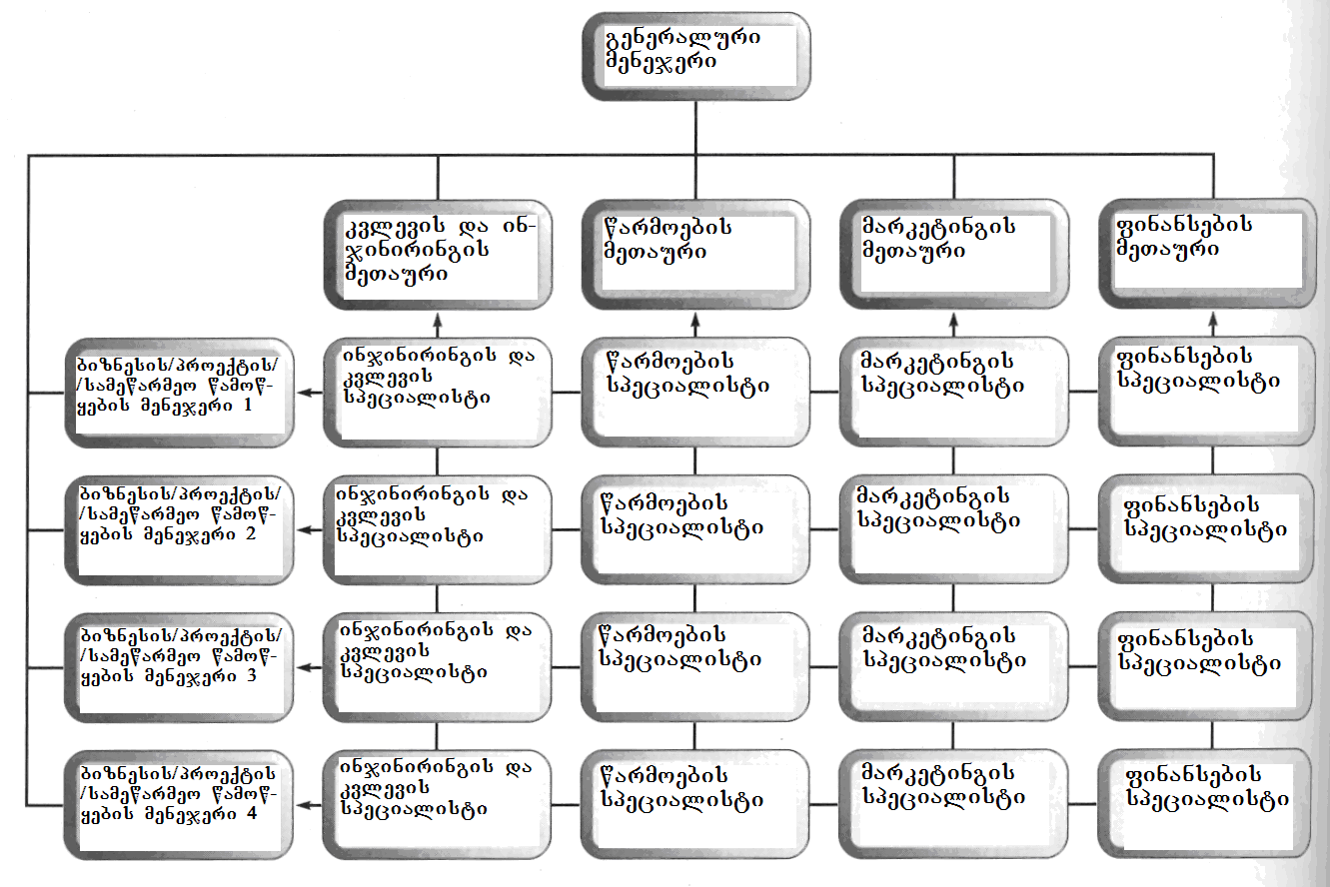
nax.45
yvelaze xSirad interesTa konfliqti warmoiqmneba proeqtebis xelmZRvanelebsa da funqciur menejerebs Soris, romlebic maT ar eqvemdebarebian. proeqtis xelmZRvanelebi moiTxoven, rom Semsruleblebma mTlianad dauTmon dro da sakuTari profesiuli resursebi proeqtis Sesrulebas, isini ki iZulebulni arian sakuTari ganyofilebebis menejerebsac daemorCilon. maTTvis diskomforts qmnis is garemoebac, rom muSaobis awyoba uwevT SeuCvevel, ucxo kolegebTan. maT aRizianebT gaurkvevlobac xvalindel dReSi, rodesac proeqtis Sesruleba damTavrdeba da isini mTlianad sakuTar funqciur menejerTa gankargulebaSi da adrindeli TanamSromlebis garemocvaSi dabrundebian.
konfliqturi situaciebisTvis xelSemwyobi a da sxva msgavsi mizezebisTvis gverdis avlis erTaderTi saSualebaa organizaciis SigniT proeqtis sruli izolireba. amisTvis kompaniis wiaRSi droebiT qmnian e.w. damoukidebel saproeqto organizacias (dso), romlis xelmRvanelic (imavdroulad igi proeqtis menejericaa), aRmasrulebeli direqtoris rangs iZens da mxolod kompaniis umaRles xelmZRvanelobas emorCileba. dso-s TanamSromlebi - rogorc kompaniis muSakebi, aseve gareSe pirebi, samuSaod ahyavT daqiravebul Semsrulebleblad, an konsultantebad. es garemoeba ganapirobebs swored dso-s mTavar xarvezs: proeqtis daxurva Znelia, vinaidan misi realizebisTvis ukve Seqmnilia mTeli organizaciuli struqtura.
bolo wlebSi gamoCnda dso-s axali nairsaxeoba – e.w. venCuruli jgufi (venture team). rogorc wesi, es aris mcire saproeqto gundi, romelic damoukidebeli biznesis TiTqmis yvela uflebiT sargeblobs da romlis mimarTac damfuZnebeli kompania praqtikulad mxolod sarisko kapitalis wyaros rols asrulebs. dafuZnebisas, kompania akeTebs garkveul finansur Senatans axal wamowyebaSi da aZlevs mas fexze dadgomis, warmoebis gaSlis da bazarze SeRwevis stadiebze mxardaWeris garantias.
damfuZnebeli kompaniis saxeli, misi gamocdileba da mxardaWera biznesis sakvanZo sferoebis gaZRolaSi, aTavisuflebs venCuruli jgufis wevr-novatorebs mravali trivialuri samewarmeo amocanis damoukideblad gadawyvetis aucileblobisgan da aZlevs maT SesaZleblobas mTlianad moaxdinon koncentrireba sakuTari inovaciuri ideis realizebaze. yvelaferi amis sanacvlod ki, isini mzad unda iyvnen imisTvis, rom warmatebis SemTxvevaSi miRwevebi uwiladon damfuZnebel kompanias.

3.7. saproeqto gundebis marTva
moyvanil msjelobebSi mkafiod Canda, rom inovaciuri procesebis realizeba, rogorc wesi saproeqto xdeba im gundebis meSveobiT, romlebic saerTo miznebis misaRwevad erToblivad momuSave specialistTa jgufebs warmoadgens aseTi jgufis muSaobis kargi analogiaa fexburTelTa gundis moqmedeba, romlis yvela wevri miuxedavad saerTo miznisa, sakmaod damoukideblad axdens sakuTari gadawyvetilebebis realizebas. gundis TiToeuli moTamaSe garkveuli funqciis SesrulebaSia specializebuli da profesiuli unar-Cvevebis sakuTar krebuls flobs. TiToeuli sargeblobs moedanze gadaadgilebis pirovnuli TavisuflebiT, romelic imavdroulad koordinirebulia mTel gundTan. Tavis moqmedebebSi, fexburTis gundi mxolod zogadi saerTo strategiiT xelmZRvanelobs da ara mkacrad dadgenili procedurebiT. aRsaniSnavia isic, rom sakuTari amocanis gadawyveta fexburTis gundma drois zustad miTiTebul monakveTSi unda daasrulos.
inovaciur gundSic (saproeqto gundSi) Tavs uyrian sxvadasxva profesiuli unarebis da kvalifikaciis adamianebs, raTa maT koleqtiurad miaRwion saerTo Sedegs - axali produqtis gamoSvebas an procesis aTvisebas. operaciuli gundisgan gansxvavebiT, saproeqto gundis muSaoba ar Seadgens ufro msxvilmasStabiani saqmianobis nawils, igi mTliani da sakmaod damoukidebeli davalebis Sesrulebazea mimarTuli.
ra gamoarCevs efeqturad moqmed saproeqto gunds? upirveles yovlisa sakuTari amocanis mTlianobaSi gacnobiereba da koleqtiuri pasuxismgebloba mis Sesrulebaze drois daTqmul periodSi. garda amisa, gundma unda SeimuSaos sakuTar saqmianobaSi koleqtiurobis dacvis mkafio kriteriumebi, romlebic proeqtis ZiriTadi mizniT iqneba ganpirobebuli. proeqtis saboloo Sedegze koncentrireba xels uwyobs gundis gamTlianebas da SenarCunebas. amasTanave, igi gansazRvravs gundis adgils organizaciis saqmianobis mTlian konteqstSi da icavs mas erTiani farTo strategiidan amovardnisgan.
aRniSnulis miRwevaSi gansakuTrebuli pasuxismgebloba proeqtis xelmZRvanels ekisreba. man sakuTari moqmedebebiT unda gaamagros koleqtivizmi gundSi, ar daaviwyos mis wevrebs proeqtis miznebi da maTi miRwevis aucilebloba. xazgasasmelia, rom saproeqto gundis Sedegianoba mis SigniT Tavmoyrili unarebis da kvalifikaciebis mravalferovnebiT aris ganpirobebuli. gundis Zala kidev ufro matulobs saproeqto amocanis Sesrulebis procesSi, sxvadasxva profesiis mqone mis wevrebs Soris saqmiani urTierTobebis awyobis kvalobaze. aRniSnuls gansakuTrebiT uwyobs xels maTi midrekileba erToblivi SemoqmedebiTi gansjisadmi, problemebis konstruqciuli gadawyvetis urTierTSeTanxmebuli povnisadmi. gundis SigniT unda arsebobdes ideebis da informaciis gaziarebis mzaoba, gadawyvetilebebis erToblivi moZiebis survili da viTarebis cvlilebebTan misadagebisken swrafva. gundis SigniT aseTi ganwyobis Seqmnaze pasuxismgebloba mTlianad proeqtis xelmZRvanels (gundis liders) ekisreba.
rig mizezTa gamo, proeqtis realizebis dasawyisSi liders uWirs misi gundis winaSe mdgomi problemebis srulfasovani gacnobiereba. am periodSi man unda Seafasos gundis xelT arsebuli yvela resursi da rac SeiZleba ufro mkafiod gansazRvros proeqtis mizani.Aamis Semdeg, liderma unda izrunos proeqtis saTanado asaxvaze organizaciis saerTo strategiul gegmaSi da gaarkvios, Tu vin aris an SeiZleba iyos dainteresebuli proeqtiT. yvelaferi es exmareba liders da mis gunds organizaciis SigniT sakuTari adgilis pozicionirebaSi. kiTxvebi, romlebzec unda moiZebnos am dros pasuxebi Semdegia:
- ramdenad Caiwereba proeqti korporaciul strategiaSi?
- ratom gaxda misi Sesruleba aucilebeli?
- ra iyo gakeTebuli adre?
- rogoria proeqtis namdvili mizani?
- ratom gakeTda arCevani am proeqtis sasargeblod?
- ra moxdeba proeqtis warumateblobis SemTxvevaSi?
- ras miiRebs organizacia proeqtis realizebisgan?
- ras moelis proeqtisgan organizaciis umaRlesi xelmZRvaneloba?
Ppasuxebi am da sxva msgavs kiTxvebze, exmareba liders gundis motivirebasa da mis SigniT rolebis ganawilebaSi. maTi meSveobiT gundis wevrebi iwyeben imis gacnobierebas, Tu ra molodinebi ukavSirdeba proeqtis Sesrulebas da rogoria sarisko situaciebi, romlebic misi realizebis msvlelobisas SeiZleba dadges.
proeqtiT dainteresebul mxareTa, e.w. steikholderTa (stakeholders) gamovlena misi sponsoris an im zemdgomi menejeris dadgeniT iwyeba, romelic uSualo SexebaSia proeqtTan da pasuxismgebelia masze umaRlesi xelmZRvanelobis winaSe. dainteresebul mxareebs Siga da gare jgufebad yofen. upirveles yovlisa aucilebelia Siga dainteresebuli mxareebis mxardaWeris mopoveba. organizaciis SigniT nebismier proeqts uwevs resursebisTvis brZola rogorc sxva proeqtebTan, ise yoveldRiuri operaciebiT dasaqmebul ganyofilebebTan. zogjer sxva menejerebi Tvlian, rom proeqtis xelmZRvanelebi swored TviTon unda iyvnen da ara mocemuli lideri. aseTi da sxva msgavsi ganwyobilebebi, qmnis ukmayofilebas organizaciis SigniT da iwvevs konfliqtebs, rac xels uSlis mis warmatebul realizebas.
gare daintesebul mxareebs SeiZleba mivakuTvnoT isini, romlebic momavalSi gamoiyeneben proeqtis realizebis Sedegebs. aseTebiESeiZleba iyvnen organizaciis momxmareblebi, adgilobrivi Temis wevrebi, sxva organizaciebi, proeqtis konsultantebi, TanaSemsruleblebi, menardeebi da a.S. SeiZleba iTqvas, rom maTi saTanadod ganwyoba proeqtis mimarT – erT-erTi urTulesia amocanaTa im rigidan, romelic proeqtis xelmZRvanelis winaSe dgeba. miuxedavad imisa, rom misi formaluri Zalaufleba ar vrceldeba am pirebsa da organizaciebze, liderma unda moZebnos efeqtiani zegavlenis gzebi, raTa uzrunvelyos proeqtisa da sakuTari mxardaWera maTi mxridan.
inovaciuri saqmianobis Tavisebureba Sesabamisi proeqtebis xelmZRvanelobis winaSe Semdeg kiTxvebs ayenebs:
- aqvs Tu ara proeqts individualoba? proeqtis safuZvlad aRebuli originaluri idea sakmaod Zlieri unda iyos, raTa gauZlos im sirTuleebsa da gaurkvevlobebs, romlebic aucileblad gaCndeba proeqtis Sesrulebisas.
- Agamodgeba Tu ara proeqtis gundi samuSaos Sesasruleblad? es damokidebulia imaze, Tu ramdenad sworad SeirCa gundis wevrebi, esmiT Tu ara maT sakuTari rolebi, rogori urTierToba aqvT erTmaneTTan da Tu acnobiereben sakuTari amocanebis kavSirs gundis sxva wevrebis davalebebTan, Tu arian mzad iswavlon da a.S.
- rogor waredgina proeqtis koncefcia gunds? aq mTavaria, gundis wevrebs gauCndeT proeqtis gansakuTrebulobis da sakuTari mniSvnelobis SegrZneba.
- ra Caido proeqtSi? imisTvis, rom gundis wevrebs sakuTari ideebi gauCndeT, unda arsebobdes saerTo sawyisi mosazrebebi da “cecxlis wamkidebeli” mainicirebeli sawyisi informacia.
- raSi xedavs proeqtis lideri sakuTar rols? Llideri, upirveles yovlisa koordinatoria, mas unda SeeZlos gundis wevrebis Zalisxmevis moyvana proeqtis koncefciasTan SesabamisobaSi. Tu liders zedmetad mkafio da detaluri warmodgenebi aqvT imaze, ra da rogor unda gakeTdes, gundi ver SeZlebs sagrZnobi wvlilis Setanas proeqtis realizebaSi.
- rogor daigegmeba proeqtis mimdinareoba? zedmetad daqucmacebul da detalizebul gegmas, SeuZlia erToblivi muSaobiT warmoqmnili SemoqmedebiTi atmosferos mospoba. gegma unda eqvemdebarebodes cvlilebebs, amitom igi ar unda iyos zedmetad detalizebuli, aRwerdes Sesasrulebeli saqmis umcires epizodebsac ki. vinaidan gundis wevrebi xSirad damoukideblad muSaoben proeqtis sxvadasxva aspeqtze, proeqtis Sesrulebis ganrigSi aucilebelia regularuli saerTo Sexvedrebis gaTvaliswineba, raTa SesaZlebeli gaxdes saqmis mimdinareobis koleqtiuri Sefaseba.
- rogor iqneba yvelaferi gaerTianebuli? saTanadod unda daigegmos proeqtis dasrulebis etapi, rac xSirad dakavSirebulia gundis wevrebis mier damoukideblad miRebuli gadawyvetilebebis erTmaneTze “mikerebasTan” da muSaobis Sedegebis erTobliv testirebasTan.
- Tu moewyoba inovaciis prezentacia? unda iyos gaTvaliswinebuli damuSavebuli procesis sacdeli (sapiloto) gaSveba an axali produqtis bazarze sawyisi mciremasStabiani lokaluri wardgena. metad momgebiania proeqtis Sesrulebis am etapze momxmareblebis monawileoba.
- rodis dasruldeba proeqti? Tu gundma icis, rom proeqtis dasruleba SeiZleba umtkivneulod gadaidos, mosalodnelia, rom mis wevrebSi Sesustdes, an SeiZleba saerTod gaqres manamde arsebuli mizanswrafva da SemoqmedebiTi ganwyoba. amitom aucilebelia dasrulebis im vadis gansazRvra, romelSic unda moxdes proeqtis Sedegis wardgena. gundis liders ar unda daaviwydes dasrulebis aRniSvna saTanado atmosferoSi, rasac gundis wevrebi maT mier Sesrulebuli samuSaos mniSvnelobis damowmebad aRiqvamen.
gundis muSaoba iSviaTad aris Sedegiani, Tuki igi spontanurad, saTanado mizanmimarTuli Zalisxmevis gareSe imarTeba. lideri unda ganixilavdes gunds, rogorc Semoqmedi adamianebis erTianobas da ara rogorc funqciur qvedanayofs. gundis SigniT arsebuli mravalferovneba – misi yvelaze didi Rirsebaa, amitom aucilebelia azrTa sxvadasxvaobis waxaliseba da arsebuli viTarebis gansxvavebuli interpretirebisTvis xelSewyoba.
proeqtis realizeba,TavisTavad gundis Seqmnis uZlieresi instrumentia, amitom gundis wevrebis yuradReba koncentrirebuli unda iyos proeqtis miznebsa da misi dasrulebis vadaze. liderma pativi unda sces gundis wevrebis mosazrebebs da waaxalisos maTi Tavisufali gamoTqma. es yvelaferi delikaturad, “fardis miRmidan” unda keTdebodes: gundi unda Tvlides, rom proeqtis warmatebuli dasruleba, saerTo Sedegia da ara mxolod lideris.

3.8. proeqtebis dagegmva da menejmenti
dRevandel samewarmeo samyaroSi, proeqtebze orientirebuli organizaciebi normad aris qceuli. proeqtebis menejmentis amerikuli institutis (Project Management Institute) ganmartebis mixedviT: ”proeqti, es aris gansazRvruli miznis miRwevaze mimarTuli droebiTi wamowyeba.” proeqtebis menejmenti proeqtis moqmedebaTa (aqtivobebis) dagegmvaSi, Sesrulebis grafikis Sedgenasa da proeqtis miznebis miRwevisTvis Tvalyuris midevnebaSi (kontrolingi) mdgomareobs. proeqtebis menejmentis mTavari amocanaa dasaxuli parametrebis dacvis uzrunvelyofa, proeqtis Sedegianobis, realizebis Rirebulebisa da drois mixedviT. proeqtebis menejmentis Tanamedrove meTodebiT sargeblobis efeqturobis maCvenebelia Semdegi informacia: Tu suecis arxis mSeneblobis Rirebulebam TiTqmis 20–jer, 1900% – iT gadaaWarba dagegmils, xolo sidneis saopero Teatrisa – 1400%–iT, la–manSis srutis qveS gamavali gvirabis agebis xarjebma mxolod 80%–iT gadaameta sawyis Sefasebebs [68].
proeqtebis Sesruleba, iseve rogorc adamianTa nebismieri sxva moRvaweoba, saWiroebs sistematur dagegmvas da marTvas. is, rac ganasxvavebs maT menejments tipuri organizaciis marTvisgan, aris proeqtebis droebiTi xasiaTi. rodesac saqme dasrulebulia, proeqtis monawileebi iSlebian, gadadian sxva proeqtebSi an ubrundebian Cveul rutinul samuSaos.
proeqti SeiZleba ”gaiSvas” organizaciis SigniT, an Sesruldes gare monawileebis mier. proqtebis Sesrulebis vadebi, rogorc wesi, metad zustad aris gansazRvruli da drois SemWidroeba, maTi menejerebis mTavari sazrunavia. miuxedavad imisa, rom proeqtebis Sesruleba uxsovari droidan mimdinareobs, maTi realizebis marTvaSi gamoyenebuli midgomebi, romelTac proeqtebis menejmentis saerTo saxelis qveS aerTianeben, SedarebiT gvian damuSavda. proeqtebis menejmentis efeqtianobaze Semdegi monacemi metyvelebs: Tu suecis arxis mSeneblobis xarjebma 19–jer gadaaWarbes dagegmils, xolo sidneis operis saboloo Rirebulebam 1400%–iT gadaameta savaraudo fass, la–manSis srutis qveS gvirabis gayvana (samuSao proeqtebis menejmentis gamoyenebiT sruldeboda), sawyis Sefasebaze mxolod 80%–iT meti dajda [67].
samwuxarod, proeqtebis menejmentis SesaZleblobebi dResac ar aris sakmarisad gamoyenebuli. magaliTad, [68]-Si moyvanili monacemebidan Cans, rom informaciuli teqnologiebis sferoSi ganxorcielebuli proeqtebis didi umravlesoba (isini, rogorc wesi, programul gadaiaraRebas iTvaliswineben), dagvianebiT da biujetis gadaxarjviT sruldeba. saSualo kompania dagegmil droSi aseTi proeqtebis mxolod 37%-s amTavrebs da mxolod 42% - s sawyisi biujetis dacviT. proeqtebis marTvis ufro farTo da Rrma dauflebis amocana aranakleb aqtualuria sxva teqnologiuri sferoebisTvisac.
proeqtebis menejerebi mravali rTuli gamowvevis winaSe dganan. pirveli da yvelaze mTavari is aris, rom maT muSaoba Cveulebrivi organizaciuli ierarqiis da brZanebebis jaWvis gareSe uwevT, vinaidan proeqtebi droebiTi da specialuri samewarmeo wamowyebebia. aqedan gamomdinare, proeqtebis menejerebi ufro adamianebis marTvis unars unda eyrdnobodnen, nacvlad mbrZaneblobis da wesebis Seqmnisa. am unars komunikaciis, motivaciis, liderobis, konfliqtebis gadaWris da molaparakebebis warmoebis Cvevebi ganapirobebs.
maT saqmianobaSi gansakuTrebuli adgili ukavia dagegmvas, vinaidan proeqtebis menejerebs uwevT saSualedo rogorc taqtikuri, ise operatiuli gegmebis Seqmnis sakmaod rTuli samuSaos Sesruleba. isini pasuxismgeblebi arian rogorc proeqtis mTlian suraTze, ise mis umcires detalebzec. proeqti, romelic ar aris kargad dagegmili, ganwirulia marcxisTvis. es rom ar moxdes, saWiroa viqonioT saTanado warmodgena proeqtebis sasicocxlo ciklze, proeqtebis menejmentis programul uzrunvelyofaze, proeqtebis menejeris eqvs rolsa da proeqtebis marTvis zogad meTodologiaze.
proeqtebis sasicocxlo cikli. nebismier proeqts aqvs sasicocxlo cikli, romlis SigniTac oTx safexurs gamoyofen (nax. 46). esenia: konceptualizacia, dagegmva, Sesruleba da dasruleba. TiToeuli maTgani drois gansxvavebul periodebs ikavebs, Tumca naxazze, simartivisTvis, isini Tanabari intervalebiT arian warmodgenilni.
zogjer maT Soris mkafio sazRvrebi arc arsebobs. magaliTad, proeqtis miznebis dadgena iwyeba konceptualizaciis safexuridan da, rogorc wesi, grZeldeba dagegmvis safexurzec. am ukanasknelis ganmavlobaSi, menejerebis yuradReba gadatanilia aRWurvilobis da mowyobilobebis SerCevaze, kadrebis daqiravebasa da amocanebis Camoyalibebaze, vadebis da grafikebis dadgenasa da a.S.
uSualod proeqtis realizacia iwyeba Sesrulebis safexurze, romelzec, saWiroebis SemTxvevaSi, xdeba damatebiTi resursebis mozidva. sabiujeto moTxovnebi yvelaze maRalia Sesrulebis stadiaze, vinaidan yvelaferi moZraobaSi swored maSin modis. Tumca, meoTxe safexurs Cven ”dasruleba” vuwodeT, es Zalian pirobiTia, vinaidan umravles SemTxvevaSi, saboloo momxmarebeli garkveuli koreqtirebisTvis ”ukan abrunebs” proeqtis realizebis Sedegs – magaliTad, gadakeTebisTvis warmoebaSi axlad aTvisebul produqts. bunebrivia, es resursebis gauTvaliswinebel xarjvas moiTxovs.

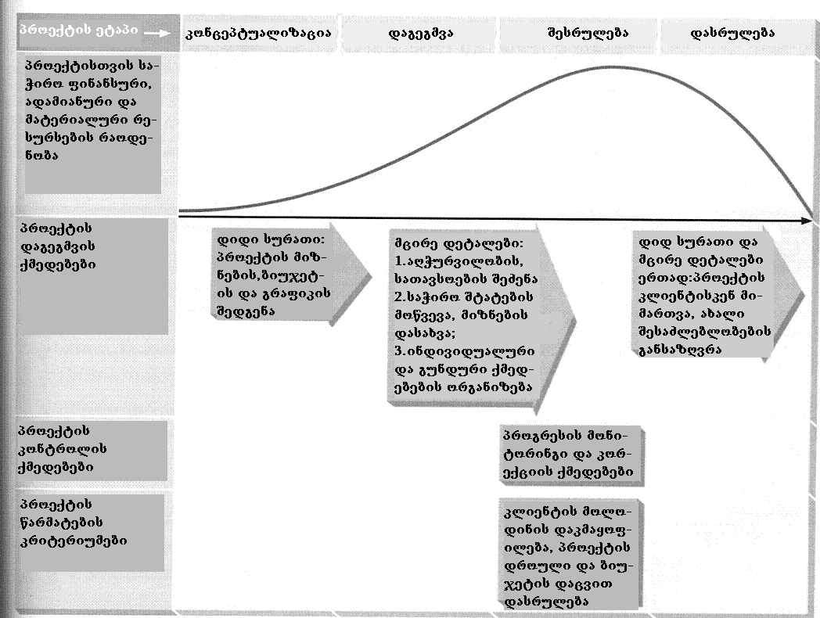
nax. 46

proeqtebis menejmentis kompiuteruli mxardaWera. uzrunvelyofa imisa, rom dagegmili qmedebebi Sesruldeba maSin, iq da imgvarad, rogorc iyo Cafiqrebuli da, saWiroebis SemTxvevaSi, makoreqtirebeli RonisZiebebi ar daigvianebs, msxvili proeqtebis SemTxvevaSi metad Znel amocanad iqceva. sabednierod, arsebobs saTanado kompiuteruli uzrunvelyofis programebi, romelTac SeuZliaT mniSvnelovani rolis Sesruleba. magram amisTvis saWiroa saTanado arCevanis gakeTeba im uamravi kompiuteruli programidan, romlebic Seiqmna proeqtebis menejmentisTvis. proeqtebis menejmentis mxardamWeri kargi programuli paketi unda iyos moqnili da informatiuli, rac proeqtis Sesrulebis yvela mniSvnelovani aspeqtis swraf momsaxurebas da Sedegebis Tanamedrove saxiT warmodgenas ukavSirdeba. mas unda SeeZlos Semdegi amocanebis gadaWra:
• daadginos da daazustos saWiro qmedebebis nusxa;
• SeZlos, Sedegebis Sesabamisad, moqnilad Secvalos prioritetebi, grafikebi da xedvebi;
• uzrunvelyos kritikuli analizis Catareba;
• uzrunvelyos gegmebis modifikaciisTvis saWiro moqniloba;
• SeZlos daxmarebis gaweva prioritetuli doneebis dadgenaSi;
• uzrunvelyos resursebis: adamianuris, aRWurvilobis, garemos, fuladi saxsrebis da a.S. gamoyenebis marTvis moqniloba;
• gaaerTianos gegmebi;
• daafiqsiros proeqtis mimdinareobis dagegmilidan gadaxris SemTxvevebi;
• avtomaturad akontrolos Sesrulebis vadebi.
proeqtebis menejerebis mier Sesasrulebeli eqvsi roli. proeqtebis menejerebis funqciebi metad mravalricxovania. garda ZiriTadi ”damnergavis” rolisa, maT uwevT mewarmis, politikosis, partnioris, bazris mkvlevarisa da instruqtor-mwvrTnelis funqciebis Sesrulebac. TiToeuli moiTxovs garkveuli strategiis SemuSavebas im gamowvevebis sapasuxod, romlebsac maTi Sesrulebis aucilebloba akisrebs proeqtebis menejers.
proeqtebis menejmentis saxelmZRvanelo xazi. proeqtebis menejers, garda dagegmvis bazuri koncefciis da marTvis ZiriTadi instrumentebis codnisa, moeTxoveba sakmarisi warmodgena im specialur moTxovnebze, romlebic proeqtebis dagegmvas da Sesrulebas ukavSirdeba. esenia:
• proeqti sruldeba grafikis Sesabamisad da Sedegze aris orientirebuli. rogorc ganmartebidan cxadia, proeqtebi iqmneba drois dadgenili periodis ganmavlobaSi specifikuri amocanebis gadasaWrelad. proeqtebis menejers moeTxoveba pozitiuri mzaoba saerTo gaurkvevlobis viTarebiT Seqmnili sakiTxebis swrafad gadaWrisadmi. am dros isini orientirebulni unda iyvnen ufro Sedegze, vidre procesze;
• proqtebis Sesrulebisas mniSvneloba aqvs rogorc mTlian suraTs, ise yvela wvrilmans. proeqtebis menejerebis TvalTaxedvaSi yovelTvis unda iyos proeqtis ZiriTadi mizani, mimdinare viTarebam da personalurma problemebma ar unda daCrdilos igi. aRniSnulis Sesruleba sakmaod rTulia, vinaidan wvrilmani problemebi mudmivad Cndeba, maTi ricxvi Zalze maRalia da menejeri mniSvnelovan zewolas ganicdis am mxriv;
• proqtebis dagegmva aucileblobaa da ara fufuneba. proeqtis damwyebi menejerebi xSirad ver umklavdebian cdunebas Tavi aaridon Sedegebze orientirebas da ver pouloben proeqtebis dagegmvisTvis saWiro drosa da resursebs;
• proeqtebis menejerebma ician proqtebis Sesrulebis vadebis dasaxvis motivaciuri siZlieris Sesaxeb. proeqtis Sesrulebis gamomwvevi da amasTan, realisturi vadebis miTiTeba, proeqtebis menejerebis erT-erT mZlavr motivaciur iaraRs warmoadgens. proeqtis Sesrulebis finaluri TariRi aris miznis miRwevis saboloo momenti rogorc proeqtze momuSave mTeli gundisTvis, ise calkeuli individebisTvis.
3.9 dagegmvis da Sesrulebis kontrolis
grafikuli iaraRebi
marTvis mecnierebis specialistebi cdiloben dagegmva/kontrolis ciklSi grafikuli analizis meTodebi danergon. amis xelSemwyob sam iaraRs warmoadgens procesebis nakadebis da gantis rukebi, aseve programebis Sefasebis da gadaxedvis teqnika (PERT-Program Evaluation and Review Technique). maTi realizeba proeqtebis menejmentis mraval kompiuterul programaSic xdeba.

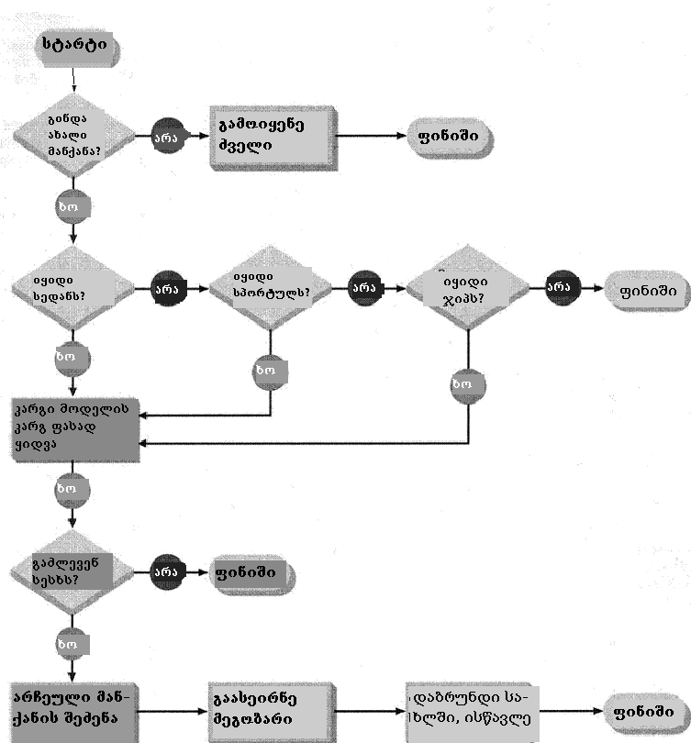
nax. 47

nakadebis rukebi. rogorc programistebi, ise xarisxis totaluri marTvis (Total Quality Management, TQM) specialistebi farTod iyeneben nakadebis rukebs (flow charts) maT winaSe mdgomi amocanebis komponentebis identificirebisa da zedmeti safexurebis da qmedebebis gamoricxvis meSveobiT, Sesasrulebeli samuSaos gamartivebisTvis. garda amisa, aseTi ruka warmoadgens metad saWiro iaraRs aucilebeli moqmedebebis Sesrulebis rigiTobis dasadgenad. magaliTad, am wignis wakiTxva SesaZlebelia mxolod mas Semdeg, rac igi SeZenili iqneba. maSasadame, qmedebas ”wignis wakiTxva”- win unda uswrebdes qmedeba –”wignis SeZena”.
nakadebis rukis magaliTi mocemulia zemoT, 47–e naxazze, sadac Cans, rom mas sxvadasxva simboloebis: marTkuTxedebis, rombebis da ovalebis gamoyenebis meSveobiT adgenen. marTkuTxedebi aRniSnavs ZiriTad movlenas, xolo rombebi ”diax”, an ”ara” tipis gadawyvetilebebs. ovalebi procesis dawyebas da dasrulebas Seesabameba. aseTi tipis rukis gamoyenebiT, yvela donis menejers saSualeba eZleva daadginos mniSvnelovani movlenebis dadgomis da gadawyvetilebebis miRebis saWiro Tanamimdevroba. qmedebebs Soris urTierTkavSiris gansazRvra nakadebis rukebis meSveobiT, metad xelsayrelia analizisTvis. am rukebis ZiriTad nakls is warmoadgens, rom isini ar aCveneben TiToeuli safexuris ganxorcielebis vadebs. maTi gamoyeneba arapraqtikuli xdeba im SemTxvevaSi, rodesac saWiroa erTdrouli, paraleluri qmedebebi da ara Tanamimdevruli.

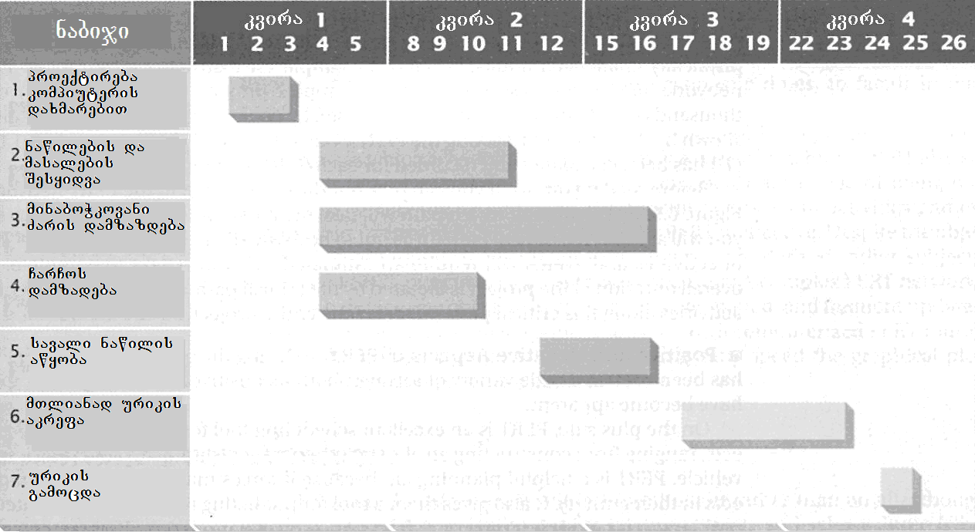
nax.48
gantis rukebi. samuSaoTa msvlelobis droSi ganawileba da koordinireba, efeqtiani dagegmvis mniSvnelovani nawilia. rodesac yoveli momdevno nabiji damokidebulia wina nabijebis warmatebul ganxorcielebaze, igi exmareba menejers imis gadawyvetaSi, Tu sad da rodis gamoiyenos mis xelT arsebuli resursebi. ruebi, romlebic henri gantma (Henry L. Gannt) Tavdapirvelad (1887 w.) warmoebis samarTavad Seqmna, dRes farTod gamoiyeneba yvela saxis organizaciuli qmedebis dagegmvisa da Sesrulebis dispetCerizaciisTvis. maTi gamoyeneba gansakuTrebiT sasargebloa msxvili proeqtebis ganxorcielebisas, iseTebis rogoricaa, magaliTad, didi organizaciis axal SenobaSi gadasvla, korporaciuli kompiuteruli qselis instalacia da a.S.
48–e naxazze warmodgenili aseTi ruka saSualebas iZleva Tvalis erTi gadavlebiT warmovidginoT procesebis mimdinareoba da SevafasoT miRweuli progresi. naxazze mocemulia TviTmavali eleqtrourikebis daproeqtebis da warmoebis momzadebis sruli cikli, warmodgenili gantis Sesabamisi rukiT. mTeli procesi gansxvavebuli xangrZlivobis Svidi etapisgan Sedgeba, romlebic jamSi 4-kvirian periods moicavs.
nakadebis rukisgan gansxvavebiT, gantis ruka saSualebas aZlevs damgegmavs Seafasos TiTouli qmedebis dasrulebisTvis saWiro dro. gantis rukebis susti mxare, iseve, rogorc nakadebis rukebisa, is aris, rom kompleqsuri samewarmeo wamowyebebis SemTxvevaSi, is metad gadatvirTuli gamodis.
PERT-qselebi. rac ufro kompleqsuria proeqti, miT metia ZiriTadi moqmedebebis swor TanamimdevrobaSi moyvanis da maTi urTierTkorelaciis moTxovna. aseTi proeqtebis ganxorcielebis marTvisas, didi sargeblobis motana SeuZlia e.w. programirebis instrumentebis gamoyenebas, romelTa Soris erT-erTi yvelaze gavrcelebulia grafikuli warmodgenis meTodi, romelsac programebis Sefasebisa da gadaxedvis teqnika (Program Evaluation and Review Technique, PERT) ewodeba. igi gansakuTrebiT efeqturia msxvili, kompleqsuri da ararutinuli proeqtebis ganxorcielebisas.
pirvelad PERT 1958 wels gamoiyena aSS-s sazRvao flotis specialuri proeqtebis ofisis menejer-konsultantTa gundma. am periodSi ofisi muSaobda cnobil Polaris-is proeqtze, romelsac unda gadaewyvita CaZirul mdgomareobaSi myofi wyalqveSa navidan sabrZolo raketebis gaSvebis metad rTuli amocana. PERT-s gamoyenebam ara marto Seitana sakuTari wvlili am proeqtis warmatebiT ganxorcielebaSi, aramed dagegmilze ori wliT adre dasrulebasac Seuwyo xeli. Magram unda aRiniSnos, rom PERT sulac ar aris proeqtebis menejmentis yvela problemis gadaWris universaluri saSualeba. igi specializebuli dagegmvis da kontrolis iaraRia, romelsac sargebloba moaqvs mxolod saTanado viTarebaSi sworad gamoyenebis SemTxvevaSi.
am teqnikas sakuTari terminologia aqvs, rogoricaa:
• PERT-SemTxveva. PERT-Si SemTxvevas uwodeben imas, risi meSveobiTac fiqsirdeba proeqtis Sesrulebis raime etapis dawyeba an dasruleba. magaliTad, Sefasebis miReba aris SemTxveva, romelic rTuli gamocdis Cabarebis etapis dasrulebas aRnusxavs;
• PERT-qmedeba. es aris Sesasrulebeli saqmis mdgeneli, misi elementi. misi Sesruleba drois garkveul periods moicavs, romelic iwyeba da mTavrdeba Sesabamisi SemTxvevebiT. magaliTad, momzadeba gamocdisTvis da misi Cabarebis procesi, orive qmedebaa;
• PERT-dro. PERT-Si dro, es aris periodi, romelic saWiroa qmedebis dawyebidan mis dasrulebamde. igi iangariSeba, rogorc saSualo romelic Sewonilia drois sami SefasebisTvis: 1. optimisturi dro (T_{O}) - romelic dasWirdeba qmedebis dasrulebas, Tuki pirobebi saukeTeso iqneba; 2. yvelaze savaraudo dro (T_{m}) - romelic normalur pirobebSi qmedebis dasrulebisTvis iqneba saWiro; 3. pesimisturi dro (T_{P}) - romelic yvelaze uares pirobebSi Sesrulebul qmedebas Seesabameba. PERT-drois (T_{e}) gamosaTvlel formulas aqvs Semdegi saxe:

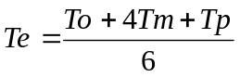

• kritikuli gza. kritikuli gza (critical path) aris urTierTdakavSirebuli qmedebebis da SemTxvevebis is Tanamimdevroba, romlis Sesrulebas yvelaze meti dro dasWirdeba. sxva sityvebiT rom vTqvaT, es aris yvelaze grZeli gza PERT-qselSi, romelic kritikulia im TvalsazrisiT, rom misi gavlisas nebismieri qmedebis gamotoveba, mTeli proeqtis Cavardnas gamoiwvevs.
PERT-qselis agebis da gamoyenebis magaliTi naCvenebia 49–e naxazze. amocana mdgomareobs imaSi, rom daproeqtdes da damzaddes satransporto TviTmavali urikebis sami partia. naxazze PERT-SemTxvevebi aRniSnulia wreSi Cawerili asoebiT, xolo PERT-qmedebebi isrebiT, romelTa dasawyisi da boloebi eyrdnoba saTanado SemTxvevebis Sesabamis wreebs. isrebi danomrilia kvadratebSi Cawerili cifrebis meSveobiT. PERT-dro (Te) gamoiTvleba da Caiwereba TiToeuli qmedebisTvis cal-calke.

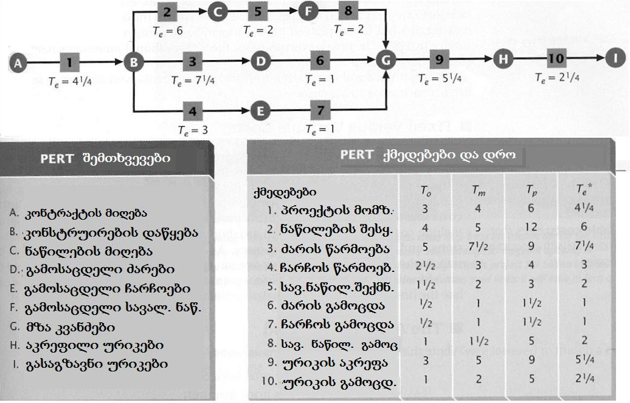
nax. 49
naxazidan Cans, rom kritikul gzas, romlis gavlasac yvelaze meti dro sWirdeba, qmnis SemTxvevebis mimdevroba A-B-C-F-G-H-L. urTierTdakavSirebuli qmedebebis da SemTxvevebis am jaWvis Sekvras 21,75 samuSao dRe dasWirdeba. swored es dro gansazRvravs mTeli proeqtis dasrulebis vadebs. kritikul gzas mikuTvnebuli nebismieri qmedebis dasrulebis dagvianeba, mTeli proeqtis Sesrulebis dayovnebas gamoiwvevs.
PERT-is gamoyenebis 50-wliani istoriis manZilze, srulad gamovlinda am teqnikis rogorc dadebiTi, ise uaryofiTi mxareebi. PERT-i Seucvleli istrumentia iseTi rTuli proeqtebis Sesrulebisas, rogoric aris msxvili eleqtrosadguris aSeneba da gaSveba, aero-kosmosuri teqnikis Seqmna da gamocda da a.S.
aseT proeqtebSi PERT exmareba menejerebs resursebze moTxovnilebis SefasebaSi, potenciuri problemebis gamokveTasa da proeqtis mimdinareobaze kontrolis dawesebaSi. Tu raime qmedeba dagegmilze ufro gvian an adre dasruldeba, misi meSveobiT SesaZlebeli xdeba dakarguli an piriqiT gamonTavisuflebuli drois savaraudo saboloo da Sualedur Sedegebze zegavlenis Sefaseba. optimisturi da pesimisturi drois gaTvlis meSveobiT, PERT exmareba menejerebs ufro realisturad gansazRvron dagegmvis diapazoni.
uaryofiTi aspeqti ki isaa, rom PERT-is gamoyeneba SeuZlebelia ganmeorebadi xasiaTis operaciebis warmoebis SemTxvevaSi, msgavsad situaciebisa, romlebic damaxasiaTebelia saamwyobo xazebisTvis mrewvelobaSi, sadac muSaobis temps mTlianad manqanebis ”svla” gansazRvravs. PERT, iseve rogorc gadawyvetilebaTa miRebis da dagegmvis sxva instrumentebi, uZluri xdeba, Tuki sawyisi daSvebebi arazustia. qmedebebis da SemTxvevebis araswori arCeva, maTi Sesrulebis drois mcdari Sefasebebi mkveTrad amcirebs PERT-is efeqtianobas. es garemoeba metad mniSvnelovania, vinaidan PERT-is gamoyenebisas drois Sefaseba, rogorc wesi, subieqturad xdeba. kritikosebi imasac aRniSnaven, rom PERT-iT sargeblobas didi dro sWirdeba, Tumca, Sesabamisi programuli paketebis gamoCenam, praqtikulad srulad moxsna es problema.

 adamianis mier damzadebuli, an struqturirebuli ram, magaliTad iaraRi, xelovnebis nimuSi da a.S.
 orTqlis manqana, romlis Tanamimdevrulad zrdadi diametris cilindrebSi orTqlis gafarToeba sam stadiad mimdinareobs, rac aumjobesebs energiis gadacemis pirobebs.

