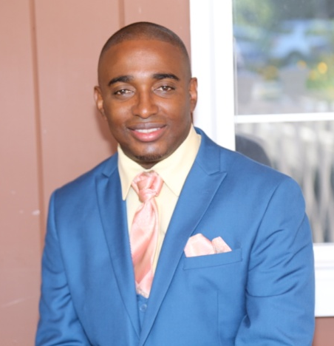
MEET BISHOP ANDREW DAUBON

Bishop Andrew Daubon was born in Kingston, Jamaica. He grew up in Clarendon, however, with his grandparents, who were pillars of the Wisbeach New Testament COG. His earliest memories of the power of God, were in the miraculous healing gift of the Holy Ghost. This he saw operating in the life of his grandmother. Though he considered it entertaining to argue with scholars about the contents of God’s word from an early age, Andrew delayed making Jesus his personal Savior. But on Sunday, February 11, 1990 the day of Nelson Mandela’s release from prison, Andrew was released from the bondage of sin.
Not long after he graduated high school he returned to Kingston and joined the Escarpment Road New Testament C.O.G. There he served as assistant, and then as youth director. He also served on the Eastwood Park District Youth Board. With all this, Andrew consciously chose to avoid the pulpit and turned down opportunities to speak at his local church and at other churches.
In 1999, Andrew migrated to Windsor CT, and joined the King’s Chapel COG. Almost immediately his pastor started asking him to preach and again he declined. He finally took the pulpit after another church booked him by referral to be the speaker for their Youth Sunday. He preached his first sermon at King’s Chapel and fulfilled the invitation the following Sunday. Since then he has preached in the United States and in Jamaica and was called on fairly regularly by pastors to fill their pulpit in their absence. Bishop Daubon and his wife served as Youth Pastors at the King's Chapel C.O.G. for several years.
In his secular employ, Bishop Daubon was the first person of color to serve as a manager of the biggest employer in Canton CT, an agency serving individuals with developmental disabilities, where he worked for over nine years.
Bishop Daubon is a graduate of the Mico University College in Jamaica, the University of Hartford and was valedictorian for his Church of God MIP (Ministerial Internship Program) class. He is currently pursuing a Master’s degree in Divinity.
He is an Ordained Bishop with the Church Of God, Cleveland TN. He is also the District Overseer for the Springfield District of churches.
He is the author of an engaging book entitled, Marriage: A Loveseat for Two
In July 2000, Bishop Daubon married the eighth wonder of the world, Michaelia, who partners with him in ministry as pastors of the Celestial Praise Church of God, Springfield MA. They are the proud parents of two beautiful daughters, Anthia and Maliha.
As one who was once told by a teacher that he would never be able to speak proper English, he has experienced that “with God all things are possible, to them that believe and are called according to His purpose.”

