Self Love/Self Bullying lesson
Talk about the term resilience.
https://gozen.com/animation/resilience-scienceguy-explanation/
Ask them to define bullying. It stands out in that it happens on a daily basis.
Have each student think about the negative things that they say to themselves on a daily basis. How do they put themselves down. Write out the insult you just said to yourself. Seeing it on a piece of paper will make it more obvious to you how hurtful your thoughts really are. When you think something like, “I am so dumb,” it likely passes through your mind so swiftly, you don’t have a chance to even register it. So many of us are so used to this kind of talk that we literally have to slow ourselves down and re-register what we are actually saying to ourselves. Writing it out is a great way to slow down and see the absurdity in your own negative self-talk. Show examples of what other students have said
Ask for volunteers to share what they have written. Ask if anyone else has ever felt that way. Point out that we are more alike that you may think. Then ask who considers themselves to be a bully (define bully first). Not many students will raise their hands.
Talk about the term self-bullying. Point out that unlike bullying, when you are self-bullying, there are no bystanders to step in and help.
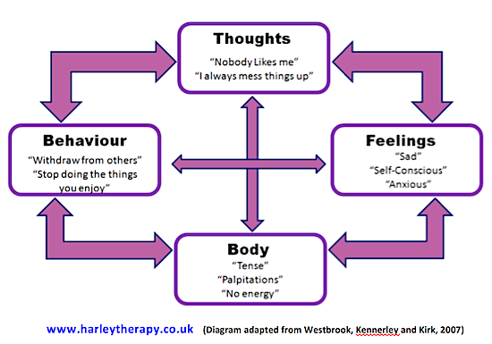
HOW TO STOP NEGATIVE SELF TALK
Play 2 wolves video
1. Talk/fight back…Say “STOP”
2. Replace the negative with a positive
3. What would you say to your friend if they were saying the same thing to themselves?
4.Watch love letter to yourself video
5. Then write a love letter to themselves

