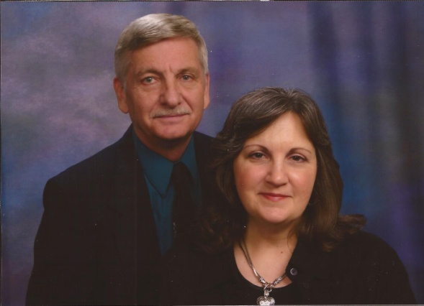
FIELD ADDRESS: MISSION BOARD ADDRESS: 69 Perinba Nagar B.E.M.A. A.N. Palayam 4744 Winchester Pike Vadamadurai P.O. Columbus, Ohio 43232 Coimbatore Ph. 614-833-0488 Tamil Nadu 641034
HOME CHURCH: USA ADDRESS: Westside Baptist Church 1808 South Walnut Street 3227 Magnolia Road Janesville, WI 53546 Bruce & Ruth Ann Schwalbe Janesville, WI 53546 Ph. 608-741-0463 Missionaries to the Deaf of India Ph. 608-756-0101 E-mail address schwalbes@hotmail.com
June 15, 2018
Dear Pastor & Church:
Greetings to you in Jesus’ name. We were encouraged to hear from deaf Pastor Anil in Bangalore, India. He has baptized two more deaf believers. This is the church which we first started in 1980.
One of our deaf students, Sivaprakash, in Coimbatore has graduated from our Christian school. He has passed all four subjects in his government examinations last month. Our new school term has begun this month.
We are helping and taking care of Ruth Ann’s mother. She has been diagnosed by her doctor with severe arthritis in her back. We would appreciate your prayers for her mother as she is in a lot of pain.
Thank you so much for your prayers for the deaf ministries in India and financial help.
This is a picture of us taken 40 years ago when we first visited India.

Yours for deaf Souls,
Bruce & Ruth Ann Schwalbe

Picture taken in 1978 in India
Received $2,500.00 for repairing the Deaf Church Building roof. Thank you so much.

