Create a MYTCOLE Account

https://tcole.nuvolaacademy.com/

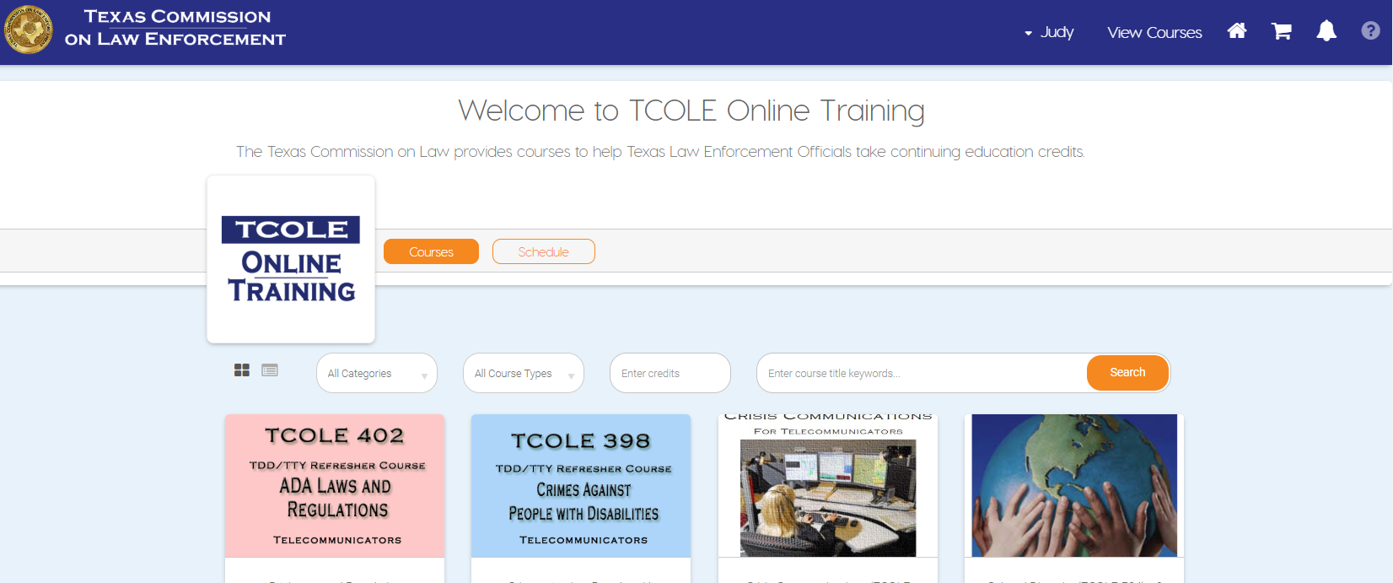

Navigate to the Corse 1305 – Rules Overview
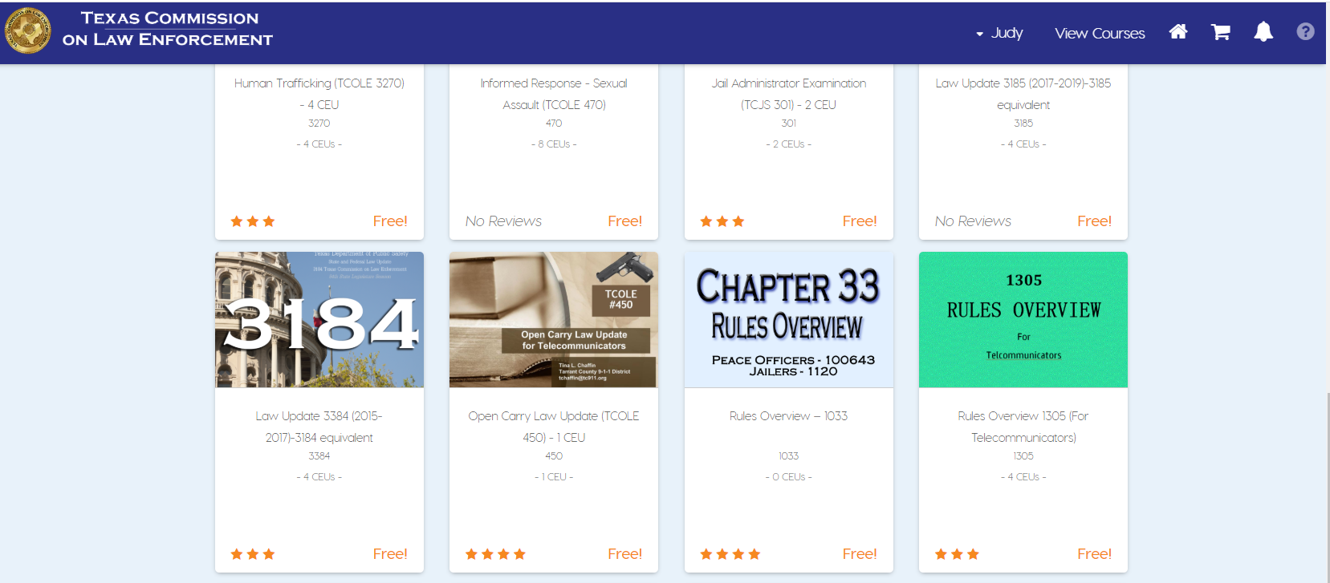

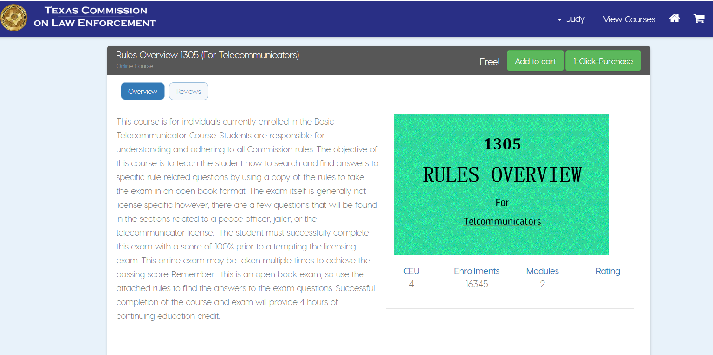

Click on Certificate (View)
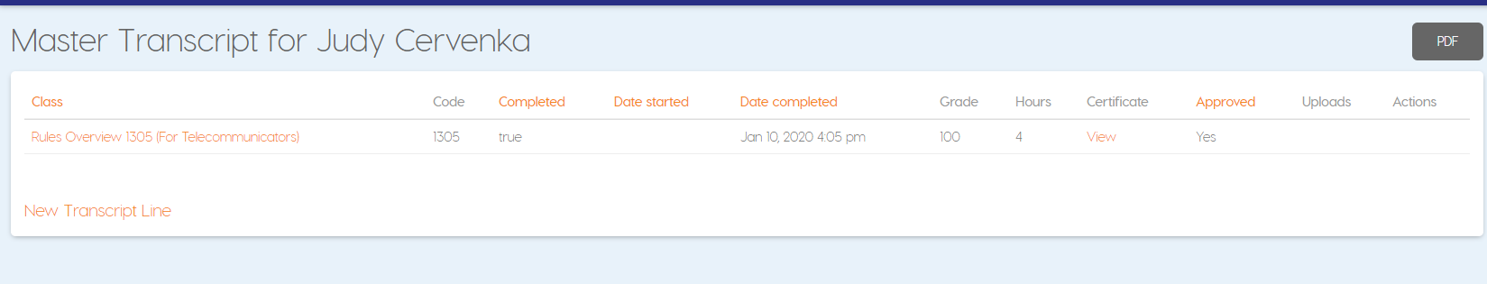
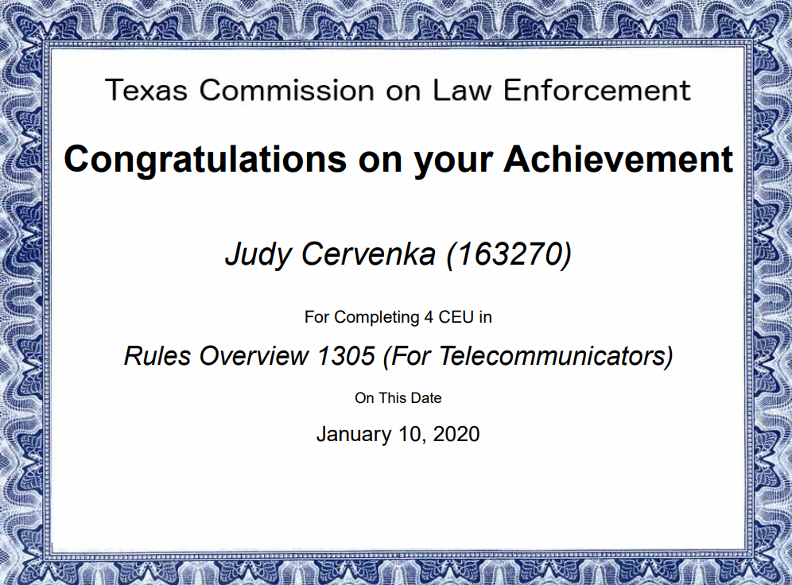
Email to tglpolicetelecommunicatioins@gmail.com

