CO-OP NEWSLETTER 2

February - July 2016

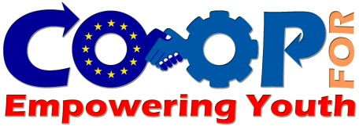

**CONTENT**

1. Survey Report
2. Training for Mentors and 2nd Partner Meeting in Bastia/FR
3. First Draft of the Repository
4. Preparations for Pilots
5. 3rd Partner Meeting in Bratislava
6. What is Next

***Survey Report***

The COOP Project consortium has conducted the survey on the local entrepreneurship environment in 6 different European Countries.

382 questionnaires were delivered to the focus group consisting of three main pillars:

- Young and unemployed people; Potential Entrepreneurs

- Enterprises founded within the last 12 months

- Small and Very Small Scale Enterprises

327 of the audience provided feedback by filling in the questionnaires and each partner prepared a detailed evaluation report on national base.

Also, a general summary report on European Entrepreneurship Environment has been prepared by COOP consortium and published in 7 languages (EN, FR, SK, RO, TR, ES, IT)

(Please visit our website to access the National Report for Turkey, the general report in Turkish and PPT Presentation of COOP Survey Results [www.kocaeliab.gov.tr](http://www.kocaeliab.gov.tr)

***Training for Mentors and 2nd Partner Meeting in Bastia/FR***

The short term joint-staff training activity of COOP Project was organized in Bastia (FR) hosted by the French partner Petra Patrimonia Corsica between 22nd and 26th of February 2016.

The trainees were provided key information and tools about the CAE ("CAE - Coopérative d'activité et d'emploi") Methodology for entrepreneurship developed in France. These tools and information will be needed during the National Pilot activities that will be organized in 4 partner countries (IT, ES, TR and RO) between September 2016 and February 2017.

On the other hand, the project managers held the second transnational coordination meeting in Bastia Simultaneously with the training activity.

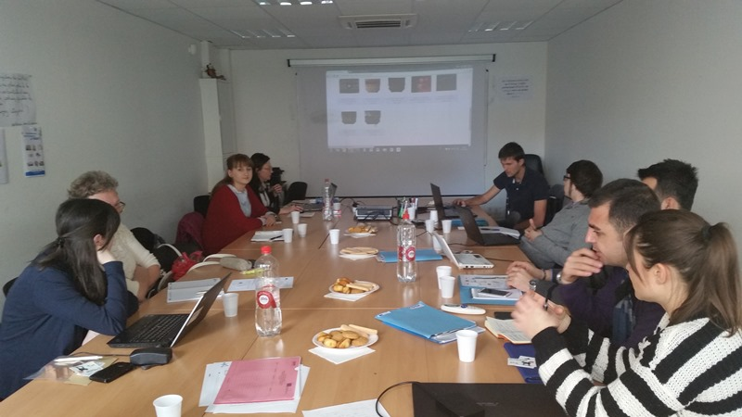

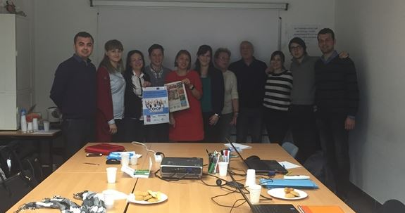

***First Draft of the Repository***

One of the main outputs of COOP Project is the “Repository: CAE COOP Services” document in which the key elements of an CAE Cooperative will be collected such as the administration of the cooperative, internal organization, banking, specific procedures applied to an entrepreneur, evaluation tools, support tools and services under the scope of a quality approach aiming to improve ‘collective practices’.

The first version of the Repository document has been published and the final version will be delivered after the Pilot Exercises in partner languages as well as in English.

.



This project has been funded with support from the European Commission. This publication [communication] reflects the views only of the author, and the Commission cannot be held responsible for any use which may be made of the information contained therein. **2015-1-RO01-KA202-015094**

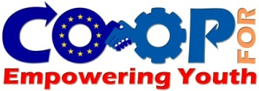

COOP

NEWSLETTER 2

***Preparations for Pilots***

The pilots will start in October in 4 different countries with at least 6 project holders/potential entrepreneurs for each country.

The partners has been established the local network and reached the related stakeholders in order to implement an effective pilot/training and obtain valuable results/outputs.

**In Turkey;** the pilot activity will be held in cooperation with “İzmit Young Entrepreneurs Centre” (www.gencgirisimcilermerkezi.com), an organization that operates under the authority of Local Municipality and provides consultancy, infrastructural opportunities (office, internet etc.), trainings, networking in some kind of incubation process.

**In Romania**; PRO VOCATIE partner is accredited by the NAT to developed training for young entrepreneurs. It has funding for this type of action. It envisages in September / October 2016 of a training month for 20 to 25 young people. During this training different contractors will come to present their own experiences of young future entrepreneurs. After the training course the trainers will pass an examination and PRO VOCATIE will certify with entrepreneurs competencies. The Romanian partner will choose 6 young people with whom will continue to open a business or to register their company. The staff of association has much discussed and exchanged idea of this phase to find a solution that meets the needs of beneficiaries. Innovation lies in the advice and guidance for finding idea and business development.

***What is Next?***

- National Multiplier Events (Dissemination Activities by partners in each partner country) in September

- Starting the Pilots in October

- 4th Transnational Meeting in Madrid in November

**In Spain;** Red2Red will cooperate with Incyde Foundation (www.incyde.org), the Chamber Institute for the Creation and Development of Business, dedicated to the promotion of the entrepreneurial spirit, improvement of entrepreneurs’ qualifications and business’ creation and consolidation: they will cooperate in the selection of 6 project holders among the participants of the Course on Business’ Creation and Consolidation organized by Incyde foreseen by October 2016

**In Italy;** the pilot activities of Promidea will include six pupils approached between the collaboration of the Istituto Agrario e Tecnico Commerciale “Mancini” of Cosenza. The activities will concern a mixed pathway, both theoretical and practical. The theoretical lessons will have an individual approach, while those practical will provide activities of tutorship into the company of each pupil. All the participants’ business ideas are focused on the innovation and modernization of their own companies and the interest of them for attending the training activities is about to expand and grow those into the perspective of replacing their parents into management.

***3rd Partner Meeting in Bratislava***

Just before the start of the National Pilots, the partners came together in Bratislava to discuss and plan the first national events and pilots. The agenda also included the evaluation of the general survey results and preparing the general report.

