CO-OP NEWSLETTER 1

September 2015-January 2016

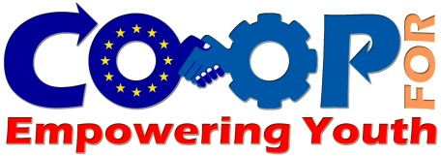

**CONTENT**

1. CO-OP Project in Brief
2. The Partnership
3. Entrepreneurship: why important?
4. First Step: Survey on the local context
   1. Target Groups
   2. Survey Reports
5. Kick-off Meeting in Bucharest
6. What is Next in CO-OP



***CO-OP PROJECT IN BRIEF***

Under EU Erasmus+ 2015 Call for Proposals; a consortium of 6 organisations from 6 different countries aimed to empower youth with support, training and guidance. With the financial support from Romanian National Agency the consortium has started to implement the **COOP for Youth Project**. This project is about sharing knowledge and experience and developing pertinent tools for start-ups for especially young and unemployed potential entrepreneurs.

***Specific Objectives:***

* To develop entrepreneurial skills of persons excluded from employment, especially young people;
* To strengthen support and secure the path of entrepreneurs;
* Professionalization of support entrepreneurship operators through the development of a common framework for entrepreneurship training;
* Creation of a network involving the formation operators, economic integration, coaching and social entrepreneurship;
* Undertake an effective dissemination and exploitation action plan in order to spread the results at regional and national levels.



***General Objective:***

* CO-OP aims to create new tools for business start-ups for young unemployed people. The Partners intend to learn from an entrepreneurship model developed in France, and proven in Slovakia trough a "Couveuse " model transfer . The concept system is called ***"CAE - Coopérative d'activité et d'emploi"*** existing in France and Belgium.

***Main Activities:***

1. *Survey on the local entrepreneurship environment*
2. *“Support for start-ups” guide*
3. *Establishing Repository "****CAE Co-op" services***
4. *Preparing a “Self-Assessment” Guide*
5. *Start up tools handbook for entrepreneurs*



This project has been funded with support from the European Commission. This publication [communication] reflects the views only of the author, and the Commission cannot be held responsible for any use which may be made of the information contained therein. **2015-1-RO01-KA202-015094**

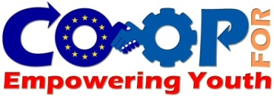

COOP

NEWSLETTER 1

***THE PARTNERSHIP***





**CRFPS Pro-Vocatie**

**(Romania)**

[**www.provocatie.ro**](http://www.provocatie.ro)

CRFPS is a vocational training and evaluation skills centre working for the promotion of equal opportunities and the development of entrepreneurship. It particularly supports entrepreneurs in the sector of social economy. Currently, the CRFPS is implementing strategic tools to improve the situation of vulnerable groups in rural areas - support for training and entrepreneurial skills in the direction of people outside the labour market in rural areas, notably young unemployed people. The centre welcomes annually for these formations about 2000 beneficiaries. It benefits from a recognized expertise in the field of entrepreneurship which gives it an important role in this project.

**PROMIDEA**

**COOPERATIVA SOCIALE**

**(Italy)**

[**www.promidea.it**](http://www.promidea.it)

Promidea is a Social Cooperative engaged for twenty years in planning and providing services for people at risk of marginalization. The agency is qualified for vocational training courses (superior training, training for completion of compulsory schooling; continuing training and retraining - Quality Certification Sector 37); Guidance and placement services especially trough managing of work experiences programs, internship and apprenticeship pathways; Counselling and mentoring tools and methodologies to improve professional inclusion; advisory on start up of social enterprises and technical assistance on planning and managing of Structural funds

**Petra Patrimonia Corsica**

**(France)**

[**www.petrapatrimonia-corse.com**](http://www.petrapatrimonia-corse.com)

“La coopérative Petra Patrimonia Corse” (PPC) provides business support program in direction of unemployed people in general and notably in direction of youth willing to create an economic activity. It aims to promote the economic initiative by allowing project managers to create business scale testing the economic feasibility of their project while learning responsibility for their own activity and to better understand the functions of the entrepreneurs in real situations.

This social and economic innovation ensures reversibility and easy access to business creation.

**T.R. Governorship of Kocaeli**

**Bureau for EU& Foreign Affairs**

**(Turkey)**

[**www.kocaeliab.gov.tr**](http://www.kocaeliab.gov.tr)

Bureau for EU and Foreign Affairs (BEUFA) is the sub-unit of the Governorship of Kocaeli which is responsible for developing and implementing socio-cultural and educational projects on behalf of the Governorship. The Bureau was founded in 2004 under responsibility of Governorship of Kocaeli in order to accelerate Turkey’s accession and to enable the province to get full benefit from EU programs. On the local network consists of Universities, National Directorate of Education Kocaeli province, Metropolitan Municipality, NGO’s and all the other institutions and all these organizations/institutions are under the scope of the Governorship. BEUFA also provides consultancy services and information within the framework of EU programmes.

**Red2Red Consultores, S.L.**

**(Spain)**

[**www.red2red.net**](http://www.red2red.net)

R2R is a private company founded in 2000 with the aim of being specialized in public policies, providing quality and sustainable services to public sector and achieving a higher-quality life for citizens. Counting with a team of experts in public policies and sustainability, Red2Red provides services to numerous local and regional administrations, the General Government Administration, the European Institutions and several multilateral organizations in the following fields: institutional strengthening, employment, training, social affairs, inclusive, sustainable and rural development, environment, regional policies, EU Funds, gender equality, gender based violence, disadvantage groups (migration, ethnic origin, Roma, people with disabilities, etc.).

**Agentúra RRI**

**(Slovakia)**

[**www.2ri.sk**](http://www.2ri.sk)

Agentúra RRI , s. r. o. is a limited liability small company, established in 2005 by a French and a Slovakian project leaders. RRI undertake actions in several areas and notably in the professional training field. The training department aims to promote entrepreneurship providing trainings and supporting disadvantaged people in order to facilitate their inclusion on the labor market.



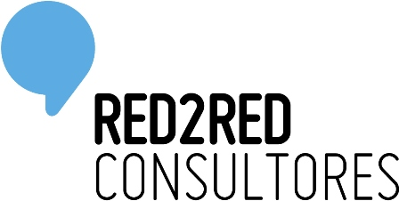



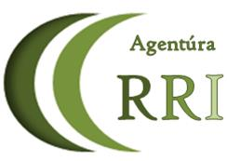



COOP

NEWSLETTER 1

This project has been funded with support from the European Commission. This publication [communication] reflects the views only of the author, and the Commission cannot be held responsible for any use which may be made of the information contained therein. **2015-1-RO01-KA202-015094**

COOP

NEWSLATTER 1

***ENTREPRENEURSHIP:***

***WHY IMPORTANT?***

Approximately 5 million young people aged 15-24 are unemployed in the EU today. As of December 2015 this represents an unemployment rate of 19.7% (source EUROSTAT).

Entrepreneurship has proven to be an excellent way of fighting youth unemployment in all Member States since over the last decade SMEs accounted for 75% of total gross job creation, according to a study by the OECD. The contribution of young SMEs is especially positive since they create almost 50% of new jobs. However, Young SMEs have a modest survival year of just over 60% after three years from entry or a mere 40% after seven years from their establishment.

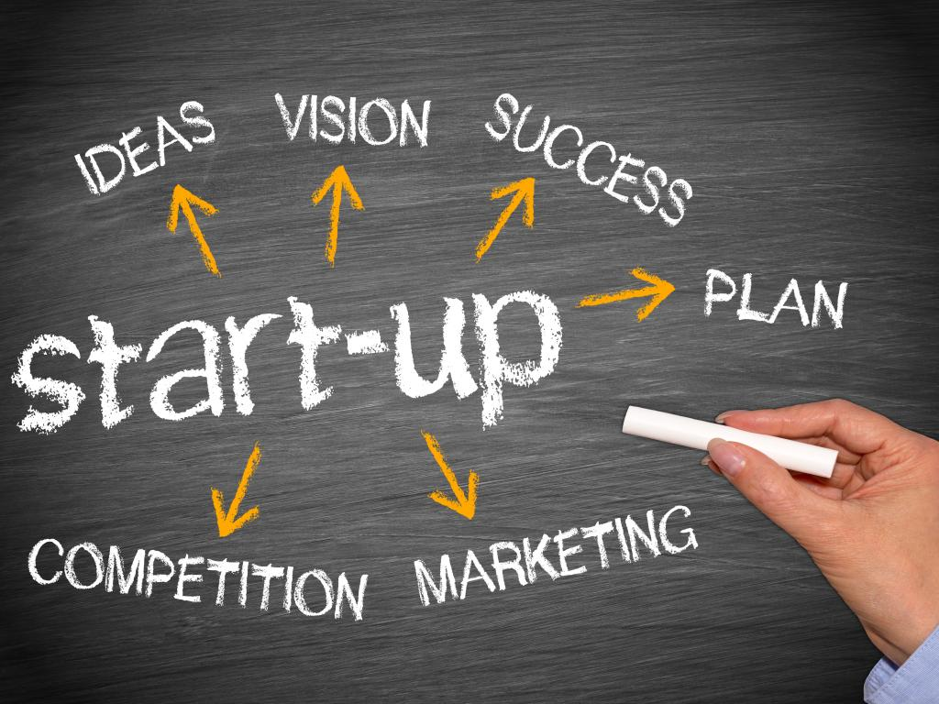

According to the European Commission, entrepreneurship is seen as “a key competence that can boost competitiveness and growth” and contribute “to the general good of society”. The OECD also finds that “public policies can help unleash the growth potential of young, innovative firms by enabling them to experiment with new business models”, for example by way of incubators. In this spirit, the Co-op Project intends to be an innovative solution to the problems faced by entrepreneurs giving youngsters the opportunity of implementing their business ideas while they benefit from expert legal and administrative advisory.







***FIRST STEP: SURVEY ON THE LOCAL CONTEXT***

Each partner has been conducting a survey to search the entrepreneurship environment on their local base. The Specific Objectives of the survey are:

* Approach young unemployed people and their business ideas to record and analyze:

if and how much they know about entrepreneurship (local model, characteristics, legal system…);

their intentions, demands, needs and competences to put in the same format;

* Approach young enterprises to record their conditions of operation and maintenance
* Approach SMEs and VSEs to record their conditions of operation and maintenance.

**Target Groups of the Survey (per country):**

Group 1: 50 young and unemployed people and project holders aged between 18 and 25

Group 2: 20 new enterprises established within the last 12 months

Group 3: 20 SME’s and VSE’s

**Survey Reports:**

The partners are in the process of conducting the surveys to aforementioned three target groups within their territory. After receiving the results, each partner will develop a national survey report reflecting the summary of the results. Then the partnership will publish a general Survey report that will be the base for the up-coming activities of CO-OP.



COOP

NEWSLETTER 1

This project has been funded with support from the European Commission. This publication [communication] reflects the views only of the author, and the Commission cannot be held responsible for any use which may be made of the information contained therein. **2015-1-RO01-KA202-015094**

***KICK-OFF MEETING IN BUCHAREST***

The kick-off meeting of CO-OP was held in the beautiful city of Bucharest with the host of our coordinator CFRPS Pro-Vocative on 16th and 17th of December 2015. Representatives from each partner organization participated in the meeting. The general agenda of the meeting was:

* Presentation by each partners of their organizations
* The Project Management strategy for CO-OP
* The Intellectual Outputs in detail and division of the tasks
* Financial aspects
* Programming the first step of CO-OP “The research Phase”

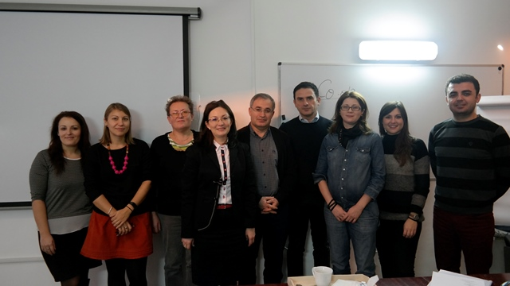 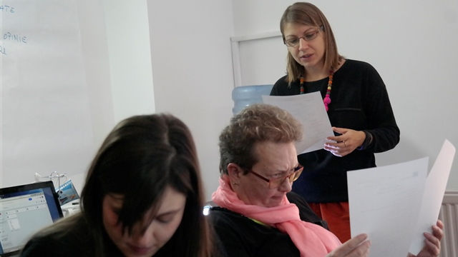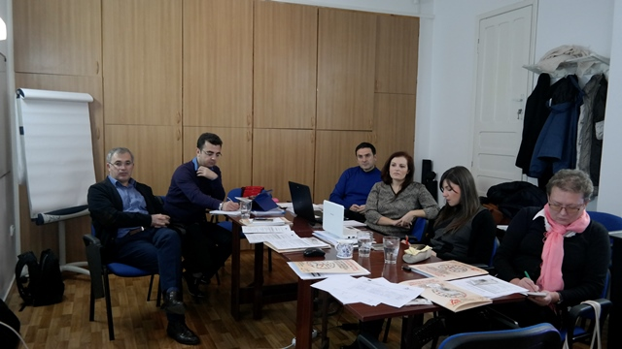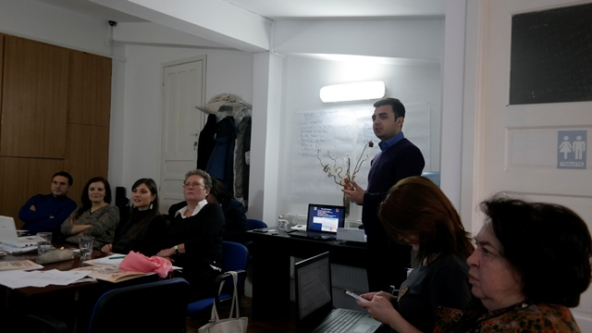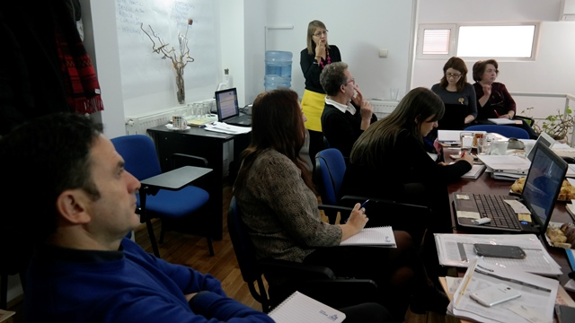

***WHAT IS NEXT?***

* Training in Bastia: 22-26 February 2016
* Second Partner Meeting: 22-23 February 2016 in Bastia
* General Survey Report: Summarising the key findings of surveys in each partner country
* Website on the air: [www.coop4youth.eu](http://www.coop4youth.eu) is on the air from March 2016
* The “CAE” Methodology: Transferring The Innovation

***WHAT IS NEXT IN CO-OP?***

* **Training in Bastia: 22-26 February 2016**
* **Second Partner Meeting: 22-23 February 2016 in Bastia FR**
* **General Survey Report: Summarising the key findings of surveys in each partner country**
* **Website on the air:** [**www.coop4youth.eu**](http://www.coop4youth.eu) **is on the air from May 2016**
* **The “CAE” Methodology: Transferring The Innovation**
* **Second Newsletter in July**

