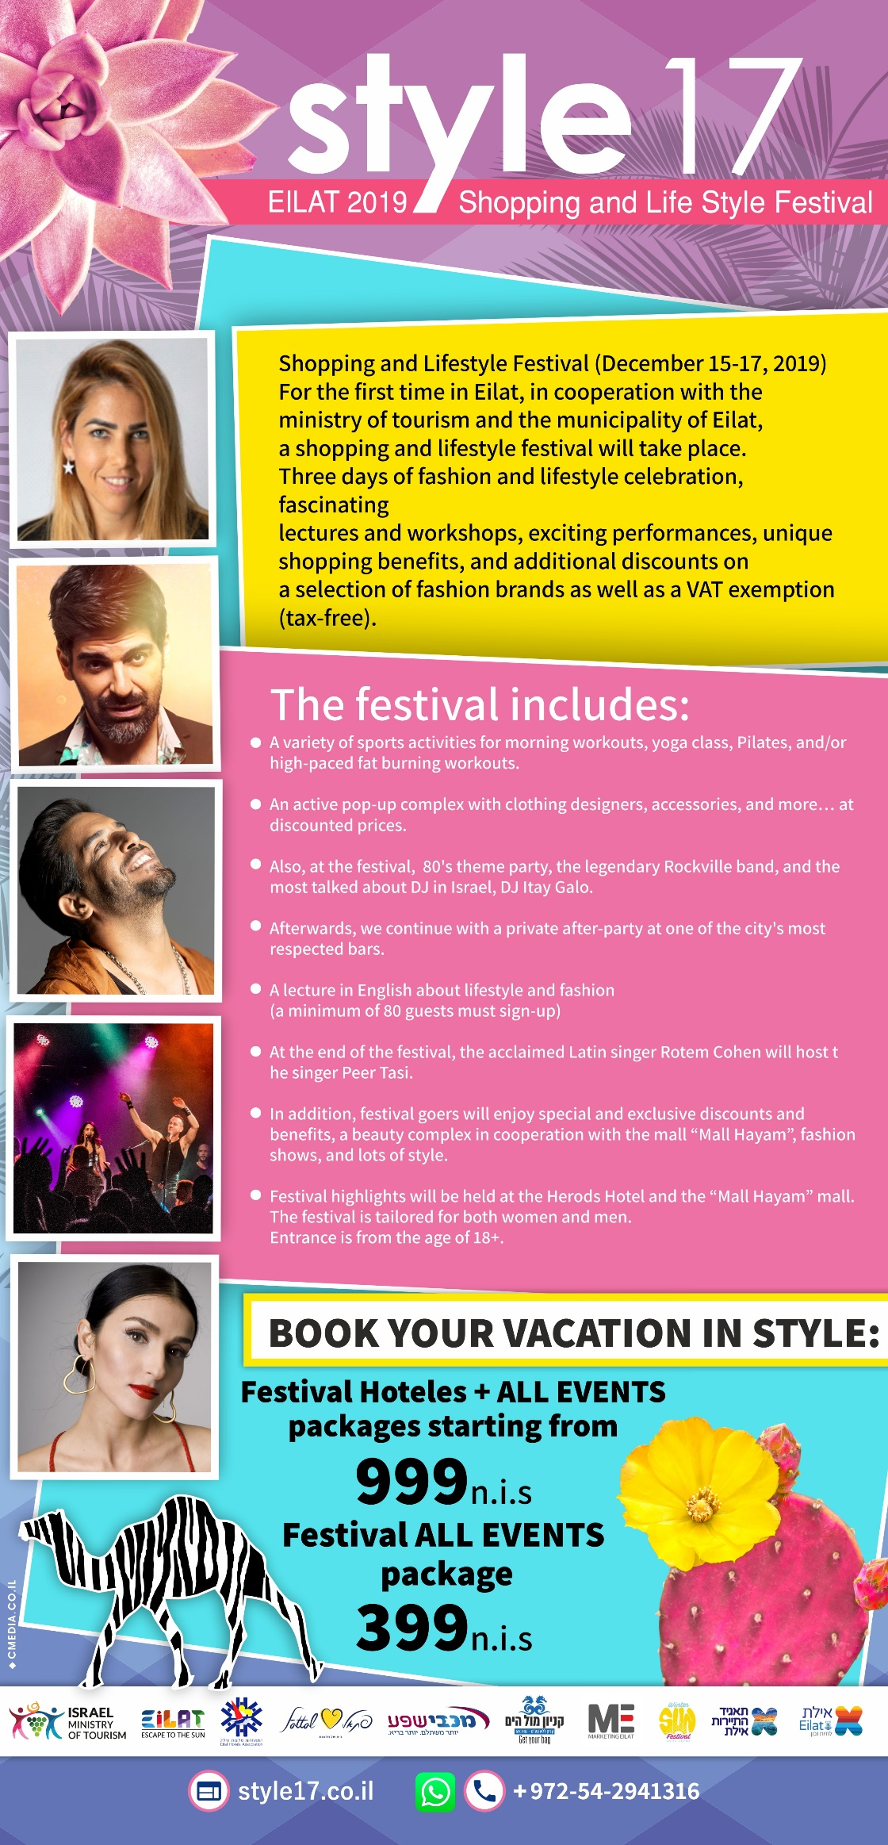

Shopping and Lifestyle Festival (December 15-17, 2019)
For the first time in Eilat, in cooperation with the ministry of tourism and the municipality of Eilat, a shopping and lifestyle festival will take place.
Three days of fashion and lifestyle celebration, fascinating lectures and workshops, exciting performances, unique shopping benefits, and additional discounts on a selection of fashion brands as well as a VAT exemption (tax-free).

The festival includes:
A variety of sports activities for morning workouts, yoga class, Pilates, and/or high-paced fat burning workouts.
An active pop-up complex with clothing designers, accessories, and more… at discounted prices.
Also, at the festival, 80’s theme party, the legendary Rockville band.
Afterwards, we continue with a private after-party at one of the city’s most respected bars.
A lecture in English about lifestyle and fashion (a minimum of 80 guests must sign-up)
At the end of the festival, the acclaimed Latin singer Rotem Cohen will host the singer Peer Tasi.
In addition, festival goers will enjoy special and exclusive discounts and benefits, a beauty complex in cooperation with the mall “Mall Hayam”, fashion shows, and lots of style.
Festival highlights will be held at the Herods Hotel and the “Mall Hayam” mall. The festival is tailored for both women and men. Entrance is from the age of 18+.

Lineup:
Day 1 | 15.12
15:00 | Arrival in Eilat and receiving of the rooms. There is a possibility to store personal objects in the mall “Mall Hayam”.
19:00 – 23:00 | Opening of the Pop-up Complex
Location: Balcony, Pavilion Hall, Herods Hotel
Designers from the web will come to the complex that should not be missed!
21:00 – 23:00 | 80’s Theme Party
Location: Herods Hotel, Pavilion Hall
“Rockville” band
#dress according to the concept
Day 2 | 16.12
Breakfast at the hotel – dressed in sportswear
Morning activity of choice
11:00 – 13:00 | “Style 17” Convention
Location: Herods Hotel, Pavilion Hall
First Lecture: Styling Workshop by Liat Ashuri
Second Lecture: Lidor Raz Cohen, founder of the “17 Day Diet”
#Lecture and discussion
21:00 – 23:00 | Cocktail Party
Location: Herods Hotel, Pavilion Hall
Full concert by Rotem Cohen hosting Peer Tasi
After party at the “5th Avenue” bar (adjacent to the Herods Hotel)
Day 3 | 17.12
Breakfast at the hotel – dressed in sportswear
Morning activity of choice
Shopping Time !!!
VAT free shopping (tax-free shopping) + additional benefits and discounts for festival goers
*Please note the check-out times at the hotel

One Lecture of Choice:
Mindfulness – by Hebrew
Instagram – by Hebrew
Healthy Cooking – by Hebrew
Everyday Makeup – by English

Sport Activities of Choice – 0ne Activitie for each day:
Yoga / Pilates / High-Paced Fat Burning Workouts
*Registration for activities and lectures will be held near the reception desk on arrival day.
*Further details will be provided at the registry counters.

Leonardo Resort Hotel:
Single Person Twin Room – 1020 NIS
Single Person Triple Room – 999 NIS

Herods Boutique Hotel:
Single Person Twin Room – 1400 NIS
Single Person Triple Room – 1400 NIS

The prices are per person per room for 2 nights breakfast included.
The prices include participation in 2 sports activities (one activity each morning), one English lecture of choice, entrance to the pop-up complex and concerts, gifts, and exclusive benefits.

Activity Pricing Without Accommodation:
Lecture – 150 NIS
One Day Sport Activity – 50 NIS
Afterparty at the 5th Avenue – 50 NIS

Fill in the details and one of our representatives will contact you within 3 business days.
You can also call our reservation department at: 054-2941316 (Sunday-Thursday from 10:00 AM to 4:00 PM).
You can send a WhatsApp message.
Please look over the festival policies and security policy.

