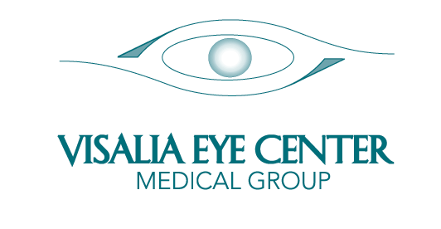
David G. Feil, M.D., F.A.C.S. Michael W. Baumann, O.D.
DIPLOMATE AMERICAN BOARD OF OPHTHALMOLOGY DOCTOR OF OPTOMETRY
COMPREHENSIVE OPHTHALMOLOGY
LASER VISION CORRECTION

Stan H. Feil, M.D. Matthew W. Oblad, O.D.
DIPLOMATE AMERICAN BOARD OF OPHTHALMOLOGY DOCTOR OF OPTOMETRY
CORNEA & EXTERNAL EYE DISEASES
LASER VISION CORRECTION

MINOR-CARE CONSENT FORM

To protect the rights of children and adolescent patients, Visalia Eye Center has adopted a written policy on the care of minor patients. Visalia Eye Center is to obtain written consent by a parent or legal guardian prior to evaluating and treating minor patients. A minor legally becomes an adult at the age of 18. Only in special circumstances can a minor consent to medical treatment as there are legal restrictions. Please refer California Family Code, Section 6920-6929.

Child/Minor’s Full Name: Date of Birth: Drug Allergies: Necessary Health History:

PERSON AUTHORIZED TO PRESENT CHILD/MINOR FOR TREATMENT:

Full Name: Relationship to Child: Contact Phone Number:

Health Insurance Name/Type: ID#/Group #:

Subscriber to Insurance: Date of Birth

Next of Kin to notify in case of emergency:

Phone Number: (___) Relationship to Patient

- I (we) hereby grant permission for medical treatment of my child/children in the event of illness, exam or injury in my absence.___(initial)

- I (we) understand this form, have read it, or had it explained to me (us) and have provided the information required.____(initial)

- I (we) understand that this consent for is valid for 1 year, and will need to be completed again upon expiration of 1 year.____(initial)

- I (we) further understand that I (we) am (are) responsible for updating new information with Visalia Eye Center when necessary.____(initial)

Legal Guardian Name (please print): Relationship:

Legal Guardian Signature: Date:

Home Address: City: State/Zip:

Home Phone Number: (____) Cell/Other: (___)

