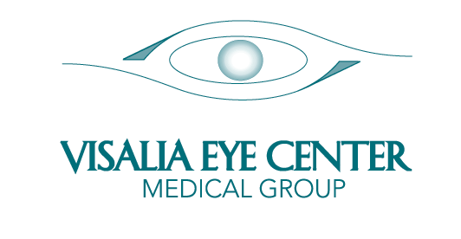

AUTHORIZATION TO RELEASE MEDICAL INFORMATION
(Please list the people below that you would like for us to share your medical information
with, for example husband, son, daughter, etc.)

You may revoke this authorization at any time.

TO: Visalia Eye Center Account No: ____________________________
Stan H. Feil, M.D.
David G. Feil, M.D.
Matthew J. Kliethermes, M.D.
Michael W. Baumann, O.D.
Matthew W. Oblad, O.D.
112 N. Akers Street
Visalia, CA 93291
559-733-4372
559-733-1758 (FAX)

I AUTHORIZE DISCLOSURE OF MY MEDICAL INFORMATION TO:

__________________________________________________________________
Name Relationship

__________________________________________________________________
Name Relationship

__________________________________________________________________
Name Relationship

__________________________________________________________________
Name Relationship

__________________________________________________________________
Name Relationship

Patient Name: ________________________________________________

Date of Birth: ________________________________________________

Signature: ________________________________________________

ADMIN/FRONTOFFICE/AUTHORIZATION

