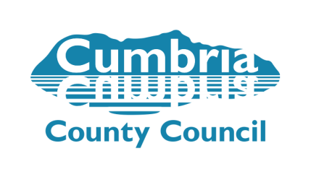
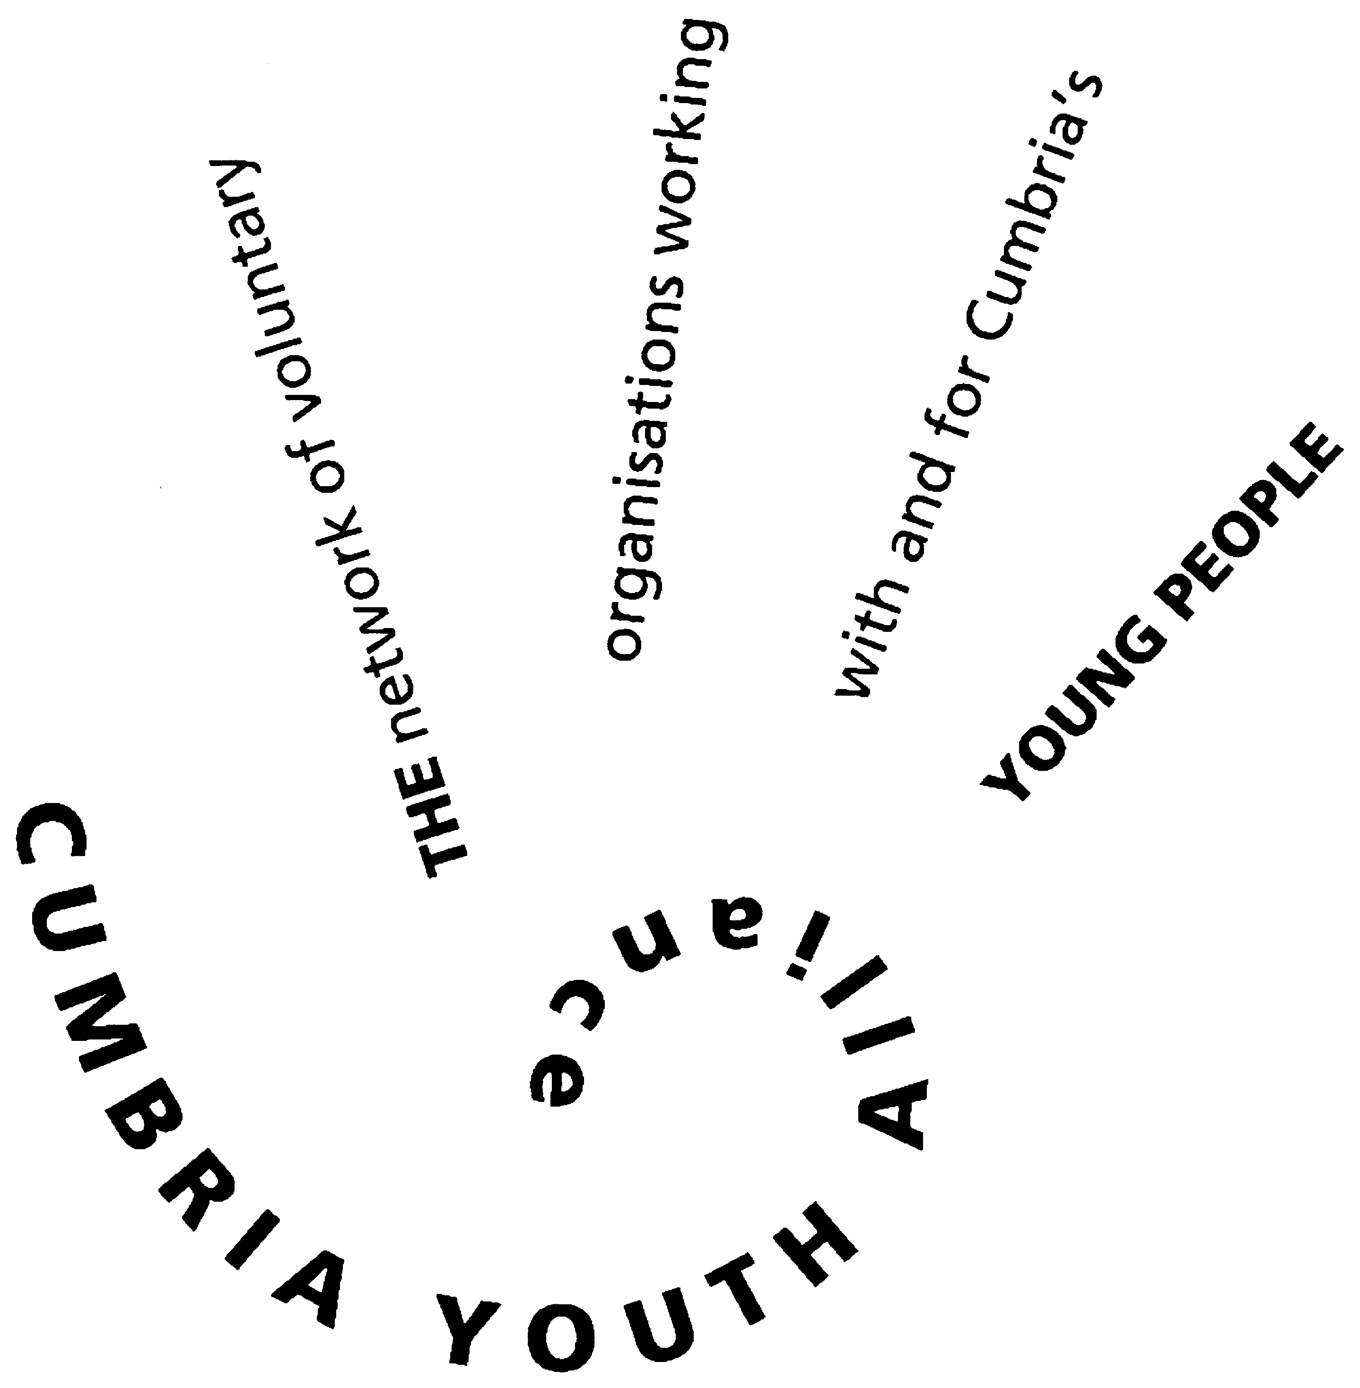
Cumbria Youth Alliance Third Sector Training Opportunity

Thanks to support from Cumbria County Council via the Youth Support Infrastructure Contract we are able to offer
Accredited Level 2 Health and Safety in the Workplace
11th May 2020
9am arrival for a 9.30 start; 4.30 finish
Skills Shop, 2-6 Derry Street, Barrow in Furness LA14 2EF
January bargain price of £30.00 per person which is heavily subsidised
Delivered for CYA by the Skills Shop Team

Refreshments provided but please bring your own lunch
Essential training for all volunteers and staff
Level 2 Accredited Health & Safety in the Workplace Course
The Health & Safety of everyone who enters your workplace is your responsibility.
Join Phil Newton from the Skills Shop to gain a basic understanding of everything you need to consider to ensure you’re legally compliant.
The course will include:
- Understanding the law
- Responsibilities of employers and employees
- How to adopt a positive health and safety culture
- Health and Safety considerations including signage, manual handling, first aid and fire requirements
- How to write effective risk assessments
Photo ID is required.
We’ll supply course booklets for people to take away so they simply need to attend with an open mind.

Places are limited to 16 per course so early booking will be essential .
To be eligible for this reduced price you must be a volunteer or a voluntary sector staff member working with children, young people or families here in Cumbria

To register complete the booking form below and it by email to cath@cya.org.uk
or post to Cumbria Youth Alliance
Town Hall Community Hub, Oxford Street, Workington, CA14 2RS
For enquiries contact Cath: 01900 603131

Booking Form
Level 2 Health and Safety at Work accredited training
11th May 2020 – Skills Shop in Barrow
delivered by
Cost: £30.00 per person

Name
Organisation
Contact Address
Email Address
Telephone number(s)
Participant Declaration (indicate with a tick in the appropriate box)
 |  |  | Yes | No
I confirm that I am a volunteer or a staff member in a voluntary organisation supporting children and young people here in Cumbria
I consent to having my data stored by Cumbria Youth Alliance and used to contact me by email, post or phone (so we can communicate with you regarding your training). I consent to having my details shared with funders who have supported this scheme/ project and allowed us to offer this at a bargain price
I confirm I wish to attend Health and Safety level 2 course on the 24th of January 2019
I confirm I will pay the £30.00 to attend the course which is non-refundable if cancelled within 7 days of commence-ment of the course
Please state where invoice should be sent (if not as above)

I confirm I am happy to be contracted about other training opportunities available to me and my organisation
Do you have any support requirements? If so please give details – eg accessibility or learning support needs
NB Please note photo ID is required to evidence candidate identity so please bring this with you to the training
Signed: |  | Dated:

