Cumbria Youth Alliance Booking Form
Outcomes Star
training to become a licensed user

WHEN
Tuesday 11th February 2020
9.30am till 3.30pm

WHERE
Cumbria Youth Alliance
Town Hall Community Hub, Oxford Street, Workington CA14 2RS

This training is FREE
Refreshments will be available but please bring your own lunch

There is no parking onsite but several car parks nearby
https://en.parkopedia.co.uk/parking/workington/

You can access this training free only if you are working with children, young people and families here in Cumbria and would like to take part in free one day training so you can measure the outcomes/impacts of your work then this is the course for you

We will be using the Youth Star to carry out the training but will talk you through the other Stars (including the new Mind Star for young people)
which are available so you get the right Star for your organisation

Outcomes Star can only be used if you are trained and accredited to use the tools under licence from Triangle Training - Cumbria Youth Alliance are licensed trainers in Cumbria for Outcomes Star and you will have a license under CYA’s agreement with Triangle Training
Want to find out more – check this out:
http://www.outcomesstar.org.uk/using-the-star/star-training/
.
There are over 40 different Stars ranging from Stars for working with early years to Stars that work with those at the end of life. Other Stars include Homelessness Star – Family Stars, Drugs and Alcohol Stars etc but on this training we will be focussing on using and embedding the Youth Star in your working practice. Once you are trained to use one Star you can use the other Stars and on-going help and assistance is always available from our team here at Cumbria Youth Alliance
This unique tool allows you to clearly demonstrate the impact your work has upon the service user and helps you understand where your service user is on the journey of change. Understanding more about the journey of change will make you more effective in face to face working with your service users as it guides your action planning and reviewing of progress
It will make reporting to funders significantly more effective so you can really show what you are achieving with your service users. The Outcomes Star is highly regarded by a number of funders as it’s an asset-based assessment which allows you to accurately draw up an action plan with your service user and monitor the impact of the work against a number of factors. You can show the distance travelled with your service user which can really motive staff and service users alike
Free one day training thanks to support from Cumbria County Council Infrastructure Contract – normally this would cost £100+ per person

Cumbria Youth Alliance Booking Form (one form per person)
Tuesday 11th February 2020
9.30am till 3.30pm
Cumbria Youth Alliance Town Hall Workington CA14 2RS
Outcomes Star - training to become a licensed user

Participant Details
Name
Organisation
Contact Address
Email Address
Telephone number(s)
Participant Declaration (indicate with a tick in the appropriate box)
 |  |  | Yes | No
I confirm that I am supporting children/young people or families
The area of Cumbria where I work is (please state)
I wish to book on the course in Workington on 11th February 20
I consent to having my data stored by Cumbria Youth Alliance and used to contact me by email, post or phone (so we can communicate with you regarding your training)
I consent to having my details shared with funders who have supported this scheme/ project
I consent to having my photograph taken during training
Do you have any support requirements? If so please give details
Do you have any special dietary requirements? If so please give details
Signed: |  | Dated:
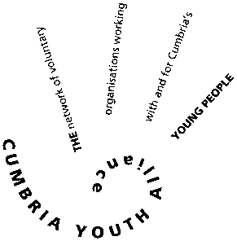
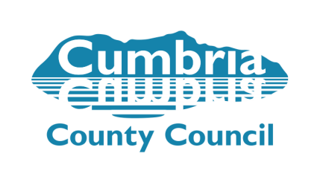
Send your completed application to
cath@cya.org.uk

