MATH  Objective & Instructions: Learn basic geometry. Fill in the blanks.  With a string figure out the dimensions that are not listed.  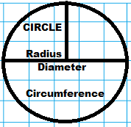  List Circle dimensions:  • Radius: _______ units  • Diameter: _______ units  • Area: __________ units²  (Use string to compute)  • Circumference: ____ units  Advanced: ∏ or π = 3.1416  Circumference=π d __ Area=∏ r²_  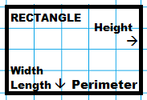  List Rectangle dimensions:  • Length: _______ units  • Width: _______ units  • Height: _______ units  • Area: _________ units²  • Perimeter: _________ units  Advanced: Area=LH ______  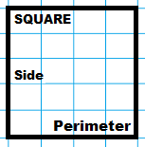  Perimeter= 2L+ 2H _____  Reference: http://www.math.com | List Square dimensions:  • Side: _______ units  • Area: _______ units²  • Perimeter _______units  Advanced: Area=S² ___ Perimeter=4S ___  TRIANGLES  Isosceles: 2 sides the same  Equilateral: 3 sides the same  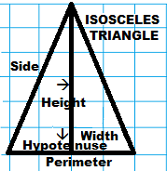  Right: 1 corner is a right angle  List Triangle dimensions:  Height: _______ units  Width: ________ units  Hypotenuse: _______ units  Area: _________ units²  (Use string to compute)  Side: _________ units  Perimeter: _________ units  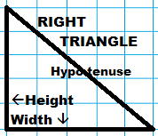  Advanced: Area=HW/2 ___  List Triangle dimensions:  Height: _______ units  Width: ________ units  Area: ________units²  (Use string to compute)  Hypotenuse: _______ units  Perimeter: ________ units  Advanced: Sides a² + b² = c²  c=__ Pythagorean Theorem | ORGANIZATION  Objective: Study Past, Present, Future.  The PAST equates to things that have happened. Those things may be avail-able to be re-visited, such as remakes of past lives, memories, chemistry.  OR  The PAST may be destroyed, closed out to be locked away, stored in memory and awareness, retold in another format.  Terms: History, Time,  Time Travel, Set, Boundaries, Death  The PRESENT equates to things happening now at this time. Most often it is a dynamic time where the PAST influences the FUTURE.  Terms: Now, Moment,  Action, The time is now  The FUTURE is the next moment of what is going to happen and reaction to it – with full range of plans, results, and living – for all living things individually and in conglomerate. Terms: Plans, The Light, Ideal, Destiny, Will Power, Infinite, Patience  CLASS16.5

