MATH  Objective & Instructions: Subtract and total the following.  1−1 =  2−1 =  3−1 =   4−1 =  5−1 =  6−1 =  7−1 =  8−1 =  9−1 =  10−1 =  2−2 =  3−2 = 4−2 =  5−2 =  6−2 =  7−2 =  8−2 =  9−2 =  10−2  =  3−3 = 4−3 =  5−3 =  6−3 =  7−3 =  8−3 =  9−3 =  10−3  =  4−4 =  5−4 =  6−4 =  7−4 =  8−4 =  9−4  =  10−4  =    5−5 =  6−5 =  7−5= |   − 8−5=    − 9−5=    − 10−5=    − 6−6=    − 7−6=    − 8−6=    − 9−6=  − 10−6=  −  7−7=  −  8−7=  − 9−7=  − 10−7=    −   8−8=    −   9−8=  −   10−8=    −   9−9=  −   10−9= | ORGANIZATION  Objective & Instructions: Learn about time.  24 hours are in 1 day.  7 days are in 1 week.  4-5 weeks are in a month.  52 weeks and 12 months are in 1 year.  10 years are in 1 decade.  10 decades, 100 years are in 1 century.  10 centuries,1000 years = 1 millennium.  Schedules:  By Day or Daily By Week or Weekly  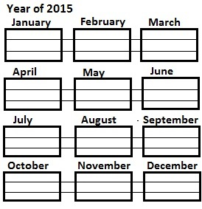  By Month or Monthly  CLASS12.5

