MATH & ORGANIZATION
Objectives & Instructions: Diagram the U.S. Government showing the various sections.

Objective: Learn how to use Charts - Degree chart, Line Graph, Bar Graph, Pie Chart
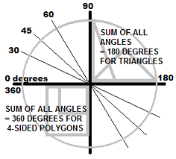 | 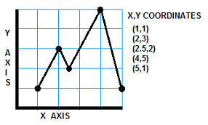
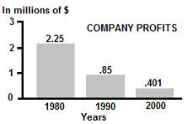 | CLASS23.5

