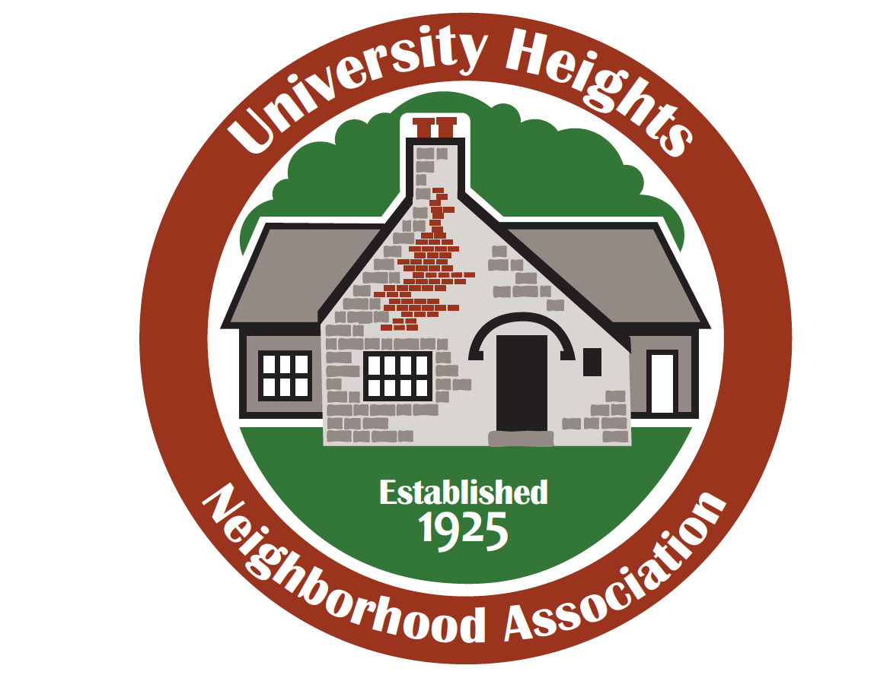
Help Build a Stronger Neighborhood

The University Heights Neighborhood Association is all about celebrating and protecting everything that makes our neighborhood the unique, vibrant community it is. But we need your help.

By becoming a member, you can help:
• work with city officials directly on issues that concern us;
• create a vision for our neighborhood;
• participate in beautification and clean-up efforts;
• help make our neighborhood safer;
• get to know your neighbors better through events.

All of this for just $10 per household per year or $20 per business or nonprofit per year. Join now, and your membership will be good through June 30, 2020. Any household, business or nonprofit within the boundaries of Brookside/Bennett Street, National Avenue, Sunshine Street and Campbell Avenue is welcome.

Your dues will help pay for neighborhood signage, clean-up events, communications expenses such as newsletters and our website, and give you a vote on issues that could affect our neighborhood.

Joining is simple: Just fill out this portion and mail it with a check payable to UHNA to 810 E. Stanford St., Springfield, MO 65807. For more information, email universityheightsneighborhood@gmail.com or call 417-838-6216. Thank you!

Name(s): _________________________________________________________

Address: _________________________________________________________

Phone: ___________________________________________________________

Email: ____________________________________________________________

