4.4 How does your garden grow? Date ………………
Brief description of your innovative idea or project (your plant) ………………………………………………….
……………………………………………………………………………………………………………………………………………………………
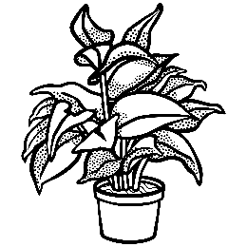

Complete each bubble with what you need to care for your idea and help it to thrive.

