3.1 A big thank you Date …………………………

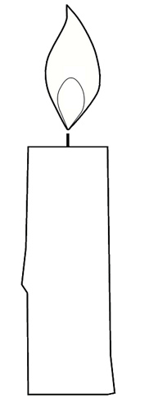
Today, I am grateful for these three things:

