Time

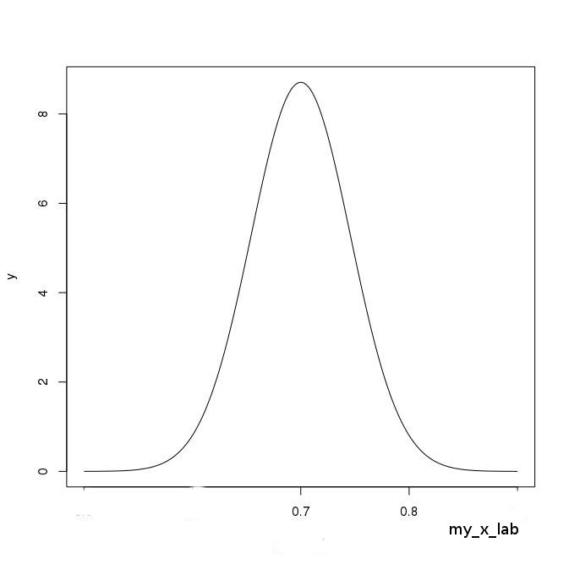

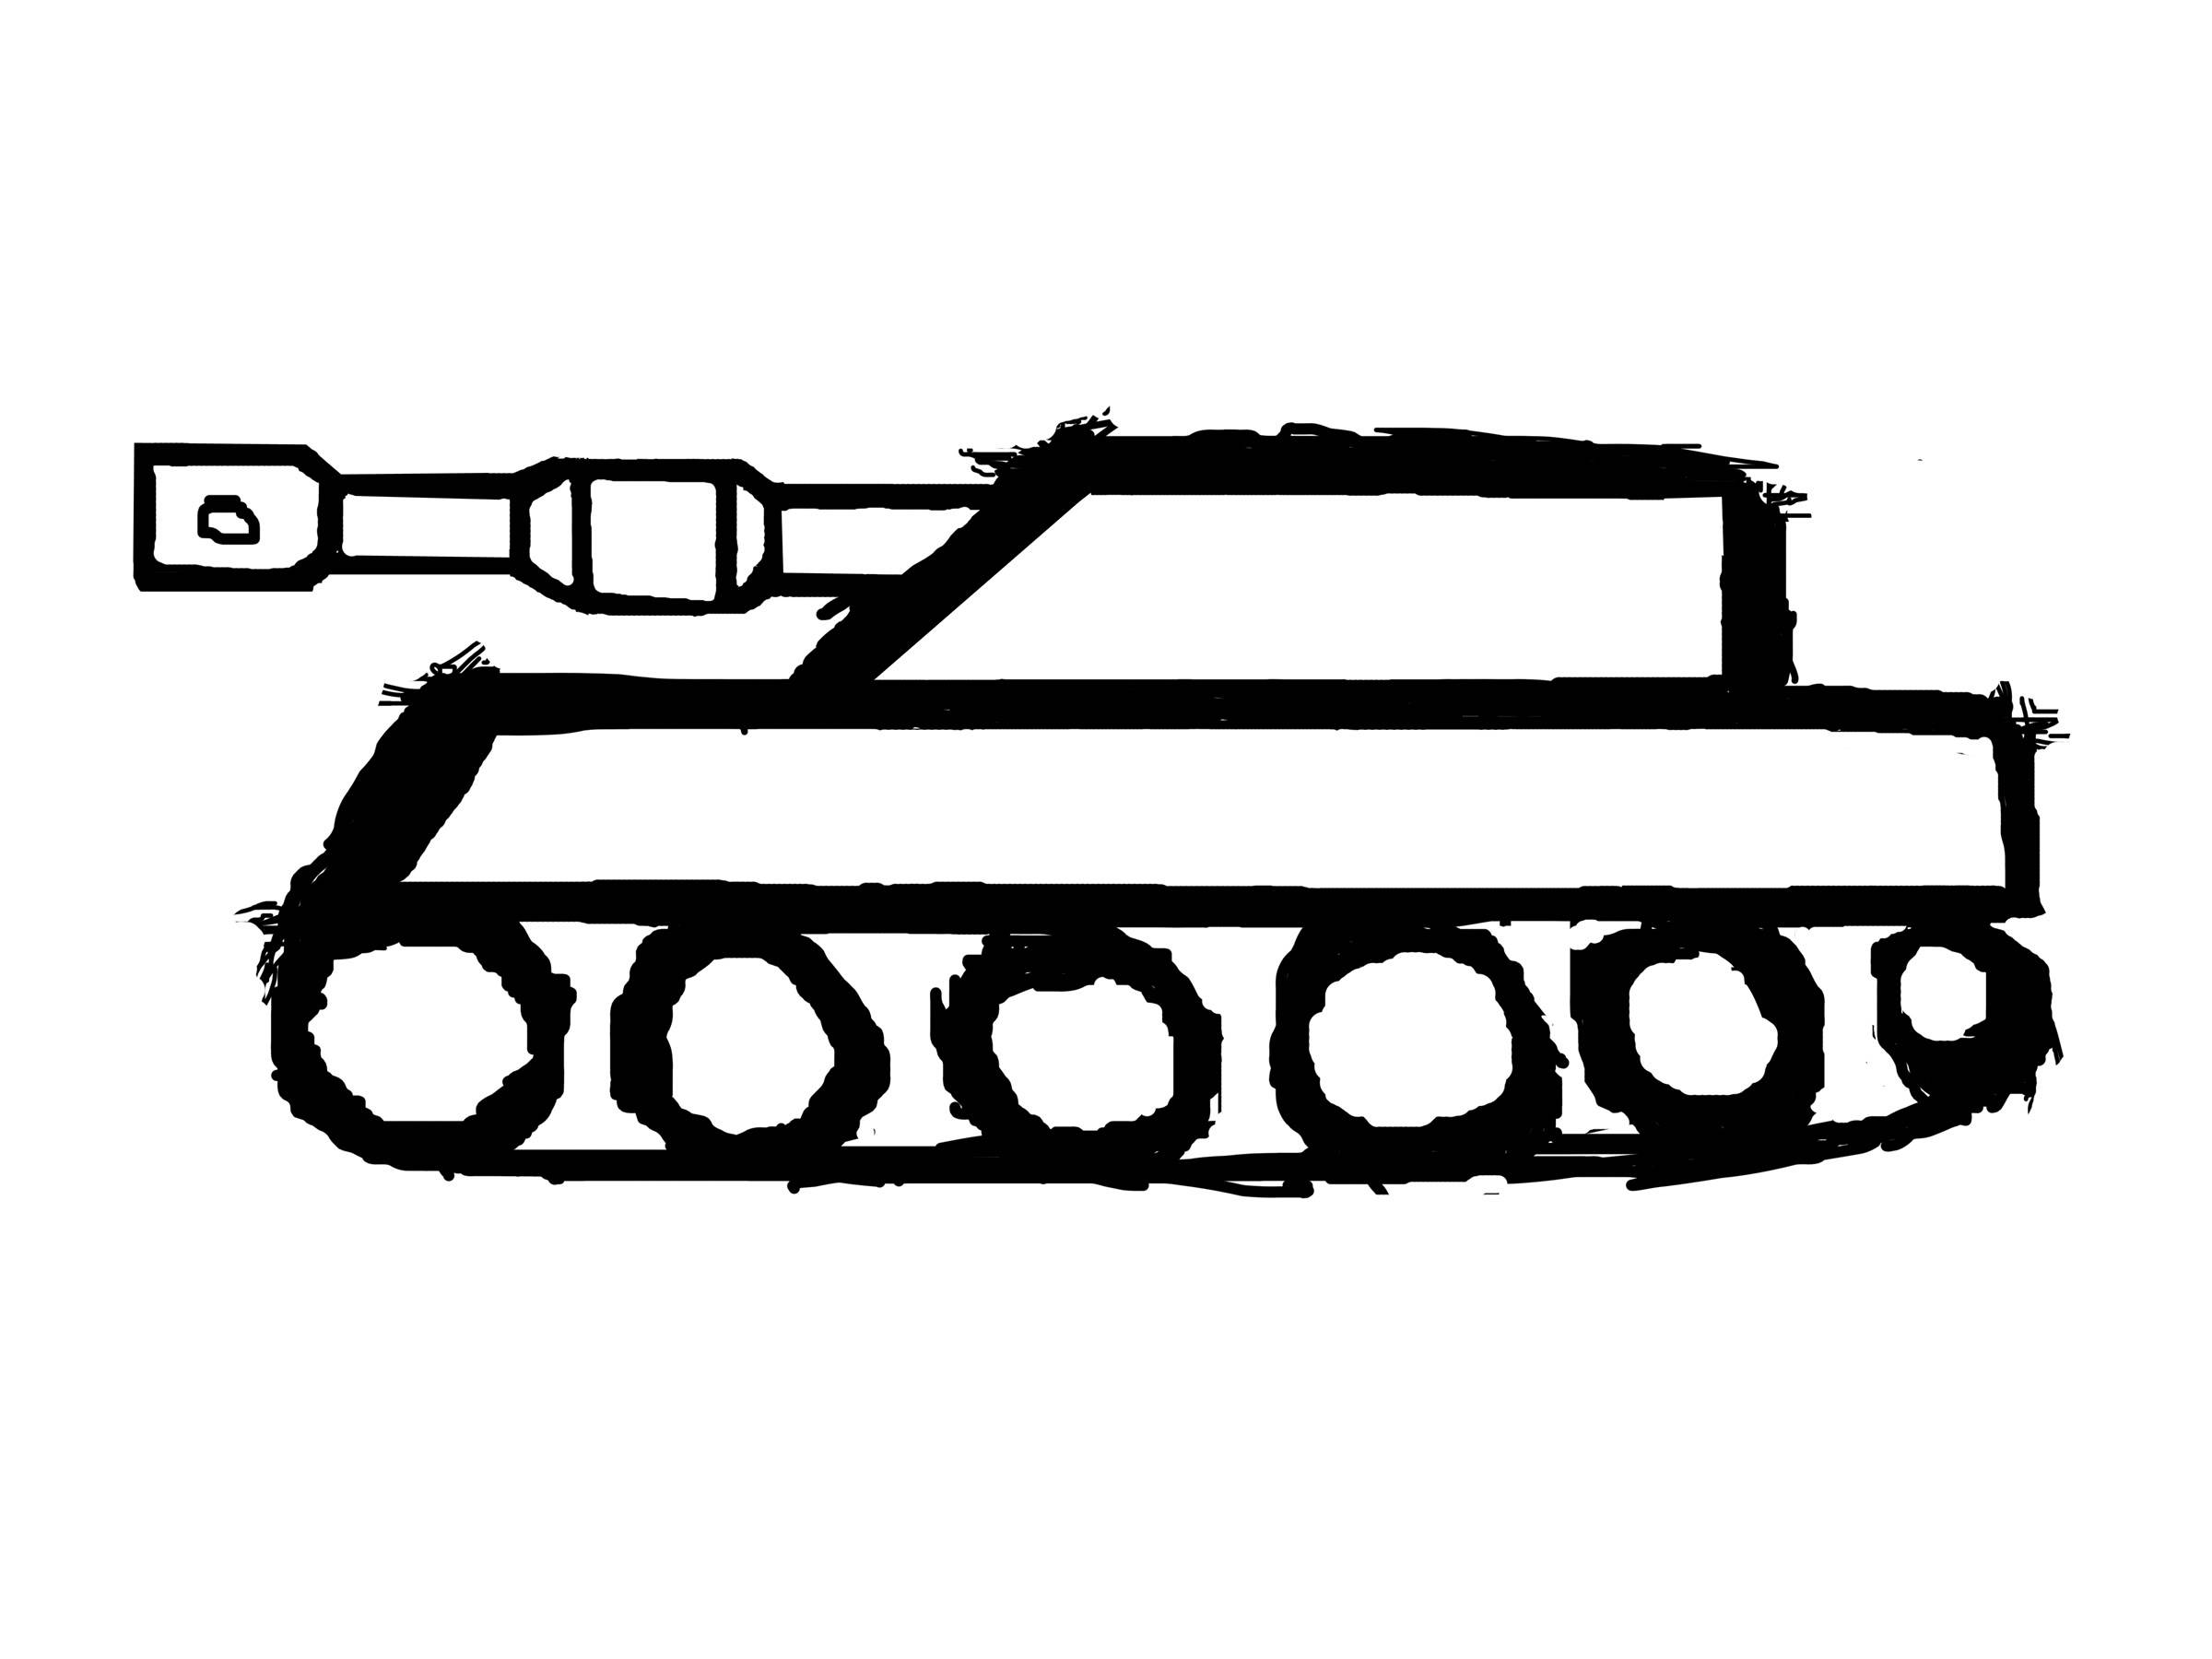



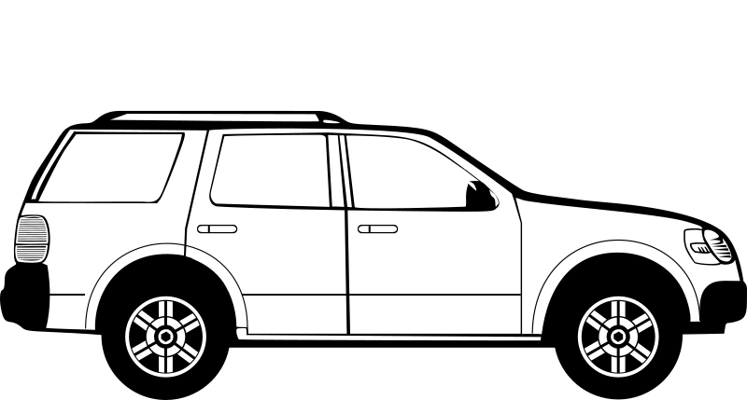

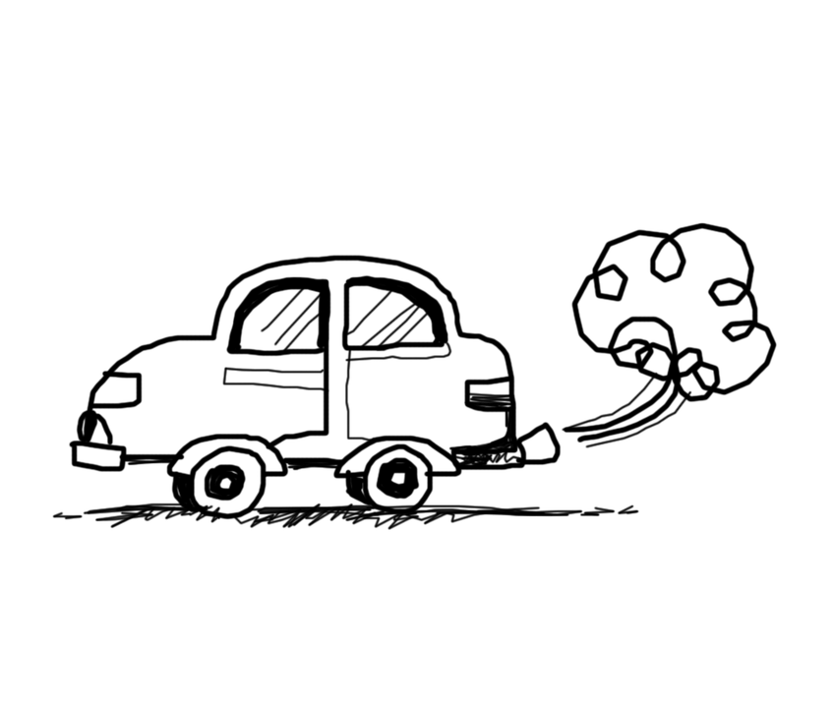

Draw a curve to represent the journey towards achieving your goal. Steep is hard; flat is easy

Improve your chances by being prepared and choosing the right equipment/vehicle for the conditions ahead.

What do I already have access to?

……………………………………………………………………………………………………………………………………………………………………….

What else do I need?..………………………………………………………………………………………………………………………………….

**2.4 Being Realistic**

**What do you want to achieve? How are you going to get there?** Date …………………

My goal is………….……………………………………………………………………………………………………………………………………………………..

Be realistic: What are my chances of success?

………………………………………………………………………………………………………………………………………………………………………………………

Degree of difficulty

dicficultyDegree of difficulty