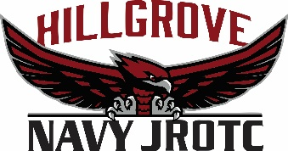
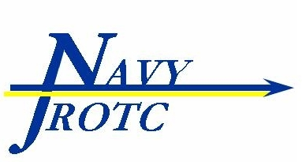
PLAN OF THE WEEK
17 Sept. – 23 Sept. 2018

Senior Naval Science Inst: LCDR Ron Hojnowski, USN (Ret) Naval Science Instructor: ETC (SS) Allen W. Harris, USN (Ret)
Company Commander: c/LCDR Mason Blum Command Master Chief: c/SCPO Peyton Valencia
Executive Officer: c/LT Emily Morrell Operations Officer: c/ENS Jennifer Harnage

 | Monday | Tuesday | Wednesday | Thursday | Friday | Sat/Sun
Classroom  Training | AMI Drill | Uniform Day  Navy Recruiter | Classroom Instruction | Classroom Instruction | PT- Blue&Gold
Team Practices | Armed Basic & Ex Drill  (1530-1730) | Unarmed Basic & Ex Drill  (1530-1730) | Orienteering  (1530-1700) | Orienteering  (1530-1730) | Colorguard Practice  (1530-1630)
Events/  Activities | Top 4 Meeting  (0730-0810)  CO/XO Meeting  (1800-1930) | Rifle Safety Training  (0700-0800) | Rifle Safety Training  (0700-0800) | Staff Meeting  (0720-0815) | PARS Due  Homecoming Parade  (1745-1900)  Rifle Safety Test  (0730-0800) | Sunday:  Mountain Madness  (0530-1800)
SAT/ACT | Test Date | Registration Deadline
SAT | 6 October 18 | 7 September 18
ACT | 27 October 18 | 28 September 18
SAT | 3 November 18 | 5 October 18
SAT | 1 December 18 | 2 November 18
ACT | 8 December 18 | 2 November 18
ACT | 9 February 19 | 11 January 19
SAT/ACT Prep: http://jrotccollegeprep.com this course is offered free of charge to all NJROTC cadets. Sign up!

Date | Upcoming Events
24-28 Sept | Fall Break
30 Sept | GAOC Orienteering- Dauset Trails
3 Oct | PARS Test
5 Oct | Football vs. McEachern
6 Oct | Great Allatoona Clean Up
9 Oct | Annual Military Inspection
9 Oct | Silver Hawk Meeting

MORNING/AFTERNOON COLOR DETAIL: King, Williams, Krusemark, Whitworth

ALL HANDS
-Be sure to come out to Drill practices if you want to be on the teams.

-Cadets and Parents keep up to date with the unit by following the Facebook, Twitter, and Instagram pages, search “Hillgrove Navy JROTC”. Keep up with our activities by frequently visiting our new unit website and calendar: Hillgrovenjrotc.com

-Our first Orienteering Meet is this weekend!! Be sure to come out and support or volunteer to help out.

QUOTE OF THE WEEK
“Don’t go around saying the world owes you a living. The world owes you nothing, it was here first.” –Mark Twain

THIS WEEK IN NAVAL HISTORY
September 18, 1947- Pursuant to provisions of the National Security Act of 1947 of previous July 26, the Department of the Air Force is established.

NAVAL TERM OF THE WEEK
Head- the naval term for the bathroom/restroom
LEADERSHIP QUALITY OF THE WEEK
Discipline- the practice of training people to obey rules or a code of behavior, using punishment to correct disobedience.

CODE OF CONDUCT RULE OF THE WEEK
Each cadet is expected to be well-mannered as each develops and matures as a lady or gentlemen. Each cadet will obey all school and NJROTC regulations and customs with regard to student behavior.

