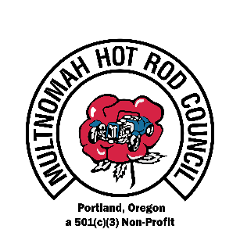
8th ANNUAL

SALUTE TO VETERANS CAR & MOTORCYCLE SHOW
WASHINGTON COUNTY FAIR COMPLEX AUGUST 10, 2019
SPONSOR REGISTRATION FORM

Company Name____________________________________Contact Name_________________________
Phone____________________________Email________________________________________________________
Address__________________________________City___________________________St_________Zip__________

SPONSORSHIP LEVELS Tax ID# 83-2091271
Included Benefits |  | Sponsorship Levels
 | Lieutenant | Captain | Major | Colonel | General
 | $50-99 | $100-299 | $300-499 | $500-1499 | $1500 +
Recognition by DJ at Car Show Event |  |  |  |  | X
Name on Car Show Flyer & 17x11 Business Window Poster |  |  |  |  | X
Flyer in 10K Portland Roadster Show Programs |  |  |  |  | X
Recognition on Website with Link to Sponsor Site |  |  |  | X | X
Framed Certificate of Appreciation |  |  |  | X | X
Booth at Car Show – up to 10x20 |  |  | X | X | X
Name on Sponsor Thank You Banners at Car Show |  | X | X | X | X
TROPHY in Sponsor’s Name & Choice of Best in Show Vehicle |  | X | X | X | X
Sponsor’s Banner/Signs May be Set up at Car Show Event | X | X | X | X | X
Name listed on Event Spectator Program | X | X | X | X | X

- SPONSORSHIP AMOUNT: $____________ SIGNATURE: ___________________________ DATE: ________
Mail completed form & your check by August 1, 2019, to 7410 SW Oleson Rd. Box 194 Portland OR 97223
Checks must be made payable to MHRC VETERANS CAR SHOW
We also accept credit cards
Card Name ______________________________Card#___________________________Exp._______CVC______Zip______
2. TROPHY INSCRIPTION: _____________________________________________________________________
3. BOOTH REQUIREMENT: Free with $300 or more sponsorship No Charge to the military
Informational Booth: 5x5 ($25)____ 10x10 ($40) ____ 10x20 ($50) ____
Retail Booth: 5x5 ($50) ____ 10x10 ($75) ____ 10x20 ($85) ____
Please include your payment in your sponsorship amount above.
4. RAFFLE DONATION: Would you like to donate an item or gift certificate? Yes ___ No ___ Raffle/Certificate Item_________________________________________ VALUE________________
Detailed trophy/booth/raffle information sent upon receipt of this form. Questions: Lynn at lynnkirwan1@comcast.net 503 780 4679, or at Veterans Car & Motorcycled Show, MHRC, & PDX Car Culture websites

