

**Supplementary ACHD Echo Acquisition Protocol for**

Ebsteins Anomaly

***The following protocol for echo in adult patients with Ebsteins anomaly is a guide for performing a comprehensive assessment of this group of patients. It is intended as a supplementary guide to the ISACHD echo protocol and sequential analysis and all regular measurements should be included. It highlights areas of interest in each view specific to Ebstein’s patients.***

**Definition:**

* Apical displacement of the septal leaflet of the tricuspid valve into the right ventricle. The posterior leaflet is sometimes also displaced. The leaflets have failed to fully delaminate from the septum and are often dysplastic with thickened, rolled & shortened chordae and under-developed papillary muscles
* Anterior leaflet is elongated and redundant with abnormal chordal attachments directly to the lateral wall.
* “Atrialization” of the basal portion of the right ventricle (aRV) with abnormal ventricular septal motion.

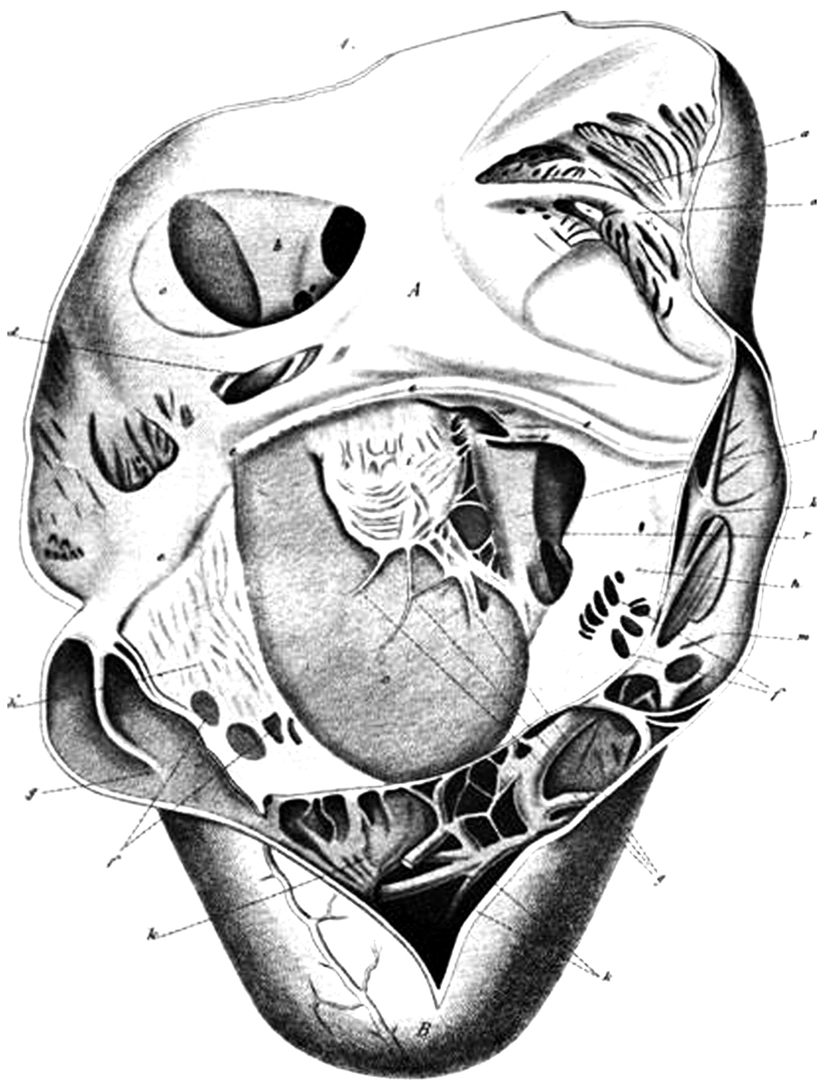

Septal leaflet

Annulus

Posterior leaflet

Anterior leaflet

Coronary sinus ostium

Patent foramen ovale

Fenestrations

Diagram 1 Diagram of Ebstein anomaly. Adapted from *Ebstein W. Ueber einen sehr seltenen Fall von Insufficienz der Valvula tricuspidalis, bedingt durch eine angeborene hochgradige Missbildung derselben. Arch Anat Physiol. 1866; 238–255.*

**Common associations:**

* ASD or PFO (bi-directional shunting is common)
* VSD
* Pulmonary atresia with intact ventricular septum
* MV prolapse
* Coarctation of aorta
* LV non compaction

**Carpentier’s Classification in Ebstein Anomaly**

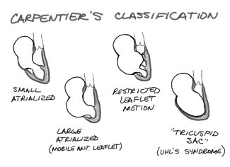

**D.**

**C.**

**B.**

**A.**

Diagram 2 Carpentier’s Classification. Type A: the volume of the true right ventricle (RV) is adequate; Type B: a large atrialized component of the RV exists, but anterior leaflet of the tricuspid valve moves freely; Type C, the anterior leaflet is severely restricted in its movement and may cause significant obstruction of the right ventricular outflow tract; Type D, almost complete atrialization of the RV except for a small infundibular component. (Carpentier A, et al. A new reconstructive operation for Ebstein’s anomaly of the tricuspid valve. *J Thorac Cardiovasc Surg.* 1988;96: 92–101. )

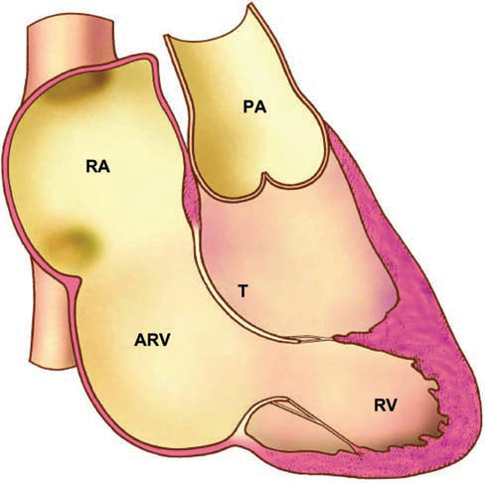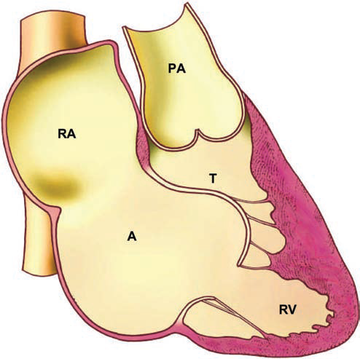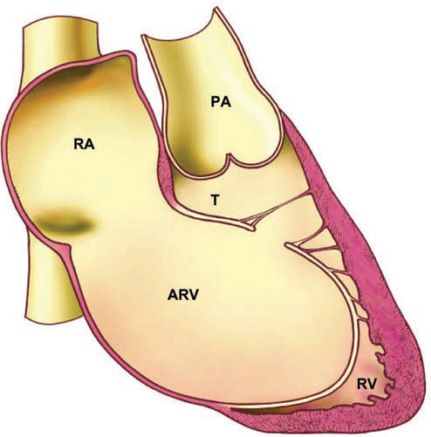

Diagram 3. Different types of Ebstein anomaly. *Diagram adapted from Popelova et al.*

**Celermajer Index in Ebsteins Anomaly**

The Celermajer Index (CI) compares the combined right atrial and atrialised right ventricular area to the area of the remainder of the cardiac chambers seen in the apical 4 chamber view and correlates with prognosis in neonates.



Figure 1: Celemajer Index measurements

Celermajer Index = Total area of right atrium + atrialised RV

Total area of functional RV + LA + LV

Celermajer’s echocardiographic grading score: the ratio of the combined area of the right atrium and atrialized right ventricle is compared with that of the functional right ventricle and left heart:

grade 1: ratio <0.5;

grade 2: ratio 0.5 to 0.99;

grade 3: ratio 1.0 to 1.49,

grade 4: ratio >=1.5

A ratio ≥1 in a neonate indicates a very poor prognosis.

(Celermajer DS, et al. Ebstein’s anomaly: presentation and outcome from fetus to adult. *J Am Coll Cardiol.* 1994;23:170 –176.)

**Imaging protocol for Ebstein anomaly**

|  |  |
| --- | --- |
| Subcostal views | * Establish abdominal and atrial situs, cardiac position & direction of apex * Assess IVC size & collapsing * Assess atrial septum * RV SAX may offer biplane FAC of RV |
| PLAX/RV inflow | * Assess displacement of septal +/- posterior leaflet involvement * Assess TR severity * Measure LV size * TV leaflets seen in RVOT in standard PLAX suggest anterior rotation of the tricuspid orifice |
| Parasternal short axis | * Assess rotation of tricuspid valve closer in position to the pulmonary valve * Assess TR severity * Assess RVOT dilatation & function * Assess size of pulmonary arteries when repair is being considered * Assess interatrial septum |
| Apical views | * Zoom on cardiac crux to establish & measure abnormal septal displacement (>2 cm or >8mm/m²) * Assess tricuspid valve anatomy including degree of direct attachment of anterior leaflet into lateral wall of RV * Assess functional right ventricular function * Assess degree of atrialisation of right ventricle (Celemajer Index) * Assess TR severity at origin of jet (large compliant RA may mask hepatic flow reversal) * Assess left ventricular function |
| Suprasternal views | * Assess aortic arch * SVC flow may show flow reversal in cases of severe TR. |

**Ebstein Anomaly Reports:**

Key points to include in transthoracic echo report:

* Valve anatomy including displacement towards apex and rotation towards the RV outflow tract
* Functional RV size & function. In severe cases, this may be only the RVOT
* Degree of atrialisation of the right ventricle
* Severity of tricuspid regurgitation
* Size of pulmonary arteries
* LV size & systolic function
* Atrial septal integrity

**Key views specific to Ebsteins Anomaly:**

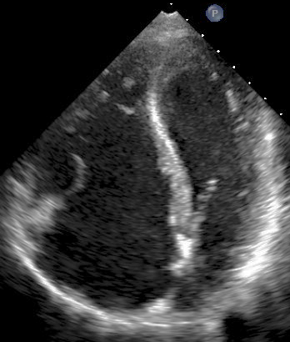

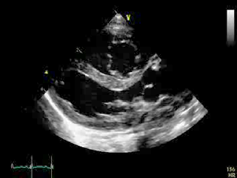

Figure 3. Apical 4 chamber view demonstrating significant apical displacement of the TV septal leaflet (arrow). A large component of the RV is atrialised. .

Fig ure 2. PLAX: note the abnormal enface orientation of the tricuspid valve. This demonstrates the abnormal anterior rotation of the valve. The RV is also dilated.

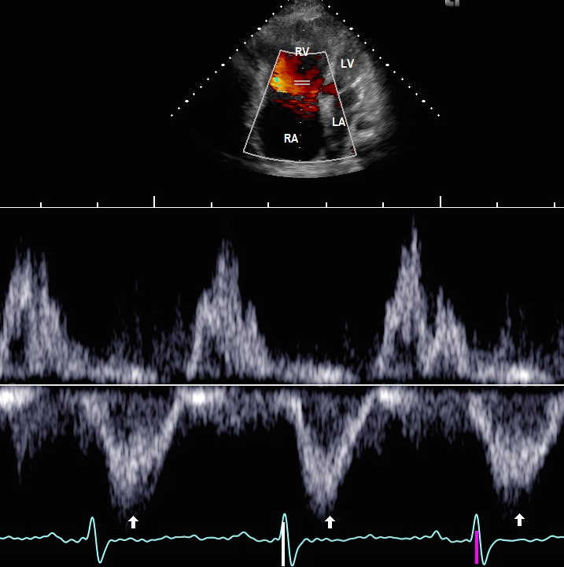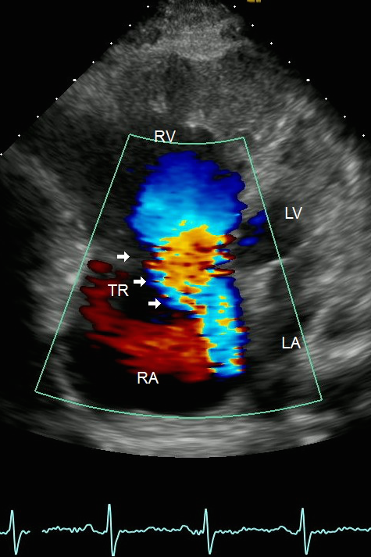

Figure 4. Severe TR from 4 chamber view with tricuspid valve Doppler profile. Note the laminar flow of tricuspid regurgitation indicating severe deficiency of valve function. Estimation of pulmonary pressures is not reliable in this scenario.

A B

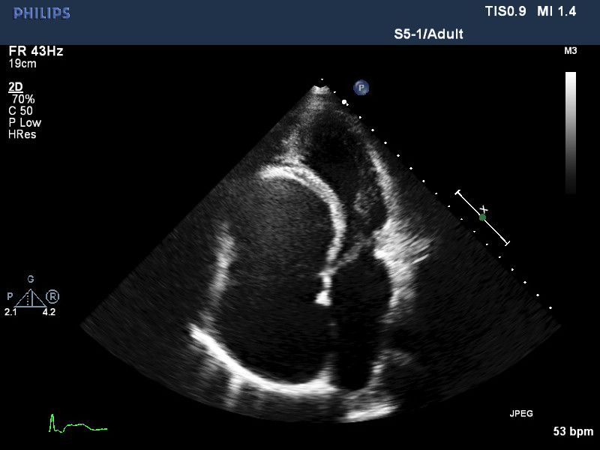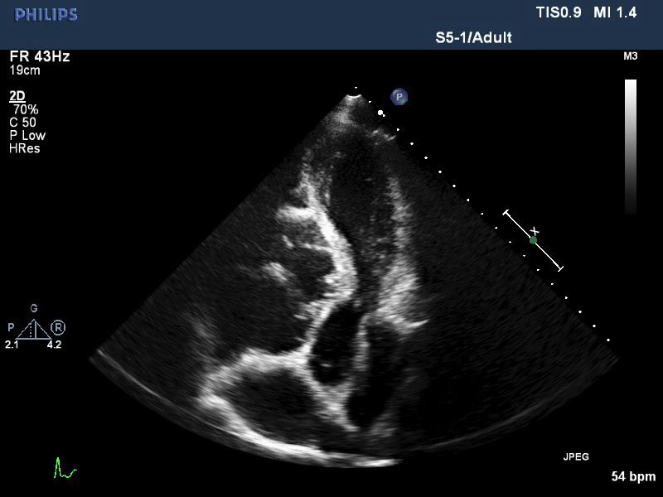

S

P

A

AoV

B

Figure 5. Carpentier type IV Ebsteins: in the 4 chamber view (A), there are no discernible leaflets due to marked anterior rotation of the valve, only the moderator band is seen. In the 5 chamber view (B), with the aortic valve as a landmark, all 3 leaflets are seen enface.