Supplementary ACHD Echo Acquisition Protocol for
TGA – Arterial Switch repair

The following protocol for echo in adult patients with Transposition of the Great Arteries with arterial switch repair is intended as a guide for performing a comprehensive assessment of this group of patients. It is intended as a supplementary guide to the ISACHD echo protocol and sequential analysis and all regular measurements should be included. It highlights areas of interest in each view specific to TGA with arterial switch repair.

Arterial Switch Operation - Surgical Techniques

The arterial switch operation corrects d-transposition circulation and anatomy by connecting the great vessels to their appropriate ventricles. This has been the standard operation for dextro-transposition (d-TGA) since the mid-late 1980’s and is usually performed in the first week of life.
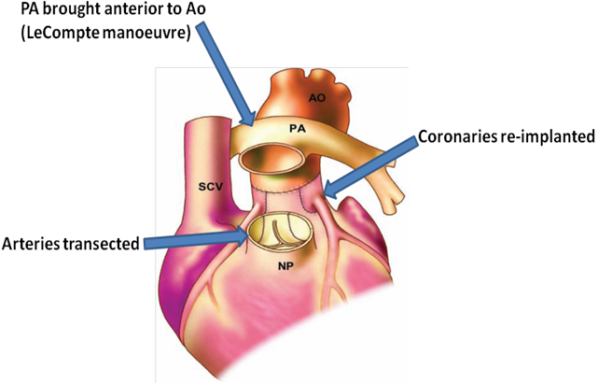

Diagram. Jatene’s arterial switch operation - diagram adapted from Popelová et al

- Jatene’s arterial switch operation involves transection of both great arteries above the semilunar valves and then
  - the aorta (originally arising from the right ventricle) is transferred to its correct position and is connected to the left ventricle. The valve (which was the pulmonary valve) remains in position and is now known as the neo-aortic valve – it functions as an aortic valve but is morphologically a pulmonary valve.
  - the coronary arteries & buttons are explanted from the pulmonary root are reimplanted into the neo-aortic root.
  - the main pulmonary artery is pulled from its posterior position so that it becomes anterior to the aorta (LeCompte manoeuvre). The branch arteries now straddle the aorta, unlike in the normal branch artery anatomy. Not all patients with arterial switch operation have this LeCompte procedure. Reference to the surgical notes of individual patients is recommended.
  - the original aortic valve remains untouched and is now referred to as the neo-pulmonary valve.

Post-operative Sequelae:

- Supravalvular pulmonary artery stenosis, caused by scarring at the anastomosis or origin of the branch arteries, requires re-intervention in about 5–30% of patients
- Supravalvular aortic stenosis occurs less often, with re-intervention required by about 2% of patients
- Right ventricular outflow tract obstruction (RVOTO) develops in the presence of a hypertrophic infundibulum
- Progressive dilatation of the neoaortic root occurs more often in complex TGA (with VSD) which can compress the branch pulmonary arteries
- Various degree of aortic valve regurgitation occurs in up to 50% of patients
- LV systolic dysfunction often seen in patients with coronary artery anomalies

Imaging Protocol for TGA – arterial switch repair
Subcostal view | - Establish abdominal and atrial situs, cardiac position & direction of apex
Apical views | - Ventricular function  - Global ventricular function  - Assessment of regional wall motion abnormalities related to stenosis of re-implanted coronary arteries  - Assess for myocardial perfusion with contrast  - Valvular assessment  - Aortic regurgitation  - Superior angulation for pulmonary regurgitation or supravalvular stenosis
PLAX views | - Routinely measure aortic root assessing for dilatation and supravalvular stenosis  - Assess for aortic regurgitation & supravalvular narrowing  - Assess for pulmonary regurgitation  - Assess for supravalvular pulmonary stenosis including in the main, left and right pulmonary arteries
Parasternal short axis | - Use a very high PSAX view to demonstrate the branch pulmonary arteries +/- LeCompte manoeuvre  - Careful interrogation of stenosis at all anastomosis sites along the pulmonary artery – including left & right branch PAsAssess aortic regurgitation
Suprasternal views | - Careful assessment of pulmonary branches – use of alternative windows e.g. supraclavicular views may be helpful  - Assess for supravalvular aortic stenosis

TGA Arterial Switch Reports
Key points to include in transthoracic echo report:
- RV size & function
- Estimate of RV systolic pressure
- Patency of PA branches, especially when LeCompte performed
- LV size & systolic function
- Aortic valve function
- Aortic root size

Key views specific to arterial switch patients:

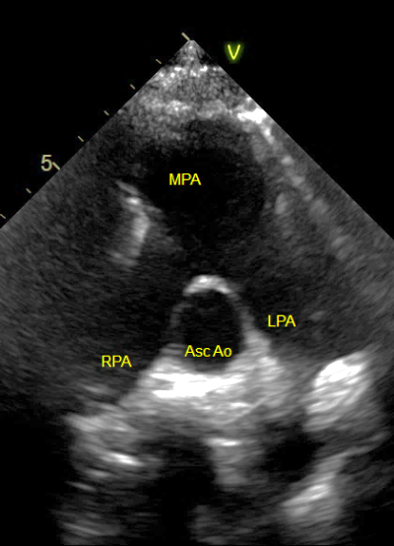
Figure 1 High PSAX view demonstrates the LeCompte manoeuvre. The pulmonary artery branches straddle the ascending aorta. This patient has dilated pulmonary arterial branches due to PA hypertension. This view can be difficult to obtain in majority of patients.
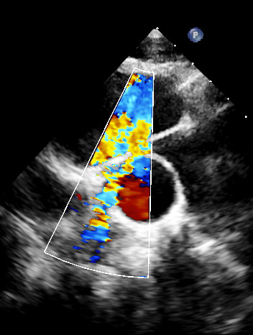
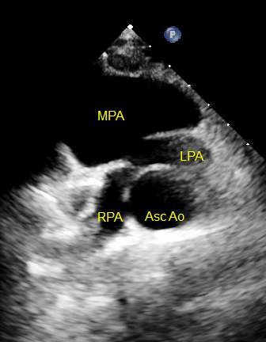

Figure 2 Another example of the LeCompte manoeuvre. Note on the 2D image the origin of the RPA is narrowed, resulting in stenosis & turbulent colour flow.

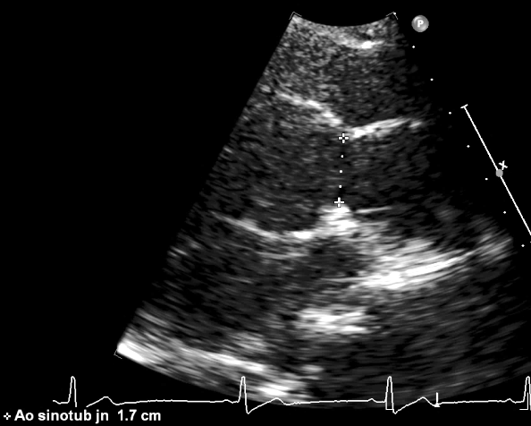
Figure 3 Supravalvular aortic stenosis at the aortic root anastomosis site. The sinotubular junction is measured here.

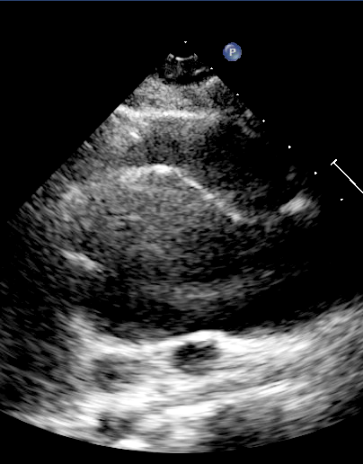
Figure 4 Dilatation of the neo-aortic root (original pulmonary root) may cause aortic regurgitation.

