

**Supplementary ACHD Echo Acquisition Protocol for**

*LV outflow obstructions*

***The following protocol for echo in adult patients with LV outflow obstructions, including subvalvular, valvular, supravalvular stenoses and coarctation and is intended as a guide for performing a comprehensive assessment of this group of patients. It is intended as a supplementary guide to the ISACHD echo protocol and sequential analysis and all regular measurements should be included. It highlights areas of interest in each view specific to LV outflow evaluation.***

**Background:**

This document incorporates the following lesions:

* Subvalvular aortic stenosis, including subaortic membranes
* Valvular stenosis, including bicuspid & dysplastic aortic valves
* Supravalvular stenosis, including hourglass narrowings and hypoplastic ascending aorta
* Coarctation of the aorta



Diagram: Aortic coarctation: relationship to the origin of the left subclavian artery is important to identify. *Diagram adapted from Popelova et al*

**Common associations:**

* Subaortic membrane
  + bicuspid aortic valve, coarctation, supramitral ring, parachute mitral valve (when all features are present, this condition is collectively referred to as Shone syndrome)
  + aortic regurgitation
* Bicuspid aortic valve – ascending aorta dilatation, coarctation, Turner syndrome
* Supravalvular stenosis – Williams syndrome
* Coarctation - bicuspid aortic valve

**Common sequelae:**

* Aortic regurgitation
* LV hypertrophy
* LV systolic & diastolic dysfunction
* In severe cases, pulmonary hypertension, secondary to LV diastolic dysfunction.
* Clinically in coarctation, reduced femoral pulses or arm-leg blood pressure gradient

**Tips & Tricks:**

1. Subaortic stenosis:

* Assess for cause of obstruction: e.g. subaortic membrane/ridge/chordae crossing outflow tract, diffused tunnel like narrowing or basal septal hypertrophy
* Turbulent flow through LVOT can damage aortic valve leaflets and cause aortic regurgitation
* Assess timing of flow – often a dynamic obstruction peaks in late systole whereas a fixed obstruction peaks in mid systole. This has important implications for patient management.

1. Aortic valve stenosis:

* Assess valve anatomy and number of leaflets
* Assess for co-existing aortic regurgitation, often eccentric if bicuspid aortic valve
* Assess aortic root and ascending aorta for dilatation (using higher left parasternal & right parasternal views)
* Use apical, suprasternal and right parasternal windows as minimum attempt to search for best Doppler/blood flow alignment to reflect the true gradient. Bicuspid valve flow is often eccentric. Non-imaging probe is highly recommended.
* Use modified Bernoulli equation to correct gradients if LVOT velocity >1.2m/sec (see below).

1. Supravalvular aortic stenosis:

* Identify level of stenosis e.g. sinotubular junction or in ascending aorta (right parasternal or apical long axis views may be helpful).
* Identify extent of stenosis – discrete or long, tunnel like narrowing (important Doppler considerations-see below)
* Use multiple windows to identify true gradient
* Confirm that aortic valve function is normal.

1. Coarctation:

* Unexplained concentric left ventricular hypertrophy can be the important clue to coarctation.
* Assess descending aorta with CW Doppler, including the non-imaging probe.
* The shape of the CW Doppler signal is more informative than the peak velocity: extension of forward flow into diastole can suggest the presence of severe stenosis and a collateral circulation, which is clinically significant, irrespective of peak gradient. In a normal situation, the cessation of aortic flow will coincide with the end of the T-wave on the ECG. In coarctation, forward flow is seen after the T-wave. This flow is often referred to as a ‘diastolic tail’.
* In long segments of coarctation, the CW Doppler gradient can be unreliable due to the assumptions of the Bernoulli equation being untrue and also the presence of significant collaterals providing an alternative pathway for flow.
* In the suprasternal view, be careful not to confuse ‘double shadows’ given by flow in the left pulmonary artery, which courses in front of the descending aorta
* Assess abdominal aortic flow for systolic blunting and any diastolic continuation of flow
* In the case of extensive collateralization, mild exercise (supine pedalling motion increasing the heart rate to 90-100 bpm) may saturate the collaterals, force flow through the coarctation and reveal the gradient.

**Imaging Protocol for LV outflow obstruction**

|  |  |
| --- | --- |
| PLAX/RV inflow | * LV size & function * LV wall thickness * Demonstrate LV outflow tract, aortic valve anatomy, number of leaflets, aortic root and ascending aorta * Assess valvular function * Assess site of stenosis |
| Apical views | * Obtain LVOT VTI with PW Doppler * Obtain peak outflow gradients and VTI using CW Doppler (with non-imaging probe) * Assess AoV regurgitation * Assess level of stenosis * Assess ventricular function * Assess diastolic function * Assess TR for pulmonary hypertension |
| Subcostal view | * Assess abdominal aortic flow profile |
| Suprasternal views | * Assess arch dimensions, site of narrowing, peak gradient, presence of diastolic forward flow. * Attempt to demonstrate collaterals if coarctation; may use mild exercise (see tips and tricks) * Obtain peak aortic/outflow gradient & VTI from suprasternal notch & clavicular views. Use of non-imaging probe is recommended |
| Right parasternal | * Assess dimensions & contour of ascending aorta * Assess peak aortic gradient. Use of non-imaging probe is recommended |

**Technical considerations:**

1. The Simplified Bernoulli equation.

* The simplified Bernoulli equation is used frequently throughout echocardiography and converts a velocity to a pressure gradient using the equation:

ΔP = 4V2

* It is simplified from a much more complex equation which accounts for convective acceleration, flow acceleration and viscous friction. The simplified equation holds multiple assumptions.
* One of the assumptions is that there is no substantial acceleration of proximal flow which is valid when proximal flow is <1.2m/sec.
* In instances when proximal flow is ≥1.2m/sec, the modified Bernoulli equation must be used in order to prevent over-estimation of gradients:

ΔP = 4 (V22 – V12)

where V2 = peak obstructive gradient (CW Doppler)

& V1 = velocity proximal to obstruction (PW Doppler)

Case example:

LVOT Vmax 1.6m/sec AoV Vmax 3.1m/s

LVOT peak gradient 10mmHg AoV peak gradient 38mmHg

LVOT mean gradient 7mmHg AoV mean gradient 22mmHg.

In this dataset, the LVOT flow is elevated at 1.6m/sec and is outside the defined ‘negligible’ contribution to the peak aortic velocity as stated in the Bernoulli equation. Therefore, these aortic gradients should be corrected.

Corrected peak AoV gradient = 4 (V22 – V12)

= 4 (3.12 – 1.62)

= 4 (9.61-2.56)

= 4 * 7.05

= 28mmHg.

Corrected mean gradient = AoV mean gradient – LVOT mean gradient

= 22 – 7

= 15mmHg.

In practical terms, this scenario most commonly arises in both aortic stenosis and in coarctation when the LVOT flow or PW Doppler just proximal to the coarctation has a velocity >1.5m/sec.

1. Long tubular narrowings:

* The Bernoulli equation is valid for discrete, localised obstructions. Where there are long tubular narrowings e.g. hypoplastic ascending aorta or long segments of coarctation, the Bernoulli equation does not accurately reflect the true pressure gradient due to rapid pressure recovery. Echo-derived gradients can appear over-estimated when compared to invasively-derived catheter gradients.

1. Multiple sites of narrowing

* Special caution should be taken in the setting of multiple sites of stenosis e.g. severe AS with coarctation as multiple assumptions of the Bernoulli equation can be violated simultaneously and therefore Doppler gradients become increasingly unreliable. Peak velocity and timing of flow may provide an idea of the gradient but alternative imaging modalities are recommended.

**Bicuspid Aortic Valve Reports**

Key points to include in transthoracic echo report:

* LV size, function & wall thickness
* Valve anatomy: true bicuspid versus functionally bicuspid, if so name the fused cusps
* Valve function: peak & mean gradients, AVA, indexed stroke volume
* Aortic measurements: LVOT, hingepoint, trans-sinus, sinotubular junction, ascending aorta, arch & isthmus
* Presence of coarctation
* Estimate of pulmonary pressure
* Assess for other associated anomalies

**Key Views Specific to LV outflow tract obstructions:**

1. Parasternal long and short axis views with aortic root/ascending aorta and view of bicuspid aortic valve.
2. M-mode recording of aortic valve movement in patient with sub-aortic stenosis.
3. Apical 5 chamber showing sub aortic stenosis CFI
4. Apical 5 chamber CW Doppler showing AS signals
5. Suprasternal view with diastolic tail versus normal
6. Abdominal aorta PW Doppler – 1 normal showing early diastolic flow reversal then diastolic forward flow as normal and 2nd showing a true diastolic tail

Parasternal long axis with subaortic membrane 2D & CFI

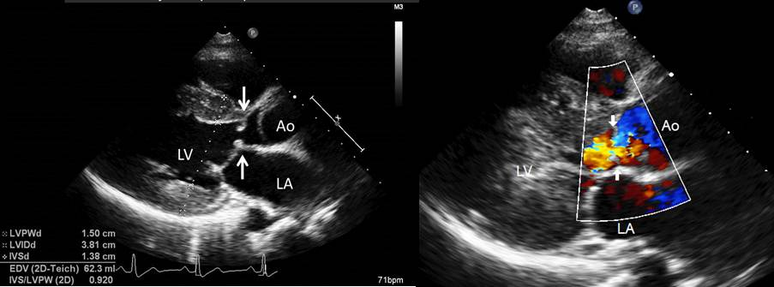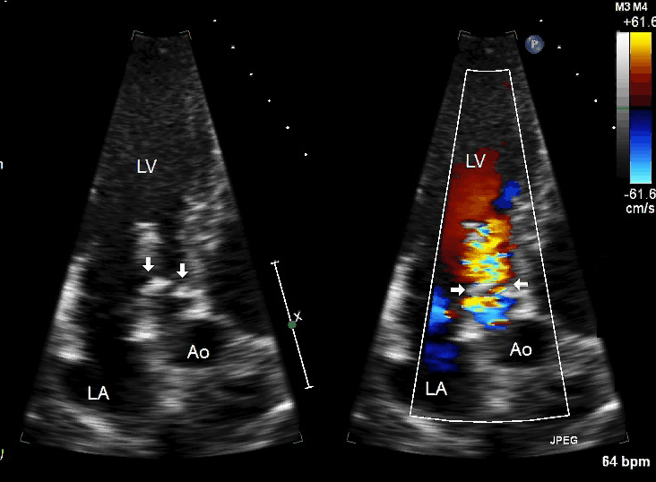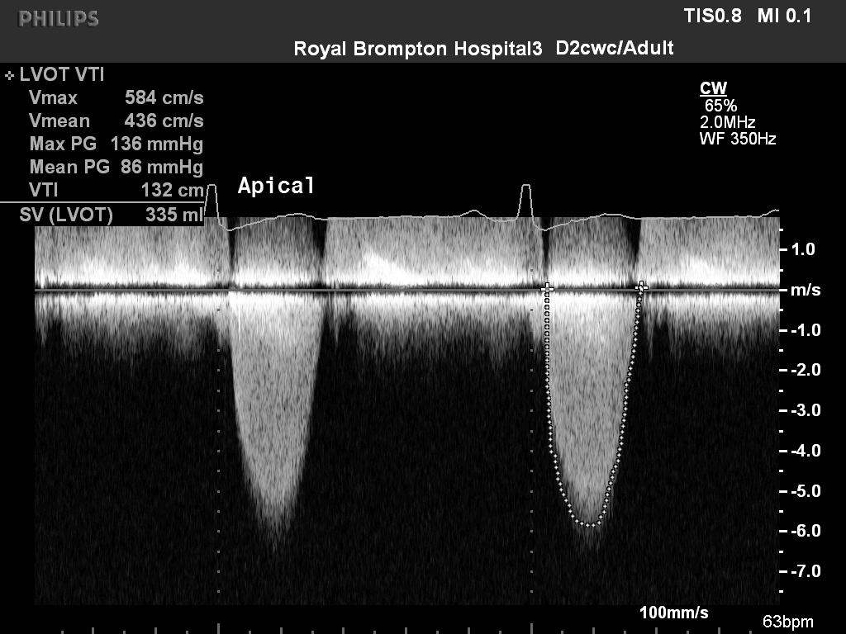

**A**

**B**

**C**

**D**

Figure 1: Subaortic membrane: A) subaortic membrane seen clearly in the outflow tract. LVH. B) turbulent colour flow arising from LVOT. C) apical long axis view showing membrane and LVOT turbulence D) CW Doppler confirms severe outflow tract obstruction

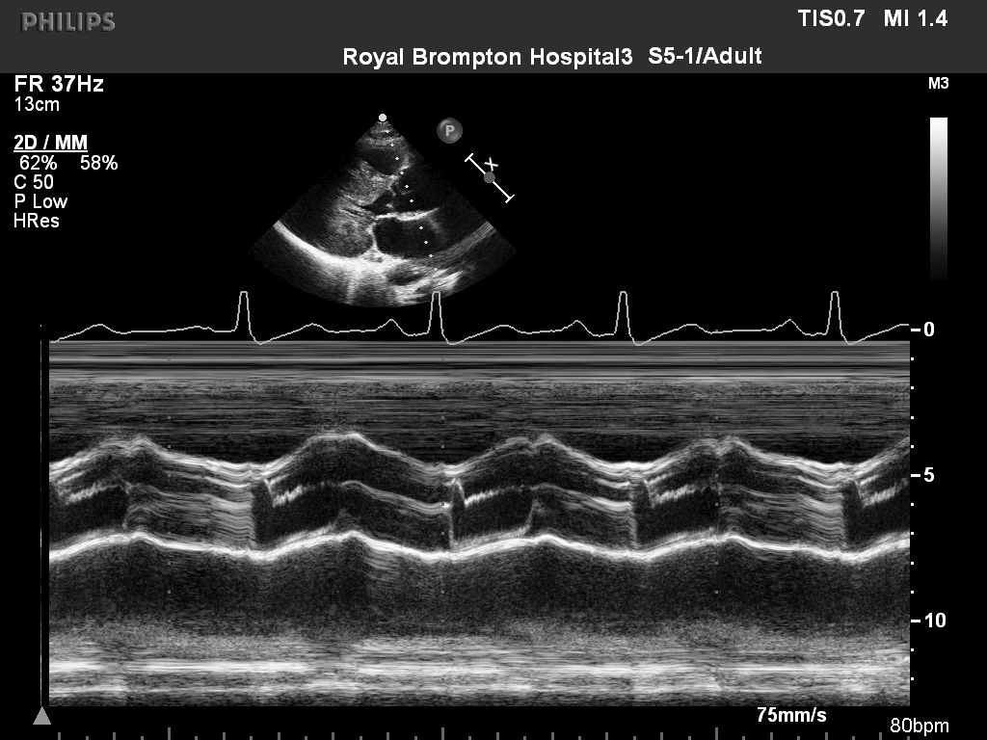

Figure 2. M-mode recording of aortic valve showing mid systolic closure of the aortic valve (arrow) in patient with sub aortic stenosis

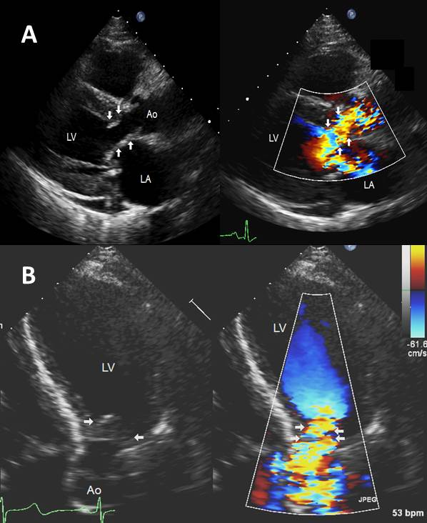

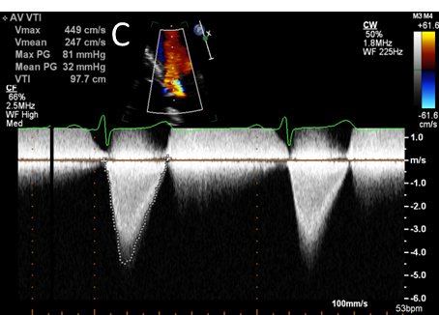

Figure 3: Tunnel like sub-aortic stenosis. A) Parasternal view showing diffused narrowing of LVOT with turbulent flow on colour Doppler. B) Apical five chamber view showing hypertrophied muscular tissue causing narrowing LVOT. C) CW Doppler confirms severe outflow tract obstruction

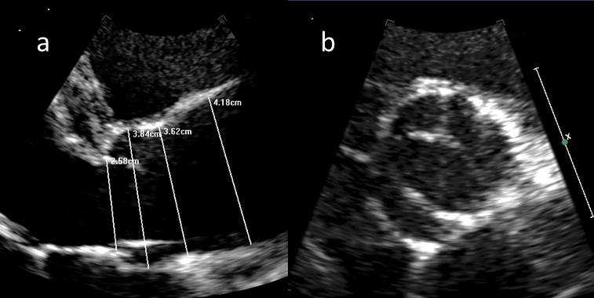

Figure 4. Bicuspid aortic valve. a)Parasternal long axis view showing bicuspid aortic valve and measurement of aortic root dimensions at ventriculo-arterial junction, trans-sinus, ST junction and ascending aorta. b) Parasternal short axis view demonstrating a bicuspid aortic valve during ventricular systole with limited opening orifice.

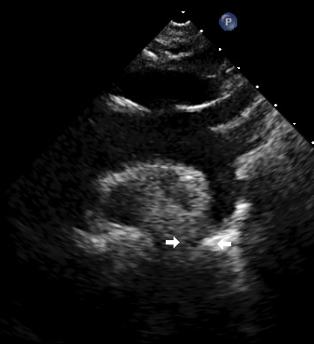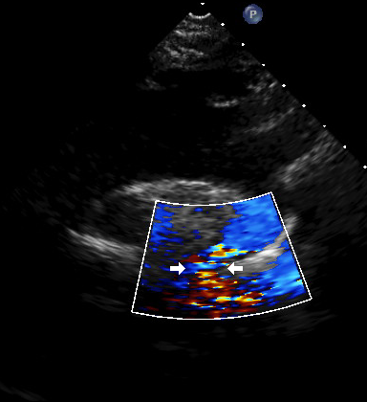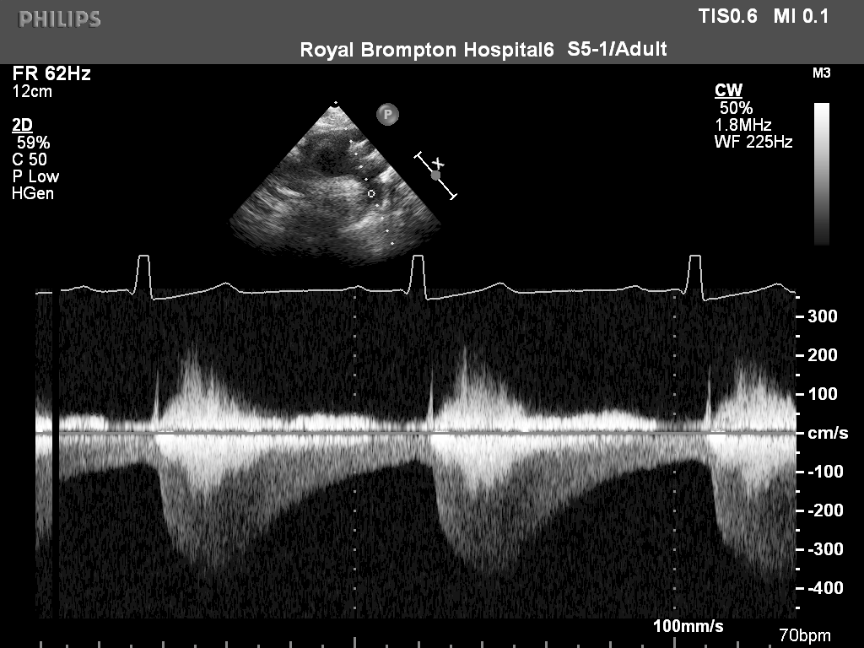

A

B

C

Figure 5. Coarctation of aorta. A) Supra-sternal view of aortic arch, narrowing at proximal descending aorta (arrow). B) Colour Doppler Mapping showing turbulent flow across the site of coarctation. C) continuous wave Doppler recording in the descending aorta showing increased peak systolic flow velocity with long diastolic tail (arrow) characteristic for significant coarctation of aorta.



A

B

C