Supplementary ACHD Echo Acquisition Protocol for
Atrioventricular Septal Defect

The following protocol for echo in adult patients with AVSD is a guide for performing a comprehensive assessment of this group of patients. It is intended as a supplementary guide to the ISACHD echo protocol and sequential analysis and all regular measurements should be included. It highlights areas of interest in each view specific to repaired AVSD.

Background
- AVSDs are characterized by a common atrioventricular junction with deficient atrioventricular septation.
- This congenital heart defect is particularly common in patients with Down syndrome (prevalence of AVSD around 30%).
- Anatomic characteristics are
  - a common ovoid shaped atrioventricular junction,
  - a defect of the membranous atrioventricular septum,
  - a 5 leaflet common valve (left and right mural leaflet, right antero-superior leaflet, superior and inferior bridging leaflet),
  - an un-wedged aorta with an elongated LVOT (i.e. “gooseneck deformity”).

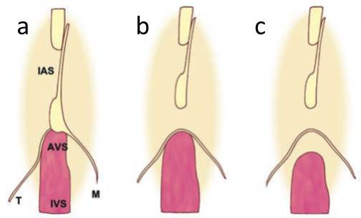
Diagram: Atrioventricular septal defect (AVSD):
- normal relation between interatrial septum (IAS), atrioventricular septum (AVS), interventricular septum (IVS), and septal cusps of tricuspid (T) and mitral (M) valves;
- incomplete AVSD (atrial septal defect type
primum)
- complete AVSD (complete atrioventricular septal defect).
Diagram adapted from Popelova et al.
- Functionally, AVSDs can be partial with shunting only at the atrial level (also called primum ASD or partial AVSDs) or complete with shunting at atrial and ventricular level (CAVSDs).
  - Partial AVSDs present with fused superior and inferior-bridging leaflets and attachment of these bridging leaflets to the scooped out crest of the ventricular septum. These patients, therefore, have 2 valve orifices with trileaflet left AV valve (albeit with a common AV junction). As the AV valves are not morphologically true mitral and tricuspid valves, they are referred to as left and right AV valves.
  - There is a continuum between partial and complete forms. There may be a VSD that is completely or partially covered by valve tissue forming an aneurysmal basal inlet ventricular septum with or without a restrictive VSD. This is called intermediate AVSD and may – as partial AVSD - be encountered unrepaired in adults.
  - Complete AVSDs present in adult life either after repair or - if unrepaired - with Eisenmenger physiology.
- After repair, atrioventricular valve malfunction (frequently regurgitation, less commonly stenosis) requires particular attention. Morphology and malfunction mechanism require detailed analysis. Residual ASD and/or VSD, LVOT obstruction, LV and RV abnormalities, and PAP elevation must be excluded or identified.

Common associations
- See ASD protocol
- AV-valve abnormalities and LVOT obstruction
- Double orifice left AV valve
- Anomalous papillary muscles
- Parachute left AV valve
- Left ventricular volume overload
- Pulmonary arterial hypertension or Eisenmenger syndrome
- Displacement of the AV node with associated arrhythmias

Residual haemodynamic lesions and complications in repaired AVSD
- Residual shunt (atrial and ventricular level)
- RV and LV dilatation and dysfunction
- Residual elevated pulmonary artery pressure
- Left-sided AV valve regurgitation, often through the closure line between superior and inferior bridging leaflet.
- Right-sided AV valve regurgitation
- LVOT obstruction

Imaging protocol for atrioventricular septal defect
Subcostal views | - Establish abdominal and atrial situs, cardiac position & direction of apex  - Assess IVC size & collapse to assess RA pressure  - Hepatic venous Doppler to assess venous flow pattern and systolic flow reversal from significant right AV valve regurgitation  - Residual shunt (VSD, ASD, LV-RA, RV-LA shunt) maybe multiple  - RV size and function  - Retrograde flow in abdominal aorta (in cases where > moderate AR present)
Parasternal views | - Shunt or residual shunt (VSD,ASD,LV-RA, RV-LA shunt) maybe multiple  - Left AV valve evaluation ( thickening, trileaflet, abnormal chordae)  - Severity and mechanism of left AV valve regurgitation (multiple jets possible)  - Assessment of papillary muscles (number, proximity to each other)  - Assess for double orifice left AV valve.  - Right AV valve evaluation (morphology)  - Severity and mechanism of right AV valve regurgitation  - CW Doppler flow velocity.  - LVOT obstruction morphology (accessory chordae, leaflet insertion, ridge)  - Colour Doppler (identify area of obstruction)  - Aortic valve morphology and quantify aortic regurgitation  - Doppler of pulmonary valve; degree of PR & estimation of PA mean & end-diastolic pressure  - Tricuspid regurgitation. CW Doppler for RV systolic pressure  - LV and LA dimension
Apical views | - Detailed LV function assessment.  - Shunt or residual shunt (VSD,ASD,LV-RA, RV-LA shunt) maybe multiple  - Aortic valve morphology and quantify aortic regurgitation  - LVOT obstruction (PW at multiple levels to identify the level of obstruction)  - Left AV valve evaluation ( thickening, septal commissure, abnormal chordae)  - Severity and mechanism of left AV valve regurgitation (multiple jets possible)  - CW for left AV valve gradient (especially after repair)  - Right AV valve evaluation (morphology)  - Severity and mechanism of right AV valve regurgitation  - Detailed RV size and function assessment (qualitative compared to LV size & quantitative).  - LA and RA size
Suprasternal views | - Assessment aortic valve Doppler gradient and regurgitation

AVSD Report Template
Key points to include in transthoracic echo report:
- Complete, partial or transitional AVSD
- Size of atrial and ventricular components
- Direction of shunting for both components
- AV valve chordal anatomy (if considered for surgery, especially straddling)
- AV valve regurgitation
- Estimate of pulmonary pressure
- Other associated lesions
- Ventricular size & function

Post repair
- Residual ASD or VSD
- Residual LV-RA shunting (Gerbode like defects)
- Left & right AV valve function
- Left & right ventricular size & function
- Estimate of pulmonary pressure
- Evaluation of associated lesions e.g. LV outflow obstruction

Key views specific to AVSD patients:

Fig 1. A: Parasternal long axis RV inflow view shows the atrial septal defect (asterisk) with Clear visualization of AV valves, on the same level. B. Parasternal short axis view showing the three leaflets (asterisk) of the left AV valve. Arrow indicates the commissure between anterior and posterior bridging leaflets

Fig 2. A: Apical 4c view AV valves are on the same level. Arrow shows the small atrial septal defect. LV and LA are dilated due to sever left AV regurgitation. B. Zoom of the AV junction showing clear chordae attachments of the superior bridging leaflet on to the septum (asterisk) . No ventricular shunt was present. Arrow shows the small atrial septal defect.

Figure 3: complete AVSD apical view in diastole

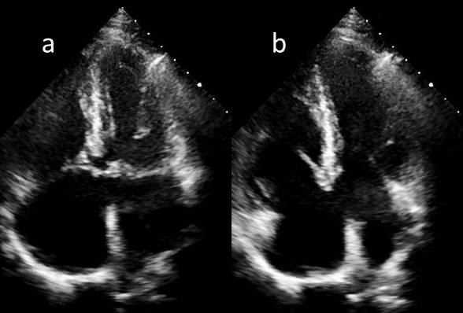
Figure 4 Partial AVSD/primum ASD. (Left) shows the primum ASD in diastole. (Right) shows no offset of the individual AV valves

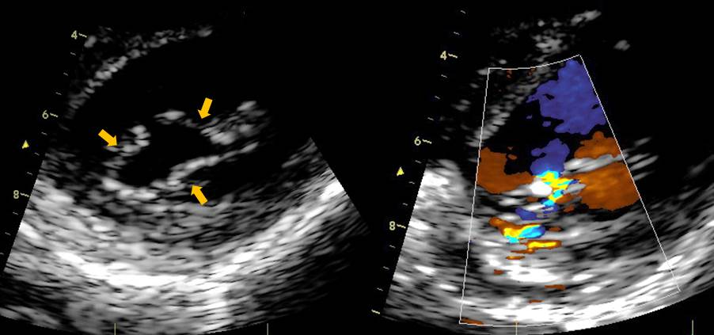
Figure 5: (left ) trileaflet left AV valve & (right) regurgitation arising from the anterior closure line /line of apposition. This is seen in partial AVSD and also in repaired common AVSD.

