100 Years of South Vietnamese Cải Lương Theatre and the Place of the Đàn Ghita Phím Lõm
Kiều Tấn

The ghita phím lõm that appeared to have been introduced through Western models but was in fact mainly inspired by Pinoy and Indonesian musicians who traveled to Southern Vietnam, is also called lục huyền cầm (6-string guitar), ghita móc phím (guitar with elevated frets), ghita cổ nhạc (guitar for old music), ghita vọng cổ (guitar for the accompaniment of the piece vọng cổ), ghita cải lương (guitar for the reformed theater), or ghita Việt Nam (Vietnamese guitar). There seems to be no other musical instrument in Vietnam with that number of different names. This specific instrument deserves to be introduced to a wider academic audience since it is closely connected to the South Vietnamese theatre tradition, especially to the “song of nostalgia” (ca vọng cổ) in the cải lương theatre (the “reformed theatre”) with its 100-year long history, in which the ghita phím lõm became a leading musical instrument.
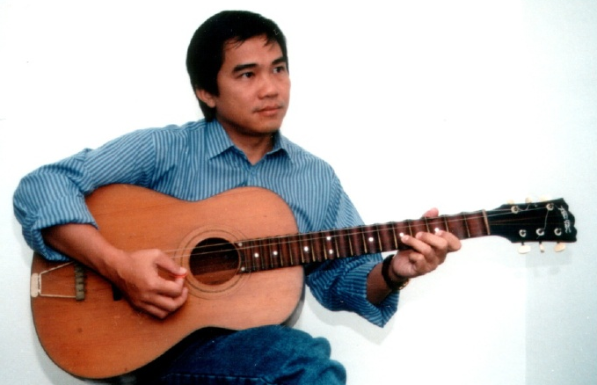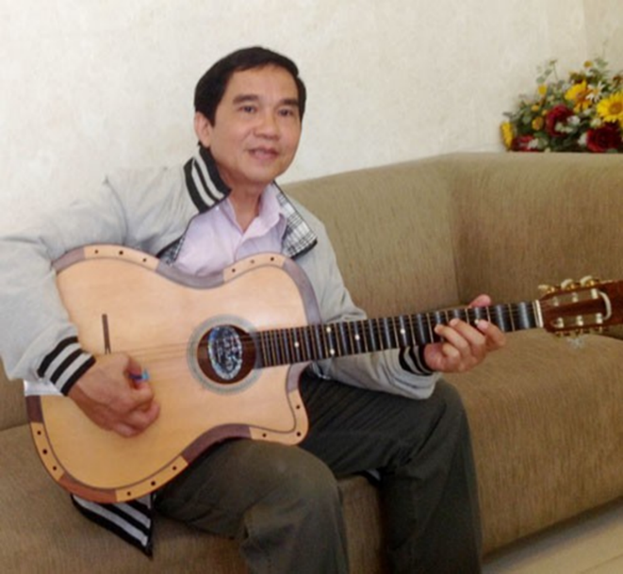
FIGURE 1 and 2: The author Kiều Tấn with his đàn guitar phím lõm (Picture by the author in 1998 and in 2018).
The ghita phím lõm was widely established at the latest in 1936 and was first named guitar vọng cổ. It was known for its use in âm nhạc tài tử (“Music of the Talented” which is the official translation in documents regarding this genre submitted to the UNESCO Representative List of Intangible Heritage of the World), where this instrument accompanied the highly sophisticated “song of nostalgia”, the ca vọng cổ, that was developed from a 2- and 4-bar (then still called Dạ cổ hoài lang and not being accompanied on the ghita phím lõm) to an 8- and 16-bar structured song and piece of music. Some of the songs were very well known and are still famous in Vietnam today: Văng vẳng tiếng chuông chùa (The temple bell is ringing), Khóc mồ bạn (Crying at your grave), Sao hôm lốm đốm điểm thưa rồi (Looking like a star down on the night scene), Thức trót canh gà (From evening to morning), Đêm khuya trông chồng (Waiting for the husband late night), Tình mẫu tử (Mother’s love), Tôn Tẩn giả điên (Tôn Tẩn is getting crazy), which were performed by the singers Tư Sạng, Tư Bé, Hai Đá, Năm Nghĩa, Tám Thưa, Út Trà Ôn. They were also available on records produced by Pathé, Béka, Odéon, or Asia and frequently replayed in public by persons important to local cultural life such as Chín Hòa, Ba Cậy, Armand Thiều, Văn Huệ, Mười Út, Bảy Hàm, and Ba Xây who improved the instrument, mainly through making use of different tunings called Xề bóp, Sài Gòn, Rạch Giá, Tứ nguyệt.
When approximately in the year 1941, the “song of nostalgia”, the ca vọng cổ, was developing a 32-bar structure (Jähnichen, 1997, Kiều Tấn 1998), the ghita phím lõm adapted to it by introducing new tunings such as dây lai After 1948, other tunings such as Ngân giang (1958) and bán Ngân giang (1969) were developed. The instrument was hence called “ghita vọng cổ”. Some of the most important songs in this scheme (32-bar structure using dây lai) were Đội gạo đường xa (Putting the rice basket on the head on a long way) performed by Hữu Phước, Sầu vương ý nhạc (Sorrowful sadness) performed by Minh Cảnh, Bạch Thu Hà khóc Võ Đông Sơ (Bạch Thu Hà cries over Võ Đông Sơ) performed by Lệ Thủy, Gánh chè bột khoai (Carrying sweet tapioca porridge) performed by Ngọc Giàu, Thoại Ba công chúa (The princes Thoại Ba) performed by Thanh Thanh Hoa, or Ba Râu đi Chợ Lớn (Ba Râu goes to Chợ Lớn) performed by Văn Hường. Those performances were accompanied on the ghita phím lõm by the then well-known musicians Văn Vĩ, Tư A, Văn Còn, Hoàng On, Hai Duyên, Duy Trì, Hoàng Huệ, Văn Hải and Văn Giỏi. Besides being great theatre musicians, these musicians also created important versions for the ghita phím lõm, however, only Master Văn Vĩ dared to play true solos. The experiences with new tunings, among them the tunings Rạch Giá and Ngân giang, allowed these musicians to contribute to the expressiveness of the musical tradition of the South Vietnamese âm nhạc tài tử by introducing specific playing patterns called “lợ” and “hợp âm trưởng” (indicating new and strange tones that are absent in other descriptions) which were completely new to the musical system and made the final phrases of the ca vọng cổ quite outstanding.
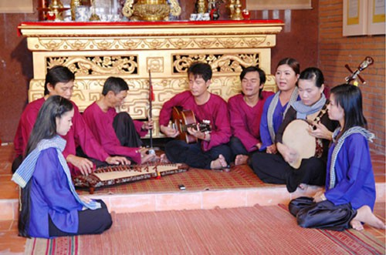
FIGURE 3: The ghita phím lõm (here played by the Nhạc Tài Tử Ensemble of Bạc Liêu [nhóm nhạc tài tử Bạc Liêu ở Khu lưu niệm Cao Văn Lầu]) is indispensable in the context of the South Vietnamese tài tử. (Photo: courtesy of Minh Hoàng).
In the past the ensemble of the dàn nhạc tài tử (ensemble of the “Music of the Talented”) had basically only three types of instruments which were kìm–tranh–cò (a long necked 2-string- “moon”-lute, the half tube 16-string zither đàn tranh, and the 2-string spike lute đàn cò) that were enriched with the đàn bầu (monochord), the đàn tam (3-string fretless lute), the đàn tỳ bà (the Vietnamized pipa), the tiêu and sáo (longitudinal and traverse flutes without mirliton attached). Now, an ensemble has to increasingly satisfy the following functions: a bass line, chords to fill in the space, and a leading melodic instrument. These aesthetic requirements result from developed habits in listening cultures during the last century and through recent global media use, which leads to familiarity with a thick sound and some fragments of harmonic progressions. In this context, the new ghita phím lõm could be used to fulfill all these requests within one instrument. No other instrument was able to practically substitute the traditional ensemble. The larger range, the capability of filling the space with broken chords, the clear melodic lines that could follow specific pitch environments such as compulsory micro-melodic approaches, vibratos raising or lowering in pitch and/or speed, through the hollowed-out frets, contributed to the instrument’s frequent appearance as an ensemble or solo instrument. Out of 6 possible strings for the guitar only 4 were first used, followed by 5, and then 6, in order to enlarge the range and to produce a bass line. Since the capodastro (a tool used on the neck of the guitar to shorten the length of the strings) was introduced, there were also no problems in accommodating the right pitch set for singers.
Although all these convenient functions helped promote the ghita phím lõm, many musicians in the world of nhạc tài tử still see this instrument as not really acceptable. Even while the traditional musicians admit that, aside from using it in the already mentioned ca vọng cổ, playing the 20 bản Tổ (3 Nam, 6 Bắc, 7 bài, 4 Oán; i.e. basic groups of pieces categorized according to their mode) and some other large compositions such as Văn thiên tường (name of a Chinese Poet, Văn Thiên Tường [文天祥 Wen Tian Xiang] living from 6 June 1236 to 9 January 1283), Trường tương tư (Being amazingly infatuated), Bình sa lạc nhạn (A bird drops down on the sand and dies), or Thanh dạ đề quyên (Feeling the voice of a crying bird at night) is easier using the ghita phím lõm without the tradition being compromised. However, in the view of conservative musicians, the shape and the underlying nature of the instrument might not be deemed appropriate. It was only after serious research started in the 1980s at the National Institute for Music Research in Ho Chi Minh City, that this held opinion of orthodoxy was given up. Finally, the fight for its inscription into the UNESCO list of Intangible Heritage of Humanity in 2013 convinced all musicians active in the scene that the repertoire of nhạc tài tử and subsequently of the cải lương theatre would have been impossible without the ghita phím lõm.
Both cultural ideas, that of the music in its development and that of the musical instrument in its changing shapes are important to the musical life in South Vietnam; it also enriched the world with exciting sounds.
Researches in the field of nhạc tài tử included the analysis of tuning systems. Since the ghita phím lõm applied the string tuning called ‘dây Lai’ using Lìu–Xàng–Hò–Xê–Líu (for example: D–G–d–a–d’) it could replace a number of other string instruments in the theatre ensemble. The stage music became richer and more diverse since this tuning made re-tunings for different registers or singers unnecessary. Basic tones could be easily shifted by adding or leaving out lower strings.
A new step in its further development in the year 1960 see the ghita phím lõm equipped with an electric amplifier, thus becoming a ghita phím lõm điện. This innovation was instantly applied in the theatre music allowing for larger audiences, more sophisticated stages and a possibility to even perform in open-air settings. The core song, the ca vọng cổ, became much more versatile and more extended than before. There was not a single theatre performance without this song. The electrified ghita phím lõm advanced to be an instrumental symbol of the cải lương theatre and it was thus often named as ghita cải lương.
Eighty years since the adoption and development of this instrument may not seem very long. However, the impact of the ghita phím lõm on the repertoire and the stage music is tremendous. The musical range was expanded into the bass register thus preparing a foundation for later harmonic progressions that were involved in the application of contemporary popular music. Also, in terms of enriching traditional features of the musical language, the ghita phím lõm adds some unique expressions based on its instrumental qualities, enabling new skills to develop among the musicians. The core song structure was further developed and became an outstanding musical form within the theatre music. The entire story of the ghita phím lõm is a result of many smart inventions and adaptations from various sources. So, it evolved from being an "unorthodox" instrument to a miracle instrument, occupying the leading position that is much respected by everyone who enjoys music in the South of Vietnam and beyond.

References
Jähnichen, Gisa. 2012. ÂM NHẠC TÀI TỬ NAM BỘ - MỘT LỐI TƯ DUY ÂM NHẠC CỦA NGƯỜI PHƯƠNG NAM. The Art of Don Ca Tai Tu and Styles of Improvisation. Edited by Vietnamese Institute for Musicology. Hanoi: Vietnamese Institute for Musicology, 163-179.
Kiều Tấn. 1997. Cây đàn ghita phím lõm. Berlin: Deutsch-Vietnamesische Gesellschaft e.V.

