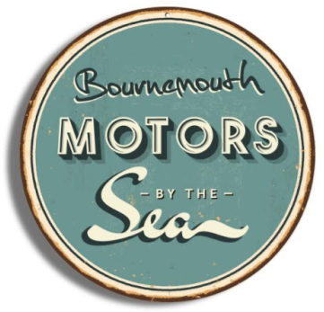
Motors by the Sea Festival
Sunday 16TH September 2018
10am – 4pm
Vehicle Entry Form
CLOSING DATE – Friday ^{31st} August 2018

Please complete and return the booking form below to hello@dominiquewallace.co.uk by
Friday 31st August 2018.

ENTRANT INFORMATION:
Name
Address
Postcode |  | Email
Home Phone |  | Mobile

VEHICLE INFORMATION:
Make |  |  | Model
Year of Manufacture |  |  | Registration Number

OTHER INFORMATION:
Are you a member of a Car Club? | Yes |  | No |  | Where possible we will try to locate car clubs together
If Yes name of Car Club

CATEGORY:
Motorcycle
Vintage
Classic
US Car
Sports
Supercar
Customised
Electric
Other (please specify)

CONDITIONS OF ENTRY:

- The event is fully covered by Public Liability Insurance, however valid insurance cover must be held by all entrants for their vehicles.
- Vehicles are entered at owner’s own risk and organisers accept no responsibility for any loss / damage / theft to exhibitor’s person, vehicle or property whilst at the event.
- All vehicles must be in a roadworthy condition and have third Party Insurance risk on and off the event area.
- All vehicles must have valid road tax and MOT (where relevant).
- Vehicles must be securely braked and engines switched off throughout the event.
- Vehicles must be clean, complete and in safe working order.
- All leakages must be kept to an absolute minimum considering the age of the vehicle.
- The driver must hold the appropriate license to drive their vehicle.
- Organisers reserve the right to refuse admission.
- Vehicles must not move during event times, unless escorted by a steward.
- Marshals’ decisions are final.
- The Organisers reserve the right to alter the event without prior notice.
- A speed limit of 5mph applies on site at all times and all vehicle movement will be controlled by Event Stewards.
- By signing this form, you have read and abide by all the above conditions of entry.
- Only signed entries can be accepted.

Signed: Date:

If you would like any further information please contact Dominique at Thirty 12 Events LTD on 07949 767096 or hello@dominiquewallace.co.uk

